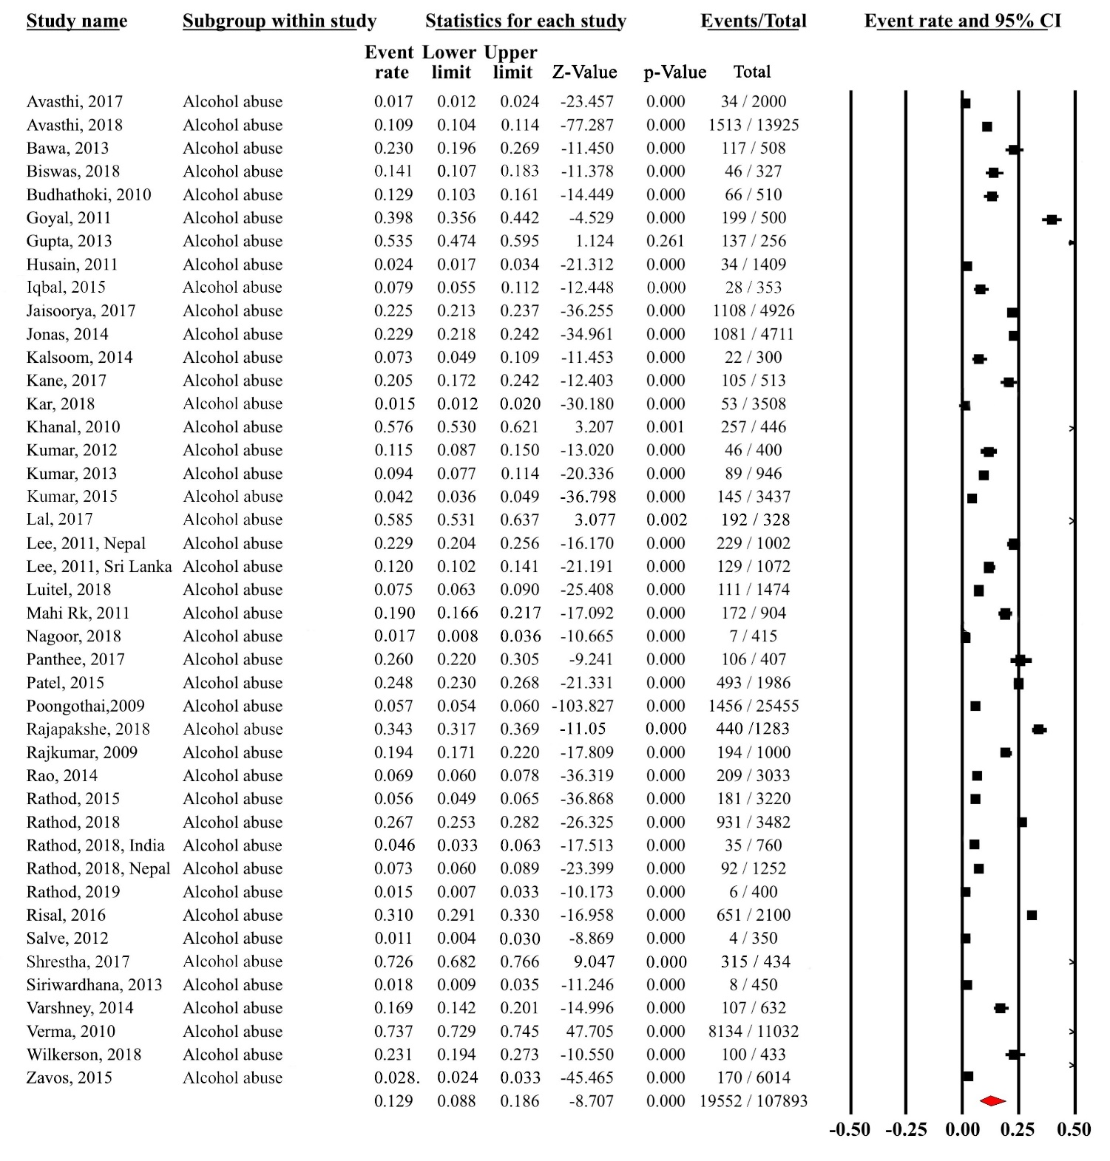
Figure 1: Forest Plot for Alcohol Use Disorder.
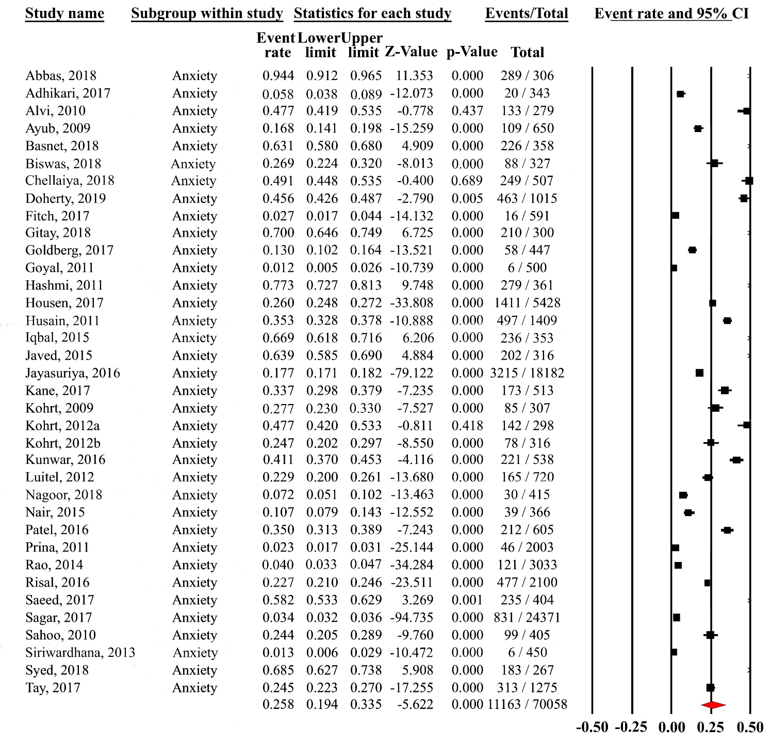
Figure 2: Forest Plot for Anxiety Disorder.

Figure 3: Forest Plot for Depressive Disorder.

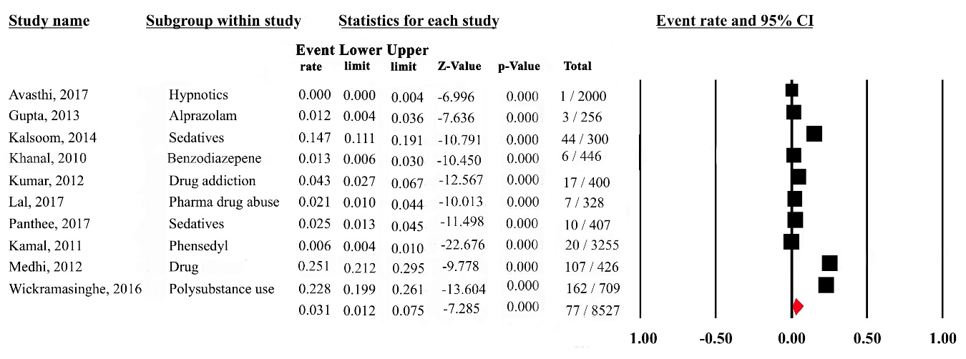
Figure 4: Forest Plot for Substance Use Disorder.

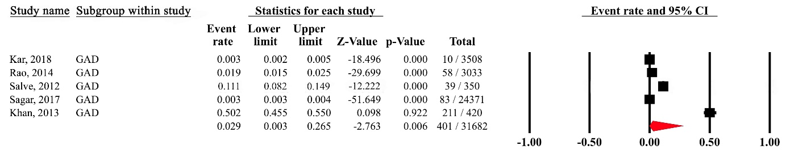
Figure 5: Forest Plot for GAD.

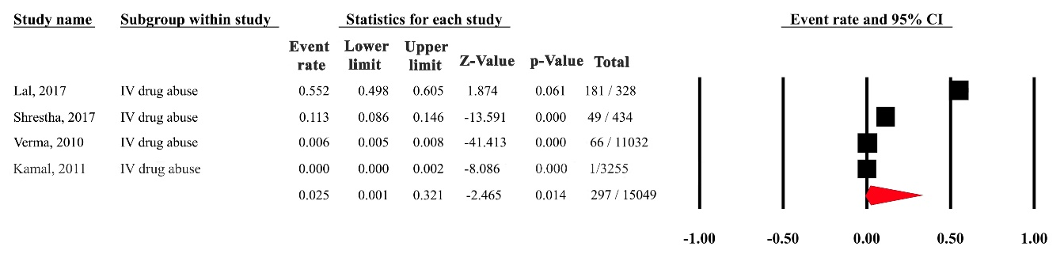
Figure 6: Forest Plot for Intravenous Drug Use.

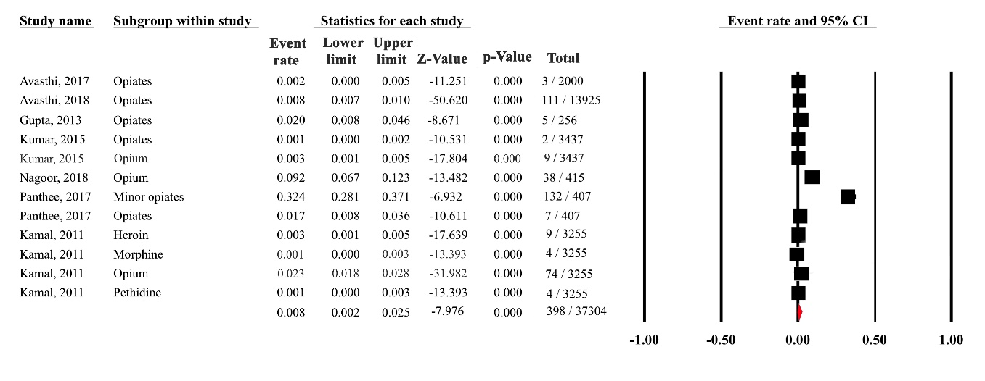
Figure 7: Forest Plot for Opioid use Disorder.

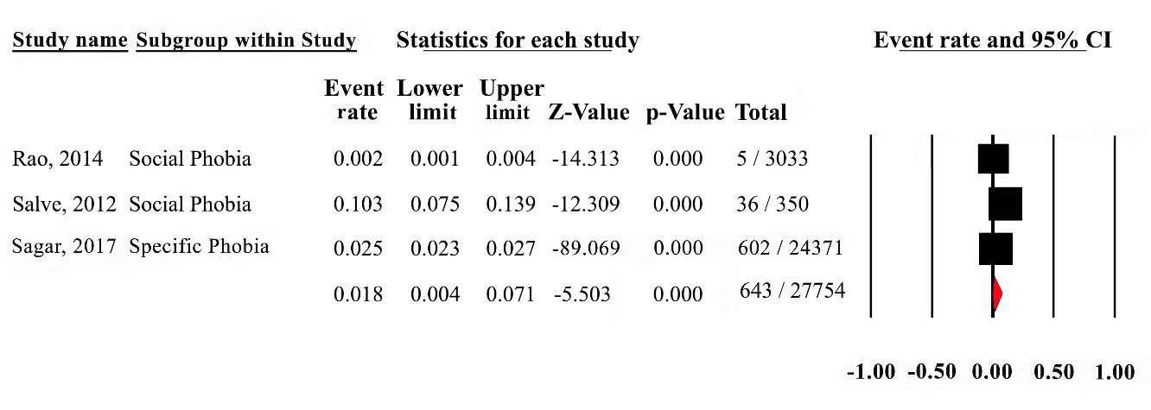
Figure 8: Forest Plot for Specific Phobia.

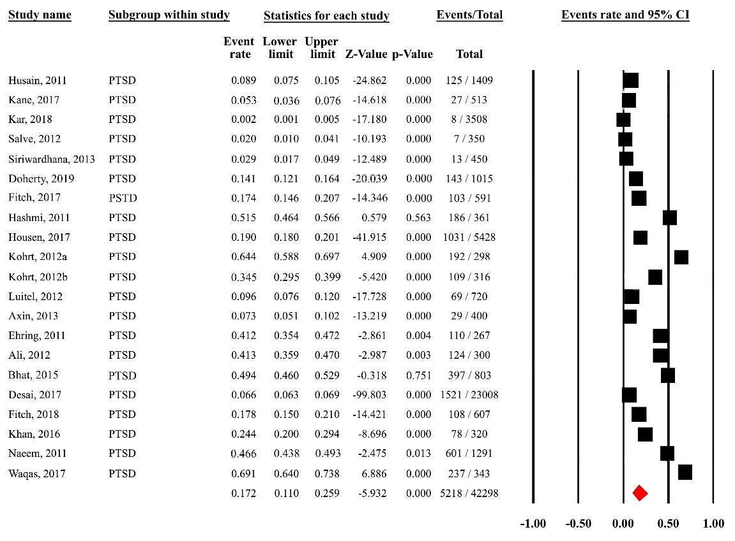
Figure 9: Forest Plot for Posttraumatic Stress Disorder.

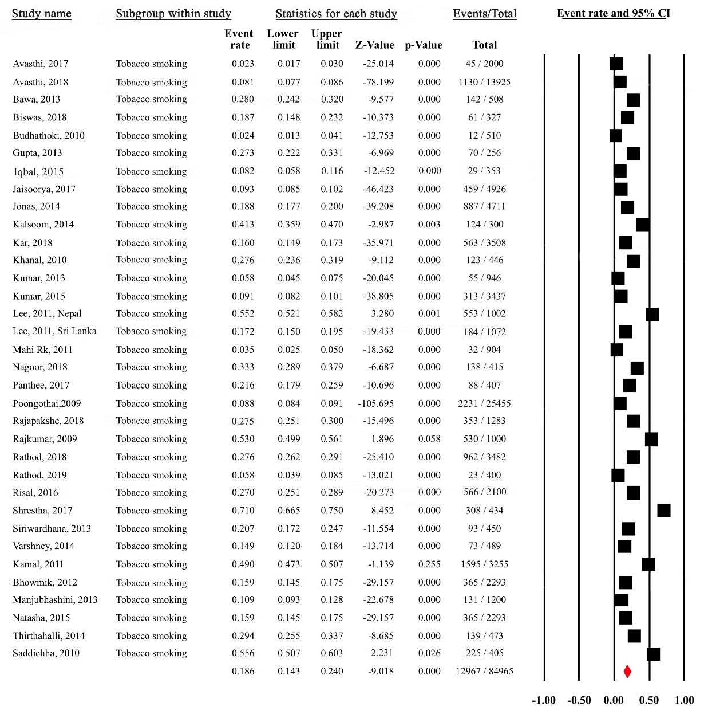
Figure 10: Forest Plot for Tobacco Use Disorder.

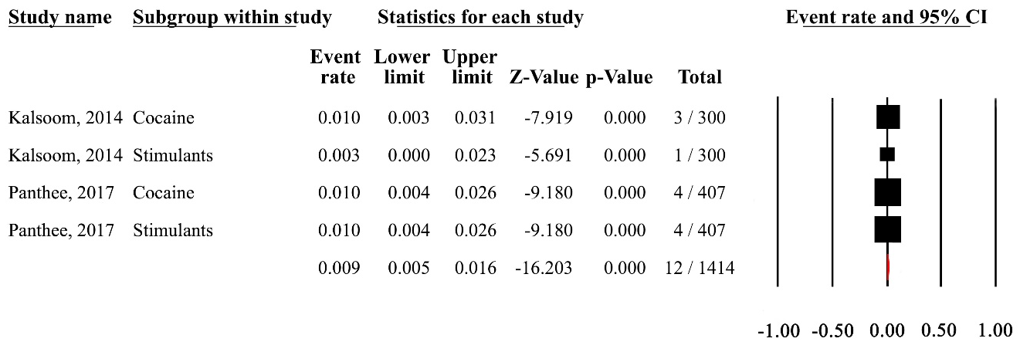
Figure 11: Forest Plot for Stimulant Disorder.

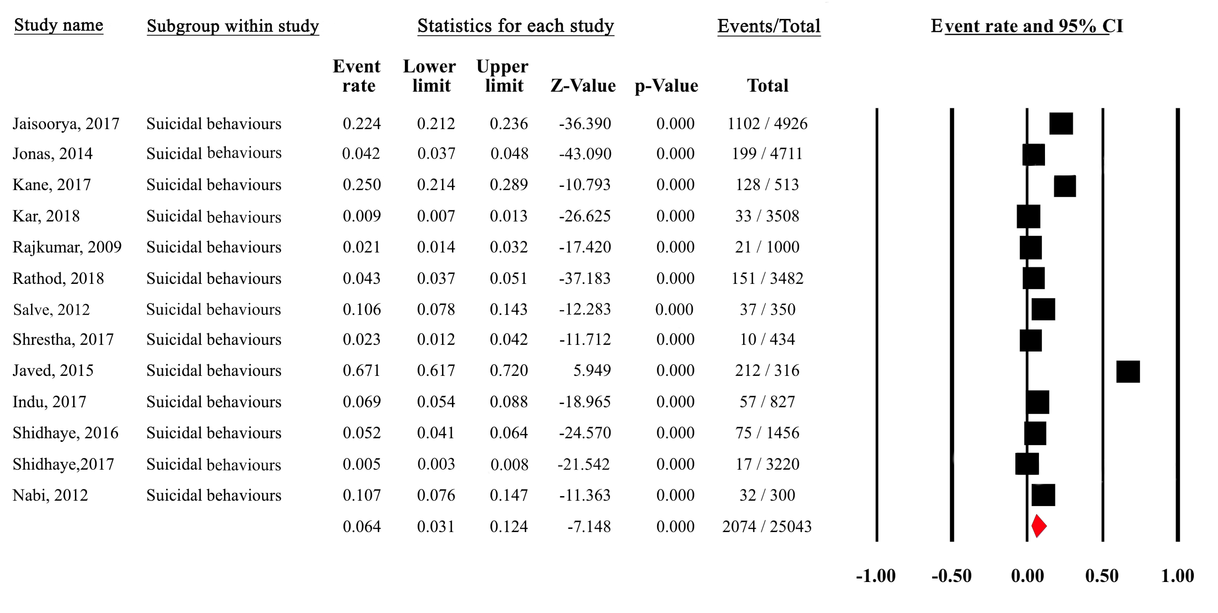
Figure 12: Forest Plot for Suicidal Behaviors.

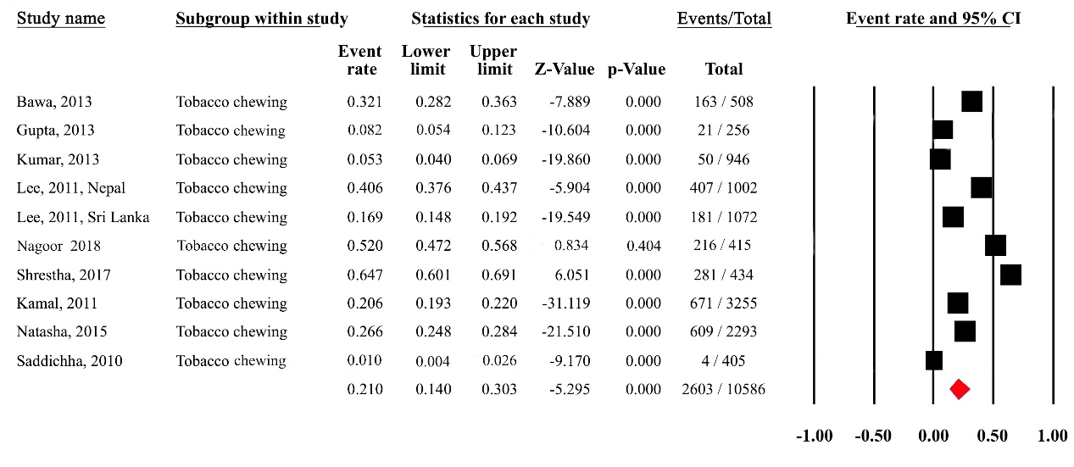
Figure 13: Forest Plot for Chewable Tobacco.

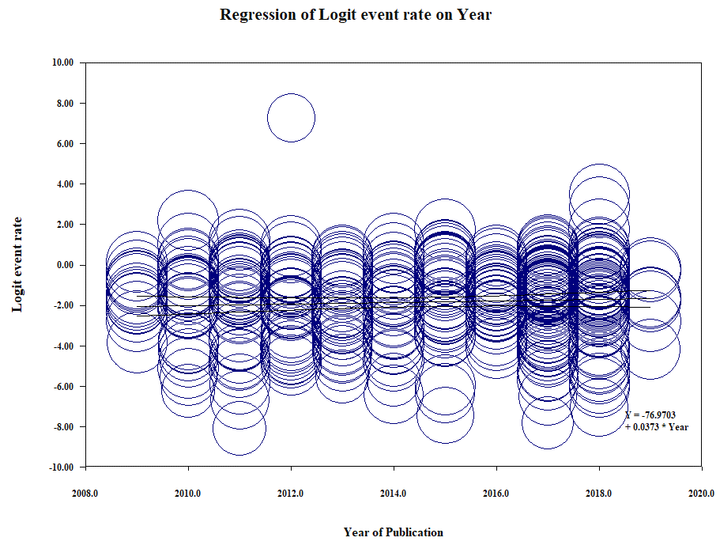
Figure 14: Meta-regression exhibiting year of publication as a covariate of prevalence estimates.

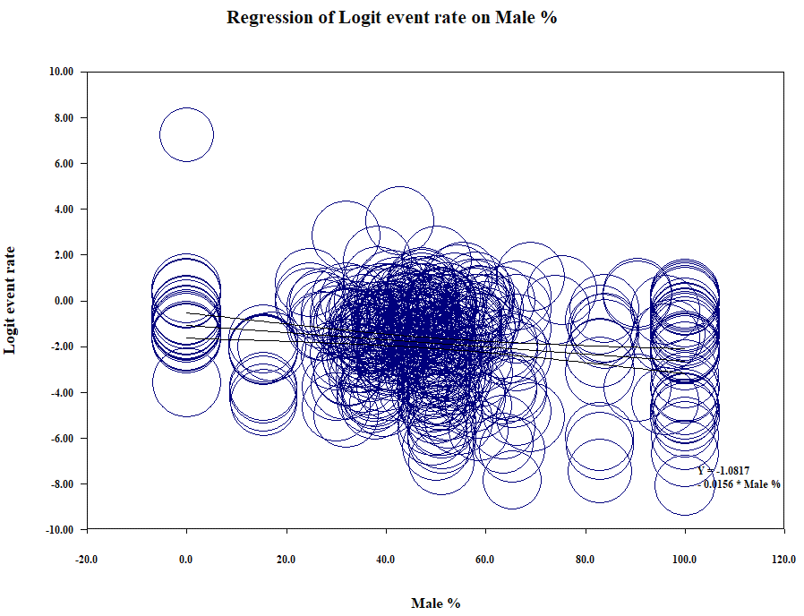
Figure 15: Meta-regression exhibiting percentage of males as a covariate of prevalence estimates.

