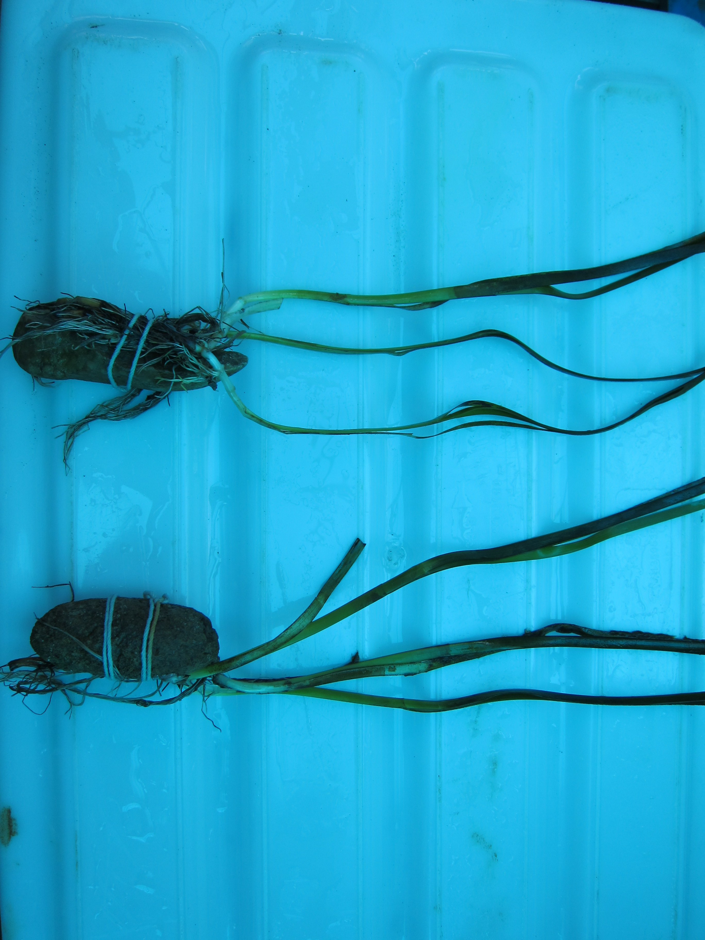
A
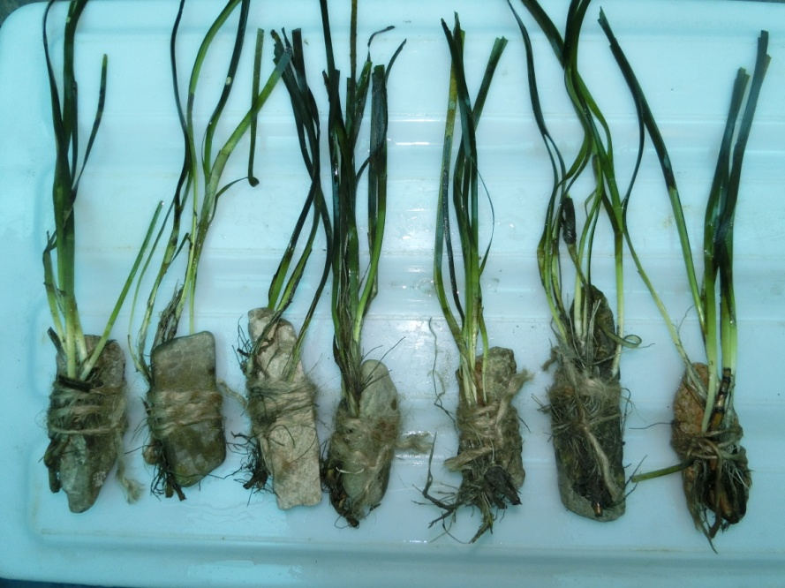
B

Fig.1. A photo showing stones with shoots; for each small elongate stone of 50–150 g, three shoots with rhizomes and roots were tied using biodegradable cotton (A) or hemp (B) thread.

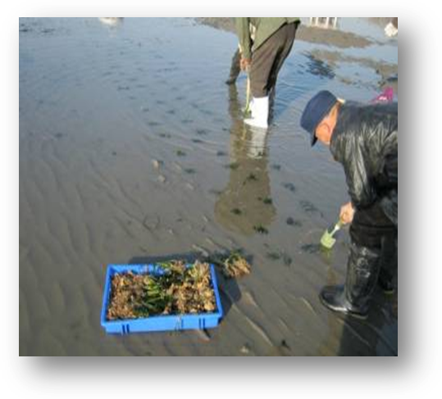
Fig.2. A photo showing eelgrass transplanting process. PUs were buried in holes dug with a scoop so that the rhizomes were situated at a depth of 2–4 cm in sediments.

