Table 1: Topic word distribution (Top 10 words)
Topic | Topic label | Main category
1 | Green Party allows use and sale at party conference | 0.073* ‘laillistaminen’ + 0.031* ‘kannattaa’ + 0.026* ‘vihreä’ + 0.017* ‘puolue’ + 0.017* ‘saada’ + 0.013* ‘kanta’ + 0.011* ‘dekriminalisointi’ + 0.009* ‘tehdä’ + 0.009* ‘ajaa’ + 0.009* ‘vastustaa’  [0.073* ‘legalization’ + 0.031* ‘support’ + 0.026* ‘green’ + 0.017* ‘party’ + 0.017* ‘get’ + 0.013* ‘position’ + 0.011* ‘decriminalization’ + 0.009* ‘do’ + 0.009* ‘drive’ + 0.009* ‘oppose’]
2 | Comparison of alcohol with cannabis | 0.036* ‘alkoholi’ + 0.020* ‘huume’ + 0.014* ‘laillinen’ + 0.013* ‘laiton’+ 0.011* ‘käyttö’ + 0.011* ‘saada’ + 0.008* ‘ihminen’ + 0.008* ‘myynti’ + 0.008* ‘nuori’ + 0.008* ‘vaikutus’  [0.036* ‘alcohol’ + 0.020* ‘drug’ + 0.014* ‘legal’ + 0.013* ‘illegal’ + 0.011* ‘use’ + 0.011* ‘get’ + 0.008* ‘person’ + 0.008* ‘sale’ + 0.008* ‘young’ + 0.008* ‘effect’]
3 | Pros and cons of legal market of cannabis | 0.024* ‘käyttö’ + 0.018* ‘verotulo’ + 0.015* ‘laillistaminen’ + 0.013* ‘kanada’ + 0.012* ‘ongelma’ + 0.012* ‘suomi’ + 0.011* ‘vero’ + 0.010* ‘valtio’ + 0.010* ‘raha’ + 0.009* ‘maksaa’  [0.024* ‘use’ + 0.018* ‘tax revenue’ + 0.015* ‘legalization’ + 0.013* ‘Canada’ + 0.012* ‘problem’ + 0.012* ‘Finland’ + 0.011* ‘tax’ + 0.010* ‘state’ + 0.010* ‘money’ + 0.009* ‘pay’]
4 | Interaction of alcohol use with cannabis and their impacts on youth | 0.072* ‘käyttö’ + 0.018* ‘vähentää’ + 0.016* ‘haitto’ + 0.016* ‘alkoholi’ + 0.014* ‘laillistaminen’ + 0.014* ‘saada’ + 0.013* ‘nuori’ + 0.012* ‘lisääntyä’ + 0.011* ‘pitää’ + 0.010* ‘laillinen’  [0.072* ‘use’ + 0.018* ‘reduce’ + 0.016* ‘harm’ + 0.016* ‘alcohol’ + 0.014* ‘legalization’ + 0.014* ‘get’ + 0.013* ‘young’ + 0.012* ‘increase’ + 0.011* ‘keep’ + 0.010* ‘legal’]
5 | The impact of legal sales of other substances | 0.026* ‘saada’ + 0.023* ‘käyttää’ + 0.018* ‘alkoholi’ + 0.014* ‘tupakka’+ 0.013* ‘laillinen’ + 0.012* ‘pitää’ + 0.008* ‘suomi’ + 0.008* ‘nuuska’+ 0.008* ‘ihminen’ + 0.008* ‘aine’  [0.026* ‘get’ + 0.023* ‘use’ + 0.018* ‘alcohol’ + 0.014* ‘tobacco’ + 0.013* ‘legal’ + 0.012* ‘keep’ + 0.008* ‘Finland’ + 0.008* ‘snus’ + 0.008* ‘person’ + 0.008* ‘substance’]
6 | Problems, drug policy and role of police | 0.027* ‘käyttö’ + 0.019* ‘ongelma’ + 0.016* ‘pitää’ + 0.010* ‘laillistaminen’ + 0.010* ‘poliisi’ + 0.009* ‘ihminen’ + 0.009* ‘huume’ + 0.008* ‘osa’ + 0.007* ‘sanoa’ + 0.007* ‘alkoholi’  [0.027* ‘use’ + 0.019* ‘problem’ + 0.016* ‘keep’ + 0.010* ‘legalization’ + 0.010* ‘police’ + 0.009* ‘person’ + 0.009* ‘drug’ + 0.008* ‘part’ + 0.007* ‘say’ + 0.007* ‘alcohol’]
7 | Interaction of alcohol with illegal drugs | 0.024* ‘alkoholi’ + 0.013* ‘huume’ + 0.012* ‘saada’ + 0.011* ‘tehdä’ + 0.010* ‘laillistaa’ + 0.010* ‘olla’ + 0.010* ‘laiton’ + 0.009* ‘kieltolaki’ + 0.009* ‘käyttää’ + 0.008* ‘thc’  [0.024* ‘alcohol’ + 0.013* ‘drug’ + 0.012* ‘get’ + 0.011* ‘do’ + 0.010* ‘legalize’ + 0.010* ‘be’ + 0.010* ‘illegal’ + 0.009* ‘prohibition’ + 0.009* ‘use’ + 0.008* ‘THC’]
8 | Other cannabis related policies | 0.027* ‘vihreä’ + 0.014* ‘olla’ + 0.012* ‘suomi’ + 0.012* ‘sallia’ + ' '0.010* ‘käyttö’ + 0.010* ‘hamppu’ + 0.009* ‘myynti’ + 0.008* ‘puoluekous’ + 0.008* ‘laillistaminen’ + 0.008* ‘saada’  [0.027* ‘green’ + 0.014* ‘be’ + 0.012* ‘Finland’ + 0.012* ‘allow’ + 0.010* ‘use’ + 0.010* ‘hemp’ + 0.009* ‘sale’ + 0.008* ‘party conference’ + 0.008* ‘legalization’ + 0.008* ‘get’]
9 | Effects of alcohol prohibition and cannabis legalization | '0.020* ‘kieltolaki’ + 0.014* ‘alkoholi’ + 0.010* ‘laillistaminen’ + 0.010* ‘nuori’ + 0.010* ‘saada’ + 0.009* ‘toimia’ + 0.009* ‘rikollinen’ + 0.009* ‘käyttö’ + 0.008* ‘vihreä’ + 0.008* ‘käyttäjä’  [0.020* ‘kieltolaki’ + 0.014* ‘alkoholi’ + 0.010* ‘legalization’ + 0.010* ‘youth’ + 0.010* ‘obtain’ + 0.009* ‘take action’ + 0.009* ‘criminal’ + 0.009* ‘use’ + 0.008* ‘green’ + 0.008* ‘user’]
10 | Cannabis legalization effects on safety and harms | 0.029* ‘käyttää’ + 0.024* ‘aiheuttaa’ + 0.024* ‘skitsofrenia’ + 0.020* ‘psykoosi’ + 0.016* ‘käyttö’ + 0.014* ‘alkoholi’ + 0.009* ‘kuolla’+ 0.009* ‘ihminen’ + 0.009* ‘tutkimus’ + 0.008* ‘kuolema’  [0.029* ‘use’ + 0.024* ‘cause’ + 0.024* ‘schizophrenia’ + 0.020* ‘psychosis’ + 0.016* ‘use’ + 0.014* ‘alcohol’ + 0.009* ‘die’ + 0.009* ‘person’ + 0.009* ‘study’ + 0.008* ‘death’]
11 | Macro level discussions about the impact of cannabis legalization | 0.012* ‘suomi’ + 0.009* ‘pitää’ + 0.008* ‘aiheuttaa’ + 0.008* ‘laillistaa’ + 0.008* ‘käyttäjä’ + 0.008* ‘olla’ + 0.007* ‘osa’ + 0.007* ‘ei’ + 0.006* ‘näkyä’ + 0.006* ‘nähdä’  [0.012* ‘Finland’ + 0.009* ‘keep’ + 0.008* ‘cause’ + 0.008* ‘legalize’ + 0.008* ‘user’ + 0.008* ‘be’ + 0.007* ‘part’ + 0.007* ‘not’ + 0.006* ‘visible’ + 0.006* ‘see’]
12 | Promotion of open discussion of cannabis legalization and decriminalization on its usage and prevalence | 0.016* ‘suomi’ + 0.014* ‘olla’ + 0.011* ‘laillistaminen’ + 0.011* ‘varmaan’ + 0.011* ‘käyttö’ + 0.011* ‘saada’ + 0.010* ‘keskustelu’+ 0.008* ‘vuosi’ + 0.007* ‘nuori’ + 0.006* ‘kertoa’  [0.016* ‘Finland’ + 0.014* ‘be’ + 0.011* ‘legalization’ + 0.011* ‘probably’ + 0.011* ‘use’ + 0.011* ‘get’ + 0.010* ‘discussion’ + 0.008* ‘year’ + 0.007* ‘young’ + 0.006* ‘tell’]
13 | Regulation and sale of cannabis like alcohol | 0.043* ‘saada’ + 0.037* ‘ostaa’ + 0.013* ‘myydä’ + 0.013* ‘kauppa’ + 0.012* ‘alko’ + 0.011* ‘pitää’ + 0.010* ‘laillisesti’ + 0.009* ‘kaveri’ + 0.009* ‘suomalainen’ + 0.007* ‘käyttää’  [0.043* ‘get’ + 0.037* ‘buy’ + 0.013* ‘sell’ + 0.013* ‘shop’ + 0.012* ‘Alko’ + 0.011* ‘keep’ + 0.010* ‘legally’ + 0.009* ‘friend’ + 0.009* ‘Finnish’ + 0.007* ‘use’]
14 | Research related discussions of alcohol and drugs regarding their impacts on health | 0.011* ‘suuri’ + 0.010* ‘alkoholi’ + 0.009* ‘aiheuttaa’ + 0.007* ‘huume’+ 0.007* ‘aihe’ + 0.007* ‘tietää’ + 0.007* ‘tutkimus’ + 0.007* ‘pitää’ + 0.006* ‘laillistaminen’ + 0.006* ‘käyttäjä’  [0.011* ‘large’ + 0.010* ‘alcohol’ + 0.009* ‘cause’ + 0.007* ‘drug’ + 0.007* ‘topic’ + 0.007* ‘know’ + 0.007* ‘research’ + 0.007* ‘keep’ + 0.006* ‘legalization’ + 0.006* ‘user’]
15 | Methods of cannabis consumption | 0.012* ‘pää’ + 0.011* ‘puhua’ + 0.011* ‘ihminen’ + 0.011* ‘suomi’ + 0.010* ‘sekaisin’ + 0.010* ‘pilvi’ + 0.010* ‘keskustelu’ + 0.010* ‘vihreä’ + 0.009* ‘haluta’ + 0.009* ‘pitää’  [0.012* ‘head’ + 0.011* ‘talk’ + 0.011* ‘person’ + 0.011* ‘Finland’ + 0.010* ‘confused’ + 0.010* ‘cloud’ + 0.010* ‘discussion’ + 0.010* ‘green’ + 0.009* ‘want’ + 0.009* ‘keep’]

Figure 1: Intertopic Distance Map

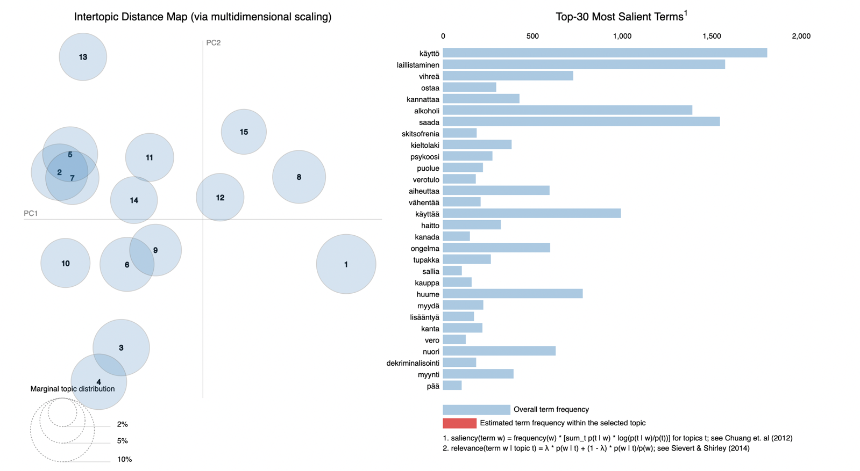

The Intertopic Distance Map is a visualization tool that illustrates the relationships between different topics in the corpus. The map displays each topic as a circle, with the size of the circle indicating the number of words belonging to that topic. The positions of the circles are determined based on the distances between topics, calculated using a technique called multidimensional scaling.

In addition to the circles, the right panel of the visualization includes a horizontal bar chart showing the 30 most prominent terms in the corpus. The bars on the chart represent the total frequency of each term in the corpus, providing insight into the most commonly used words and phrases across the different topics. This allows readers to better understand the distribution and prominence of different terms across the corpus.

Figure 2: Distribution of tweets across topics

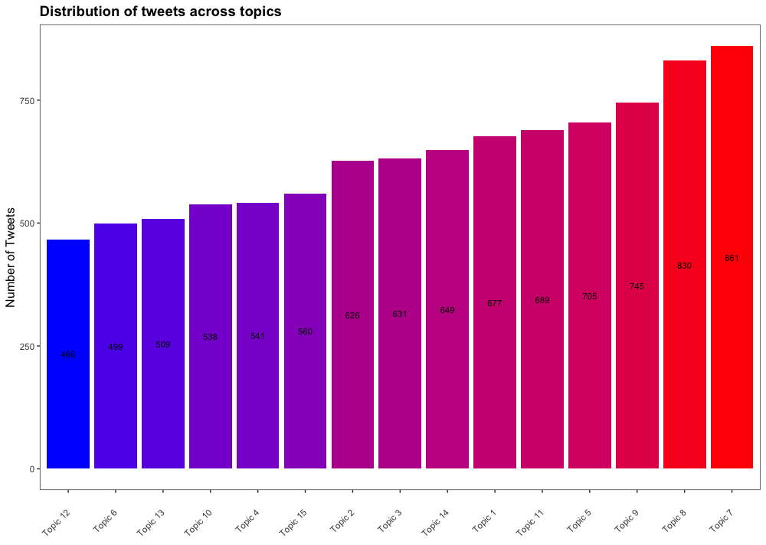
Figure 2 displays the distribution of tweets across 15 topics related to discussions about cannabis legalization in Finland. Each topic is represented by a different color in the stacked bar chart. The height of each color indicates the proportion of tweets that belong to that specific topic. The chart provides a visual representation of the relative frequency of topics in the dataset and allows for easy identification of the most prevalent topics discussed on Twitter regarding cannabis legalization in Finland.

