Appendix A: Data Sources and Measures/Definitions of State-level Control Variables
Variables | Measures / Definitions | Sources and links (if available)
State population coverage of local T21 laws | % | University of Michigan T21 Population Coverage Database  https://sph.umich.edu/cseph/helper/our-research/t21-data.html
Other Tobacco Control Policies
Cigarette taxes | $/pack | Tax Policy Center  https://taxpolicycenter.org/statistics/state-cigarette-tax-rates
State population coverage of comprehensive ISR by venue (bars, restaurants, and workplaces - separately) | % | Seidenberg, A. B., Braganza, K., Chomas, M., Diaz, M. C., Friedman, A. S., Phillips, S., & Pesko, M. (2024). Coverage of Indoor Smoking and Vaping Restrictions in the US, 1990–2021. American Journal of Preventive Medicine, 67(4), 494-502.
State population coverage of comprehensive IVR by venue (bars, restaurants, and workplaces - separately) | %
Presence of indoor smoking bans on K-12 campus | binary | State Tobacco Activities Tracking and Evaluation (STATE) System Legislation (custom report)
Presence of indoor smoking bans on university campus | binary
E-cigarette taxes | $/ml | Cotti, C., Nesson, E., Pesko, M. F., & Phillips, S. (2024). Standardising the measurement of e-cigarette tax rates in the USA , 2010–2023. Tobacco Control.
Presence of MLPA for e-cigarettes at 18 | Binary | State Tobacco Activities Tracking and Evaluation (STATE) System Legislation (custom report)
Alcohol and Marijuana Policies
Beer excise taxes | $/gallon | Tax Policy Center  https://www.taxpolicycenter.org/statistics/state-alcohol-excise-tax-rates
Presence of medical marijuana laws | binary | Insurance Institute of Highway Safety  https://www.iihs.org/research-areas/alcohol-and-drugs/marijuana-laws-table
Presence of recreational marijuana laws | binary
Weight-related Policies
Gasoline taxes | $/gallon | Tax Policy Center  https://www.taxpolicycenter.org/statistics/state-motor-fuels-tax-rates
Soda sales taxes | % | Bridging the Gap https://bridgingthegap.ihrp.uic.edu/research/sodasnack_taxes/index.html [Note: this link has expired, but we had the data.]  Supplemented by Tax Foundation  https://taxfoundation.org/data/all/state/sales-tax-rates/  https://taxfoundation.org/data/all/state/halloween-candy-tax-groceries-soda-sales-tax/
Food sales taxes | %
(Continue)
Variables | Measures / Definitions | Sources and links (if available)
Weight-related Policies
High school Physical education (PE) time requirement | Binary ($≥$60min/wk) | National Cancer Institute  https://class.cancer.gov/StateProfiles
High school Nutrition education standards | Binary  (Curriculum required)
High school beverage nutrition standards by venue (cafeterias, vending machines, school stores, fundraisers - separately) | Binary  (Meet/exceed federal guidelines)
Economic Conditions
State personal income per capita | $ | Bureau of Economic Analysis  https://www.bea.gov/itable/regional-gdp-and-personal-income
State unemployment rates | % | Bureau of Labor Statistics Local Area Unemployment Statistics https://data.bls.gov/cgi-bin/dsrv?la
Additional Controls for Extended Study Periods to 2023
State population coverage of comprehensive flavored tobacco sales restrictions (by product) | % | Donovan, E. M., Braganza, K., Diaz, M. C., Seidenberg, A. B., Kreslake, J. M., & Pesko, M. F. (2025). Population coverage and comprehensiveness of flavoured tobacco sales restrictions in the USA, 2010–2023. Tobacco Control.
State COVID-19 incidence | cases per 100,000 population | CDC COVID-19 Data Tracker  http://covid.cdc.gov/covid-data-tracker  U.S. Census Bureau population estimates  https://www.census.gov/topics/population/data.html

Appendix B: Description of ATUS Data and Methods
As another supplemental analysis of weight-related behaviors, we use data from the 2009-2019 American Time Use Survey (ATUS), a nationally representative cross-sectional survey on how Americans allocate their daily time. We focus on young adults aged 18-20. Given the relatively small sample size (N=4,170), the ATUS results should be interpreted as suggestive.
Table A6 presents summary statistics for the ATUS sample. On average, young adults report 15 minutes of daily exercise, though 86% report no exercise at all (not shown). To account for exercise intensity, we convert exercise minutes into metabolic equivalent of task (MET) values, which average 72 minutes daily. Respondents also spend 262 minutes (over 4 hours) per day in sedentary leisure (excluding sleep) and 85 minutes eating (excluding food preparation), including 65 minutes eating at home and 20 minutes eating out.
Due to the high prevalence of zeros for variables like daily exercise minutes, we estimate a two-part model based on Equation (1), consisting of a Logit model for participation and a negative binomial model for conditional duration. Due to the small sample size, we estimate at annual level to avoid sparse cells, but we control month fixed effects and day-of-week fixed effects. We also estimate corresponding event study estimates for marginal effects from the two-part model.

Appendix C: Ancillary Tables and Figures
Table A1. Statewide T21 Laws Effective Dates and Local T21 Population Coverage before Statewide or Federal T21 Laws
States | Statewide  T21 Laws  Effective Dates | Local T21 Population Coverage before Statewide T21 Laws | Local T21 Population Coverage before Federal T21 Law
17 states that adopted statewide T21 laws before federal T21
Hawaii | 1-01-2016 | 13.8%
California | 6-09-2016 | 0.2%
District of Columbia | 2-18-2017
New Jersey | 11-01-2017 | 9.0%
Oregon | 1-01-2018 | 9.1%
Maine | 7-01-2018 | 5.0%
Massachusetts | 12-31-2018 | 72.0%
Illinois | 7-01-2019 | 37.8%
Virginia | 7-01-2019
Delaware | 7-16-2019
Arkansas | 9-01-2019 | 1.0%
Texas | 9-01-2019 | 5.4%
Vermont | 9-01-2019
Connecticut | 10-01-2019 | 17.2%
Maryland | 10-01-2019
Ohio | 10-16-2019 | 17.1%
New York | 11-13-2019 | 74.6%
27 states that adopted statewide T21 laws after federal T21
Washington | 1-1-2020
Kentucky | 3-26-2020
Oklahoma | 5-19-2020
Iowa | 6-29-2020
Wyoming | 7-1-2020
Pennsylvania | 7-1-2020
South Dakota | 7-1-2020
Utah | 7-1-2020 | 2.7% | 2.5%
Indiana | 7-1-2020
Mississippi | 7-8-2020
Colorado | 7-14-2020 | 22.5% | 17.2%
Georgia | 7-22-2020 | 0.5%
New Hampshire | 7-30-2020 | 6.5% | 6.5%
Minnesota | 8-1-2020 | 51.3% | 34.7%
(Continue Table A1)
States | Statewide  T21 Laws  Effective Dates | Local T21 Population Coverage before Statewide T21 Laws | Local T21 Population Coverage before Federal T21 Law
Nebraska | 8-15-2020
New Mexico | 1-1-2021
Tennessee | 1-1-2021
Nevada | 5-27-2021
Rhode Island | 7-7-2021 | 3.6% | 3.4%
North Dakota | 8-1-2021
Louisiana | 8-1-2021
Alabama | 8-1-2021
Florida | 10-1-2021 | 3.6% | 2.1%
Idaho | 7-1-2022
Michigan | 7-21-2022
Kansas | 7-1-2023 | 34.0% | 32.5%
West Virginia | 6-7-2024
7 states without statewide T21 as of 2025
Alaska |  |  | 41.1%
Arizona |  |  | 2.6%
Missouri |  |  | 41.8%
Montana
North Carolina
South Carolina
Wisconsin
Note: Statewide Tobacco 21 (T21) law effective dates are from Tobacco21.org. Data on local T21 population coverage are from the University of Michigan T21 Population Coverage Database. For states without statewide T21 adoption during our study period, empty cells indicate 0% local coverage.

Table A2. Summary Statistics for BRFSS and YRBS Samples
 | Weighted Mean (St. D.)
 | BRFSS 18-20 | YRBS 18+
 | [N=88,534] | [N=86,472]
Outcome Variables
BMI | 24.37 (4.73) | 24.50 (5.37)
Overweight or Obese | 0.357 (0.479) | 0.358 (0.479)
Obese | 0.124 (0.330) | 0.137 (0.344)
Exercise participation | 0.852 (0.355) | 0.811 (0.392)
Adequate fruit intake (meet USDA standard) | 0.294 (0.456) | 0.295 (0.456)
Adequate vegetable intake (meet USDA standard) | 0.210 (0.407) | 0.193 (0.395)
Excessive TV watching (3+ hours per school day) |  | 0.272 (0.445)
Heavy soda intake (>3 times per day) |  | 0.056 (0.231)
Current smoking | 0.118 (0.322) | 0.178 (0.383)
Frequent smoking |  | 0.065 (0.247)
Everyday smoking | 0.069 (0.253)
Current drinking | 0.336 (0.472) | 0.429 (0.495)
Binge drinking | 0.155 (0.362)
Frequent mental distress | 0.134 (0.341)
Marijuana use |  | 0.258 (0.437)
Frequent marijuana use |  | 0.120 (0.325)
Demographic Covariates
Age 18 | 0.373 (0.484)
Age 19 | 0.318 (0.466)
Age 20 | 0.309 (0.462)
Female | 0.464 (0.499) | 0.460 (0.498)
White, non-Hispanic | 0.547 (0.498) | 0.514 (0.500)
Black, non-Hispanic | 0.128 (0.335) | 0.179 (0.383)
Hispanic | 0.211 (0.408) | 0.231 (0.422)
Other races, non-Hispanic | 0.113 (0.317) | 0.076 (0.265)
Some high school | 0.166 (0.372)
High school graduate | 0.466 (0.499)
Some college | 0.360 (0.480)
Student | 0.490 (0.500)
Employed | 0.373 (0.484)
Group average household income ($) | 49,184 (16,878)
Grade 11 |  | 0.081 (0.272)
Grade 12 |  | 0.907 (0.291)
Note: Summary statistics use data-provided sampling weights.

Table A3. BRFSS Covariate Balance Tests
Variables | Estimated Effects (St. Errors)
Age 19 | 0.016 (0.016)
Age 20 | 0.004 (0.012)
Female | -0.012 (0.009)
Black, non-Hispanic | 0.017 (0.017)
Hispanic | -0.025 (0.011)**
Other races, non-Hispanic | 0.003 (0.015)
High school graduate | 0.001 (0.012)
Some high school | -0.004 (0.008)
Student | -0.016 (0.009)*
Employed | 0.002 (0.011)
Ln (group average household income) | -0.008 (0.017)
Note: The balance test is conducted by regressing each covariate on the statewide T21 indicator, controlling other individual demographics, state covariates, state fixed effects, and year-month fixed effects. Regressions include individuals in 50 states and the District of Columbia (N=88,534). All regressions use BRFSS-provided sampling weights. Robust standard errors in parenthesis are clustered at the state level. State covariates include cigarette taxes, state population coverages of comprehensive ISR by venue (bars, restaurants, and workplaces), state population coverages of comprehensive IVR by venue (bars, restaurants, and workplaces), standardized e-cigarette taxes, presence of MLPA for e-cigarettes at 18, beer taxes, medical marijuana laws, recreational marijuana laws, gasoline taxes, soda sales taxes, food sales taxes, state PE time requirements, state nutrition education standards, state school beverage nutrition standards by venue (cafeterias, vending machines, school stores, fundraisers), personal income per capita, and unemployment rates. *** p<0.01, ** p<0.05, * p<0.1.

Table A4. Effects of T21 Laws on Body Weight among High School Students Aged 18+, YRBS, 2009-2019, Subsample by Gender and Race, DID Estimates
 | BMI | Overweight or Obese | Obese | BMI  Z-Scores | Overweight or Obese (BMIZ) | Obese  (BMIZ)
 | (1) | (2) | (3) | (4) | (5) | (6) | # Obs.
By Gender
Male | -1.150***  (0.399)  [-4.6%] | -0.141***  (0.036)  [-34.9%] | -0.024  (0.026)  [-16.8%] | -0.331***  (0.095)  [-26.8%] | -0.178***  (0.035)  [-54.5%] | -0.050*  (0.027)  [-29.6%] | 47,202
Female | -0.198  (0.406)  [-0.8%] | 0.008  (0.029)  [2.5%] | 0.023  (0.025)  [18.7%] | -0.025  (0.076)  [-2.4%] | 0.025  (0.035)  [9.0%] | 0.023  (0.023)  [21.5%] | 39,270
By Race/Ethnicity
White | -0.980***  (0.344)  [-4.1%] | -0.131***  (0.043)  [-41.8%] | 0.009  (0.021)  [8.5%] | -0.310***  (0.077)  [-27.8%] | -0.131***  (0.039)  [-52.7%] | -0.037  (0.031)  [-32.4%] | 49,307
Nonwhite | -0.792  (0.572)  [-3.2%] | -0.070*  (0.037)  [-16.8%] | -0.010  (0.036)  [-6.3%] | -0.208*  (0.107)  [-18.1%] | -0.078**  (0.037)  [-22.5%] | -0.010  (0.038)  [-6.8%] | 37,165
Note: Regressions include YRBS sampled high school students aged 18+ in 44 states (N=86,472). All regressions use YRBS -provided sampling weights. Robust standard errors in parenthesis are clustered at the state level. Regressions control binary indicators for respondents’ gender, race/ethnicity, and grades, local T21 population coverage, cigarette taxes, state population coverages of comprehensive ISR by venue (bars, restaurants, and workplaces), state population coverages of comprehensive IVR by venue (bars, restaurants, and workplaces), standardized e-cigarette taxes, presence of MLPA for e-cigarettes at 18, beer taxes, medical marijuana laws, recreational marijuana laws, gasoline taxes, soda sales taxes, food sales taxes, state PE time requirements, state nutrition education standards, state school beverage nutrition standards by venue (cafeterias, vending machines, school stores, fundraisers), personal income per capita, unemployment rates, state fixed effects, and year fixed effects. *** p<0.01, ** p<0.05, * p<0.1.

Table A5. Effects of T21 Laws on Weight-Related Behaviors, 2009-2019, Subsample Analysis, TWFE Logit Marginal Effects
Panel A: BRFSS 18-20 | Current  Smoking | Everyday Smoking | Exercise | Fruit | Vegetable | Current Drinking | Binge Drinking | FMD
 | (1) | (2) | (3) | (4) | (5) | (6) | (7) | (8)
By Gender
Male | -0.037***  (0.012) | -0.032***  (0.008) | 0.013  (0.017) | 0.041  (0.028) | 0.026  (0.019) | -0.017  (0.021) | -0.032  (0.021) | -0.016**  (0.008)
Female | -0.035***  (0.011) | -0.020***  (0.007) | 0.029  (0.021) | 0.043  (0.038) | -0.038**  (0.016) | -0.054  (0.045) | -0.014  (0.022) | -0.021  (0.017)
By Race
White | -0.065***  (0.022) | -0.047***  (0.011) | -0.003  (0.011) | 0.008  (0.036) | -0.009  (0.028) | -0.032  (0.022) | -0.019  (0.020) | -0.048***  (0.017)
Nonwhite | -0.011  (0.007) | -0.010*  (0.006) | 0.048*  (0.026) | 0.100***  (0.029) | 0.012  (0.020) | -0.027  (0.044) | -0.033*  (0.017) | 0.014  (0.022)
By Income
High Income | -0.078  (0.050) | -0.042  (0.029) | -0.047  (0.031) | 0.289***  (0.098) | 0.071*  (0.039) | -0.068  (0.063) | 0.026  (0.051) | -0.024  (0.015)
Low Income | -0.025***  (0.009) | -0.020***  (0.006) | 0.036*  (0.020) | 0.027  (0.025) | -0.006  (0.017) | -0.016  (0.026) | -0.022*  (0.012) | -0.009  (0.010)
By Education
With HSD | -0.023**  (0.009) | -0.015**  (0.007) | 0.023  (0.017) | 0.023  (0.020) | 0.014  (0.019) | -0.024  (0.026) | -0.015  (0.013) | -0.017**  (0.008)
Without HSD | -0.132***  (0.028) | -0.115***  (0.021) | 0.019  (0.053) | 0.236**  (0.096) | -0.060  (0.042) | -0.120**  (0.053) | -0.081**  (0.036) | -0.016  (0.031)
By BMI
BMI$≥$25 | -0.023**  (0.011) | -0.031***  (0.010) | 0.030  (0.020) | -0.055**  (0.022) | 0.049*  (0.027) | -0.084**  (0.040) | -0.041***  (0.015) | -0.008  (0.019)
BMI<25 | -0.039***  (0.013) | -0.026***  (0.007) | 0.002  (0.011) | 0.089**  (0.037) | -0.013  (0.024) | -0.007  (0.020) | -0.003  (0.021) | -0.013  (0.011)
Panel B:  YRBS 18+ | Current Smoking | Frequent Smoking | Exercise | Excessive TV | Heavy  Soda | Current Drinking | Marijuana Use | Frequent  Marijuana
 | (1) | (2) | (3) | (4) | (5) | (6) | (7) | (8)
By Gender
Male | -0.055  (0.046) | -0.099***  (0.026) | -0.010  (0.035) | -0.114***  (0.030) | -0.074***  (0.026) | -0.032  (0.039) | -0.062**  (0.030) | -0.107***  (0.026)
Female | 0.039  (0.029) | -0.018  (0.022) | 0.084  (0.052) | -0.053  (0.039) | 0.016  (0.016) | 0.042  (0.035) | -0.008  (0.028) | -0.024  (0.018)
By Race
White | -0.055  (0.037) | -0.052  (0.040) | -0.074***  (0.023) | -0.077  (0.063) | -0.185***  (0.047) | -0.016  (0.036) | 0.010  (0.027) | -0.052***  (0.019)
Nonwhite | 0.009  (0.045) | -0.039***  (0.012) | 0.160**  (0.063) | 0.003  (0.034) | -0.034  (0.026) | 0.007  (0.032) | -0.113***  (0.038) | -0.097***  (0.020)
Note: All regressions use survey-provided sampling weights. Robust standard errors in parenthesis are clustered at the state level. Regressions in Panel A control respondents’ age (along with age-specific time trends), gender, race/ethnicity, educational attainment, student status, and employment status, as well as logarithmic group average income. Regressions in Panel B control binary indicators for respondents’ gender, race/ethnicity, and grades. All regressions control cigarette taxes, state population coverages of comprehensive ISR by venue (bars, restaurants, and workplaces), state population coverages of comprehensive IVR by venue (bars, restaurants, and workplaces), standardized e-cigarette taxes, presence of MLPA for e-cigarettes at 18, beer taxes, medical marijuana laws, recreational marijuana laws, gasoline taxes, soda sales taxes, food sales taxes, state PE time requirements, state nutrition education standards, state school beverage nutrition standards by venue (cafeterias, vending machines, school stores, fundraisers), personal income per capita, and unemployment rates. Regressions in Panel A control state fixed effects and year-by-month fixed effects. Regressions in Panel B control state fixed effects and year fixed effects. *** p<0.01, ** p<0.05, * p<0.1.

Table A6. Summary Statistics for ATUS Samples
 | Weighted Mean (Standard Deviation)
 | [N=4,170]
Dependent Variables
Minutes doing exercise per day | 14.9 (64.7)
MET value of minutes doing exercise per day | 71.8 (317.0)
Minutes relaxing sedentarily per day | 262.1 (303.0)
Minutes eating per day | 84.8 (123.5)
Minutes eating at home per day | 65.1 (98.9)
Minutes eating out per day | 19.7 (82.0)
Demographic Characteristics
Female | 0.484 (0.500)
White, non-Hispanic | 0.559 (0.497)
Black, non-Hispanic | 0.108 (0.311)
Hispanic | 0.260 (0.439)
Other races, non-Hispanic | 0.073 (0.259)
Some high school | 0.338 (0.473)
High school graduate | 0.321 (0.467)
Some college | 0.336 (0.472)
Group average household income ($) | 84,743 (60,728)
Employed | 0.534 (0.499)
Student | 0.600 (0.490)
Note: Summary statistics use ATUS-provided sampling weights.

Table A7. Effects of T21 Laws on Weight-Related Daily Activities among Young Adults Aged 18-20, ATUS, 2009-2019, Two-Part Model
 | Estimated  Coefficients |  | Marginal  Effects
Dependent  Variables | First Part  (Logit) | Second Part  (Negative Binomial) | Marginal  Effects
Dependent  Variables | (1) | (2) | (3)
MET value of minutes doing exercise | -0.169  (0.803) | 0.880***  (0.218) | 38.53  (34.87)  [82.2%]
Minutes relaxing sedentarily | -0.143  (0.280) | -0.187  (0.119) | -50.61*  (45.41)  [-20.1%]
Minutes eating | 1.428**  (0.610) | 0.378**  (0.163) | 47.19***  (15.06)  [58.5%]
Minutes eating at home | 1.106***  (0.354) | 0.322*  (0.169) | 36.44***  (11.83)  [56.1%]
Minutes eating out | 0.112  (0.364) | -0.591**  (0.278) | -10.03  (7.40)  [-63.6%]
Note: All regressions use ATUS-provided sampling weights. Robust standard errors in parenthesis are clustered at the state level. Percent changes relative to pre-treatment means for treated states are reported in brackets. Regressions control respondents’ age (along with age-specific time trends), gender, race/ethnicity, educational attainment, student status, employment status, logarithmic group average income, cigarette taxes, state population coverages of comprehensive ISR by venue (bars, restaurants, and workplaces), state population coverages of comprehensive IVR by venue (bars, restaurants, and workplaces), standardized e-cigarette taxes, presence of MLPA for e-cigarettes at 18, beer taxes, medical marijuana laws, recreational marijuana laws, gasoline taxes, soda sales taxes, food sales taxes, state PE time requirements, state nutrition education standards, state school beverage nutrition standards by venue (cafeterias, vending machines, school stores, fundraisers), personal income per capita, unemployment rates, state fixed effects, year fixed effects, month fixed effects, and day-of-week fixed effects. *** p<0.01, ** p<0.05, * p<0.1.

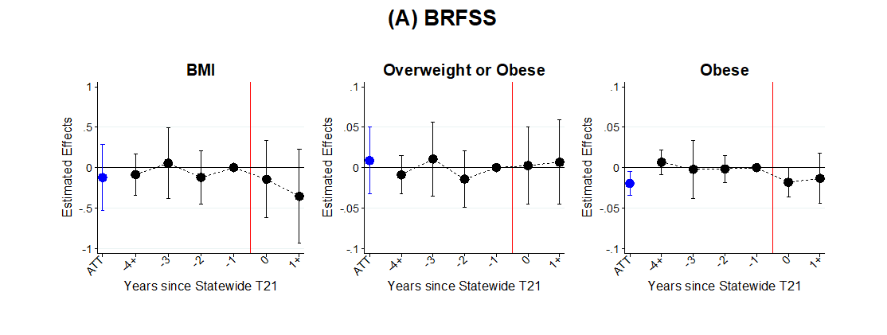
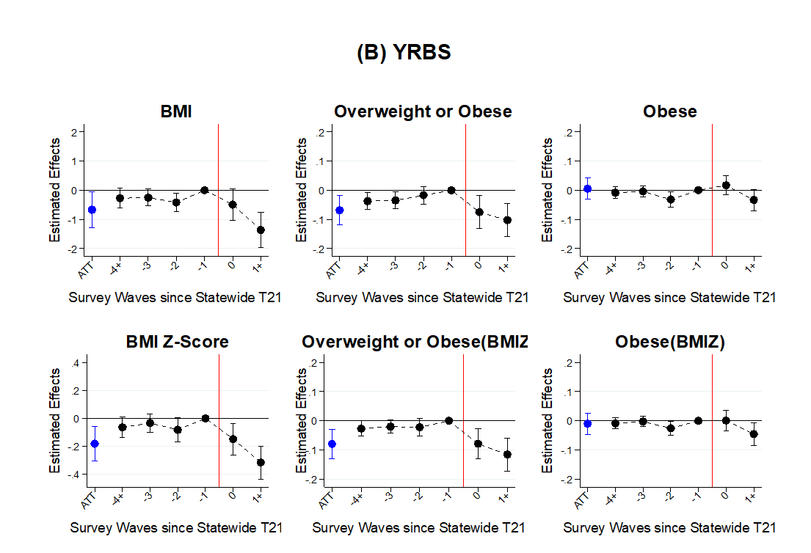

Figure A1. Effects of T21 Laws on Body Weight, 2009-2019, Logit Models for Binary Outcomes

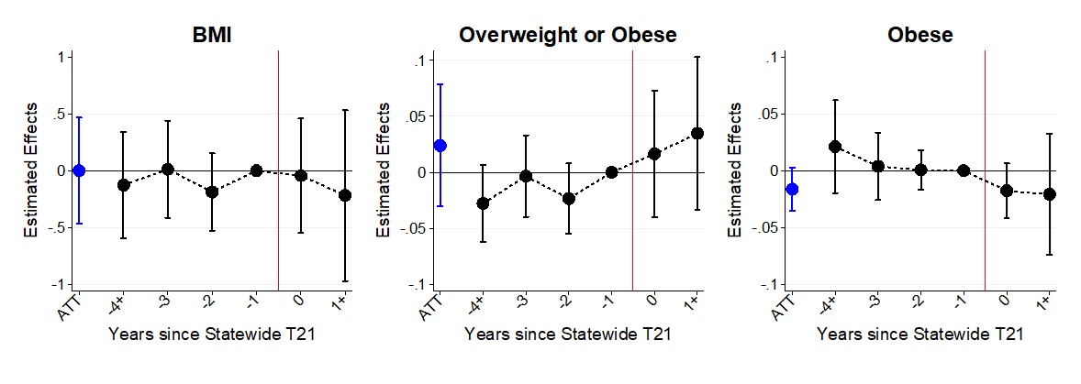
Figure A2. Effects of T21 Laws on Body Weight among Young Adults Aged 18-20, BRFSS, 2009-2019, State-Specific Time Trends

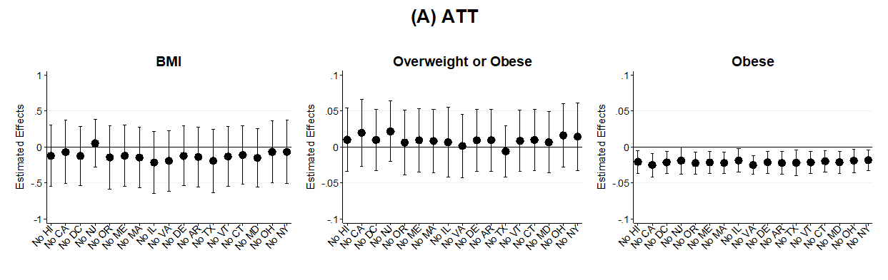
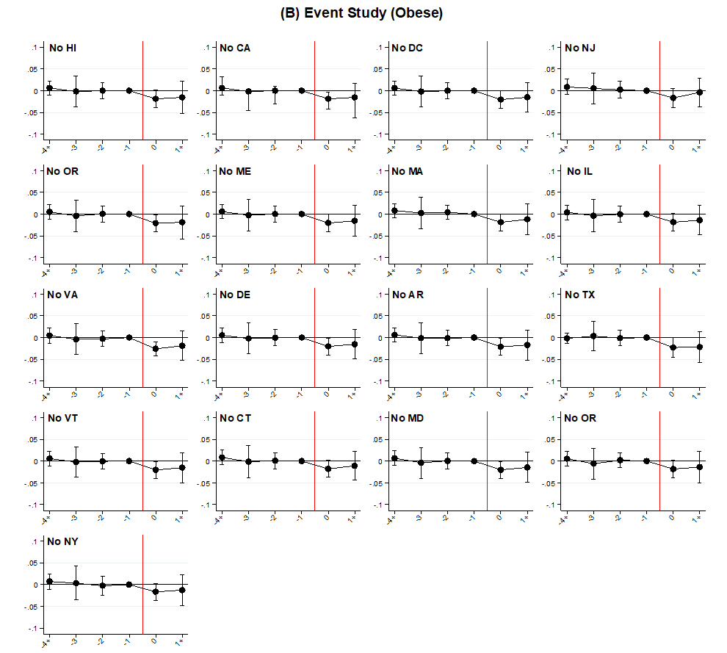
Figure A3. Effects of T21 Laws on Body Weight among Young Adults Aged 18-20, BRFSS, 2009-2019, Leave-One-Treated-State-Out Robustness Check
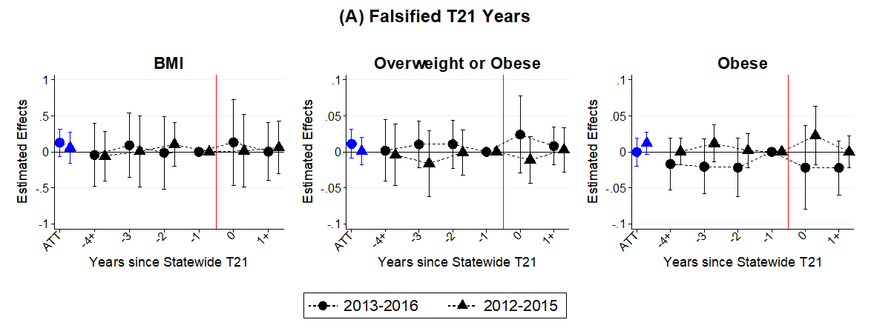
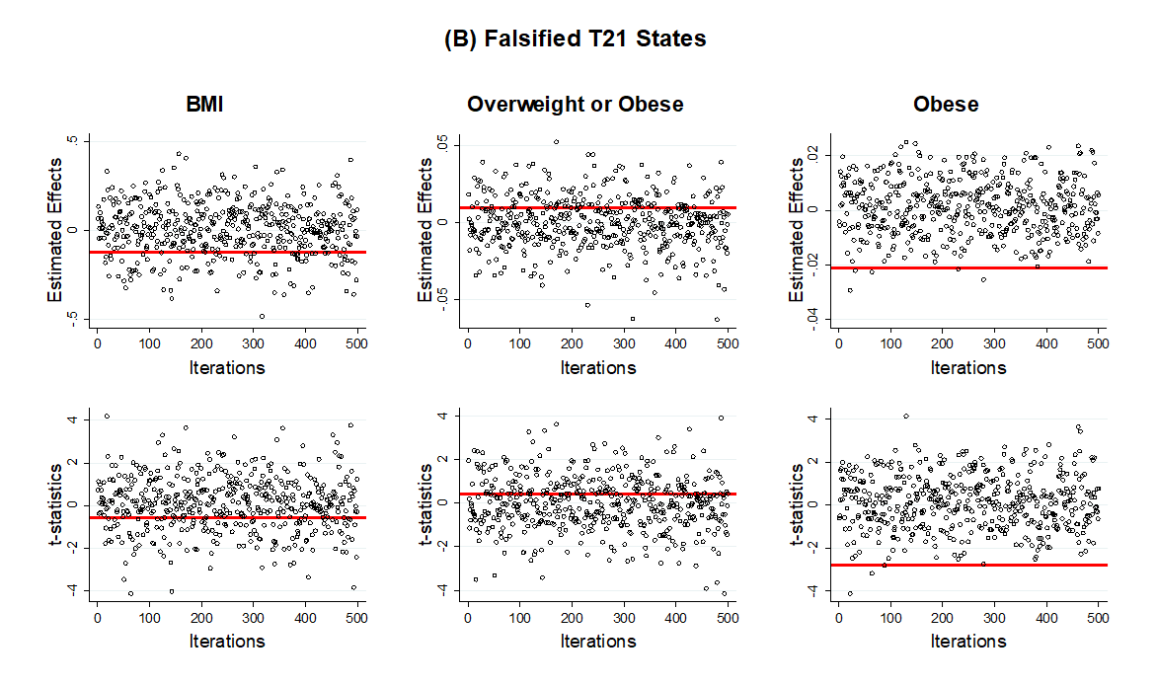 Figure A4. Effects of T21 Laws on Body Weight among Young Adults Aged 18-20, BRFSS, 2009-2019, Falsified Timing and Falsified States

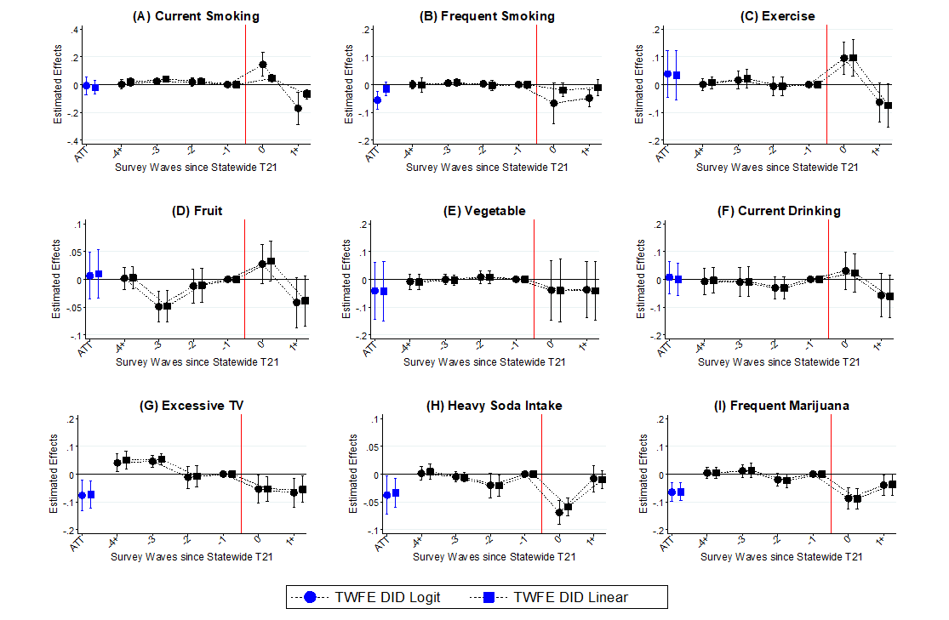
Figure A5. Effects of T21 Laws on Weight-Related Behaviors among High Schoolers Aged 18+, YRBS, 2009-2019
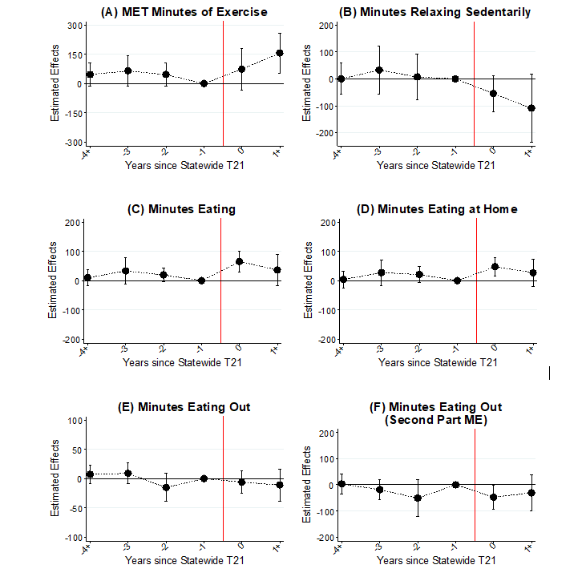

Figure A6. Effects of T21 Laws on Weight-Related Daily Activities among Young Adults Aged 18-20, ATUS, 2009-2019, Two-Part Model Marginal Effects
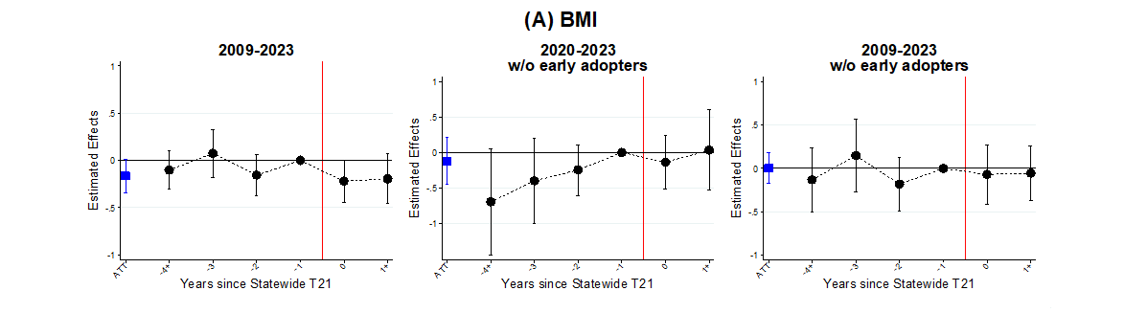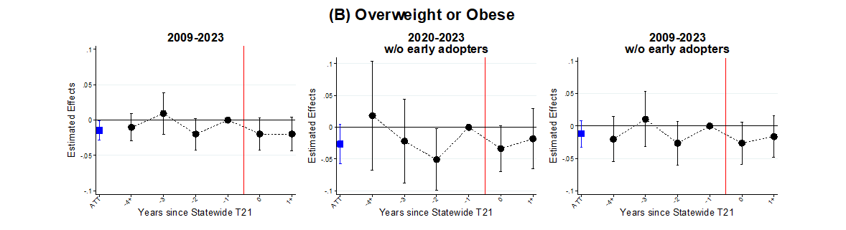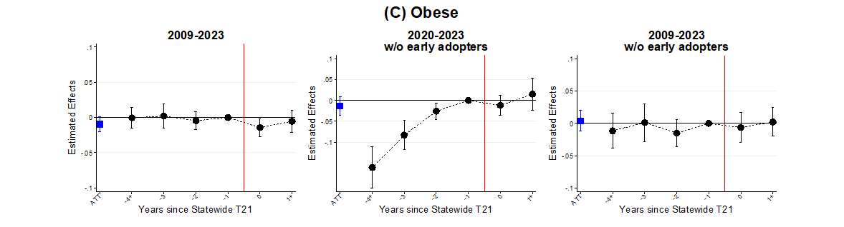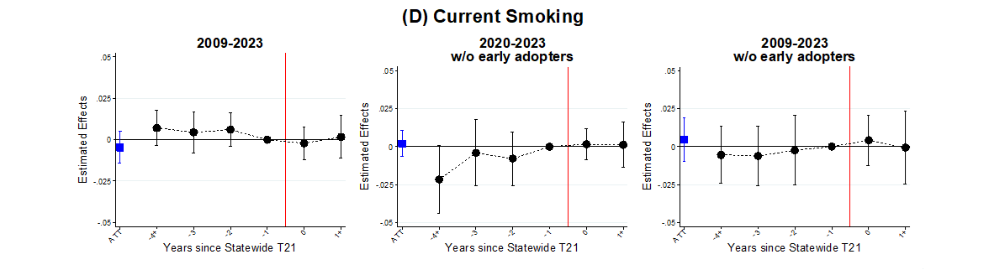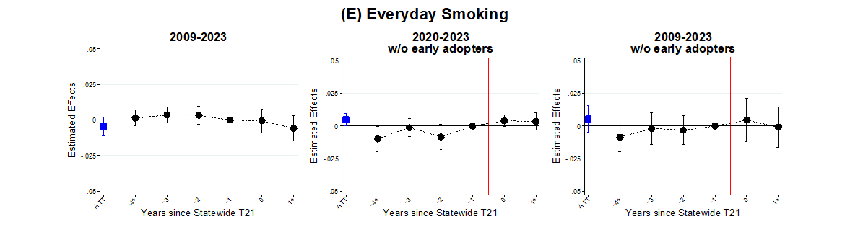
Figure A7. Effects of T21 Laws on Body Weight and Smoking among Young Adults Aged 18-20, BRFSS, 2009-2023
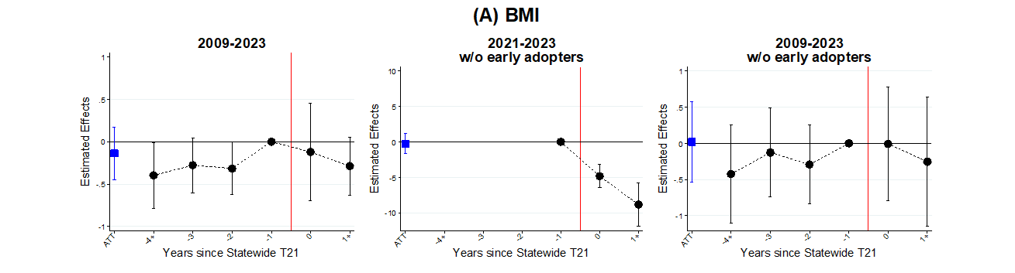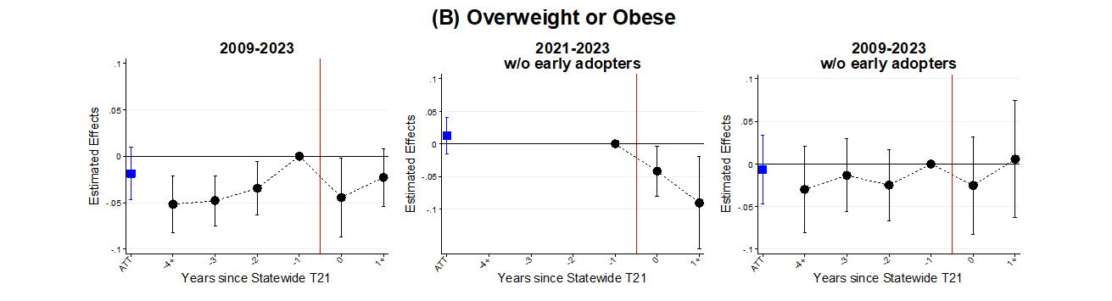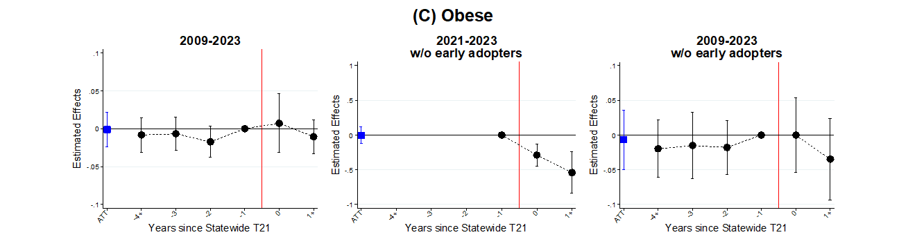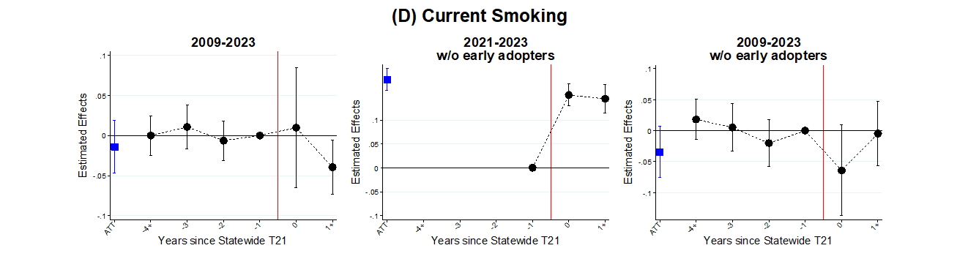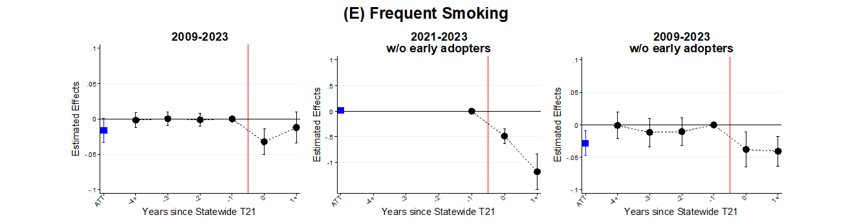
Figure A8. Effects of T21 Laws on Body Weight and Smoking among High Schoolers Aged 18+, YRBS, 2009-2023
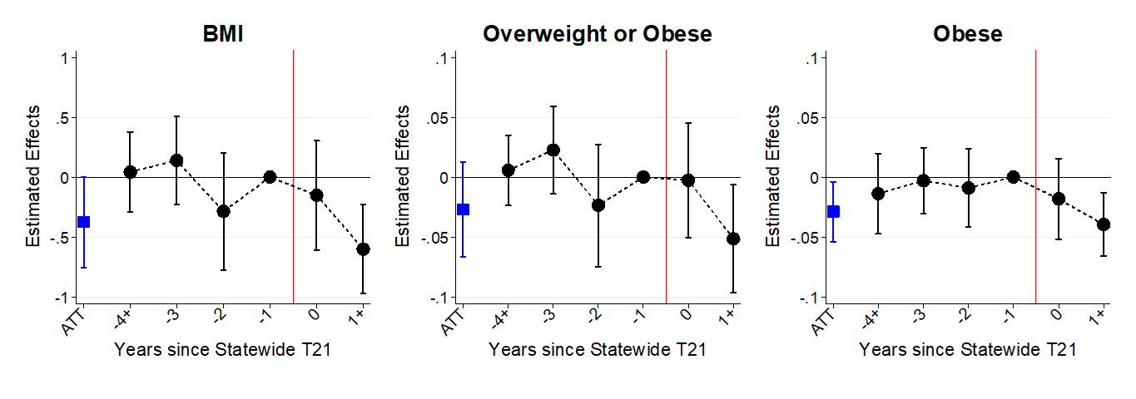
Figure A9. Effects of T21 Laws on Body Weight among Young Adults Aged 18-20, BRFSS, Stacked DID with All 17 Pre-Federal Adopters

MET is defined as working metabolic rate relative to resting metabolic rate (Dave and Yang, 2022).

