Table S1: Distribution of sociodemographic variables and patterns of drug use among 5th grade students participating in the PROERD cluster randomized controlled trial, according to the students included in the longitudinal analysis and those that were lost in the 9-month follow-up. Attrition analysis for covariates (N = 1,727).
Sociodemographic variables and patterns of drug use | Losses** |  | Follow-up* |  | pª
Sociodemographic variables and patterns of drug use | (N = 393) |  | (N = 1,334) |  | pª
Sociodemographic variables and patterns of drug use | N | % | N | % | pª
Group
Control | 226 | 57.51 | 700 | 52.47 | 0.079
Intervention | 167 | 42.49 | 634 | 47.53 | 0.079
Sex
Female | 178 | 45.29 | 667 | 50.00 | 0.101
Male | 215 | 54.71 | 667 | 50.00 | 0.101
Age
09 – 11 years | 352 | 89.57 | 1,301 | 97.53 | <0.001
12 – 15 years | 41 | 10.43 | 33 | 2.47 | <0.001
Baseline Drug Use
Alcohol
Lifetime drug use | 66/ 393 | 16.79 | 237/ 1,334 | 17.77 | 0.656
Past-year drug use | 41/ 392 | 10.46 | 123 / 1,329 | 9.26 | 0.476
Binge drinking
Lifetime drug use | 11 / 391 | 2.81 | 22/ 1,329 | 1.66 | 0.142
Past-year drug use | 9 / 392 | 2.30 | 11 / 1,329 | 0.83 | 0.017
Tobacco
Lifetime drug use | 9 / 389 | 2.31 | 22 / 1,333 | 1.65 | 0.387
Past-year drug use | 3 / 389 | 0.77 | 9 / 1,333 | 0.68 | 0.841
Marijuana
Lifetime drug use | 6 /388 | 1.55 | 4 / 1,333 | 0.30 | 0.004
Past-year drug use | 2/ 388 | 0.52 | 2 / 1,333 | 0.15 | 0.188
* The cases answered the questionnaire at the beginning of the study and at 9 month follow-up.
** The cases answered the questionnaire only in the beginning.
a. Chi-Square Test.

Table S2: Distribution of sociodemographic variables and patterns of drug use among 7th grade students participating in the PROERD cluster randomized controlled trial, according to the students included in the longitudinal analysis and those that were lost in the 9-month follow-up. Attrition analysis for covariates ​​(N = 2,303).
Sociodemographic variables and patterns of drug use | Losses** |  |  | Follow-up* |  | pª
Sociodemographic variables and patterns of drug use | (N = 564) |  |  | (N = 1.739) |  | pª
Sociodemographic variables and patterns of drug use | N | % |  | N | % | pª
Group
Control | 267 | 47.34 |  | 836 | 48.07 | 0.762
Intervention | 297 | 52.66 |  | 903 | 51.93 | 0.762
Gender
Female | 309 | 54.79 |  | 878 | 50.49 | 0.076
Male | 255 | 45.21 |  | 861 | 49.51 | 0.076
Age
10 – 13 years | 466 | 82.62 |  | 1.660 | 95.46 | <0.001
14 – 17 years | 98 | 17.38 |  | 79 | 4.54 | <0.001
Baseline Drug Use
Alcohol
Lifetime drug use | 251/ 561 |  | 44.74 | 615 / 1,737 | 35.41 | <0.001
Past-year drug use | 138 / 560 |  | 24.64 | 320 / 1,735 | 18.44 | 0.001
Binge drinking
Lifetime drug use | 85 / 560 |  | 15.18 | 144 / 1,736 | 8.29 | <0.001
Past-year drug use | 57 / 560 |  | 10.18 | 75 / 1,736 | 4.32 | <0.001
Tobacco
Lifetime drug use | 44 / 560 |  | 7.86 | 68 / 1,736 | 3.92 | <0.001
Past-year drug use | 19 / 560 |  | 3.39 | 17 / 1,735 | 0.98 | <0.001
Inhalants
Lifetime drug use | 71 / 559 |  | 12.70 | 168 / 1,733 | 9.69 | 0.043
Past-year drug use | 19 / 559 |  | 3.40 | 38 / 1,733 | 2.19 | 0.111
Marijuana
Lifetime drug use | 45 / 560 |  | 8.04 | 33 / 1,735 | 1.90 | <0.001
Past-year drug use | 24 / 560 |  | 4.29 | 17 / 1,735 | 0.98 | <0.001
Cocaine
Lifetime drug use | 2 / 559 |  | 0.36 | 7/ 1,733 | 0.40 | 0.879
Past-year drug use | 1/ 559 |  | 0.18 | 1/ 1,733 | 0.06 | 0.399
* The cases answered the questionnaire at the beginning of the study and at 9 month follow-up.
** The cases answered the questionnaire only in the beginning.
a. Chi-Square Test.

Table S3: Characteristics of interviwees (n = 19).
Interviewees | Sex (F/M) | Age | Education level^{b} | Position in police hierarchyª | Years teaching PROERD
P1 | F | 42 | - | Cabo | 5
P2 | F | 26 | High School | Soldado | 1
P3 | M | 32 | High School | Cabo | 5
P4 | M | 45 | High School | Cabo | 14
P5 | M | 40 | High School | Cabo | 15
P6 | M | 38 | High School | Cabo | 11
P7 | M | 42 | Universitary | Cabo | 6
P8 | M | 32 | High School | Soldado | <1
P9 | M | 42 | High School | Cabo | 12
P10 | M | 39 | High School | Cabo | 4
P11 | F | 47 | High School | Cabo | 10
P12 | F | 40 | High School | Cabo | 2
P13 | M | 34 | High School | Soldado | 4,5
P14 | M | 33 | Under graduation | Cabo | 1
P15 | M | 46 | High School | Cabo | 9
P16 | M | - | High School | Cabo | 9
P17 | F | 48 | Under graduation | Cabo | 19
P18 | F | 48 | Under graduation | Cabo | 15
P19 | F | 49 | Graduation | Cabo | 10
a-Soldado is the lowest level in the Military Police hierarchy. Cabo is the following level. So, Soldado and Cabo are the two lowest level in the hierarchy.
b- We have transfomed the Brazilian category to the US pattern. So High School includes also the officers that have started a college but did not received a degree. Undergradution is the first degree that universities offer and Graduation is the higher level (master and doctoral degrees).

Anex S1: Semi-structured interview script for police officers

Sex, age, education level, police rank, years teaching PROERD.
Initial Context
- How and why did you join PROERD?
In your opinion, what are the effects of PROERD on participating children (5th and 7th grades) and how do you perceive it?
Relations
- What do you think about the alignment between school management and classroom work for program implementation? Conveniences and Difficulties.
- How can these relationships influence the program effects?
Program Implementation
- Was the received training sufficient? Why?
- How does it (the training) influence your practice? Why?
- What is your opinion about the manuals? Do you think they is suitable for the age groups?
- How does the manual support class planning?
- Is the program content suitable for the age groups?
- What does and does not work for the students? What are the conveniences and difficulties found in the classroom? What activities are most accepted and least accepted by students?
- Is it different to implement the curricula for the fifth and seventh grades? Why?
- How does the demands of the program implementation (class planning, relationship with the principals and pedagogical coordination) influence your daily life as a police officer and vice vesa (how does your daily life as a police officer influence the program implementation)?
Sugestions
- What would you change in the program?
What are the lessons learned that can help expanding the project?

Figure S1. Code tree including the used and non-used codes for the qualitative analysis.
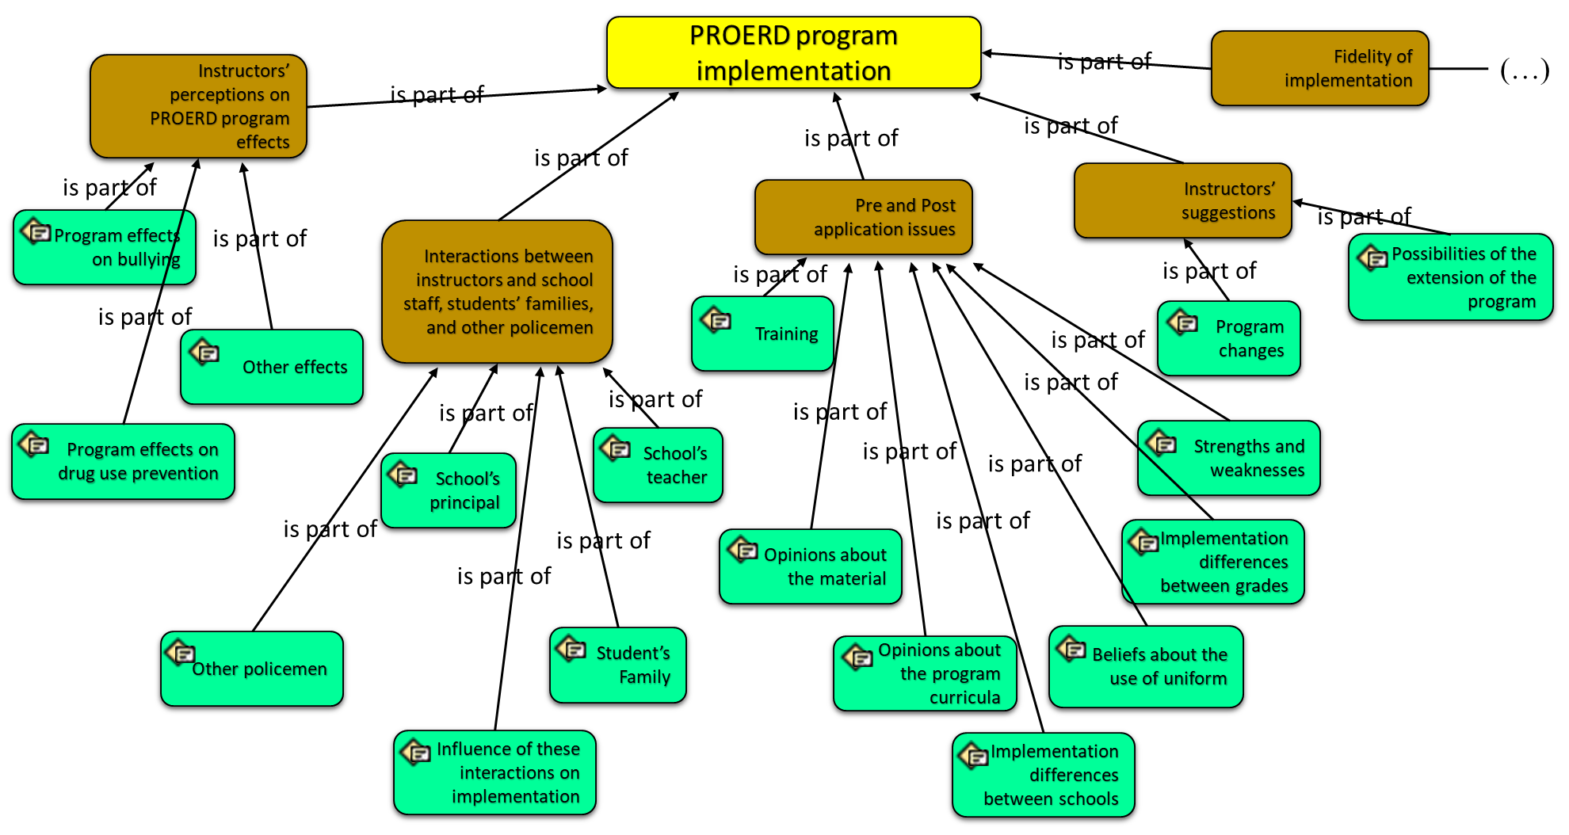
Figure S1. Continue…
