Title
The cannabinoid receptor-1 gene interacts with stressful life events to increase the risk for problematic alcohol use

Authors
Lisa Bornscheuer ^{1,4}, Andreas Lundin ², Yvonne Forsell ², Catharina Lavebratt ^{3,4}, Philippe A. Melas ^{4,5, *}

Affiliations
¹ Department of Public Health Sciences, Stockholm University, 10691 Stockholm, Sweden
² Department of Global Public Health, Karolinska Institutet, 17177 Stockholm, Sweden
³ Department of Molecular Medicine and Surgery, Karolinska Institutet, 17176 Stockholm, Sweden
⁴ Center for Molecular Medicine, L8:00, Karolinska University Hospital, 17176 Stockholm, Sweden
⁵ Center for Psychiatry Research, Department of Clinical Neuroscience, Karolinska Institutet & Stockholm Health Care Services, 11364 Stockholm, Sweden

* Correspondence: L8:00, Karolinska University Hospital, 17176, Stockholm, Sweden. Tel: +46 70 888 44 05. E-mail address: Philippe.Melas@ki.se

Supplemental Material

Supplemental Tables

Table S1. Univariate OR estimates following logistic regression of problematic alcohol use (i.e., AUDIT score ≥8) on rs2023239 and SLEs
Exposure | OR (95% CI) † | p-value
CT&CC | 1.14 (0.87, 1.49) | 0.34
Child SLEs (≥1) | 1.63 (1.25, 2.13) | ≤ 0.01
Adult SLEs (≥2) | 1.60 (1.25, 2.05) | ≤ 0.01
Adult SLEs (≥3) | 1.62 (1.24, 2.13) | ≤ 0.01
OR: Odds Ratios; CI: Confidence Interval; SLEs: Stressful Life Events
†Crude models

Table S2. Logistic regression of problematic alcohol use (i.e., AUDIT score ≥8) on ≥1 SLEs in childhood stratified by rs2023239
rs2023239 | OR (95% CI) † | p-value | OR (95% CI) ‡ | p-value
TT | 1.30 (0.93, 1.83) | 0.13 | 1.10 (0.77, 1.58) | 0.61
CT | 2.20 (1.35, 3.58) | ≤ 0.01 | 2.00 (1.17, 3.41) | ≤ 0.01
CC | 3.25 (0.47, 22.71) | 0.24 | 0.98 (0.08, 12.6) | 0.99
OR: Odds Ratios; CI: Confidence Interval; SLEs: Stressful Life Events
†Crude model; ‡Model adjusted for age, sex, anxiety, depression

Table S3. Logistic regression of problematic alcohol use (i.e., AUDIT score ≥8) on ≥2 SLEs in adulthood stratified by rs2023239
rs2023239 | OR (95% CI) † | p-value | OR (95% CI) ‡ | p-value
TT | 1.27 (0.93, 1.72) | 0.13 | 1.16 (0.83, 1.63) | 0.38
CT | 2.33 (1.46, 3.72) | ≤ 0.01 | 1.71 (1.0, 2.94) | 0.05
CC | 0.89 (0.14, 5.81) | 0.9 | 0.43 (0.04, 4.39) | 0.48
OR: Odds Ratios; CI: Confidence Interval; SLEs: Stressful Life Events
†Crude model; ‡Model adjusted for age, sex, anxiety, depression, child SLEs (0/≥1)

Table S4. Logistic regression of problematic alcohol use on ≥3 SLEs in adulthood stratified by rs2023239
rs2023239 | OR (95% CI) † | p-value | OR (95% CI) ‡ | p-value
TT | 1.30 (0.91, 1.85) | 0.14 | 1.11 (0.75, 1.65) | 0.59
CT | 2.26 (1.38, 3.68) | ≤ 0.01 | 1.71 (0.96, 3.05) | 0.07
CC | 0.77 (0.08, 7.58) | 0.82 | 0.46 (0.03, 7.05) | 0.58
OR: Odds Ratios; CI: Confidence Interval; SLEs: Stressful Life Events
†Crude model; ‡Model adjusted for age, sex, anxiety, depression, child SLEs (0/≥1)
Table S5. Logistic regression of problematic alcohol use on 0-1/2/≥3 adult SLEs stratified by rs2023239
rs2023239 | Adult SLEs | OR (95% CI) † | p-value | OR (95% CI) ‡ | p-value
TT | 2 | 1.17 (0.79, 1.74) | 0.42 | 1.16 (0.77, 1.74) | 0.49
 | ≥3 | 1.36 (0.94, 1.96) | 0.1 | 1.17 (0.77, 1.76) | 0.47
CT | 2 | 1.91 (1.06, 3.44) | 0.03 | 1.46 (0.75, 2.83) | 0.26
 | ≥3 | 2.75 (1.61, 4.7) | ≤ 0.01 | 2.00 (1.05, 3.73) | 0.04
CC | 2 | 1.04 (0.1, 11.26) | 0.98 | 0.51 (0.03, 8.13) | 0.64
 | ≥3 | 0.78 (0.07, 8.25) | 0.84 | 0.36 (0.02, 6.87) | 0.5
OR: Odds Ratios; CI: Confidence Interval; SLEs: Stressful Life Events
†Crude model; ‡Model adjusted for age, sex, anxiety, depression, child SLEs (0/≥1)

Table S6. Interaction between CNR1’s rs2023239 genotype and adult SLEs (≥ 2 † or >3 ‡) on the odds of problematic alcohol use (i.e., AUDIT score ≥ 8)
 | < 2 SLE |  | ≥ 2 SLE |  | OR (95% CI) for SLE within strata of genotype
 | N case/control | OR (95% CI) | N case/control | OR (95% CI) | OR (95% CI) for SLE within strata of genotype
TT | 96 / 1,015 | 1 | 86 / 717 | 1.15 (0.83, 1.61)  p = 0.4 | 1.16 (0.83, 1.63)  p = 0.38
CC & CT | 36 / 441 | 0.92 (0.61, 1.4)  p = 0.7 | 51 / 284 | 1.48 (0.99, 2.2)  p = 0.06 | 1.57 (0.93, 2.64)  p = 0.09
ORs (95% CI) for genotype within strata of SLE |  | 0.93 (0.61, 1.41) p = 0.73 |  | 1.28 (0.86, 1.9)  p = 0.22

Case/control refers to problematic alcohol use (yes/no)
OR: Odds Ratios; CI: Confidence Interval; SLEs: Stressful Life Events
Estimates adjusted for age, sex, diagnosis of anxiety or depression, child SLEs (≥1)
†Crude RERI estimate for adult SLEs (≥ 2) = 0.77 (95% CI: 0.07-1.47; p-value = 0.03)
†Adjusted RERI estimate for adult SLEs (≥ 2) = 0.4 (95% CI: -0.25-1.05; p-value = 0.23), calculated with values from table above 1.48 - 0.92 - 1.15 + 1 = 0.4
‡Crude RERI estimate for adult SLEs (≥ 3) = 0.82 (95% CI: -0.14-1.77; p-value = 0.1)
‡Adjusted RERI estimate for adult SLEs (≥ 3) = 0.51 (95% CI: -0.3-1.32; p-value = 0.22)

Table S7. Overview of sex-stratified RERI estimates: additive interaction between CNR1’s rs2023239 genotype and child SLEs (≥1) / adult SLEs (≥ 2) on the odds of problematic alcohol use (cut-off in women: AUDIT score ≥ 6; cut-off in men: AUDIT score ≥ 8; see also Methods)
Additive interaction | RERI (95% CI); p-value | n
Genotype x child SLEs (women)* | 1.13 (0.4, 1.87); ≤ 0.01 | 1,559
Genotype x child SLEs (men)* | 0.31 (-0.82, 1.43); 0.59 | 1,080
Genotype x adult SLEs (women)** | 0.39 (-0.17, 0.96); 0.17 | 1,532
Genotype x adult SLEs (men)** | 0.14 (-0.72, 1.0); 0.74 | 1,065

*Estimates adjusted for age, diagnosis of anxiety or depression
**Estimates adjusted for age, diagnosis of anxiety or depression, child SLEs (≥1)

Table S8. Interaction between CNR1’s rs2023239 genotype and adult SLEs (≥ 2 † or ≥ 3 ‡) in PART wave I on the odds of problematic alcohol use in PART wave II (i.e., AUDIT score ≥ 8)

 | < 2 SLE |  | ≥ 2 SLE |  | OR (95% CI) for SLE within strata of genotype
 | N case/control | OR (95% CI) | N case/control | OR (95% CI) | OR (95% CI) for SLE within strata of genotype
TT | 99 / 1,020 | 1 | 81 / 723 | 1.12 (0.8, 1.56)  p = 0.5 | 1.06 (0.76, 1.48)  p = 0.74
CC & CT | 34 / 448 | 0.82 (0.54, 1.25)  p = 0.35 | 43 / 288 | 1.31 (0.87, 1.98)  p = 0.2 | 1.83 (1.63, 3.17)  p = 0.03
ORs (95% CI) for genotype within strata of SLE |  | 0.83 (0.54, 1.26) p = 0.38 |  | 1.18 (0.78, 1.78)  p = 0.44

Case/control refers to problematic alcohol use (yes/no)
OR: Odds Ratios; CI: Confidence Interval; SLEs: Stressful Life Events
Estimates adjusted for age, sex, diagnosis of anxiety or depression, child SLEs (≥1)
†Crude RERI estimate for adult SLEs (≥ 2) = 0.6 (95% CI: -0.03-1.23; p-value = 0.06)
†Adjusted RERI estimate for adult SLEs (≥ 2) = 0.37 (95% CI: -0.24-0.99; p-value = 0.23), calculated with values from table above 1.31 - 0.82 - 1.12 + 1 = 0.37
‡Crude RERI estimate for adult SLEs (≥ 3) = 0.44 (95% CI: -0.48-1.35; p-value = 0.35)
‡Adjusted RERI estimate for adult SLEs (≥ 3) = 0.25 (95% CI: -0.61-1.12; p-value = 0.57)

Table S9. Number of observations for each combination of genotype and Five Factor Model personality trait
Trait | Number of observations (N)
 | TT | CT | CC | Total
Extraversion | 1,538 | 630 | 43 | 2,211
Neuroticism | 1,546 | 632 | 42 | 2,220
Conscientiousness | 1,548 | 632 | 42 | 2,222
Openness | 1,543 | 628 | 43 | 2,214
Agreeableness | 1,525 | 625 | 43 | 2,193

Table S10. Logistic regression of problematic alcohol use (i.e., AUDIT score ≥8)# on Five Factor Model trait z-scores
Trait | OR (95% CI) † | p-value | OR (95% CI) ‡ | p-value
Extraversion | 0.9 (0.79, 1.03) | 0.11 | 0.96 (0.83, 1.1) | 0.53
Neuroticism | 1.3 (1.14, 1.48) | ≤0.01 | 1.4 (1.22, 1.6) | ≤0.01
Conscientiousness | 0.71 (0.63, 0.81) | ≤0.01 | 0.75 (0.66, 0.85) | ≤0.01
Openness | 1.09 (0.95, 1.25) | 0.22 | 1.12 (0.97, 1.28) | 0.12
Agreeableness | 0.77 (0.67, 0.89) | ≤0.01 | 0.8 (0.7, 0.93) | ≤0.01
# Assessed at PART wave III
OR: Odds Ratios; CI: Confidence Interval; † Crude model; ‡ Model adjusted for age and sex
Supplemental Figures

Figure S1
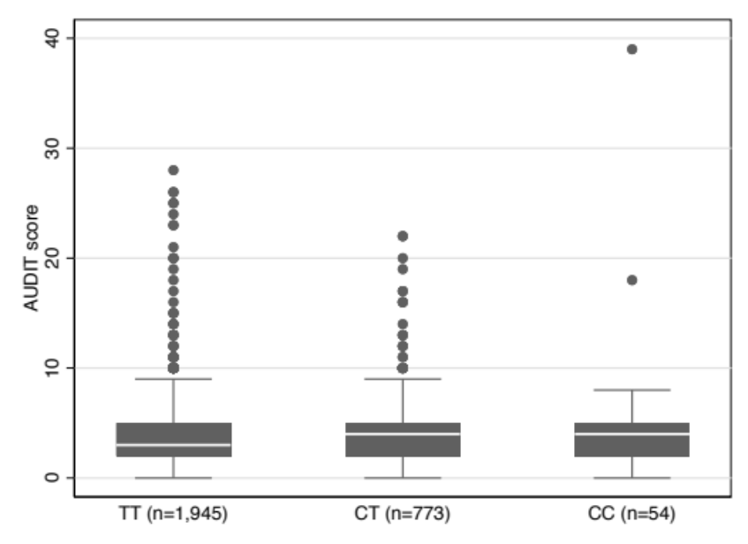
Fig. S1. Box plot of AUDIT score by rs2023239 genotype

Figure S2
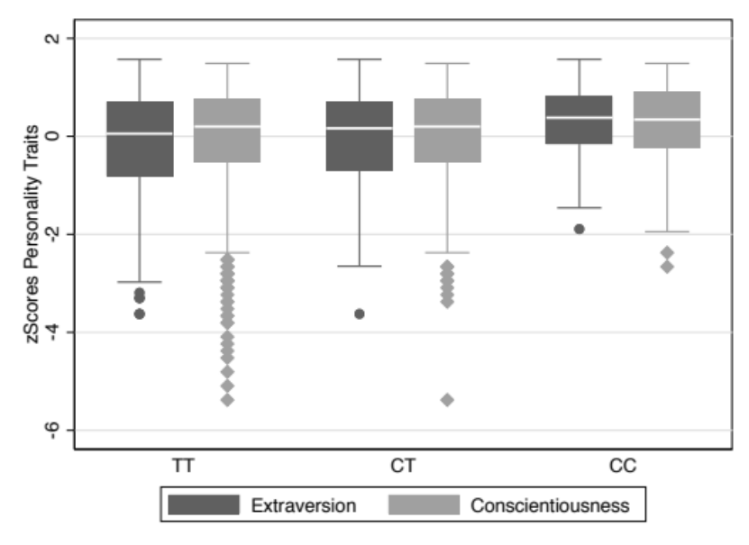
Fig S2. Box plots for extraversion and conscientiousness z-scores by rs2023239 genotype

Figure S3
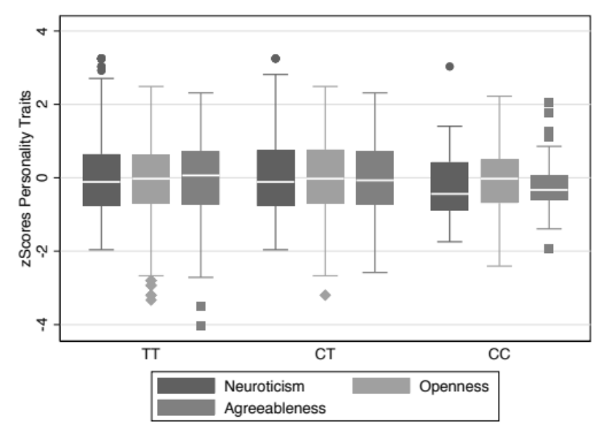
Fig S3. Box plots for neuroticism, agreeableness, and openness z-scores by rs2023239 genotype

Figure S4
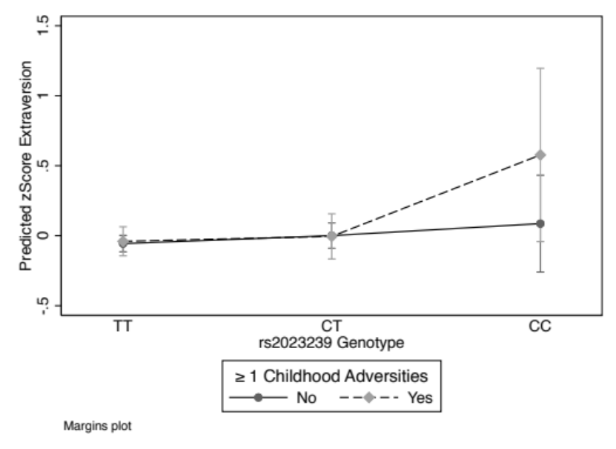
Fig S4. Predicted mean extraversion z-scores across categories of rs2023239 genotype (TT/CT/CC) and stressful life events (0/≥1) in childhood
Error bars represent 95% CIs. Adjusted for age and sex. Interaction terms not statistically significant (CT*child SLEs: p-value=0.84; CC*child SLEs: p-value=0.2)

Figure S5
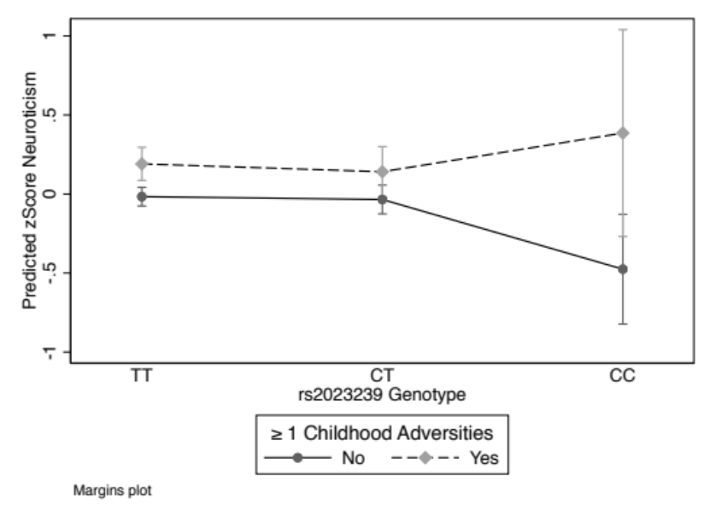
Fig S5. Predicted mean neuroticism z-scores across categories of rs2023239 genotype (TT/CT/CC) and stressful life events (0/≥1) in childhood
Error bars represent 95% CIs. Adjusted for age and sex. Interaction terms not statistically significant (CT*child SLEs: p-value=0.78; CC*child SLEs: p-value=0.09)

Figure S6
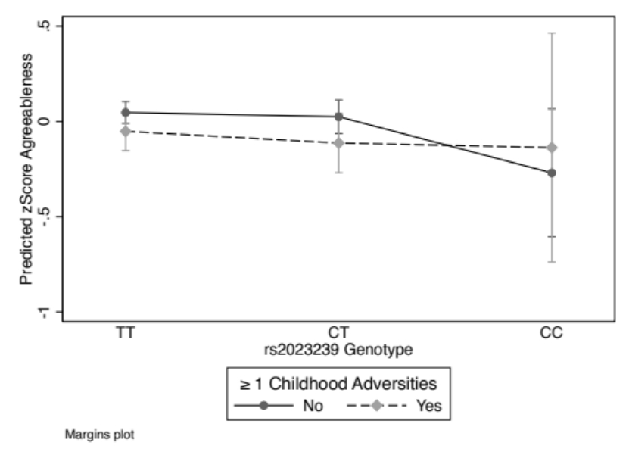
Fig S6. Predicted mean agreeableness z-scores across categories of rs2023239 genotype (TT/CT/CC) and stressful life events (0/≥1) in childhood
Error bars represent 95% CIs. Adjusted for age and sex. Interaction terms not statistically significant (CT*child SLEs: p-value=0.72; CC*child SLEs: p-value=0.52)

