Supplementary Table 1 Searching strategy by database
Database | Search string | Number of entries
PubMed | ("human papillomavirus"[TIAB] OR HPV[TIAB] OR "cervical cancer"[TIAB])  AND  (knowledge [TIAB])  AND  (Cameroon [Mesh] OR Cameroon [TIAB] OR Cameroonian [TIAB] OR Cameroun [TIAB]) | 57
Scopus | TITLE-ABS-KEY ("human papillomavirus" OR HPV OR "cervical cancer")  AND  TITLE-ABS-KEY (vaccine OR vaccination OR vaccines OR knowledge OR awareness OR attitude OR practice)  AND  TITLE-ABS-KEY (Cameroon OR Cameroonian OR Cameroun) | 70
Web of sciences | ("human papillomavirus" OR HPV OR "cervical cancer")  AND (vaccine OR vaccination OR vaccines OR knowledge OR awareness OR attitude OR practice)  AND  (Cameroon OR Cameroonian OR Cameroun) | 145
Embase | ("human papillomavirus" OR HPV OR "cervical cancer")  AND (vaccine OR vaccination OR vaccines OR knowledge OR awareness OR attitude OR practice)  AND  (Cameroon OR Cameroonian OR Cameroun) | 83
Cochrane Library | (“human papillomavirus” OR HPV OR “cervical cancer”)  AND  (vaccine OR vaccination OR knowledge OR awareness OR attitude OR practice)  AND  (Cameroon OR Cameroonian OR Cameroun) | 8
African Journals Online (AJOL) | (“human papillomavirus” OR HPV OR “cervical cancer”)  AND  (vaccine OR vaccination OR knowledge OR awareness OR attitude OR practice)  AND  (Cameroon OR Cameroonian OR Cameroun) | 77
Health Sciences and Disease | (“human papillomavirus” OR HPV OR “cervical cancer”)  AND  (vaccine OR vaccination OR knowledge OR awareness OR attitude OR practice)  AND  (Cameroon OR Cameroonian OR Cameroun) | 2

Subgroup analysis
Study period
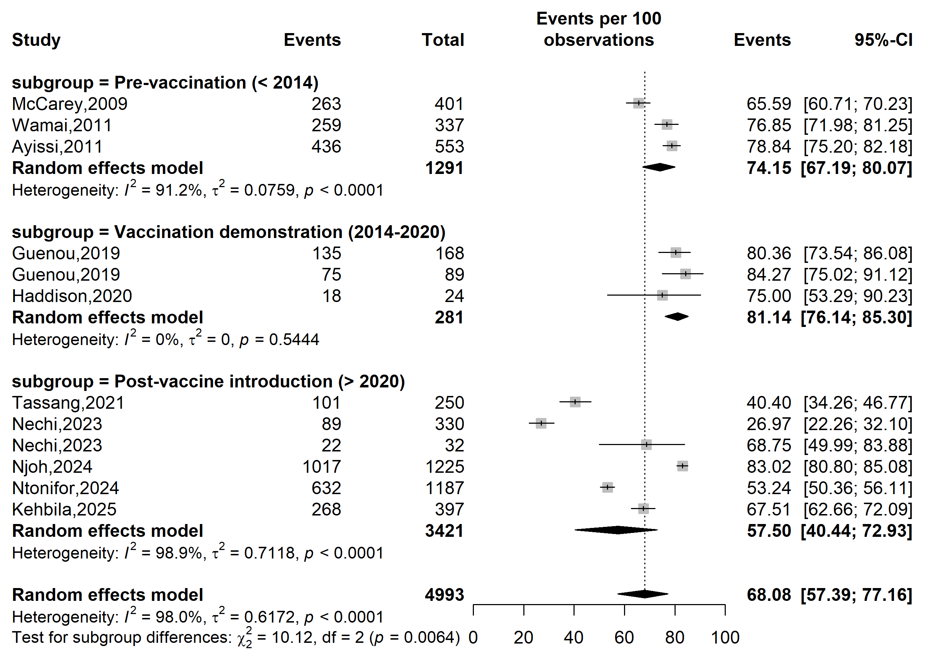
Supplementary Fig. 1 Pooled prevalence of willingness to vaccinate against human papillomavirus (HPV) according to specific HPV vaccine introduction timeframe in Cameroon

Study setting
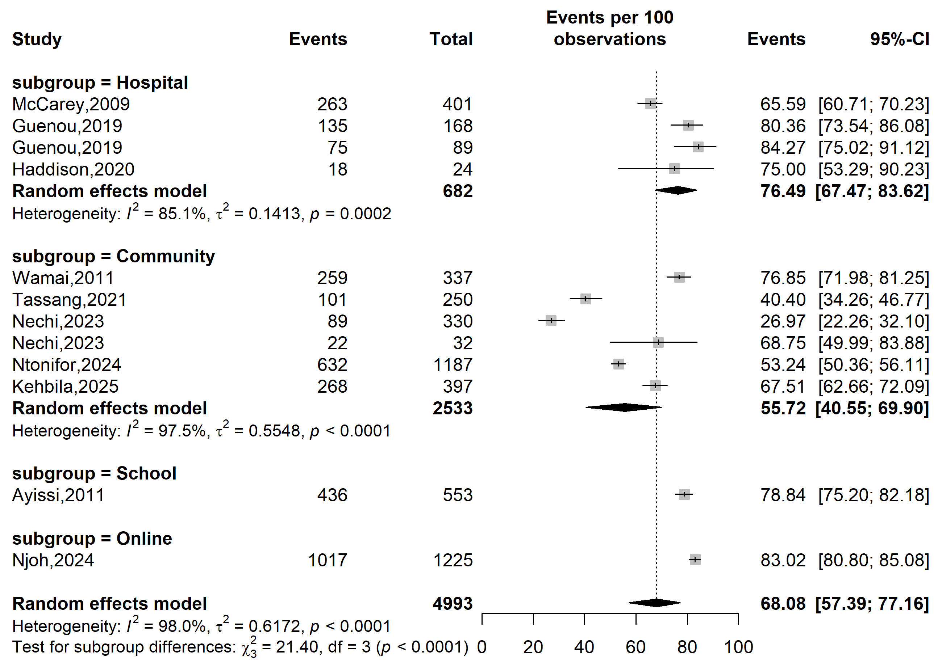
Supplementary Fig. 2 Pooled prevalence of willingness to vaccinate against human papillomavirus according to study settings in Cameroon

Study site
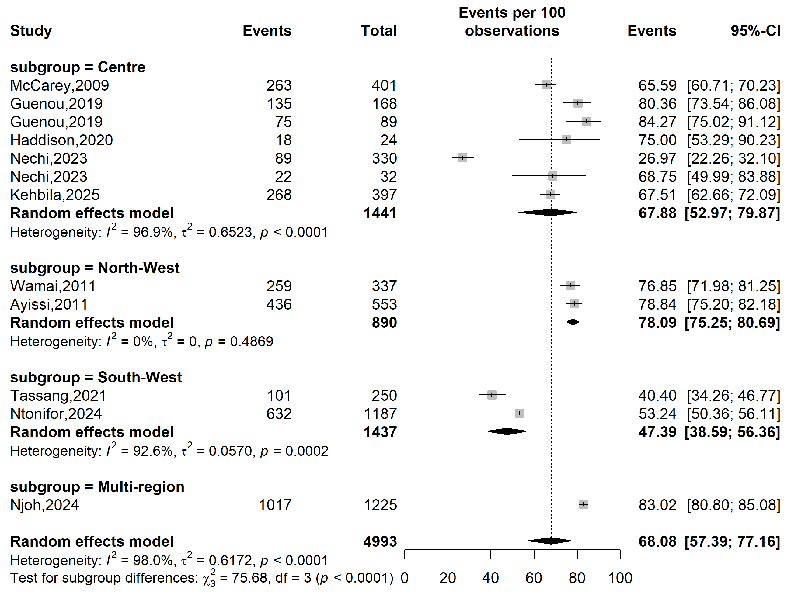
Supplementary Fig. 3 Pooled prevalence of willingness to vaccinate against human papillomavirus according to study sites in Cameroon

Sampling method
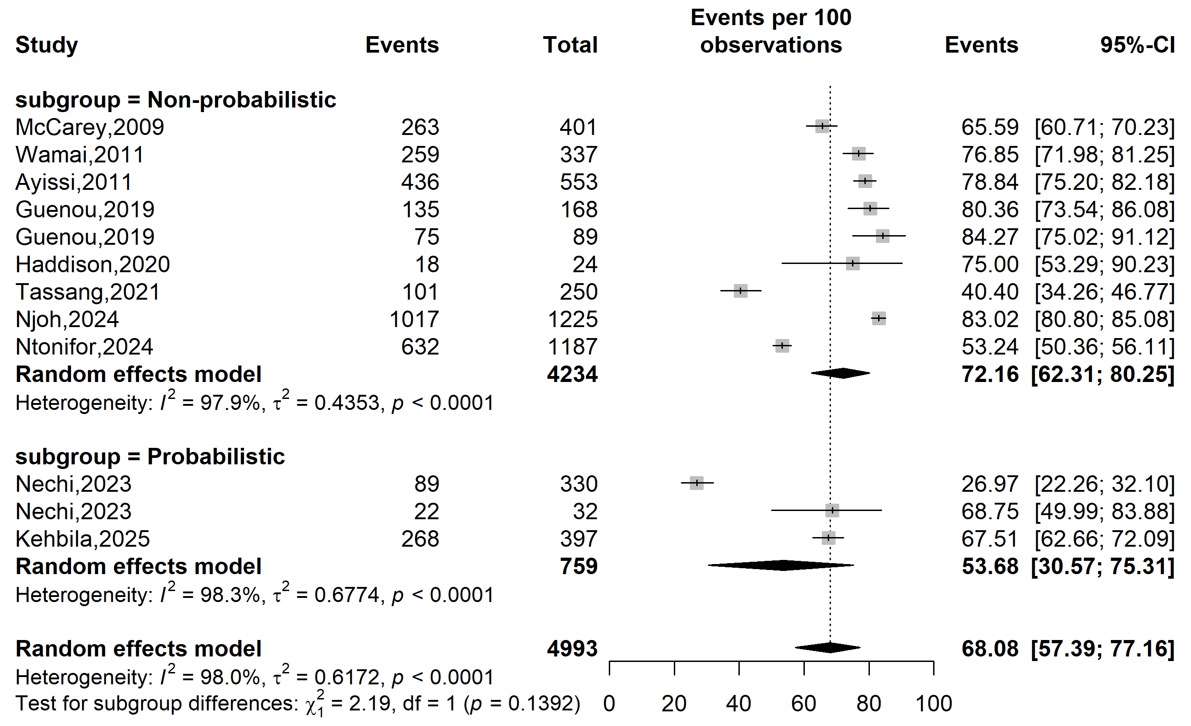
Supplementary Fig. 4 Pooled prevalence of willingness to vaccinate against human papillomavirus by sampling methods in Cameroon

Type of participants
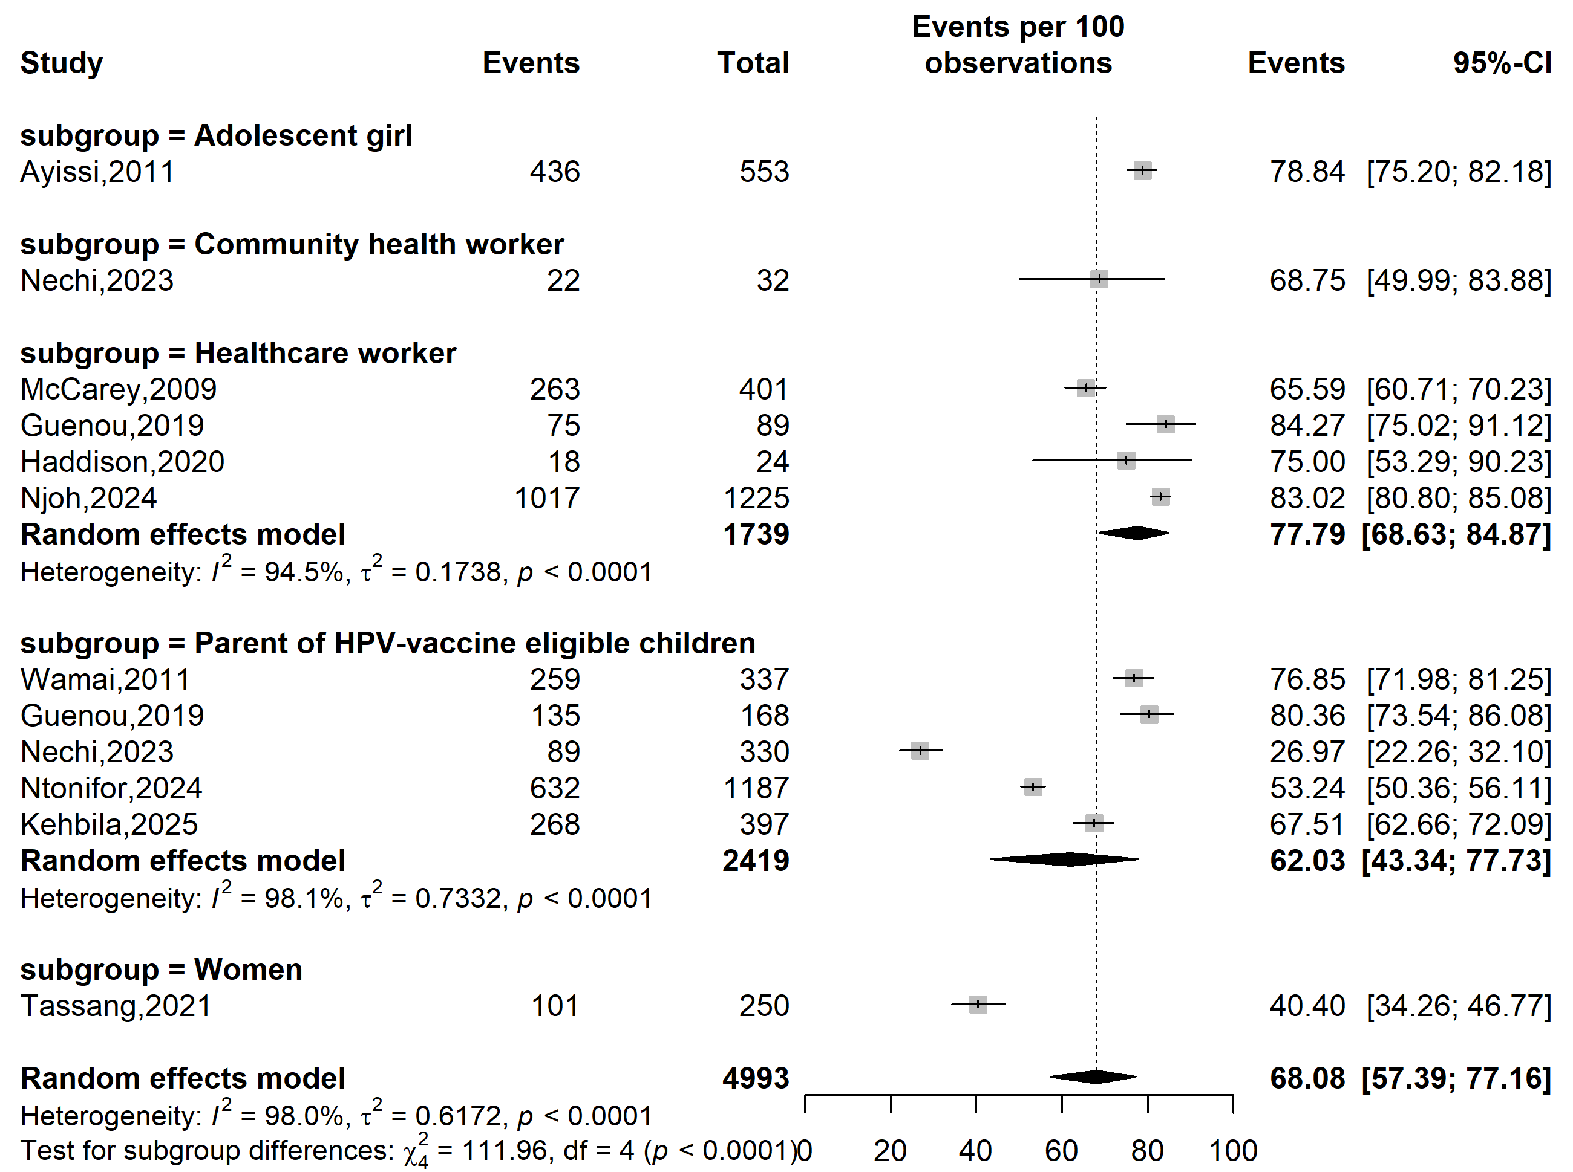
Supplementary Fig. 5 Pooled prevalence of willingness to vaccinate against human papillomavirus by sampling methods in Cameroon

Study period
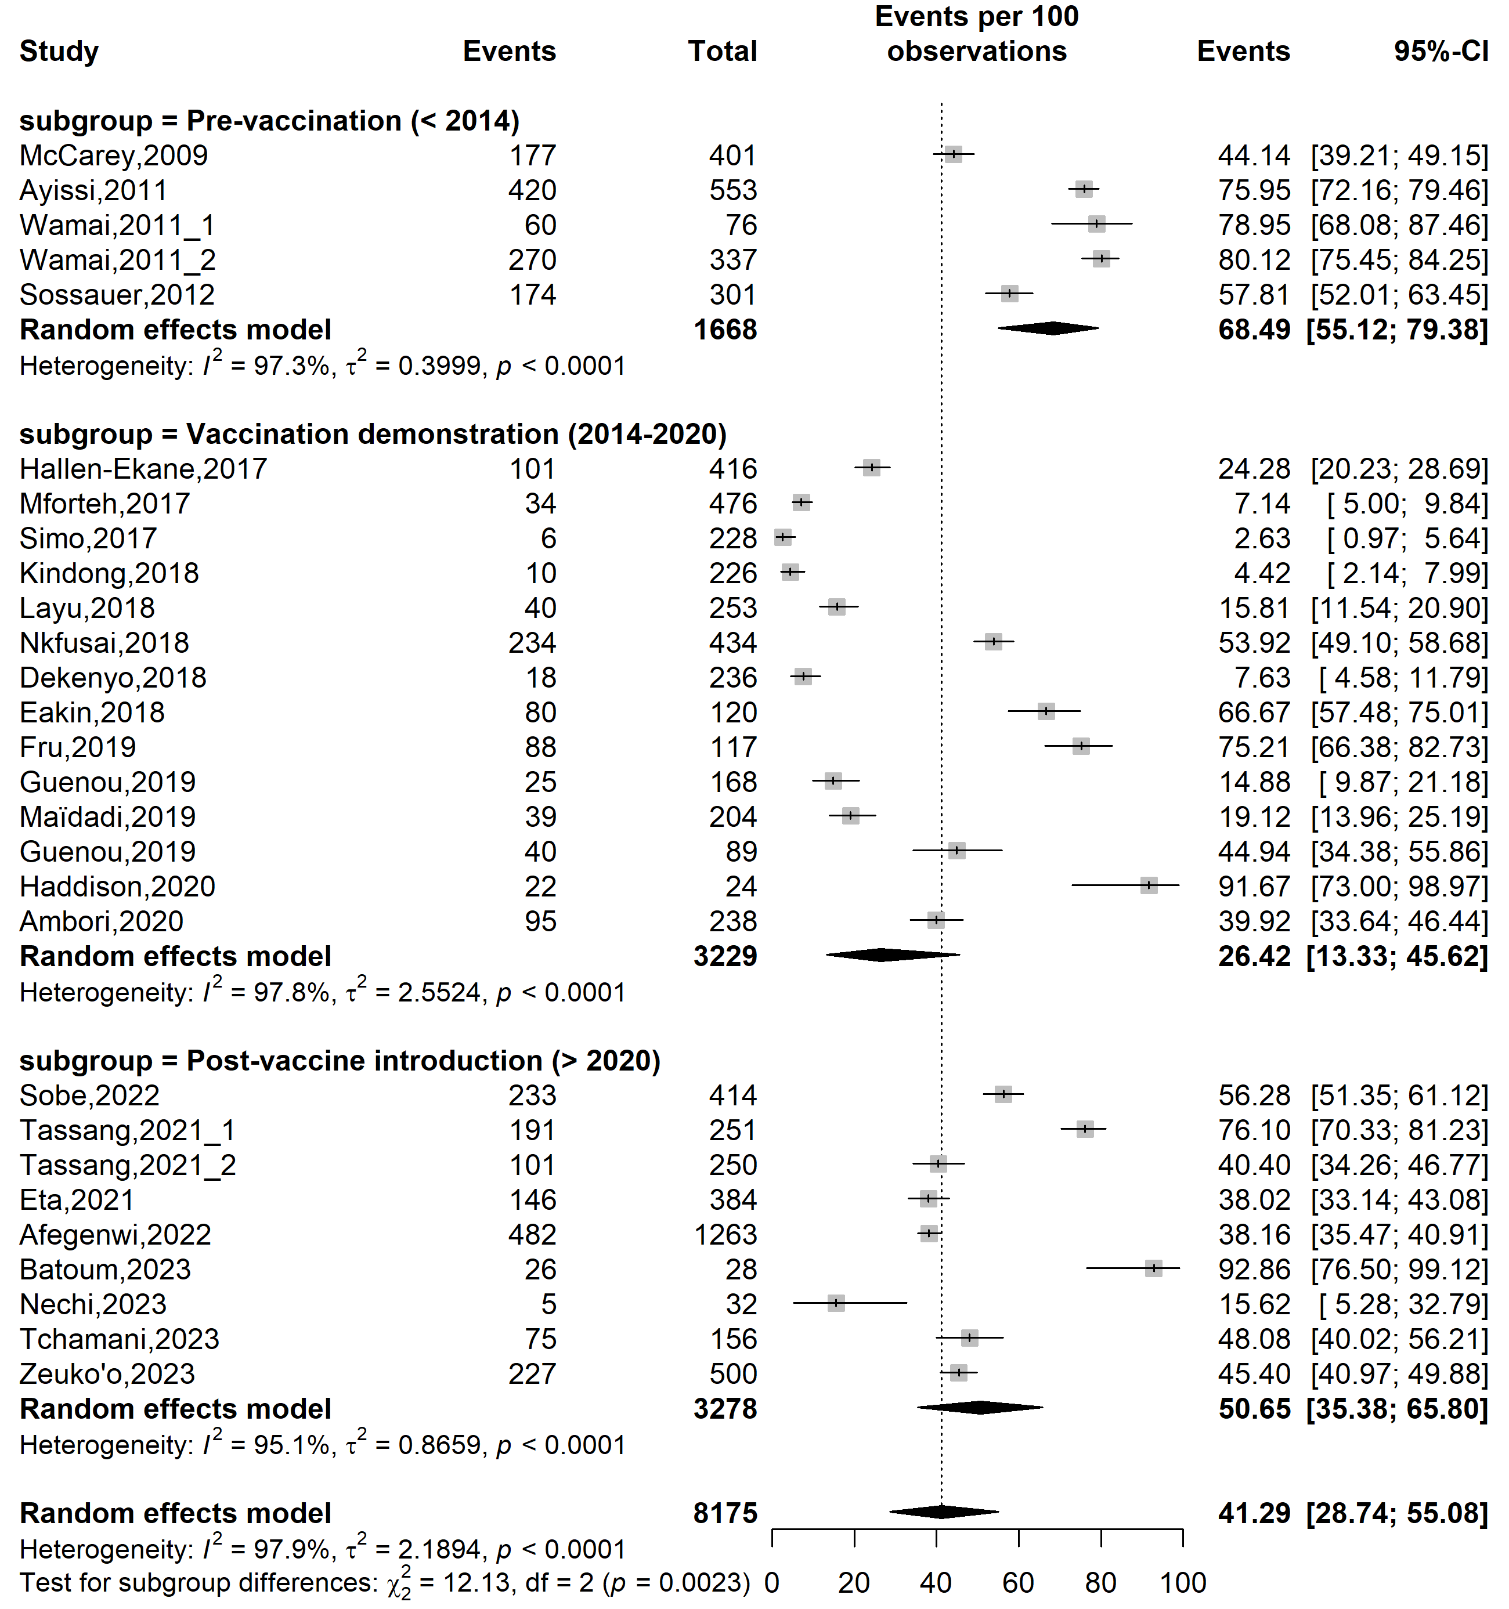
Supplementary Fig. 6 Pooled prevalence of human papillomavirus (HPV) vaccine awareness according to specific HPV vaccine introduction timeframe in Cameroon

Study setting
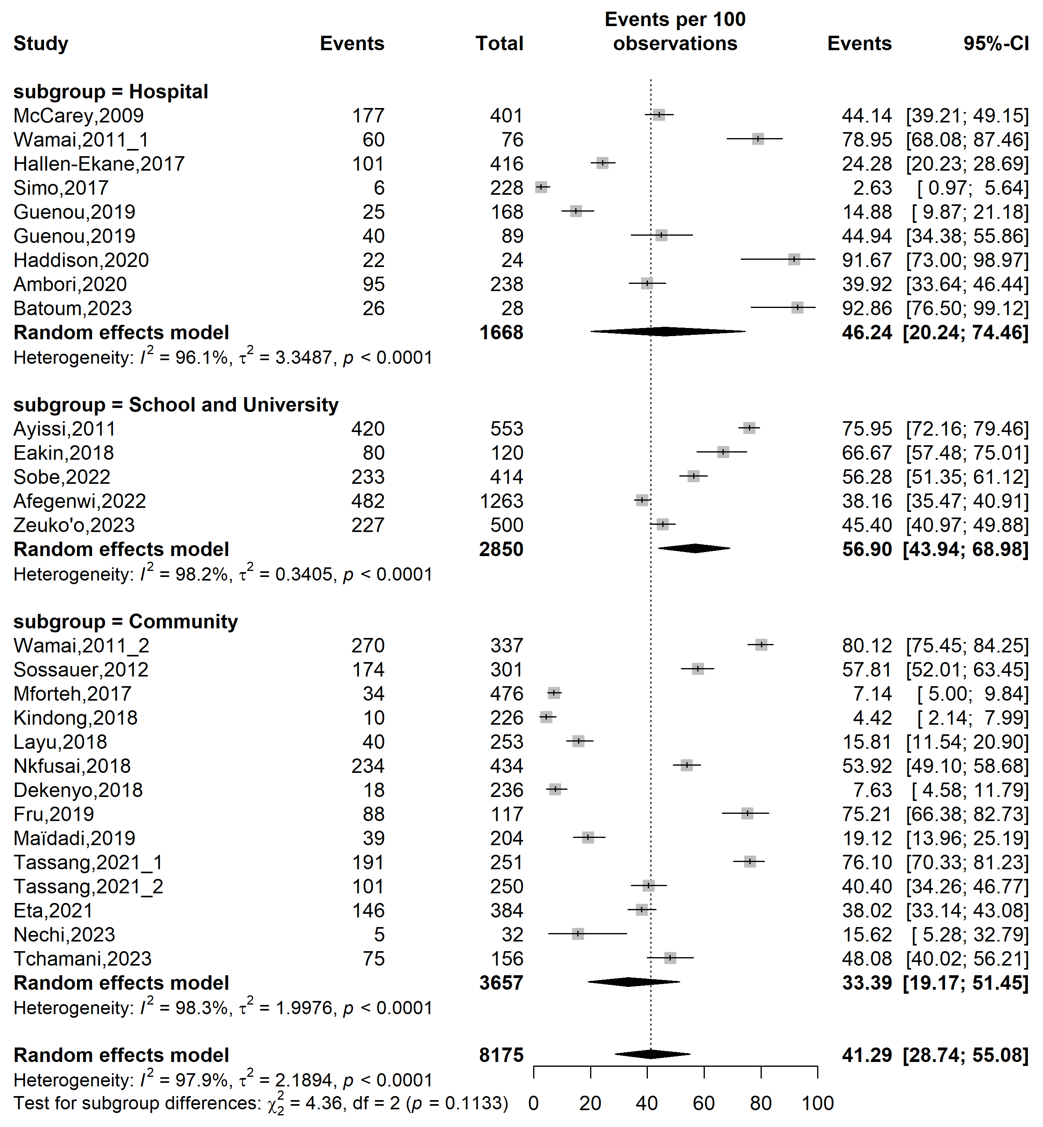
Supplementary Fig. 7 Pooled prevalence of human papillomavirus vaccine awareness according to study settings in Cameroon

Study site
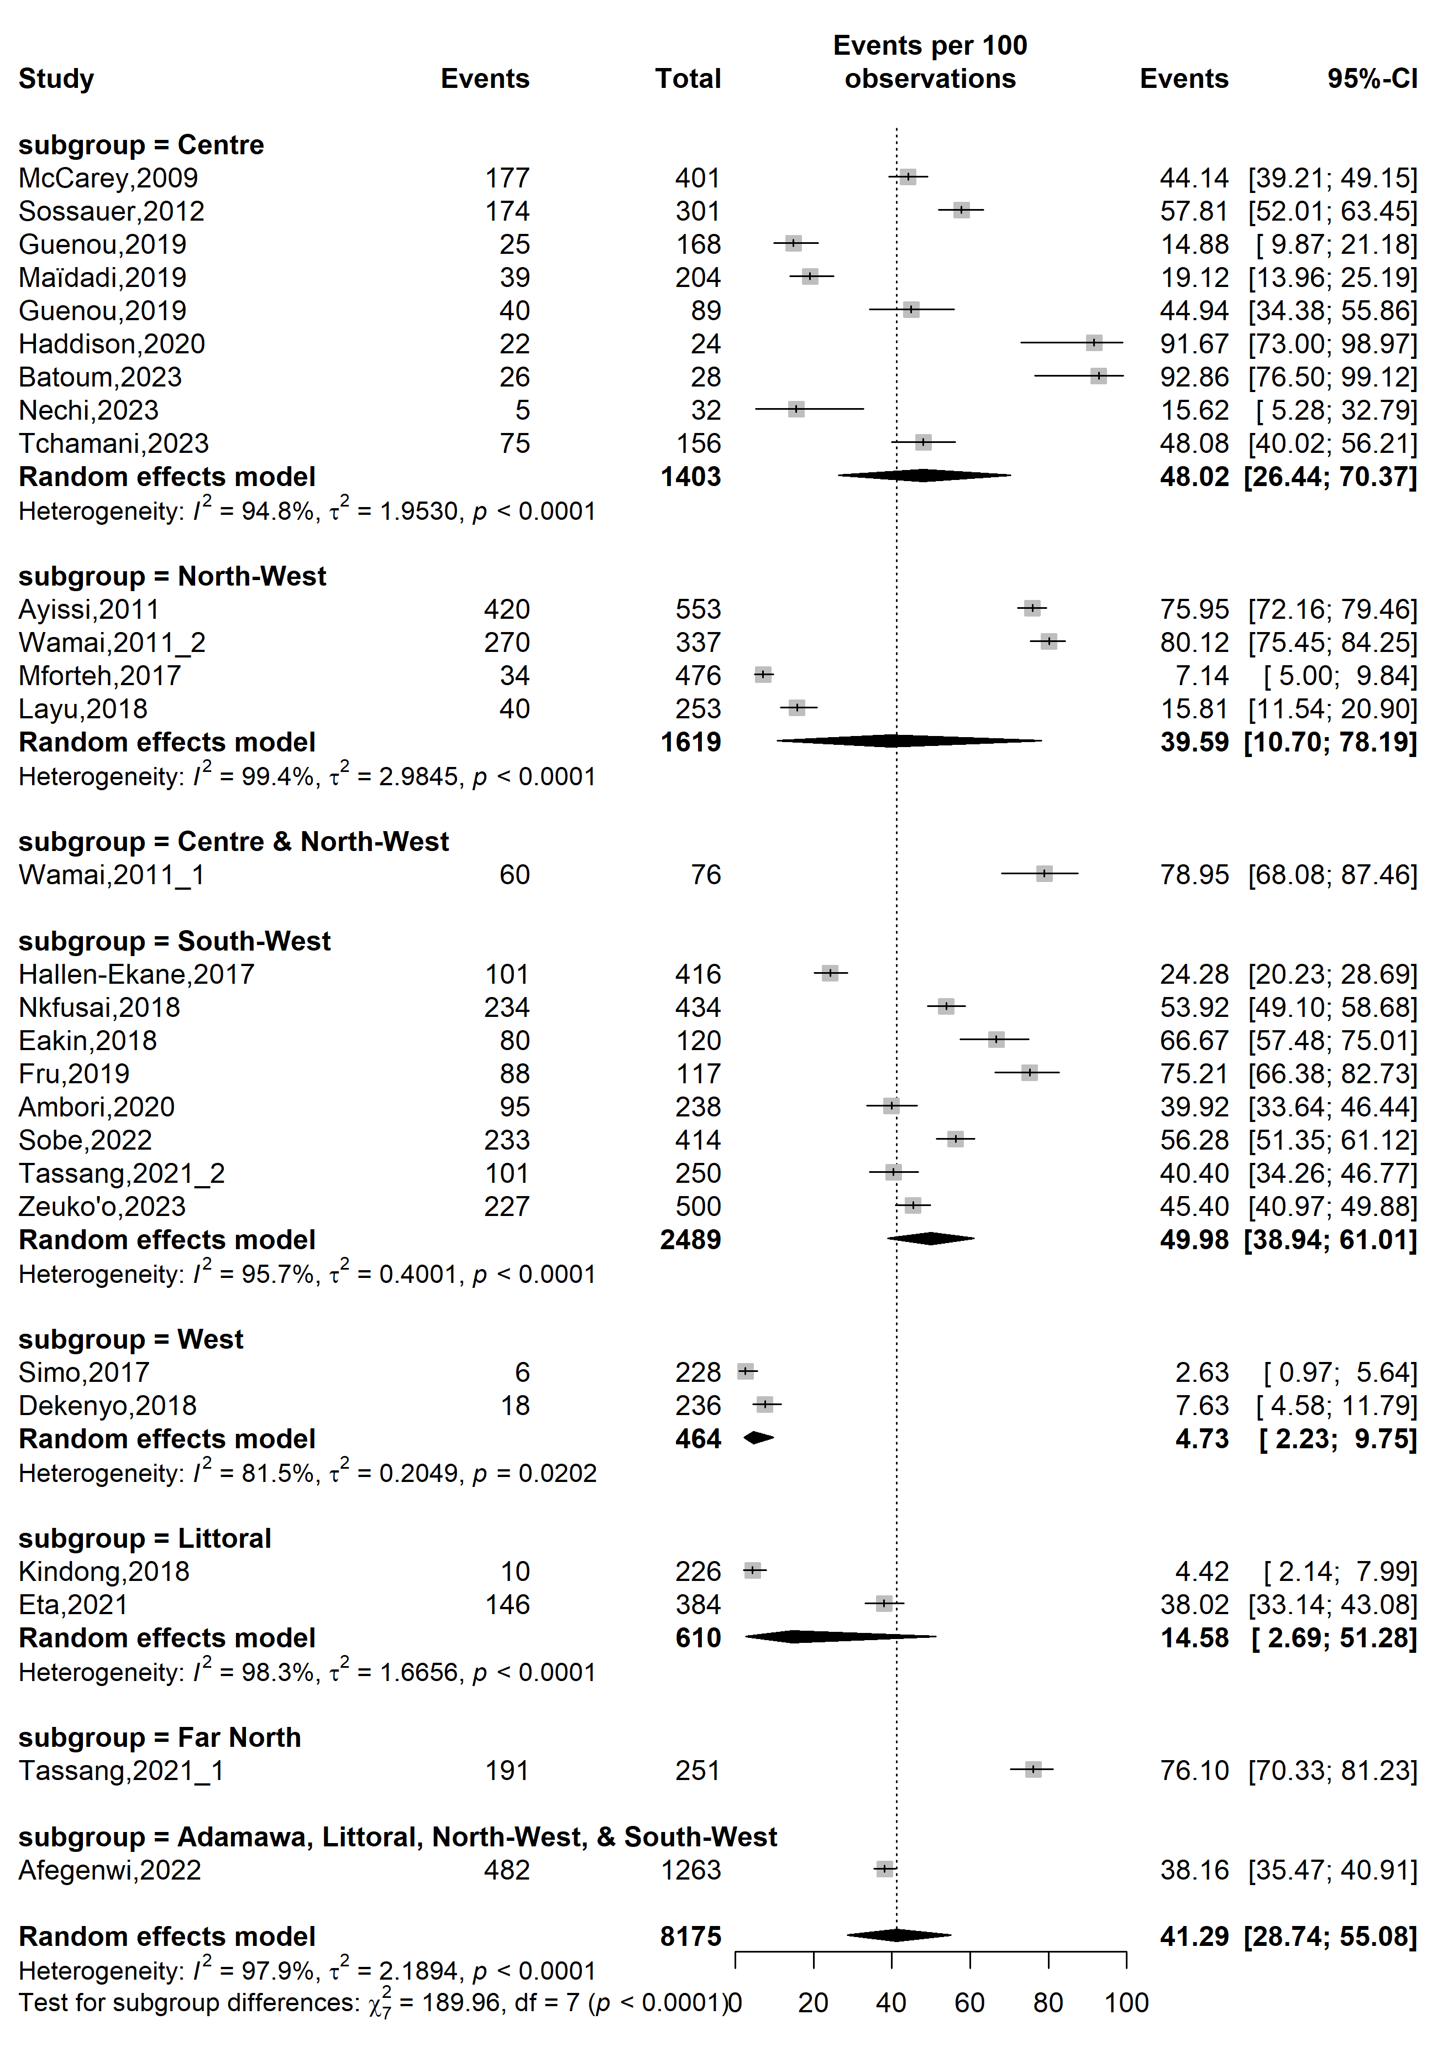
Supplementary Fig. 8 Pooled prevalence of human papillomavirus vaccine awareness according to study sites in Cameroon
Sampling method
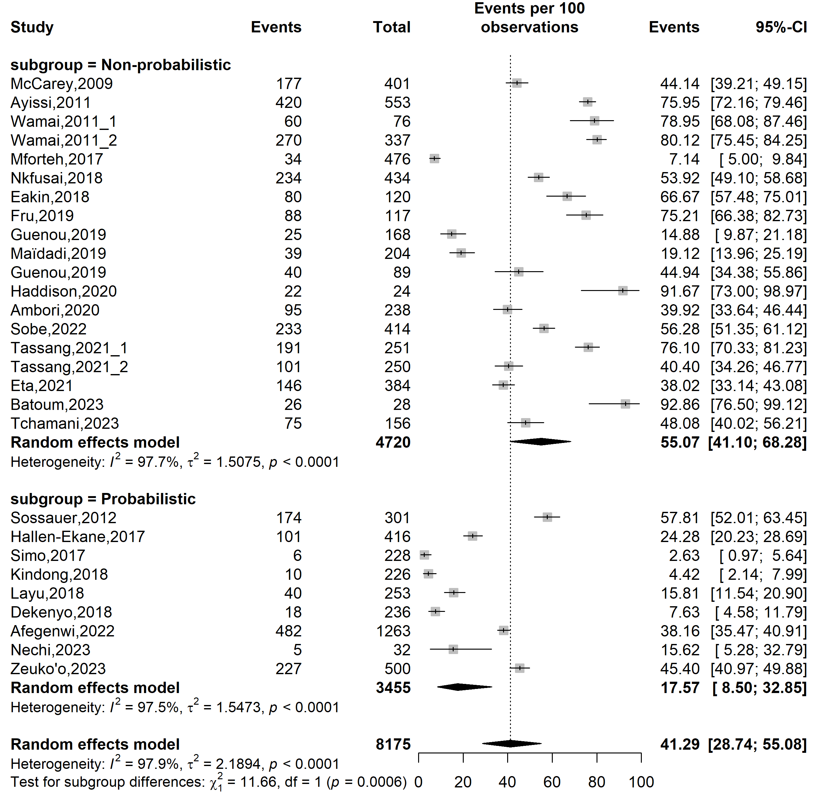
Supplementary Fig. 9 Pooled prevalence of human papillomavirus vaccine awareness by sampling methods in Cameroon

Type of participants
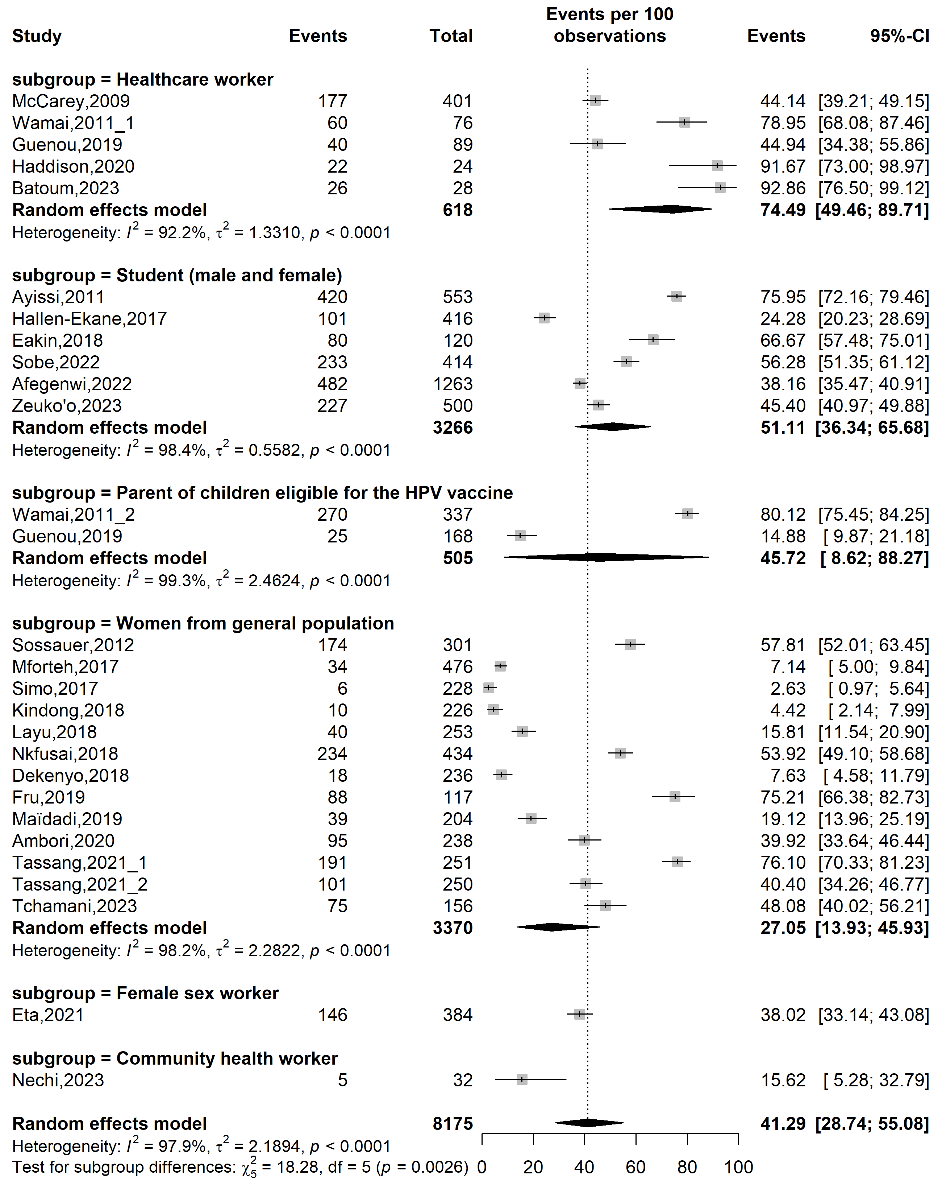
Supplementary Fig. 10 Pooled prevalence of human papillomavirus vaccine awareness by types of participants in Cameroon
Publication bias assessment
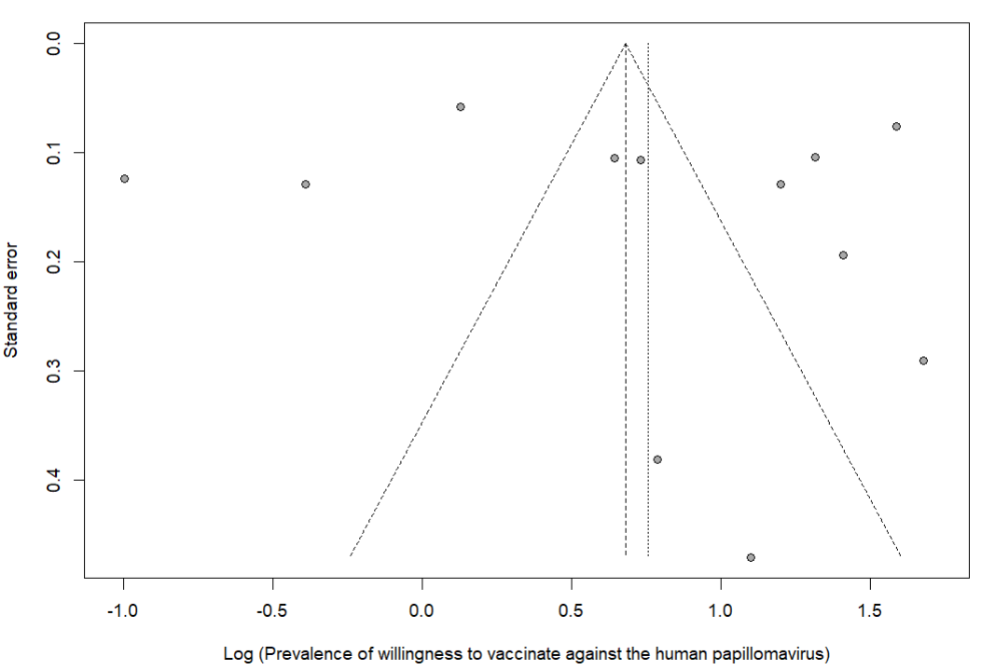
Egger’s test p-value = 0.707
Begg’s test p-value = 0.784

Supplementary Fig. 11 Funnel plot displaying the risk of publication bias of studies assessing willingness to vaccinate against human papillomavirus in Cameroon

Sensitivity analysis
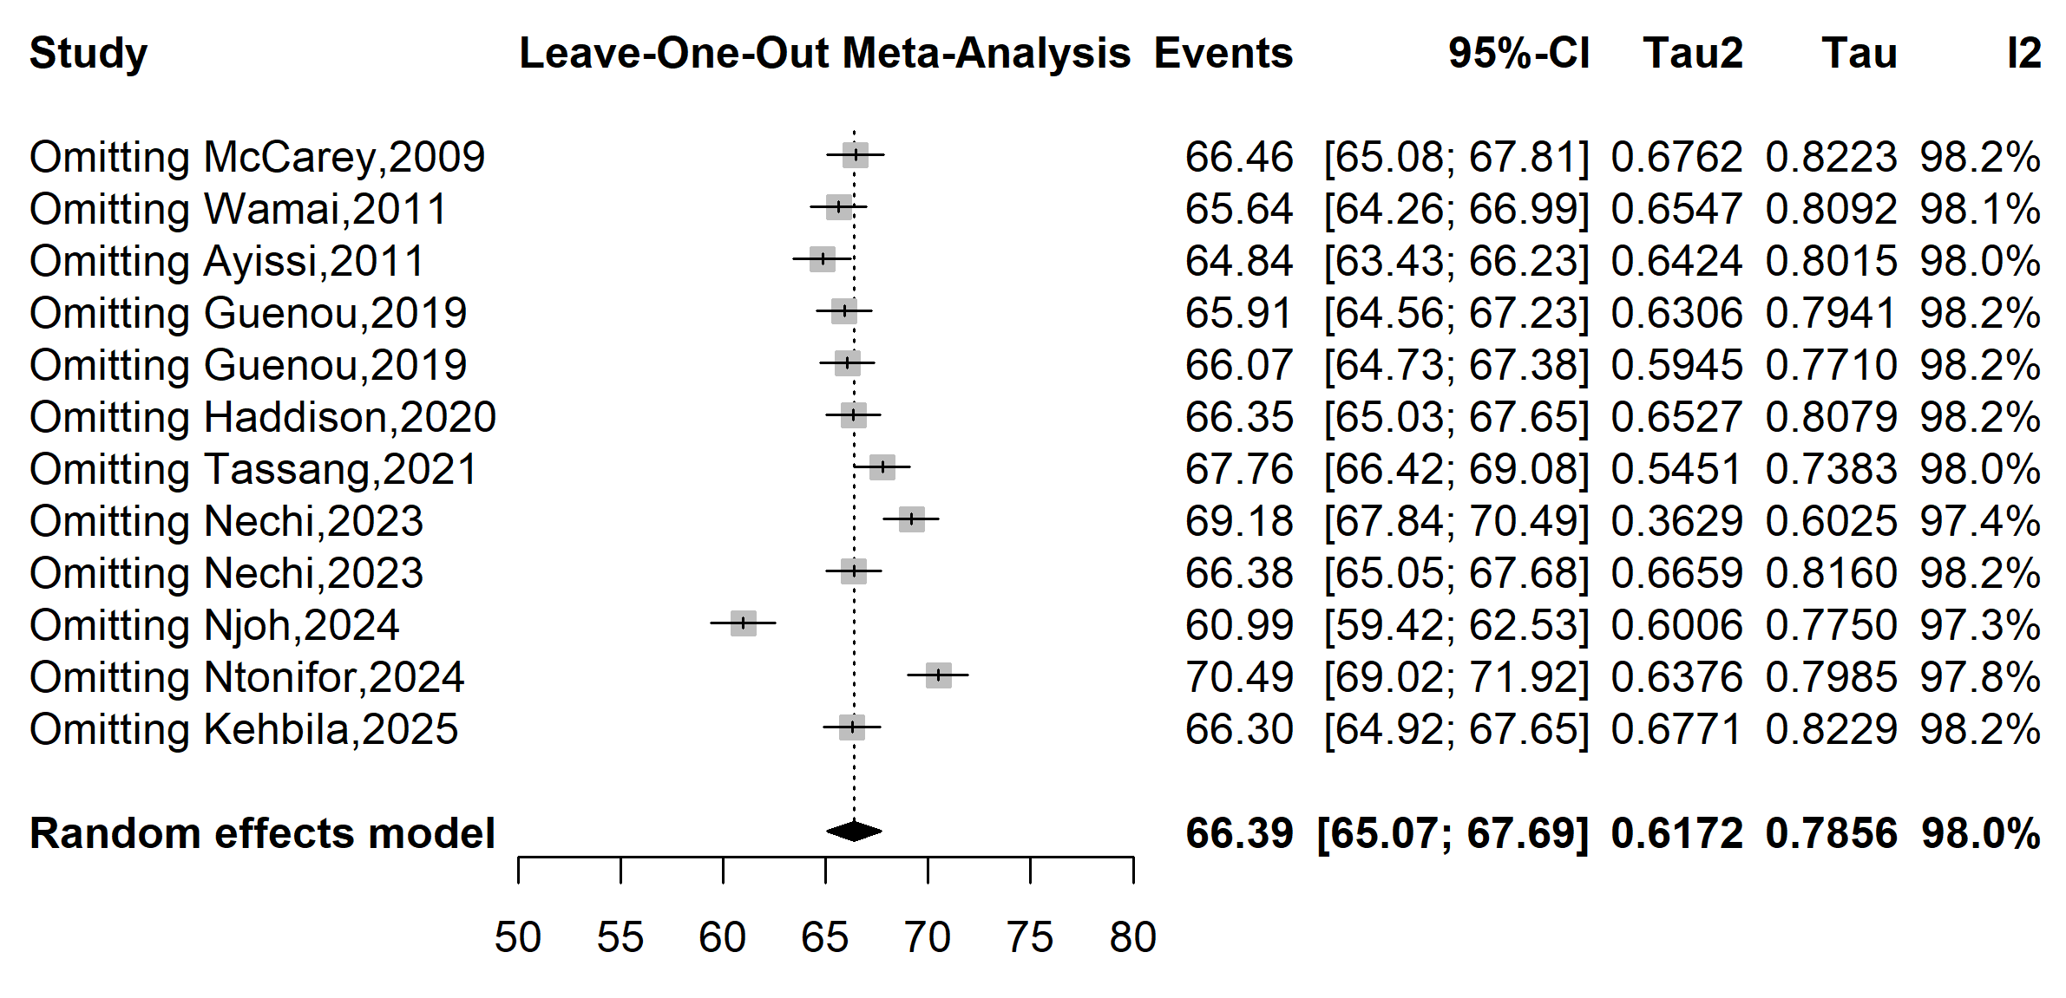
Supplementary Fig. 12 Sensitivity analysis of the pooled prevalence of willingness to vaccinate against human papillomavirus in Cameroon

Publication bias assessment
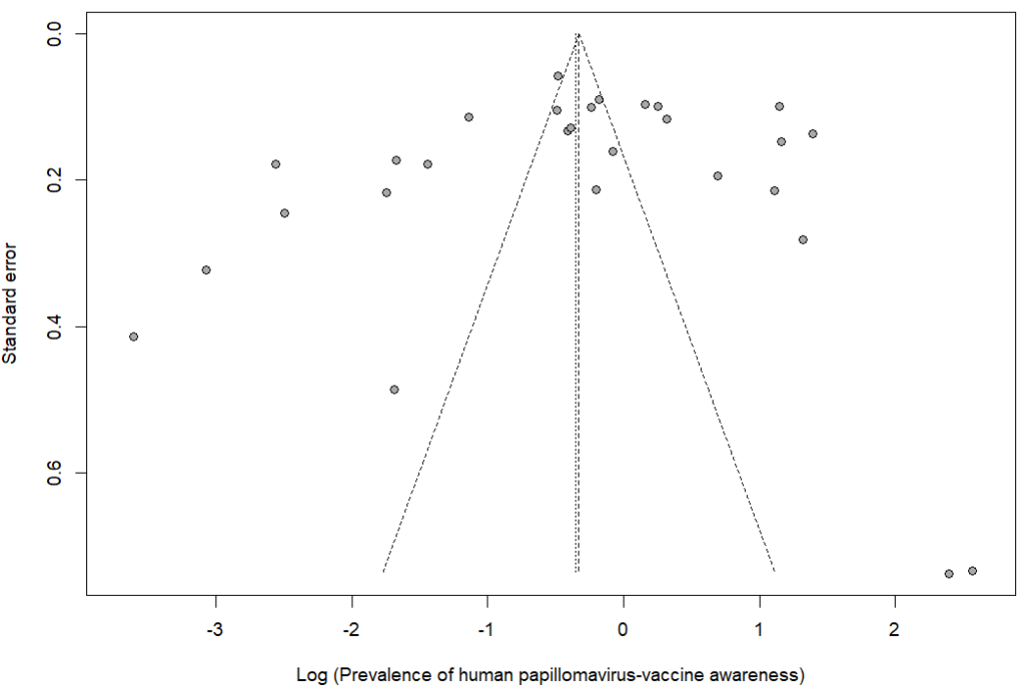
Egger’s test p-value = 0.455
Begg’s test p-value = 0.323

Supplementary Fig. 13 Funnel plot displaying the risk of publication bias of studies assessing the prevalence of human papillomavirus vaccine awareness in Cameroon

Sensitivity analysis
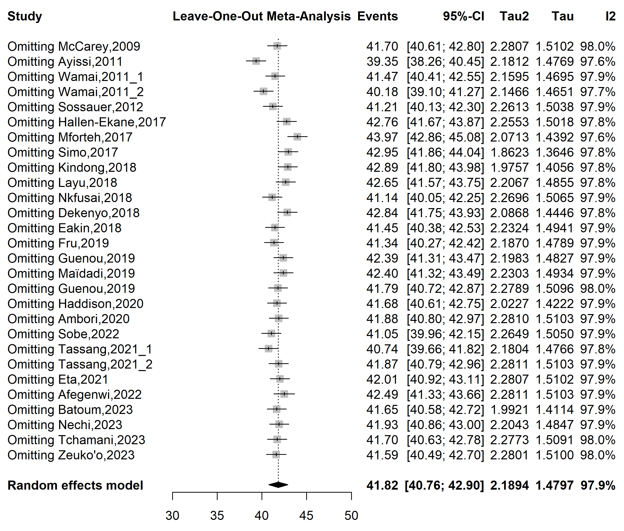
Supplementary Fig. 14 Sensitivity analysis of the pooled prevalence of human papillomavirus vaccine awareness in Cameroon

Sensitivity analysis
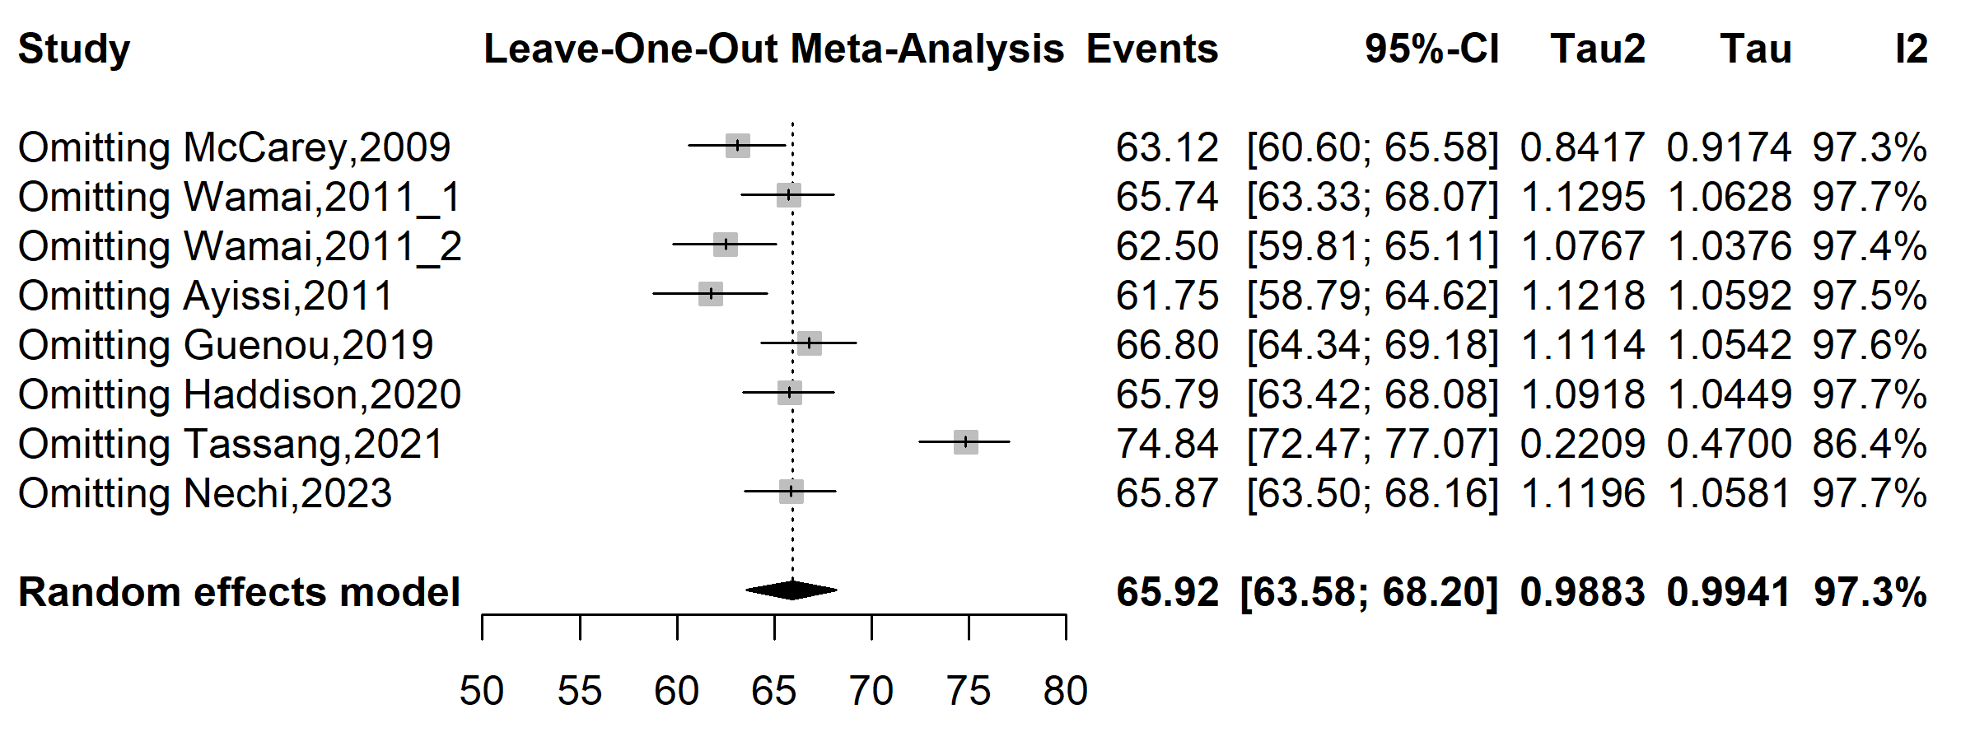
Supplementary Fig. 15 Forest plot displaying the sensitivity analysis of pooled the prevalence of human papillomavirus vaccine recommendation in Cameroon

Publication bias assessment
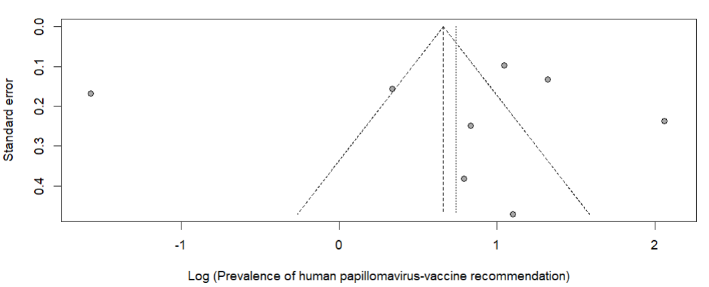

Supplementary Fig. 16 Funnel plot displaying the risk of publication bias of studies assessing the prevalence of human papillomavirus vaccine recommendation in Cameroon

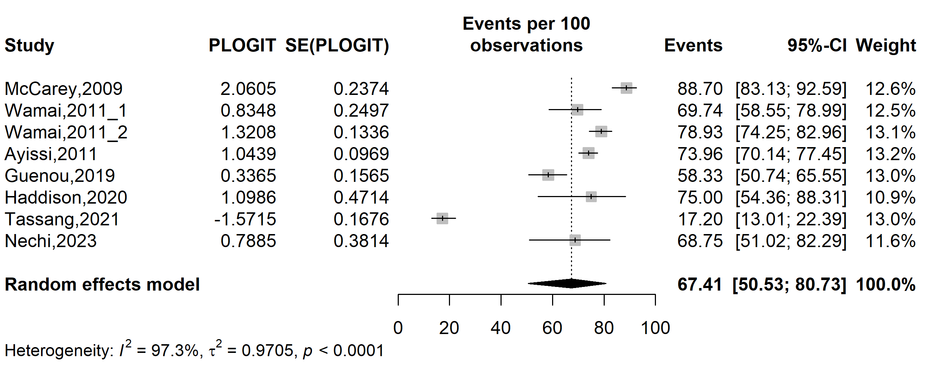
Supplementary Fig. 17 Forest plot displaying the trim and fill analysis of studies assessing the prevalence of human papillomavirus vaccine recommendation in Cameroon

Sensitivity analysis
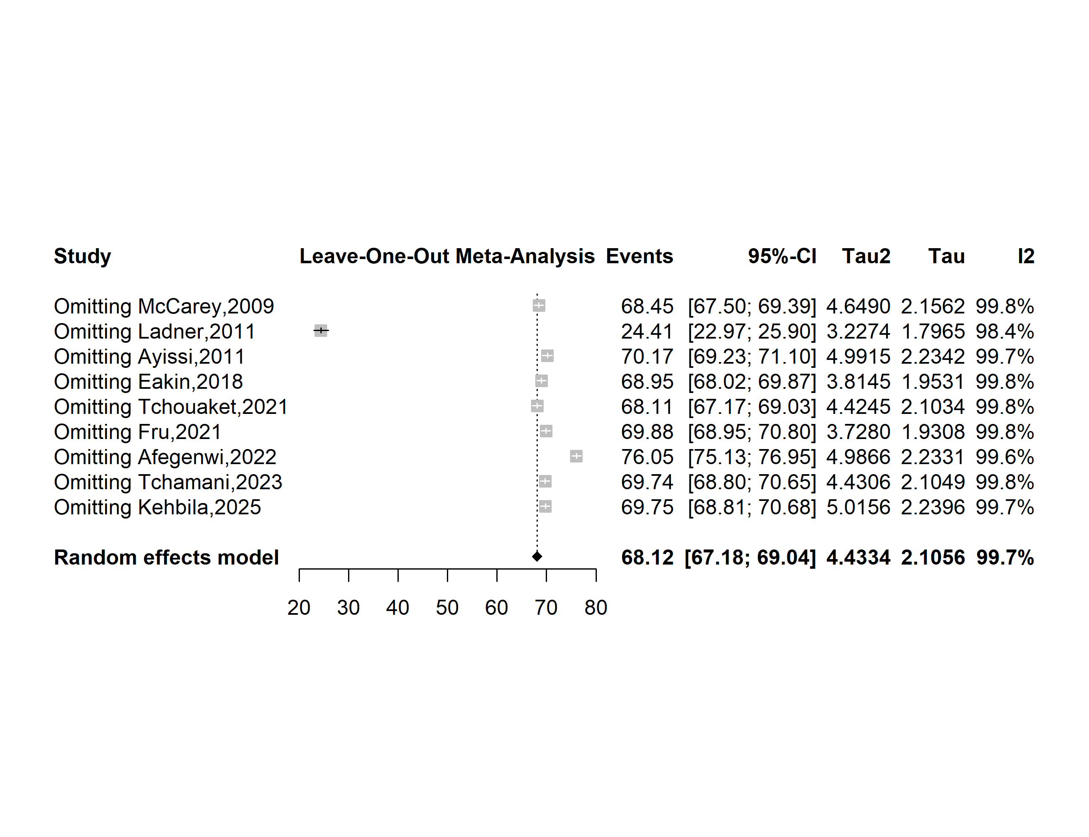
Supplementary Fig. 18 Forest plot displaying the sensitivity analysis of pooled the prevalence of human papillomavirus vaccine uptake in Cameroon

Publication bias assessment
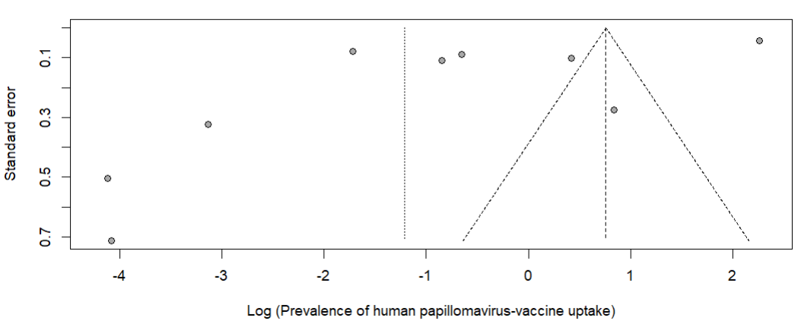
Supplementary Fig. 19 Funnel plot displaying the risk of publication bias of studies assessing the prevalence of human papillomavirus vaccine uptake in Cameroon

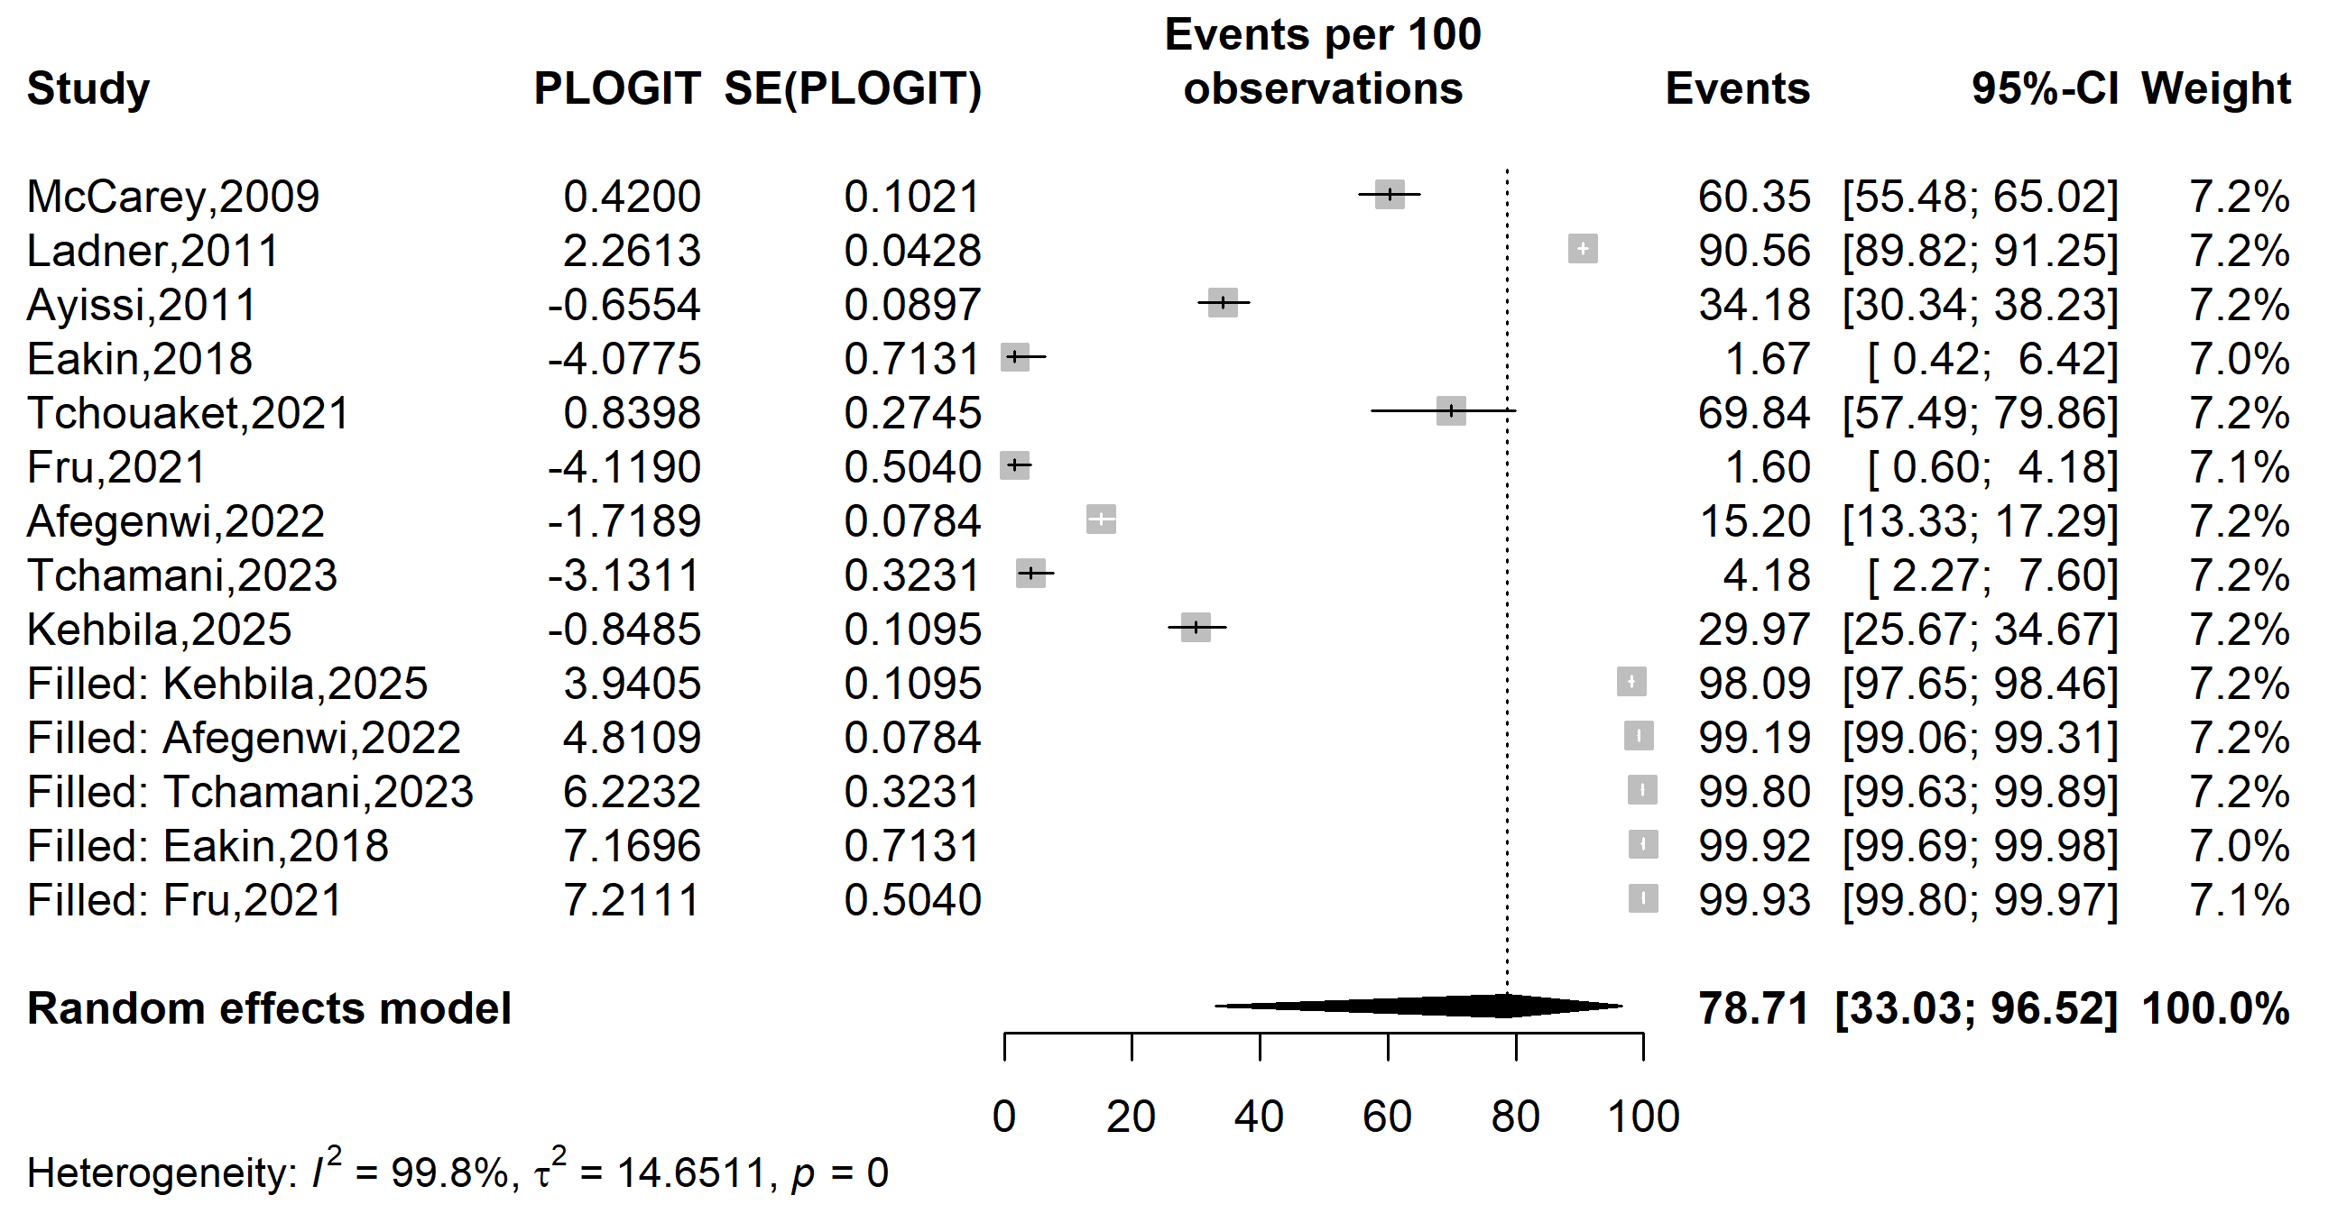
Supplementary Fig. 20 Forest plot displaying the trim and fill analysis of studies assessing the prevalence of human papillomavirus vaccine uptake in Cameroon

Predictor of HPV vaccine hesitancy

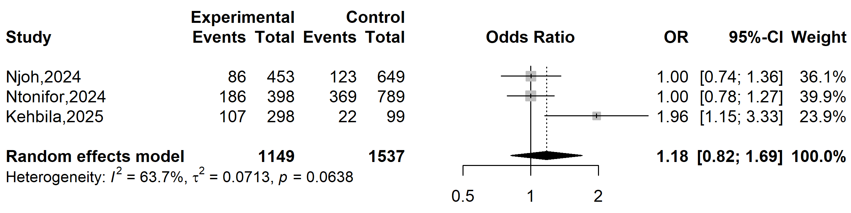
Supplementary Fig. 21 Pooled odds ratio hesitancy to vaccinate against human papillomavirus in Cameroon (Gender: female vs. male)

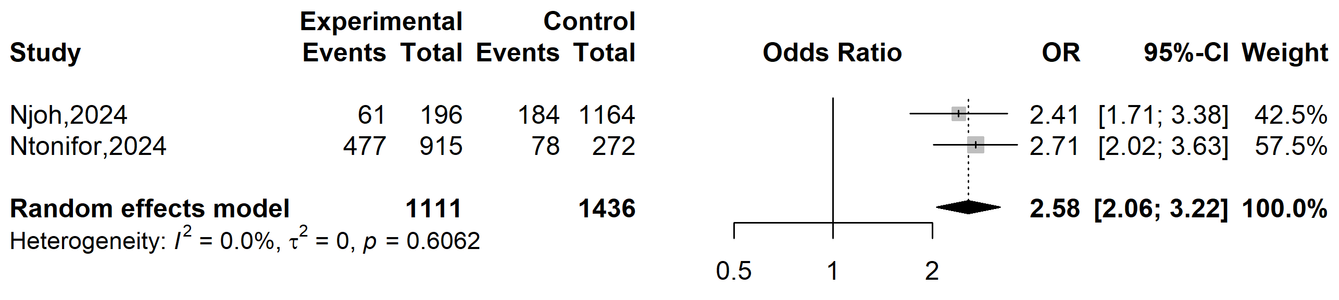
Supplementary Fig. 22 Pooled odds ratio of hesitancy to vaccinate against human papillomavirus (HPV) in Cameroon (Individual knowledge of HPV: no vs. yes)

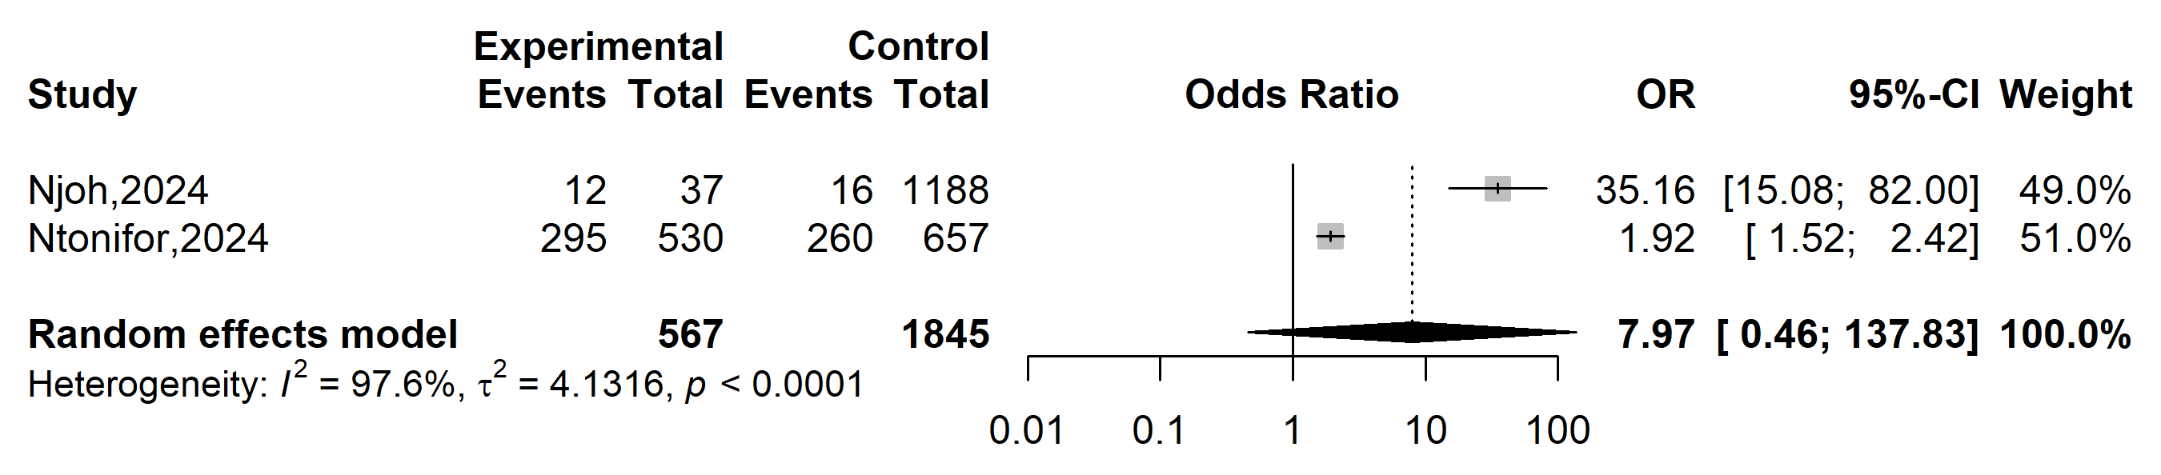
Supplementary Fig. 23 Pooled odds ratio of hesitancy to vaccinate against human papillomavirus in Cameroon (Individual knowledge of cervical cancer: no vs. yes)

