For feature selection using XGBoost, we filtered features with importance greater than 0.005 based on the Gini coefficient. This criterion ensures that only the most influential features are included in subsequent analyses, thereby improving the model's interpretability and efficiency. The screening process carefully evaluated the contribution of each feature to the predictive power of the model and ensured that all retained features significantly impacted the model. After screening, a detailed list was created for each dataset, including the name, classification, and Gini coefficient of each feature. The table below presents the full list, highlighting the statistical significance of each feature and providing a foundation for further analysis and model tuning. The dataset initially included a large number of features: 270 features in total. To enhance accuracy and efficiency, a data cleaning process was conducted to remove highly correlated features. Feature selection was then applied using Gini importance [57] to identify the most relevant features for the analysis. A higher Gini score indicates greater feature importance in classification tasks. After this process, 62 features were selected for the combined dataset (Fitbit and mobile data). Similar optimization processes were applied to subsets of the dataset containing only Fitbit or mobile data.
- Fitbit Dataset: Initially included 90 features; 26 features were retained after cleaning and selection.
- Mobile Dataset: Initially included 182 features; 49 features were retained after cleaning and selection.
This reduction suggests that the optimization process successfully identified a core set of relevant features for each dataset, enabling a more focused and effective analysis. Despite the differences in feature sets, the selected features represent the most relevant variables for the analysis.
- For the Mobile dataset, using machine learning for feature selection, we identified 49 features ranked by their Gini scores, with the highest scores indicating greater importance in classification tasks. The top features included the number of Bluetooth samples (0.0671), walking (0.0600), and the radius of gyration (0.0490). These features span multiple categories, including activity, calls, Wi-Fi, location, and time.
- For the Fitbit dataset, we identified 26 features through machine learning feature selection, ranked by their Gini scores. The top features included sleep start time (0.0957), sleep duration (0.0901), minutes awake during sleep (0.0850), and sleep end time (0.0843). These features span multiple categories, including steps, time, and heart rate. The Fitbit results demonstrated a diverse set of features across these categories, highlighting their significance in predictive modeling.
- For the MobiFit dataset, we identified 64 features using machine learning feature selection. The most important features based on Gini scores included the number of Bluetooth samples (0.0474), walking (0.0458), sleep end time (0.0427), and the number of unique Wi-Fi hotspots (0.0412). These features span multiple categories, including activity, Wi-Fi, steps, keypress, location, time, and heart rate.
The optimized datasets with reduced features are expected to yield more accurate and meaningful results, facilitating better conclusions and informed decision-making. These features encompass a wide range of measurements related to physical activity, communication behaviors, battery usage, and sleep patterns, emphasizing their utility in predictive modeling.
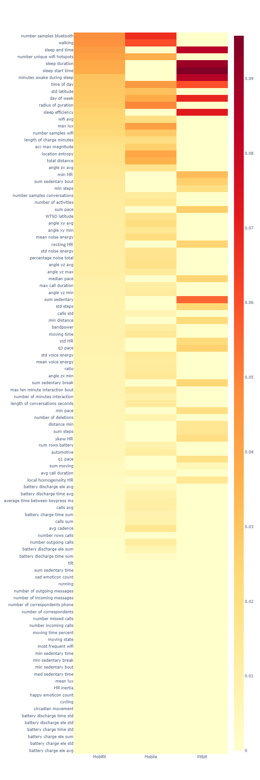
Figure S1. Selected Features for Modeling
Table S1. Mobile Feature Importance
No. | Category | Feature name | GINI score
1 | bluetooth | number samples bluetooth | 0.0671
2 | activity | walking | 0.0600
3 | location | radius of gyration | 0.0490
4 | time | time of day | 0.0435
5 | light | max lux | 0.0415
6 | location | location entropy | 0.0399
7 | time | day of week | 0.0382
8 | Wi-Fi | number unique Wi-Fi hotspots | 0.0372
9 | location | total distance | 0.0359
10 | location | std latitude | 0.0312
11 | Wi-Fi | number samples Wi-Fi | 0.0281
12 | accelerometer | acc max magnitude | 0.0264
13 | accelerometer | angle xy avg | 0.0212
14 | conversation plug-in | mean noise energy | 0.0210
15 | battery | length of charge minutes | 0.0204
16 | Wi-Fi | wifi avg | 0.0203
17 | accelerometer | angle yz avg | 0.0184
18 | location | WTSD latitude | 0.0178
19 | conversation plug-in | percentage noise total | 0.0177
20 | accelerometer | angle zx avg | 0.0176
21 | conversation plug-in | std noise energy | 0.0169
22 | gait | avg cadence | 0.0164
23 | activity | number of activities | 0.0164
24 | accelerometer | angle xy min | 0.0154
25 | location | moving time | 0.0146
26 | accelerometer | angle zx min | 0.0143
27 | conversation plug-in | std voice energy | 0.0138
28 | accelerometer | angle yz max | 0.0138
29 | conversation plug-in | max len minute interaction bout | 0.0135
30 | activity | ratio | 0.0134
31 | conversation plug-in | number samples conversations | 0.0132
32 | accelerometer | angle yz min | 0.0130
33 | conversation plug-in | length of conversations seconds | 0.0129
34 | conversation plug-in | mean voice energy | 0.0128
35 | call | number outgoing calls | 0.0126
36 | activity | automotive | 0.0120
37 | activity | bandpower | 0.0119
38 | call | max call duration | 0.0117
39 | call | calls avg | 0.0108
40 | keypress | average time between keypress ms | 0.0099
41 | conversation plug-in | number of minutes interaction | 0.0093
42 | battery | num rows battery | 0.0087
43 | call | calls sum | 0.0085
44 | battery | battery discharge time avg | 0.0084
45 | keypress | number of deletions | 0.0081
46 | battery | battery charge time sum | 0.0078
47 | call | calls std | 0.0071
48 | battery | battery discharge time sum | 0.0068
49 | call | avg call duration | 0.0059

Table S2. Fitbit Feature Importance
No. | Category | Feature name | GINI score
1 | sleep | sleep start time | 0.0957
2 | sleep | sleep duration | 0.0901
3 | sleep | minutes awake during sleep | 0.0850
4 | sleep | sleep end time | 0.0843
5 | sleep | sleep efficiency | 0.0729
6 | time | day of week | 0.0693
7 | time | time of day | 0.0599
8 | step | sum sedentary | 0.0554
9 | heart rate | min HR | 0.0324
10 | step | sum pace | 0.0273
11 | step | sum sedentary bout | 0.0263
12 | step | q3 pace | 0.0261
13 | step | median pace | 0.0252
14 | heart rate | resting HR | 0.0252
15 | step | sum sedentary break | 0.0244
16 | step | std steps | 0.0241
17 | step | min distance | 0.0224
18 | heart rate | std HR | 0.0221
19 | step | min pace | 0.0205
20 | heart rate | skew HR | 0.0202
21 | step | min steps | 0.0198
22 | step | q1 pace | 0.0188
23 | step | sum steps | 0.0160
24 | step | distance min | 0.0158
25 | heart rate | local homogeneity HR | 0.0155
26 | step | sum moving | 0.0053

Table S3. MobiFit Feature Importance
No. | Category | Feature name | GINI score
1 | bluetooth | number samples bluetooth | 0.0474
2 | activity | walking | 0.0458
3 | sleep | sleep end time | 0.0427
4 | Wi-Fi | number unique Wi-Fi hotspots | 0.0412
5 | sleep | sleep duration | 0.0386
6 | sleep | sleep start time | 0.0379
7 | sleep | minutes awake during sleep | 0.0303
8 | time | time of day | 0.0296
9 | location | std latitude | 0.0288
10 | time | day of week | 0.0285
11 | location | radius of gyration | 0.0275
12 | sleep | sleep efficiency | 0.0253
13 | Wi-Fi | Wi-Fi avg | 0.0247
14 | light | max lux | 0.0245
15 | wifi | number samples Wi-Fi | 0.0231
16 | battery | length of charge minutes | 0.0201
17 | accelerometer | acc max magnitude | 0.0182
18 | location | location entropy | 0.0176
19 | location | total distance | 0.0173
20 | accelerometer | angle zx avg | 0.0159
21 | heart rate | min HR | 0.0155
22 | step | sum sedentary bout | 0.0141
23 | step | min steps | 0.0139
24 | conversation plug-in | number samples conversations | 0.0131
25 | activity | number of activities | 0.0127
26 | step | sum pace | 0.0123
27 | location | WTSD latitude | 0.0122
28 | accelerometer | angle xy avg | 0.0116
29 | accelerometer | angle xy min | 0.0115
30 | conversation plug-in | mean noise energy | 0.0113
31 | heart rate | resting HR | 0.0112
32 | conversation plug-in | std noise energy | 0.0112
33 | conversation plug-in | percentage noise total | 0.0110
34 | accelerometer | angle yz avg | 0.0109
35 | accelerometer | angle yz max | 0.0107
36 | step | median pace | 0.0102
37 | call | max call duration | 0.0096
38 | accelerometer | angle yz min | 0.0090
39 | step | sum sedentary | 0.0089
40 | step | std steps | 0.0089
41 | call | calls std | 0.0085
42 | step | min distance | 0.0085
43 | activity | bandpower | 0.0085
44 | location | moving time | 0.0083
45 | heart rate | std HR | 0.0079
46 | step | q3 pace | 0.0079
47 | conversation plug-in | std voice energy | 0.0077
48 | conversation plug-in | mean voice energy | 0.0076
49 | activity | ratio | 0.0073
50 | accelerometer | angle zx min | 0.0072
51 | step | sum sedentary break | 0.0072
52 | conversation plug-in | max len minute interaction bout | 0.0071
53 | conversation plug-in | number of minutes interaction | 0.0069
54 | conversation plug-in | length of conversations seconds | 0.0063
55 | step | min pace | 0.0062
56 | keypress | number of deletions | 0.0062
57 | step | distance min | 0.0060
58 | step | sum steps | 0.0058
59 | heart rate | skew HR | 0.0058
60 | battery | num rows battery | 0.0057
61 | activity | automotive | 0.0056
62 | step | q1 pace | 0.0054

