SUPPLEMENTARY MATERIAL

Whole-Genome Sequencing, Annotation and Phenotypic Taxonomic Confirmation of a Multidrug-Resistant Escherichia coli Strain Isolated from the Blood of a Sepsis Patient

Peter M. Eze^{1,2*}, Lucy Dillon¹, Jurnorain Gani³, Timothy Planche³, Linda B. Oyama¹, Christopher J. Creevey¹

¹School of Biological Sciences, Queen’s University Belfast, United Kingdom

²Department of Environmental Health Science, Nnamdi Azikiwe University, Nigeria

³Institute of Infection and Immunity, City St. George's, University of London, United Kingdom

*Corresponding author: p.eze@qub.ac.uk

ABSTRACT

Sepsis (blood stream infection) caused by multidrug-resistant (MDR) bacteria, particularly Escherichia coli, represents a significant global health threat due to high morbidity, mortality, and limited treatment options. E. coli, a major causative agent of bloodstream infections, has evolved highly virulent and MDR strains, which contribute to the increasing burden of antimicrobial resistance (AMR), complicating clinical management and reducing the efficacy of conventional antibiotic therapies. In this study, we characterised the genomic and phenotypic drug resistance mechanism of E. coli 266631E isolated from a sepsis patient, highlighting the negative implications of MDR E. coli in sepsis. Antimicrobial susceptibility testing and minimum inhibitory concentration analysis revealed resistance to multiple antibiotics, including amoxicillin, cefotaxime, ciprofloxacin, gentamicin, and tobramycin. Whole genome sequencing identified a broad array of AMR genes encoding resistance to various antibiotic classes, such as macrolides, fluoroquinolones, aminoglycosides, carbapenems, and cephalosporins. Notably, the CTX-M-15 gene, a key extended-spectrum β-lactamase determinant, was found in both the bacterial chromosome and an IncF-type plasmid, emphasizing the potential for horizontal gene transfer and rapid dissemination of resistance. Confirming the taxonomy of the novel and unidentified bacterial strain through querying its 16S rRNA sequence and genome in recognised bacterial taxonomic databases presented a challenge. The isolate showed genetic similarity to E. coli, E. fergusonii, and Shigella species despite their phenotypic differences and variations in their pathogenic traits. However, a simple phenotypic laboratory procedure, based on the biochemical and cultural differences among these bacteria in Coliform ChromoSelect Agar, confirmed the isolate as E. coli. This study underscores the critical importance of integrating phenotypic methods with genomic tools for the accurate identification of clinically significant bacteria. It also highlights the need for both phenotypic and genetic surveillance of key MDR variants in healthcare settings to enable timely, precise diagnosis and targeted treatment of life-threatening infections such as sepsis.

TABLE OF CONTENTS

Content |  | Page
Figure S1: | Result of MALDI-TOF analysis | 3
Figure S2: | Screenshot of AMRFinderPlus output showing AMR genes in contig 1 (chromosome) and contig 3 (IncF-type plasmid) showing predicted AMR genes at 100% identity | 4
Figure S3: | Screenshot of starAMR output showing AMR genes in contig 1 (chromosome) and contig 3 (IncF-type plasmid) showing predicted AMR genes at ≥99% identity | 5
Figure S4: | Screenshot of RGI output of contig 1 (chromosome) showing predicted AMR genes at ≥99% identity | 6
Figure S5: | Screenshot of RGI output of contig 3 (IncF-type plasmid) showing predicted AMR genes at ≥99% identity | 9
Figure S6: | NCBI BLAST Search of bacterial 16S rRNA sequence on NCBI Standard Databases [Core nucleotide database option (core nt) option] | 10
Figure S7: | NCBI BLAST Search of bacterial 16S rRNA sequence on NCBI’s rRNA/ITS databases [16S ribosomal RNA sequences (Bacterial and Archaea) option] | 11
Figure S8: | Snapshot of Greengenes2 BLAST result output | 12
Figure S9: | Snapshot of SILVA BLAST result output | 13
Figure S10: | Sourmash of 1,595 genomes showing the average nucleotide identity (ANI) | 14
Figure S11: | Sourmash of 1,595 genomes showing the Jaccard index | 15
Figure S12: | (A) Phylogeny of the isolate using FastTree (B) Reduced representation of 1,595 isolates | 16

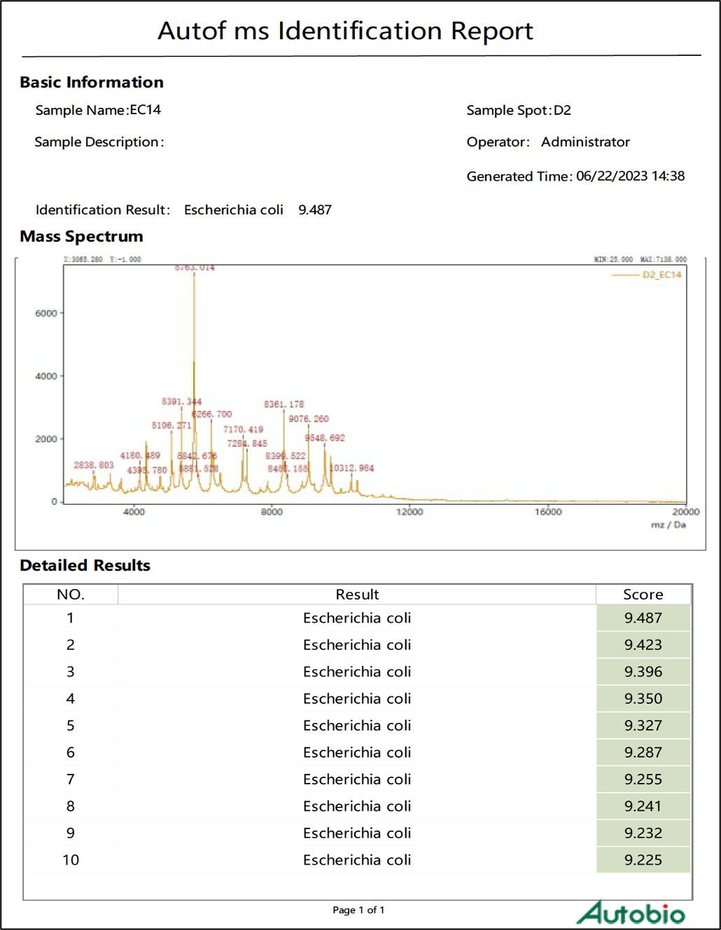

Figure S1: Result of MALDI-TOF analysis

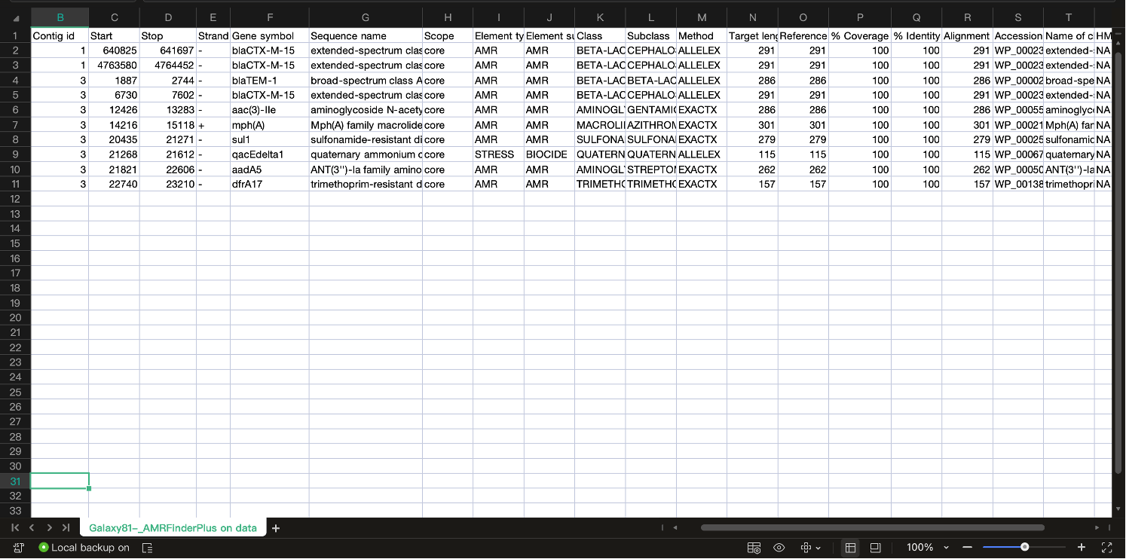

Figure S2: Screenshot of AMRFinderPlus output showing AMR genes in contig 1 (chromosome) and contig 3 (IncF-type plasmid) showing predicted AMR genes at 100% identity

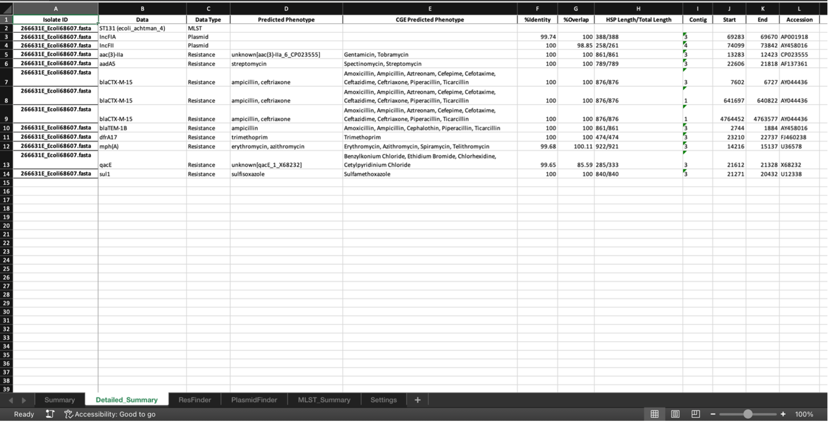

Figure S3: Screenshot of starAMR output showing AMR genes in contig 1 (chromosome) and contig 3 (IncF-type plasmid) showing predicted AMR genes at ≥99% identity

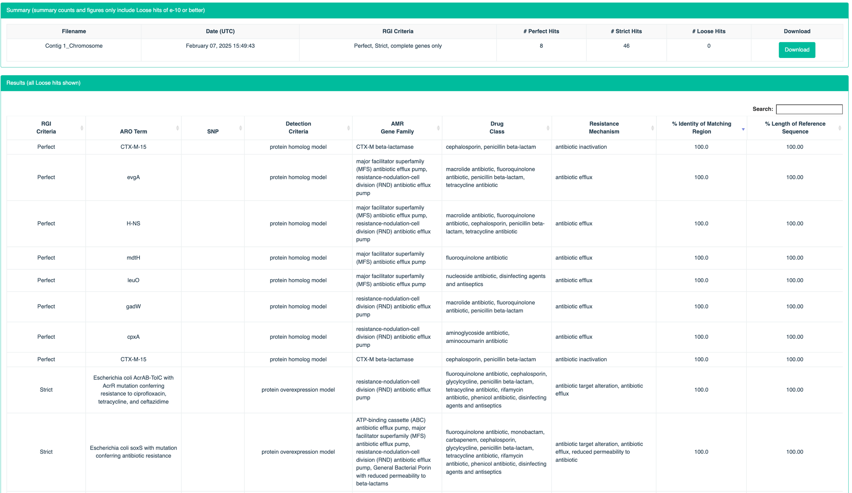

Figure S4: Screenshot of RGI output of contig 1 (chromosome) showing predicted AMR genes at ≥99% identity

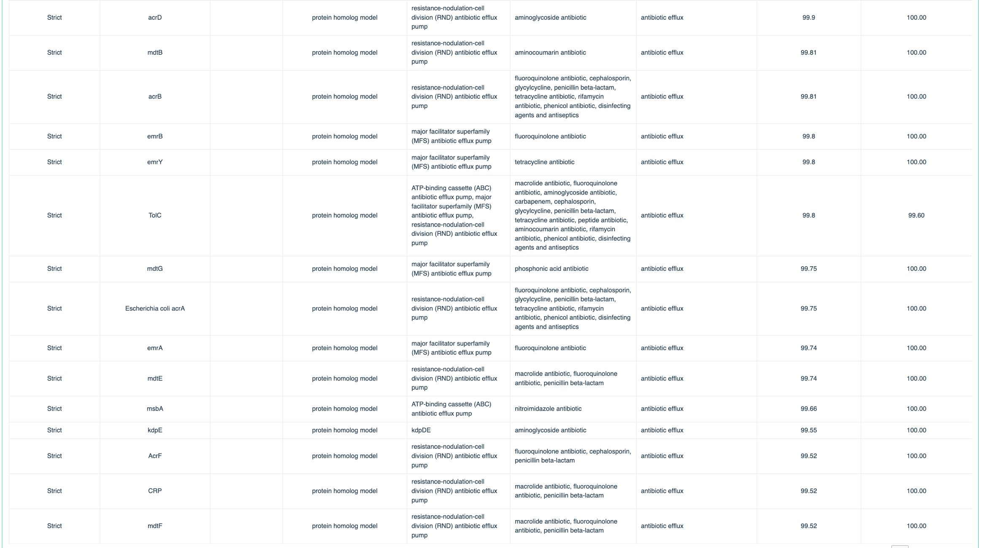

Figure S4: Screenshot of RGI output of contig 1 (chromosome) showing predicted AMR genes at ≥99% identity…(continued_2)

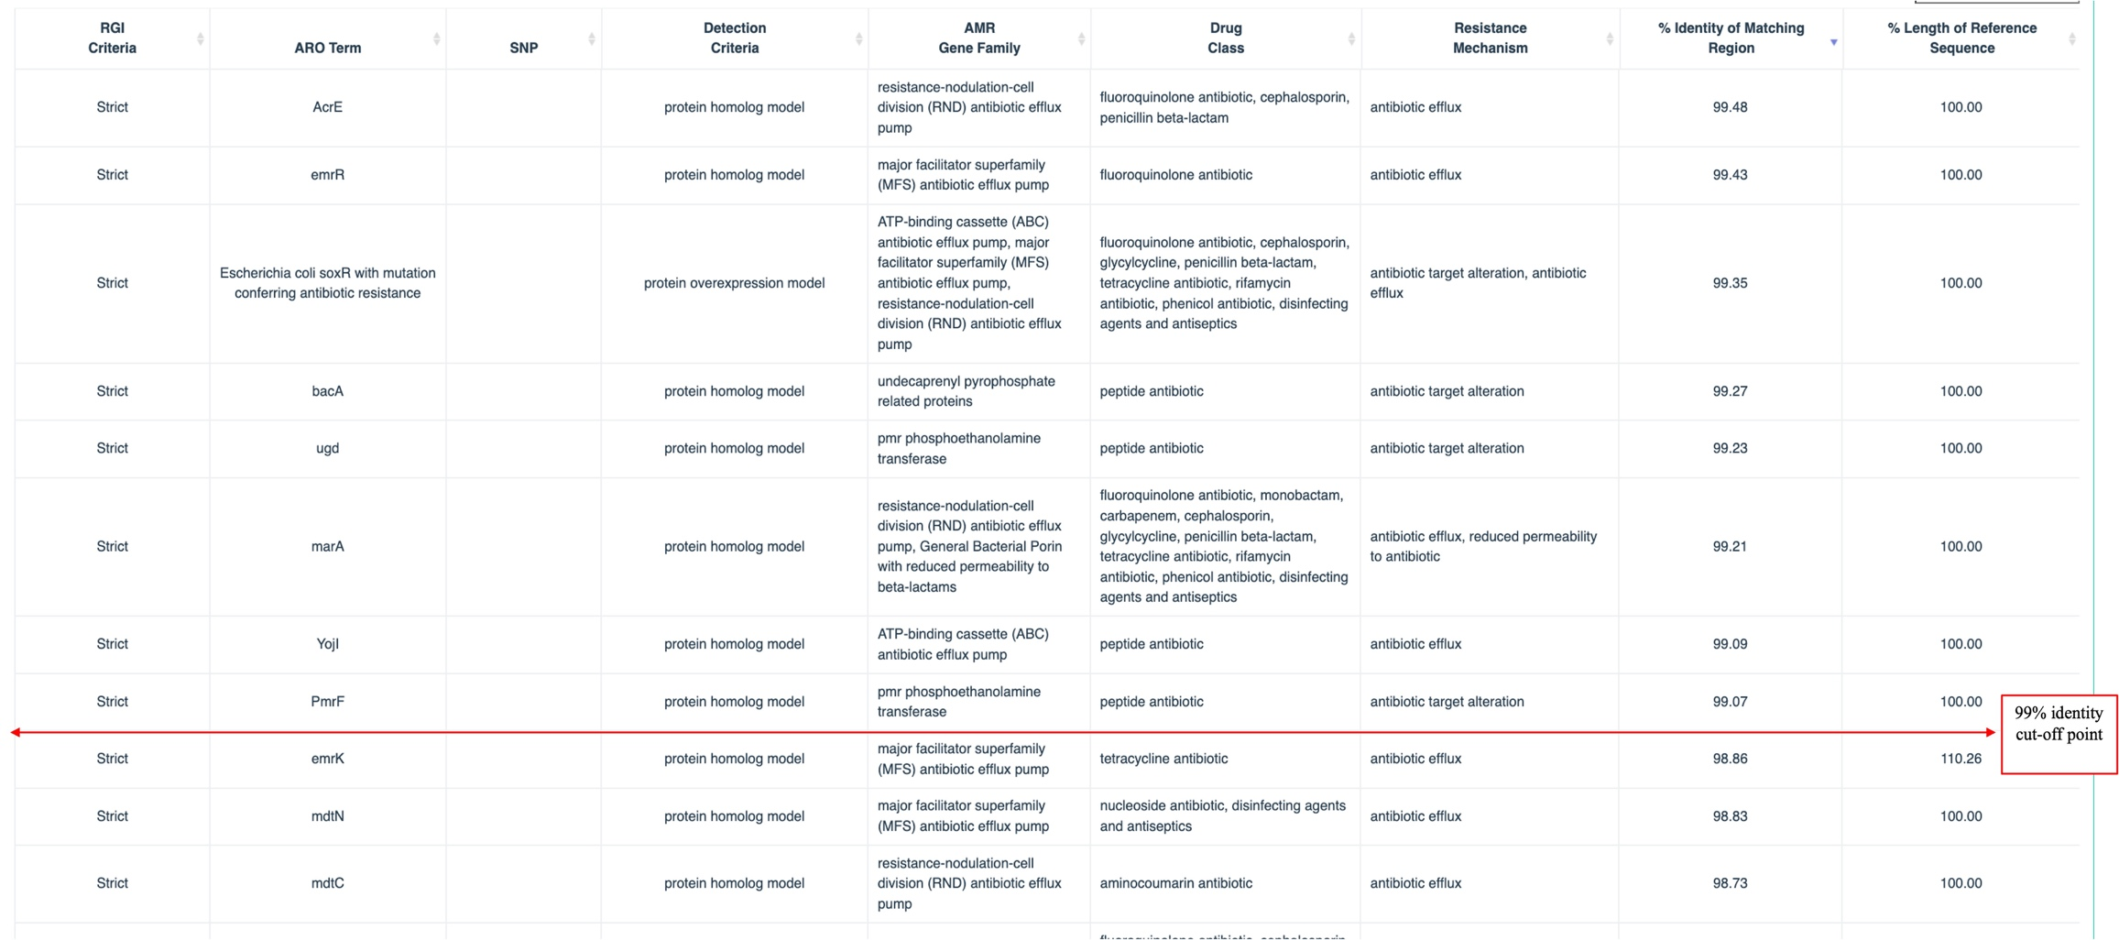

Figure S4: Screenshot of RGI output of contig 1 (chromosome) showing predicted AMR genes at ≥99% identity…(continued_3)

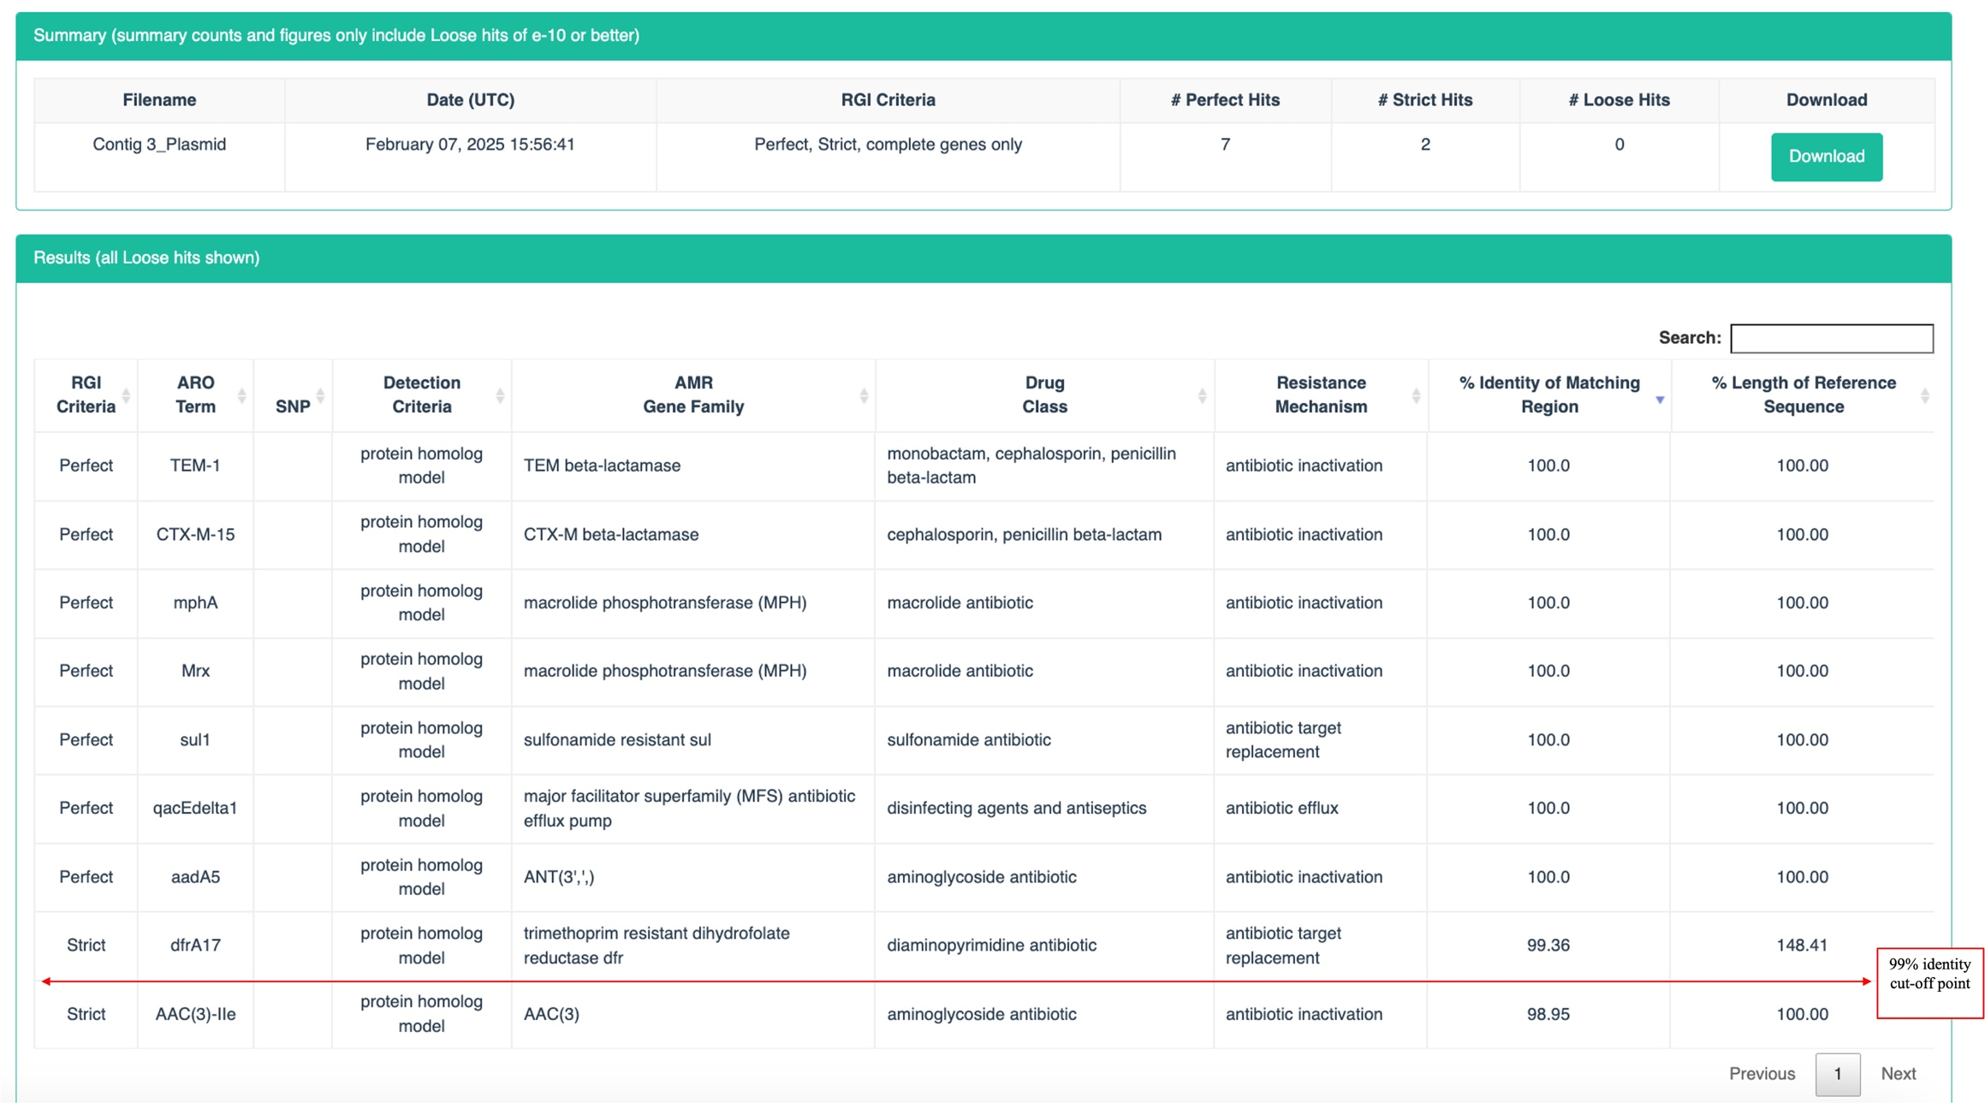

Figure S5: Screenshot of RGI output of contig 3 (IncF-type plasmid) showing predicted AMR genes at ≥99% identity

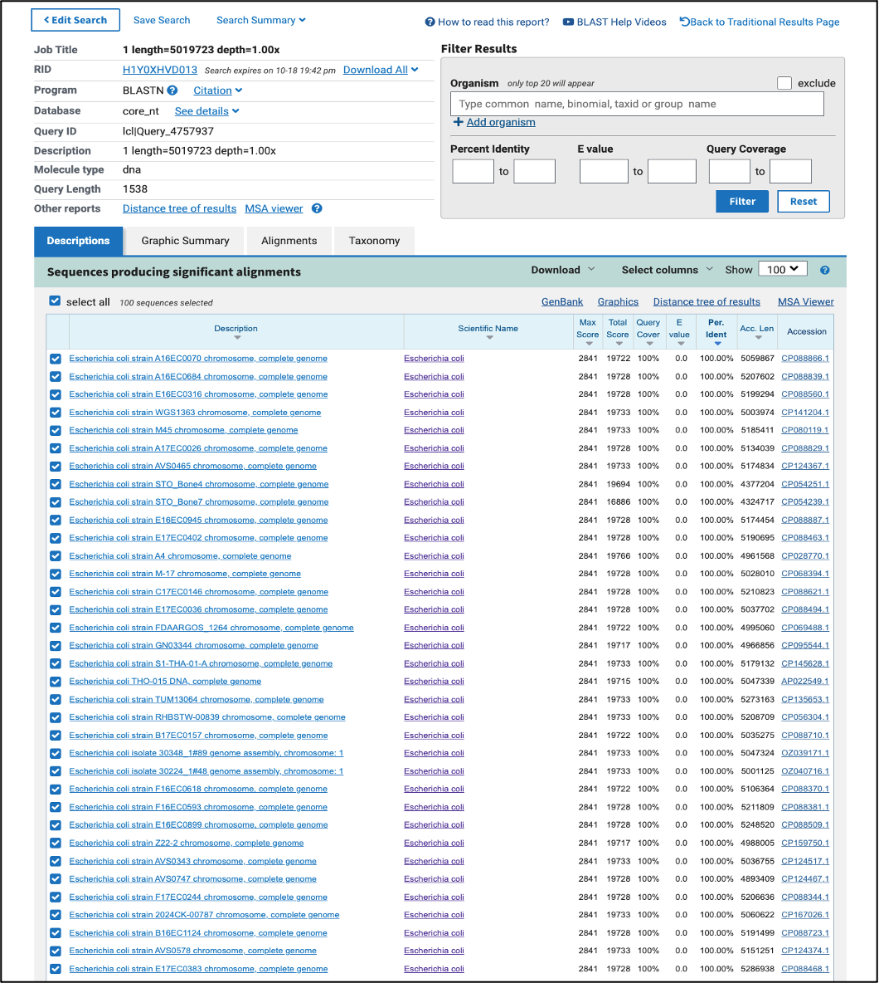
Figure S6: NCBI BLAST Search of bacterial 16S rRNA sequence on NCBI Standard Databases [Core nucleotide database option (core nt) option]

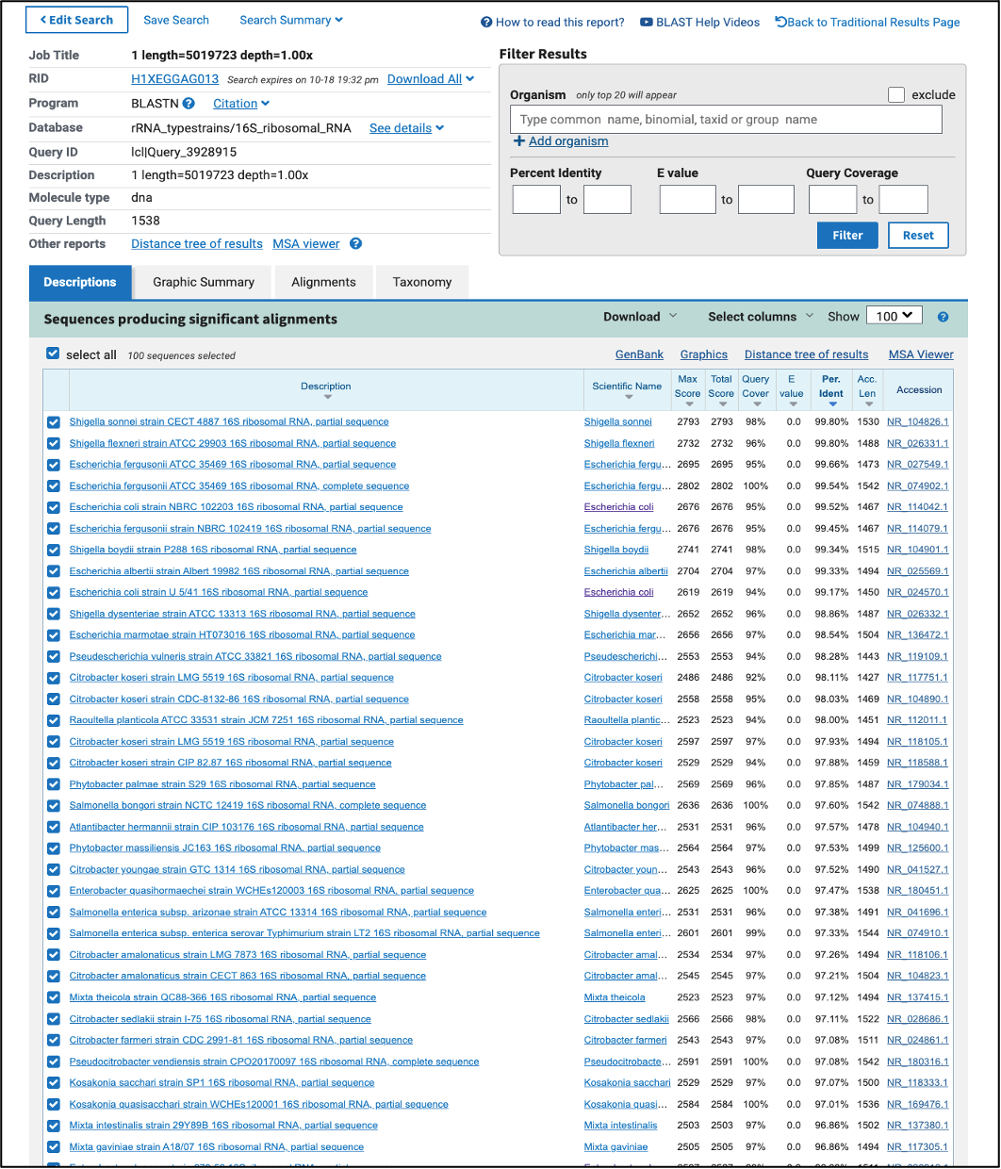
Figure S7: NCBI BLAST Search of bacterial 16S rRNA sequence on NCBI’s rRNA/ITS databases [16S ribosomal RNA sequences (Bacterial and Archaea) option]

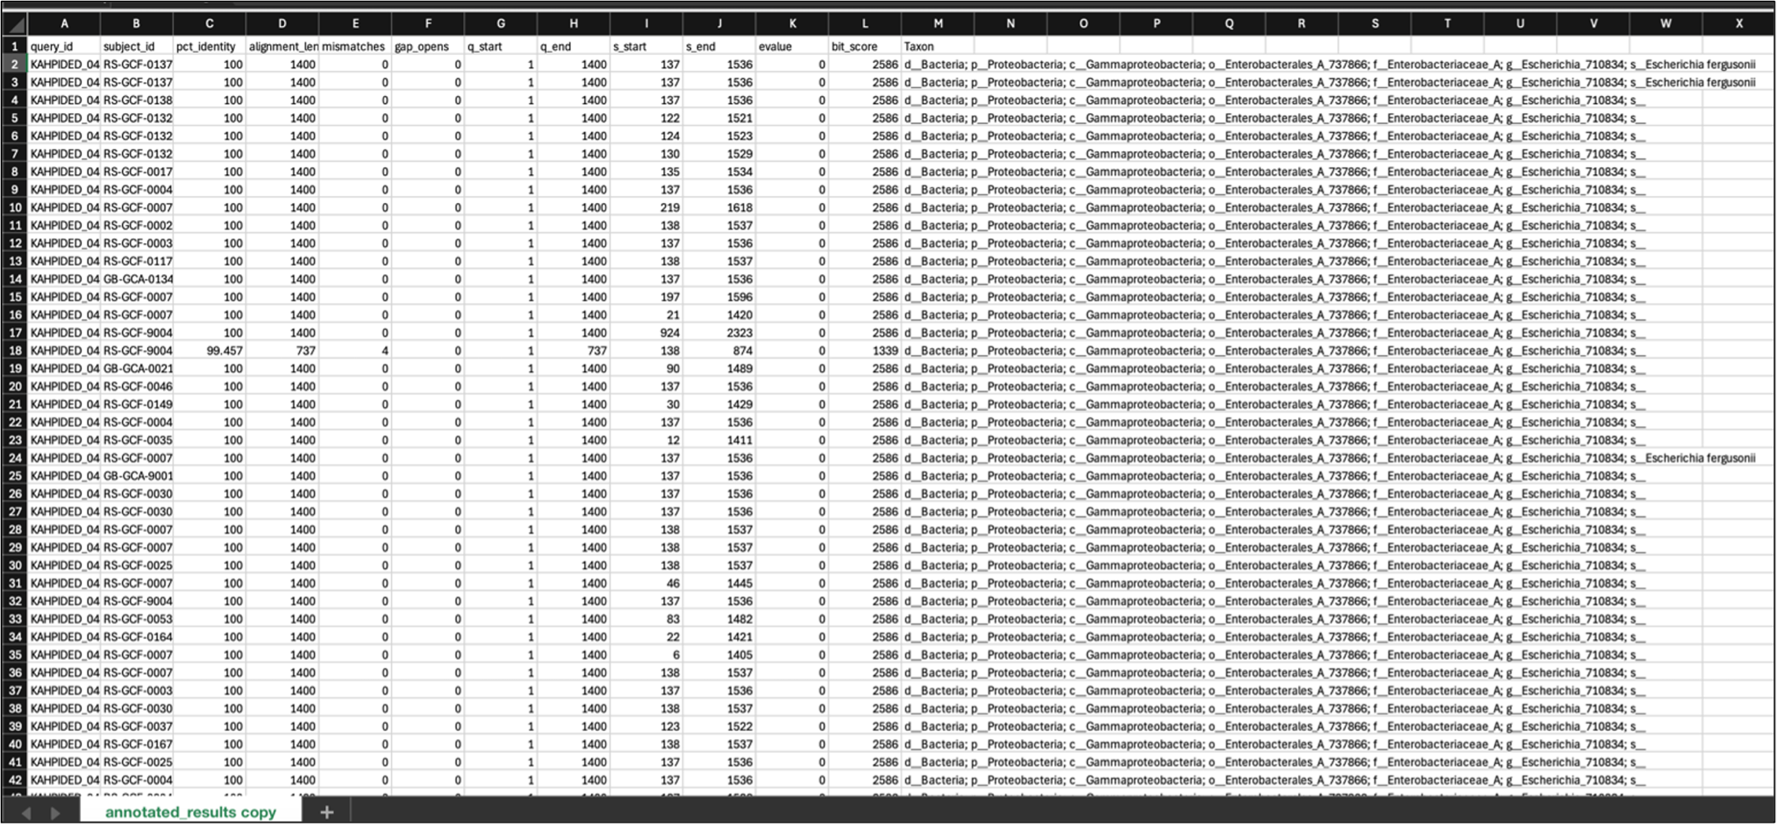
Figure S8: Snapshot of Greengenes2 BLAST result output
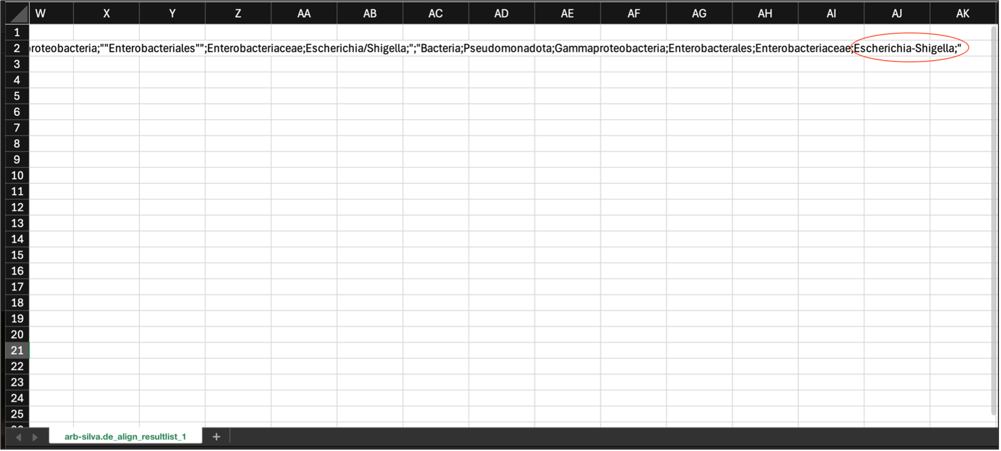
Figure S9: Snapshot of SILVA BLAST result output

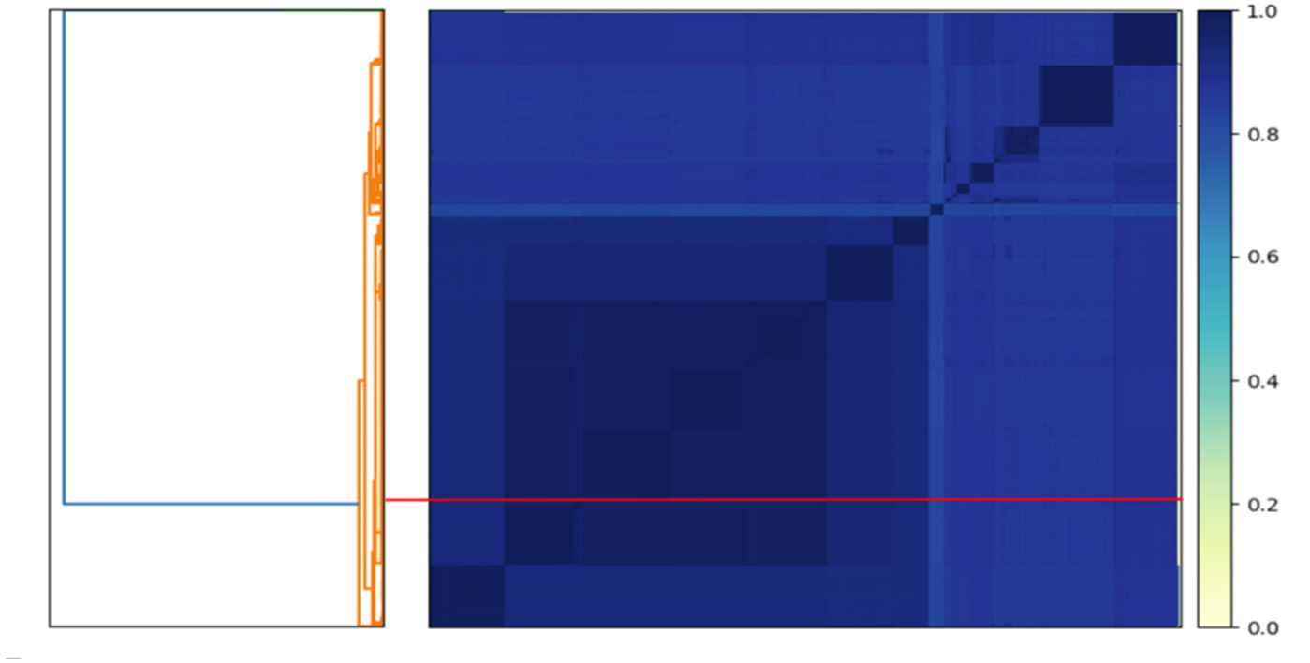
Figure S10: Sourmash of 1,595 genomes showing the average nucleotide identity (ANI). The red line on both plots indicates the placement of the isolate

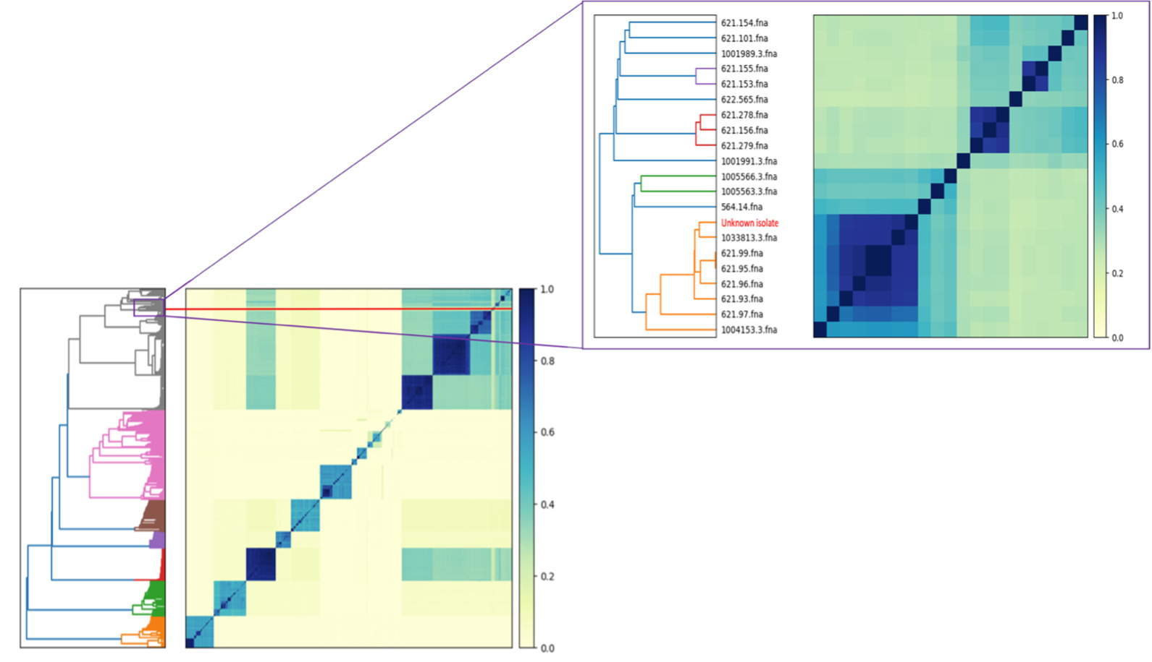

Figure S11: Sourmash of 1,595 genomes showing the Jaccard index. The darker the colour, the more genetically similar the isolates are. The red line in the plot indicates the placement of the isolate (labelled as ''unknown isolate''), which is clustered among multiple Shigella and Escherichia spp. Note: Genome IDs beginning with 621 belong to the genus Shigella, while the others belong to Escherichia.

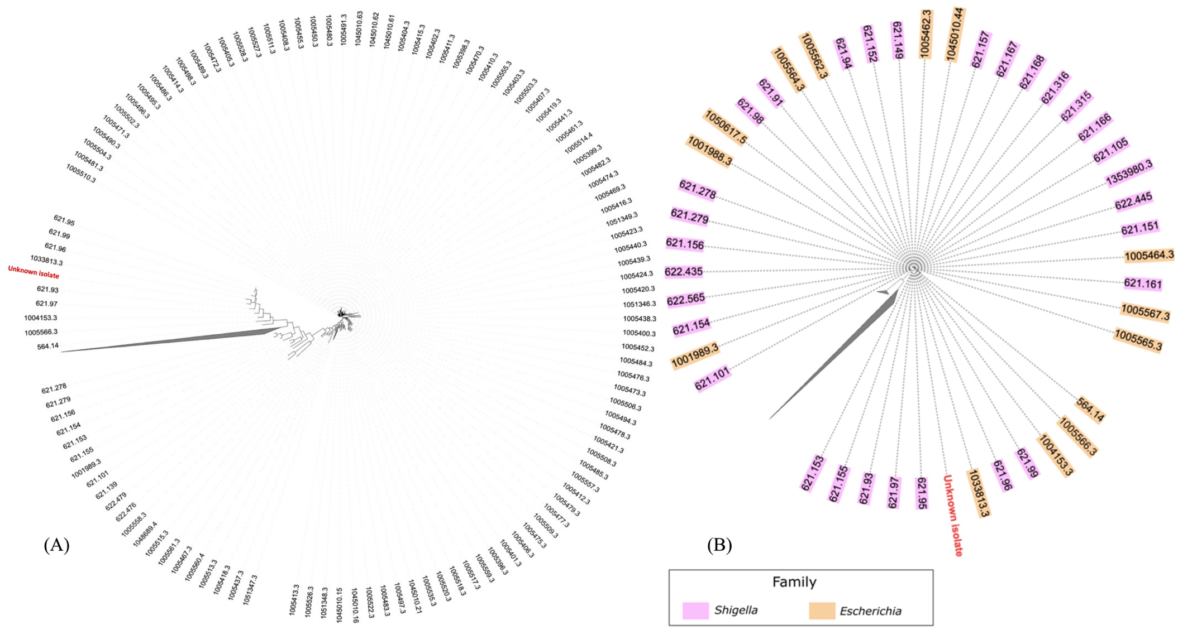

Figure S12: (A) Phylogeny of the isolate using FastTree (B) Reduced representation of 1,595 isolates (clades have been removed to be able to visualise the isolate and surrounding genomes).

