Molecular pathology and synaptic loss in primary tauopathies: [¹⁸F]AV-1451 and [¹¹C]UCB-J PET study

Supplementary Figures = 3
Supplementary Figure 1. The association between synaptic density ([¹¹C]UCB-J) and molecular pathology ([¹⁸F]AV-1451) is a function of disease severity. A) Scatter plot [¹¹C]UCB-J and [¹⁸F]AV-145 partial volume uncorrected BP_{ND} from 23 patients with PSP and 12 patients with amyloid-negative corticobasal syndrome . Each grey line in A represents a patient’s data across 73 regions of interest (excluding those with previously reported off-target binding, i.e. basal ganglia and substantia nigra); the black line illustrates the overall model fit from equation 2. B) The slope for each individual (i.e. each grey line in A) is negatively correlated with disease severity (as measured with the PSP rating scale); R= -0.6, p<0.005.

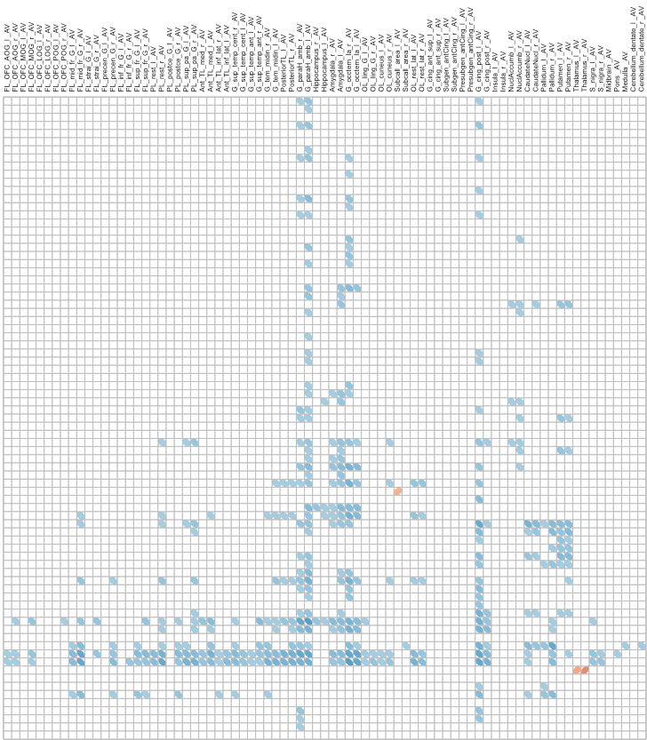
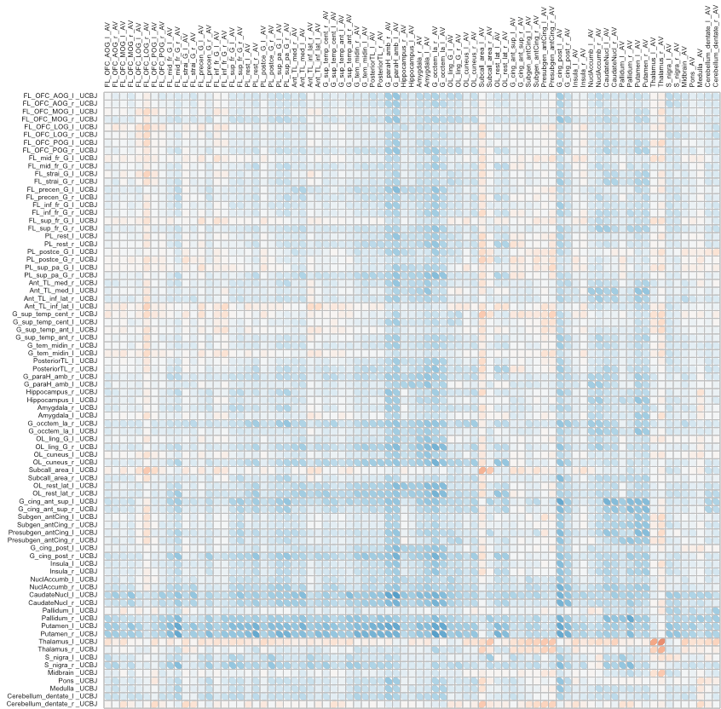
Frontal
Parietal
Temporal
Occipital
BG
BS
Cingulate
Frontal
Parietal
Temporal
Occipital
BG
BS
Cingulate
Frontal
Parietal
Cingulate
Temporal
Occipital
BS
BG
Frontal
Parietal
Temporal
Occipital
BG
BS
Cingulate
Frontal
Parietal
Temporal
Occipital
BG
BS
Cingulate
Frontal
Parietal
Cingulate
Temporal
Occipital
BS
BG
[¹⁸F]AV-1451
[¹⁸F]AV-1451
[¹¹C]UCB-J
Supplementary figure 2. Cortical molecular pathology is negatively correlated with subcortical synaptic density. Correlation between [¹⁸F]AV-1451 BP_{ND} in a source region (horizontal axis) and [¹¹C]UCB-J BP_{ND} in a target region (vertical axis), across 79 regions of interest in patients, using partial volume uncorrected binding potentials. The black box in the lower left quadrant focuses on cortical [¹⁸F]AV-1451 BP_{ND} and subcortical [¹¹C]UCB-J BP_{ND}. Significant correlations (at p<0.05, uncorrected for multiple comparisons) are outlined in the matrix on the right.
Abbreviation: l: left, r:right, FL: Frontal Lobe, OFC: Orbitofrontal Cortex, AOG: Anterior Orbital Gyrus, MOG: Middle Orbital Gyrus, LOG: Lateral Orbital Gyrus, POG: Posterior Orbital Gyrus, mid_fr_G: Middle Frontal Gyrus, strai_G: Straight Gyrus, precen_G: Precentral Gyrus, inf_fr_G: Inferior Frontal Gyrus, sup_fr_G: Superior Frontal Gyrus; PL: Parietal Lobe, postce_G: Postcentral Gyrus, sup_pa_G: Superior Parietal Gyrus: TL: Temporal Lobe, Ant_med: Anterior Medial, Ant_inf_lat: Anterior Inferiolateral, "G_sup_temp_cent: Superior Temporal Gyrus – superior part, G_sup_temp_ant: Superior Temporal Gyrus- Anterior part, G_tem_midin_r: Middle and Inferior Temporal Gyrus, G_paraH_amb: Parahippocampal and ambient gyri, G_occtem_la: Occipitotemporal Gyrus – Lateral Part (Fusiform Gyrus), OL_ling_G_l: Lingual Gyrus, Subcall_area: Subcallosal Area, OL_rest_lat: Latera Remainder of Occipital Lobe, G_cing_ant_sup: Cingulate Gyrus Anterior Part, Subgen_antCing: Subgenual Frontal Lobe, Presubgen_antCing: Presubgenual Frontal Lobe, G_cing_post: Cingulate Gyrus – posterior part; BG: Basal Ganglia; BS: Brainstem

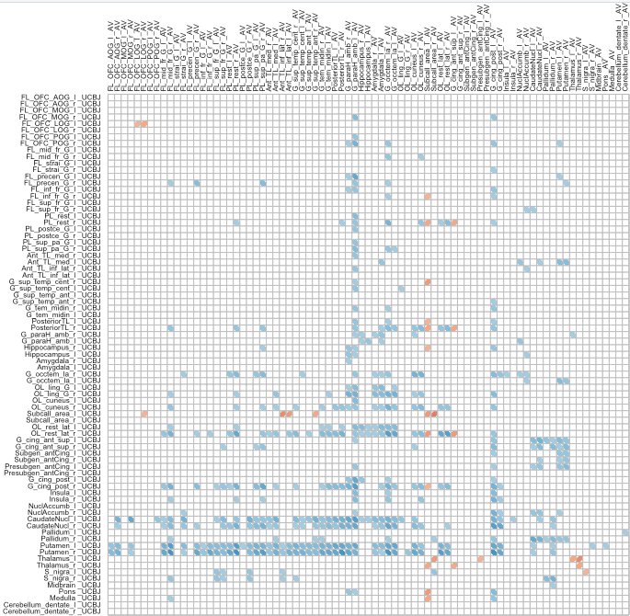
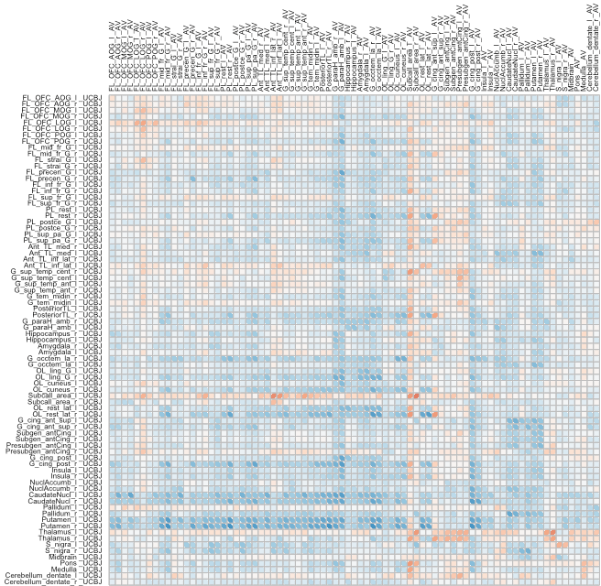
Frontal
Parietal
Temporal
Occipital
BG
BS
Cingulate
Frontal
Parietal
Temporal
Occipital
BG
BS
Cingulate
Frontal
Parietal
Cingulate
Temporal
Occipital
BS
BG
Frontal
Parietal
Temporal
Occipital
BG
BS
Cingulate
Frontal
Parietal
Temporal
Occipital
BG
BS
Cingulate
Frontal
Parietal
Cingulate
Temporal
Occipital
BS
BG
[¹⁸F]AV-1451
[¹⁸F]AV-1451
[¹¹C]UCB-J
Supplementary figure 3. Cortical molecular pathology is negatively correlated with subcortical synaptic density. Correlation between [¹⁸F]AV-1451 BP_{ND} in a source region (horizontal axis) and [¹¹C]UCB-J BP_{ND} in a target region (vertical axis), across 79 regions of interest in patients, using GTM partial volume corrected binding potentials. The black box in the lower left quadrant focuses on cortical [¹⁸F]AV-1451 BP_{ND} and subcortical [¹¹C]UCB-J BP_{ND}. Significant correlations (at p<0.05, uncorrected for multiple comparisons) are outlined in the matrix on the right.
Abbreviation: l: left, r:right, FL: Frontal Lobe, OFC: Orbitofrontal Cortex, AOG: Anterior Orbital Gyrus, MOG: Middle Orbital Gyrus, LOG: Lateral Orbital Gyrus, POG: Posterior Orbital Gyrus, mid_fr_G: Middle Frontal Gyrus, strai_G: Straight Gyrus, precen_G: Precentral Gyrus, inf_fr_G: Inferior Frontal Gyrus, sup_fr_G: Superior Frontal Gyrus; PL: Parietal Lobe, postce_G: Postcentral Gyrus, sup_pa_G: Superior Parietal Gyrus: TL: Temporal Lobe, Ant_med: Anterior Medial, Ant_inf_lat: Anterior Inferiolateral, "G_sup_temp_cent: Superior Temporal Gyrus – superior part, G_sup_temp_ant: Superior Temporal Gyrus- Anterior part, G_tem_midin_r: Middle and Inferior Temporal Gyrus, G_paraH_amb: Parahippocampal and ambient gyri, G_occtem_la: Occipitotemporal Gyrus – Lateral Part (Fusiform Gyrus), OL_ling_G_l: Lingual Gyrus, Subcall_area: Subcallosal Area, OL_rest_lat: Latera Remainder of Occipital Lobe, G_cing_ant_sup: Cingulate Gyrus Anterior Part, Subgen_antCing: Subgenual Frontal Lobe, Presubgen_antCing: Presubgenual Frontal Lobe, G_cing_post: Cingulate Gyrus – posterior part; BG: Basal Ganglia; BS: Brainstem

