DFAQ-CU Inventory
Instructions: Please read each of the following questions and mark the response alternative that best describes your use of cannabis. Note that the term cannabis is being used to refer to marijuana, cannabis concentrates, and cannabis-infused edibles.

1. Have you ever used cannabis?
0 = No
1 = Yes

*If response = 0 then skip to end of questionnaire

2. Which of the following best captures when you last used cannabis?

1 = over a year ago
2 = 9 – 12 months ago
3 = 6 – 9 months ago
4 = 3 – 6 months ago
5 = 1 – 3 months ago
6 = less than 1 month ago
7 = last week
8 = this week
9 = yesterday
10 = today*
11 = I am currently high*

*If response = 10 (today) or 11 (I am currently high) then answer 2b below

2b. How high are you right now?
0 = I am not at all high
1 = I am a little bit high
2 = I am moderately high
3 = I am very high
4 = I am extremely high

3. Which of the following best captures the average frequency you currently use cannabis?

0 = I do not use cannabis
1 = less than once a year
2 = once a year
3 = once every 3-6 months (2-4 times/yr))
4 = once every 2 months (6 times/yr)
5 = once a month (12 times/yr)
6 = 2 – 3 times a month
7 = once a week
8 = twice a week
9 = 3 – 4 times a week
10 = 5 – 6 times a week
11 = once a day
12 = more than once a day

4. Which of the following best captures how long you have been using cannabis at this frequency?

1 = less than 1 month
2 = 1 – 3 months
3 = 3 – 6 months
4 = 6 – 9 months
5 = 9 – 12 months
6 = 1 – 2 years
7 = 2 – 3 years
8 = 3 – 5 years
9 = 5 – 10 years
10 = 10 – 15 years
11 = 15 – 20 years
12 = more than 20 years
5. Before the period of time you indicated above, how frequently did you use cannabis?

0 = I did not use cannabis
1 = less than once a year
2 = once a year
3 = once every 3-6 months (2-4 times/yr.)
4 = once every 2 months (6 times/yr.)
5 = once a month
6 = 2 – 3 times a month
7 = once a week
8 = twice a week
9 = 3 – 4 times a week
10 = 5 – 6 times a week
11 = once a day
12 = more than once a day

6. How many days of the past week did you use cannabis?

0 = 0 days
1 = 1 day
2 = 2 days
3 = 3 days
4 = 4 days
5 = 5 days
6 = 6 days
7 = 7 days

7. Approximately how many days of the past month did you use cannabis? ____________

8. Which of the following best captures the number of times you have used cannabis in your entire life?

1 = 1 – 5 times in my life
2 = 6 – 10 times in my life
3 = 11 – 50 times in my life
4 = 51 –100 times in my life
5 = 101 – 500 times in my life
6 = 501 – 1000 times in my life
7 = 1001 – 2000 times in my life
8 = 2001 – 5000 times in my life
9 = 5001 – 10,000 times in my life
10 = More than 10,000 times in my life

9. Which of the following best captures your pattern of cannabis use throughout the week?
0 = I do not use cannabis at all
1 = I only use cannabis on weekends
2 = I only use cannabis on weekdays
3 = I use cannabis on weekends and weekdays

10. How many hours after waking up do you typically first use cannabis?

0 = I do not use cannabis at all
1 = 12 – 18 hours after waking up
2 = 9 – 12 hours after waking up
3 = 6 – 9 hours after waking up
4 = 3 – 6 hours after waking up
5 = 1 – 3 hours after waking up
6 = within 1 hour of waking up
7 = within ½ hour of waking up
8 = immediately upon waking up

11. How many times a day, on a typical weekday, do you use cannabis? ____________

12. How many times a day, on a typical weekend, do you use cannabis? ____________

13. What is the primary method you use to ingest cannabis?

0 = I do not use cannabis
1 = Joints
2 = Blunts (cigar sized joints)
3 = Hand pipe
4 = Bong (water pipe)
5 = Hookah
6 = Vaporizer (e.g., Volcano, Vape pen)
7 = Edibles
8 = Other _______________________

14. Which of the following other methods to ingest cannabis do you use regularly (at least 25% of the time use you cannabis)? [Mark all that apply]

0 = None
1 = Joints
2 = Blunts (cigar sized joints)
3 = Hand pipe
4 = Bong (water pipe)
5 = Hookah
6 = Vaporizer (e.g., Volcano, Vape pen)
7 = Edibles
8 = Other _______________________

15. What is the primary form of cannabis you use?
0 = None****
A = Marijuana***
B = Concentrates (e.g., Oil, Wax, Shatter, Butane Hash Oil, Dabs)**
C = Edibles*
D = Other____________________

16. What other forms of cannabis do you use regularly (at least 25% of the time you use cannabis)? [Mark all that apply]
0 = None****
A = Marijuana***
B = Concentrates (e.g., Oil, Wax, Shatter, Butane Hash Oil, Dabs)**
C = Edibles*
D = Other____________________

****If response to questions 15 and 16 = 0 (None) then skip to question 29
***If responses to questions 15 or 16 = A (Marijuana) then answer questions 17-21
**If responses to question 15 or 16 = B (Concentrates) then answer questions 22-26
*If responses to question 15 or 16 = C (Edibles) then answer question 27
Note: If you use more than one form of cannabis then complete all of the associated questions listed above.
***If responses to questions 15 or 16 = A (Marijuana) then answer questions 17-21 below.

Please use the image below to refer to various quantities of marijuana. The image is not to scale; the dollar bill is included to help provide size perspective.

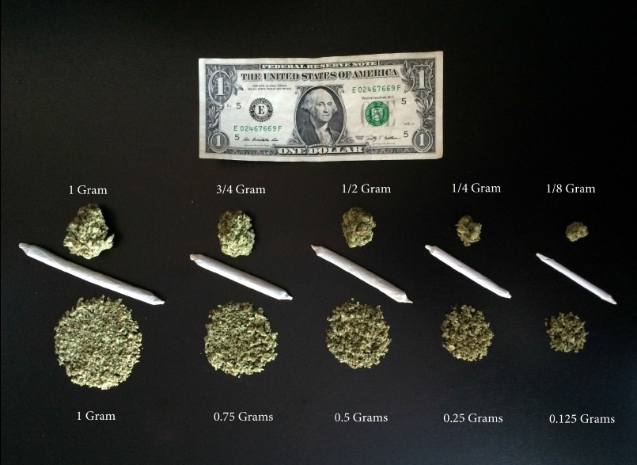

For questions 17 to 19 below, clearly indicate the number of grams of marijuana you use with a number between 0 – 100. Do NOT include other forms of cannabis you may use (such as concentrates). You may use up to 3 decimals to indicate amounts under 1 gram.

Note: 1/8 of a gram = 0.125 grams, ¼ of a gram = 0.25 grams, ½ of a gram = 0.5 grams, ¾ of a gram = 0.75 grams. 1/8 of a ounce = 3.5 grams, ¼ of an ounce = 7 grams, ½ ounce = 14 grams, 1 ounce = 28 grams

17. In a typical session, how much marijuana do you personally use? ______________________

18. On a typical day you use marijuana, how much do you personally use? _________________

19. In a typical week you use marijuana, how much marijuana do you personally use? ________

20. On a typical day you use marijuana, how many sessions do you have? __________________
21. What is the average THC content of the marijuana you typically use? Leave blank if you do not know.

1 = 0 – 4%
2 = 5 – 9%
3 = 10 – 14%
4 = 15 – 19%
5 = 20 – 24%
6 = 25 – 30%
7 = greater than 30%

**If response to questions 15 or 16 = B (Concentrates) then answer questions 22-26 below

22. In a typical session you use cannabis concentrates, how many hits do you personally take? __

23. On a typical day you use cannabis concentrates, how many hits do you personally take? ____

24. How many hits of cannabis concentrates did you personally take yesterday? _____________

25. On a typical day you use cannabis concentrates, how many sessions do you have? _________

26. What is the average THC content of the concentrates you typically use? Leave blank if you do not know.

1 = 0 – 9%
2 = 10 – 19%
3 = 20 – 29%
4 = 30 – 39%
5 = 40 – 49%
6 = 50 – 59%
7 = 60 – 69%
8 = 70 – 79%
9 = 80 – 90%
10 = greater than 90%

**If response to questions 15 or 16 = C (Edibles) then answer question 27 below

27. When you eat edibles how many milligrams of THC do you personally ingest in a typical

session? ___________

28. What is your current age? ___________

29. How many years in total have you used cannabis? ___________

30. How old were you when you FIRST tried cannabis? ___________

31. Has there been any time in your life when you used cannabis regularly (2 or more times per month for 6 months or longer)?
0 = No
1 = Yes*

*If response = 1 (Yes) then answer questions 31b and 31c below

31b. How old were you when you FIRST STARTED using cannabis regularly (2 or more

times/month)? ___________

31c. Has there been any time in your life when you used cannabis on a daily or near daily basis for 6 months or longer?
0 = No
1 = Yes*

*If response = 1 (Yes) then answer question 31ci below

31ci. How old were you when you FIRST STARTED using cannabis on a daily or

near daily basis? ___________

32. Which of the following best captures the average frequency that you used cannabis before the age of 16?

0 = more than once a day
1 = once a day
2 = 5 – 6 times a week
3 = 3 – 4 times a week
4 = twice a week
5 = once a week
6 = 2 – 3 times a month
7 = once a month
8 = once every 2 months (6 times/yr.)
9 = once every 3-6 months (2-4 times/yr.)
10 = once a year
11 = less than once a year
12 = never

33. Do you have a physician’s recommendation to use cannabis for medicinal purposes?
0 = No
1 = Yes*
2 = Yes, but I use it for both medicinal and recreational purposes*

*If response = 1 or 2 (Yes) then answer questions 33b and 33c

33b. Which medical condition(s) do you use cannabis for?

________________________________________________________________________

33c. What percentage of the time do you use cannabis for recreational (rather than

medicinal) purposes? ________________

DFAQ-CU Scoring

Daily Sessions Items: 20, 25

Frequency Items: 2, 3, 6, 7, 8, 9, 10, 11, 12

Age of Onset Items: 30, 31b, 31ci, 32

Marijuana Quantity Items: 17, 18, 19

Concentrate Quantity Items: 22, 23, 24,
Edibles Quantity Item: 27
Note: Standardize (z-transform) scores prior to calculating the mean of each of the 6 factors (daily sessions, frequency, age of onset, marijuana quantity, concentrate quantity, edibles quantity).

Screening/Characterization Items: 1, 2b, 4, 5, 13, 14, 15, 16, 21, 26, 28, 29, 31, 31c, 33, 33b, 33c

Contact us at: DFAQCU@gmail.com if you would like a Qualtrics version of the DFAQ-CU shared to your Qualtrics account.

