Supplementary Information

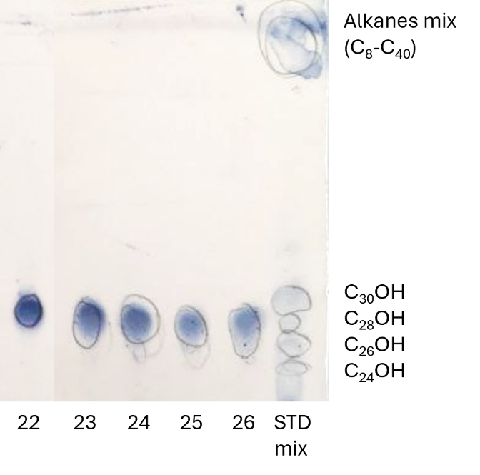
Figure S1: TLC of fractions 22-26, together with the standard mixture of policosanols and alkanes.

Figure S2: Cytotoxic effects of H₂O₂ on HaCat cell line. Cells were exposed to the indicated concentrations of H₂O₂ for 30 min. Cell viability was measured by CCk-8, and values are expressed as the mean ± SD of three independent done in quadruplicate. Significance one-way ANOVA with Tuckey’s multiple comparison test (*** p < 0.001 and ** p < 0.01 vs Ctrl).

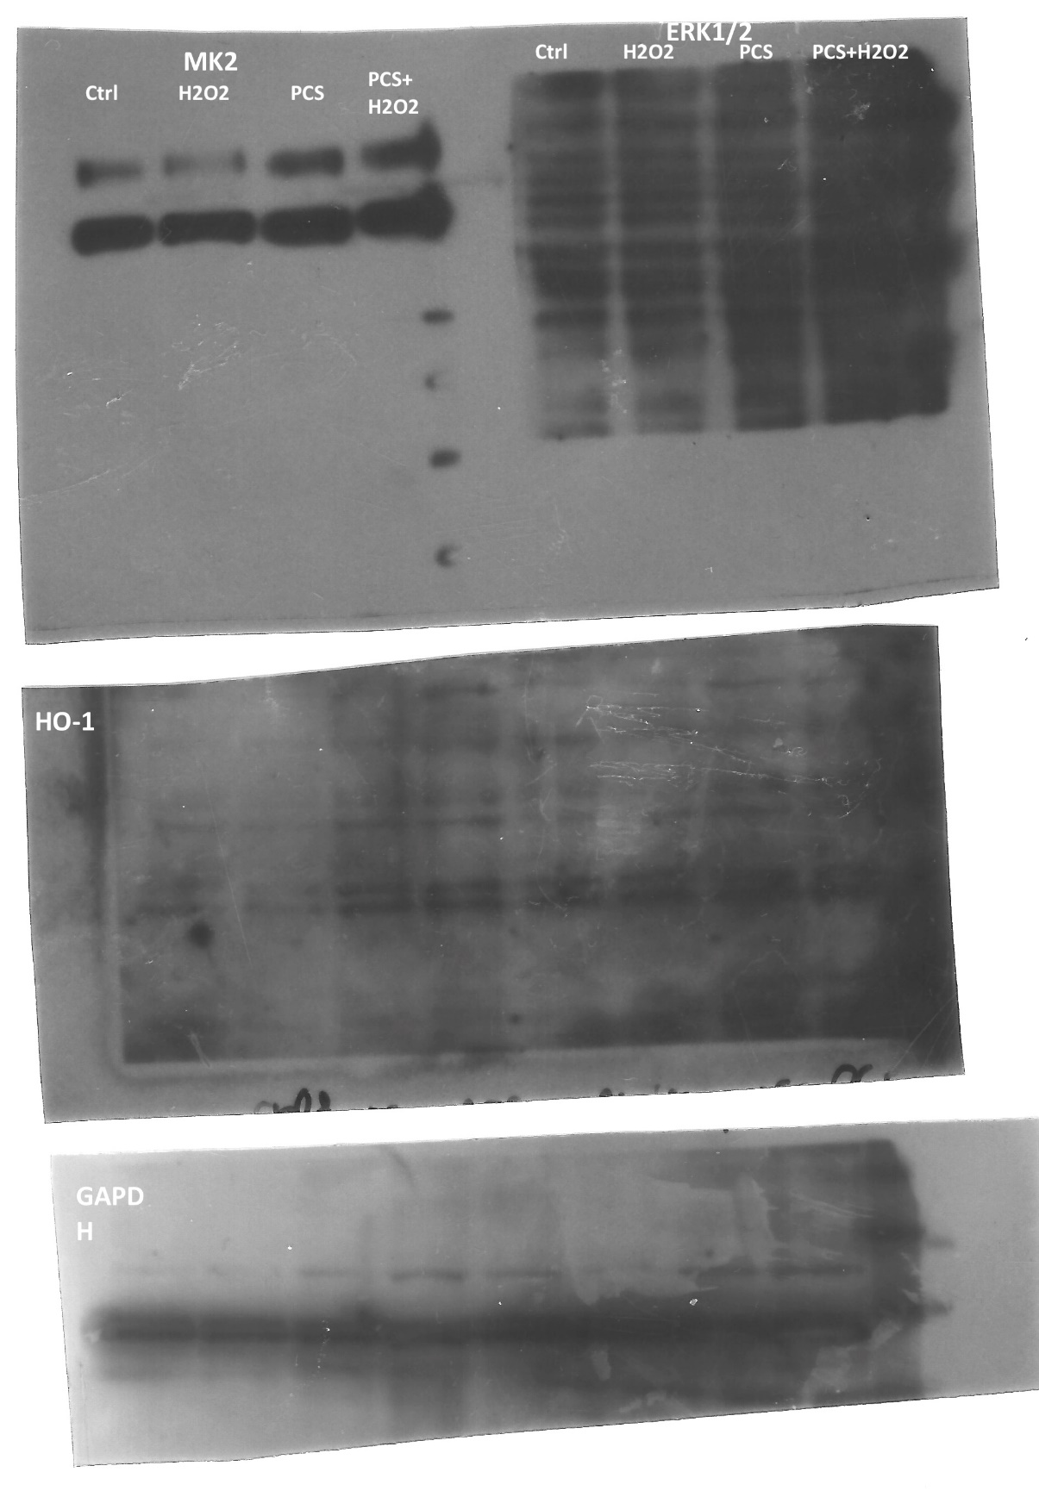
Figure S3: Uncropped western blot of MK2 protein (49 kDa) and HO-1 (30 kDa) of HaCaT cell lysate treated with 350 μM H₂O₂ for 30 min, PCs at 100 μg/mL for 12 h alone and PCs at 100 μg/mL for 12 h before the treatment with of 350 μM H₂O₂ for 30 min.

Figure S4: Vitality of cells after 18 h pre-treatment with PCs from hemp wax and Tween20 vs. untreated cells.

