Supplementary Material

The effectiveness of psychological interventions for cannabis use in adults: A systematic review and meta-analysis

Table S1. Summary of measures reported by meta-analyses on the effectiveness of psychological interventions for cannabis use.
Table S2. Electronic search strategy for the systematic review conducted.
Table S3. Details of the retrieved studies included.
Table S4. PRISMA Checklist.

Table S1. Summary of measures reported by meta-analyses on the effectiveness of psychological interventions for cannabis use.
Studies | Measures reported by meta-analyses
Halicka et al., 2025 | - Point abstinence and continuous abstinence  - Intensity of withdrawal and/or craving  - Quantity of use  - Frequency of use
Tanner-Smith et al., 2021 | - Frequency  - Screening for hazardous, harmful and dependent use of cannabis
Calomarde-Gómez et al., 2021 | - Abstinence  - Quantity of use  - Frequency of use  - Cannabis use disorder severity
Imtiaz et al., 2020 | - Abstinence  - Frequency
Gates et al., 2016 | - Abstinence  - Cannabis-related problems  - Frequency
White et al., 2015 | - Abstinence  - Frequency
Magill et al., 2009 | - The outcome indicator for effect size calculation was selected in the following order: (1) biological measures, (2) measures of use frequency, and (3) sample proportions

Table S2. Electronic search strategy used for the present systematic review and meta-analysis
Database; Search | Search terms
PubMed;  k=3 091 | (Cannabis[Title/Abstract] OR marijuana[Title/Abstract] OR THC[Title/Abstract] OR tetrahydrocannabinol[Title/Abstract] OR hashish[Title/Abstract]) AND (“Psychosocial treatment”[Title/Abstract] OR “Psychological treatment”[Title/Abstract] OR Psychotherapy[Title/Abstract] OR Therapy[Title/Abstract] OR “Contingency management”[Title/Abstract] OR “case management”[Title/Abstract] OR “Cognitive behavioral therapy”[Title/Abstract] OR CBT[Title/Abstract] OR “Cognitive behaviour therapy”[Title/Abstract] OR “Relapse prevention”[Title/Abstract] OR “Dialectical behavior therapy”[Title/Abstract] OR “Group drug counseling”[Title/Abstract] OR “Motivational interviewing”[Title/Abstract] OR “Motivational enhancement interviewing”[Title/Abstract] OR “Motivational enhancement therapy”[Title/Abstract] OR “12-step facilitation”[Title/Abstract] OR “Social support”[Title/Abstract] OR “Mindfulness-based meditation”[Title/Abstract] OR Psychoeducation[Title/Abstract] OR “Therapeutic community”[Title/Abstract] OR “Skills training”[Title/Abstract] OR “abstinence reinforcement therapy”[Title/Abstract] OR “Brief intervention”[Title/Abstract] OR “Computer-assisted therapy”[Title/Abstract] OR “Family therapy”[Title/Abstract])
PsycINFO;  k=2 758 | (Abstract: Cannabis OR Abstract: marijuana OR Abstract: THC OR Abstract: tetrahydrocannabinol OR Abstract: hashish) AND (Abstract: Psychosocial treatment OR Abstract: Psychological treatment OR Abstract: Psychotherapy OR Abstract: Therapy OR Abstract: Contingency management OR Abstract: case management OR Abstract: Cognitive behavioral therapy OR Abstract: CBT OR Abstract: Cognitive behaviour therapy OR Abstract: Relapse prevention OR Abstract: Dialectical behavior therapy OR Abstract: Group drug counseling OR Abstract: Motivational interviewing OR Abstract: Motivational enhancement interviewing OR Abstract: Motivational enhancement therapy OR Abstract: 12-step facilitation OR Abstract: Social support OR Abstract: Mindfulness-based meditation OR Abstract: Psychoeducation OR Abstract: Therapeutic community OR Abstract: Skills training OR Abstract: abstinence reinforcement therapy OR Abstract: Brief intervention OR Abstract: Computer-assisted therapy OR Abstract: Family therapy)
Web of Science;  k=4 977 | (AB=(Cannabis OR marijuana OR THC OR tetrahydrocannabinol OR hashish)) AND (AB=(Psychosocial treatment OR Psychological treatment OR Psychotherapy OR Therapy OR Contingency management OR case management OR Cognitive behavioral therapy OR CBT OR Cognitive behaviour therapy OR Relapse prevention OR Dialectical behavior therapy OR Group drug counseling OR Motivational interviewing OR Motivational enhancement interviewing/ Motivational enhancement therapy OR 12-step facilitation OR Social support OR Mindfulness-based meditation OR Psychoeducation OR Therapeutic community OR Skills training OR abstinence reinforcement therapy OR Brief intervention OR Computer-assisted therapy OR Family therapy))
^{Note.} A search in Google Scholar with the exact keywords and cross-referencing enabled the finding of an additional 63 articles.

Table S3. Details of the retrieved studies.
Authors, years | Design of studies  Studies countries | Description of sample | Comparisons groups | Results | Risk of bias
Babor et al., 2004 | RCT  (no blind assessors)  United States of America | Criteria related to cannabis  Diagnosis of current marijuana dependence, and used marijuana on at least 40 of the 90 days prior to the study  Criteria related to other substances  Excluded diagnosis of dependence on another drug or alcohol | Intervention group  MET + CBT + case management (133)  9 sessions  Control group  Brief MET (128)  2 sessions | Cannabis-related problems  Marijuana Problems Scale  1-month: SMD=-0.52, CI=-0.77; -0.27  6-month: SMD=-0.42, CI=-0.67, -0.17  Severity of medical problem  Addiction Severity Index medical subscale  1-month: SMD=-0.21, CI=-0.46; 0.03  6-month: SMD=-0.03, CI=-0.28; 0.22  Severity of employment problem  Addiction Severity Index employment subscale  1-month: SMD=-0.10, CI=-0.34; 0.15  6-month: SMD=0.05, CI=-0.20; 0.30  Severity of psychiatric problem  Addiction Severity Index psychiatric subscale  1-month: SMD=-0.11, CI=-0.35, 0.14  6-month: SMD=-0.26, CI=-0.51; 0.00  Depression  Beck Depression Inventory  1-month: SMD=-0.32, CI-0.57; -0.08  6-month: SMD=-0.32, CI-0.57; -0.07  Anxiety  State–Trait Anxiety Inventory state portion  1-month: SMD=-0.38, CI=-0.63; -0.14  6-month: SMD=-0.44, CI=-0.69; -0.18  Dependence symptoms  Structured Clinical Interview for DSM-IV  1-month: SMD=-0.53, CI=-0.78, -0.29  6-month: SMD=-0.36, CI=-0.62, -0.11  Quantity  TLFB  1-month: SMD=-0.30, CI=-0.54; -0.06  6-month: SMD=-0.05, CI=-0.30, 0.20  Frequency  TLFB  1-month: SMD=-0.52, CI=-0.77; -0.28  6-month: SMD=-0.43, CI=-0.68; -0.17  12-month: SMD=-0.22, CI=-0.47; 0.03  Abstinence  TLFB  1-month: OR=3.03, CI=1.45; 6.33  6-month: OR=1.70, CI=0.80; 3.63  12-month: OR=2.03, CI=1.03; 4.01 | 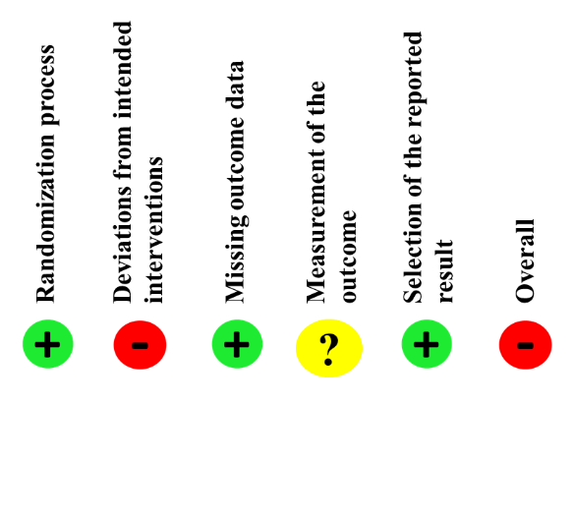
Babor et al., 2004 | RCT  (no blind assessors)  United States of America |  | Intervention group  MET + CBT + case management (133)  9 sessions  Control group  delayed treatment (137)
  Cannabis-related problems
  Marijuana Problems Scale
  1-month: SMD=-0.40, CI=-0.64; -0.16
  Severity of medical problem
  Addiction Severity Index medical subscale
  1-month: SMD=0.25, CI=0.01; 0.49
  Severity of employment problem
  Addiction Severity Index employment subscale
  1-month: SMD=0.00, CI-0.24; 0.24
  Severity of psychiatric problem
  Addiction Severity Index psychiatric subscale
  1-month: SMD=0.00, -0.24; 0.24
  Depression
  Beck Depression Inventory
  1-month: SMD=-0.02, CI=-0.26; 0.22
  Anxiety
  State–Trait Anxiety Inventory state portion
  1-month: SMD=-0.20, CI=-0.44; 0,04
  Dependence symptoms
  Structured Clinical Interview for DSM-IV
  1-month: SMD=-0.88, CI=-1.13; -0.63
  Abstinence
  TLFB
  1-month: OR=7.76, CI=2.91; 20.72
  Quantity
  TLFB
  1-month: SMD=-0.56, CI=-0.80; -0.32
  Frequency
  TLFB
  1-month: SMD=-1.13, CI=-1.38; -0.87

Authors, years | Design of studies  Studies countries | Description of sample | Comparisons groups | Results | Risk of bias
Budney et al., 2000 | RCT  (no blind assessors)  United States of America | Criteria related to cannabis  diagnosis of current marijuana  dependence, and have used marijuana in the past 30 days.  Criteria related to other substances  Excluded current dependence on alcohol or any other drug except nicotine | Intervention group  MI + CBT (20)  14 sessions  Control group  MI (20)  14 sessions | Cannabis-related problems  Drug Abuse Screening Test adapted for use with marijuana abusers  Post: SMD=0.10, CI-0.52; 0.72  Severity of medical problem  Addiction Severity Index medical subscale  Post: SMD=0.00, CI=-0.62; 0.62  Severity of employment problem  Addiction Severity Index employment subscale  Post: SMD=0.00, CI=-0.62; 0.62  Severity of family/social relations problems  Addiction Severity Index family/social relations subscales  Post: SMD=-0.20, CI=-0.82; 0.42  Severity of psychiatric problem  Addiction Severity Index psychiatric subscale  Post: SMD=-0.77, CI=-1.42; -0.13  Psychiatric distress  Brief symptom inventory (global symptom index)  Post: SMD=-0.25, CI=-0.87; 0.37  Readiness to change cannabis  University of Rhode Island Change Assessment  Post: SMD=0.79, CI=0.15; 1.44 | 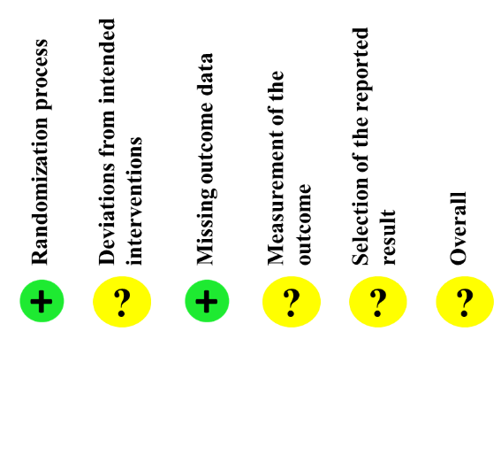
Budney et al., 2000 | RCT  (no blind assessors)  United States of America |  | Intervention group  MI + CBT + voucher-based incentives (20)  14 sessions  Control group  MI + CBT (20)  14 sessions | Cannabis-related problems  Drug Abuse Screening Test adapted for use with marijuana abusers  Post: SMD=0.46, CI=-0.17; 1.09  Severity of medical problem  Addiction Severity Index medical subscale  Post: SMD=0.06, CI=-0.56; 0.68  Severity of employment problem  Addiction Severity Index employment subscale  Post: SMD=0.00, CI=-0.62; 0.62  Severity of family/social relations problems  Addiction Severity Index family/social relations subscales  Post: SMD=-0.09, CI=-0.71; 0.53  Severity of psychiatric problem  Addiction Severity Index  Post: SMD=0.05, CI=-0.57; 0.67  Psychiatric distress  brief symptom inventory (global symptom index)  Post: SMD=0.29, CI=-0.33; 0.92  Readiness to change cannabis  University of Rhode Island Change Assessment  Post: SMD=-0.04, CI=-0.66; 0.58
Budney et al., 2000 | RCT  (no blind assessors)  United States of America |  | Intervention group  MI + CBT + voucher-based incentives (20)  14 sessions  Control group  MI (20)  14 sessions | Cannabis-related problems  Drug Abuse Screening Test adapted for use with marijuana abusers  Post: SMD=0.52, CI=-0.11; 1.15  Severity of medical problem  Addiction Severity Index medical subscale  Post: SMD=0.06, CI=-0.56; 0.68  Severity of employment problem  Addiction Severity Index employment subscale  Post: SMD=0.00, CI=-0.62;0.62  Severity of family/social relations problems  Addiction Severity Index family/social relations subscales  Post: SMD=-0.28, CI=-0.90; 0.34  Severity of psychiatric problem  Addiction Severity Index psychiatric subscale  Post: SMD=-0.66, CI=-1.29; -0.02  Psychiatric distress  brief symptom inventory (global symptom index)  Post: SMD=0.01, CI=-0.61; 0.63  Readiness to change cannabis  University of Rhode Island Change Assessment  Post: SMD=0.69, CI=0.05; 1.33

Authors, years | Design of studies  Studies countries | Description of sample | Comparisons groups | Results | Risk of bias
Budney et al., 2006 | RCT  (no blind assessors)  United States of America | Criteria related to cannabis  Diagnosis of current cannabis dependence, and have used marijuana in the past 30 days  Criteria related to other substances  Excluded current dependence on alcohol or any other drug except nicotine | Intervention group  Abstinence-based vouchers (30)  14 sessions  Control group  CBT (30)  14 sessions | Cannabis-related problems  Marijuana Problem Scale  Post: SMD=-0.21, CI=-0.72; 0.29  Quantity  TLFB  Post: SMD=0.47, CI=-0.04; 0.98  Frequency  TLFB  Post: SMD=0.28, CI=-0.23; 0.79  3-month: SMD=0.31, CI=-0.20; 0.82  6-month: SMD=0.32, CI=-0.19; 0.83  9-month: SMD=0.18, CI=-0.33; 0.69  12-month: SMD=-0.01, CI=-0.52; 0.49  Abstinence  Urine test  Post: OR=1.56, CI=0.53; 4.53  3-month: OR=0.80, CI=0.22; 2.07  6-month: OR=1.98, CI=0.51; 7.63  9-month: OR=1.30, CI=0.31; 5.40  12-month: OR=0.66, CI=0.18; 2.36 | 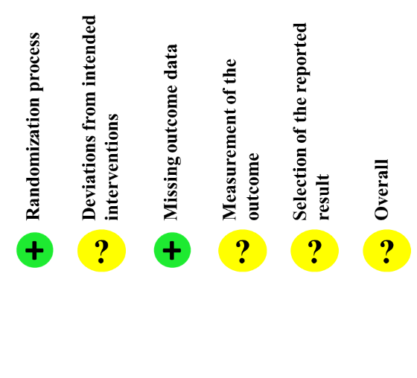
Budney et al., 2006 | RCT  (no blind assessors)  United States of America |  | Intervention group  CBT + Abstinence-based vouchers (30)  14 sessions  Control group  CBT (30)  14 sessions | Cannabis-related problems  Marijuana Problem Scale  Post: SMD=-0.31, CI=-0.82; 0.20  Frequency  TLFB  Post: SMD=0.12, CI=-0.39; 0.63  3-month: SMD=-0.07, CI=-0.58; 0.43  6-month: SMD=-0.16, CI=-0.67; 0.35  9-month: SMD=-0.36, CI=-0.87; 0.15  12-month: SMD=-0.39, CI=-0.90; 0.12  Quantity  TLFB  Post: SMD=0.45, CI=-0.06; 0.96  Abstinence  Urine test  Post: OR=1.78, CI=0.62; 5.17  3-month: OR=3.06, CI=0.97; 9.66  6-month: OR=3.25, CI=0.89; 11.90  9-month: OR=3.25, CI=0.89; 11.90  12-month: OR=1.90, CI=0.62; 5.86
Budney et al., 2006 | RCT  (no blind assessors)  United States of America |  | Intervention group  CBT + Abstinence-based vouchers (30)  14 sessions  Control group  Abstinence-based vouchers (30)  14 sessions | Cannabis-related problems  Marijuana Problem Scale  Post: SMD=-0.10, CI=-0.61; 0.40  Quantity  TLFB  Post: SMD=0.04, CI=-0.47; 0.54  Frequency  TLFB  Post: SMD=-0.17, CI=-0.67; 0.34  3-month: SMD=-0.40, CI=-0.91; 0.11  6-month: SMD=-0.49, CI=-1.01; 0.02  9-month: SMD=-0.56, CI=-1.08; -0.05  12-month: SMD=-0.40, CI=-0.91; 0.11  Abstinence  Urine test  Post: OR=1.15, CI=0.41; 3.20  3-month: OR=3.82, CI=1.15; 12.71  6-month: OR=1.64, CI=0.53; 5.12  9-month: OR=2.50, CI=0.74; 8.50  12-month: OR=2.89, CI=0.86; 9.74
Budney et al., 2006 | RCT  (no blind assessors)  United States of America |  | Intervention group  CBT (30)  14 sessions  Control group  Abstinence-based vouchers (30)  14 sessions | Cannabis-related problems  Marijuana Problem Scale  Post: SMD=0.21, CI=-0.29; 0.72  Quantity  TLFB  Post: SMD=-0.47, CI=-0.98; 0.04  Frequency  TLFB  Post: SMD=-0.28, CI=-0.79; 0.,23  3-month: SMD=-0.31, CI=-0.82; 0.20  6-month: SMD=-0.32, CI=-0.83; 0.19  9-month: SMD=-0.18, CI=-0.69; 0.33  12-month: SMD=0.01, CI=-0.49; 0.52  Abstinence  Urine test  Post: OR=0.64, CI=0.22; 1.87  3-month: OR=1.25, CI=0.34; 4.64  6-month: OR=0.51, CI=0.13; 1.95  9-month: OR=0.77, CI=0.19; 3.20  12-month: OR=1.52, CI=0.42, CI=5.47

Authors, years | Design of studies  Studies countries | Description of sample | Comparisons groups |  | Results | Risk of bias
Carroll et al., 2006 | RT  (no blind assessors)  United States of America | Criteria related to cannabis  Current marijuana dependence or submit  a marijuana-positive urine specimen at baseline  Criteria related to other substances  Excluded severe substance  dependence that required inpatient treatment and detoxification and current physical dependence on alcohol or opioids | Intervention group  Individual drug counseling + CM (24)  8 sessions  Control group  Individual drug counseling (30)  8 sessions |  | Abstinence  TLFB  3-month: OR=2.38, CI=0.55; 10.20  6-month: OR=1.00, CI=0.32; 3.12  Urine test  3-month: OR=1.42, CI=0.37; 5.47  6-month: OR=2.10, CI=0.70; 6.26
Carroll et al., 2006 | RT  (no blind assessors)  United States of America |  | Intervention group MET + CBT (27)  8 sessions  Control group  Individual drug counseling + CM (24)  8 sessions |  | Abstinence  TLFB  3-month: OR=1.00, CI=0.26; 3.80  6-month: OR=2.50, CI=0.80; 7.81  Urine test  3-month: OR=0.80, CI=0.20; 3.13  6-month: OR=0.77, CI=0.25; 2.33
Carroll et al., 2006 | RT  (no blind assessors)  United States of America |  | Intervention group MET + CBT (27)  8 sessions  Control group  Individual drug counseling (30)  8 sessions |  | Abstinence  TLFB  3-month: OR=2.38, CI=0.58; 9.72  6-month: OR=2.50, CI=0.85; 7.31  Urine test  3-month: OR=1.13, CI=0.30; 4.27  6-month: OR=1.62, CI=0.57; 4.62
Carroll et al., 2006 | RT  (no blind assessors)  United States of America |  | Intervention group MET + CBT + CM (27)  8 sessions  Control group  MET + CBT (27)  8 sessions |  | Abstinence  TLFB  3-month: OR=1.38, CI=0.40; 4.80  6-month: OR=0.40, CI=0.13; 1.21  Urine test  3-month: OR=2.08, CI=-0.59; 7.38  6-month: OR=0.74, CI=0.25; 2.17
Carroll et al., 2006 | RT  (no blind assessors)  United States of America |  | Intervention group MET + CBT + CM (27)  8 sessions  Control group  Individual drug counseling + CM (24)  8 sessions |  | Abstinence  TLFB  3-month: OR=1.38, CI=0.38; 5.07  6-month: OR=1.00, CI=0.31; 3.21  Urine test  3-month: OR=1.67, CI=0.46; 6.06  6-month: OR=0.57, CI=0.19; 1.74
Carroll et al., 2006 | RT  (no blind assessors)  United States of America |  | Intervention group MET + CBT + CM (27)  8 sessions  Control group  Individual drug counseling (30)  8 sessions |  | Abstinence  TLFB  3-month: OR=3.29, CI=0.83; 12.98  6-month: OR=1.00, CI=0.33; 3.01  Urine test  3-month: OR=2.36, CI=0.67; 8.27  6-month: OR=1.20, CI=0.42; 3.44
Authors, years | Design of studies  Studies countries | Description of sample | Comparisons groups | Results |  | Risk of bias
Copeland et al., 2001 | RCT  (blind assessors)  Australia | Criteria related to cannabis  Must have expressed a  desire to cease cannabis use  Criteria related to other substances  More than weekly use of drugs other than cannabis, nicotine, or alcohol in the past six months were excluded. | Intervention group CBT + MI + relapse prevention (78)  6 sessions  Control group  Delayed Treatment (69) |  | Cannabis-related problems  Cannabis Problems Questionnaire  4-month: SMD=-0.96, CI=-1.30; -0.62  Psychological distress  Global severity Index subscale of SCL -90-R  4-month: SMD=0.00, CI=-0.32; 0.32  Severity of cannabis dependence  Severity of Dependence Scale  4-month: SMD=-0.88, CI=-1.22; -0.55  Abstinence  TLFB  4-month: OR=0.99, CI=0.50; 1.93  Quantity  TLFB  4-month: SMD=-0.52, CI=-0.85; -0.20 | 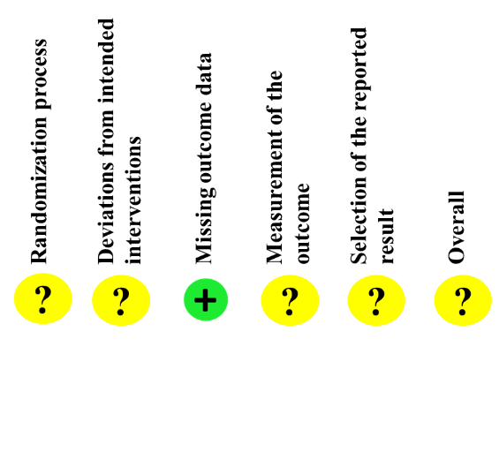
Hoch et al., 2012 | RCT  (blind assessors)  Germany | Criteria related to cannabis  Current regular cannabis use defined as use of any cannabis product at least twice a week in the past month, meeting DSM-IV  criteria for lifetime cannabis abuse or dependence  Criteria related to other substances  Excluded current DSM-IV-dependence on  alcohol or any other illicit drug with symptoms of withdrawal, tolerance  or craving | Intervention group CBT + MET + problem-solving training (79)  10 sessions  Control group  Delayed Treatment (31) |  | Disability days  CIDI disability days index  Post: SMD=-0.46, CI=-0.88; -0.04  Severity of medical problems  Addiction Severity Index medical subscale  Post: SMD=-0.22, CI=-0.64, 0.19  Severity of employment problem  Addiction Severity Index employment subscale  Post: SMD=0.00, CI=-0.42; 0.42  Satisfaction  Addiction Severity Index satisfaction subscale  Post: SMD=0.10, CI=-0.32; 0.51  Severity of family/social relations problems  Addiction Severity Index family/social relations subscales  Post: SMD=-0.25, CI=-0.67; 0.17  Psychiatric symptoms  Brief Symptom Inventory  Post: SMD=-0.69, CI=-1.12; -0.27  Quantity  TLFB  Post: SMD=-0.71, CI=-1.14; -0.29  Abstinence  TLFB  Post: OR=6.58, CI=2.11; 20.56 | 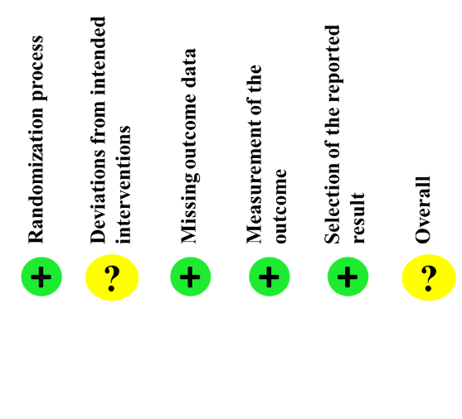

Authors, years | Design of studies  Studies countries | Description of sample | Comparisons groups | Results | Risk of bias
Hoch et al., 2014 | RCT  (blind assessors)  Germany | Criteria related to cannabis  Use of any cannabis product at least twice per week over the course of the past 12 months  Criteria related to other substances  Excluded ICD-10 dependence in the previous 12 months on alcohol or any other illicit drug (apart from cannabis) with symptoms of withdrawal, tolerance or craving, current use of opiate substitution or sedative-hypnotic medication. | Intervention group CBT + MET + problem-solving training (166)  10 sessions  Control group  Delayed Treatment (106) | Cannabis-related problems  Cannabis Problems Questionnaire  Post: SMD=-0.67, CI=-0.92; -0.42  Severity of cannabis use problems  Cannabis Use Problems Identification Test.  Post: SMD=-0.70, CI=-0.95; -0.44  Severity of cannabis dependence  Severity of Dependence Scale  Post: SMD=-0.55, CI=-0.80; -0.30  Dependence cannabis symptoms  ICD-10 criteria of dependence  Post: SMD=-0.83, CI=-1.08; -0.57  Quantity  TLFB  Post: SMD=-0.72, CI=-0.97; -0.47  Abstinence  TLFB  Post: OR=4.07, CI=2.43; 7.08 | 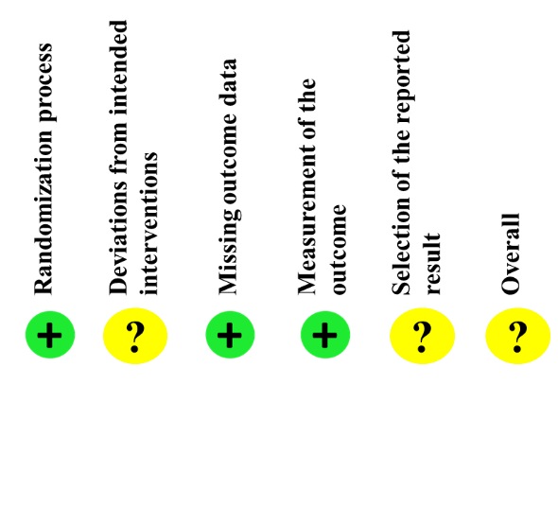
Jungerman et al., 2007 | RCT  (no blind assessors)  Brazil | Criteria related to cannabis  Smoked marijuana at least 40 times in the 90 days prior to interview (i.e., 3 times per week).  Criteria related to other substances  Excluded criteria for dependence on any other drug (or alcohol), | Intervention group MI + relapse prevention (4 sessions in 1-month) (56)  4 sessions  Control group  Delayed Treatment (52) | Cannabis-related problems  Marijuana Problems Scale  3-month: SMD=-0.09, CI=-0.46; 0.29  Severity of cannabis dependence  Substance-dependence subscale from the DSM-III-R checklist  3-month: SMD=-0.37, CI=-0.75; 0.01  Quantity  TLFB  3-month: SMD=-0.59, CI=-0.98; -0.21  Frequency  TLFB  3-month: SMD=-0.92, CI=-1.32; -0.53  Abstinence  TLFB  3-month: OR=0,45, CI=0.04; 5.17 | 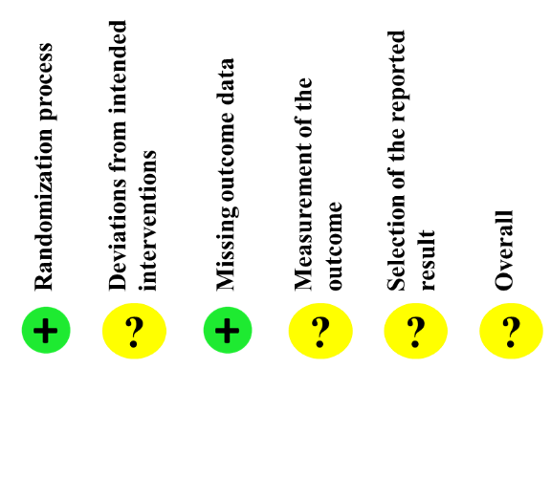
Jungerman et al., 2007 | RCT  (no blind assessors)  Brazil |  | Intervention group MI + relapse prevention (4 sessions in 3-month) (56)  4 sessions  Control group  Delayed Treatment (52) | Cannabis-related problems  Marijuana Problems Scale  1-month: SMD=0.14, CI=-0.25; 0.52  Severity of cannabis dependence  Substance-dependence subscale from the DSM-III-R checklist  1-month: SMD=-0.10, CI=-0.49; 0.28  Quantity  TLFB  1-month: SMD=-0.61, CI=-1.01; -0.22  Frequency  TLFB  1-month: SMD=-0.68, CI=-1.07; -0.28  Abstinence  TLFB  1-month: OR=1.53, CI=0.25; 9.56
Authors, years | Design of studies  Studies countries | Description of sample | Comparisons groups | Results | Risk of bias
Litt et al., 2008 | RCT  (no blind assessors)  United States of America | Criteria related to cannabis  Diagnosis of current cannabis dependence  Criteria related to other substances  Excluded for current alcohol or drug dependence | Intervention group  CM (50)  9 sessions  Control group  Case Management (no skills relevant to managing substance use were taught) (54)  9 sessions | Readiness to change cannabis  Readiness to Change Questionnaire  Post: SMD=0.35, CI=-0.04; 0.74  Self-efficacy  20-item modification of a smoking cessation self-efficacy questionnaire  Post: SMD=0.21, CI=-0.18; 0.59  Coping Skills  Coping Strategies Scale  Post: SMD=0.02, CI=-0.37; 0.40  Abstinence  TLFB  Post: OR=2.26, CI=0.77; 6.65  5-month: OR=1.53, CI=0.53; 4.36  8-month: OR=0.78, CI=0.25; 2.45  11-month: OR=0.79, CI=0.25; 2.46  14-month: OR=0.60, CI=0.20; 1.80 | 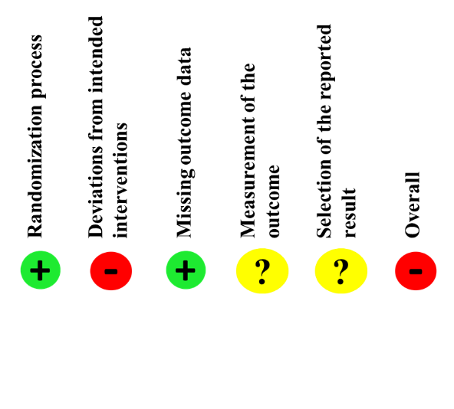
Litt et al., 2008 | RCT  (no blind assessors)  United States of America |  | Intervention group MET + CBT (55)  9 sessions  Control group  Case Management (no skills relevant to managing substance use were taught) (54)  9 sessions | Readiness to change cannabis  Readiness to Change Questionnaire  Post: SMD=0.30, CI=-0.08; 0.68  Self-efficacy  20-item modification of a smoking cessation self-efficacy questionnaire  Post: SMD=0.23, CI=-0.15; 0.60  Coping Skills  Coping Strategies Scale  Post: SMD=0.08, CI=-0.30; 0.46  Abstinence  TLFB  Post: OR=1.17, CI=0.37; 3.73  5-month: OR=1.87, CI=0.68; 5.20  8-month: OR=1.28, CI=0.46; 3.54  11-month: OR=1.00, CI=0.34; 2.90  14-month: OR=1.28, CI=0.46; 3.54
Litt et al., 2008 | RCT  (no blind assessors)  United States of America |  | Intervention group MET + CBT (55)  9 sessions  Control group  CM (50)  9 sessions | Readiness to change cannabis  Readiness to Change Questionnaire  Post: SMD=-0.05, CI=-0.43; 0.33  Self-efficacy  20-item modification of a smoking cessation self-efficacy questionnaire  Post: SMD=0.03, CI=-0.35; 0.41  Coping Skills  Coping Strategies Scale  Post: SMD=0.07, CI=-0.32; 0.45  Abstinence  TLFB  Post: OR=0.52, CI=0.18; 1.46  5-month: OR=1.24, CI=0.47; 3.26  8-month: OR=1.63, CI=0.54; 4.87  11-month: OR=1.27, CI=0.41; 3.98  14-month: OR=1.79, CI=0.60; 5.40
Litt et al., 2008 | RCT  (no blind assessors)  United States of America |  | Intervention group MET + CBT + CM (59)  9 sessions  Control group  Case Management (no skills relevant to managing substance use were taught) (54)  9 sessions | Readiness to change cannabis  Readiness to Change Questionnaire  Post: SMD=0.38, CI=0.01; 0.75  Self-efficacy  20-item modification of a smoking cessation self-efficacy questionnaire  Post: SMD=-0.08; CI=-0.45; 0.29  Coping Skills  Coping Strategies Scale  Post: SMD=0.21, CI=-0.16; 0.58  Abstinence  TLFB  Post: OR=1.83, CI=0.63; 5.36  5-month: OR=2.09, CI=0.77; 5.65  8-month: OR=1.70, CI=0.64; 4.51  11-month: OR=1.88, CI=0.71; 4.94  14-month: OR=1.59, CI=0.63; 4.00
Litt et al., 2008 | RCT  (no blind assessors)  United States of America |  | Intervention group MET + CBT + CM (59)  9 sessions  Control group  CM (50)  9 sessions | Readiness to change cannabis  Readiness to Change Questionnaire  Post: SMD=-0.03, CI=-0.40; 0.35  Self-efficacy  20-item modification of a smoking cessation self-efficacy questionnaire  Post: SMD=-0.31, CI=-0.69; 0.07  Coping Skills  Coping Strategies Scale  Post: SMD=0.19, CI=-0.18; 0.57  Abstinence  TLFB  Post: OR=0.81, CI=0.32; 2.07  5-month: OR=1.38, CI=0.54; 3.54  8-month: OR=2.17, CI=0.75; 6.23  11-month: OR=2.39, CI=0.84; 6.82  14-month: OR=2.65, CI=0.92; 7.60
Litt et al., 2008 | RCT  (no blind assessors)  United States of America |  | Intervention group MET + CBT + CM (59)  9 sessions  Control group  MET + CBT (55)  9 sessions | Readiness to change cannabis  Readiness to Change Questionnaire  Post: SMD=0.03, CI=-0.34; 0.40  Self-efficacy  20-item modification of a smoking cessation self-efficacy questionnaire  Post: SMD=-0.32, CI=-0.69; 0.05  Coping Skills  Coping Strategies Scale  Post: SMD=0.13, CI=-0.24; 0.50  Abstinence  TLFB  Post: OR=1.57, CI=0.56; 4.40  5-month: OR=1.11, CI=0.46; 2.68  8-month: OR=1.33, CI=0.53; 3.36  11-month: OR=1.88, CI=0.71; 4.94  14-month: OR=1.48, CI=0.58; 3.73
Authors, years | Design of studies  Studies countries | Description of sample | Comparisons groups | Results | Risk of bias
Litt et al., 2013 | RCT  (no blind assessors)  United States of America | Criteria related to cannabis  Diagnosis of marijuana dependence or  abuse  Criteria related to other substances  Excluded current dependence on drugs other than nicotine and marijuana | Intervention group  MET + CBT + CM (60)  9 sessions  Control group  Case Management (61)  9 sessions | Cannabis-related problems  Marijuana Problems Scale  Post: SMD=0.07, CI=-0.29; 0.43  3-month: SMD=0.04, CI=-0.32; 0.40  6-month: SMD=-0.12, CI=-0.48, 0.23  9-month: SMD=-0.04, CI=-0.40; 0.31  12-month: SMD=-0.02, CI=-0.38; 0.34  Proportion days abstinent  TLFB  Post: SMD=0.36, CI=0.00; 0.72  3-month: SMD=0.28, CI=-0.08; 0.64  6-month: SMD=0.32, CI=-0.04; 0.68  9-month: SMD=0.00, CI=-0.36; 0.36  12-month: SMD=0.11, CI=-0.25; 0.47  Abstinence  TLFB  Post: OR=1.54, CI=0.55; 4.36  3-month: OR=2.36, CI=0.99; 5.64  6-month: OR=2.11, CI=0.90; 4.93  9-month: OR=1.23, CI=0.53; 2.87  12-month: OR=1.76, CI=0.70; 4.44 | 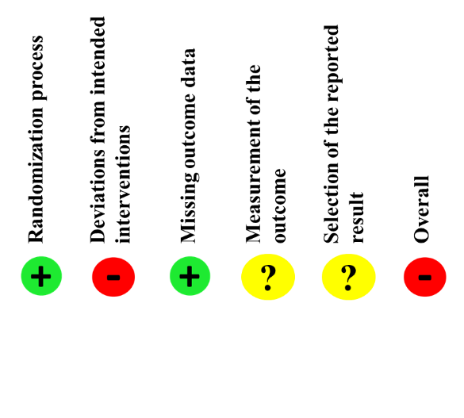

Authors, years | Design of studies  Studies countries | Description of sample | Comparisons groups | Results | Risk of bias
Litt et al., 2020 | RCT  (no blind assessors)  United States of America | Criteria related to cannabis  Diagnosis of cannabis  dependence  Criteria related to other substances  Could meet criteria for dependence on other substances, but must have reported that marijuana was their primary  substance of abuse | Intervention group  MET + CBT (44)  9 sessions  Control group  Individualized Assessment and Treatment Program (46)  9 sessions | Cannabis- related problems  Marijuana Problems Scale  Post: SMD=0.31, CI=-0.15; 0.76  2-month: SMD=0.30, CI=-0.18; 0.78  5-month: SMD=0.28, CI=-0.17; 0.74  8-month: SMD=0.35, CI=-0.16; 0.86  11-month: SMD=0.47, CI=0.02; 0.93  Abstinence  TLFB  Post: SMD=-0.42, CI=-0.84; 0.00  2-month: SMD=-0.61, CI=-1.04; -0.19  5-month: SMD=-0.38, CI=-0.81; 0.05  8-month: SMD=-0.57, CI=-1.01; -0.13  11-month: SMD=-0.44, CI=-0.89; 0.01 | 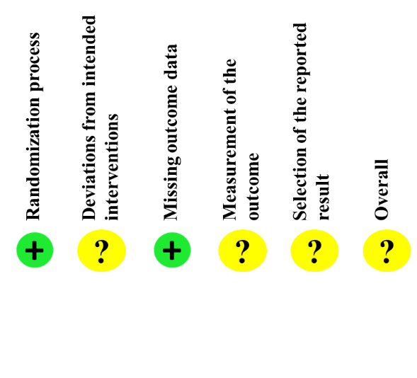
Litt et al., 2020 | RCT  (no blind assessors)  United States of America |  | Intervention group  MET + CBT + CM (46)  9 sessions  Control group  Individualized Assessment and Treatment Program (46)  9 sessions | Cannabis- related problems  Marijuana Problems Scale  Post: SMD=0.02, CI=-0.42; 0.46  2-month: SMD=-0.18, CI=-0.65; 0.29  5-month: SMD=-0.13, CI=-0.59; 0.32  8-month: SMD=-0.02, CI=-0.52; 0.49  11-month: SMD=0.15, CI=-0.29; 0.58  Abstinence  TLFB  Post: SMD=0.02, CI=-0.38; 0.43  2-month: SMD=-0.07, CI=-0.48; 0.34  5-month: SMD=-0.10, CI=-0.32; 0.51  8-month: SMD=-0.28, CI=-0.71; 0.15  11-month: SMD=-0.14, CI=-0.57; 0.30
Litt et al., 2020 | RCT  (no blind assessors)  United States of America |  | Intervention group  MET + CBT + CM (46)  9 sessions  Control group  MET + CBT (44)  9 sessions | Cannabis- related problems  Marijuana Problems Scale  Post: SMD=-0.31, CI=-0.76; 0.15  2-month: SMD=-0.50, CI=-0.99; -0.01  5-month: SMD=0.45, CI=-0.91; 0.02  8-month: SMD=-0.38, CI=-0.91; 0.15  11-month: SMD=-0.38, CI=-0.82, 0.07  Abstinence  TLFB  Post: SMD=0.46, CI=0.04; 0.88  2-month: SMD=0.55, CI=0.12; 0.98  5-month: SMD=0.50, CI=0.06; 0.93  8-month: SMD=0.28, CI=-0.16; 0.71  11-month: SMD=0.31, CI=0.14; 0.75
Litt et al., 2020 | RCT  (no blind assessors)  United States of America |  | Intervention group  MET + CBT + CM (46)  9 sessions  Control group  CM + Individualized Assessment and Treatment Program (46)  9 sessions | Cannabis- related problems  Marijuana Problems Scale  Post: SMD=0.12, CI=-0.34; 0.57  2-month: SMD=-0.13, CI=-0.59; 0.34  5-month: SMD=-0.05, CI=-0.51; 0.41  8-month: SMD=0.07, CI=-0.44; 0.59  11-month: SMD=-0.20, CI=-0.63; 0.23  Abstinence  TLFB  Post: SMD=0.07, CI=-0.34; 0.48  2-month: SMD=-0.02, CI=-0.44; 0.39  5-month: SMD=0.17, CI=-0.25; 0.59  8-month: SMD=-0.07, CI=-0.49; 0.35  11-month: SMD=-0.02, CI=-0.46; 0.41
Litt et al., 2020 | RCT  (no blind assessors)  United States of America |  | Intervention group  MET + CBT (44)  9 sessions  Control group  CM + Individualized Assessment and Treatment Program (46)  9 sessions | Cannabis- related problems  Marijuana Problems Scale  Post: SMD=0.12, CI=-0.34; 0.57  2-month: SMD=-0.13, CI=-0.59; 0.34  5-month: SMD=-0.05, CI=-0.51; 0.41  8-month: SMD=0.07, CI=-0.44; 0.59  11-month: SMD=-0.20, CI=-0.63; 0.23  Abstinence  TLFB  Post: SMD=-0.37, CI=-0.79; 0.05  2-month: SMD=-0.57, CI=-0.99; -0.14  5-month: SMD=-0.31, CI=-0.74; 0.12  8-month: SMD=-0.35, CI=-0.78; 0.08  11-month: SMD=-0.33, CI=-0.78; 0.11
Litt et al., 2020 | RCT  (no blind assessors)  United States of America |  | Intervention group  CM + Individualized Assessment and Treatment Program (46)  9 sessions  Control group  Individualized Assessment and Treatment Program (46)  9 sessions | Cannabis- related problems  Marijuana Problems Scale  Post: SMD=-0.09, CI=-0.54; 0.36  2-month: SMD=-0.03, CI=-0.48; 0.43  5-month: SMD=-0.08, CI=-0.53; 0.37  8-month: SMD=-0.09, CI=-0.58; 0.41  11-month: SMD=0.31, CI=-0.13; 0.75  Abstinence  TLFB  Post: SMD=-0.05, CI=-0.46; 0.36  2-month: SMD=-0.05, CI=-0.45; 0.36  5-month: SMD=-0.07, CI=-0.48; 0.35  8-month: SMD=-0.21, CI=-0.63; 0.21  11-month: SMD=-0.11, CI=-0.55; 0.32
Authors, years | Design of studies  Studies countries | Description of sample | Comparisons groups | Results | Risk of bias
Pèlerin et al., 2025 | RCT  (no blind assessors)  France | Criteria related to cannabis  Regular use of cannabis at  least 7 times per week,  dependence or abuse  associated to  Mini-International  Neuropsychiatric  Interview of at least 4 days per week, covering eight days of consumption in the last 2 weeks. Volunteers to stopping cannabis consumption  Criteria related to other substances  Excluded substance dependence or abuse. alcohol and other substances | Intervention group  Mindfulness-based relapse prevention (16)  8 sessions  Control group  TAU (standard outpatient care  provided by a psychiatrist  trained in addictology with experience of cannabis user care.) (16) | Withdrawal symptoms  Cannabis Withdrawal Scale  Post: SMD=-1.84, CI=-2.73; -0.95  1-month: SMD=-1.16, CI=-2.36; 0.04  Frequency  TLFB  Post: SMD=0.79, CI=-1.75, -0.02  1-month: SMD=-1.37, CI=-2.60; -0.13 | 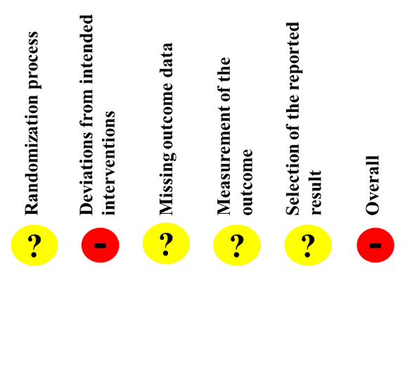
Sinha et al., 2003 | RT  (no blind assessors)  United States of America | Criteria related to cannabis  Diagnosis of marijuana abuse or dependence  Criteria related to other substances  Excluded currently abusing opiates or cocaine, or whose principal substance of abuse was not marijuana | Intervention group  MET + CM (37  3 sessions  Control group  MET (28)  3 sessions | Severity of cannabis dependence  Addiction Severity Index  Post: SMD=0.18, CI=-0.32; 0.67  1-month: SMD=0.11, CI=-0.38; 0.60  Readiness to change cannabis  Stages of Change Readiness and Treatment Eagerness Scale  Post: SMD=0.29, CI=-0.21; 0.78  1-month: SMD=0.22, CI=-0.27, 0.71  Frequency  Questionnaire maison (self-report (using a weekly substance use calendar)  Post: SMD=0.50, CI=0.00;1.00  1-month: SMD=0.22, CI=-0.27; 0.71 | 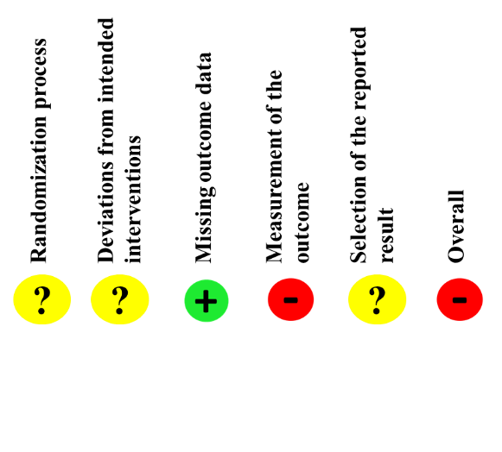
Stephens et al., 1994 | RCT  (no blind assessors)  United States of America | Criteria related to cannabis  More than 50 times in the past 90 days  Criteria related to other substances  Excluded recent abuse or dependence on alcohol or  other drug | Intervention group  Relapse prevention group (80)  10 sessions  Control group  Social support group (87)  10 sessions | Severity of cannabis dependence  Drug Abuse Screening Test  3-month: SMD=-0.12, CI=-0.43; 0.20  6-month: SMD=0.02, CI=-0.30; 0.33  12-month: SMD=0.08, CI=-0.23; 0.40  Frequency  Self-developed questionnaire  1-month: SMD=-0.30, CI=-0.60; 0.01  3-month: SMD=-0.06, CI=-0.36; 0.24  6-month: SMD=-0.01, CI=-0.32; 0.29  9-month: SMD=0.12, CI=-0.18; 0.43  12-month: SMD=0.04, CI=-0.26; 0.34  Abstinence  Self-developed questionnaire  3-month: OR=0.72, CI=0.38; 1.35  6-month: OR=0.81, CI=0.40; 1.64  12-month: OR=0.78, CI=0.35; 1.78 | 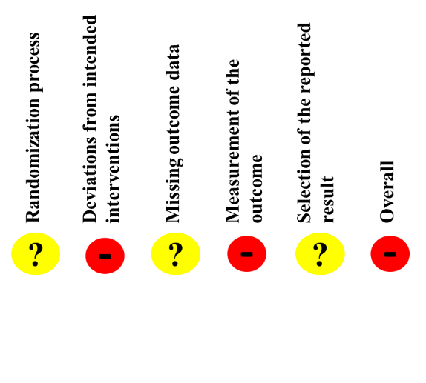
Authors, years | Design of studies  Studies countries | Description of sample | Comparisons groups | Results | Risk of bias
Stephens et al., 2000 | RCT  (no blind assessors)  United States of America | Criteria related to cannabis  More than 50 times in the past 90 days  Criteria related to other substances  Excluded recent abuse or dependence on alcohol or other drug | Intervention group  Relapse prevention support group (CBT + social support processes) (103)  14 sessions  Control group  Brief MI (80)  2 sessions | Cannabis-related problems  Adapted from other drug use severity instruments  Post: SMD=0.06, CI=-0.24; 0.36  3-month: SMD=0.06, CI=-0.25; 0.36  9-month: SMD=-0.10, CI=-0.40; 0.19  12-month: SMD=-0.10, CI=-0.39; 0.19  Severity of cannabis dependence  Marijuana dependence scale  Post: SMD=0.01, CI=-0.30; 0.31  3-month: SMD=0.17, CI=-0.14; 0.47  9-month: SMD=0.00, CI=-0.29; 0.30  12-month: SMD=0.02, CI=-0.27; 0.32  Frequency  Self-developed questionnaire  Post: SMD=-0.12, CI=-0.42; 0.19  3-month: SMD=0.04, CI=-0.26; 0.35  9-month: SMD=0.02, CI=-0.27; 0.32  12-month: SMD=-0.06, CI=-0.35; 0.23 | 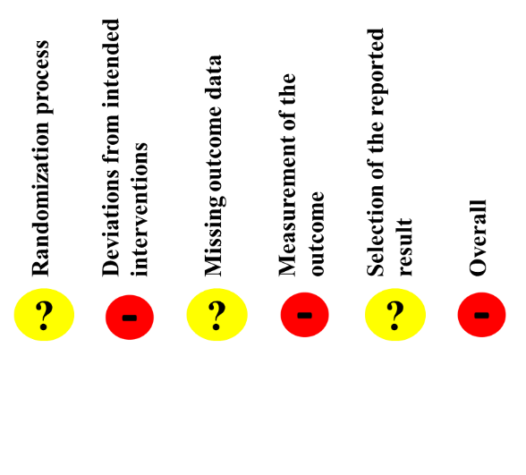
Stephens et al., 2000 | RCT  (no blind assessors)  United States of America |  | Intervention group  Relapse prevention support group (CBT + social support processes) (95)  14 sessions  Control group  Delayed Treatment (79) | Cannabis-related problems  Adapted from other drug use severity instruments  Post: SMD=-1.03; CI=-1.35; -0.72  Severity of cannabis dependence  Marijuana dependence scale  Post: SMD=-1.00, CI=-1.31; -0.68  Frequency  Self-developed questionnaire  Post: SMD=-1.01; CI=-1.33; -0.69
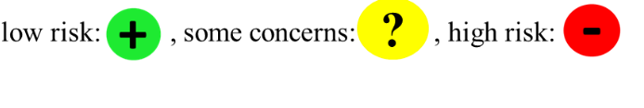
RT: randomized trial, RCT: randomized controlled trial, TAU: treatment as usual, MET: Motivational enhancement therapy, MI: Motivational interviewing, CM: Contingency management, CBT: cognitive behavioral therapy; TLFB: Timeline Follow-Back, NR: not report, SMD: standard mean difference, OR: Odd ratio, Significant results are in bold.
Table S4. PRISMA Checklist.
Section/topic | # | Checklist item | Reported on page #
TITLE
Title | 1 | Identify the report as a systematic review, meta-analysis, or both.
ABSTRACT
Structured summary | 2 | Provide a structured summary including, as applicable, background, objectives, data sources, study eligibility criteria, participants, and interventions; study appraisal and synthesis methods; results; limitations; conclusions and implications of key findings; systematic review registration number.
INTRODUCTION
Rationale | 3 | Describe the rationale for the review in the context of what is already known.
Objectives | 4 | Provide an explicit statement of questions being addressed with reference to participants, interventions, comparisons, outcomes, and study design (PICOS).
METHODS
Protocol and registration | 5 | Indicate if a review protocol exists, if and where it can be accessed (e.g., Web address), and, if available, provide registration information including registration number.
Eligibility criteria | 6 | Specify study characteristics (e.g., PICOS, length of follow-up) and report characteristics (e.g., years considered, language, publication status) used as criteria for eligibility, giving rationale.
Information sources | 7 | Describe all information sources (e.g., databases with dates of coverage, contact with study authors to identify additional studies) in the search and date last searched.
Search | 8 | Present full electronic search strategy for at least one database, including any limits used, such that it could be repeated.
Study selection | 9 | State the process for selecting studies (i.e., screening, eligibility, included in systematic review, and, if applicable, included in the meta-analysis).
Data collection process | 10 | Describe method of data extraction from reports (e.g., piloted forms, independently, in duplicate) and any processes for obtaining and confirming data from investigators.
Data items | 11 | List and define all variables for which data were sought (e.g., PICOS, funding sources) and any assumptions and simplifications made.
Risk of bias in individual studies | 12 | Describe methods used for assessing risk of bias of individual studies (including specification of whether this was done at the study or outcome level), and how this information is to be used in any data synthesis.
Summary measures | 13 | State the principal summary measures (e.g., risk ratio, difference in means).
Synthesis of results | 14 | Describe the methods of handling data and combining results of studies, if done, including measures of consistency (e.g., I2) for each meta-analysis.
Risk of bias across studies | 15 | Specify any assessment of risk of bias that may affect the cumulative evidence (e.g., publication bias, selective reporting within studies).
Additional analyses | 16 | Describe methods of additional analyses (e.g., sensitivity or subgroup analyses, meta-regression), if done, indicating which were pre-specified.
RESULTS
Study selection | 17 | Give numbers of studies screened, assessed for eligibility, and included in the review, with reasons for exclusions at each stage, ideally with a flow diagram.
Study characteristics | 18 | For each study, present characteristics for which data were extracted (e.g., study size, PICOS, follow-up period) and provide the citations.
Risk of bias within studies | 19 | Present data on risk of bias of each study and, if available, any outcome level assessment (see item 12).
Results of individual studies | 20 | For all outcomes considered (benefits or harms), present, for each study: (a) simple summary data for each intervention group (b) effect estimates and confidence intervals, ideally with a forest plot.
Synthesis of results | 21 | Present results of each meta-analysis done, including confidence intervals and measures of consistency.
Risk of bias across studies | 22 | Present results of any assessment of risk of bias across studies (see Item 15).
Additional analysis | 23 | Give results of additional analyses, if done (e.g., sensitivity or subgroup analyses, meta-regression [see Item 16]).
DISCUSSION
Summary of evidence | 24 | Summarize the main findings including the strength of evidence for each main outcome; consider their relevance to key groups (e.g., healthcare providers, users, and policy makers).
Limitations | 25 | Discuss limitations at study and outcome level (e.g., risk of bias), and at review-level (e.g., incomplete retrieval of identified research, reporting bias).
Conclusions | 26 | Provide a general interpretation of the results in the context of other evidence, and implications for future research.
FUNDING
Funding | 27 | Describe sources of funding for the systematic review and other support (e.g., supply of data); role of funders for the systematic review.

