Supplementary Materials

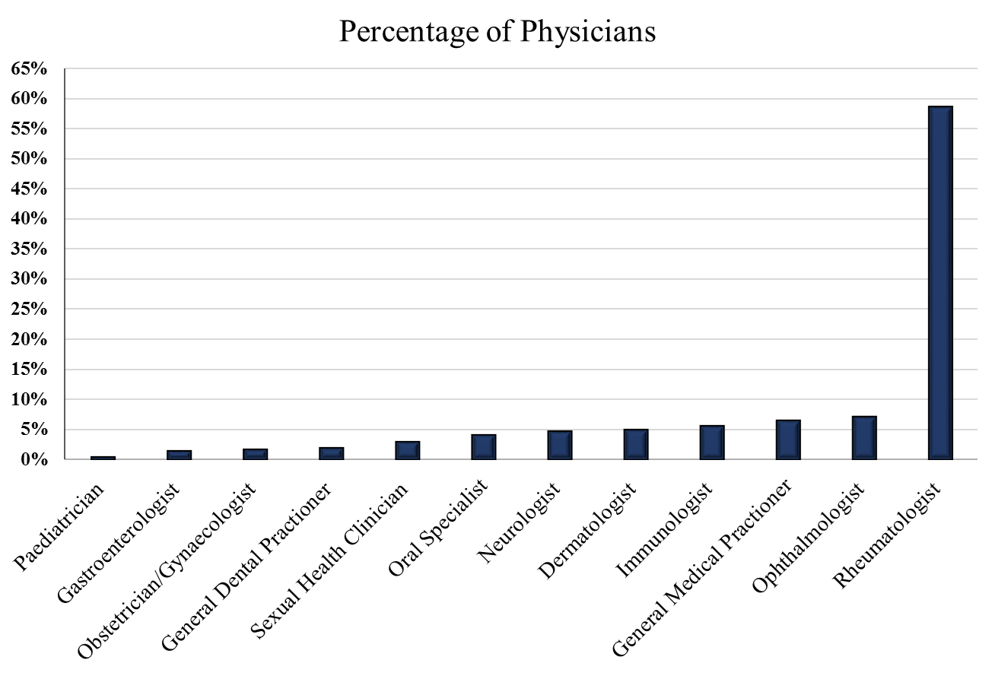
Figure S2: The percentage of physicians who made the initial diagnosis and referred patients to BS centres.

