Supplementary Material
Table A.1: Summary of Lifeskills Learning Objectives
Main topics (set) | Learning Objectivesª
Road safety  (Urban Road) | Awareness of the effectiveness of fluorescent/reflective materials.  A realistic understanding of speed and stopping distances.  Have developed some of the skills and knowledge necessary for survival in today’s traffic.  Awareness of implications of not wearing seatbelts.
Consumer rights  (Supermarket) | Awareness of the law regarding the sale of some products (e.g. solvents, cigarettes, lottery cards).  Awareness of labels on foods (ingredients, sell-by dates).
Harmful substances, drug awareness  (Garage) | Awareness of importance of safe storage of harmful household substances.  Awareness and understanding of drugs that help and drugs that can harm.
Home safety, fire, 999 call  (House set 1) | Aware of potential dangers in bathroom (poisoning, drowning, scalds).  Aware of potential fire hazards in bedroom (candles, cigarettes, matches, electric blanket).  Understand importance of fitting smoke alarm.  Be able to develop fire escape plan and make 999 emergency call to fire brigade.
Home safety, security, crime reduction, gas escape  (House set 2) | Able to identify dangers to toddler and/or older person in living room.  Able to devise strategy for action in event of unexpected caller to door.  Identify hazards in kitchen and dining room.  Able to recognise smell of gas and know what to do if there is a leak.  Able to make telephone call to utility (TRANSCO).
Electrical, garden, building site safety  (Garden/Electricity sub-station/Building Site) | Aware of common dangers in garden (e.g. BBQ, paddling pool).  Awareness of dangers of electrical apparatus in home and community and potential for electrocution.  Aware that building sites are dangerous and not suitable places for children.
First aid, 999 call  (Playground) | Aware of what action to take when finding injured or unconscious person.  Aware of the ‘recovery position’ and had an opportunity to practice putting casualty into it.  Have had opportunity to practice making a 999 call.
Environment, water safety, railway safety  (River/railway) | Aware of the dangers posed by water.  Appreciation of how they can help someone in distress in water whilst remaining safe themselves.  Be aware of dangers of trespass and vandalism on the railway.  Know what action to take if obstructions/debris are found on railway track.
Country code, farm safety, rural road safety  (Country Lane/farm) | Awareness of road safety in rural environment.  Awareness of the provisions of the Country Code.  Have an awareness of hazards on farms.
ªAdapted from the Guides’ Briefing Notes, November 2000

Table A.2: Comparison of included and excluded sample
 |  | Excluded sample n=5822ª | Study sample  n=4290^{b} | Comparing excluded and study sample  p-value (χ² test for categorical, t test for continuous variables)
Age at outcome | mean (years) | 13.9 | 13.9 | 0.26
Sex | Female | 45.1 (43.8-46.3) | 54.2 (52.7-55.7) | <0.0005
 |  | n=4680
Maternal education | Degree | 5.7 (5.0-6.4) | 14.4 (13.4-15.5) | <0.0005
 | A level | 16.5 (15.5-17.6) | 25.8 (24.5-27.1)
 |  | 35.4 (34.0-36.8) | 37.4 (36.0-38.9)
 | None/Vocational | 42.4 (41.0-43.9) | 22.4 (21.2 - 23.6)
 |  | n=4031
Parental occupational social class | I or II | 42.2 (40.7-43.8) | 58.3 (56.8-59.7) | <0.0005
 | III non-manual | 29.7 (28.4-31.2) | 27.0 (25.7-28.3)
 | III manual | 19.1 (17.9-20.3) | 10.5 (9.7-11.5)
 | IV or V | 9.0 (8.1-9.9) | 4.2 (3.7-4.9)
 |  | n=381
Cycle proficiency training | Yes | 34.6 (30.0-39.6) | 38.6 (37.1-40.0) | 0.13
 |  | n=5822
Lifeskills attendance | Yes | 60.3 (59.1-61.1) | 59.3 (57.8-60.8) | 0.29
ª Excluded due to not having complete outcome and/or confounder data [outcome data: returned 13yr 10mth questionnaire; confounders: sex, age, maternal education, parental occupational class, cycle proficiency training).
^{b} Study sample consists of individuals with complete outcome and confounder data.

Table A.3: Outcomes by sex
Outcome | Boys |  |  |  | Girls |  |  |  |  | χ² p value
Outcome | n/N |  | % |  | n/N |  | % |  |  | χ² p value
Road Safety
Owns cycle helmetª | 971/1557 |  | 62.4 |  | 1047/1736 |  | 60.3 |  |  | 0.23
Wore cycle helmet ^{b} | 365/969 |  | 37.7 |  | 372/1045 |  | 35.6 |  |  | 0.34
Wore reflective or fluorescent clothingª | 70/1492 |  | 4.5 |  | 46/1754 |  | 2.6 |  |  | 0.004
Always/mostly uses pedestrian crossings on way to school^{c} | 654/1256 |  | 52.1 |  | 959/1599 |  | 60.0 |  |  | <0.00005
Wore seat belt last time in car | 1603/1679 |  | 95.5 |  | 1994/2053 |  | 97.1 |  |  | 0.007
Always wears seatbelt | 1479/1679 |  | 88.1 |  | 1870/2053 |  | 91.1 |  |  | 0.003
Road traffic accident in past year as pedestrian or cyclist | 20/1273 |  | 1.6 |  | 16/1668 |  | 1.1 |  |  | 0.14
Perceived substance use as ‘very harmful’ to health
Alcohol
Frequent drinking - physical health | 962/1383 |  |  | 69.6 |  | 1331/1832 |  | 72.7 | 0.05
Regular drinking - mental health | 771/1383 |  |  | 55.8 |  | 1038/1832 |  | 56.7 | 0.61
Binge drinking - physical health | 805/1383 |  |  | 58.2 |  | 1093/1832 |  | 59.7 | 0.41
Binge drinking - mental health | 635/1383 |  |  | 45.9 |  | 806/1832 |  | 44.0 | 0.28
Tobacco
Smoking - physical health | 1071/1383 |  |  | 77.4 |  | 1322/1832 |  | 72.2 | 0.0007
Smoking - mental health | 591/1383 |  |  | 42.7 |  | 665/1832 |  | 36.3 | 0.0002
Cannabis
Cannabis - physical health | 945/13836 |  |  | 68.3 |  | 1344/1832 |  | 73.4 | 0.002
Cannabis - mental health | 943/1383 |  |  | 68.2 |  | 1293/1832 |  | 70.6 | 0.14
Use of substances
Alcohol
Regular drinking |  | 215/1052 |  | 20.4 |  | 226/1349 |  | 16.8 | 0.02
Binge drinking |  | 114/1052 |  | 10.8 |  | 122/1349 |  | 9.0 | 0.14
Behavioural problems |  | 100/1052 |  | 9.5 |  | 112/1349 |  | 8.3 | 0.30
Tobacco
Recent smoking |  | 125/1052 |  | 11.9 |  | 247/1349 |  | 18.3 | <0.00005
Weekly smoking |  | 61/1052 |  | 5.8 |  | 147/1349 |  | 10.9 | <0.00005
Cannabis
Occasional cannabis |  | 107/1052 |  | 10.2 |  | 106/1349 |  | 7.9 | 0.05
Problematic cannabis use |  | 46/1052 |  | 4.4 |  | 27/1349 |  | 2.0 | 0.0008
A&E
A&E attendance |  | 185/694 |  | 26.7 |  | 190/1074 |  | 17.7 | <0.0005
ªRestricted to those who own their own bike
^{b}Restricted to those who own their own bike and helmet
^{c}Restricted to those who crossed at least one road on way to school

Table A.4: Outcomes by maternal education
Outcomes |  | Degree |  |  | A level |  |  | O Level |  |  |  |  | Vocational/None |  |  |  | χ² p value
 |  | n/N |  | % | n/N |  | % | n/N |  |  | % |  | n/N | % |  |  | χ² p value
Road Safety
Owns cycle helmetª |  | 305/385 |  | 79.2 | 576/831 |  | 69.3 |  | 773/1292 |  | 59.8 |  | 364/785 |  | 46.4 |  | <0.0005
Wore cycle helmet ^{b} |  | 156/305 |  | 51.2 | 232/576 |  | 40.3 |  | 254/771 |  | 32.9 |  | 95/362 |  | 26.2 |  | <0.0005
Wore reflective or fluorescent clothingª |  | 6/391 |  | 1.5 | 30/833 |  | 3.6 |  | 47/1305 |  | 3.6 |  | 33/787 |  | 4.2 |  | 0.13
Always/mostly uses pedestrian crossings on way to school^{c} |  | 191/332 |  | 57.5 | 418/721 |  | 58.0 |  | 628/1099 |  | 57.1 |  | 376/703 |  | 53.5 |  | 0.31
Wore seat belt last time in car |  | 416/430 |  | 96.7 | 911/943 |  | 96.6 |  | 1402/1454 |  | 96.4 |  | 868/905 |  | 95.9 |  | 0.83
Always wears seatbelt |  | 390/430 |  | 90.7 | 859/943 |  | 91.1 |  | 1307/1454 |  | 89.9 |  | 793/905 |  | 87.6 |  | 0.08
Road traffic accident in past year as pedestrian or cyclist |  | 7/390 |  | 1.8 | 6/738 |  | 0.8 |  | 16/1157 |  | 1.4 |  | 7/656 |  | 1.1 |  | 0.48
Perceived substance use as ‘very harmful’ to health
Alcohol
Regular drinking - physical health |  | 298/406 |  | 73.4 | 576/807 |  | 71.4 |  | 898/1253 |  | 71.7 | 521/749 |  | 69.6 |  |  | 0.56
Regular drinking - mental health |  | 218/406 |  | 53.7 | 445/807 |  | 55.1 |  | 704/1253 |  | 56.2 | 442/749 |  | 59.0 |  |  | 0.28
Binge drinking - physical health |  | 242/406 |  | 59.6 | 484/807 |  | 60.0 |  | 735/1253 |  | 58.7 | 437/749 |  | 58.3 |  |  | 0.90
Binge drinking - mental health |  | 166/406 |  | 40.9 | 372/807 |  | 46.1 |  | 566/1253 |  | 45.2 | 337/749 |  | 45.0 |  |  | 0.37
Tobacco
Smoking - physical health |  | 326/406 |  | 80.3 | 610/807 |  | 75.6 |  | 928/1253 |  | 74.1 | 529/749 |  | 70.6 |  |  | 0.003
Smoking - mental health |  | 119/406 |  | 29.3 | 303/807 |  | 37.6 |  | 510/1253 |  | 40.7 | 324/749 |  | 43.3 |  |  | <0.0005
Cannabis
Cannabis - physical health |  | 269/406 |  | 66.3 | 560/807 |  | 69.4 |  | 910/1253 |  | 72.6 | 550/749 |  | 73.4 |  |  | 0.03
Cannabis - mental health |  | 263/406 |  | 64.8 | 553/807 |  | 68.5 |  | 877/1253 |  | 70.0 | 543/749 |  | 72.5 |  |  | 0.05
Use of substances
Alcohol
Regular drinking | 66/354 |  | 18.6 |  |  | 116/654 | 17.7 | 170/912 |  | 18.6 |  | 89/481 |  | 18.5 |  | 0.97
Binge drinking | 30/354 |  | 8.5 |  |  | 54/654 | 8.3 | 98/912 |  | 10.8 |  | 54/481 |  | 11.2 |  | 0.21
Behavioural problems | 31/354 |  | 8.8 |  |  | 45/654 | 6.9 | 86/912 |  | 9.4 |  | 50/481 |  | 10.4 |  | 0.18
Tobacco
Recent smoking | 39/354 |  | 11.0 |  |  | 98/654 | 15.0 | 153/912 |  | 16.8 |  | 82/481 |  | 17.1 |  | 0.06
Weekly smoking | 17/354 |  | 4.8 |  |  | 45/654 | 6.9 | 91/912 |  | 10.0 |  | 55/481 |  | 11.4 |  | 0.001
Cannabis
Occasional cannabis | 43/354 |  | 12.2 |  |  | 54/654 | 8.3 | 71/912 |  | 7.8 |  | 45/481 |  | 9.4 |  | 0.09
Problematic cannabis use | 9/354 |  | 2.5 |  |  | 13/654 | 2.0 | 31/912 |  | 3.4 |  | 20/481 |  | 4.2 |  | 0.16
A&E
A&E attendance | 42/283 |  | 14.8 |  |  | 104/478 | 21.8 | 137/650 |  | 21.1 |  | 92/357 |  | 25.8 |  | 0.01
ªRestricted to those who own their own bike
^{b}Restricted to those who own their own bike and helmet
^{c}Restricted to those who crossed at least one road on way to school

Table A.5: Outcomes by highest occupational social class
Outcomes |  | I and II |  |  | IIInm |  |  | IIIm |  |  |  |  | IV and V |  |  |  | χ² p value
 |  | n/N |  | % | n/N |  | % | n/N |  |  | % |  | n/N | % |  |  | χ² p value
Road Safety
Owns cycle helmetª |  | 1268/1845 |  | 68.7 | 524/939 |  | 55.8 |  | 180/374 |  | 48.1 |  | 46/135 |  | 34.1 |  | <0.0005
Wore cycle helmet ^{b} |  | 524/1265 |  | 41.4 | 143/524 |  | 27.3 |  | 58/180 |  | 32.2 |  | 12/45 |  | 26.7 |  | <0.0005
Wore reflective or fluorescent clothingª |  | 58/1854 |  | 3.1 | 31/954 |  | 3.3 |  | 18/372 |  | 4.8 |  | 9/136 |  | 6.6 |  | 0.08
Always/mostly uses pedestrian crossings on way to school^{c} |  | 880/1551 |  | 56.7 | 478/848 |  | 56.4 |  | 185/319 |  | 58.0 |  | 70/137 |  | 51.1 |  | 0.58
Wore seat belt last time in car |  | 1996/2064 |  | 96.7 | 1032/1068 |  | 96.6 |  | 399/426 |  | 93.7 |  | 170/174 |  | 97.7 |  | 0.01
Always wears seatbelt |  | 1880/2064 |  | 91.1 | 956/1068 |  | 89.5 |  | 359/426 |  | 84.3 |  | 154/174 |  | 88.5 |  | <0.0005
Road traffic accident in past year as pedestrian or cyclist |  | 22/1659 |  | 1.3 | 11/842 |  | 1.3 |  | <5/310 |  | <1.0 |  | <5/130 |  | <1.0 |  | 0.58
Perceived substance use as ‘very harmful’ to health
Alcohol
Regular drinking - physical health |  | 1281/1779 |  | 72.0 | 651/931 |  | 69.9 |  | 257/351 |  | 73.2 | 104/154 |  | 67.5 |  |  | 0.39
Regular drinking - mental health |  | 985/1779 |  | 55.4 | 529/931 |  | 56.8 |  | 209/351 |  | 59.5 | 86/154 |  | 55.8 |  |  | 0.52
Binge drinking - physical health |  | 1058/1779 |  | 59.5 | 550/931 |  | 59.1 |  | 207/351 |  | 59.0 | 83/154 |  | 53.9 |  |  | 0.61
Binge drinking - mental health |  | 786/1779 |  | 44.2 | 411/931 |  | 44.2 |  | 175/351 |  | 49.9 | 69/154 |  | 44.8 |  |  | 0.26
Tobacco
Smoking - physical health |  | 1356/1779 |  | 76.2 | 678/931 |  | 72.8 |  | 254/351 |  | 72.4 | 105/154 |  | 68.2 |  |  | 0.04
Smoking - mental health |  | 625/1779 |  | 35.1 | 395/931 |  | 42.4 |  | 165/351 |  | 47.0 | 71/154 |  | 46.1 |  |  | <0.0005
Cannabis
Cannabis - physical health |  | 1237/1779 |  | 69.5 | 693/931 |  | 74.4 |  | 248/351 |  | 70.7 | 111/154 |  | 72.1 |  |  | 0.06
Cannabis - mental health |  | 1220/1779 |  | 68.6 | 669/931 |  | 71.9 |  | 239/351 |  | 68.1 | 108/154 |  | 70.1 |  |  | 0.32
Use of substances
Alcohol
Regular drinking | 258/1424 |  | 18.1 |  |  | 133/658 | 20.2 | 37/224 |  | 16.5 |  | 13/95 |  | 13.7 |  | 0.33
Binge drinking | 139/1424 |  | 9.8 |  |  | 69/658 | 10.5 | 21/224 |  | 9.4 |  | 7/95 |  | 7.4 |  | 0.79
Behavioural problems | 117/1424 |  | 8.2 |  |  | 57/658 | 8.7 | 27/224 |  | 12.1 |  | 11/95 |  | 11.6 |  | 0.22
Tobacco
Recent smoking | 194/1424 |  | 13.6 |  |  | 115/658 | 17.5 | 44/224 |  | 19.6 |  | 19/95 |  | 20.0 |  | 0.02
Weekly smoking | 101/1424 |  | 7.1 |  |  | 64/658 | 9.7 | 32/224 |  | 14.3 |  | 11/95 |  | 11.6 |  | 0.002
Cannabis
Occasional cannabis | 130/1424 |  | 9.1 |  |  | 50/658 | 7.6 | 25/224 |  | 11.2 |  | 8/95 |  | 8.4 |  | 0.41
Problematic cannabis use | 41/1424 |  | 2.9 |  |  | 16/658 | 2.4 | 14/224 |  | 6.3 |  | <5/95 |  | <3.0 |  | 0.03
A&E
A&E attendance | 228/1079 |  | 21.1 |  |  | 112/453 | 24.7 | 25/171 |  | 14.6 |  | 10/65 |  | 15.4 |  | 0.03
ªRestricted to those who own their own bike
^{b}Restricted to those who own their own bike and helmet
^{c}Restricted to those who crossed at least one road on way to school
Figure A.1: Sample flow diagram
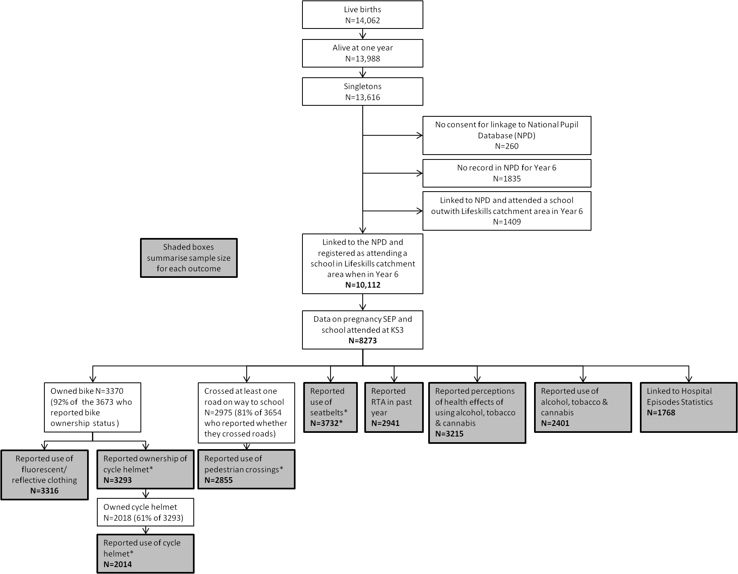
*For these outcomes, multilevel models included both school attended and neighbourhood (LSOA) of residence and so sample is further restricted to those who have data on LSOA of residence (this restriction reduced each sample by approximately 60, compared to when LSOA was not included).

