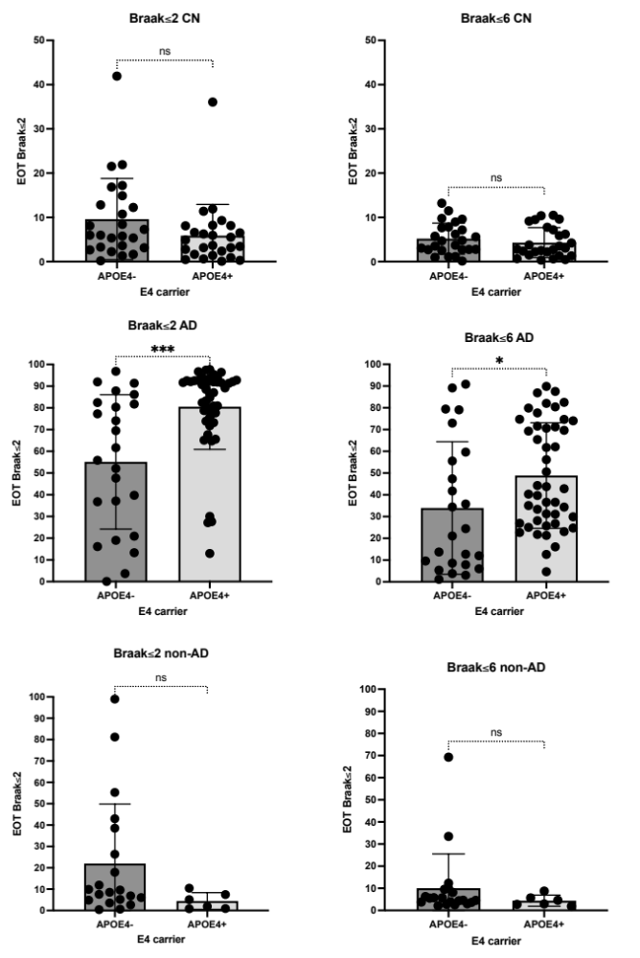

Supplementary material 1 :
Analyzes of the ApoE4 status impact on EOT (extent of tauopathy) in both regions Braak≤2 and Braak≤6 for the CN (cognitively normal), AD (Aß+ MCI and demented subjects) and non-AD (Aß- MCI and demented subjects).

Supplementary material 2 :
Individual detail of the ten subjects with Fronto-temporal degeneration:

Four (out of ten) FTD patients had a behavioral phenotype. They all had negative tau-PET in neocortex, specifically in the frontal cortex. All patients younger than 65 had genetics testing: Mutations were not found for any of those cases.

- FTD1 was a 67-year-old woman with a clinical diagnosis of behavioral FTD. MMSE was 20/30 and while she had episodic memory performance (-1.9 z-scores), she had even worse language (-3.0z) and executive (-4.6z) functions. Her PiB-PET proved negative for amyloidosis (CL=-26.4) and CSF proved normal for both t-tau (262pg/ml) and p-tau (35pg/ml), although Ab42 was below threshold (206pg/ml).

- FTD3 was 61-year-old man with a clinical diagnosis of behavioral FTD. MMSE was 27/30 and neuropsychological assessment demonstrated episodic memory (-2.6 z-scores) and behavioral impairment. CSF was normal for all biomarkers. Tau-PET was negative.

- FTD4 was a 75-year-old woman with a clinical diagnosis of behavioral FTD. MMSE was 27/30 and neuropsychological assessment was within norms for all tests, including executive functions, although behavioral impairment was noted. Her CSF was normal for all biomarkers. FDG-PET confirmed frontal hypometabolism. Tau-PET demonstrated a moderate and isolated uptake in the MTL.

- FTD6 was a 59-year-old man with a clinical diagnosis of behavioral FTD with amyotrophic lateral sclerosis. Genetics analyses came back negative. MMSE was 27/30 and neuropsychological assessment demonstrated language (-2.0 z-scores) and executive (-1.7z) dysfunction while episodic memory was within norms. CSF was normal for Ab42 and p-tau, but t-tau was slightly elevated (387pg/ml, normal<381).

Five (out of ten) FTD patients had primary progressive aphasia. Four had negative tau-PET whereas one was strongly positive in both MTL and neocortex.

- FTD2 was a 67-year-old man with a clinical diagnosis of semantic-variant primary progressive aphasia. MMSE was 15/30 and neuropsychological assessment demonstrated executive dysfunction and very poor fluency (both semantic and lexical) although naming was within norms. His CSF proved negative for Ab42 (826pg/ml) and p-tau (53pg/ml), but slightly positive for t-tau (457pg/ml).

- FTD5 was a 59-year-old woman with a clinical diagnosis of primary progressive aphasia. MMSE was 27/30 and neuropsychological evaluation demonstrated severe language dysfunction including in naming (-3.4 z-scores) and verbal episodic memory (-2.1z) with normal executive functions. Her CSF was normal for both Ab42 and p-tau, although t-tau was measured at 383pg/ml.

- FTD7 was a 57-year-old woman with a clinical diagnosis of primary progressive aphasia with behavioral impairment. Cognitive assessment showed an MMSE=16/30 and severe language dysfunction (-5.8 z-scores). CSF was normal and genetics testing proved negative. Tau-PET was also negative in all regions.

- FTD8: detailed in the manuscript

- FTD10 was a 76-years old man subject. He presented a moderate semantic impairment with -2.76 z-score in language. CSF was normal and tau-PET was completely negative.

One (out of ten) FTD patient presented with amnestic phenotype: FTD8, detailed in the manuscript.

