Supplementary Figure 1. Directed acyclic graph demonstrating the modelling approach used to determine the association between the site-level Ambulance:Escalation Index and mortality.
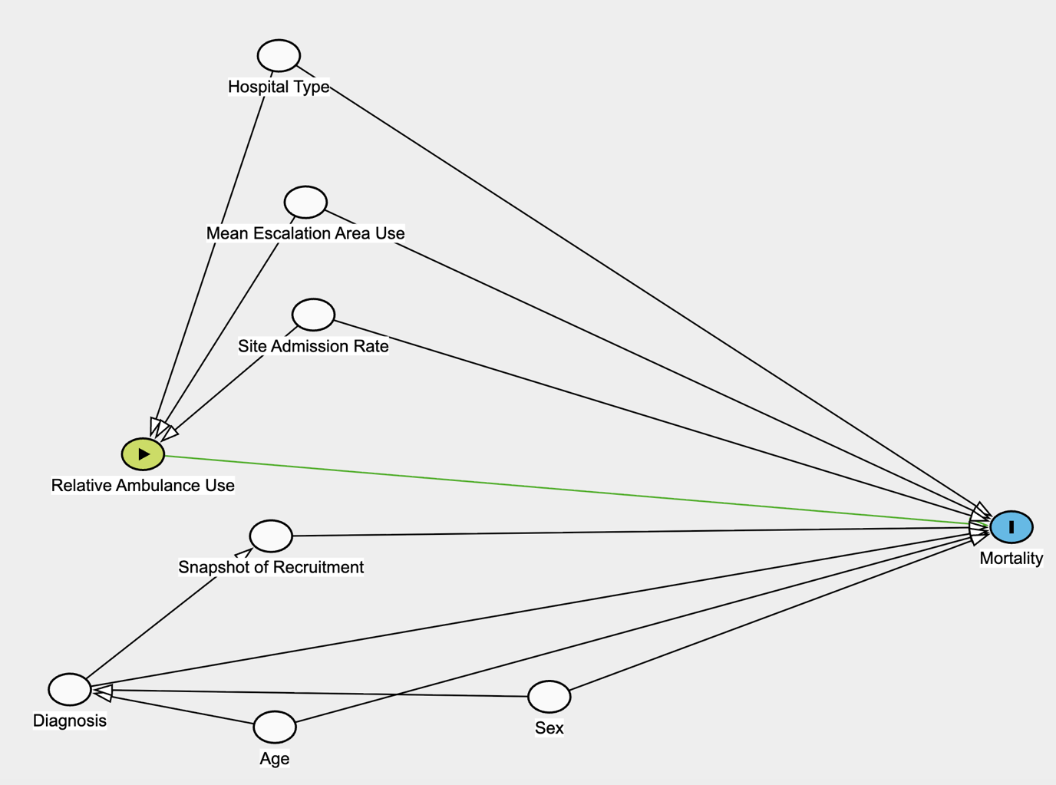

Supplementary 2. Partial effects plot for the penalised-spline Cox model assessing the linearity assumption for the association between the Ambulance:Escalation Index and mortality. Ticks indicate site-level data points.
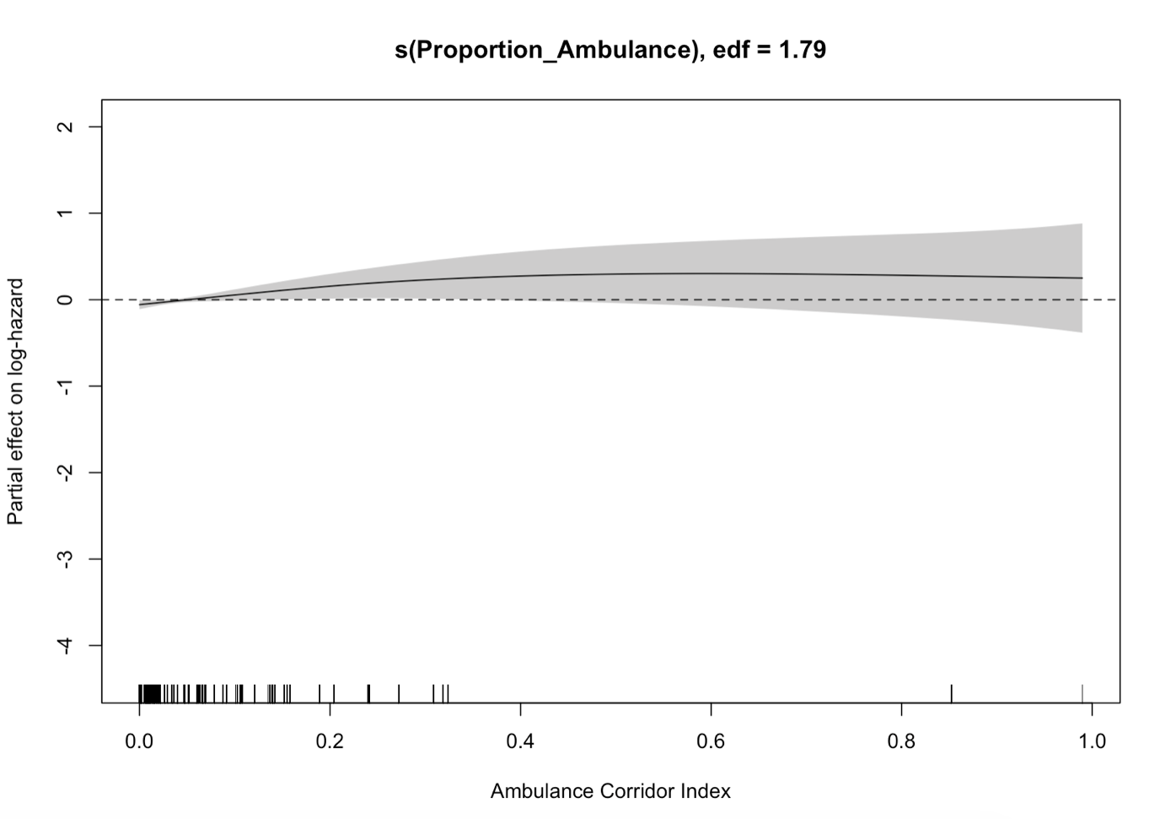

Supplementary Figure 3. Plot for leave-one-out analysis, demonstrating stability of results to single site-level influence.
