Supplementary Material

Bactericidal and biofilm eradication efficacy of a fluorinated benzimidazole derivative, TFBZ, against methicillin-resistant Staphylococcus aureus
Qian Chen^{1†}， Zhihui Dong^{1†}， Xuedi Yao^{1†}， Huan Sun¹， Xin Pan²*， Jikai Liu¹* and Rong Huang¹*
* Correspondence: Xin Pan, px520520@126.com; Jikai Liu, liujikai@mail.scuec.edu.cn; Rong Huang, ronghuang@mail.scuec.edu.cn.

Table of Contents
1 ¹H NMR, ¹³C NMR and ¹⁹F NMR spectra of TFBZ 2
2 High-resolution mass spectra of TFBZ 4
3 Supplementary Figures and Tables 5
3.1 Supplementary Tables 5
3.2 Supplementary Figures 6

¹H NMR, ¹³C NMR and ¹⁹F NMR spectra of TFBZ
¹H NMR (500 MHz, DMSO-d₆) of TFBZ
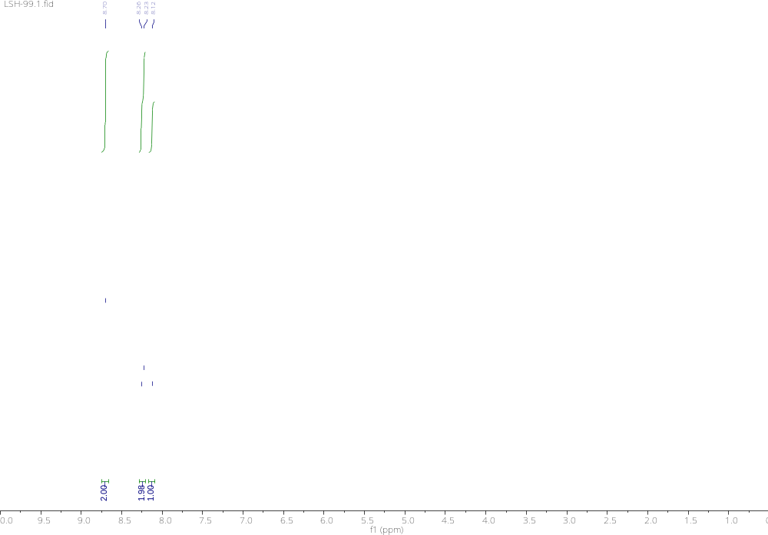

¹³C NMR (125 MHz, DMSO-d₆) of TFBZ
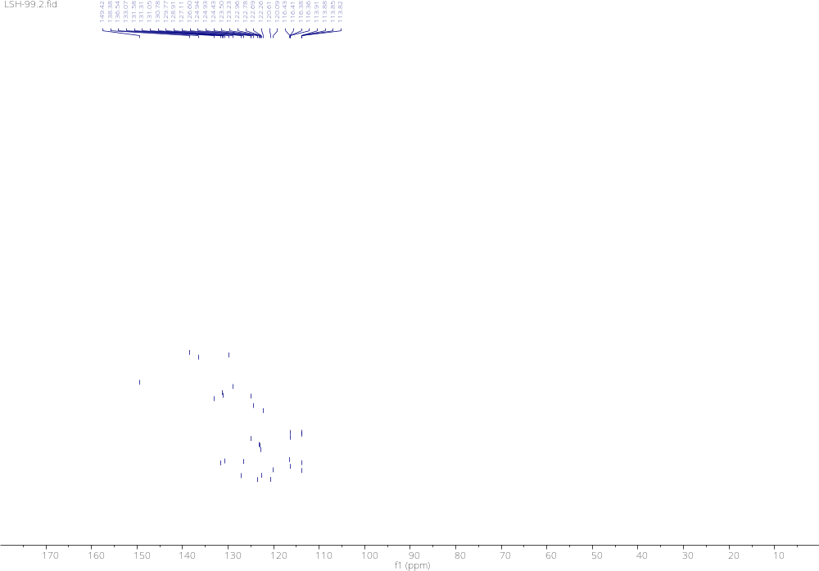
¹⁹F NMR (471 MHz, DMSO-d₆) of TFBZ
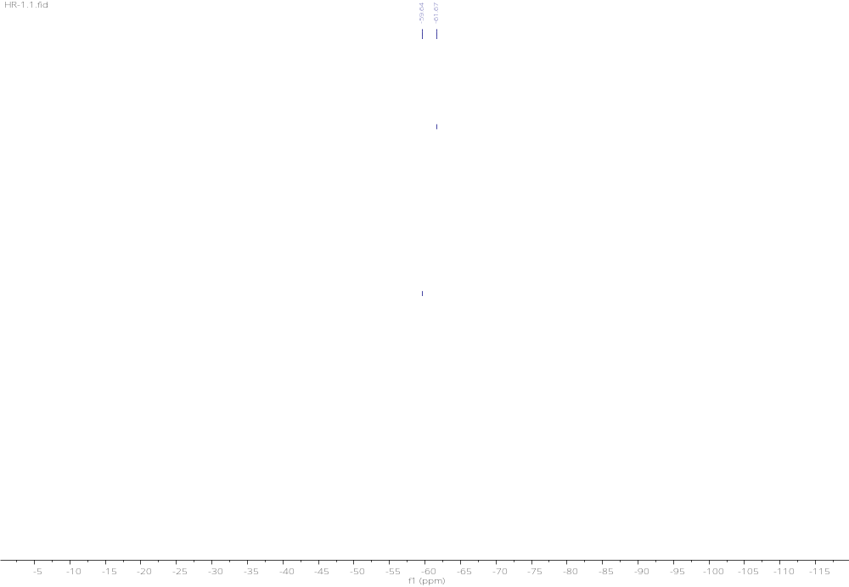

High-resolution mass spectra of TFBZ
High-resolution mass spectrum of TFBZ
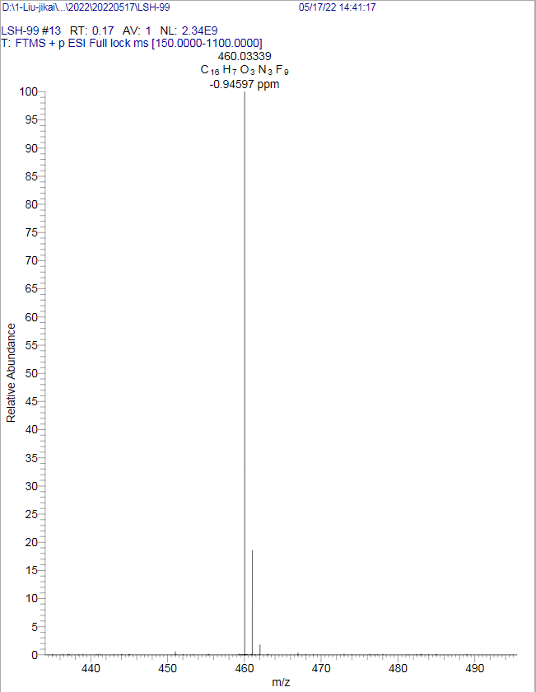

Supplementary Figures and Tables

Supplementary Tables
Supplementary Table 1. Anti-MRSA activity of TFBZ and vancomycin
Compound | MIC(µg/mL) | MBC(µg/mL) | MBEC(µg/mL)
TFBZ | 4 | 8 | 8
Vancomycin | 2 | 4 | -
ª MIC represents minimum inhibitory concentration.
^{b} MBC represents minimum bactericidal concentration.
^{C} MBEC represents minimum biofilm eradication concentration.
Supplementary Table 2. Antibacterial effect of TFBZ against a series of strain
Bacterial strains | MIC₅₀ (μg/mL)
MRSA | 1.15
S. aureus | 0.99
E. coli | 42.95
P. aeruginosa | >64
Salmonella | >64
ª MIC₅₀ represents the minimum inhibitory concentration required to inhibit the growth of 50% of a specific microbial population.
Supplementary Table 3. RT-qPCR Primer sequences
Gene | Primer sequences (5´to 3´)
SdrC | Forward: CCTGCTGGCTTAACACAA  Reverse: AGTCGCTATCTGAGTCTGA
ClfB | Forward: GGAAGTGCTGATGGTGATT  Reverse: TCTGAGTCTGAGTCGCTAT
infC | Forward: CGGTCAAGATGGTGAACAA  Reverse: ACTGGTGGTTTCGCATTC
dltB | Forward: GGTTAGGTGGACATCAGATT  Reverse: ACGATATTCATTGCCTGTTG
MurQ | Forward: GTACTTCTGGTGCTAATGATAC  Reverse: ACGCCATTGCTTCATCAT
MoeA | Forward: AATCAGGTGCGGTTGTAG  Reverse: CAGCGTCAGATTCAGTCA
rplN | Forward: CAGGTGTTCGTCGTAATGA  Reverse: GTACTTCTGGTGCTAATGATAC
icaD | Forward: ATGGTCAAGCCCAGACAGAG  Reverse: AGTATTTTCAATGTTTAAAGCAA
icaA | Forward: ACACTTGCTGGCGCAGTCAA  Reverse: TCTGGAACCAACATCCAACA
16S rDNA | Forward: CGCAATGGGCGAAAGC  Reverse: TACGATCCGAAGACCTTCATCA

Supplementary Figures
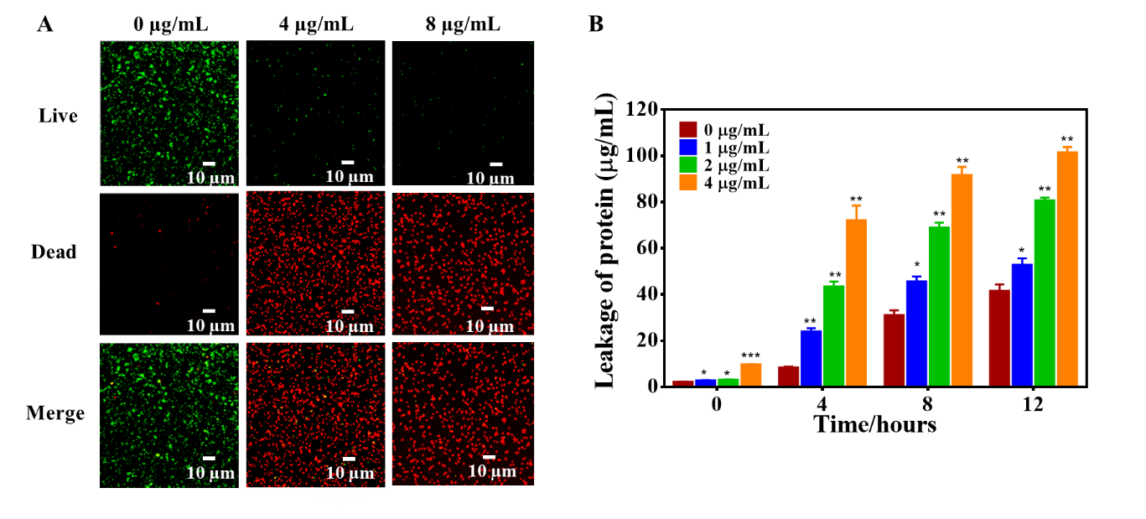Supplementary Figure 1. Effect of TFBZ on planktonic MRSA. (A) Confocal images of MRSA stained with SYTO9 (green) and PI (red) after incubation with TFBZ (0, 4, 8 μg/mL) for 2 h. (B) Protein leakage of MRSA upon exposure to TFBZ (0, 1, 2, 4 μg/mL) on at different time intervals (0, 4, 8 and 12 h).
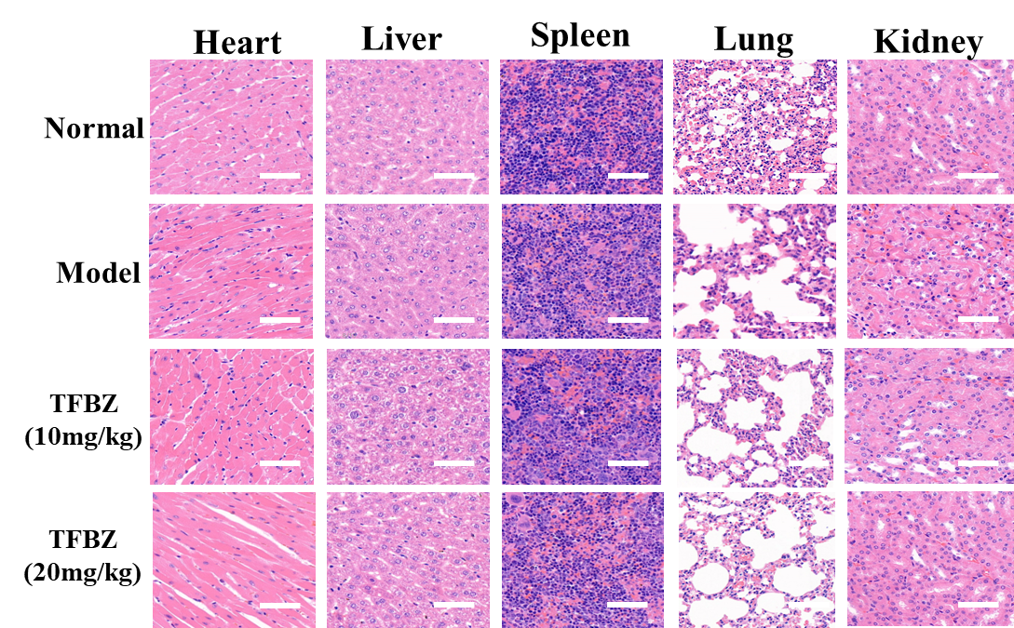
Supplementary Figure 2. Representative H&E staining images of the main organs (heart, liver, spleen, lung, and kidney) collected from mice sacrificed after therapy.

