Supplementary Figure 1 – Age-sex standardised monthly consultation incidence for each health condition
(Epilepsy not presented due to low numbers)
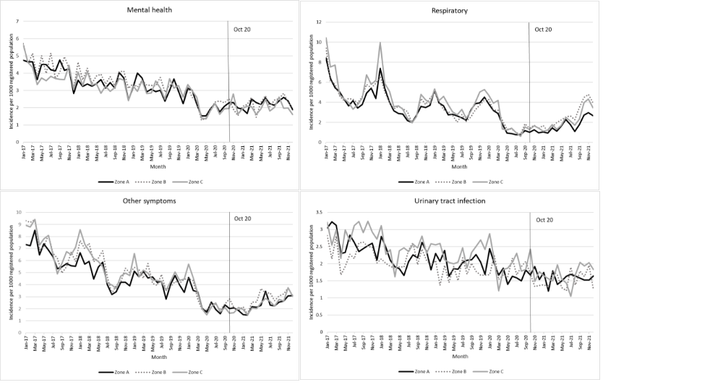
Supplementary Figure 2 – Age-sex standardised monthly consultation incidence vs volume of odour complaints post-October 2020
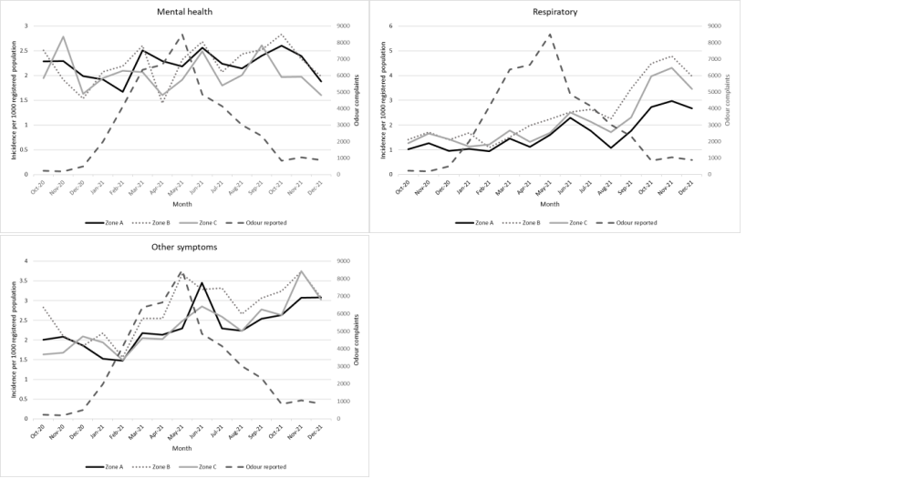

Supplementary Table 1 Associations of zone with consultation prevalence between October-December 2021, split into three periods
 | Zone A vs Zone B  (Zone B is reference) |  |  | Zone A vs Zone C  (Zone C is reference) |  |  | Zone B vs Zone C  (Zone C is reference)
 | RR | Lower 95% CI | Upper 95% CI | RR | Lower 95% CI | Upper 95% CI | RR | Lower 95% CI | Upper 95% CI
October-December 2020
Mental health | 0.82 | 0.71 | 0.94 | 1.04 | 1.03 | 1.05 | 1.26 | 1.11 | 1.44
Respiratory | 0.82 | 0.69 | 0.98 | 0.79 | 0.75 | 0.82 | 0.96 | 0.82 | 1.12
Other symptoms | 0.74 | 0.66 | 0.82 | 0.95 | 0.92 | 0.98 | 1.30 | 1.13 | 1.49
Urinary tract infection | 0.91 | 0.81 | 1.01 | 0.76 | 0.67 | 0.87 | 0.84 | 0.80 | 0.89
Epilepsy | 0.83 | 0.78 | 0.89 | 0.93 | 0.65 | 1.34 | 1.12 | 0.82 | 1.52
January-September 2021
Mental health | 0.87 | 0.84 | 0.90 | 1.16 | 1.11 | 1.21 | 1.33 | 1.28 | 1.38
Respiratory | 0.82 | 0.72 | 0.93 | 0.99 | 0.93 | 1.07 | 0.96 | 0.82 | 1.12
Other symptoms | 0.66 | 0.63 | 0.68 | 0.88 | 0.84 | 0.92 | 1.34 | 1.28 | 1.39
Urinary tract infection | 0.95 | 0.84 | 1.07 | 0.89 | 0.78 | 1.01 | 0.93 | 0.89 | 0.98
Epilepsy | 0.93 | 0.80 | 1.08 | 1.37 | 1.10 | 1.71 | 1.48 | 1.21 | 1.81
October-December 2021
Mental health | 0.82 | 0.79 | 0.85 | 1.12 | 1.06 | 1.18 | 1.37 | 1.25 | 1.49
Respiratory | 0.74 | 0.70 | 0.78 | 0.80 | 0.74 | 0.86 | 1.08 | 1.05 | 1.11
Other symptoms | 0.66 | 0.65 | 0.68 | 0.81 | 0.79 | 0.83 | 1.22 | 1.18 | 1.26
Urinary tract infection | 0.80 | 0.70 | 0.91 | 0.77 | 0.67 | 0.88 | 0.96 | 0.94 | 0.98
Epilepsy | 0.78 | 0.52 | 1.17 | 1.20 | 1.08 | 1.34 | 1.55 | 0.98 | 2.45
Age-sex standardised. RR=risk ratio adjusted for consultations rates January 2017-September 2020

Supplementary Table 2 Associations of zone with consultation incidence between October-December 2021, split into three periods
 | Zone A vs Zone B  (Zone B is reference) |  |  | Zone A vs Zone C  (Zone C is reference) |  |  | Zone B vs Zone C  (Zone C is reference)
 | RR | Lower 95% CI | Upper 95% CI | RR | Lower 95% CI | Upper 95% CI | RR | Lower 95% CI | Upper 95% CI
October-December 2020
Mental health | 1.10 | 0.92 | 1.32 | 1.03 | 0.83 | 1.28 | 0.94 | 0.68 | 1.29
Respiratory | 0.71 | 0.69 | 0.74 | 0.74 | 0.68 | 0.81 | 1.04 | 0.99 | 1.09
Other symptoms | 0.88 | 0.73 | 1.07 | 1.10 | 0.92 | 1.32 | 1.25 | 0.91 | 1.72
Urinary tract infection | 1.17 | 0.97 | 1.41 | 0.91 | 0.67 | 1.22 | 0.78 | 0.69 | 0.87
Epilepsy | 1.06 | 0.52 | 2.15 | 0.58 | 0.24 | 1.43 | 0.55 | 0.14 | 2.11
January-September 2021
Mental health | 0.98 | 0.88 | 1.09 | 1.07 | 0.97 | 1.19 | 1.10 | 1.03 | 1.17
Respiratory | 0.67 | 0.57 | 0.79 | 0.83 | 0.77 | 0.89 | 1.23 | 1.08 | 1.39
Other symptoms | 0.81 | 0.72 | 0.91 | 0.98 | 0.91 | 1.07 | 1.21 | 1.14 | 1.30
Urinary tract infection | 1.03 | 0.93 | 1.15 | 0.98 | 0.84 | 1.14 | 0.95 | 0.82 | 1.11
Epilepsy | 1.72 | 1.24 | 2.38 | 1.60 | 1.02 | 2.51 | 0.93 | 0.53 | 1.65
October-December 2021
Mental health | 0.96 | 0.91 | 1.02 | 1.24 | 1.17 | 1.31 | 1.29 | 1.16 | 1.43
Respiratory | 0.63 | 0.60 | 0.66 | 0.71 | 0.67 | 0.76 | 1.13 | 1.11 | 1.15
Other symptoms | 0.87 | 0.79 | 0.97 | 0.93 | 0.83 | 1.05 | 1.07 | 0.96 | 1.18
Urinary tract infection | 0.97 | 0.76 | 1.24 | 0.81 | 0.74 | 0.88 | 0.83 | 0.71 | 0.97
Epilepsy | 2.48 | 1.14 | 5.43 | 1.04 | 0.42 | 2.61 | 0.42 | 0.28 | 0.64
Age-sex standardised. RR=risk ratio adjusted for consultations rates January 2017-September 2020

