Genomic evidence that governmentally produced Cannabis sativa poorly represents genetic variation available in state markets
Daniela Vergara^{1*}, Ezra L. Huscher¹⁺, Kyle G. Keepers¹⁺, Rahul B. Pisupati², Anna L. Schwabe³, Mitchell E. McGlaughlin³, and Nolan C. Kane^{1*}

¹Kane Laboratory, Department of Ecology and Evolutionary Biology, University of Colorado Boulder, Boulder, Colorado, USA
² Gregor Mendel Institute (GMI), Austrian Academy of Sciences, Vienna Biocenter (VBC), Dr. Bohr-Gasse 3, 1030 Vienna, Austria
³ University of Northern Colorado, School of Biological Sciences, Greeley, CO 80639, USA.
+Authors that contributed equally

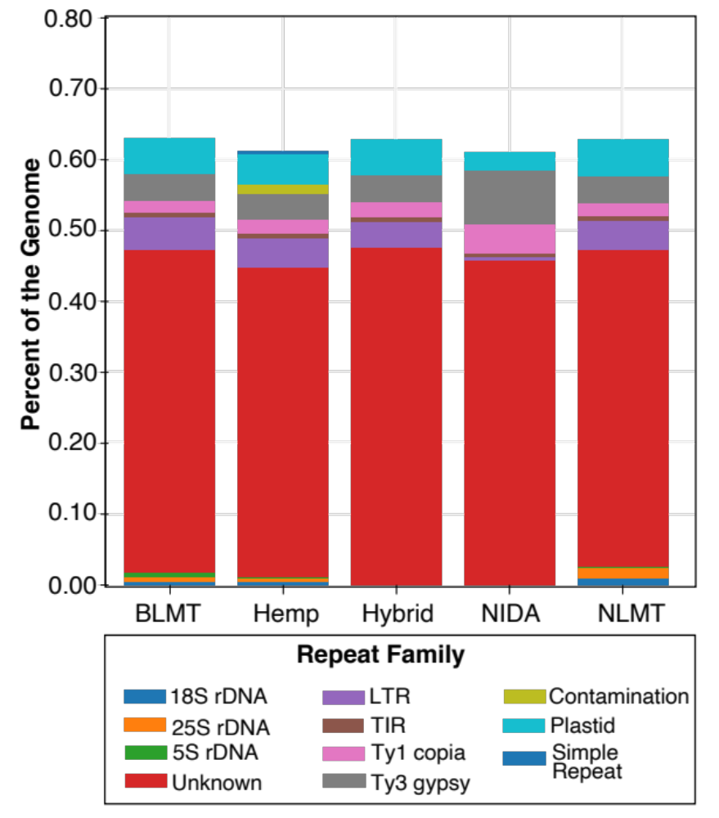
Supporting Information Figure S1. Repetitive content characterization. The graph based clustering algorithm Repeat Explorer characterized the percentage of the genome that belong to the different repeat families. Exact numbers in table S4.

Supporting Information Table S1. Genetic and genomic information. Cultivar name (column 1), Sample ID (column 2), classification based on Structure (Column 3), NCBI accession number (column 4), provider (column 5), genome calculations (columns 6-10), haplotype groups (columns 11-12), heterozygosity calculations (columns 13-20), PCA (columns 21-40), cannabinoid loci statistics (columns 41-76), olivetolic acid synthase statistics (columns 77-82), olivetolate geranyltransferase statistics (columns 83-85).
Supporting Information Table S2. Population assignment probability. Sructure’s population assignment probability. Individuals with an assignment probability of <60% to any group were assigned to the ‘hybrid’ grouping.
Supporting Information Table S3. Cannabinoid BLAST results. Cannabinoid BLAST results to the Cs10 assembly with more than 80% identity and an alignment length of greater than 1000bp.
Supporting Information Table S4. Repeat Families. Different families based on the clustering algorithm used in Repeat Explorer.

