Appendix A
Figure A.1 The THC Unit by Product Category
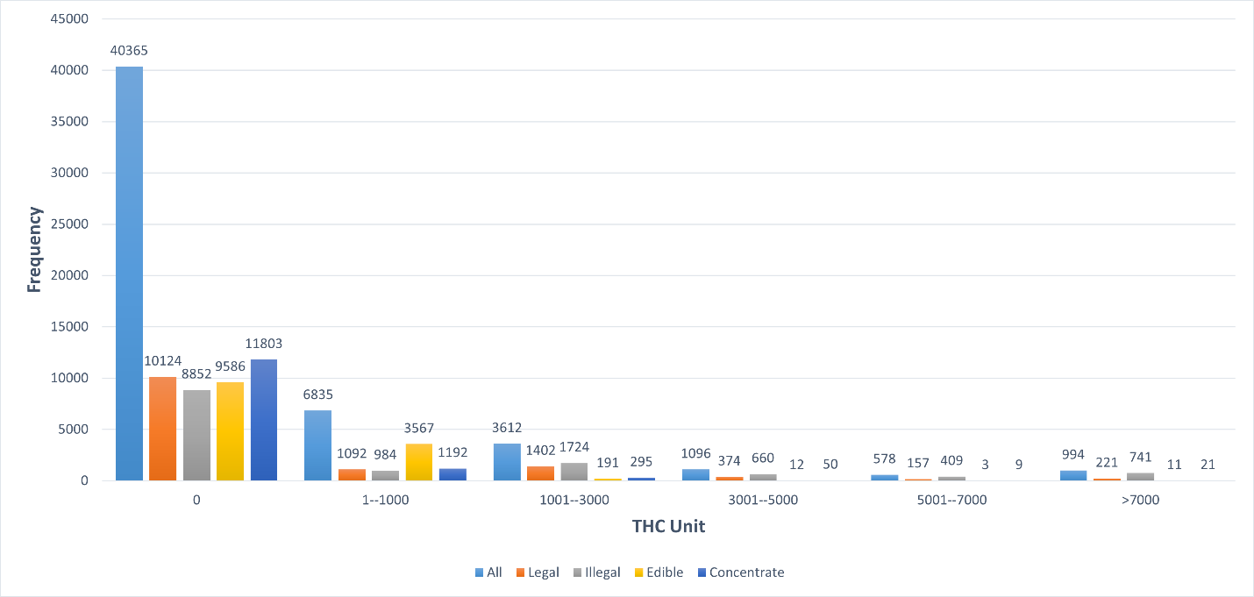
Notes: In Figure A.1, for all categories, the average THC unit is 668, with a standard deviation of 3,935.65; 75.48% observations have zero THC unit. For legal flower consumption, the average THC unit is 740 (SD: 4,229.39); For illegal flower consumption, the average THC unit is 1649.20 (SD: 6,306.49); For Edible, the average THC unit is 104.97 (SD: 510.63); For Concentrate, the average THC unit is 177.37 (SD: 1,585.74).
Figure A.2 The Unit by Product Category
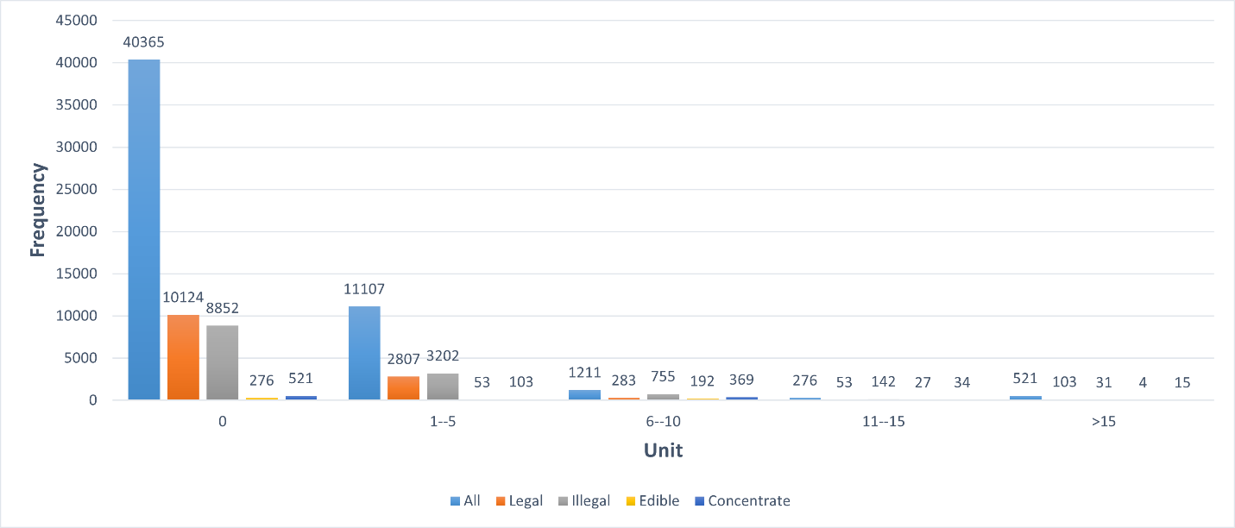
Notes: In Figure A.2, for all categories, the average unit is 1.02, with a standard deviation of 5.30; 75.48% observations have zero units. For legal flower consumption, the average unit is 0.96 (SD: 4.96); For illegal flower consumption, the average unit is 2.22 (SD: 8.67); For edible, the average unit is 0.64 (SD: 2.24); For Concentrate, the average unit is 0.24 (SD: 2.29).

Table A.1: Summary Statistics (Observation = 1,525)
VARIABLES | Percent/Mean (SD)
Sociodemographic Factors
Age | 48.80 (15.30)
Gender
Female | 45.70%
Male | 53.97%
Do not know | 0.33%
Race/Ethnicity
White, non-Hispanic | 72.66%
Black, non-Hispanic | 11.02%
Other, non-Hispanic | 1.44%
Hispanic | 10.75%
2+ Races, non-Hispanic | 4.13%
Education
No High School or GED | 5.77%
High School Graduate | 20.33%
Some College | 32.26%
Bachelor’s Degree or Higher | 41.64%
Household Income
Less than $10,000 | 4.59%
$10,000 to $24,999 | 11.41%
$25,000 to $49,999 | 17.51%
$50,000 to $74,999 | 14.95%
$75,000 to $99,999 | 14.03%
$100,000 to $149,999 | 16.72%
$150,000 or more | 20.79%
Cannabis use and spending
Monthly Cannabis Expenditure | 118.41 (172.35)
% expenditure spent by forms
Flowers | 46.87%
Edibles | 27.76%
Cartridges | 13.21%
Others | 12.16%
Daily use | 54.07%
All purchases are from legal sources | 54.30%

Table A.2: Other Factors Contributing to Cannabis Consumption, Estimated Using
Zero-Inflated Negative Binomial Regressions, N=53,480

 |  | (1) |  | (2) |  | (3) |  |  | (4)
VARIABLES |  | Outcome = Unit |  |  |  | Outcome = THC Unit
Within-Subject Effects:
Product Constant (Base: Legal Flower)
Illegal Flower |  | 0.544*** |  | 0.588*** |  | 0.576*** |  |  | 0.609***
 |  | (0.080) |  | (0.064) |  | (0.075) |  |  | (0.059)
Edible |  | -0.130 |  | -0.046 |  | -2.030*** |  |  | -1.940***
 |  | (0.105) |  | (0.078) |  | (0.099) |  |  | (0.074)
Cartridge |  | -1.452*** |  | -1.404*** |  | -1.569*** |  |  | -1.522***
 |  | (0.108) |  | (0.088) |  | (0.102) |  |  | (0.084)
Between-Subject Effects:
Expenditures |  | 0.430*** |  | 0.448*** |  | 0.373*** |  |  | 0.386***
 |  | (0.027) |  | (0.027) |  | (0.033) |  |  | (0.034)
Age |  | -0.037 |  | -0.073 |  | 0.074 |  |  | 0.047
 |  | (0.130) |  | (0.099) |  | (0.103) |  |  | (0.077)
Gender (Base: Male)
Female |  | 0.118 |  | 0.129* |  | 0.103 |  |  | 0.112*
 |  | (0.075) |  | (0.054) |  | (0.061) |  |  | (0.045)
Not Reported |  | 0.331 |  | 0.340 |  | 0.006 |  |  | -0.028
 |  | (0.325) |  | (0.345) |  | (0.217) |  |  | (0.238)
Race and Ethnicity (Base: White, Non-Hispanic)
Black, non-Hispanic |  | 0.323* |  | 0.265* |  | 0.076 |  |  | 0.062
 |  | (0.130) |  | (0.111) |  | (0.099) |  |  | (0.082)
Other, non-Hispanic |  | -0.061 |  | -0.033 |  | -0.012 |  |  | 0.003
 |  | (0.159) |  | (0.128) |  | (0.149) |  |  | (0.131)
Hispanic |  | 0.225 |  | 0.143 |  | 0.093 |  |  | 0.007
 |  | (0.143) |  | (0.095) |  | (0.123) |  |  | (0.083)
2+ Races, non-Hispanic |  | -0.058 |  | -0.058 |  | 0.104 |  |  | 0.124
 |  | (0.118) |  | (0.121) |  | (0.116) |  |  | (0.116)
Household Income (Base: Less than $10,000)
$10,000 to $24,999 |  | -0.440 |  | -0.401 |  | -0.239 |  |  | -0.213
 |  | (0.291) |  | (0.218) |  | (0.209) |  |  | (0.170)
$25,000 to $49,999 |  | -0.501 |  | -0.444* |  | -0.298 |  |  | -0.254
 |  | (0.260) |  | (0.185) |  | (0.179) |  |  | (0.146)
$50,000 to $74,999 |  | -0.232 |  | -0.285 |  | -0.101 |  |  | -0.188
 |  | (0.294) |  | (0.209) |  | (0.215) |  |  | (0.153)
$75,000 to $99,999 |  | -0.301 |  | -0.337 |  | -0.165 |  |  | -0.192
 |  | (0.270) |  | (0.191) |  | (0.192) |  |  | (0.145)
$100,000 to $149,999 |  | -0.236 |  | -0.194 |  | -0.153 |  |  | -0.124
 |  | (0.273) |  | (0.202) |  | (0.187) |  |  | (0.152)
$150,000 or more |  | -0.359 |  | -0.273 |  | -0.313 |  |  | -0.224
 |  | (0.263) |  | (0.197) |  | (0.178) |  |  | (0.146)
Education (Base: No High School Diploma or GED)
High School Graduate |  | -0.067 |  | -0.178 |  | 0.093 |  |  | -0.036
 |  | (0.183) |  | (0.146) |  | (0.159) |  |  | (0.130)
Some College |  | -0.452** |  | -0.420*** |  | -0.342** |  |  | -0.341***
 |  | (0.141) |  | (0.124) |  | (0.110) |  |  | (0.102)
Bachelor's or higher |  | -0.402** |  | -0.400** |  | -0.321** |  |  | -0.345**
 |  | (0.156) |  | (0.135) |  | (0.121) |  |  | (0.108)
State Fixed Effects |  | No |  | Yes |  | No |  |  | Yes
Note: Semi-elasticities are reported for categorical variables. Standard errors clustered at the individual level are in parentheses * p < 0.05, ** p < 0.01, *** p < 0.001

Table A.3: Own- and Cross-Price Elasticities of Demand Among Different
Cannabis Forms, Estimated using Zero-Inflated Negative Binomial Regressions, N=53,480

 |  | (1) |  | (2) |  | (3) |  |  | (4)
VARIABLES |  | Outcome = Unit |  |  |  | Outcome = THC Unit
Within-Subject Effects:
Product Constant (Base: Legal Flower)
Illegal Flower |  | 0.697* |  | 0.590* |  | 0.269 |  |  | 0.297
 |  | (0.304) |  | (0.240) |  | (0.220) |  |  | (0.205)
Edible |  | -0.425 |  | -0.481 |  | -1.298*** |  |  | -1.101***
 |  | (1.157) |  | (0.293) |  | (0.267) |  |  | (0.235)
Cartridge |  | -0.772 |  | -0.194 |  | -0.802** |  |  | -0.908***
 |  | (0.633) |  | (0.422) |  | (0.304) |  |  | (0.253)
THC Levels (Base: 10%)
15% |  | 0.166** |  | 0.110 |  | 0.738*** |  |  | 0.716***
 |  | (0.052) |  | (0.061) |  | (0.059) |  |  | (0.047)
25% |  | 0.246*** |  | 0.210*** |  | 1.320*** |  |  | 1.323***
 |  | (0.048) |  | (0.053) |  | (0.050) |  |  | (0.041)
30% |  | 0.386*** |  | 0.344*** |  | 2.092*** |  |  | 2.076***
 |  | (0.053) |  | (0.055) |  | (0.058) |  |  | (0.048)
Between-Subject Effects:
Bases of Tax Imposed (Base: Weight)
Price |  | 0.106 |  | 0.124 |  | 0.168* |  |  | 0.098
 |  | (0.090) |  | (0.087) |  | (0.085) |  |  | (0.065)
THC |  | -0.006 |  | 0.081 |  | 0.054 |  |  | 0.021
 |  | (0.088) |  | (0.094) |  | (0.083) |  |  | (0.071)
Expenditures |  | 0.430*** |  | 0.303*** |  | 0.373*** |  |  | 0.386***
 |  | (0.027) |  | (0.022) |  | (0.033) |  |  | (0.034)
Age |  | -0.050 |  | 0.074 |  | 0.061 |  |  | 0.046
 |  | (0.125) |  | (0.146) |  | (0.099) |  |  | (0.077)
Gender (Base: Male)
Female |  | 0.118 |  | 0.129* |  | 0.103 |  |  | 0.112*
 |  | (0.075) |  | (0.054) |  | (0.061) |  |  | (0.045)
Not Reported |  | 0.331 |  | 0.340 |  | 0.006 |  |  | -0.028
 |  | (0.325) |  | (0.345) |  | (0.217) |  |  | (0.238)
Race and Ethnicity (Base: White, Non-Hispanic)
Black, non-Hispanic |  | 0.323* |  | 0.021 |  | 0.084 |  |  | 0.065
 |  | (0.126) |  | (0.153) |  | (0.097) |  |  | (0.081)
Other, non-Hispanic |  | -0.027 |  | 0.085 |  | 0.016 |  |  | 0.018
 |  | (0.159) |  | (0.221) |  | (0.144) |  |  | (0.128)
Hispanic |  | 0.239 |  | -0.068 |  | 0.101 |  |  | 0.005
 |  | (0.139) |  | (0.221) |  | (0.122) |  |  | (0.083)
2+ Races, non-Hispanic |  | -0.039 |  | 0.171 |  | 0.128 |  |  | 0.147
 |  | (0.119) |  | (0.202) |  | (0.119) |  |  | (0.119)
Household Income (Base: Less than $10,000)
$10,000 to $24,999 |  | -0.428 |  | -0.262 |  | -0.221 |  |  | -0.190
 |  | (0.278) |  | (0.264) |  | (0.203) |  |  | (0.169)
$25,000 to $49,999 |  | -0.488 |  | -0.326 |  | -0.280 |  |  | -0.239
 |  | (0.251) |  | (0.244) |  | (0.176) |  |  | (0.146)
$50,000 to $74,999 |  | -0.218 |  | -0.073 |  | -0.080 |  |  | -0.168
 |  | (0.283) |  | (0.270) |  | (0.211) |  |  | (0.153)
$75,000 to $99,999 |  | -0.298 |  | -0.126 |  | -0.155 |  |  | -0.180
 |  | (0.257) |  | (0.236) |  | (0.186) |  |  | (0.145)
$100,000 to $149,999 |  | -0.227 |  | -0.214 |  | -0.144 |  |  | -0.116
 |  | (0.263) |  | (0.240) |  | (0.183) |  |  | (0.151)
$150,000 or more |  | -0.343 |  | -0.225 |  | -0.295 |  |  | -0.204
 |  | (0.253) |  | (0.230) |  | (0.176) |  |  | (0.146)
Education (Base: No High School Diploma or GED)
High School Graduate |  | -0.075 |  | 0.066 |  | 0.121 |  |  | -0.012
 |  | (0.176) |  | (0.192) |  | (0.156) |  |  | (0.130)
Some College |  | -0.450** |  | -0.253 |  | -0.315** |  |  | -0.316**
 |  | (0.138) |  | (0.141) |  | (0.108) |  |  | (0.103)
Bachelor or higher |  | -0.414** |  | -0.289 |  | -0.301* |  |  | -0.322**
 |  | (0.152) |  | (0.159) |  | (0.119) |  |  | (0.108)
State Fixed Effects |  | No |  | Yes |  | No |  |  | Yes
Standard errors in parentheses
* p < 0.05, ** p < 0.01, *** p < 0.001

Table A.4: Subgroup Analyses of the Impacts of Attributes on THC Consumption, Estimated Using ZINB Regressions
 | (1) |  | (2) |  | (3) |  |  | (4)
GROUP | Daily |  | Nondaily |  | 21-40 |  |  | >40
N | 28,724 |  | 24,684 |  | 18,960 |  |  | 34,520
Within-Subject Effects:
Pre-Tax Price Levels (Base: $10 for flowers and edibles; $ 20 for cartridges)
100% increase | -0.538*** |  | -0.551*** |  | -0.590*** |  |  | -0.503***
 | (0.038) |  | (0.034) |  | (0.043) |  |  | (0.032)
200% increase | -0.955*** |  | -0.906*** |  | -1.043*** |  |  | -0.851***
 | (0.046) |  | (0.047) |  | (0.054) |  |  | (0.041)
300% increase | -1.241*** |  | -1.179*** |  | -1.400*** |  |  | -1.094***
 | (0.065) |  | (0.059) |  | (0.072) |  |  | (0.057)
THC Levels (Base: low)
Medium low | 0.734*** |  | 0.744*** |  | 0.745*** |  |  | 0.701***
 | (0.060) |  | (0.059) |  | (0.069) |  |  | (0.055)
Medium high | 1.385*** |  | 1.298*** |  | 1.278*** |  |  | 1.375***
 | (0.054) |  | (0.055) |  | (0.060) |  |  | (0.054)
High | 1.892*** |  | 2.121*** |  | 1.947*** |  |  | 1.978***
 | (0.058) |  | (0.062) |  | (0.069) |  |  | (0.055)
Tax Levels (Base: 20% or equivalent)
40% or equivalent | -0.194** |  | -0.231*** |  | -0.265*** |  |  | -0.157**
 | (0.061) |  | (0.064) |  | (0.062) |  |  | (0.059)
60% or equivalent | -0.286*** |  | -0.348*** |  | -0.277*** |  |  | -0.343***
 | (0.048) |  | (0.042) |  | (0.053) |  |  | (0.040)
80% or equivalent | -0.351*** |  | -0.407*** |  | -0.402*** |  |  | -0.338***
 | (0.050) |  | (0.053) |  | (0.062) |  |  | (0.043)
Between-Subject Effects:
Bases of Tax Imposed (Base: Weight)
Price | 0.123 |  | 0.045 |  | 0.112 |  |  | 0.154
 | (0.080) |  | (0.098) |  | (0.097) |  |  | (0.080)
THC | 0.070 |  | -0.099 |  | 0.109 |  |  | 0.017
 | (0.086) |  | (0.103) |  | (0.100) |  |  | (0.088)
Notes: State fixed effects and other covariates are controlled for. Marginal effects or semi-elasticities estimated using eydx are reported. Standard errors clustered at the individual levels are in parentheses. * p < 0.05, ** p < 0.01, *** p < 0.001.

Table A.5: Economic Relationship Based on THC Consumption between Different Forms in the Matrix.
Price  Consumption | Legal flowers | Illegal flowers | Edibles | Cartridges
Legal flowers | Reduction | Substitutes
Illegal flowers | Substitutes | Reduction |  | Substitutes
Edibles | Complements | Complements | Reduction | Complements
Cartridges |  | Complements |  | Reduction
Matrix of relationships based on Table 3, Column 4.

