Supplementary Materials
Davis et al., Education shares distinct genetic influences with substance use and disorder

Supplementary Figures 2
Supplementary Figure 1. Bivariate MiXeR results for educational attainment (EA) and alcohol-related traits. 2
Supplementary Figure 2. Bivariate MiXeR results for educational attainment (EA) and cannabis-related traits. 3
Supplementary Figure 3. Miami plots of alcohol-related traits and educational attainment. 4
Supplementary Figure 4. Miami plots of cannabis-related traits and educational attainment 5
Supplementary Figure 5. Gene-based Manhattan plot for alcohol-related traits with educational attainment. 6
Supplementary Figure 6. Gene-based Manhattan plot for alcohol-related traits with the cognitive components of educational attainment. 7
Supplementary Figure 7. Gene-based Manhattan plot for alcohol-related traits with the non-cognitive components of educational attainment. 8
Supplementary Figure 8. Gene-based Manhattan plot for cannabis-related traits with educational attainment. 9
Supplementary Figure 9. Gene-based Manhattan plot for cannabis-related traits with the cognitive aspects of educational attainment. 10
Supplementary Figure 10. Gene-based Manhattan plot for cannabis-related traits with the non-cognitive aspects of educational attainment. 11
Supplementary Figure 11. MAGMA results of BrainSpan 11 different developmental ages for each joint analysis. 12
Supplementary Figure 12. MAGMA results of GTEx v8 30 tissue types for each joint analysis. 13
Supplementary Figure 13. MAGMA results of GTEx v8 53 tissue types for each joint analysis. 14

Supplementary Figures

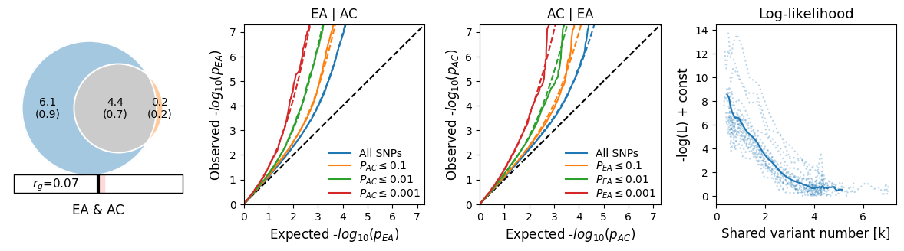

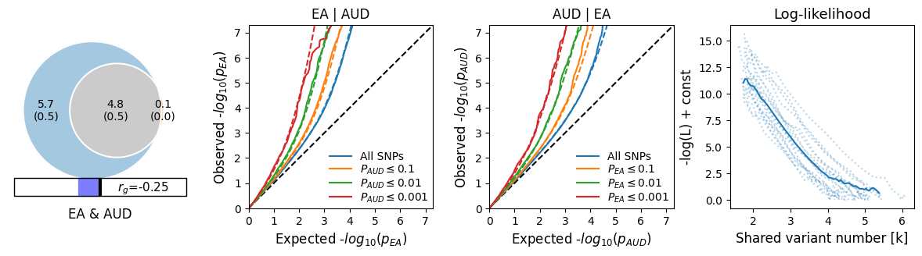

Supplementary Figure 1. Bivariate MiXeR results for educational attainment (EA) and alcohol-related traits.
Note: EA = educational attainment, AC = alcohol consumption, AUD = alcohol use disorder.

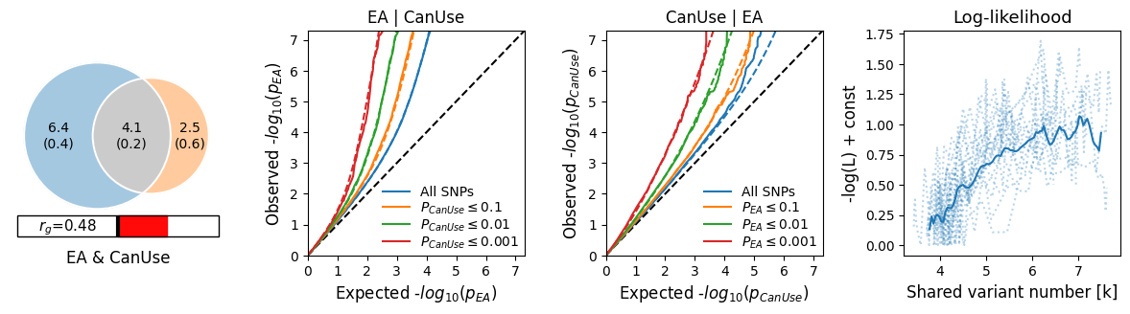

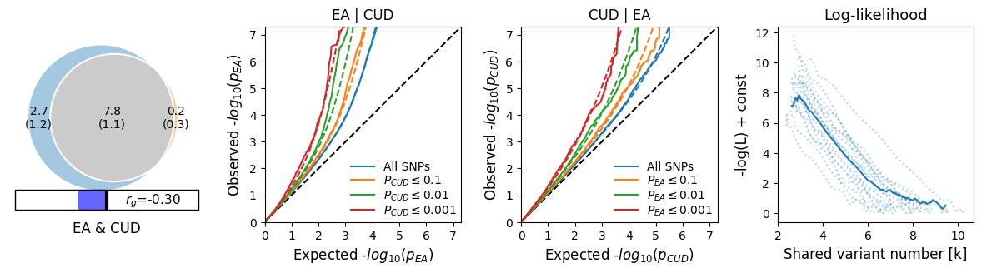

Supplementary Figure 2. Bivariate MiXeR results for educational attainment (EA) and cannabis-related traits.
Note: EA = educational attainment, CanUse = lifetime cannabis use, CUD = cannabis use disorder.

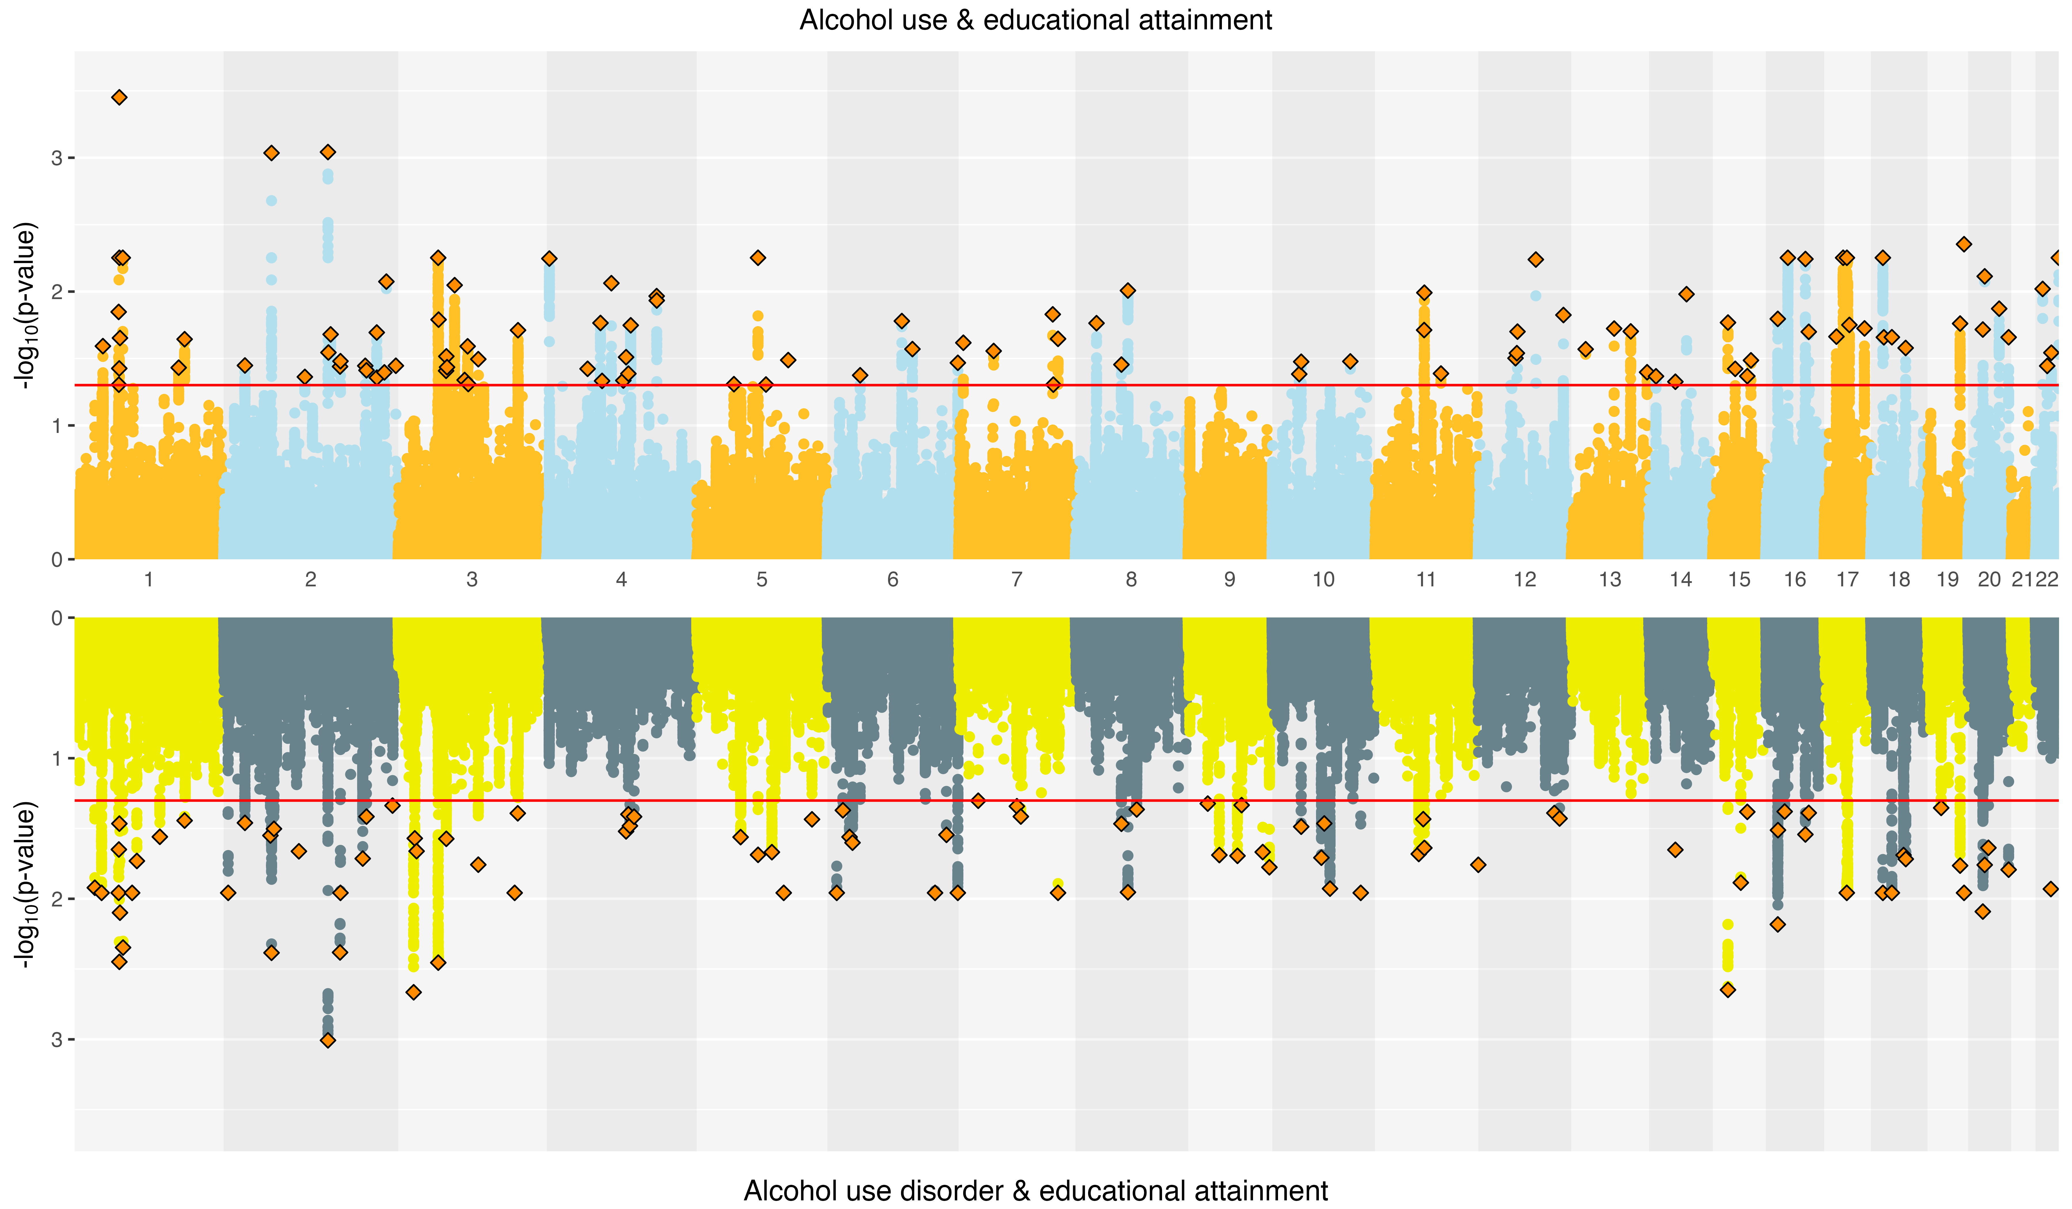

Supplementary Figure 3. Miami plots of alcohol-related traits and educational attainment.
Note: Log₁₀-transformed conjFDR values for each SNP are on the y axes and chromosomal positions are on the x axes. The horizontal line is the threshold for significant shared associations of alcohol use and alcohol use disorder with educational attainment (conjFDR <0.05). Independent lead SNPs are outlined diamonds.
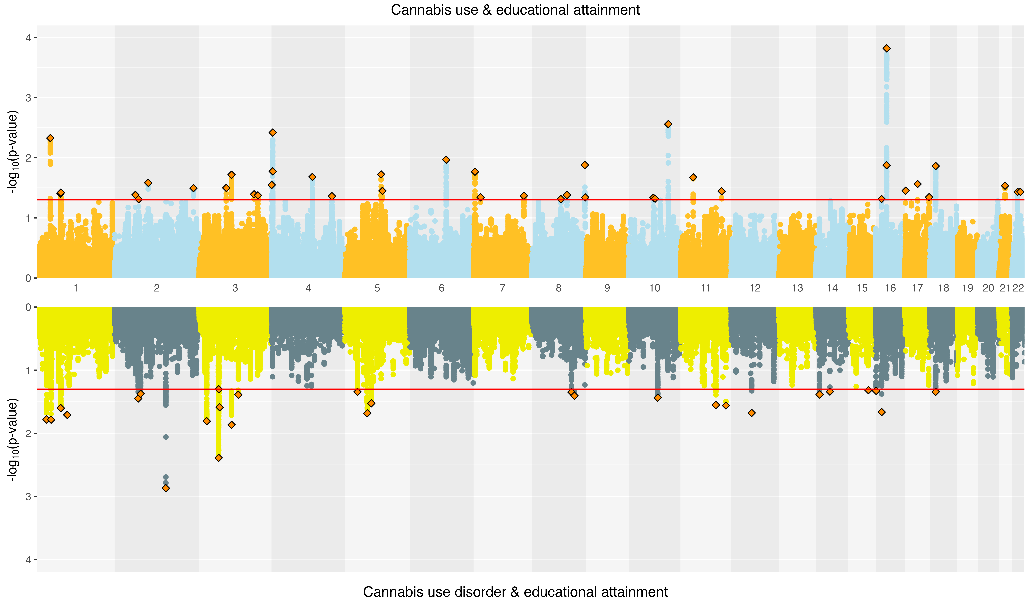

Supplementary Figure 4. Miami plots of cannabis-related traits and educational attainment
Note: Log₁₀-transformed conjFDR values for each SNP are on the y axes and chromosomal positions are on the x axes. The horizontal line is the threshold for significant shared associations of cannabis use and cannabis use disorder with educational attainment (conjFDR <0.05). Independent lead SNPs are outlined diamonds.
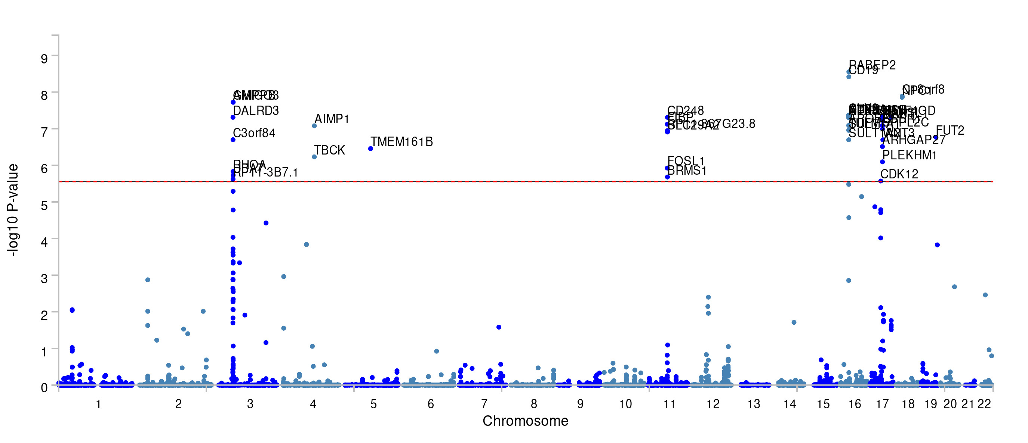

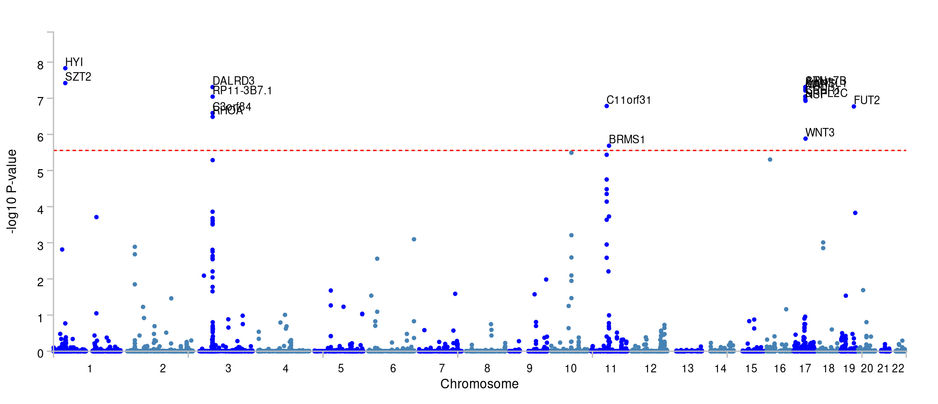

Supplementary Figure 5. Gene-based Manhattan plot for alcohol-related traits with educational attainment.
Note: The top panel displays results for the joint SNP-level associations of alcohol consumption (AC) and educational attainment (EA), while the bottom panel shows results for alcohol use disorder (AUD) and EA.
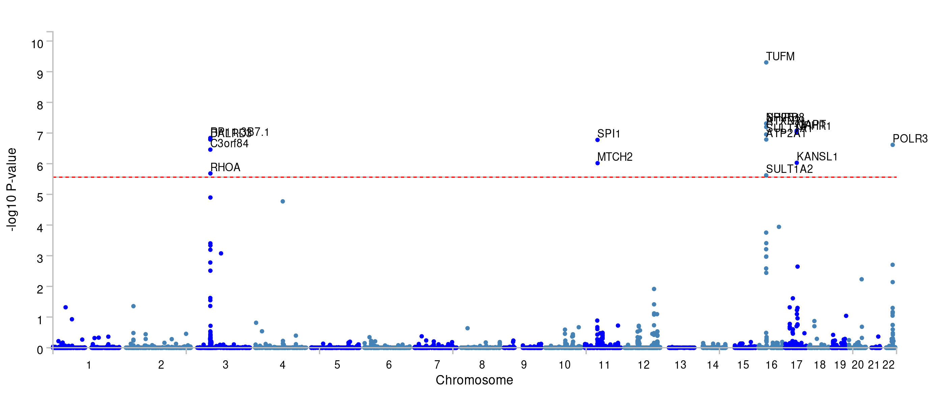

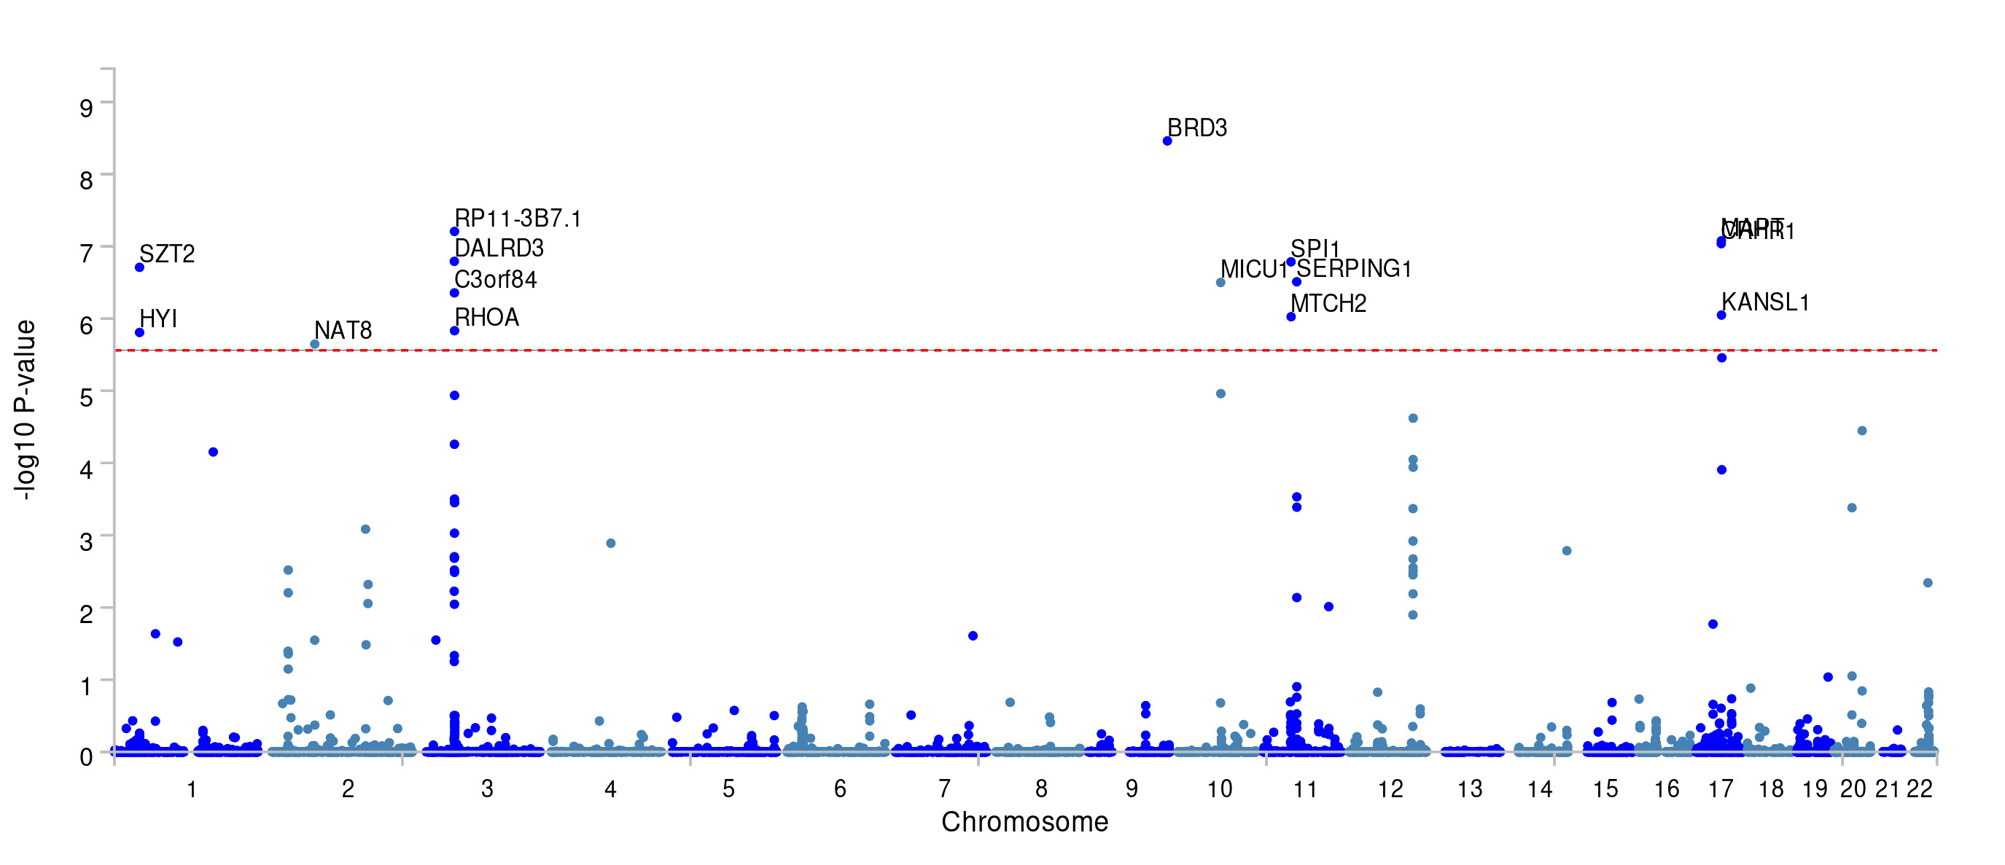

Supplementary Figure 6. Gene-based Manhattan plot for alcohol-related traits with the cognitive components of educational attainment.
Note: The top panel displays results for the joint SNP-level associations of alcohol consumption (AC) and cognitive components of educational attainment (CogEA), while the bottom panel shows results for alcohol use disorder (AUD) and CogEA.
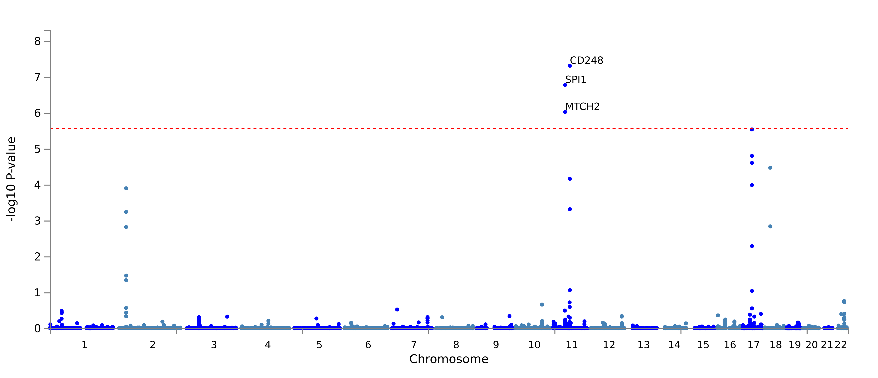

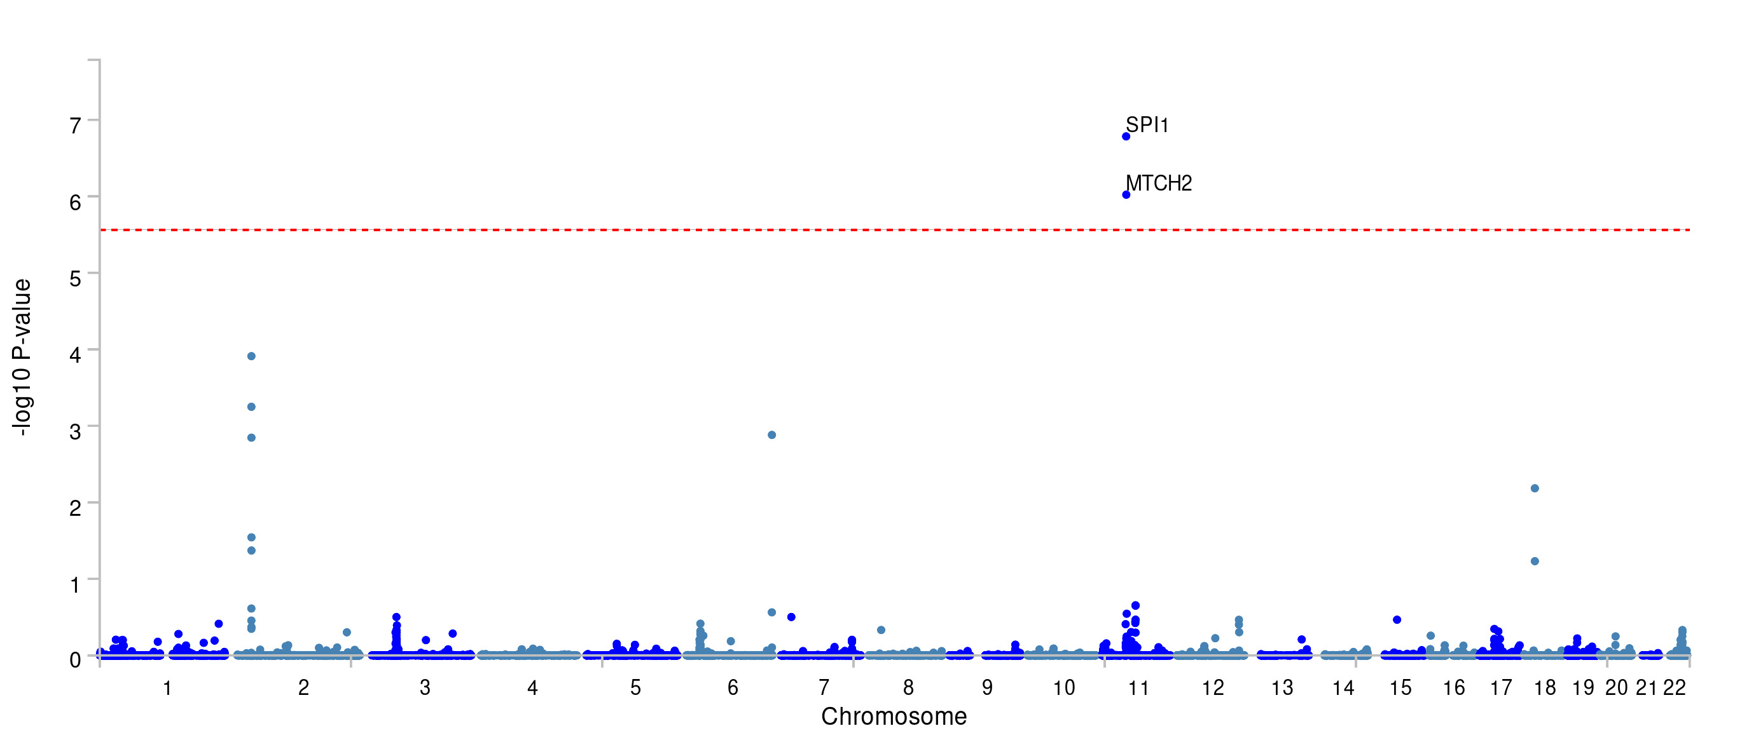

Supplementary Figure 7. Gene-based Manhattan plot for alcohol-related traits with the non-cognitive components of educational attainment.
Note: The top panel displays results for the joint SNP-level associations of alcohol consumption (AC) and the non-cognitive components of educational attainment (NonCogEA), while the bottom panel shows results for alcohol use disorder (AUD) and NonCogEA.
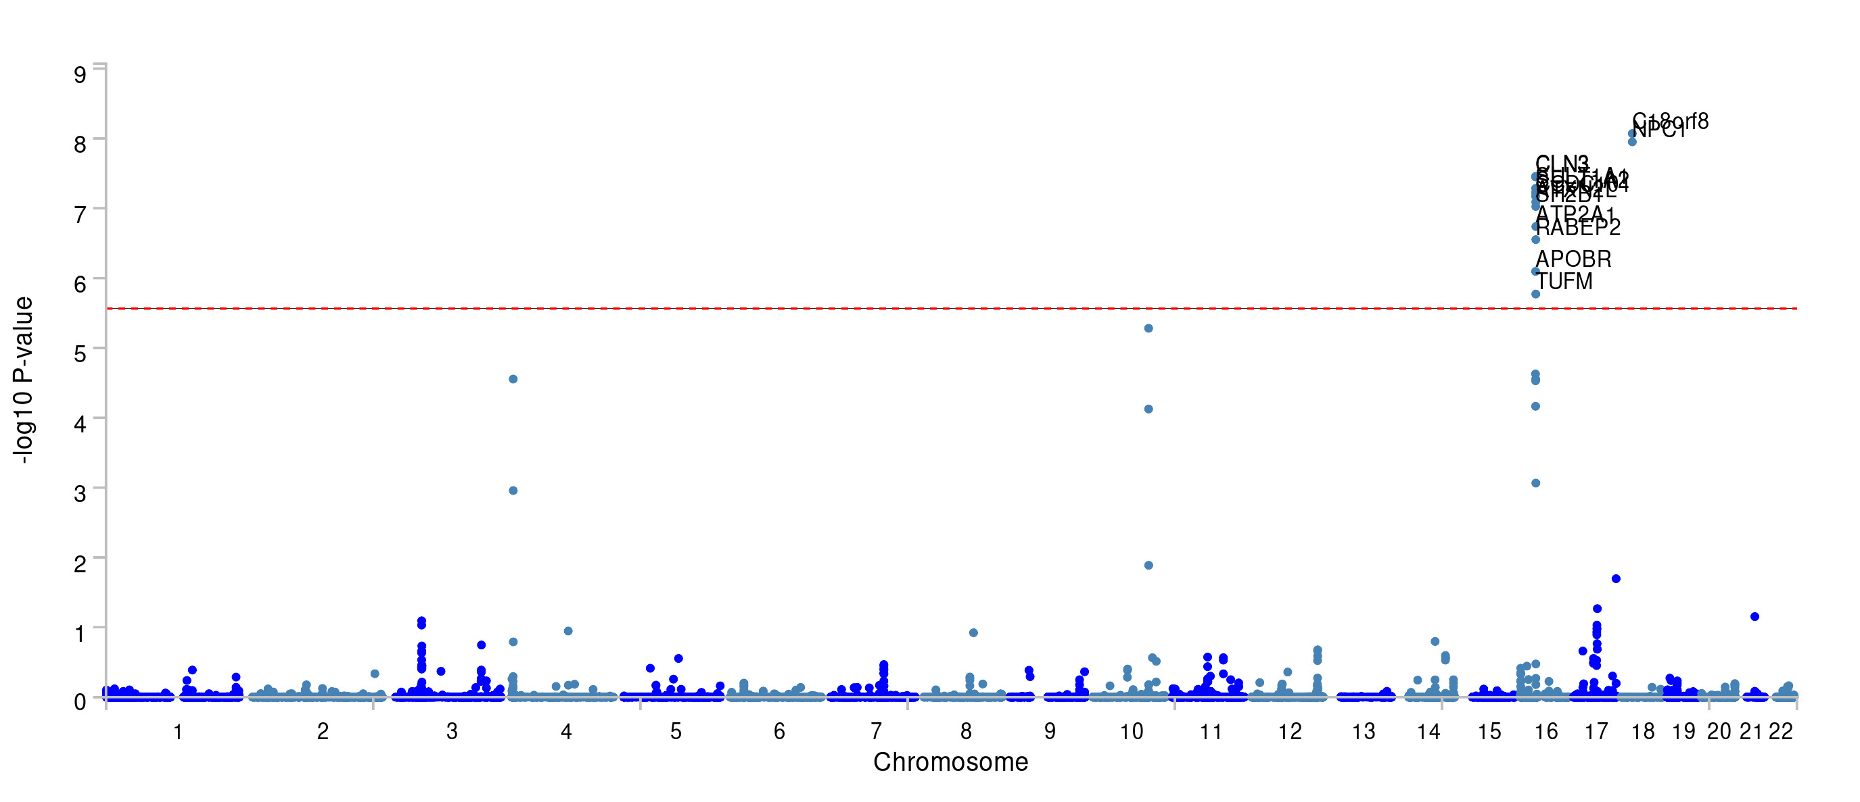

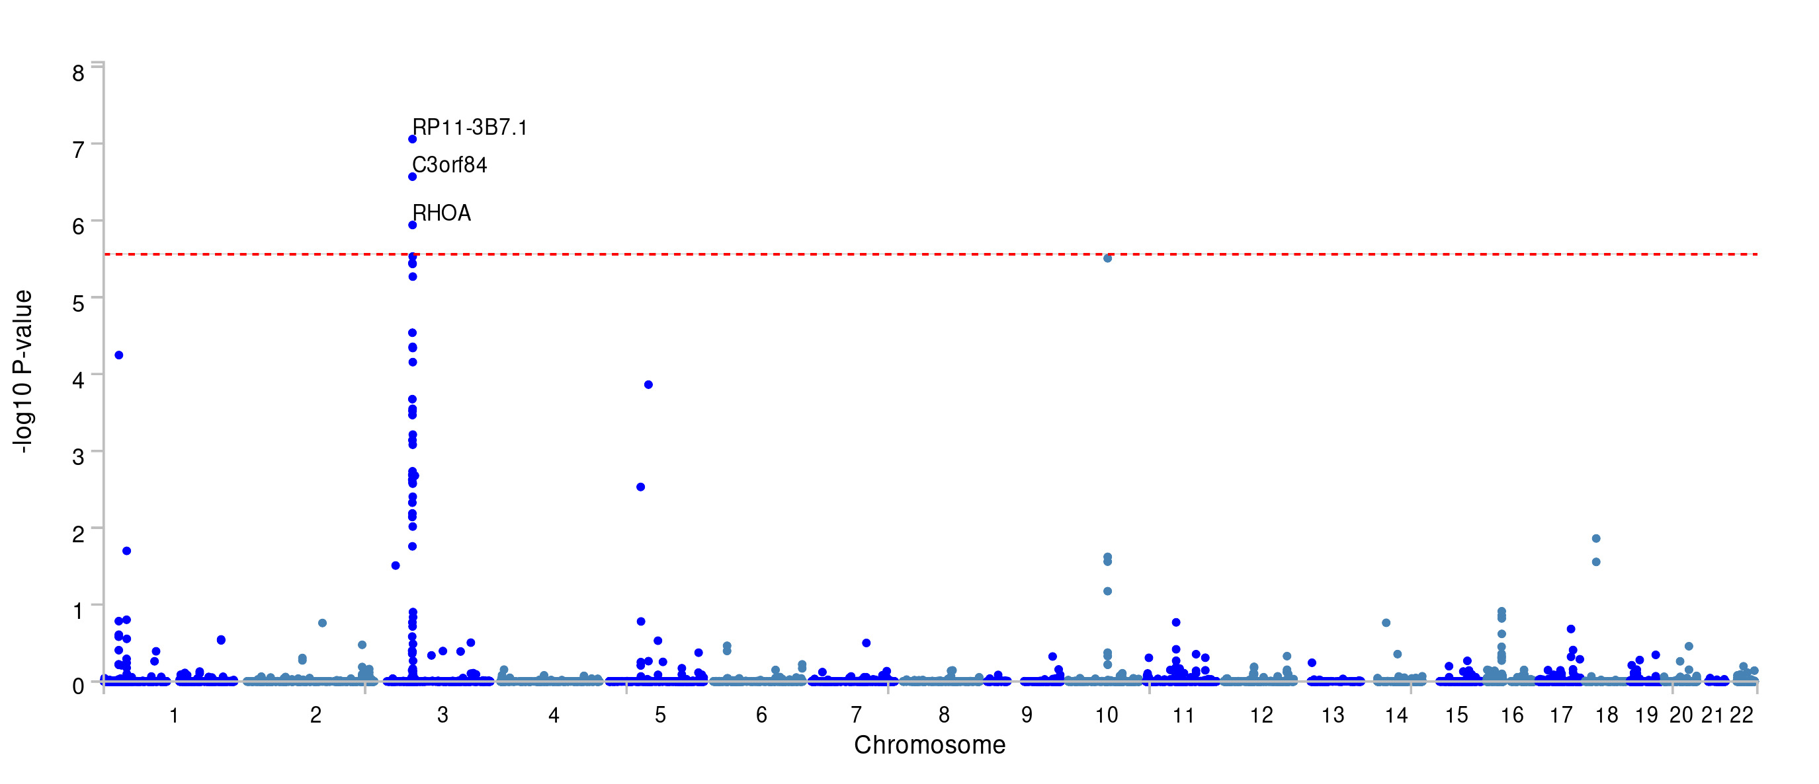

Supplementary Figure 8. Gene-based Manhattan plot for cannabis-related traits with educational attainment.
Note: The top panel displays results for the joint SNP-level associations of lifetime cannabis use (CanUse) and educational attainment (EA), while the bottom panel shows results for cannabis use disorder (CUD) and EA.
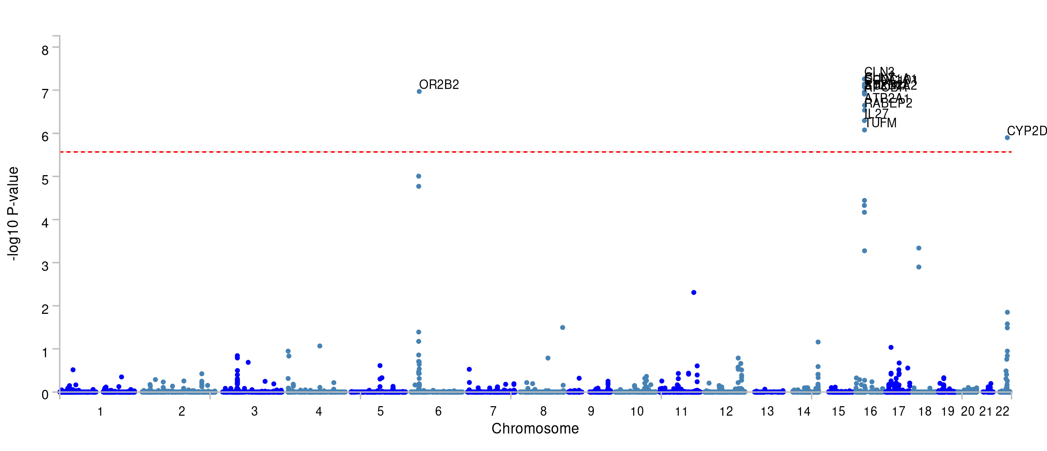

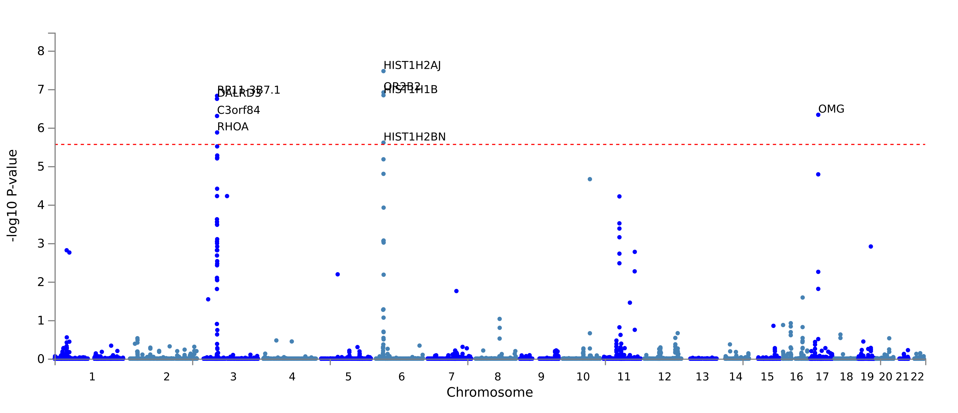

Supplementary Figure 9. Gene-based Manhattan plot for cannabis-related traits with the cognitive aspects of educational attainment.
Note: The top panel displays results for the joint SNP-level associations of lifetime cannabis use (CanUse) and the cognitive components of educational attainment (CogEA), while the bottom panel shows results for cannabis use disorder (CUD) and CogEA.
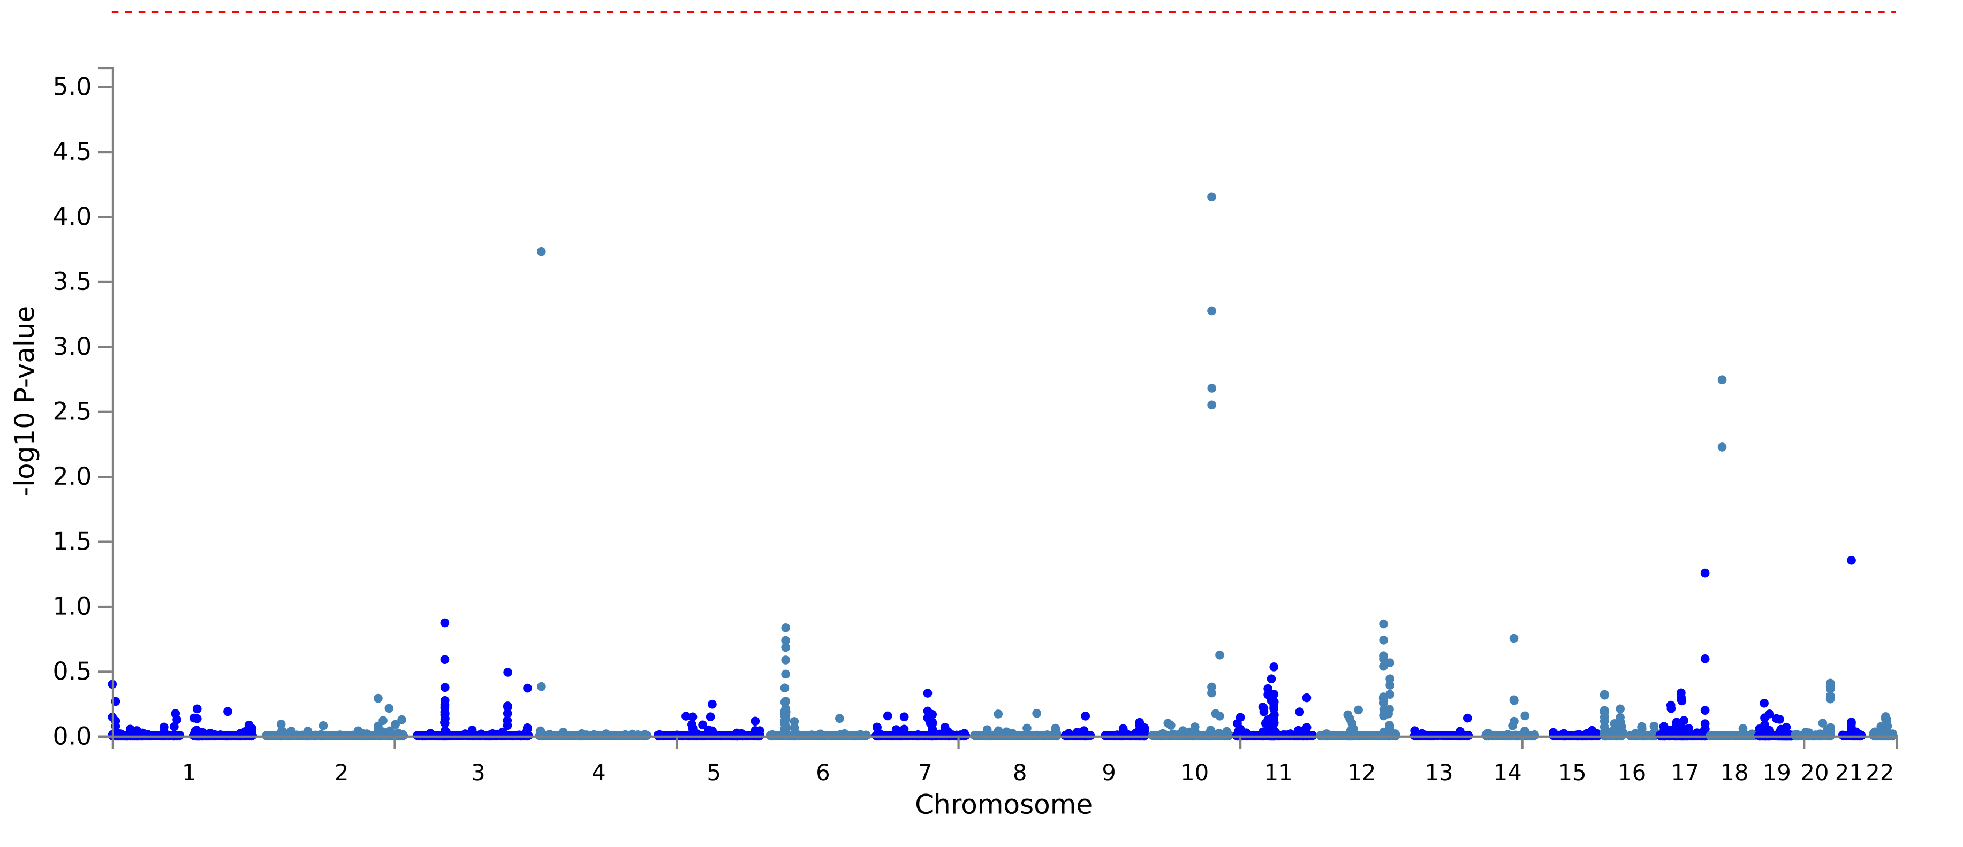

Supplementary Figure 10. Gene-based Manhattan plot for cannabis-related traits with the non-cognitive aspects of educational attainment.
Note: The top panel displays results for the joint SNP-level associations of lifetime cannabis use (CanUse) and the non-cognitive components of educational attainment (NonCogEA), while the bottom panel shows results for cannabis use disorder (CUD) and NonCogEA.
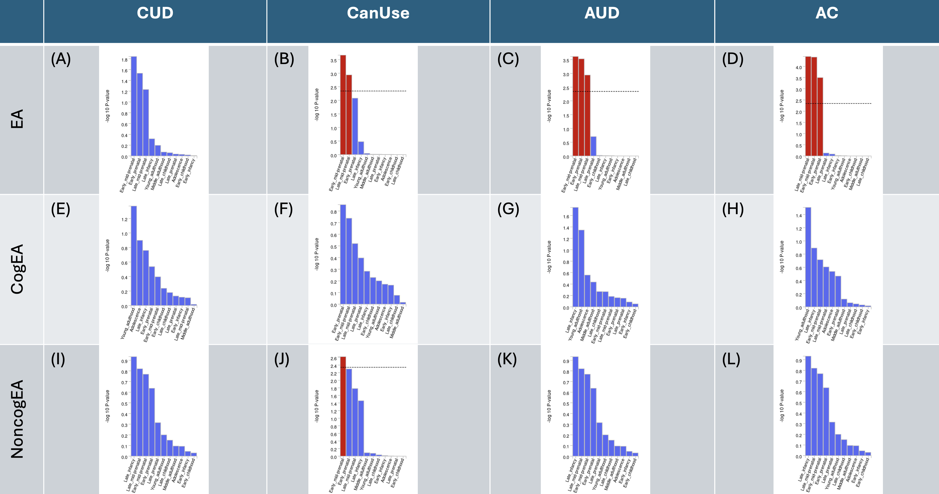

Supplementary Figure 11. MAGMA results of BrainSpan 11 different developmental ages for each joint analysis.
Results that were significant after multiple testing correction are highlighted in red. Panels A-D represent the results of enrichment analysis for joint condFDR analyses of EA with CUD, CanUse, AUD, and AC, respectively. E-H represent those of joint analyses of CogEA with the four substance-related traits, and I-L represent NonCogEA with the four traits.

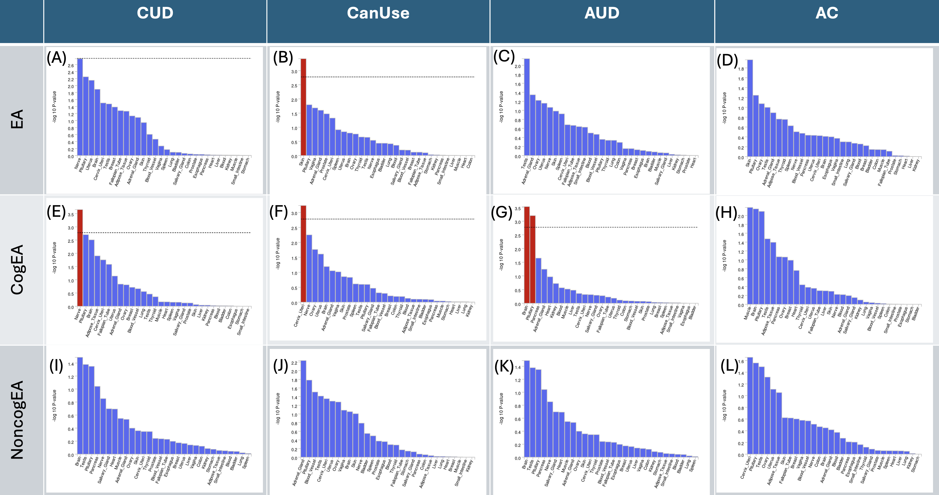

Supplementary Figure 12. MAGMA results of GTEx v8 30 tissue types for each joint analysis.
Results that were significant after multiple testing correction are highlighted in red. Panels A-D represent the results of enrichment analysis for joint condFDR analyses of EA with CUD, CanUse, AUD, and AC, respectively. E-H represent those of joint analyses of CogEA with the four substance-related traits, and I-L represent NonCogEA with the four traits.

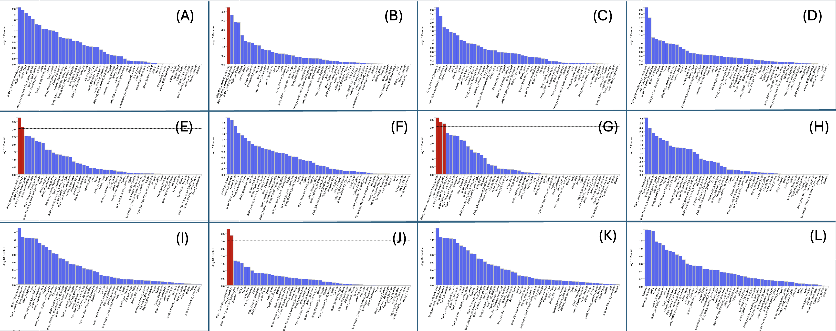

Supplementary Figure 13. MAGMA results of GTEx v8 53 tissue types for each joint analysis.
Results that were significant after multiple testing correction are highlighted in red. Panels A-D represent the results of enrichment analysis for joint condFDR analyses of EA with CUD, CanUse, AUD, and AC, respectively. E-H represent those of joint analyses of CogEA with the four substance-related traits, and I-L represent NonCogEA with the four traits.

