Supplementary materials

Table S1. Survey questions used to derive all study variables
Survey item | Question
Cannabis use frequency in past year | “In the LAST 12 MONTHS, how often did you use CANNABIS (also known as marijuana, ′′weed′′, ′′pot′′, ′′grass′′, hashish, ′′hash′′, hash oil, etc.)? 1 or 2 times; 3 to 5 times; 6 to 9 times; 10 to 19 times; 20 to 39 times; 40 or more times; Used, but not in the last 12 months; Never used in lifetime; Don’t know what cannabis is.”
Cannabis use frequency in past month | “In the last 4 weeks, how often did you use cannabis?” Once or twice; once or twice each week; three or four times each week; five or six times each week; once each day; more than once each day; or did not use cannabis in the last 4 weeks.
Psychological distress | “During the past 30 days, about how often did you feel nervous, hopeless, restless or fidgety, so depressed that nothing could cheer you up, that everything was an effort, or worthless?” Response options were 0 = None of the time, 1 = A little of the time, 2 = Some of the time, 3 = Most of the time, and 4 = All of the time.
School grade of cannabis use initiation | When (if ever) did you first try cannabis (also known as marijuana, ′′weed′′, ′′pot′′, ′′grass′′, hashish, ′′hash′′, hash oil)? Never tried cannabis in lifetime; Grade 4 or before; Grade 5; Grade 6; Grade 7; Grade 8; Grade 9; Grade 10; Grade 11; Grade 12.
Age | How old are you?  - 10 years of age or younger  - 11 years  - 12 years  - 13 years  - 14 years  - 15 years  - 16 years  - 17 years  - 18 years  - 19 years  - 20 years or older
Sex | Were you born male or female?  - Male  - Female
Socioeconomic status | Imagine this ladder below shows how Canadian society is set up. At the top of the ladder are people who are the ″best off″ – they have the most money, the most education, and the jobs that bring the most respect. At the bottom are the people who are ″worst off″ – they have the least money, little education, no jobs or jobs that no one wants. Now think about your family. Please check off the numbered box that best shows where you think your family would be on this ladder.  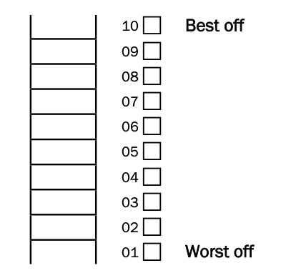
Past-year cigarette use | In the LAST 12 MONTHS, how often did you smoke tobacco CIGARETTES?  - Smoked a few puffs to a whole cigarette in the last 12 months  - Smoked more than one cigarette, but not every day  - 1 or 2 cigarettes a day  - 3 to 5 cigarettes a day  - 6 to 10 cigarettes a day  - 11 to 15 cigarettes a day  - 16 to 20 cigarettes a day  - 21 to 29 cigarettes a day  - 30 or more cigarettes a day  - Smoked, but not in the last 12 months  - Never smoked cigarettes in lifetime
Past-year alcohol use | In the LAST 12 MONTHS, how often did you drink ALCOHOL — liquor (rum, whiskey, etc.), wine, beer, coolers?  - Had a sip of alcohol to see what it’s like  - Drank only at special events (for example,  - holidays or at weddings)  - Once a month or less often  - 2 or 3 times a month  - Once a week  - 2 or 3 times a week  - 4 or 5 times a week  - Almost every day – 6 or 7 times a week  - Drank, but not in the last 12 months  - Never drank alcohol in lifetime
Gender identity (2017-2019) | How do you describe yourself?  - Male  - Female  - Transgender  - None of the above  - Prefer not to answer
Gender identity (2023) | Gender identity refers to a person’s internal sense or feeling of being a woman, a man, both, neither or anywhere on the gender spectrum, which may or may not be the same as the person’s sex assigned at birth (e.g., male, female). It is different from and doesnot determine a person’s sexual orientation. What is your gender identity?  - Boy or man  - Gender fluid  - Gender queer  - Girl or woman  - Non-Binary  - Questioning/Not sure  - Trans boy or man  - Trans girl or woman  - Two-Spirit  - My gender identity is not listed above  - I do not understand this question  - I prefer not to answer
Using cannabis to cope with mental health problems (2023) | “In the last 12 months, did you use cannabis (in any way) to cope with a mental health problem, such as to relieve anxiety or depression? Yes, No.”
Unmet mental healthcare need (2023) | “In the last 12 months, was there ever a time when you felt you might need professional help (such as from a doctor, counsellor or other mental health worker) for mental health concerns (problems with emotions, behaviours), but you did not seek help? Yes, No.”

Table S2. Modified least-squares models assessing sex and survey cycle interactions on the additive scale.
 | Sex interaction model |  |  |  | Survey year interaction model
 | Psychological distress  (K6 13+) |  |  |  | Psychological distress  (K6 13+)
Variables | aPD | 95% CI |  | Joint test p-value | aPD | 95% CI |  | Joint test p-value
Cannabis use frequency past 12m |  |  |  | <0.001 |  |  |  | <0.001
Never | Ref | - | - |  | Ref | - | -
1 or 2 times | 0.04 | -0.01 | 0.09 |  | 0.05 | 0.01 | 0.08
3 to 9 times | -0.00 | -0.05 | 0.04 |  | 0.04 | 0.01 | 0.07
10 to 39 times | -0.02 | -0.05 | 0.01 |  | 0.02 | -0.01 | 0.06
40 or more times | 0.02 | -0.03 | 0.07 |  | 0.08 | 0.04 | 0.12
Sex |  |  |  | <0.001 |  |  |  | <0.001
Male | Ref | - | - |  | Ref | - | -
Female | 0.16 | 0.14 | 0.17 |  | 0.18 | 0.16 | 0.19
Survey year (scaled to yearly change) | 0.02 | 0.02 | 0.02 | <0.001 | 0.02 | 0.01 | 0.02 | <0.001
Cannabis use frequency*survey year |  |  |  | - |  |  |  | 0.004
Yearly change 1 or 2 times | - | - | - |  | 0.01 | -0.00 | 0.02
Yearly change 3 to 9 times | - | - | - |  | 0.00 | -0.00 | 0.01
Yearly change 10 or 39 times | - | - | - |  | 0.01 | -0.00 | 0.01
Yearly change 40 or more times | - | - | - |  | 0.02 | 0.01 | 0.03
Cannabis use frequency*sex |  |  |  | <0.001
Female 1 or 2 times | 0.03 | -0.03 | 0.09 |  | - | - | -
Female 3 to 9 times | 0.09 | 0.03 | 0.15 |  | - | - | -
Female 10 or 39 times | 0.10 | 0.04 | 0.17 |  | - | - | -
Female 40 or more times | 0.17 | 0.09 | 0.25 |  | - | - | -
Notes: Ref=reference category; aPD=adjusted prevalence difference; 95% CI=95% confidence interval. All models adjusted for age, SES, past 12m cigarette use frequency, and past 12m alcohol use frequency.

Table S3. Sensitivity analysis assessing gender identity as an effect modifier instead of sex, estimated from a multivariable modified least-squares model

 | Adjusted prevalence differences for the association between past-year cannabis use (yes vs. no) and psychological distress (K6 13+) conditional on gender identity
Gender | aPD | 95% CI |  | p-value
Boy or man | 0.03 | -0.00 | 0.06 | 0.09
Girl or woman | 0.08 | 0.04 | 0.12 | <0.01
Transgender or gender diverse | 0.02 | -0.09 | 0.14 | 0.69
Notes: aPD=adjusted prevalence difference; 95% CI=95% confidence interval. Model adjusted for survey cycle, age, SES, past 12m cigarette use frequency, and past 12m alcohol use frequency.

Gender was only measured among high school students from 2017 onwards and evolved from 2017 to 2023 to include additional categories (n = 14,598). To harmonize the different measures across the waves and ensure sufficient cell sizes, we categorized gender as boys/men, girls/women, and transgender/gender diverse.

Table S4. Beta estimates for the association between past-year cannabis use frequency and psychological distress (K6 score) conditional on survey year, estimated from multivariable linear regression model

 |  | Psychological distress (K6 score)ª
Year | Cannabis use frequency past 12m | β | 95% CI |  | p-value
2013 | Never | Ref | - | -
2013 | 1 or 2 times | 0.16 | -0.53 | 0.84 | 0.65
2013 | 3 to 9 times | 0.44 | -0.25 | 1.14 | 0.21
2013 | 10 to 39 times | -0.19 | -1.06 | 0.68 | 0.67
2013 | 40 or more times | -0.08 | -0.98 | 0.81 | 0.86
2015 | Never | Ref | - | -
2015 | 1 or 2 times | 0.46 | -0.05 | 0.97 | 0.08
2015 | 3 to 9 times | 0.58 | 0.06 | 1.11 | 0.03
2015 | 10 to 39 times | 0.09 | -0.56 | 0.74 | 0.79
2015 | 40 or more times | 0.42 | -0.31 | 1.15 | 0.26
2017 | Never | Ref | - | -
2017 | 1 or 2 times | 0.75 | 0.33 | 1.18 | <0.01
2017 | 3 to 9 times | 0.72 | 0.30 | 1.15 | <0.01
2017 | 10 to 39 times | 0.37 | -0.14 | 0.87 | 0.16
2017 | 40 or more times | 0.93 | 0.30 | 1.55 | <0.01
2019 | Never | Ref | - | -
2019 | 1 or 2 times | 1.05 | 0.57 | 1.54 | <0.01
2019 | 3 to 9 times | 0.86 | 0.41 | 1.31 | <0.01
2019 | 10 to 39 times | 0.64 | 0.13 | 1.15 | 0.01
2019 | 40 or more times | 1.43 | 0.81 | 2.05 | <0.01
2023 | Never | Ref | - | -
2023 | 1 or 2 times | 1.65 | 0.78 | 2.51 | <0.01
2023 | 3 to 9 times | 1.14 | 0.38 | 1.91 | <0.01
2023 | 10 to 39 times | 1.20 | 0.32 | 2.08 | 0.01
2023 | 40 or more times | 2.44 | 1.55 | 3.33 | <0.01
Notes: 95% CI=95% confidence interval. Model adjusted for sex, age, SES, past 12m cigarette use frequency, and past 12m alcohol use frequency.
ª K6 treated as continuous outcome (score ranges from 0 to 24 indicating depression/anxiety symptoms). Beta estimates represent changes in K6 score.

Table S5. Beta estimates for the association between past-year cannabis use frequency and psychological distress (K6 score) conditional on sex, estimated from multivariable linear regression model

 |  | Psychological distress (K6 score)ª
Sex | Cannabis use frequency past 12m | β | 95% CI |  | p-value
Male | Never | Ref | - | -
Male | 1 or 2 times | 0.58 | -0.09 | 1.25 | 0.09
Male | 3 to 9 times | 0.08 | -0.53 | 0.7 | 0.79
Male | 10 to 39 times | -0.12 | -0.70 | 0.45 | 0.67
Male | 40 or more times | 0.30 | -0.44 | 1.05 | 0.42
Female | Never | Ref | - | -
Female | 1 or 2 times | 1.25 | 0.67 | 1.83 | <0.01
Female | 3 to 9 times | 1.42 | 0.86 | 1.98 | <0.01
Female | 10 to 39 times | 1.26 | 0.53 | 1.99 | <0.01
Female | 40 or more times | 2.58 | 1.80 | 3.37 | <0.01
Notes: 95% CI=95% confidence interval. Model adjusted for survey year, age, SES, past 12m cigarette use frequency, and past 12m alcohol use frequency.
ª K6 treated as continuous outcome (score ranges from 0 to 24 indicating depression/anxiety symptoms). Beta estimates represent changes in K6 score.

Table S6. Sensitivity analysis using past-month cannabis use frequency as the exposure (instead of past-year), modified Poisson and least-squares models estimating the association between cannabis use frequency and psychological distress (K6 13+)

 | Modified Poisson model  Main effects only |  |  |  | Modified least-squares model  Cannabis*sex additive interaction |  |  |  | Modified least-squares model  Cannabis*year additive interaction
 | Psychological distress (K6 13+) |  |  |  | Psychological distress (K6 13+) |  |  |  | Psychological distress (K6 13+)
Variables | aPR | 95% CI |  | Joint test p-value | aPD | 95% CI |  | Joint test p-value | aPD | 95% CI |  | Joint test p-value
Cannabis use frequency past 4 weeks |  |  |  | 0.003 |  |  |  | <0.001 |  |  |  | <0.001
Never | Ref | - | - |  | Ref | - | - |  | Ref | - | -
<Weekly | 1.11 | 1.00 | 1.23 |  | -0.01 | -0.04 | 0.02 |  | 0.03 | 0.01 | 0.06
Weekly | 1.27 | 1.10 | 1.46 |  | 0.01 | -0.04 | 0.06 |  | 0.07 | 0.00 | 0.11
Daily+ | 1.20 | 1.01 | 1.42 |  | -0.01 | -0.07 | 0.06 |  | 0.06 | -0.00 | 0.13
Sex |  |  |  | <0.001 |  |  |  | <0.001 |  |  |  | <0.001
Male | Ref | - | - |  | Ref | - | - |  | Ref | - | -
Female | 2.69 | 2.48 | 2.92 |  | 0.16 | 0.15 | 0.18 |  | 0.18 | 0.16 | 0.19
Survey cycle (scaled to yearly change) | 1.10 | 1.09 | 1.11 | <0.001 | 0.02 | 0.02 | 0.02 | <0.001 | 0.02 | 0.01 | 0.02 | <0.001
Cannabis use frequency*survey cycle |  |  |  |  |  |  |  |  |  |  |  | 0.049
Yearly change <Weekly | - | - | - |  | - | - | - |  | 0.00 | -0.00 | 0.01
Yearly change Weekly | - | - | - |  | - | - | - |  | 0.01 | 0.11 | 0.02
Yearly change Daily+ | - | - | - |  | - | - | - |  | 0.02 | 0.00 | 0.03
Cannabis use frequency*sex |  |  |  |  |  |  |  | <0.001
Female <Weekly | - | - | - |  | 0.08 | 0.02 | 0.13 |  | - | - | -
Female Weekly | - | - | - |  | 0.15 | 0.08 | 0.22 |  | - | - | -
Female Daily+ | - | - | - |  | 0.21 | 0.10 | 0.32 |  | - | - | -
Notes: Ref=reference category; aPR=adjusted prevalence ratio; aPD=adjusted prevalence difference; 95% CI=95% confidence interval. Cannabis*sex and cannabis*year interactions not included in the final modified Poisson model because they were not statistically significant on the multiplicative scale (p>0.05). All models adjusted for age, SES, past 12m cigarette use frequency, and past 12m alcohol use frequency.

Table S7: Comparison of complete cases to respondents excluded due to missing data.

Variable | Category | Complete cases n=32,110 | Excluded (missing data) n=2,897 | χ2/t-test p-value
Psychological distress (K6 13+) | No | 80.8% | 84.0% | 0.119
 | Yes | 19.2% | 16.0%
Cannabis use frequency past 12m | Never | 79.5% | 84.0% | 0.080
 | 1–2 times | 6.1% | 4.4%
 | 3–9 times | 5.6% | 4.3%
 | 10–39 times | 4.4% | 3.4%
 | 40+ times | 4.5% | 3.9%
Age (years) | Mean (SD) | 15.1 (1.8) | 14.7 (1.9) | <0.001
Socioeconomic status (1-10 scale) | Mean (SD) | 6.9 (1.6) | 7.1 (1.7) | 0.065
Cigarette use frequency past 12m | Never | 89.5% | 91.2% | 0.189
 | <Daily | 8.4% | 6.5%
 | Daily+ | 2.1% | 2.4%
Alcohol use frequency past 12m | Never | 40.8% | 48.9% | 0.005
 | <Weekly | 53.9% | 45.6%
 | Weekly+ | 5.3% | 5.4%
Survey year | 2013 | 18.0% | 11.5% | 0.004
 | 2015 | 17.2% | 10.2%
 | 2017 | 17.7% | 21.0%
 | 2019 | 16.7% | 16.5%
 | 2023 | 30.3% | 40.8%
Sex | Male | 51.1% | 58.7% | <0.001
 | Female | 48.9% | 41.3%

Notes: The excluded group had missing data for at least one of the variables included in this table. As a proportion, missingness was higher in 2023 because the full sample was administered the K6 psychological distress scale unlike earlier years when only half the sample completed the K6 by design.

Table S8. Proportion of adolescents endorsing cannabis use in 2023 who reported using cannabis to cope with a mental health problem, stratified by sex and past-year cannabis use frequency

Sex | Cannabis use past 12m | % used cannabis to cope with mental health problem past 12m
Male | 1 or 2 times | 12.8%
Male | 3 to 9 times | 21.0%
Male | 10 to 39 times | 61.1%
Male | 40+ times | 63.4%
Female | 1 or 2 times | 32.1%
Female | 3 to 9 times | 44.8%
Female | 10 to 39 times | 78.1%
Female | 40+ times | 96.0%
Overall | Yes | 48.4%

Using cannabis to cope with mental health problems was measured with the question: “In the last 12 months, did you use cannabis (in any way) to cope with a mental health problem, such as to relieve anxiety or depression? Yes, No.” This question was only asked in 2023.

Table S9. Proportion of adolescents in 2023 reporting unmet need for professional mental healthcare, stratified by sex and past-year cannabis use frequency

Sex | Cannabis use past 12m | % with unmet need for professional mental healthcare past 12m
Male | Never | 17.0%
Male | 1 or 2 times | 20.3%
Male | 3 to 9 times | 17.0%
Male | 10 to 39 times | 34.5%
Male | 40+ times | 33.3%
Female | Never | 42.6%
Female | 1 or 2 times | 60.9%
Female | 3 to 9 times | 63.2%
Female | 10 to 39 times | 71.2%
Female | 40+ times | 78.3%
Overall | No | 29.2%
Overall | Yes | 50.5%

Note: Having an unmet mental healthcare need was measured with the question: “In the last 12 months, was there ever a time when you felt you might need professional help (such as from a doctor, counsellor or other mental health worker) for mental health concerns (problems with emotions, behaviours), but you did not seek help? Yes, No.” This question was only asked in 2023.

Figure S1: Illustration of the relationship between survey year and estimated adjusted probability of psychological distress (K6 13+) modified by past-year cannabis use frequency
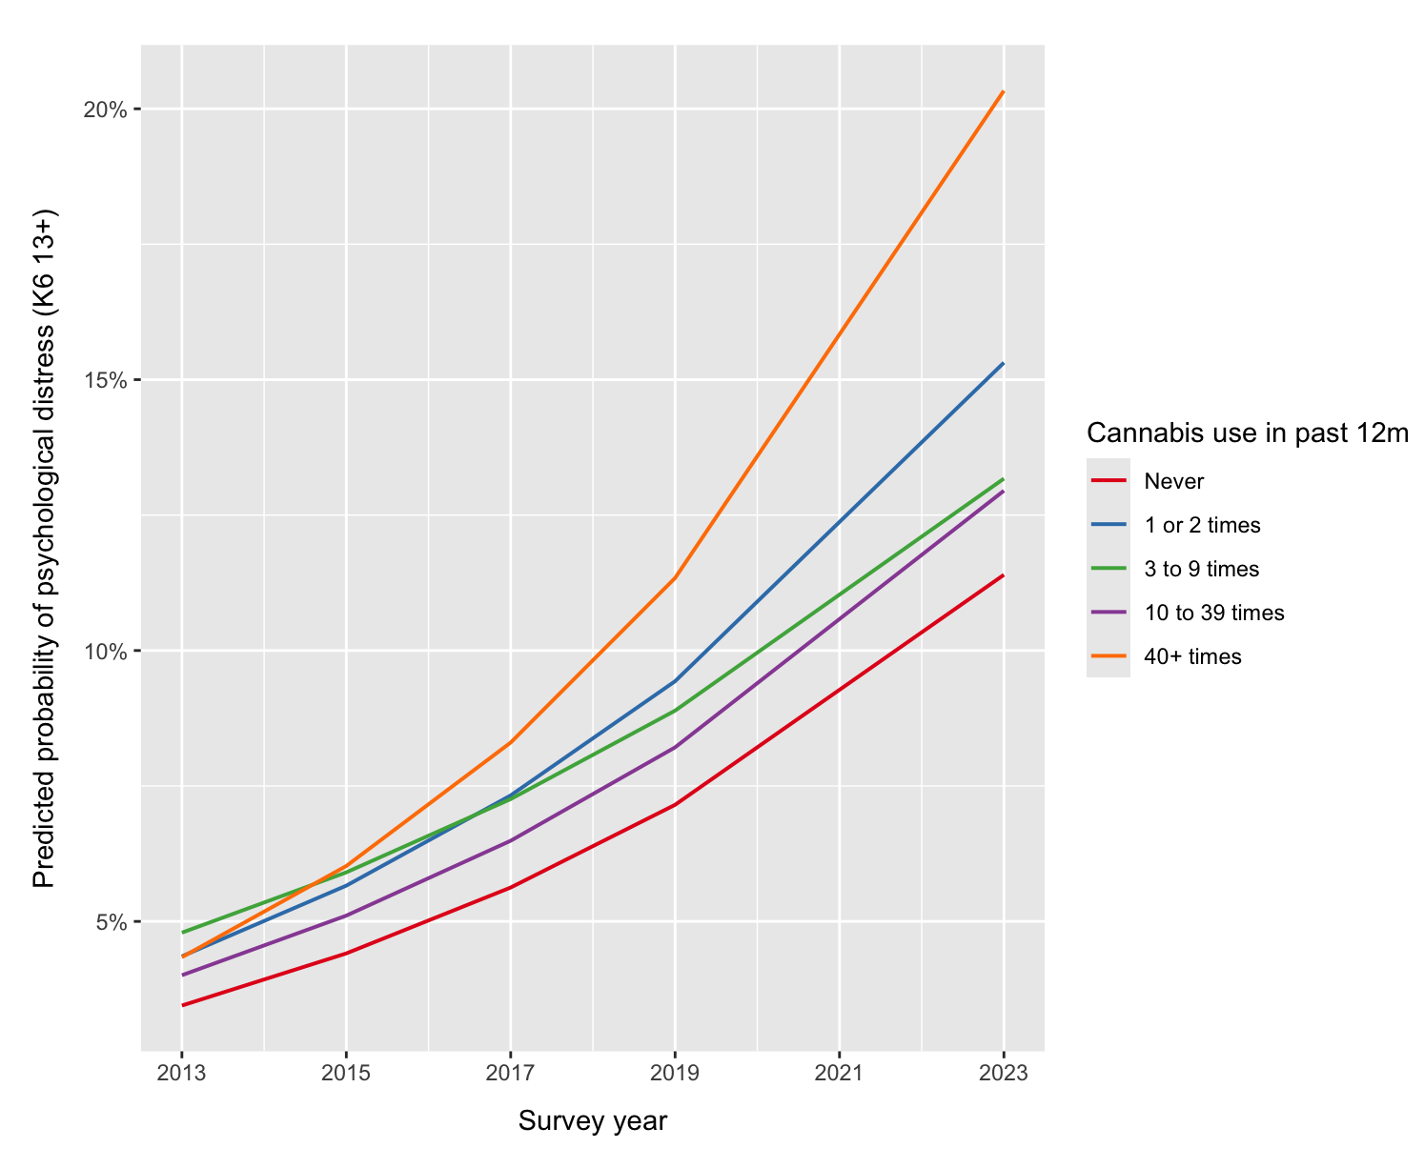

Note: Adjusted probabilities of psychological distress were estimated from a multivariable logistic regression model, assuming all other covariates (sex, cigarette use, alcohol use, age, SES) were held at reference (categorical) or mean (continuous) values.

Figure S2. Illustration of the relationship between past-year cannabis use and estimated adjusted probability of psychological distress (K6 13+) modified by sex and survey year, with 95% confidence intervals
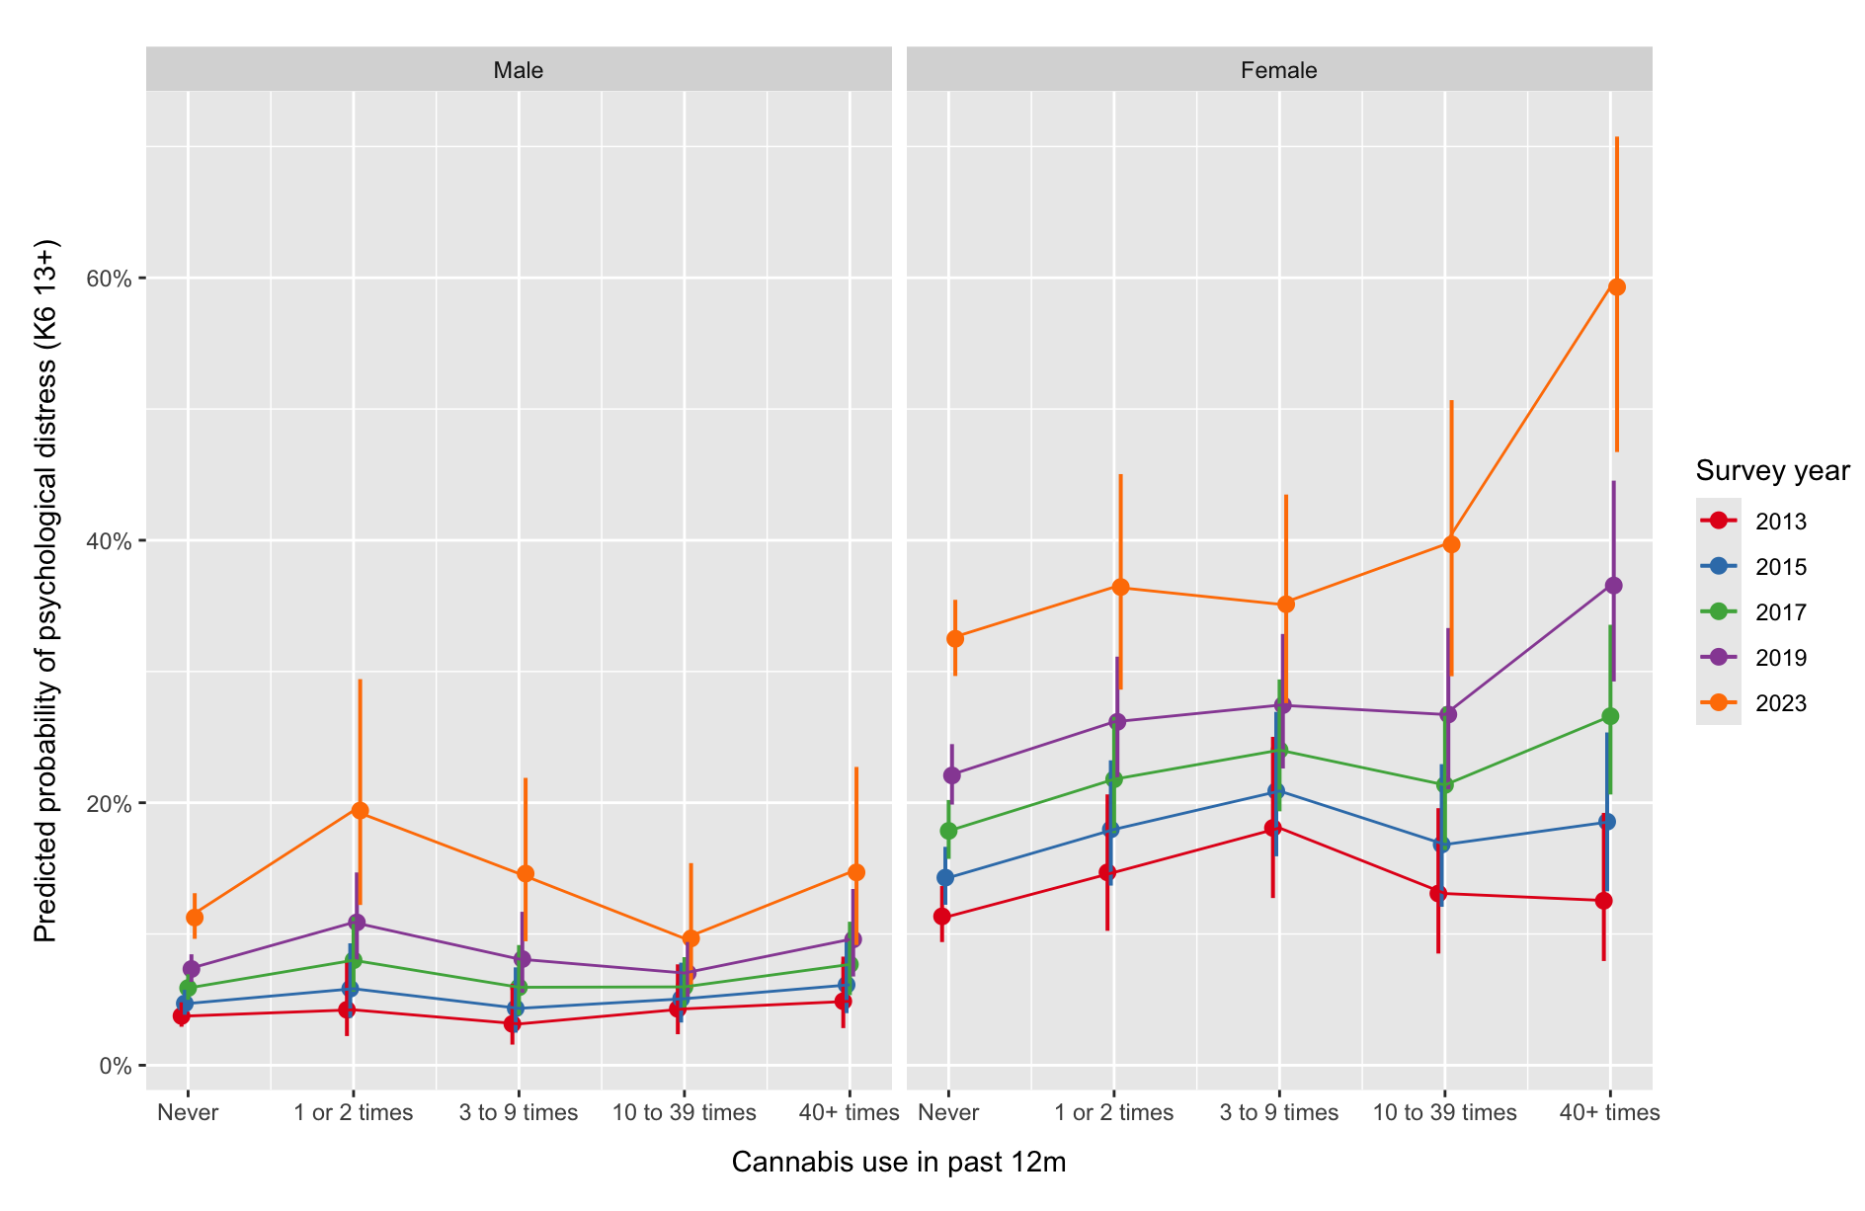
Note: Adjusted probabilities of psychological distress were estimated from a multivariable logistic regression model to ensure that probabilities were bounded between 0% and 100% (model adjusted for cigarette use, alcohol use, age, SES). The three-way cannabis*sex*year interaction was non-significant on the multiplicative and additive scales (p>0.05) and is presented for illustrative purposes.

Figure S3. Illustration of the relationship between past-year cannabis use and estimated adjusted probability of psychological distress (K6 13+) modified by gender identity, with 95% confidence intervals
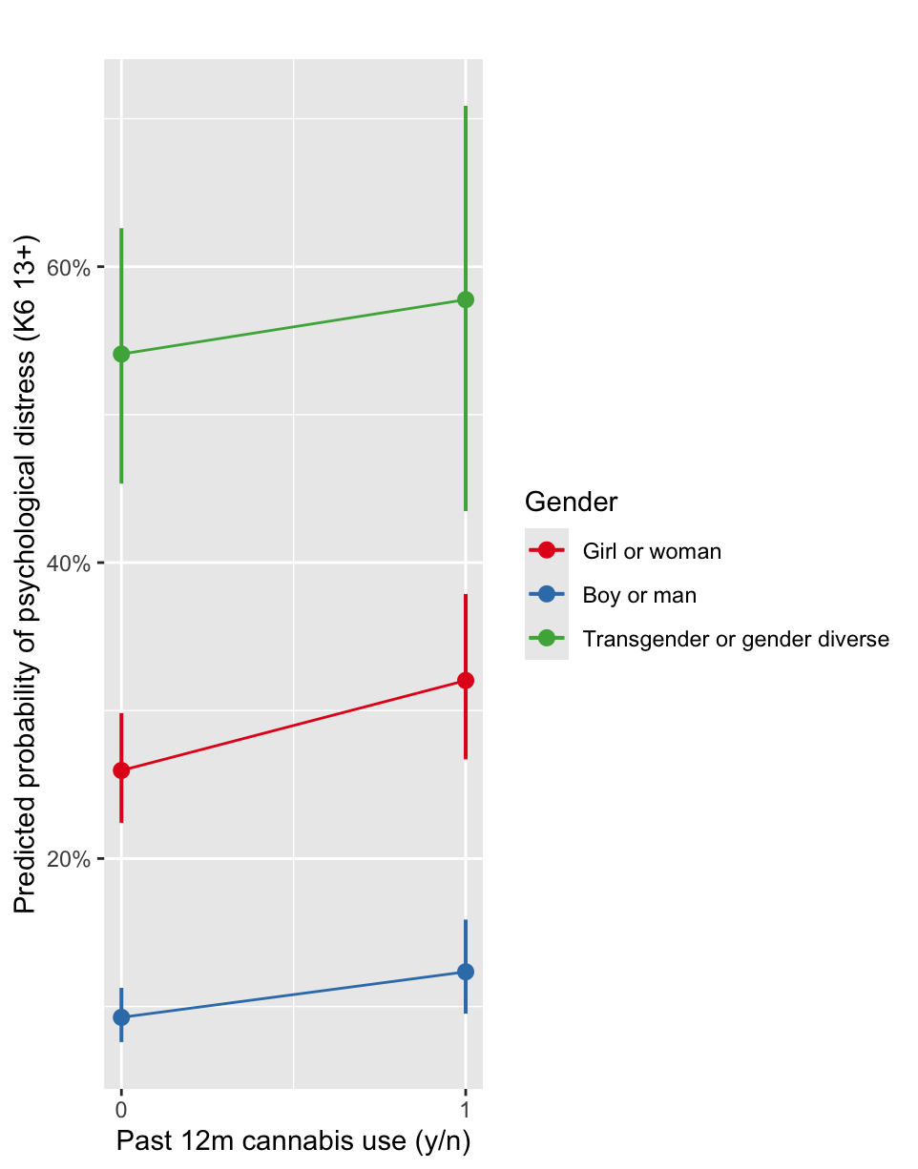

Note: Adjusted probabilities of psychological distress were estimated from a multivariable logistic regression model to ensure that probabilities were bounded between 0% and 100% (model adjusted for survey year, cigarette use, alcohol use, age, SES).
Supplementary methods

Three-way interaction tests assess whether the joint effect of three variables differs from what would be expected under additivity:

$$null: {PD}_{111}-{PD}_{110}-{PD}_{101}-{PD}_{011}+{PD}_{100}+{PD}_{010}+{PD}_{001}=0$$

or multiplicativity:
$$null: \frac{{PR}_{111}}{{PR}_{110}{PR}_{101}{PR}_{011}{ / PR}_{100}{PR}_{010}{PR}_{001}}=1$$

of their lower-order effects. Thus, a three-way interaction indicates that one or more of the two-way interactions (e.g., cannabis*time) differs across the levels of a third variable (e.g., sex).

