Supplementary Tables:
Table S1. Raw ACE decomposed Variances and Covariances from Latent Growth Models
Random Intercepts
 | Alcohol |  | Cannabis | Parents | Home | School
Alcohol | V = 0.069  A = 0.002  C = 0.029  E = 0.038
Cannabis | Cov_{V} = 0.037  Cov_{A} = 0.021  Cov_{C} = 0.000  Cov_{E} = 0.016 |  | V = 0.112  A = 0.068  C = 0.000  E = 0.044
Parents | Cov_{V} = -0.138  Cov_{A} = 0.005  Cov_{C} = -0.094  Cov_{E} = -0.049 |  | Cov_{V} = -0.191  Cov_{A} = -0.114  Cov_{C} = -0.071  Cov_{E} = -0.006 | V = 4.796  A = 1.329  C = 1.244  E = 2.223
Home | Cov_{V} = -0.013  Cov_{A} = 0.001  Cov_{C} = -0.003  Cov_{E} = -0.011 |  | Cov_{V} = -0.065  Cov_{A} = -0.038  Cov_{C} = 0.001  Cov_{E} = -0.027 | Cov_{V} = 0.033  Cov_{A} = -0.002  Cov_{C} = 0.004  Cov_{E} = 0.031 | V = 0.029  A = 0.001  C = 0.022  E = 0.006
School | Cov_{V} = 0.001  Cov_{A} = 0.005  Cov_{C} = -0.006  Cov_{E} = 0.003 |  | Cov_{V} = -0.038  Cov_{A} = -0.035  Cov_{C} = 0.004  Cov_{E} = -0.007 | Cov_{V} = -0.016  Cov_{A} = 0.044  Cov_{C} = -0.019  Cov_{E} = -0.041 | Cov_{V} = 0.016  Cov_{A} = 0.011  Cov_{C} = 0.001  Cov_{E} = 0.004 | V = 0.025  A = 0.016  C = 0.008  E = 0.001
Random Age Effects

 | Alcohol |  | Cannabis | Parents | Home | School
Alcohol | V = 9.040  A = 5.027  C = 0.011  E = 4.003
Cannabis | Cov_{V} = 16.637  Cov_{A} = 3.333  Cov_{C} = 0.086  Cov_{E} = 12.449 |  | V = 60.970  A = 6.869  C = 2.227  E = 51.875
Parents | Cov_{V} = 6.426  Cov_{A} = 11.584  Cov_{C} = -0.750  Cov_{E} = -4.408 |  | Cov_{V} = -10.535  Cov_{A} = -7.424  Cov_{C} = 4.010  Cov_{E} = -7.121 | V = 424.311  A = 280.494  C = 30.102  E = 113.714
Home | Cov_{V} = -2.014  Cov_{A} = -1.543  Cov_{C} = -0.143  Cov_{E} = -0.328 |  | Cov_{V} = -56.280  Cov_{A} = -5.287  Cov_{C} = -1.311  Cov_{E} = -49.685 | Cov_{V} = 46.747  Cov_{A} = 15.943  Cov_{C} = 5.552  Cov_{E} = 25.251 | V = 16.049  A = 6.961  C = 2.437  E = 6.652
School | Cov_{V} = 1.642  Cov_{A} = 5.120  Cov_{C} = -0.357  Cov_{E} = -3.120 |  | Cov_{V} = 19.577  Cov_{A} = 7.902  Cov_{C} = 0.587  Cov_{E} = 11.088 | Cov_{V} = -33.204  Cov_{A} = -34.157  Cov_{C} = 4.290  Cov_{E} = -3.338 | Cov_{V} = 8.941  Cov_{A} = 6.296  Cov_{C} = 0.704  Cov_{E} = 1.942 | V = 14.764  A = 9.973  C = 1.216  E = 3.575
Random Age² Effects

 | Alcohol |  | Cannabis | Parents | Home | School
Alcohol | V = 10.099  A = 0.573  C = 0.005  E = 4.521
Cannabis | Cov_{V} = 15.837  Cov_{A} = 3.174  Cov_{C} = 0.695  Cov_{E} = 11.969 |  | V = 58.584  A = 5.643  C = 1.971  E = 50.971
Parents | Cov_{V} = 6.810  Cov_{A} = 12.332  Cov_{C} = -0.345  Cov_{E} = -5.177 |  | Cov_{V} = -9.434  Cov_{A} = -5.794  Cov_{C} = 3.467  Cov_{E} = -7.107 | V = 472.351  A = 315.558  C = 34.307  E = 122.485
Home | Cov_{V} = -2.427  Cov_{A} = -1.732  Cov_{C} = -0.044  Cov_{E} = -0.651 |  | Cov_{V} = -53.439  Cov_{A} = -4.612  Cov_{C} = -1.113  Cov_{E} = -49.686 | Cov_{V} = 48.498  Cov_{A} = 15.426  Cov_{C} = 4.979  Cov_{E} = 28.093 | V = 16.964  A = 6.894  C = 2.762  E = 7.308
School | Cov_{V} = 1.926  Cov_{A} = 5.576  Cov_{C} = -0.345  Cov_{E} = -3.305 |  | Cov_{V} = 18.426  Cov_{A} = 7.098  Cov_{C} = 0.466  Cov_{E} = 10.862 | Cov_{V} = -35.145  Cov_{A} = -36.572  Cov_{C} = 4.573  Cov_{E} = -3.146 | Cov_{V} = 9.224  Cov_{A} = 6.559  Cov_{C} = 0.673  Cov_{E} = 1.992 | V = 15.661  A = 10.602  C = 0.503  E = 3.555
Growth Parameter Means
 | Alcohol |  | Cannabis | Parents | Home | School
Intercept | 0.138 |  | 0.078 | 16.351 | 0.061 | -0.058
Age | -0.551 |  | -0.216 | 4.139 | -1.541 | 1.706
Age² | 0.650 |  | 0.289 | -5.060 | 1.503 | -1.852
Unstandardized variances, cross-phenotypic covariances, and genetic, shared environmental, and non-shared environmental variance components acquired from multivariate growth models. “Alcohol” and “Cannabis” are log transformed drinks per week and log transformed cannabis uses per week, “Parents” was the maximum parental monitoring score reported by any parental figure at a given timepoint, and “Home” and “School” represent the fraction of time spent at home between midnight and 5am and the fraction of time spent at school between 8am and 3pm. Notably, this does not represent a single simultaneously estimated covariance matrix. Rather, values for covariances were derived from five separate bivariate models and presented together here. Bolded values indicate that 95% maximum-likelihood based confidence intervals did not include zero.

Supplementary Figures:
Figure S1. The per-person rate of data acquisition by time since enrollment in the study, binned by week, for A) the remote surveys, with a green line showing the maximum number of surveys possible in any given week if each twin completed every survey immediately after the survey was scheduled. Please note that most surveys would not even be noticed until the twin received a reminder notification, which would only be pushed the following day. The peak at year 1.0 may reflect a participant desire to receive their 1-year honorarium, thereby catching up on surveys. In plot B) Android and iOS location frequencies are shown. The Android and iOS software necessary to collect locations was under development at the start of the study and was completed for Android before iOS, leading to the observed lag in B and the continual increase seen for iOS up until year 2 was complete.
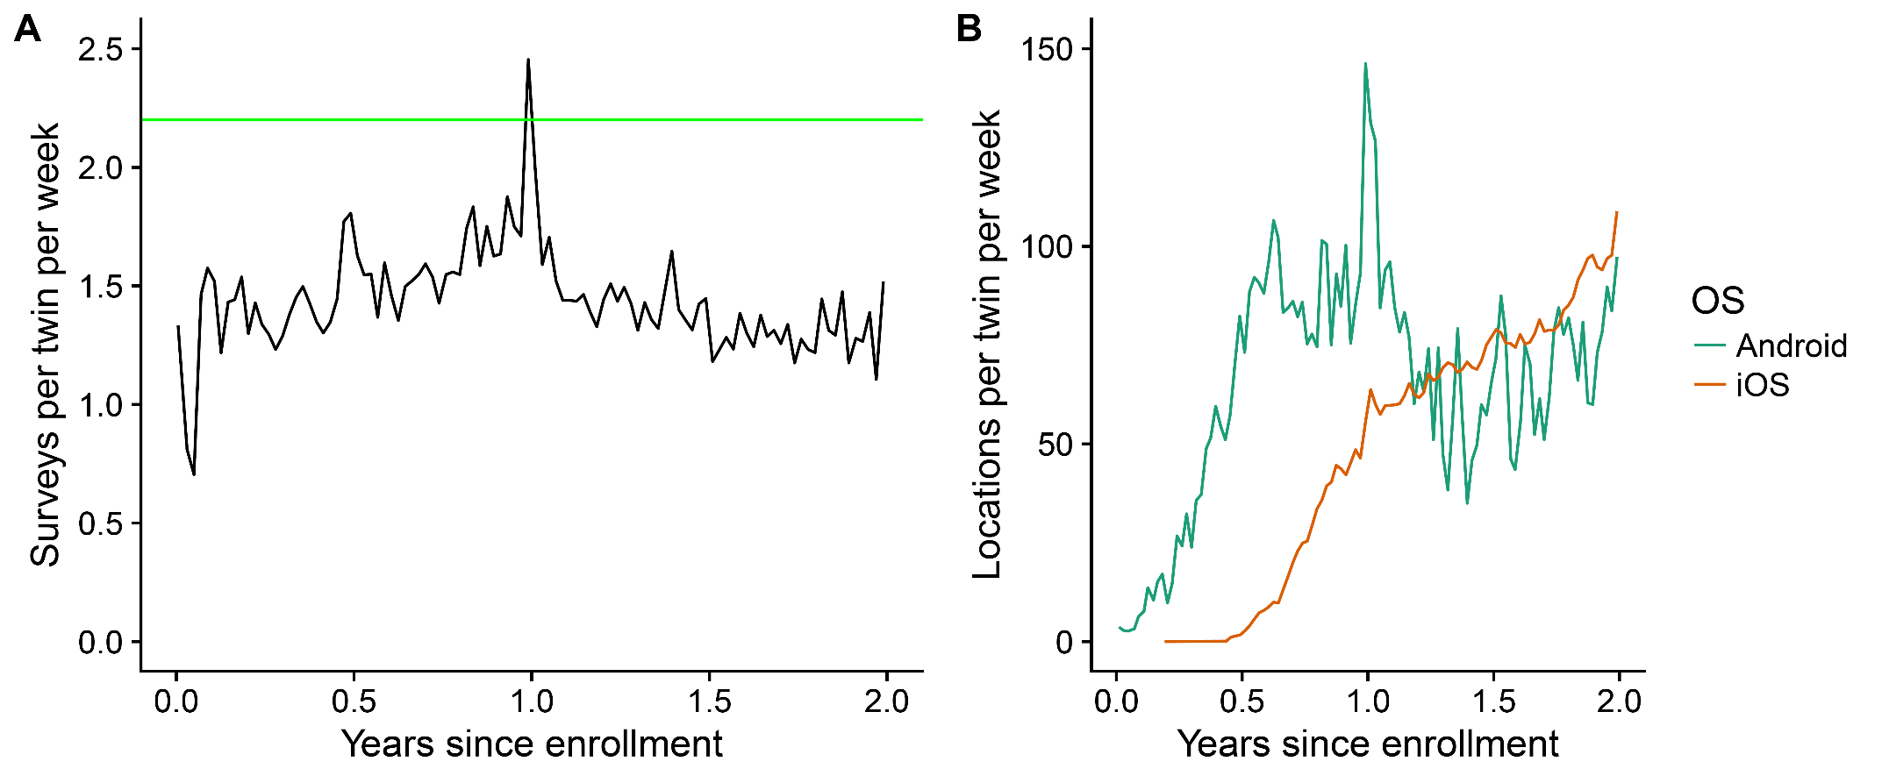
Figure S2. Stacked histograms of the intervals in A) time and B) space between consecutive locations for a twin, conditional on the type of phone used by the twin. The expected patterns are seen. First, the Android time intervals center around five minutes and have less variance than the iOS time intervals. Second, most iOS space intervals are 500 meters or larger and Android space intervals are much more likely to be small or zero. The larger distances (e.g., 1 kilometer or larger), especially for iOS, were observed during piloting when the participant was driving in a car. Particularly large distances (e.g., >100 kilometers) were observed, in some cases, between airports, indicating the individual had just traveled by airplane.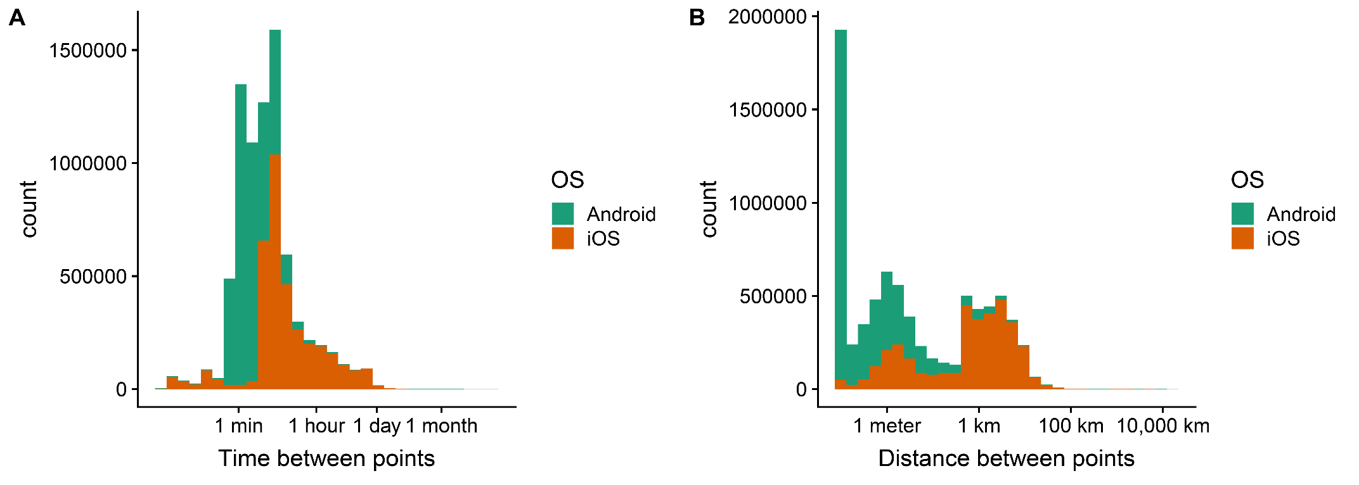
Figure S3. Boxplots of the length in hours of the forward fills of the iOS location data, conditional on A) the hour of the day, and B) the day of the week, of the point being filled forward. Outliers are not displayed to avoid overplotting. As expected, fills starting at night or at the start of the school day are longer, indicating that twins are less likely to move late at night and during the school day. Fills starting Monday through Thursday are longer than those starting on Friday, Saturday, or Sunday, indicating that twins move more overnight on Friday, Saturday, and Sunday. This is consistent with twins spending less time at home and at school on weekends.
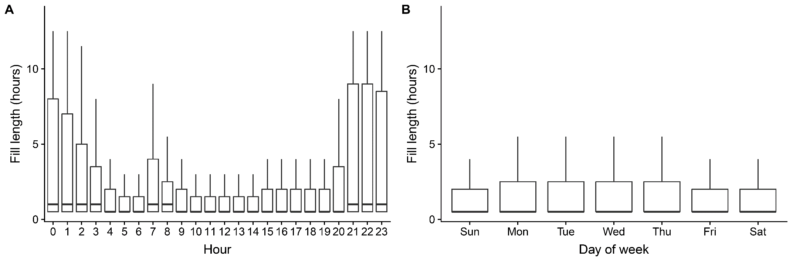
Figure S4. Heatmaps showing the fraction of filled and standardized points recorded before age 18 that were A) within 100 meters of a home address for a given twin, or B) that were within 200 meters of a Colorado high school on a school day, conditional on the day of the week and the hour of the day. As expected, participants are more likely to be at home at night than during the day and on weekday nights than on weekend nights. Twins are less likely to be at home during school hours on school days than on weekends. Participants tend to be at school during school hours on weekdays. They also spend less time at school on Friday than the other weekdays.

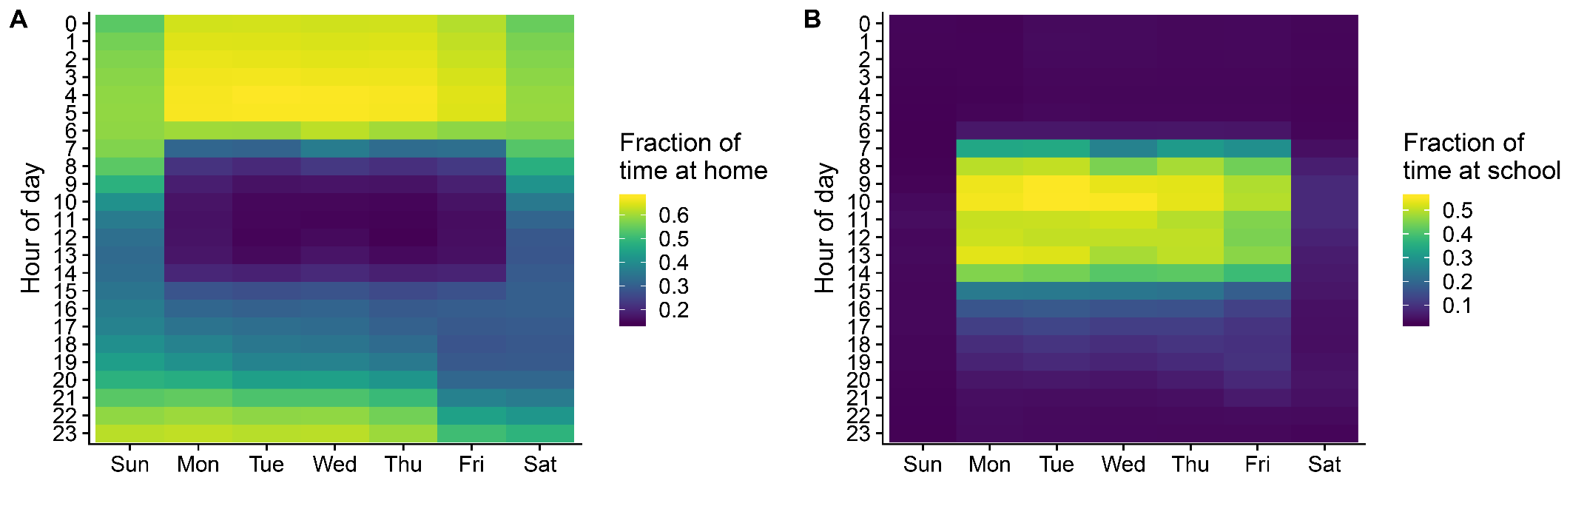

Figure S5. A calendar heatmap showing the fraction of filled and standardized points recorded before age 18 that were within 200 meters of a Colorado high school, for each calendar day. Weekends, summer months, and school holidays consistently show a much lower fraction of points at school.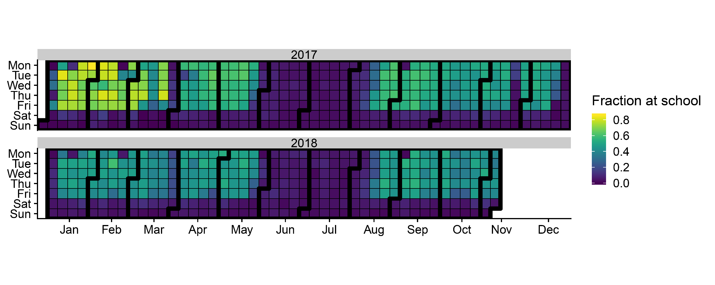

Appendix A: Parental monitoring questionnaire

