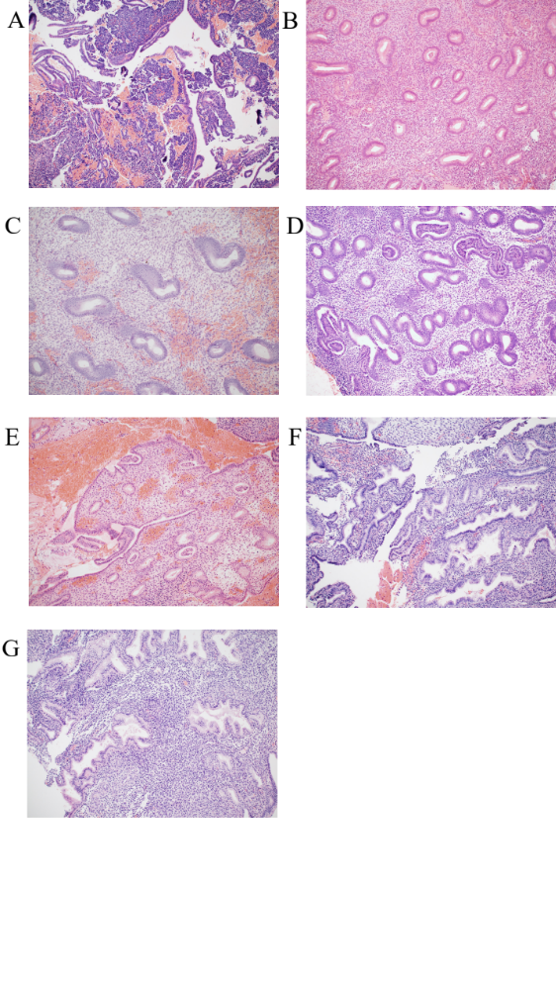

Supplementary figure 1: Hematoxylin and eosin stained histology images for 7 menstrual stages of the endometrium. Representative histology images that were used to categorize each sample into 1 of 7 different menstrual stages based on morphological descriptions outlined in the Noyes criteria. This included samples from the (A) menstrual (B), early proliferative (C), mid proliferative (D), late proliferative (E), early secretory (F), mid secretory (G) and late secretory stage.

