A multi-country study comparing typed to automatic speech recognition-based medical documentation speeds among Low-and-Middle-Income Trained Clinicians

Dr. Tobi Olatunji^{1,2,3}, Chinemelu Aka¹, Chibuzor Okocha^{2,9}, Dr. Gloria Katuka^{2,6}, Amina Tassallah^{2,4}, Naome Etori^{2,7}, Dr. Lukman Ismaila^{2,8}, Prof. Bilal A. Mateen^{10,11}, Prof Rebecca Weintraub¹²

Affiliations
¹ Intron Health
² BioRAMP Labs
³ Georgia Institute of Technology
⁴ Brown University
⁶ Microsoft
⁷ University of Minnesota-Twin Cities
⁸ Johns Hopkins University
⁹ University of Florida
¹⁰ PATH
¹¹ University of Birmingham
¹² Harvard Medical School

Corresponding Author
Tobi Olatunji
tobi@intron.io

Key Words: dictation, keyboard speed, speech recognition, LMIC

Word Count: 3658
Tables: 1
Figures: 6

Supplementary Material

Supplementary Fig 1: Distribution of Dictation Speed Up
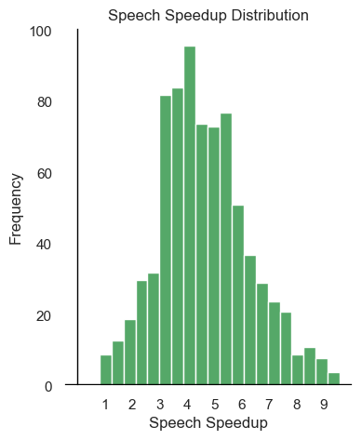

Supplementary Fig 2: Distribution of Accuracy Ratings
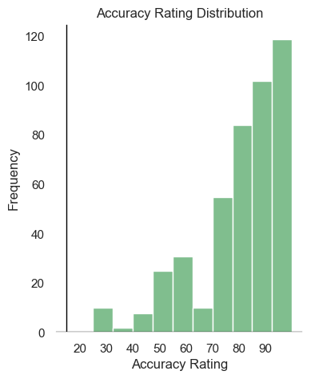

Supplementary Fig 3: Distribution of Accuracy rating by Country

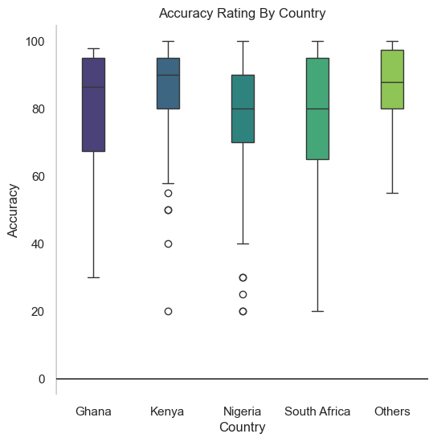

Supplementary Fig 4: Word Cloud of free text feedback

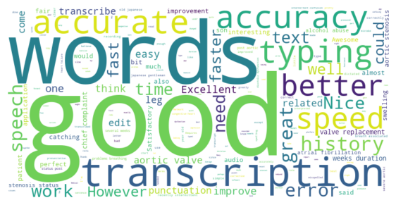

Supplementary Table 1: Country Counts

Country | count
Nigeria | 313
South Africa | 294
Kenya | 119
Ghana | 30
Philippines | 8
Zimbabwe | 7
Botswana | 3
India | 2
United States | 2
Cameroon | 1
Uganda | 1
Jamaica | 1
Mozambique | 1
Pakistan | 1
Lesotho | 1

Supple T2: Normalized Accent Counts

Language | count
zulu | 141
yoruba | 115
swahili | 106
igbo | 61
hausa | 44
xhosa | 37
setswana | 32
sesotho | 22
pedi | 20
twi | 17
urhobo | 16
tsonga | 14
afrikaans | 13
shona | 11
luo | 6
tagalog | 5
ibibio | 8
english | 5
ebira | 5
pidgin | 5
ndebele | 5
ewe | 4
bekwarra | 4
fante | 4
venda | 4
kikuyu | 4
ijaw | 4
bini | 4
ibo | 3
nembe | 3
fulani | 3
isoko | 3
filipino | 3
igala | 3
jaba | 3
kamba | 3
kalabari | 3
kwahu | 2
efik | 2
ika | 2
tiv | 2
ogoni | 2
swati | 2
bajju | 2
ibani | 1
patois | 1
ga | 1
urdu | 1
dangme | 1
izon | 1
hindi | 1
kalenjin | 1
utugwang | 1
evie | 1
idoma | 1
ukwani | 1
ibra | 1
edo | 1
meru | 1
tehl | 1
bade | 1
ham | 1
atyap | 1
adara | 1
kanuri | 1
french | 1
eritrean | 1
telugu | 1
navajo | 1
amo | 1
limbum | 1
luhya | 1

