Period
Event rate (%)

Case fatality rate (%)
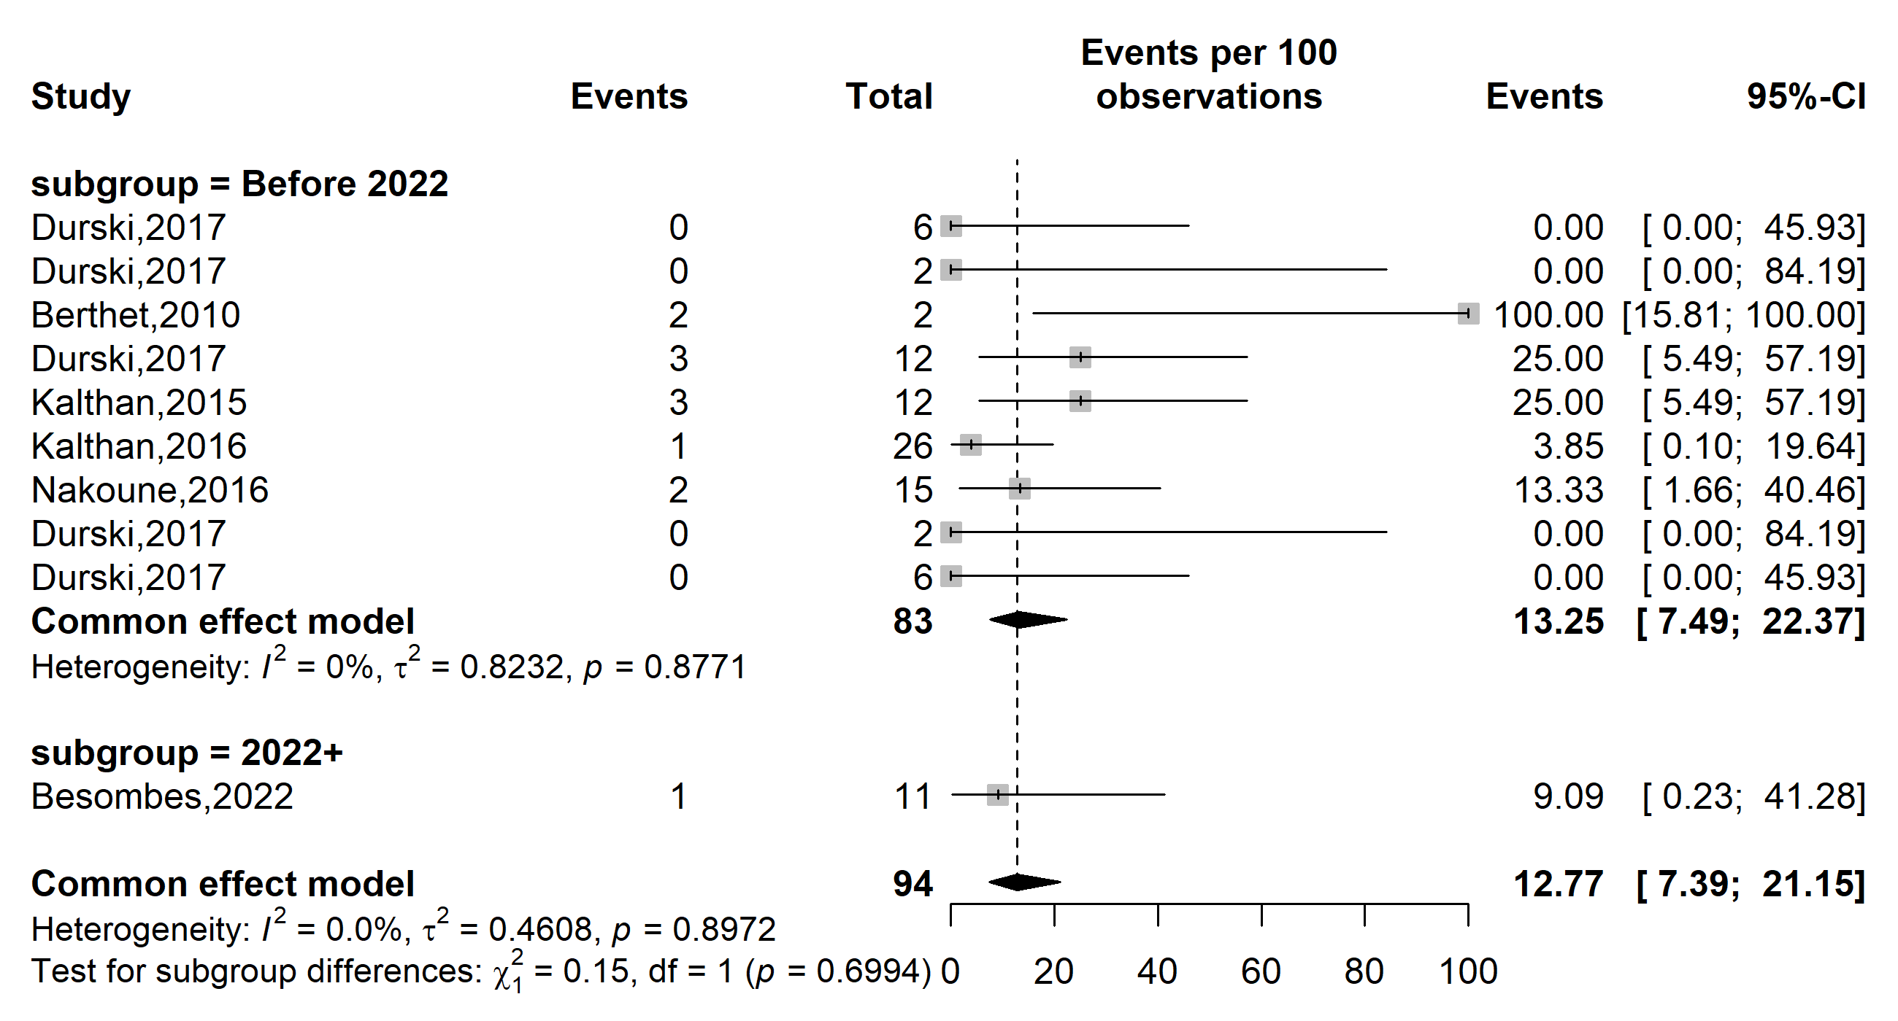
Supplementary Fig. 1 Pooled case fatality rate by study period among suspected Mpox cases in Central African Republic (CAR) (the period represents before and since the 2022 pandemic)

Region
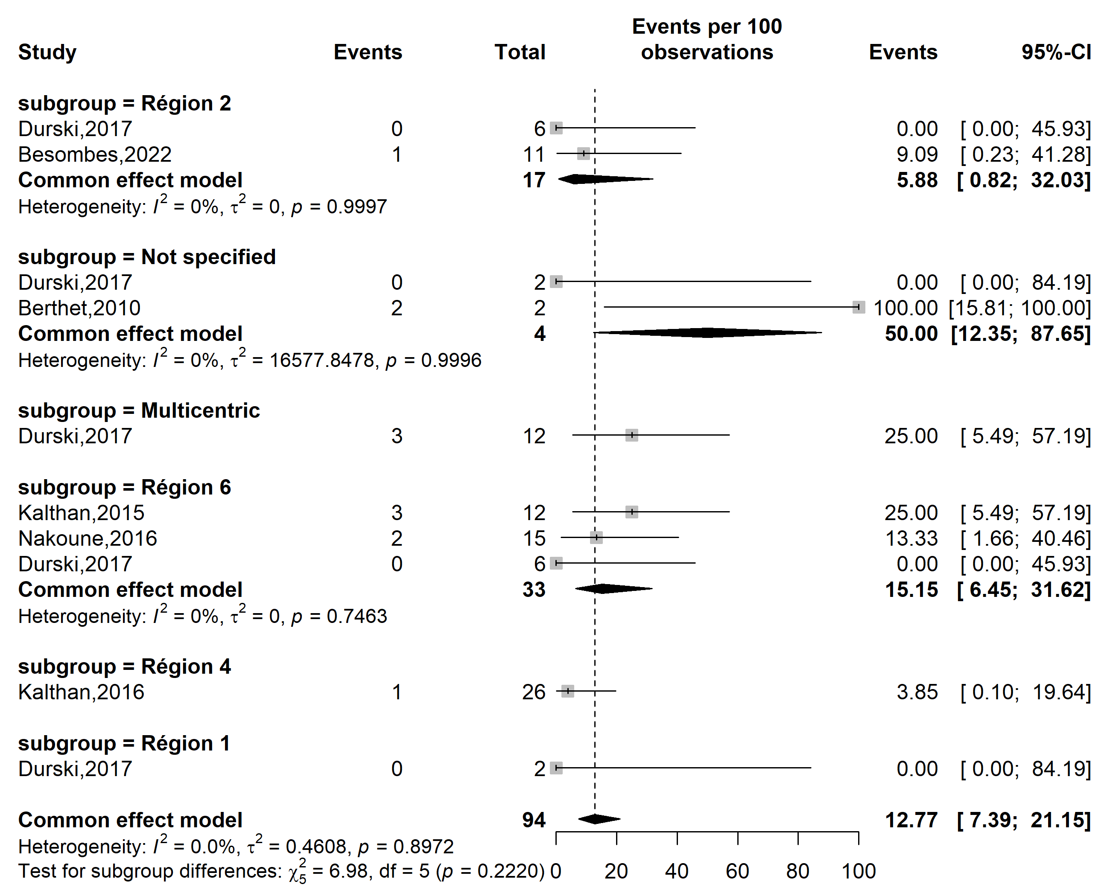
Case fatality rate (%)
Event rate (%)

Supplementary Fig. 2 Pooled case fatality rate among suspected Mpox cases by CAR’s regions

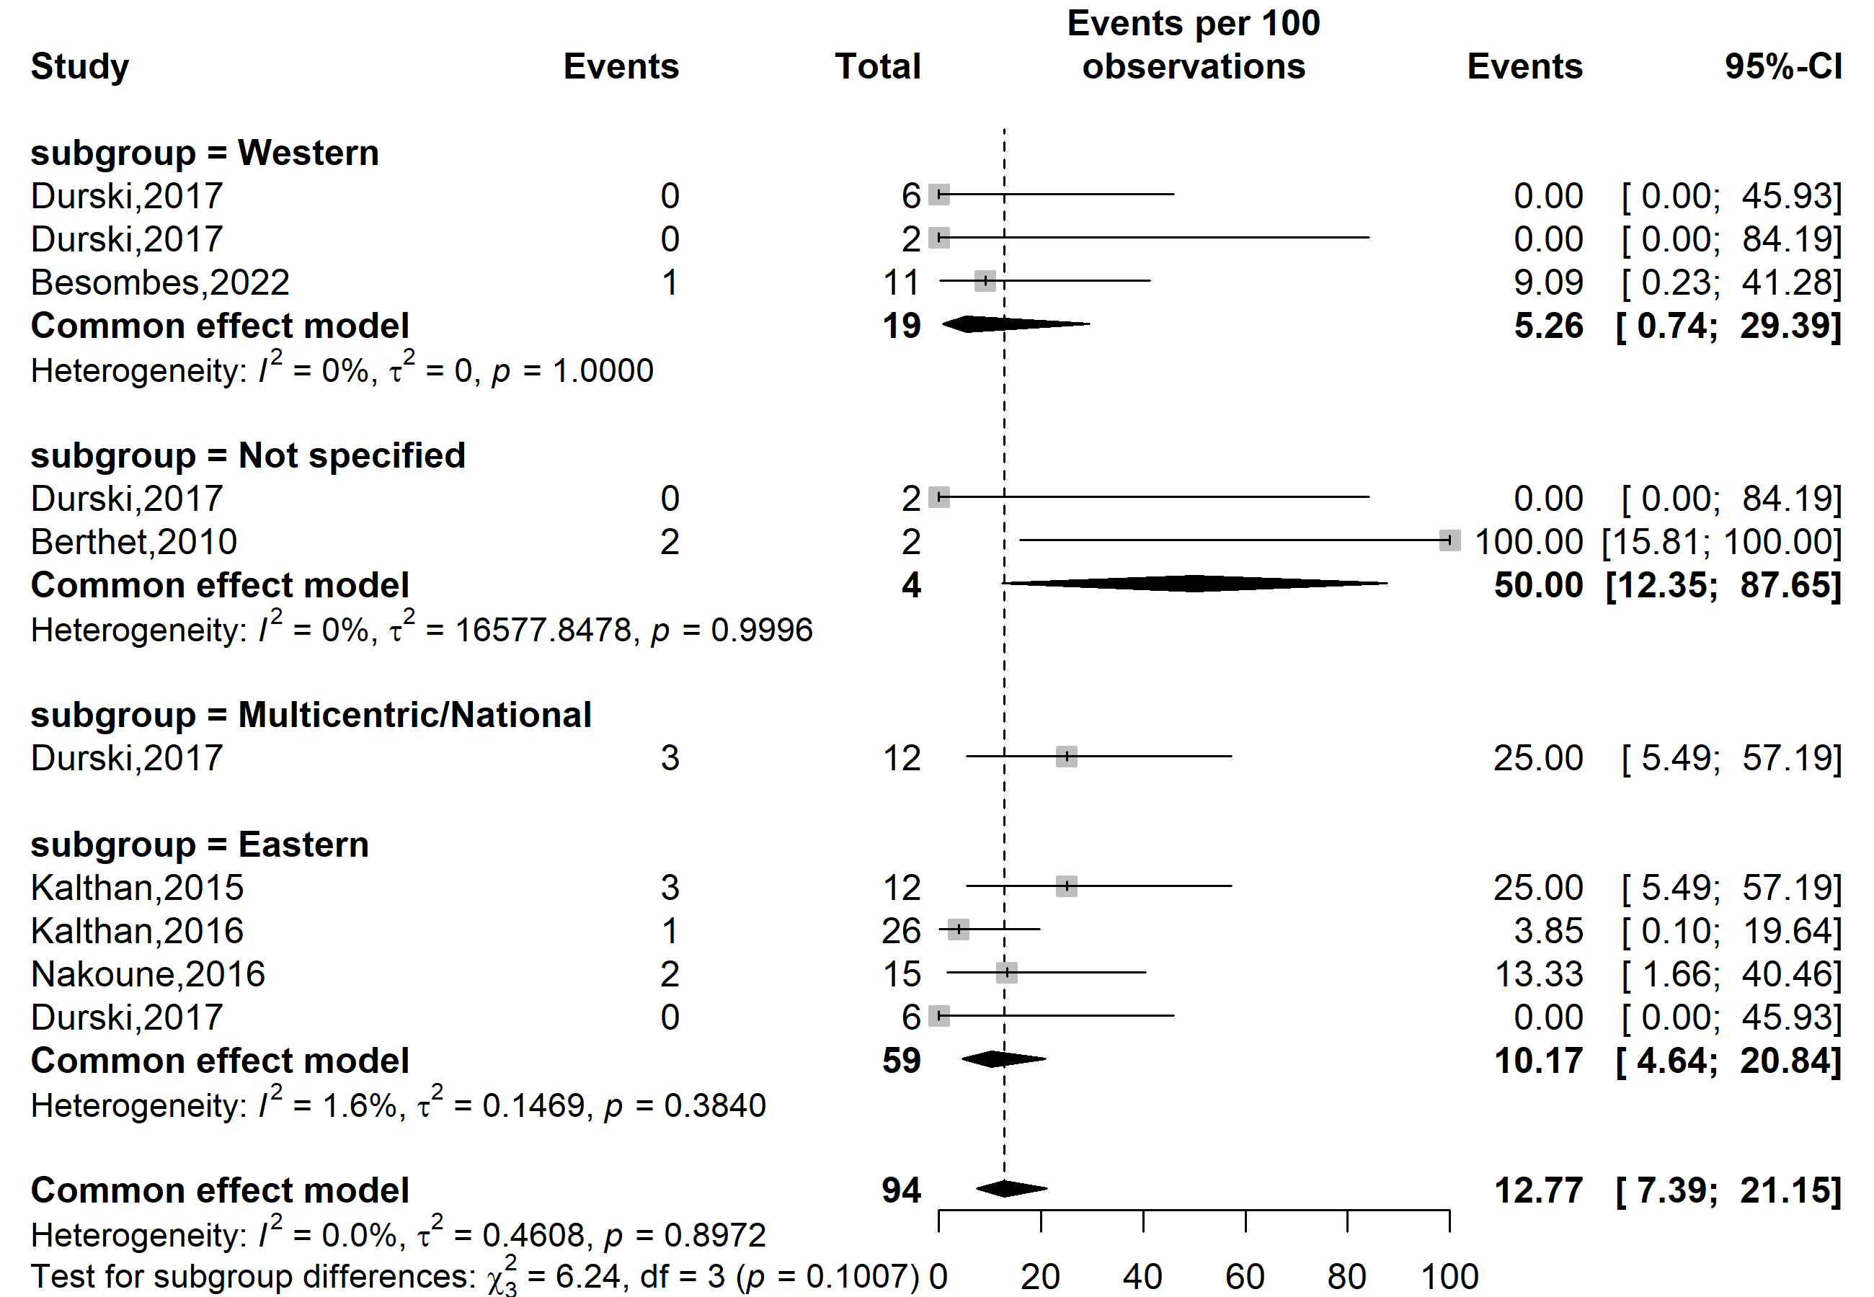
Case fatality rate (%)
Event rate (%)

Supplementary Fig. 3 Pooled case fatality rate by region location among suspected Mpox cases in CAR (HCW: Healthcare worker)

Participant
Event rate (%)

Case fatality rate (%)
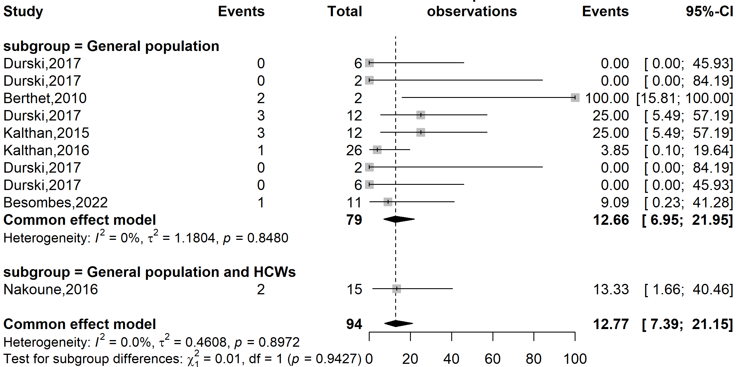
Supplementary Fig. 4 Pooled case fatality rate by type of participants involved among suspected Mpox cases in CAR (HCW: Healthcare worker)

Publication bias
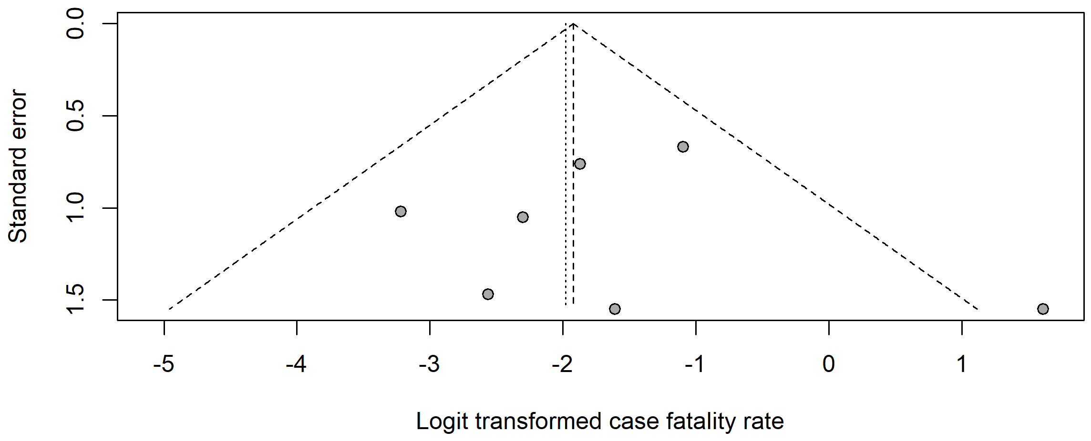
Egger’s test (p-value = 0.743)
Begg’s test (p-value = 0.711)
Supplementary Fig. 5 Funnel plot with pseudo 95% confidence limits and tests assessing the publication bias of studies included

Sensitivity analysis
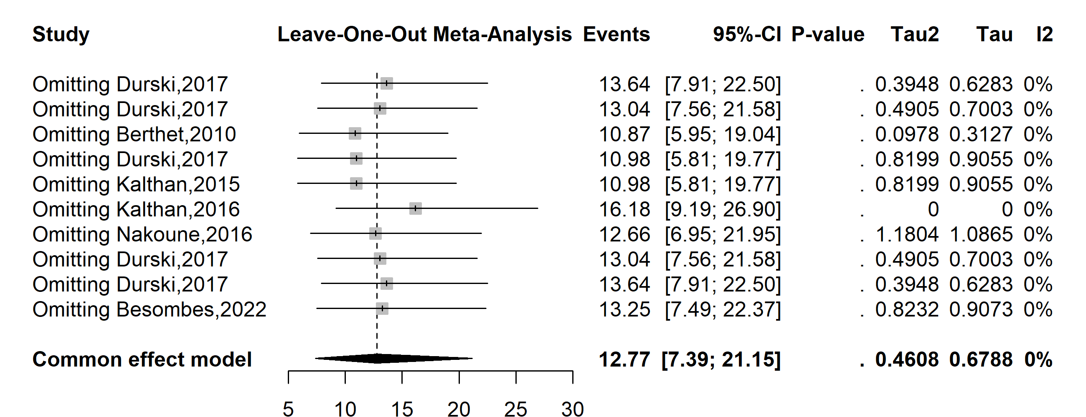
Supplementary Fig. 6 Sensitivity analysis of the suspected Mpox case fatality rate pooled estimate in CAR

