Supplementary
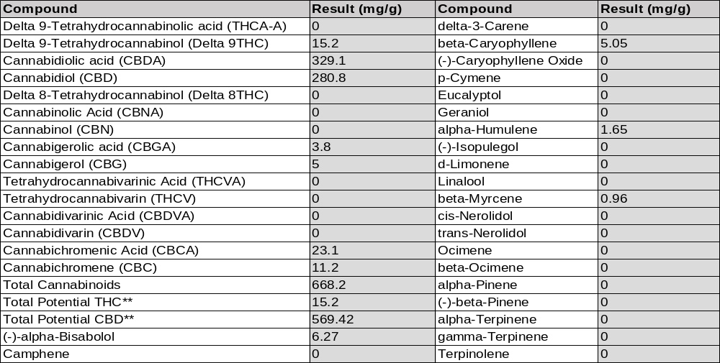
Table S1. * Total Cannabinoids result reflects the absolute sum of all cannabinoids detected. ** Total Potential THC/CBD is calculated using the following formulas to take into account the loss of a carboxyl group during decarboxylation step. Total THC = THC + (THCa *(0.877)) and Total CBD = CBD + (CBDa *(0.877)) LOQ: Limit of quantification

Primer | Sequence (5’-3’)
GAPDH | F - 5’-GAGGCAGGGATGATGT TCTG-3’  R - 5’ CAGCCTCAAGATCATCAGCA-3’
BCL-2 | F - 5’- CGGAGGCTGGGATGCCTTTG -3’  R - 5’- TTTGGGGCAGGCATGTTGAC -3
c-Myc | F - 5’ CCTGGTGCTCCATGAGGAGAC 3’  R - 5’ CAGACTCTGACCTTTTGCCAG 3’
TP53 | F - 5'-TGCGTGTGGAGTATTTGGATG-3’  R - 5'-TGGTACAGTCAGAGCCAACCTC-3'
Supplementary Table 2: Primer sequence used in the study

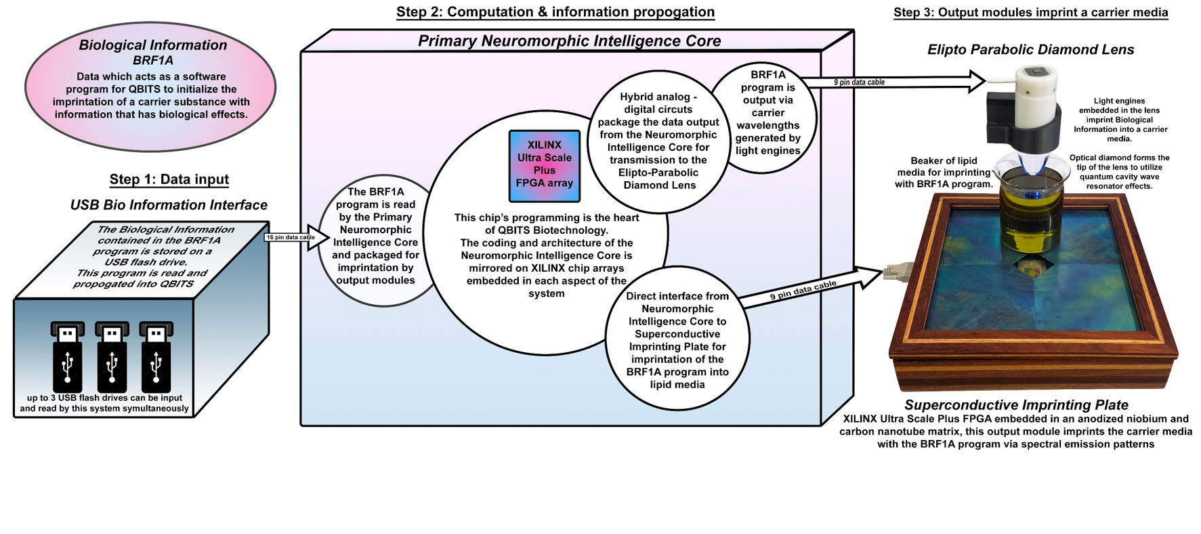
Supplementary Figure 1: “Imprinting Process” using the Quantum Biological Information Transfer System (QBITS) Biotechnology

