Supplemental Figure 1. LocusZoom plots of each locus in different populations. Note: Only concordant variants were plotted.
Supplemental Figure 2: Manhattan plots of gene-based analyses. A: 1kg-EUR-like; B: 1kg-AFR-like; C: 1kg-AMR-like; D: meta-analysis of 1kg-AFR-like and 1kg-EUR-like; E: meta-analysis of 1kg-EUR-like and 1kg-AMR-like; F: meta-analysis of 1kg-AFR-like, 1kg-EUR-like, and 1kg-AMR-like.

Supplemental Figure 1. LocusZoom plots of each locus in different populations. Note: Only concordant variants were plotted.
Locus 1: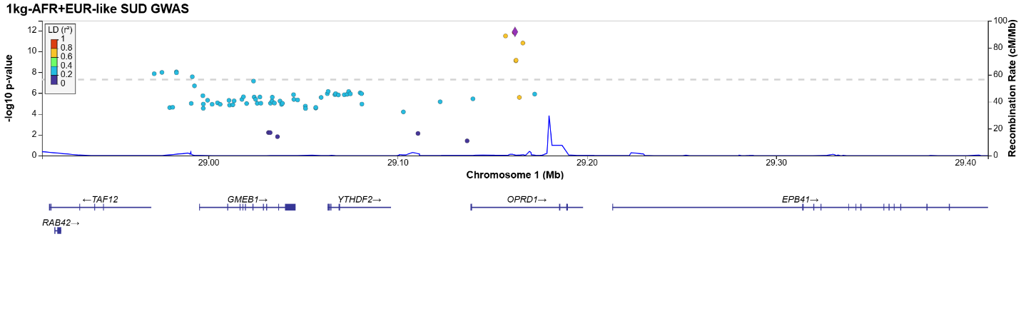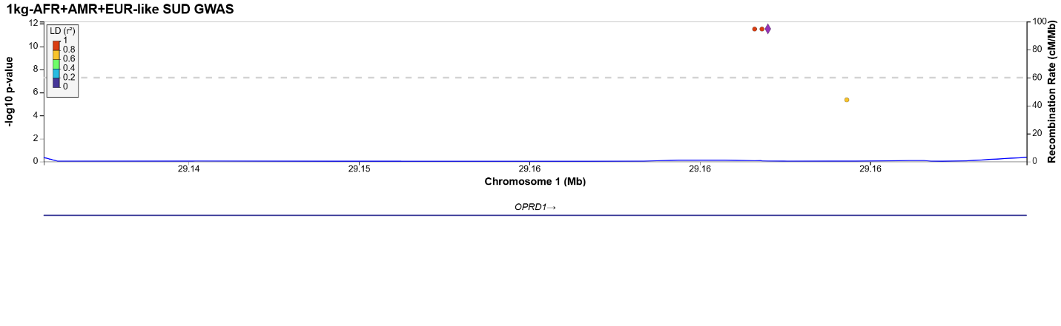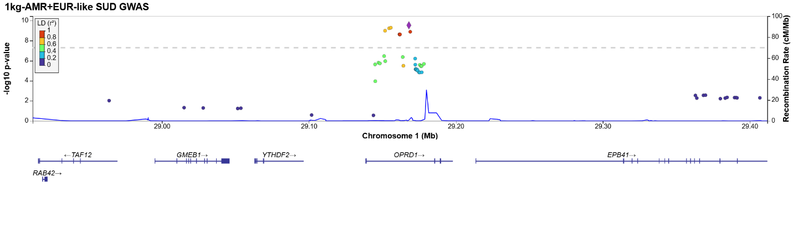
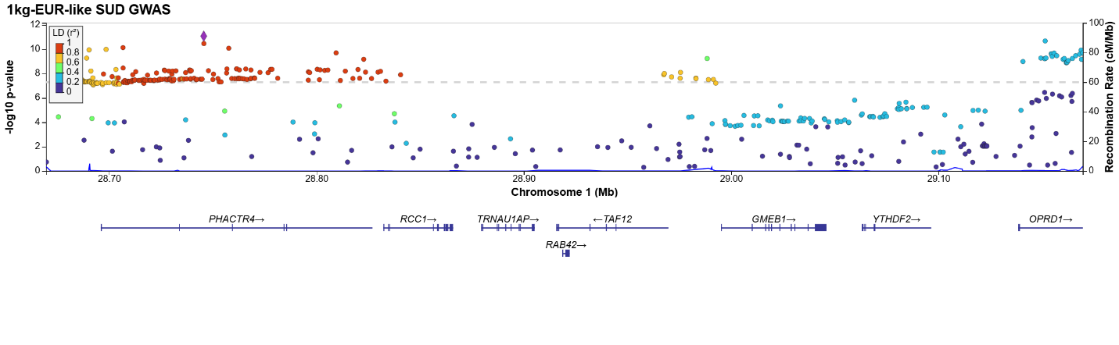
Locus 2:
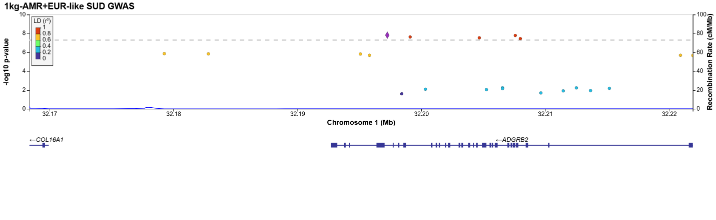
Locus 3:
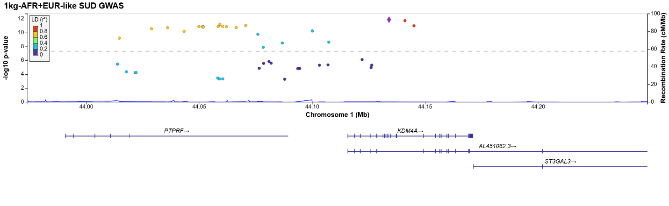
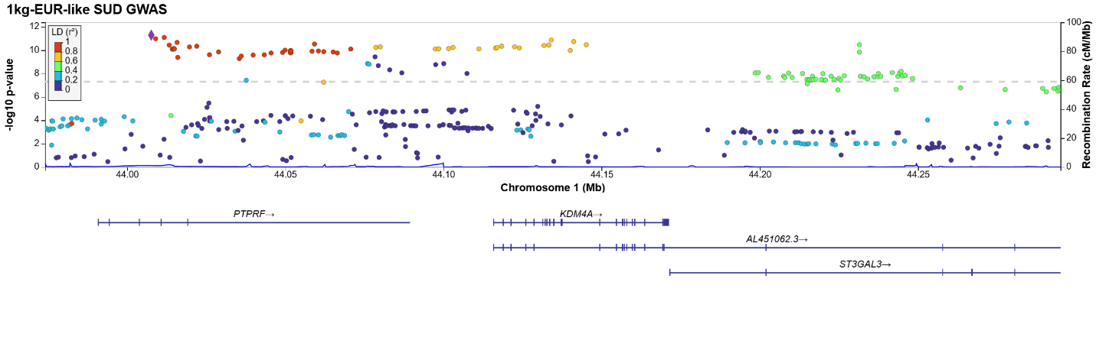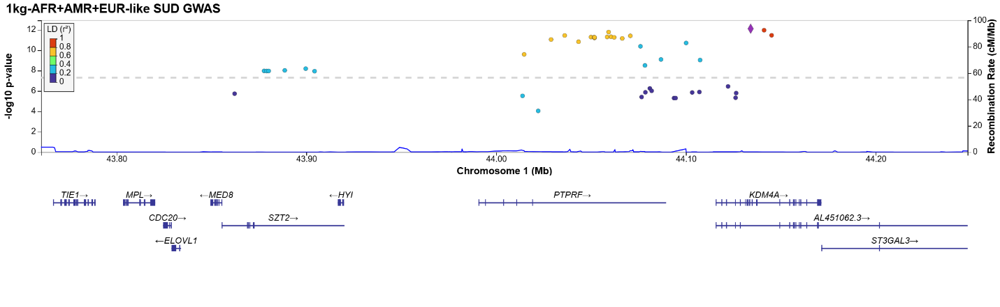
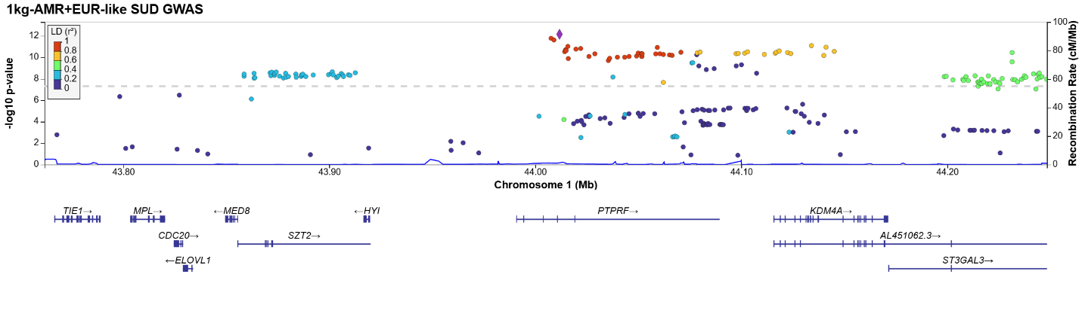
Locus 4:
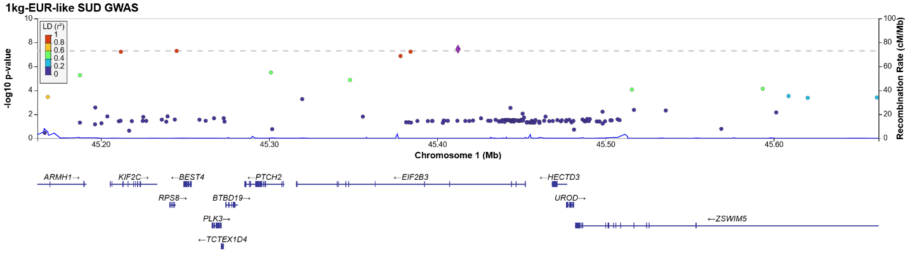
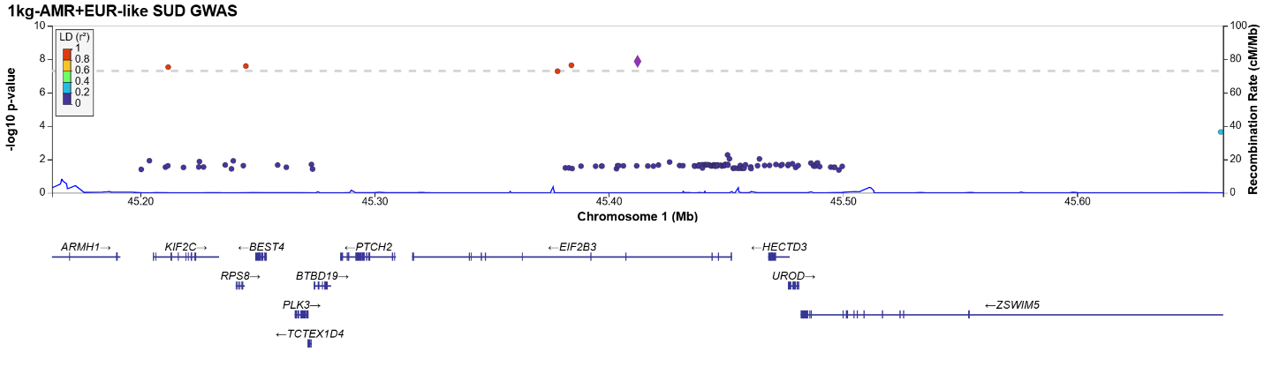
Locus 5:
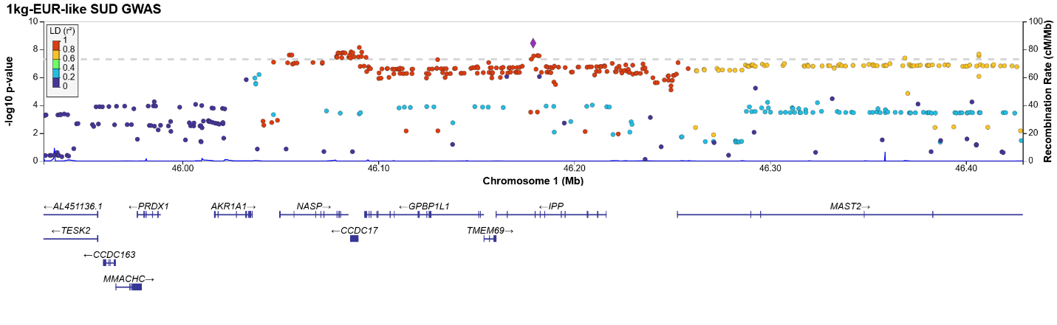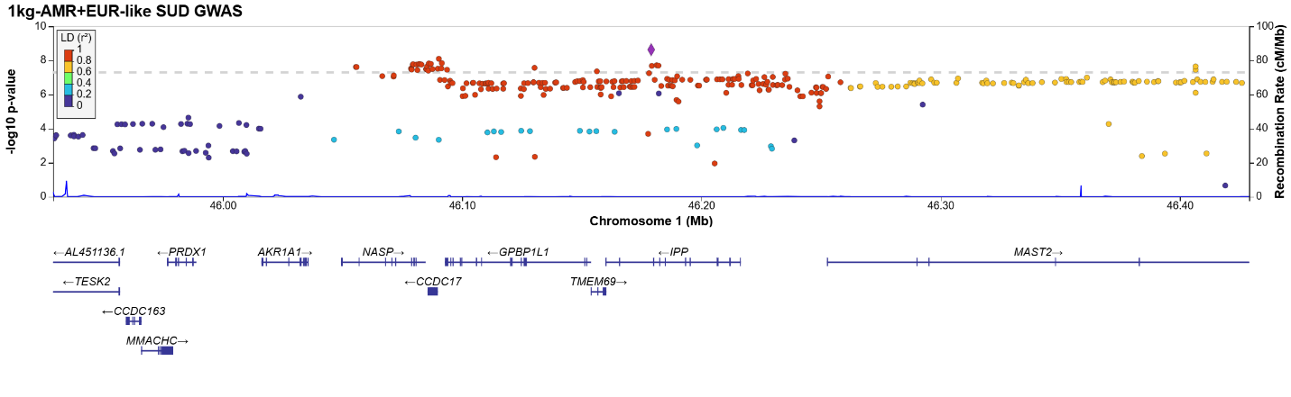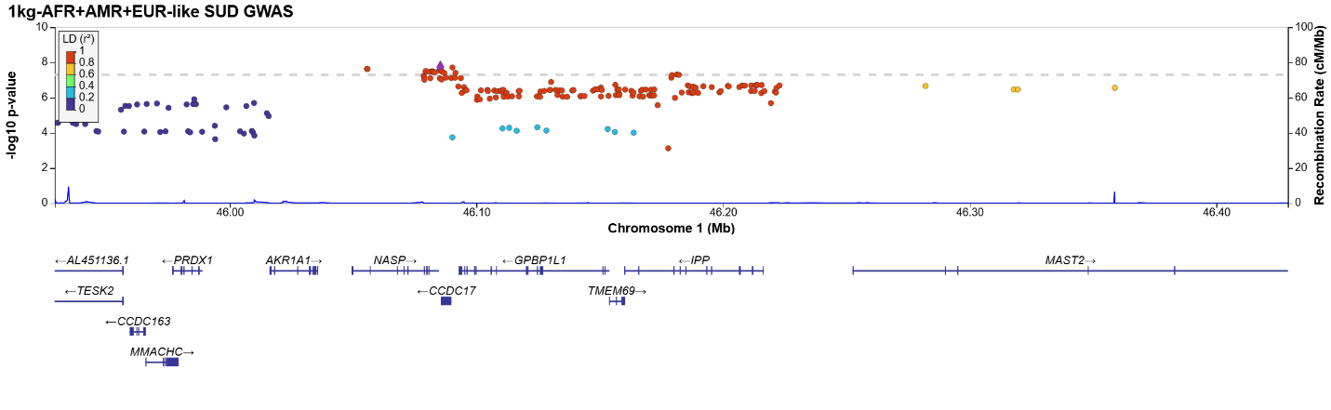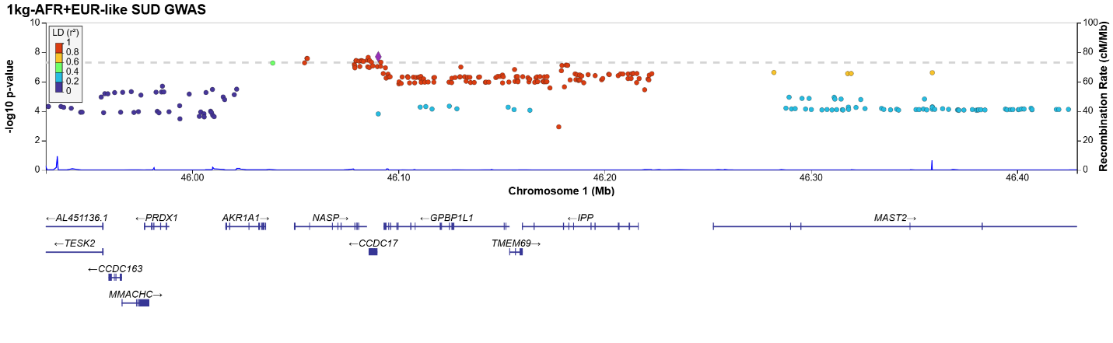
Locus 6:
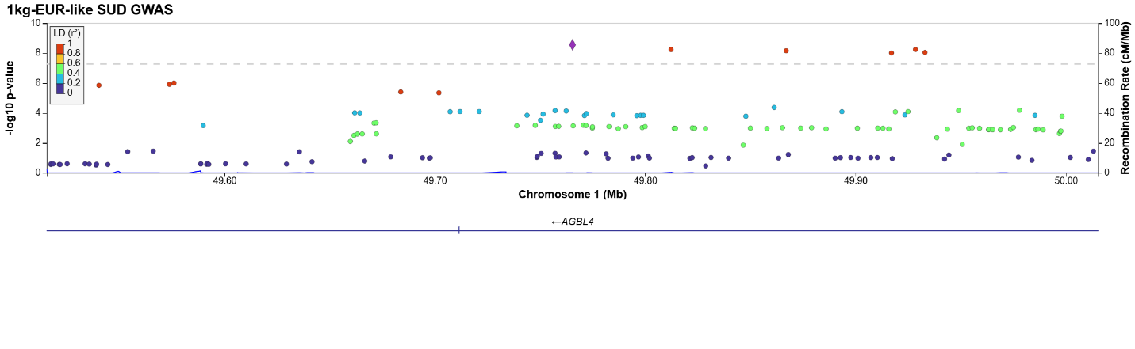
Locus 7:
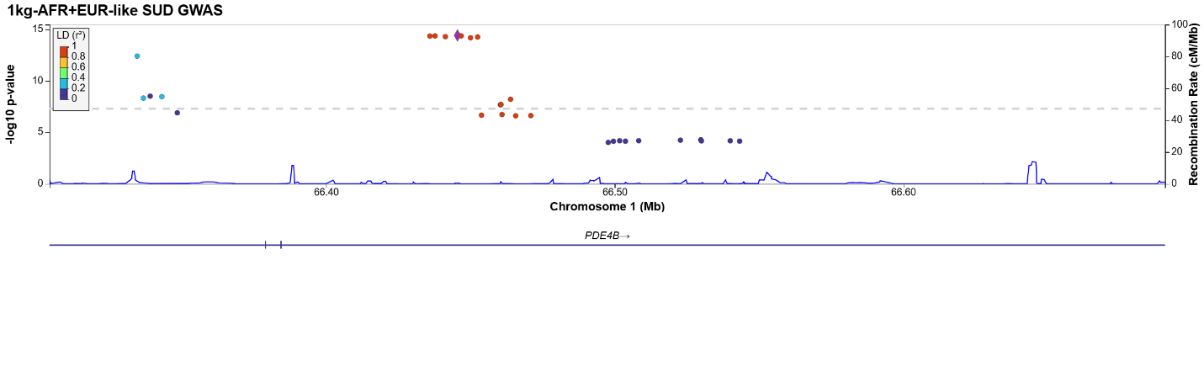
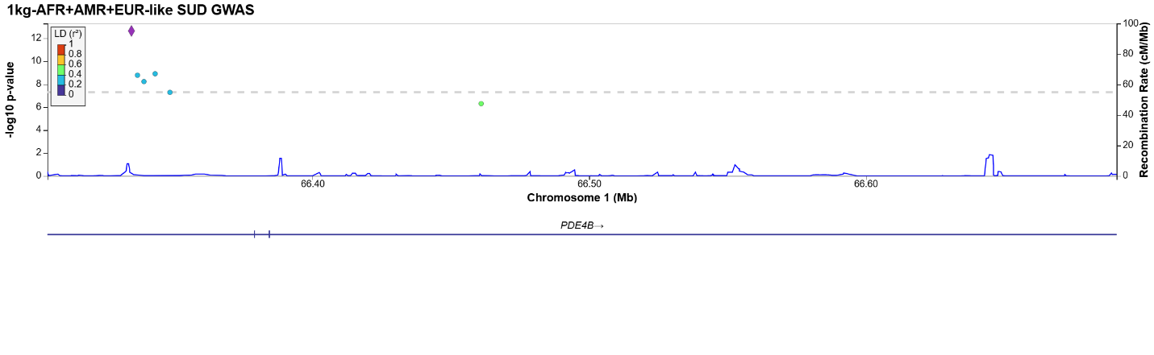
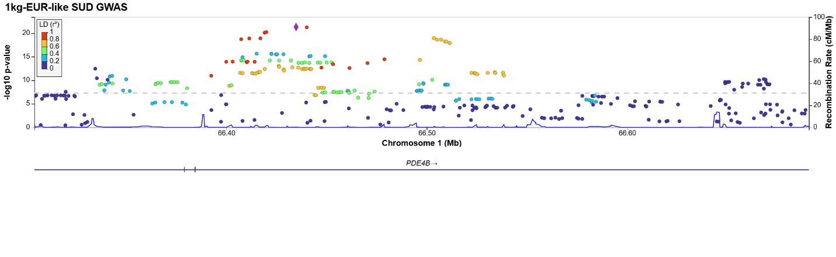
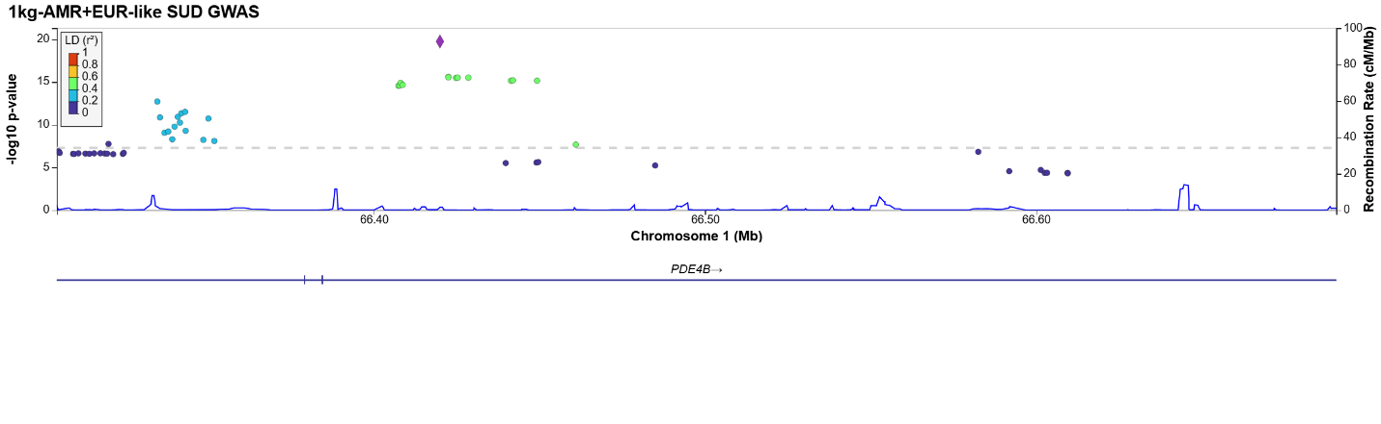
Locus 8:
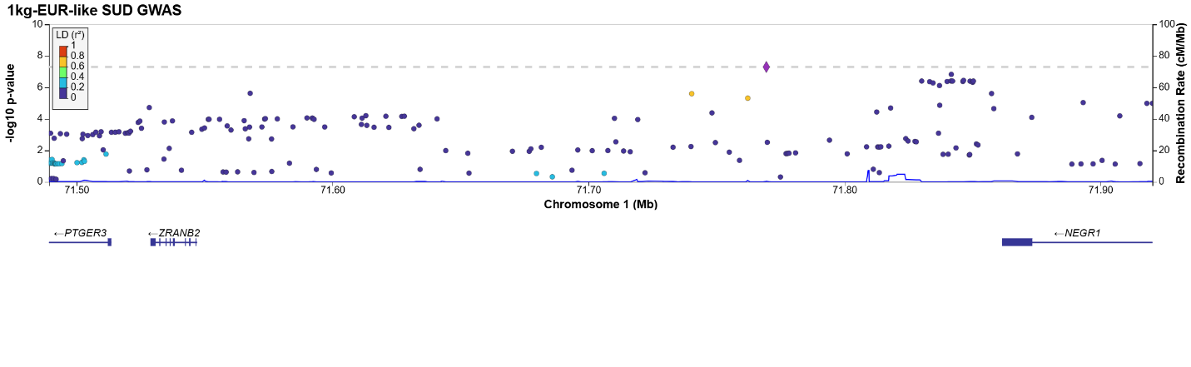
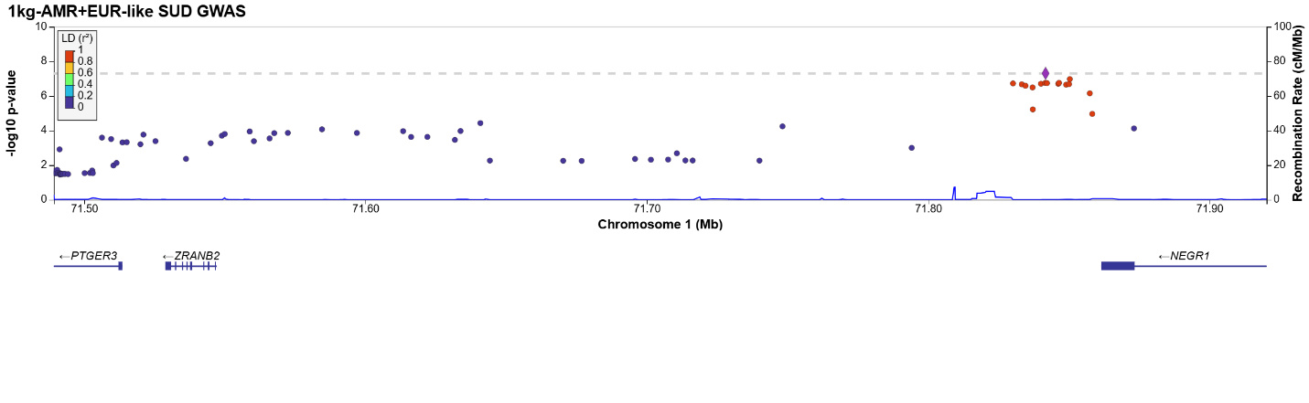
Locus 9:
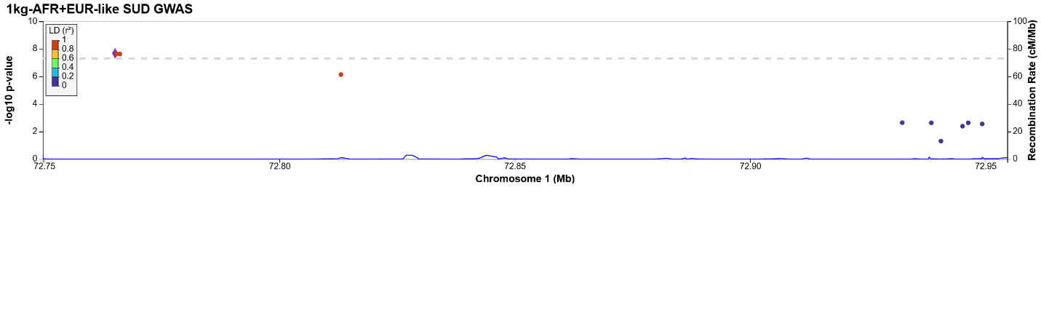
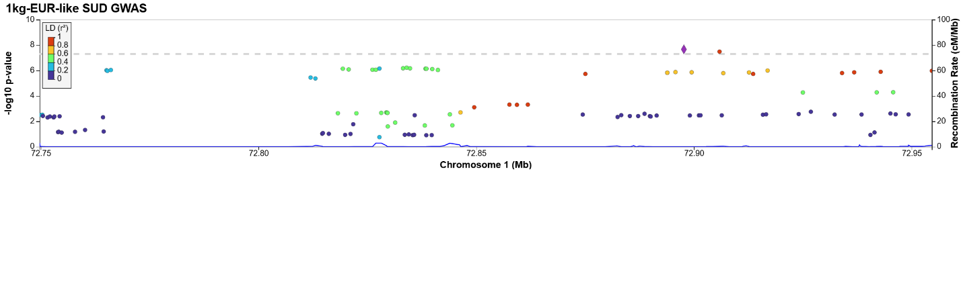
Locus 10:
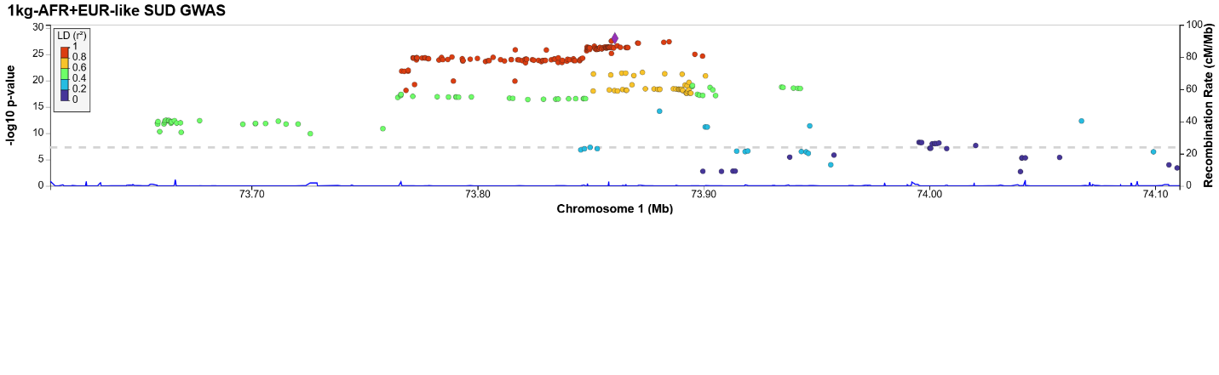
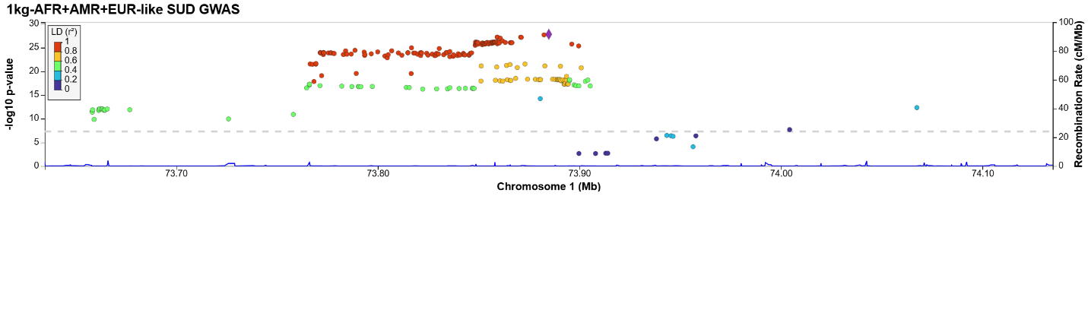
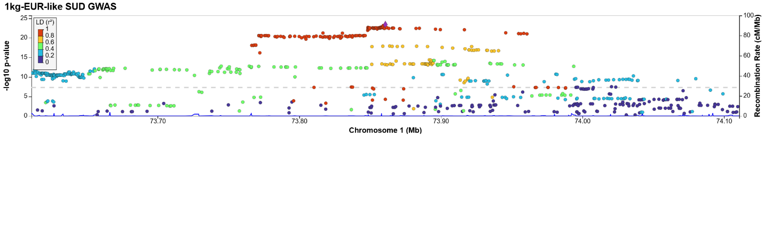
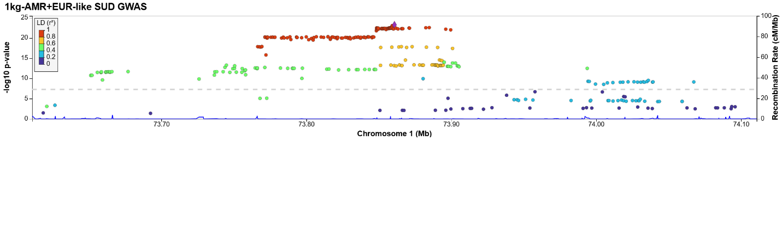
Locus 11:
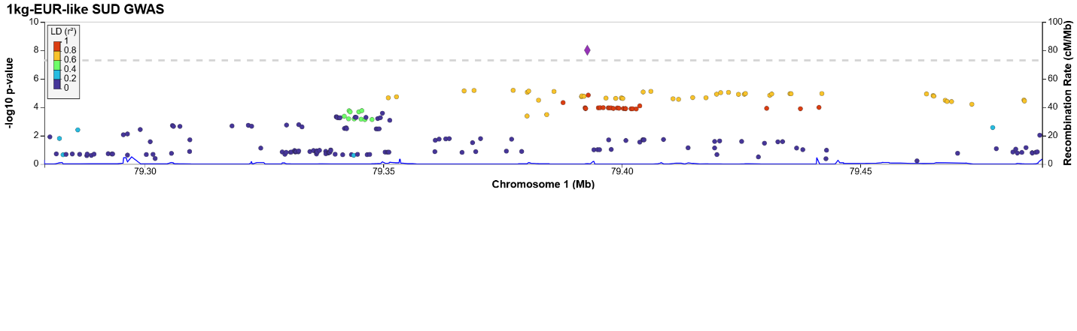
Locus 12:
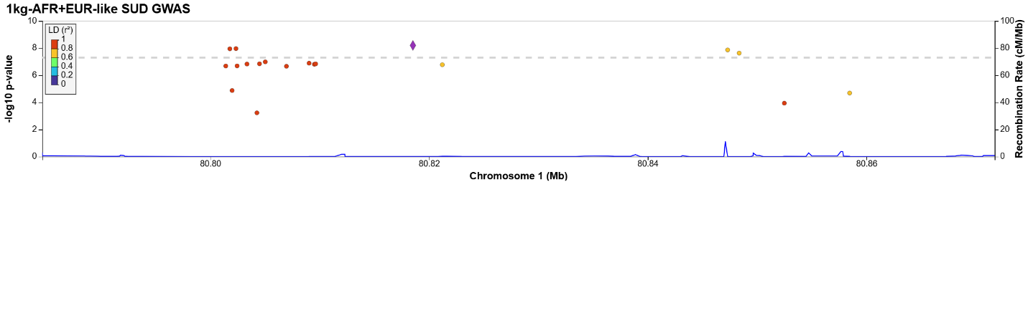
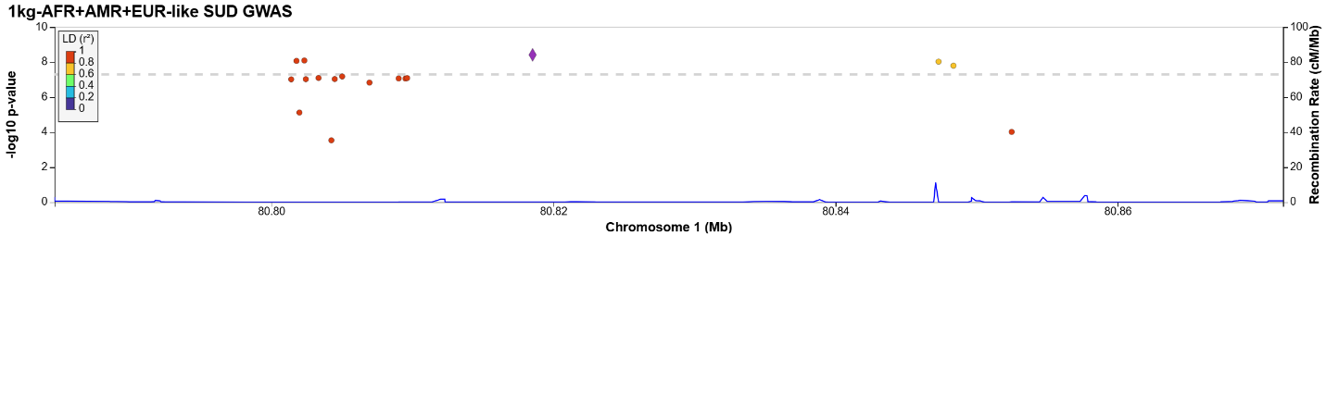
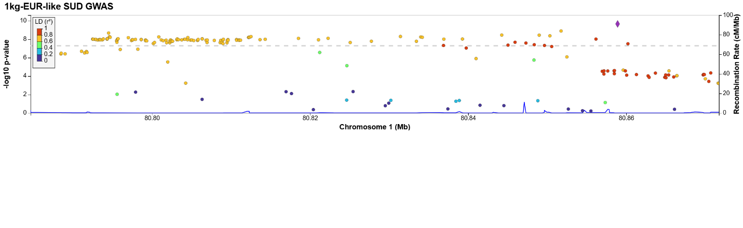
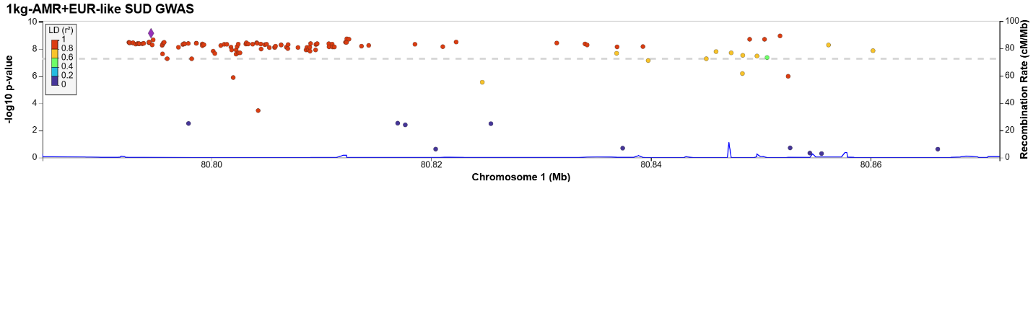
Locus 13:
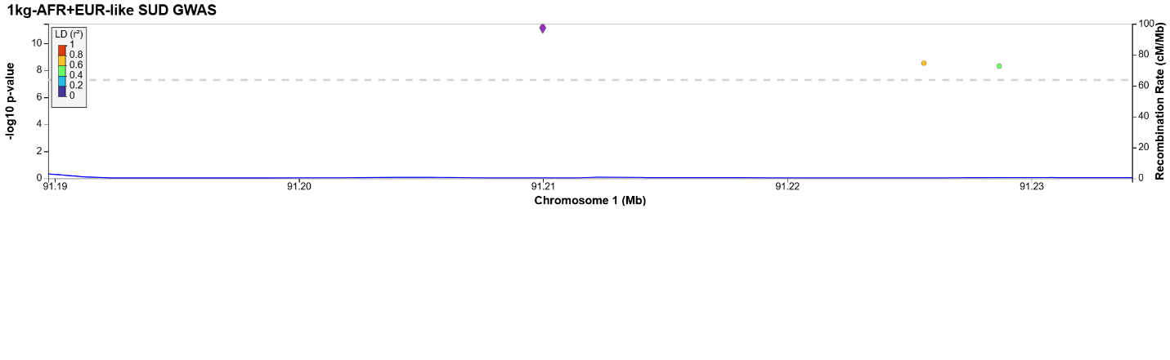
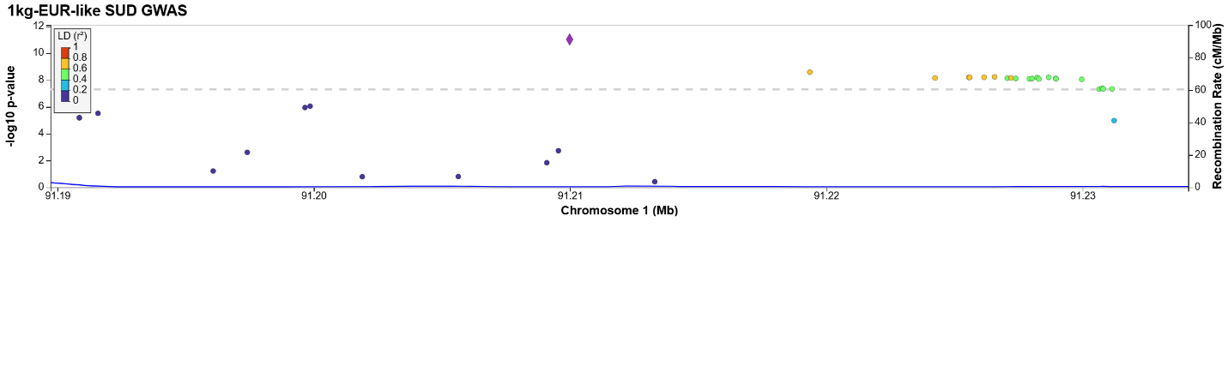
Locus 14:
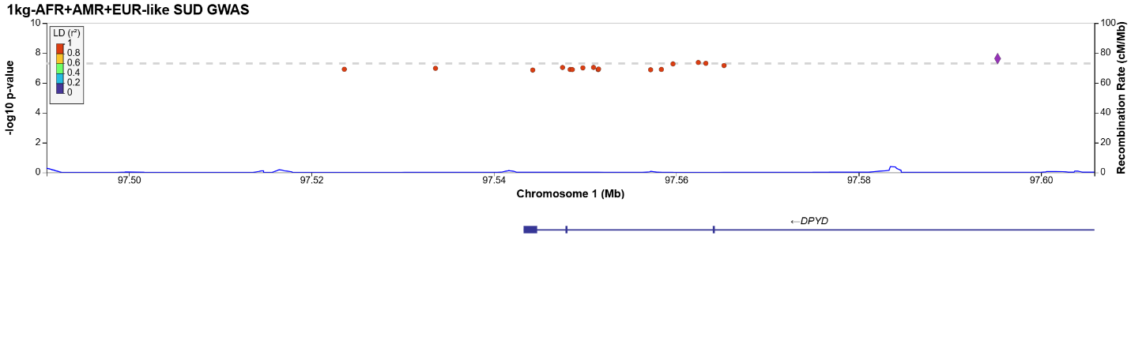
Locus 15:
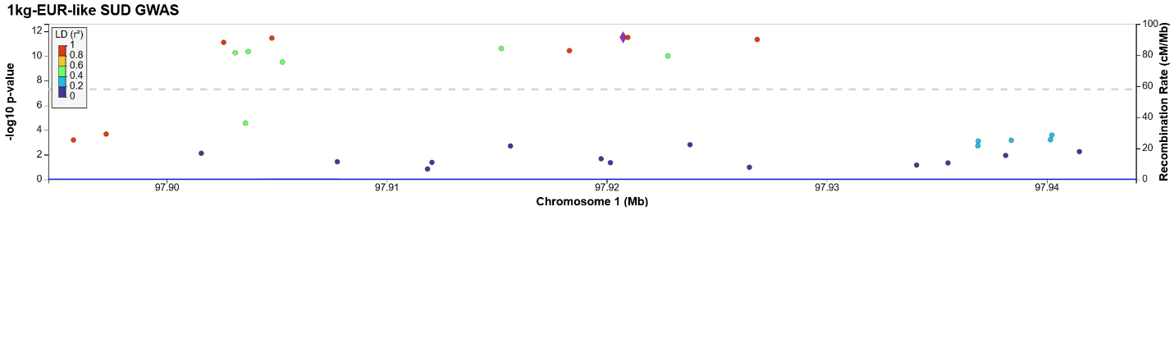
Locus 16:
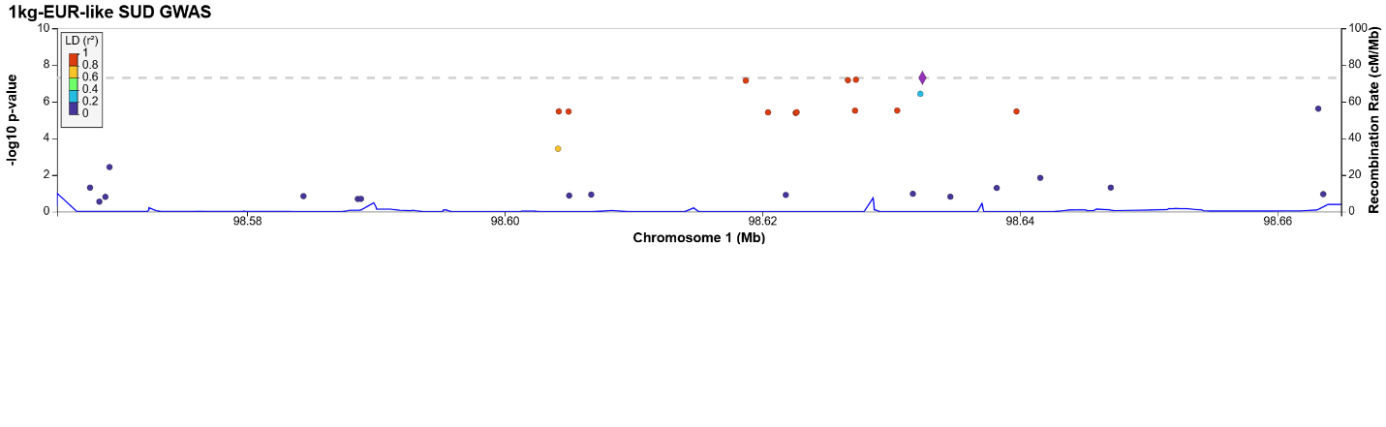
Locus 17:
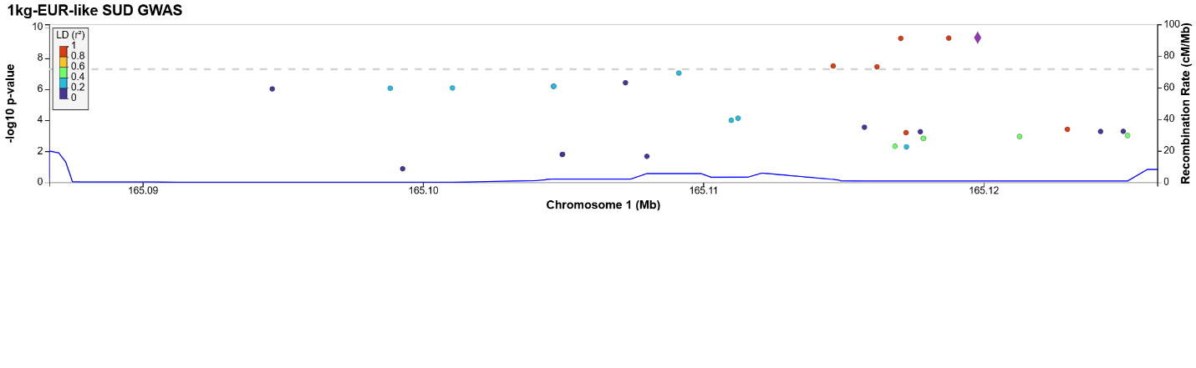
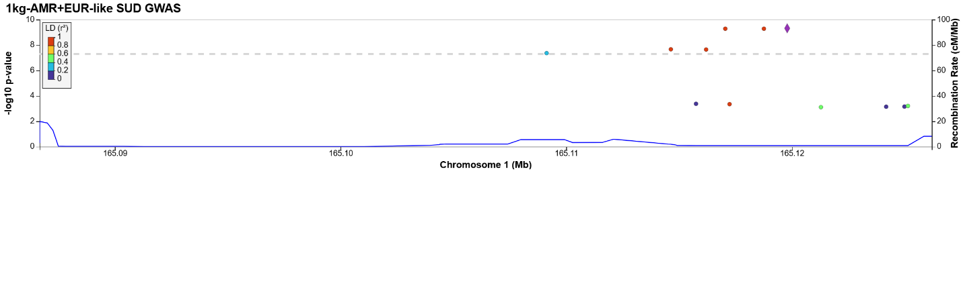
Locus 18:
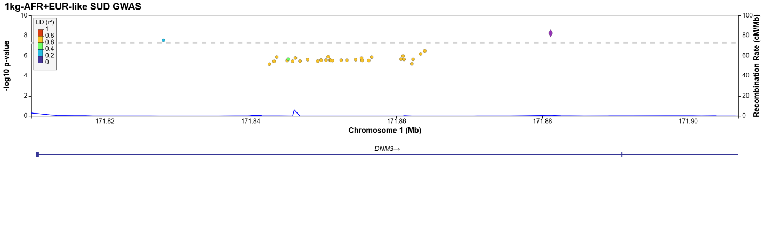
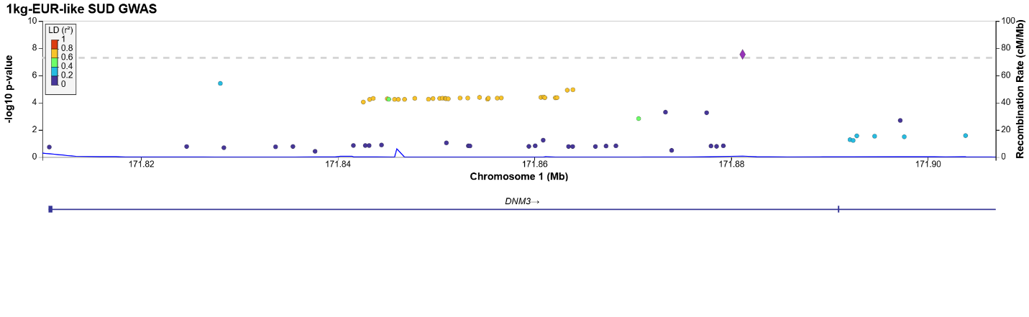
Locus 19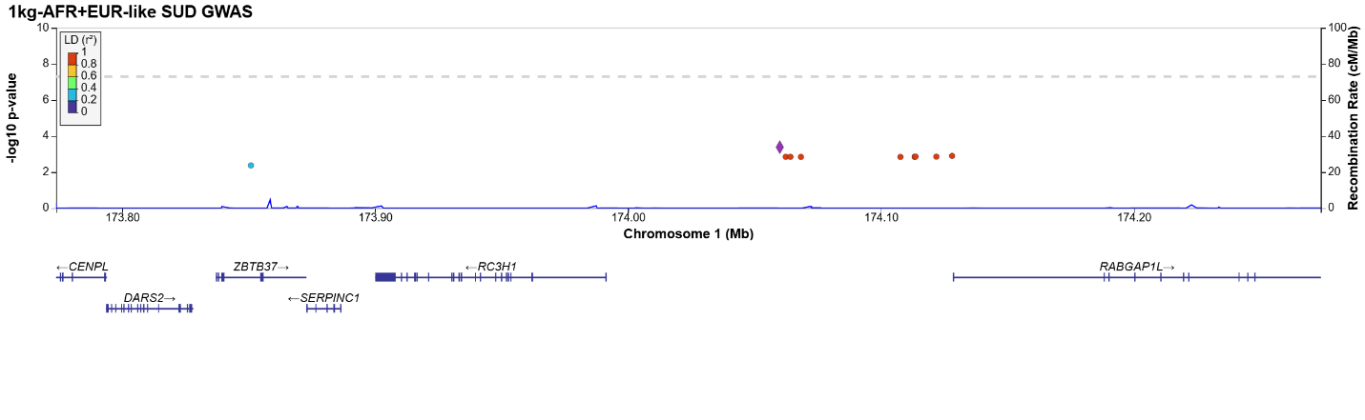
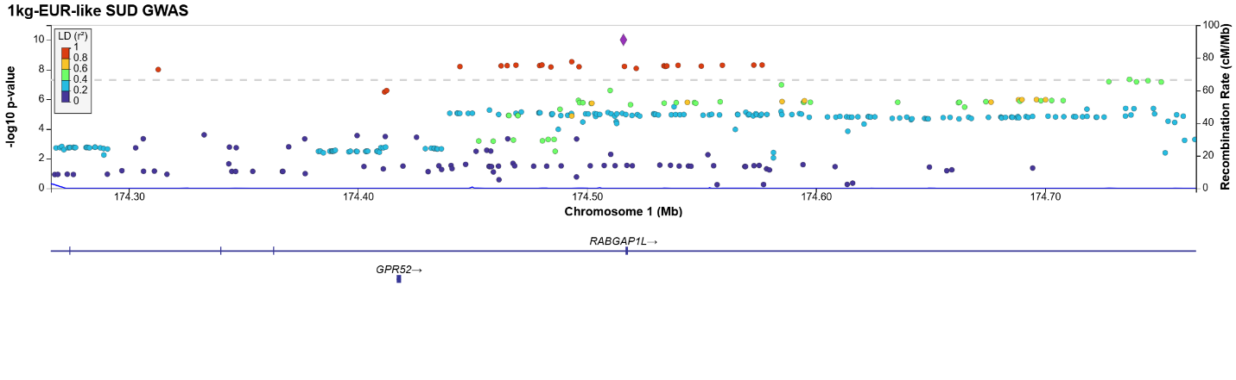
Locus 20:
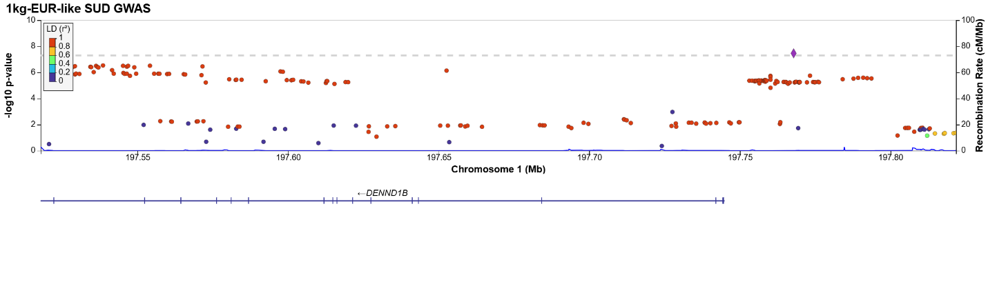
Locus 21:
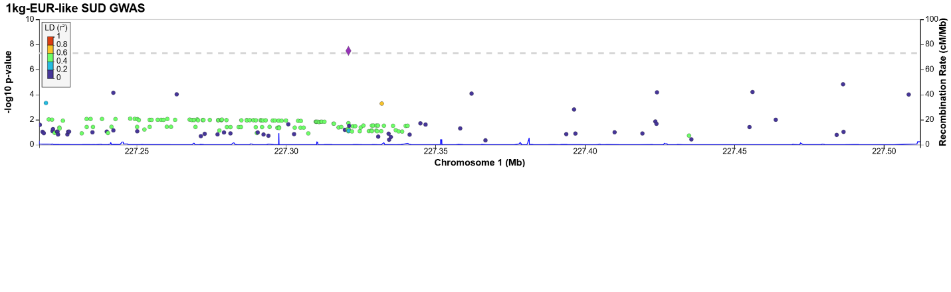
Locus 22:
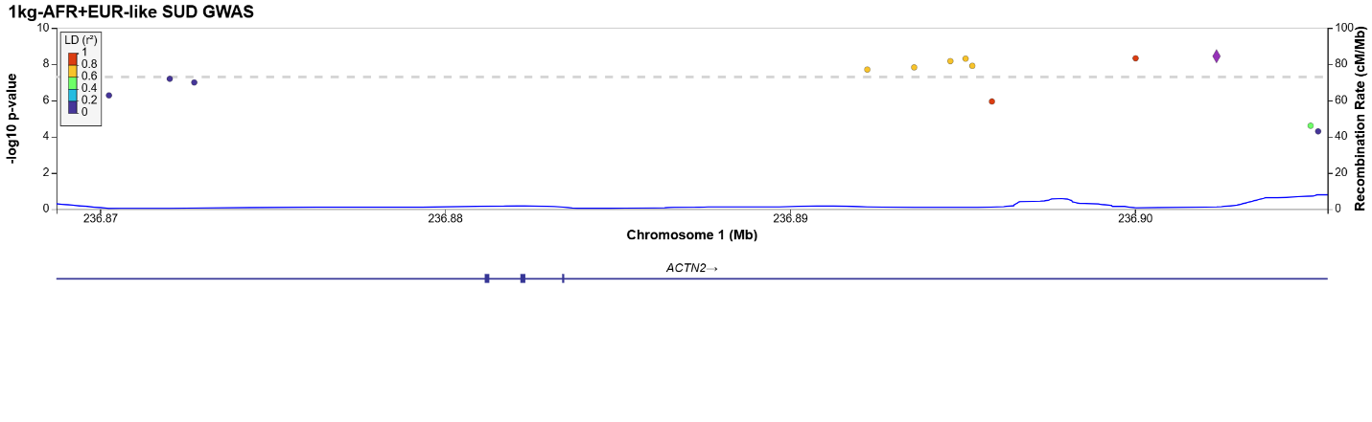
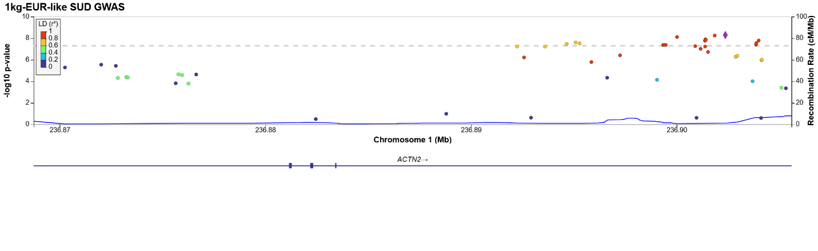
Locus 23:
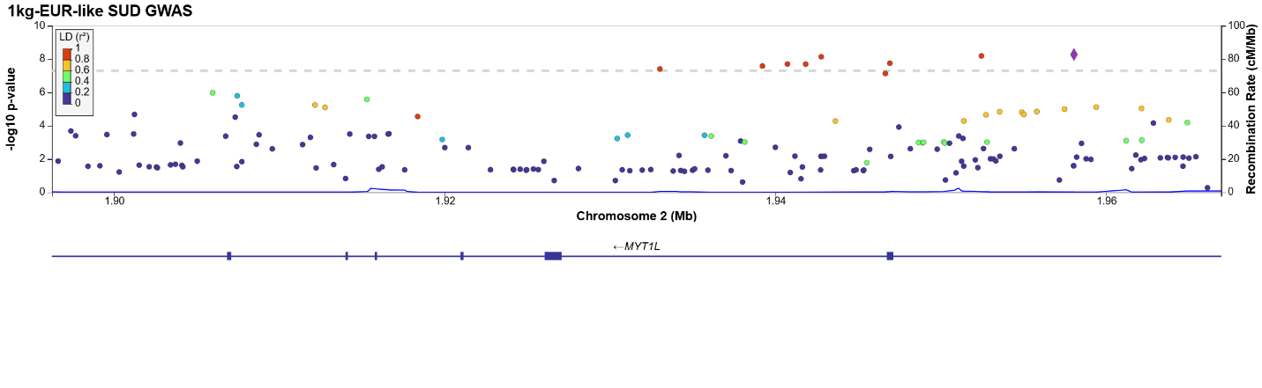
Locus 24:
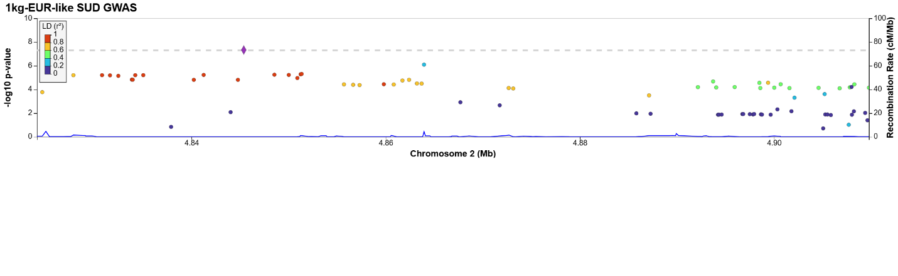
Locus 25:
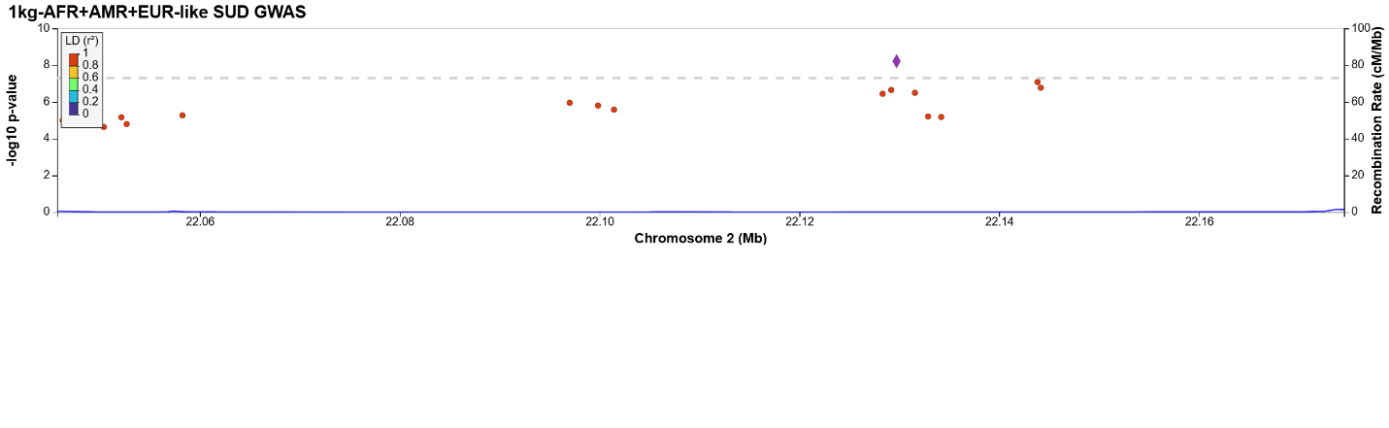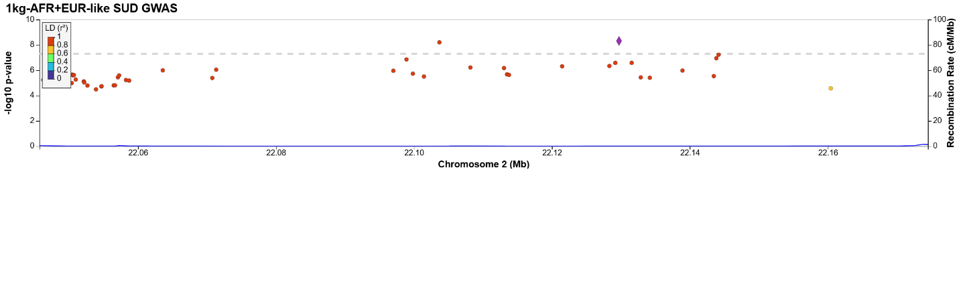
Locus 26:
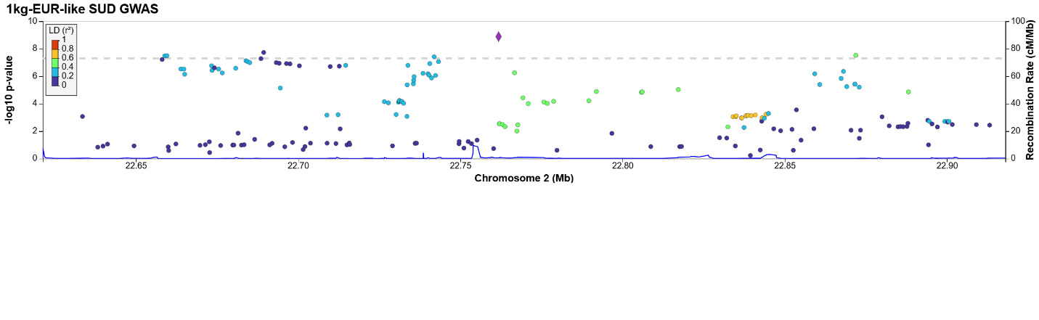
Locus 27:
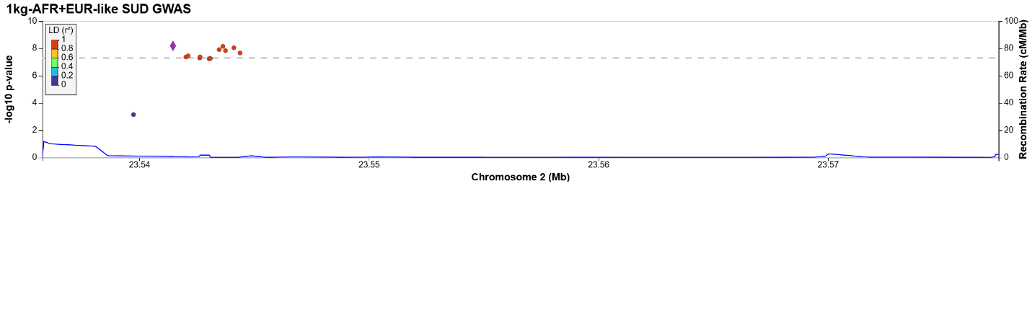
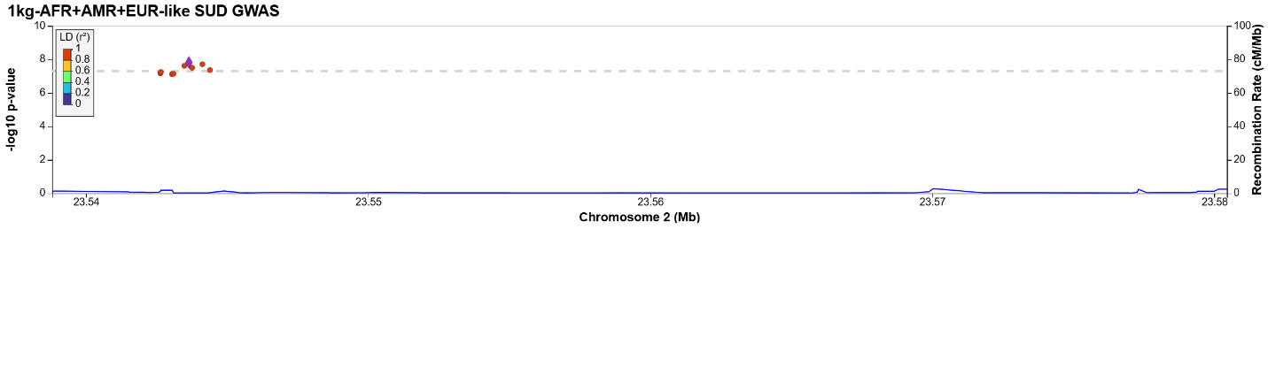
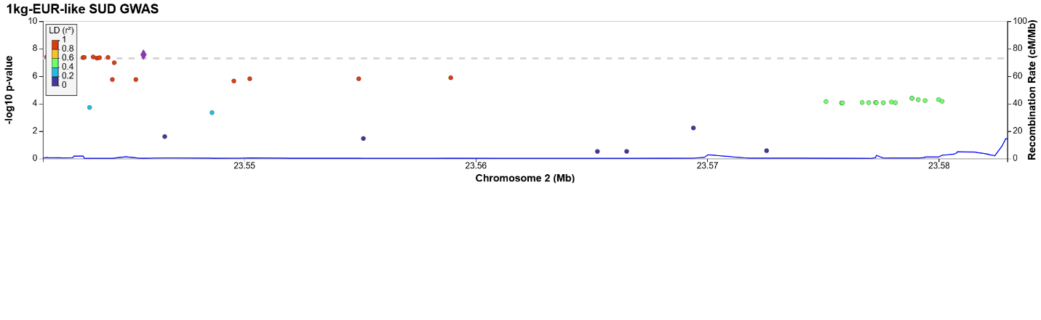
Locus 28:
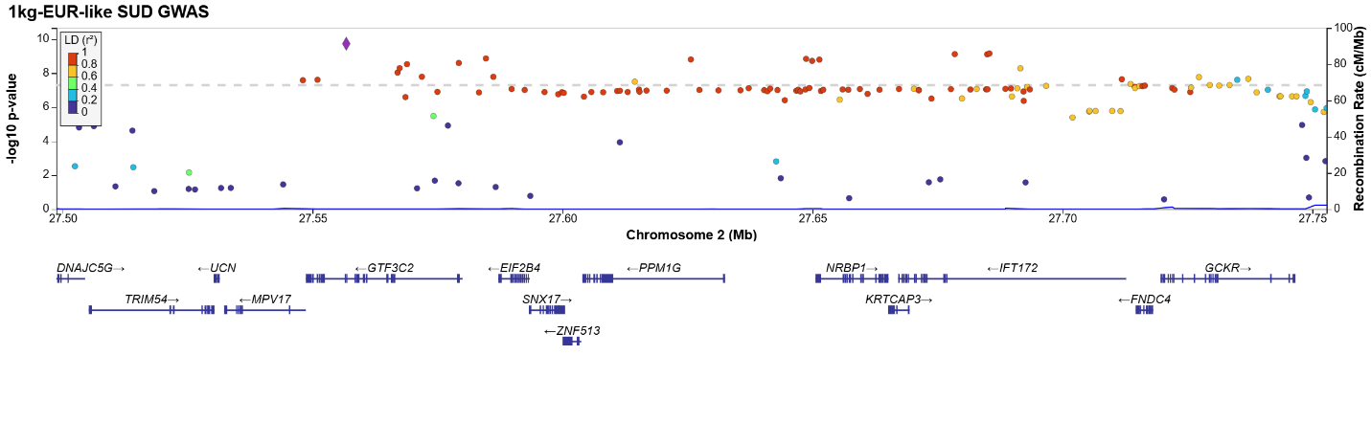
Locus 29:
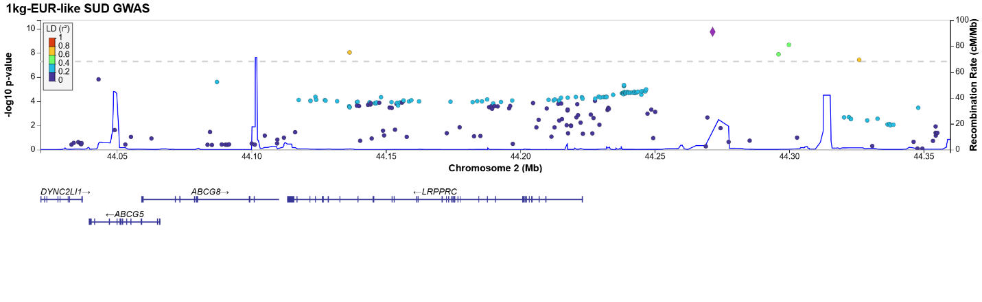
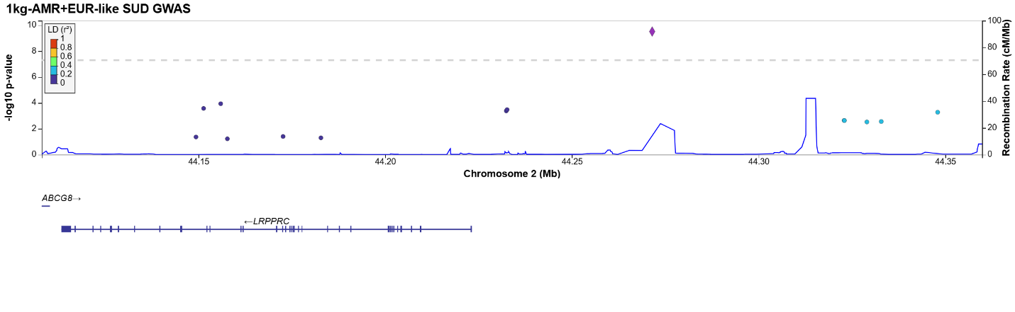
Locus 30:
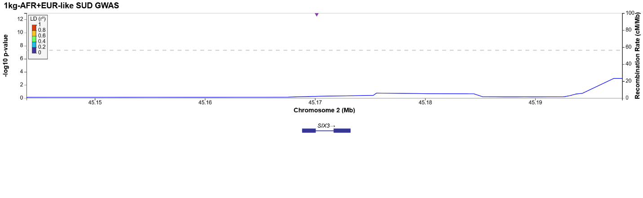
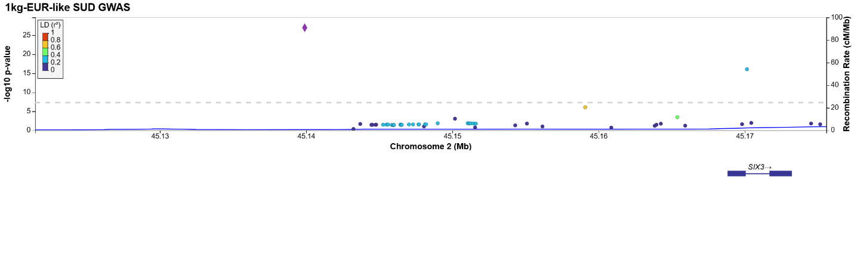
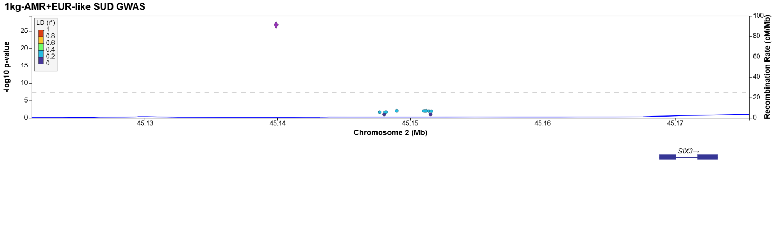
Locus 31:
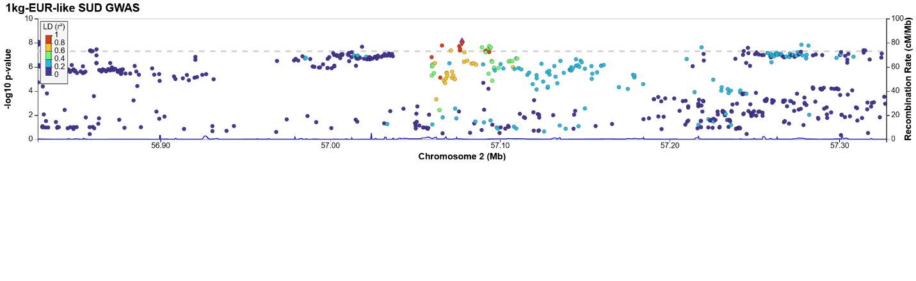
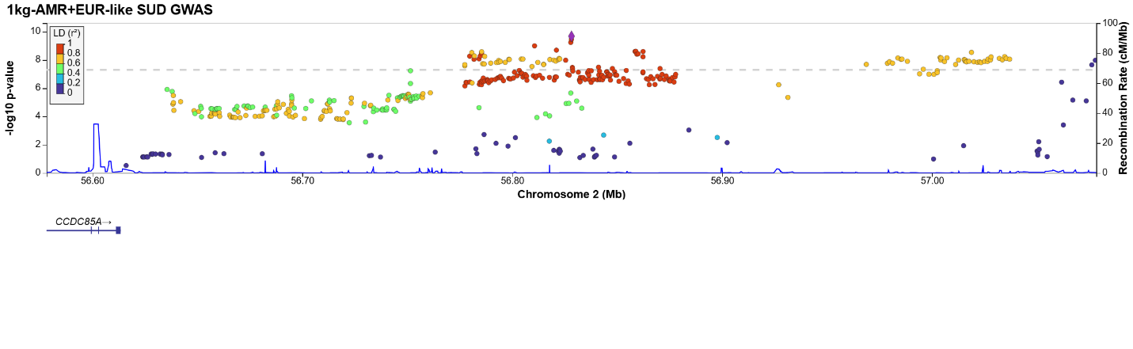
Locus 32:
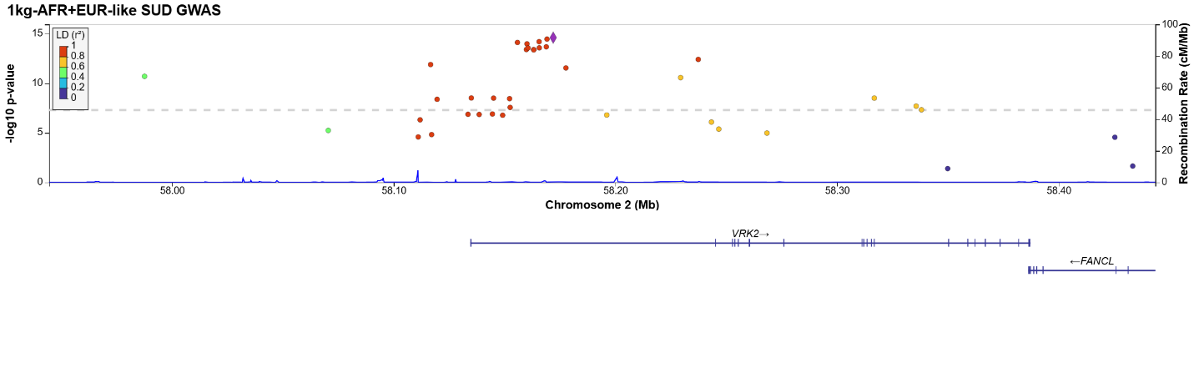
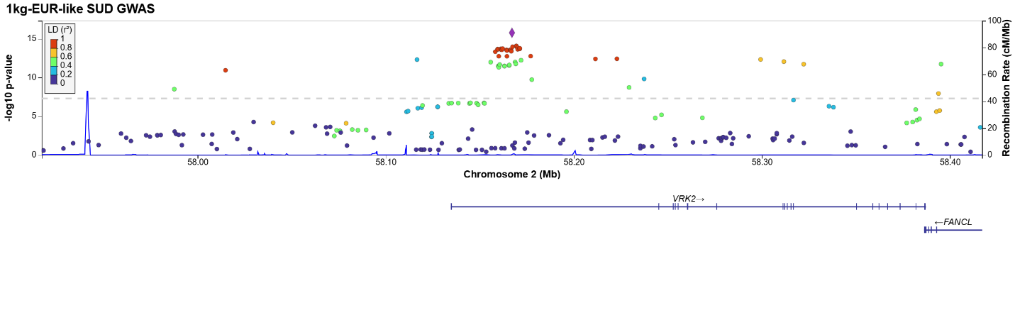
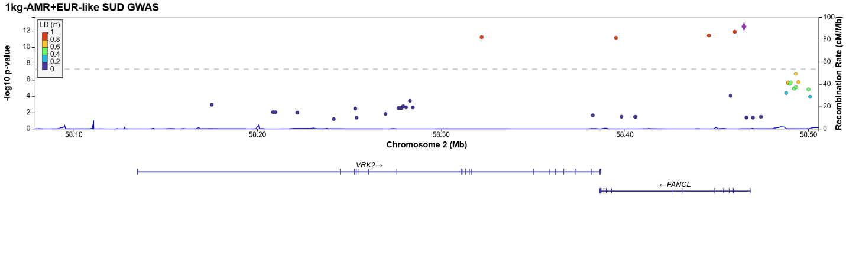
Locus 33:
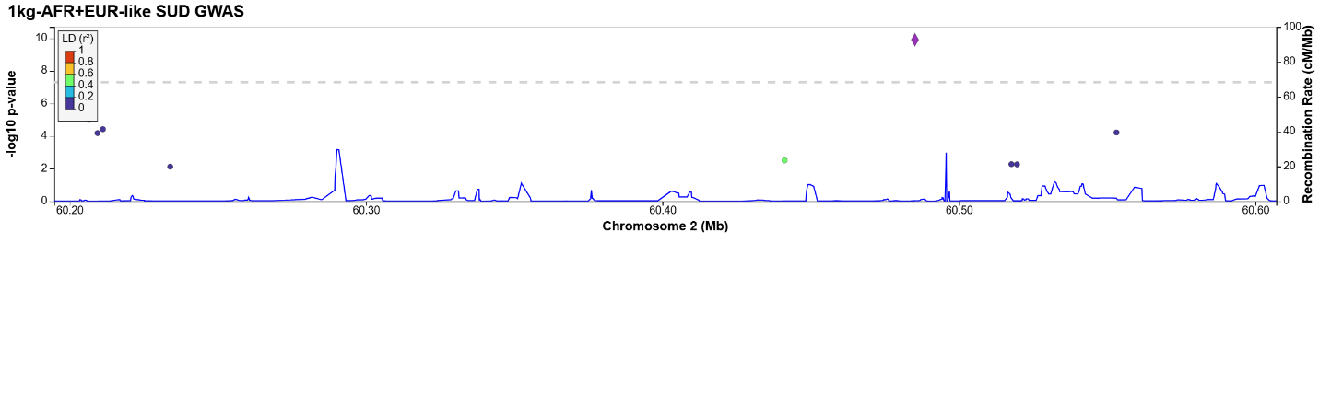
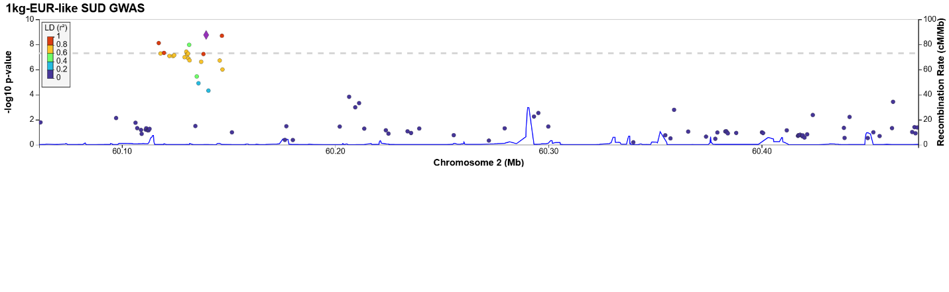
Locus 34:
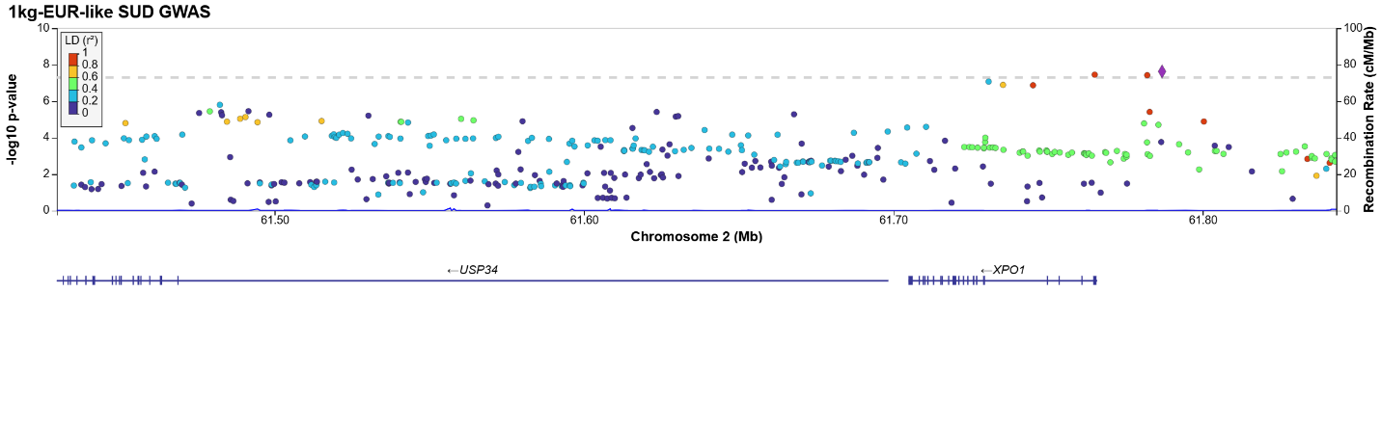
Locus 35:
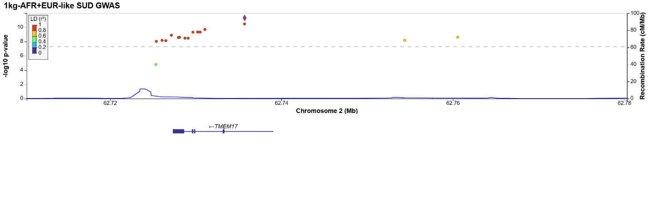
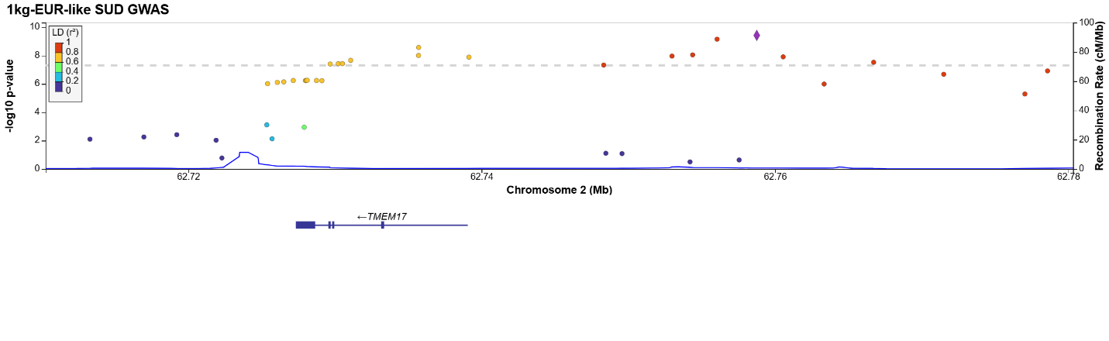
Locus 36:
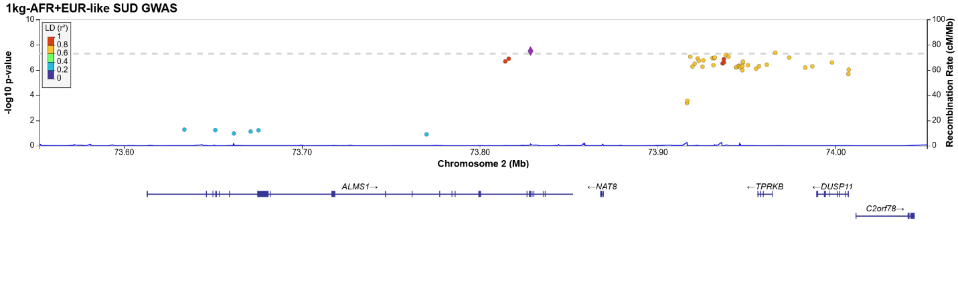
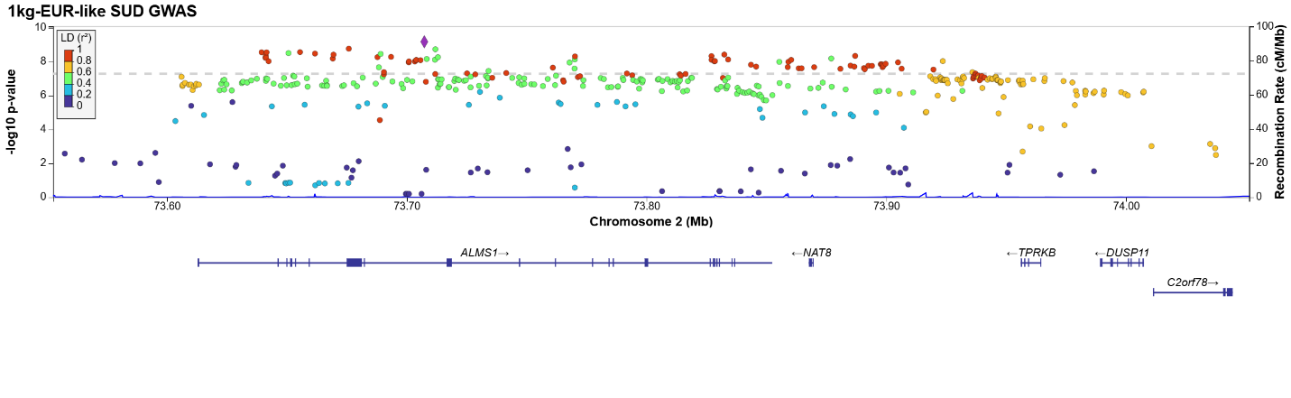
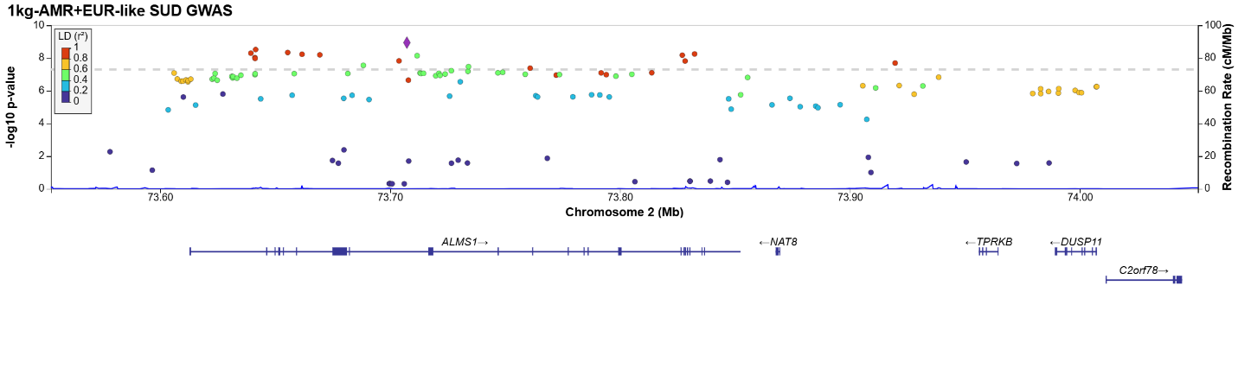
Locus 37:
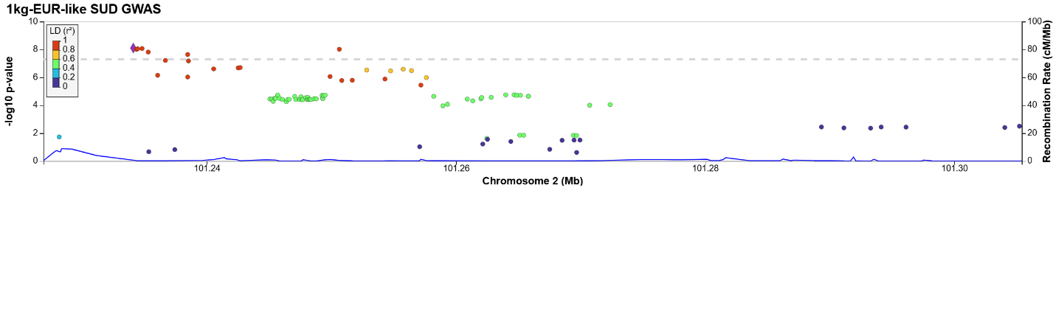
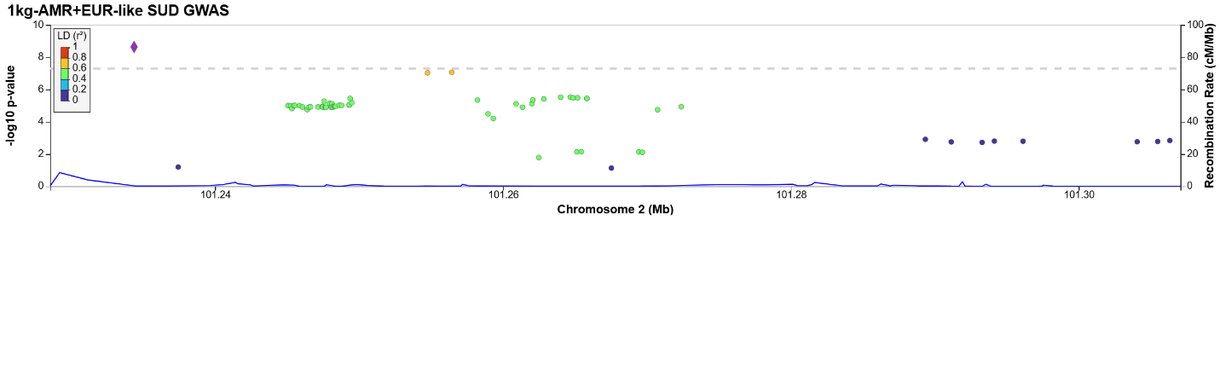
Locus 38:
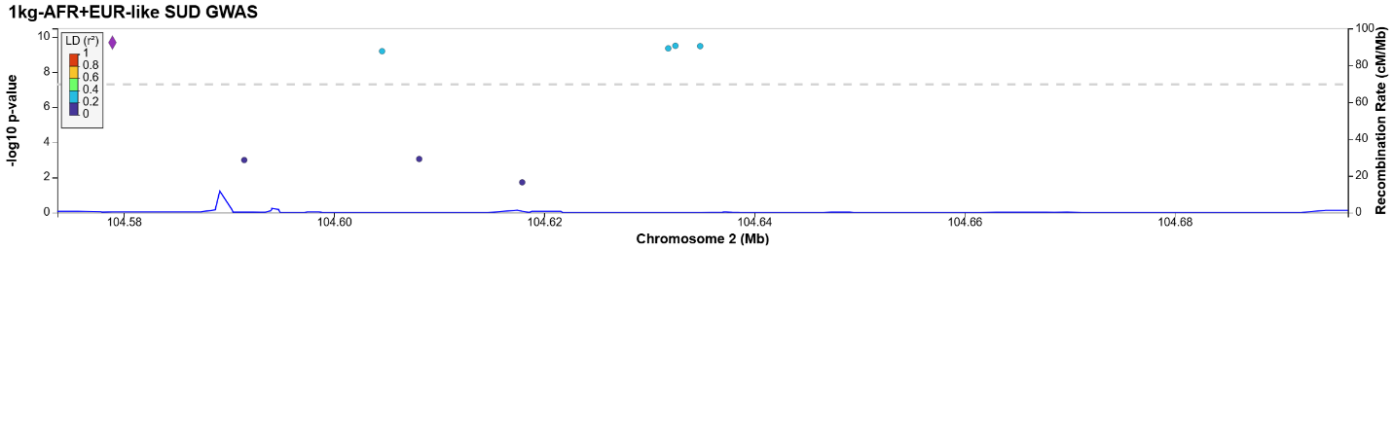
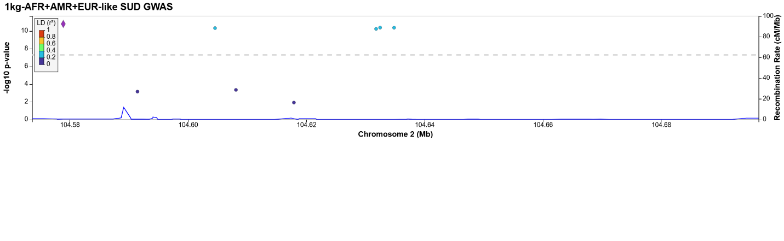
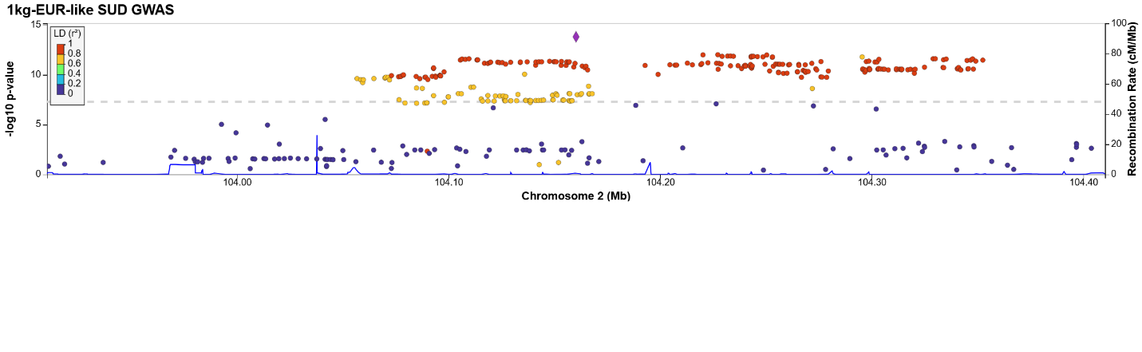
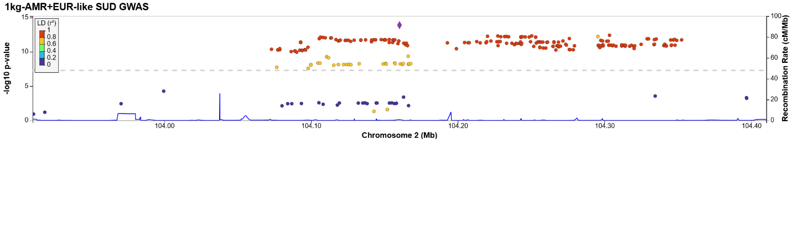
Locus 39:
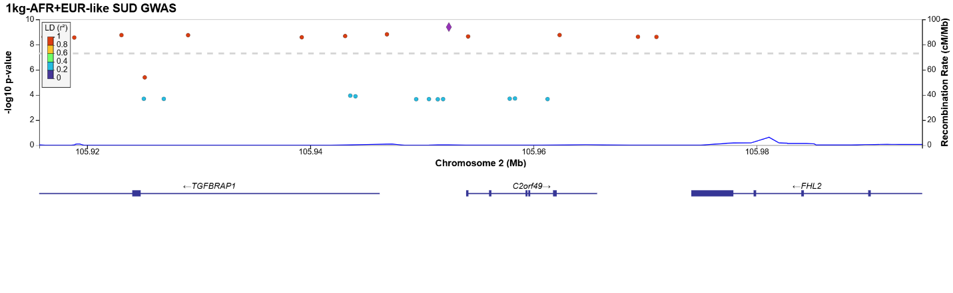
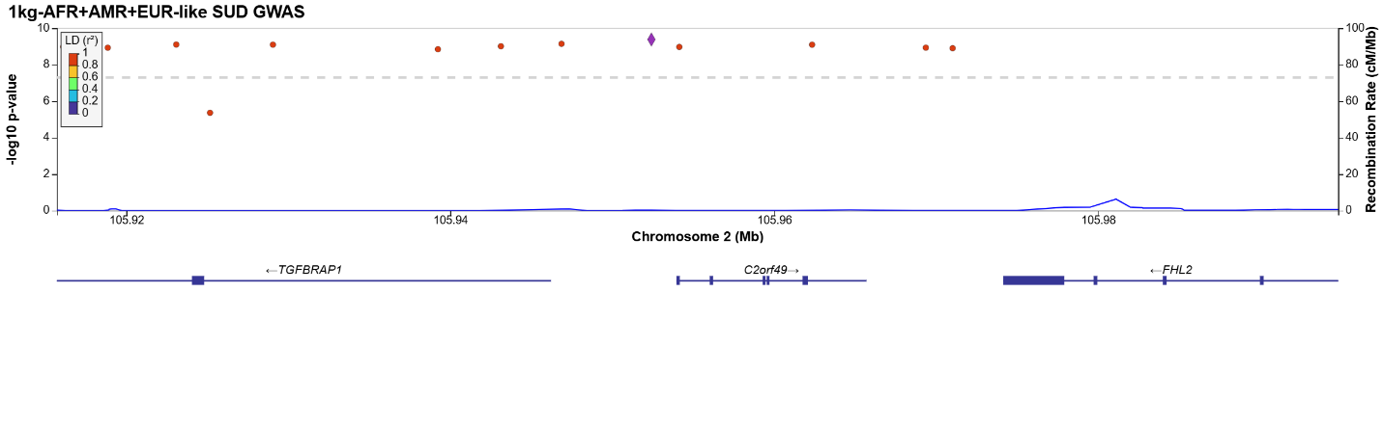
Locus 40:
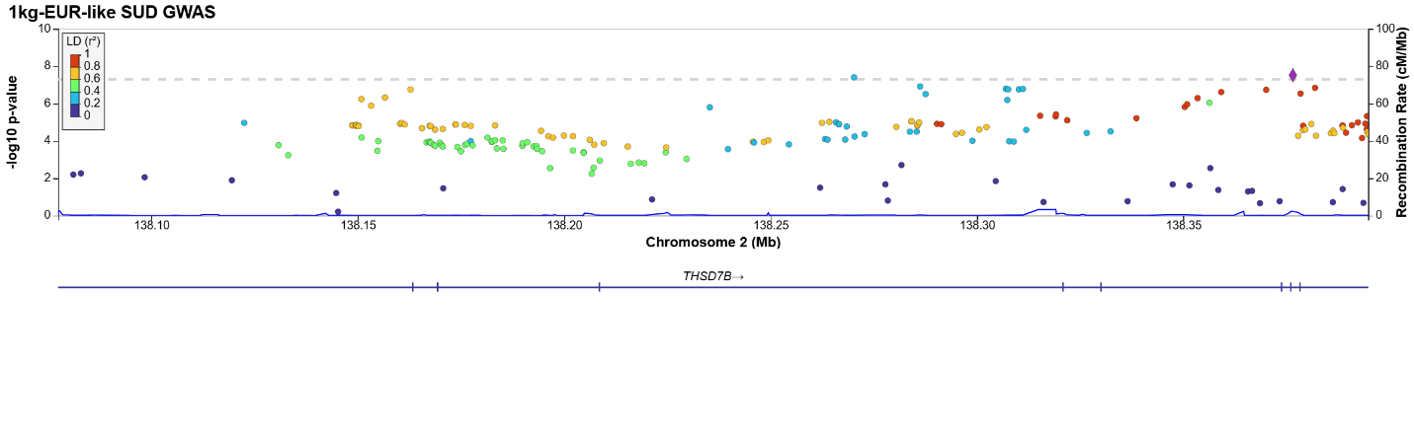
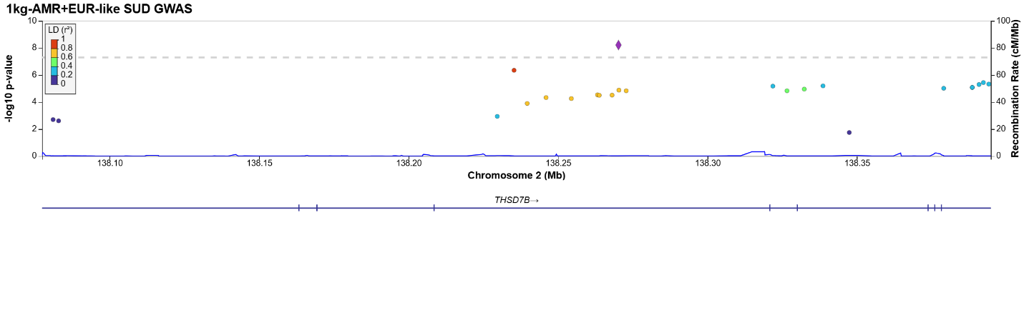
Locus 41:
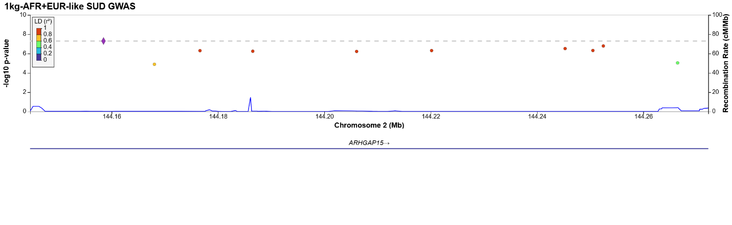
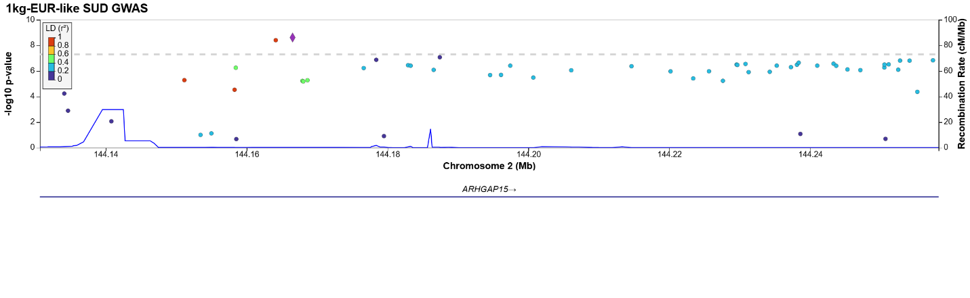
Locus 42:
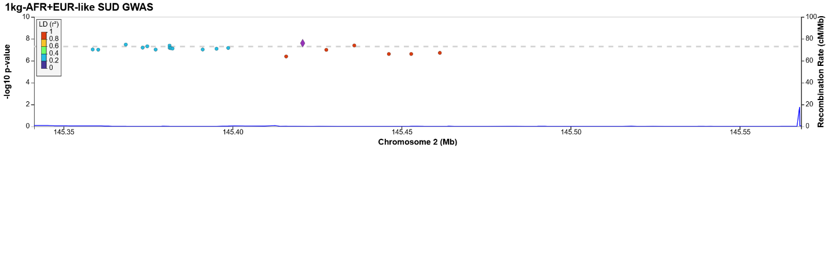
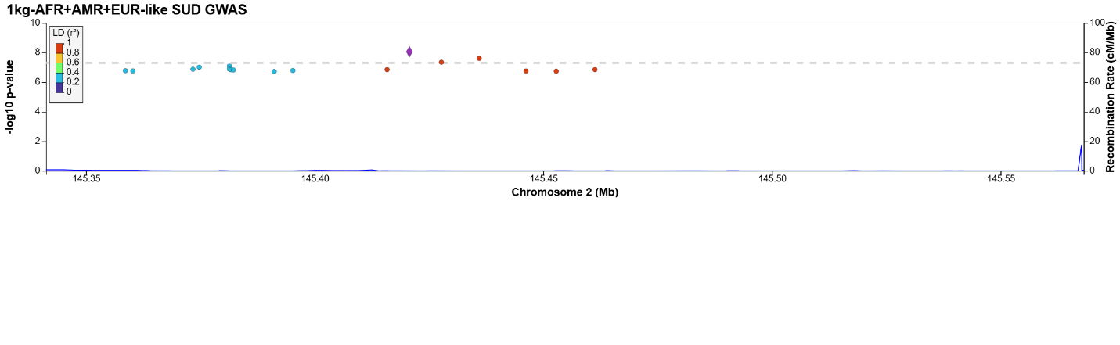
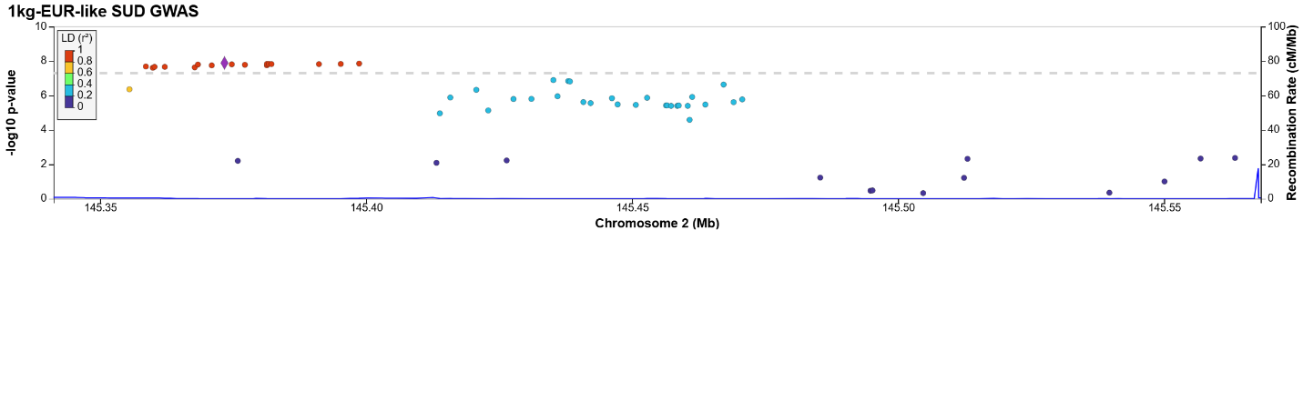
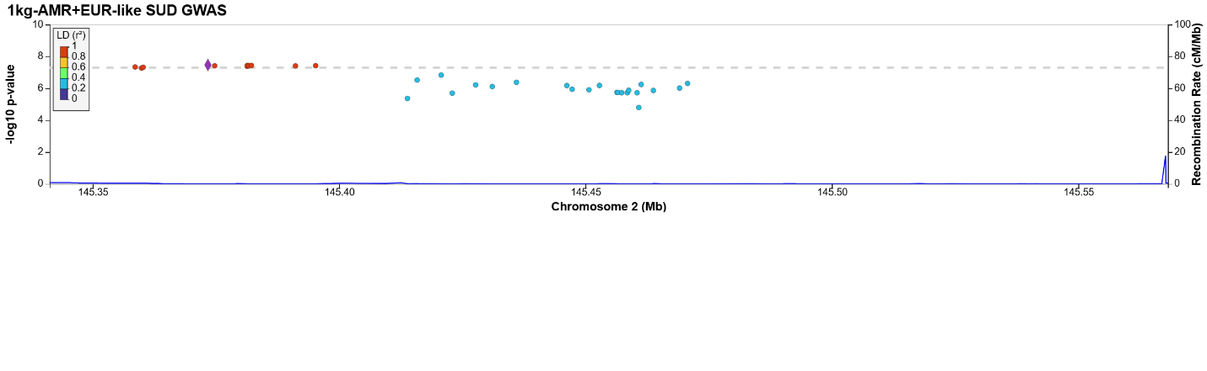
Locus 43:
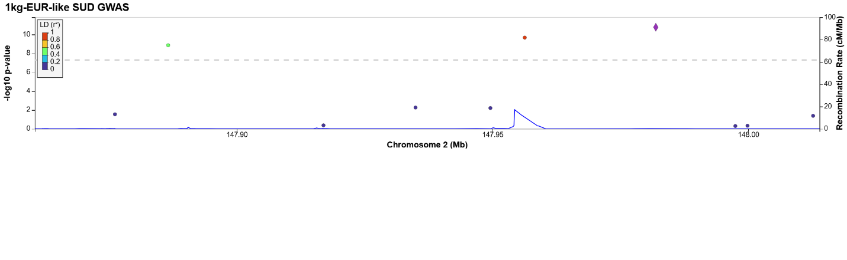
Locus 44:
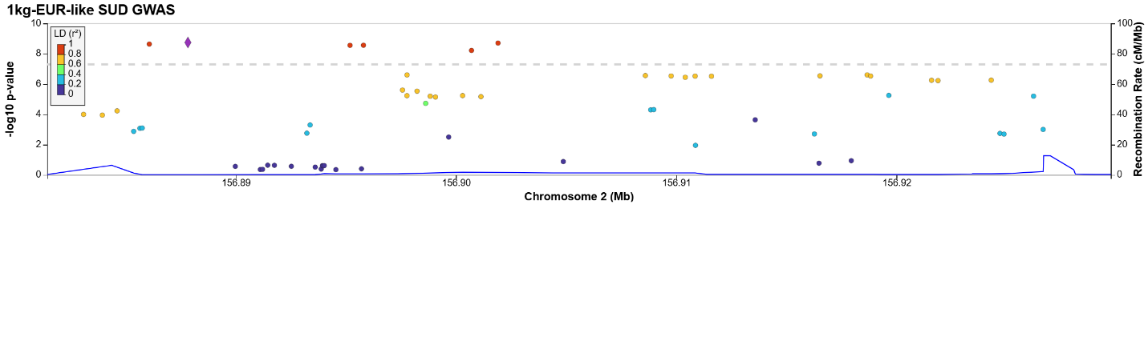
Locus 45:
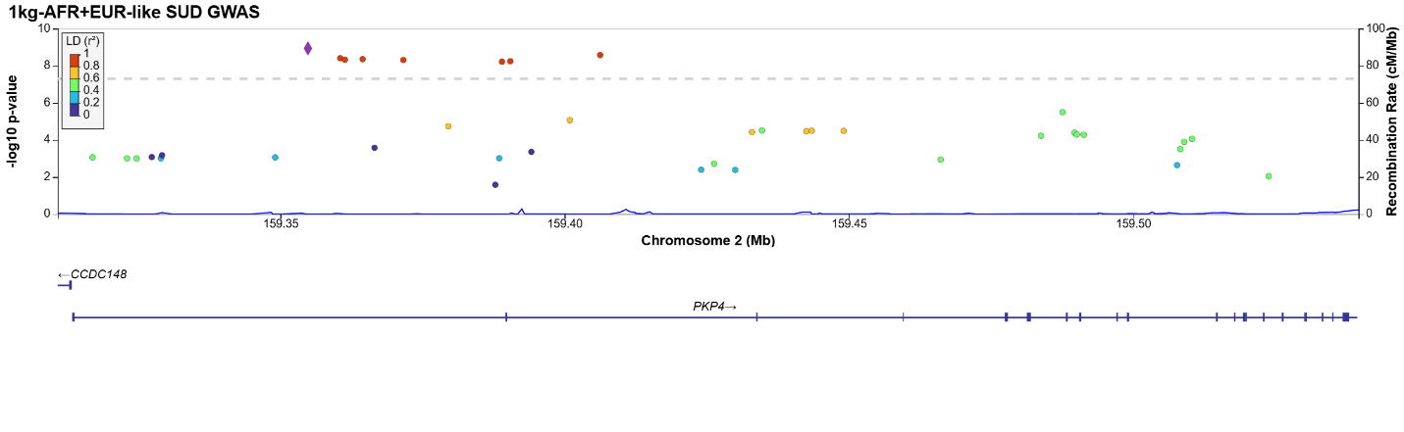
Locus 46:
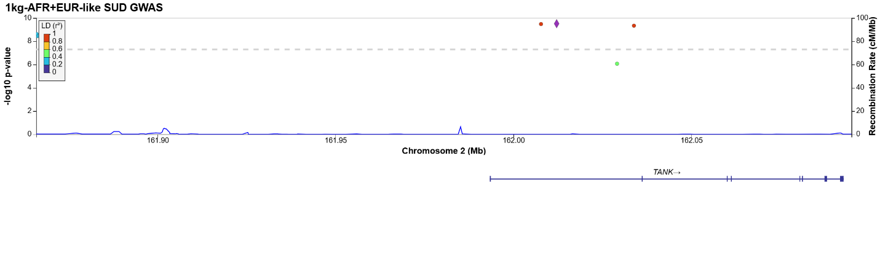
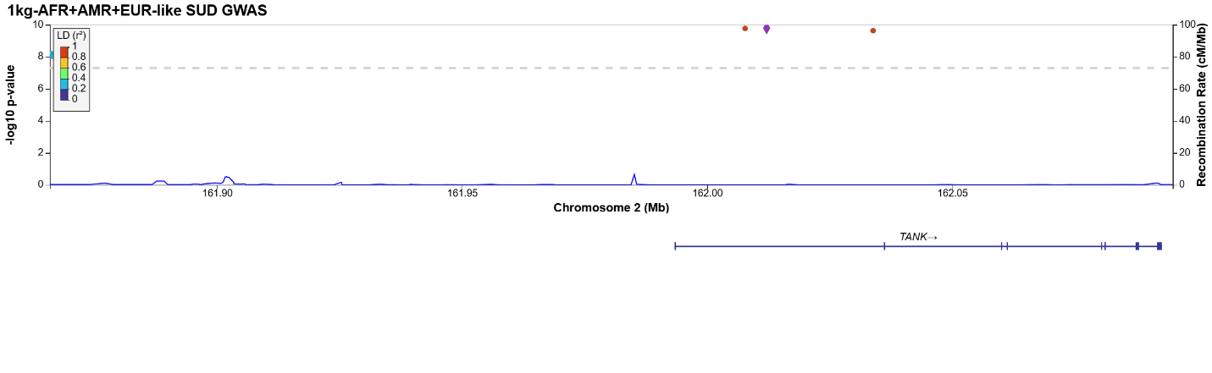
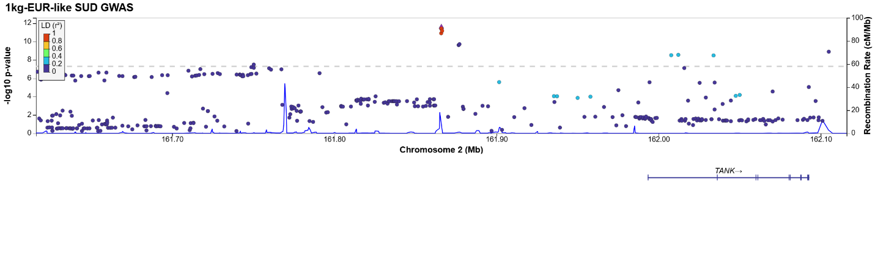
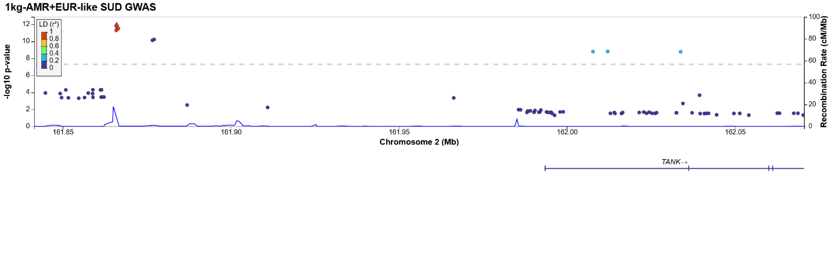
Locus 47:
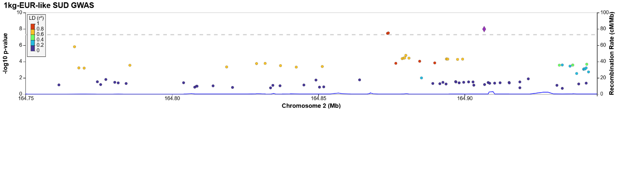
Locus 48:
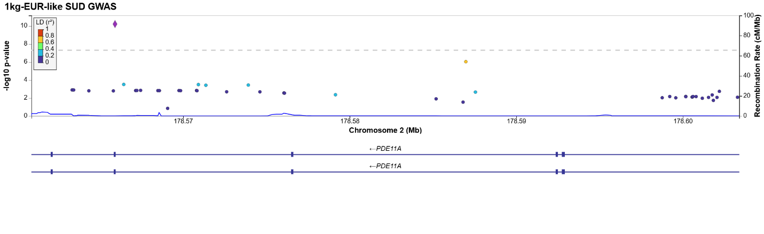
Locus 49:
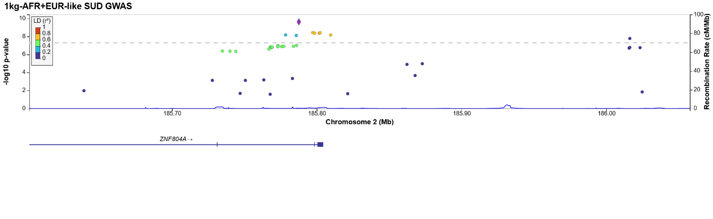
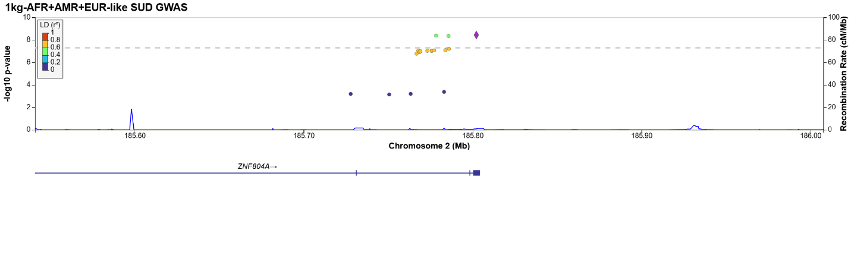
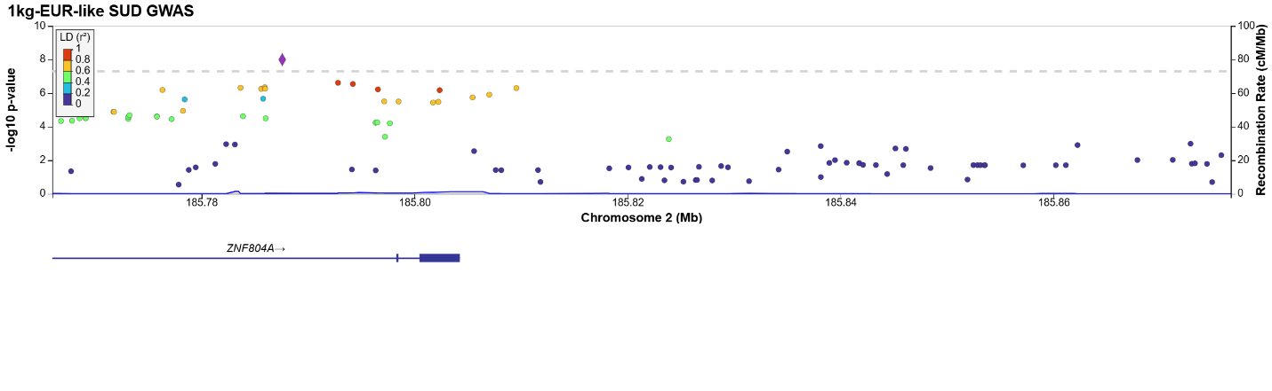
Locus 50:
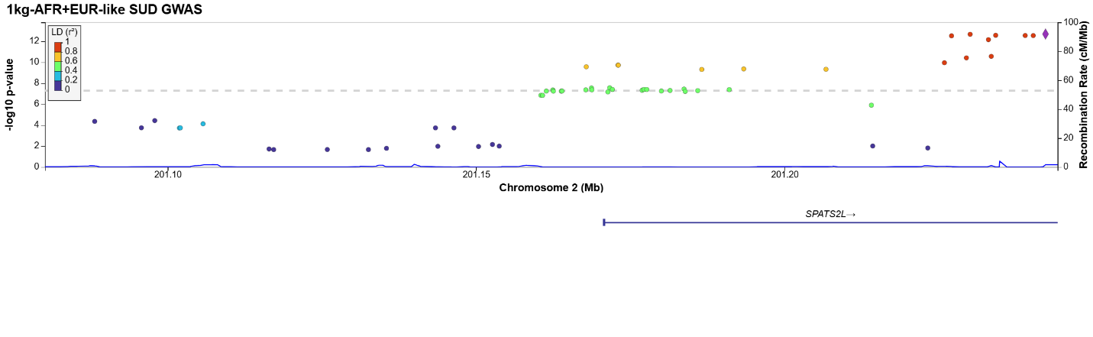
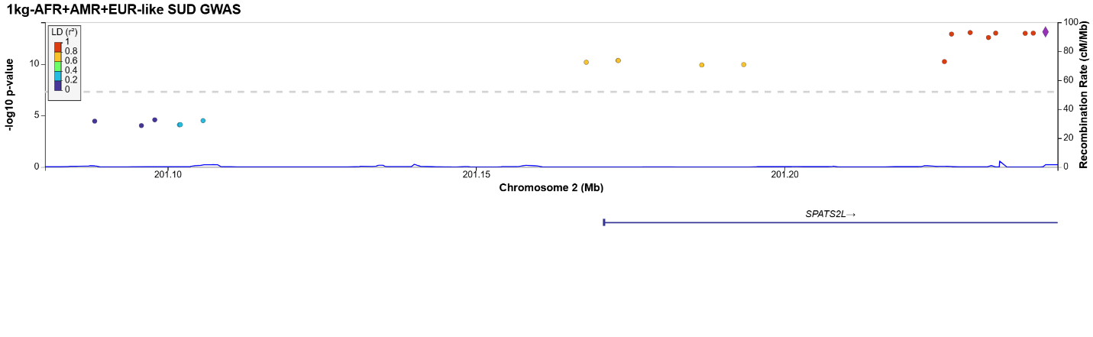
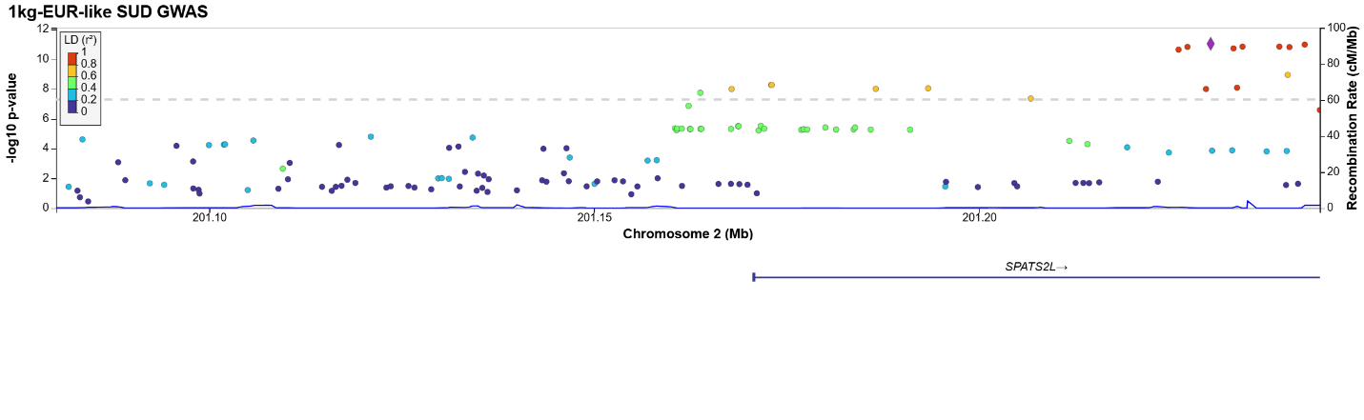
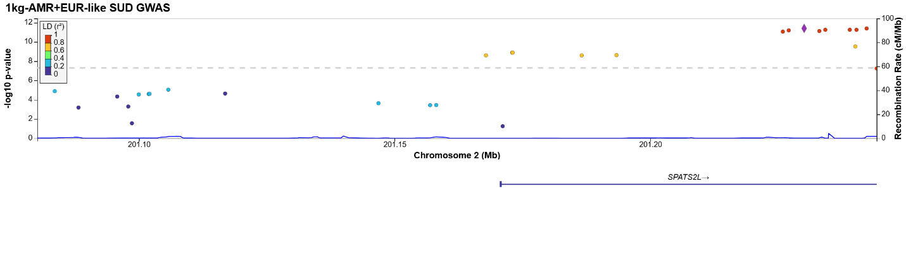
Locus 51:
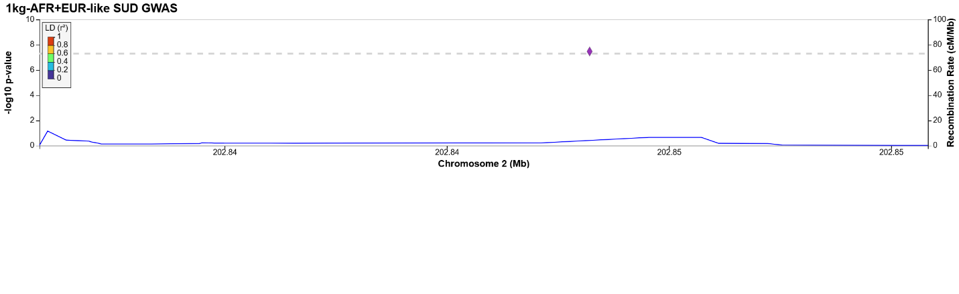
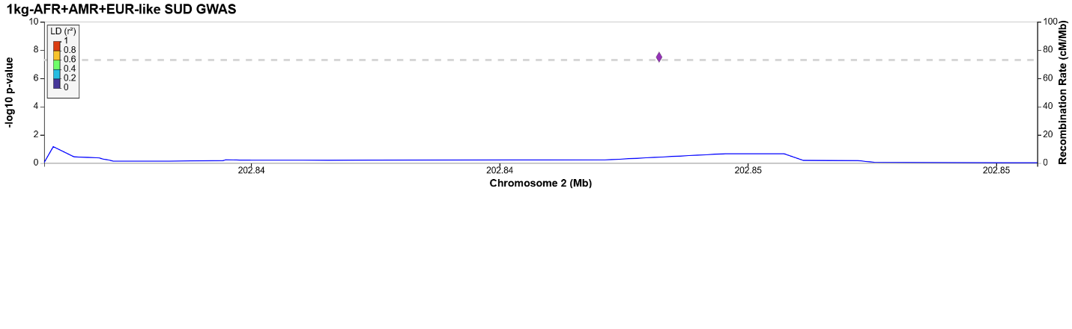
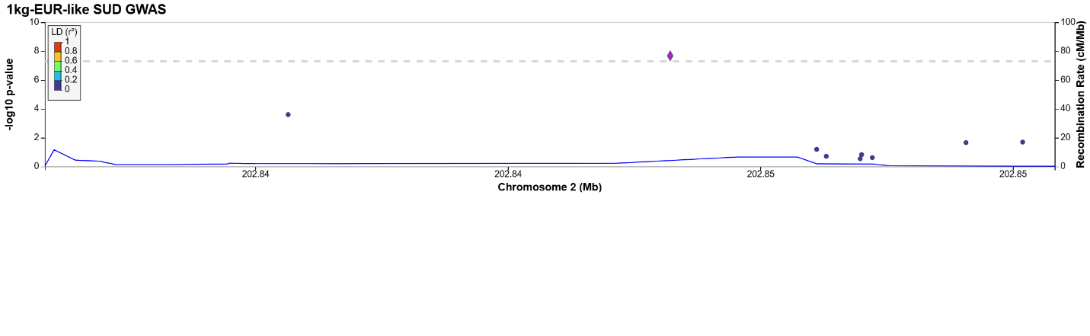
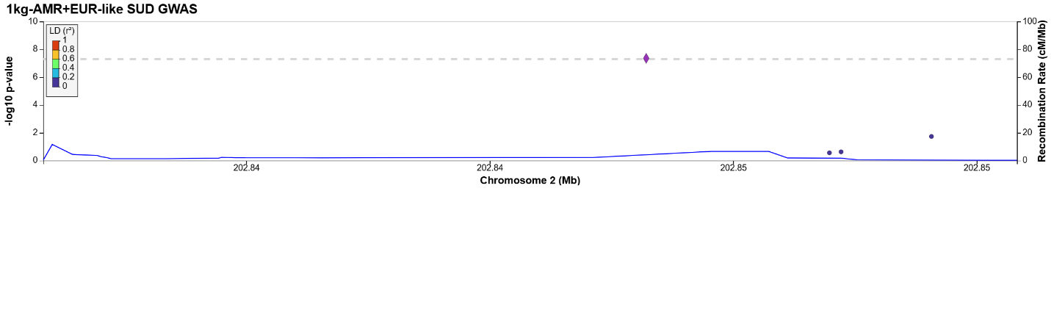
Locus 52:
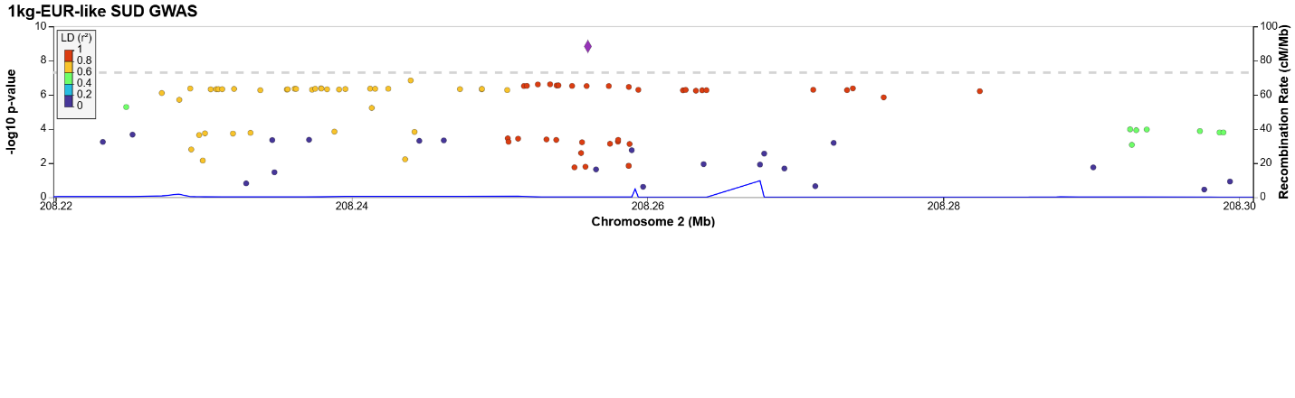
Locus 53:
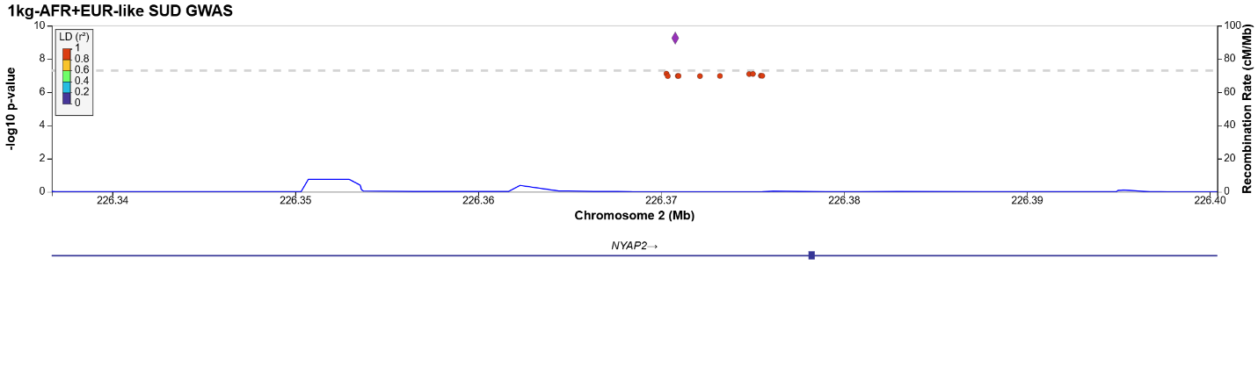
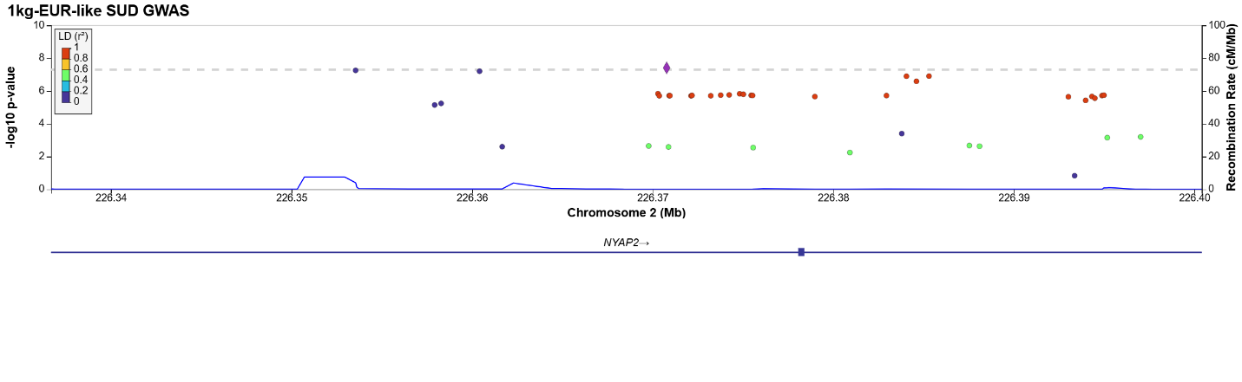
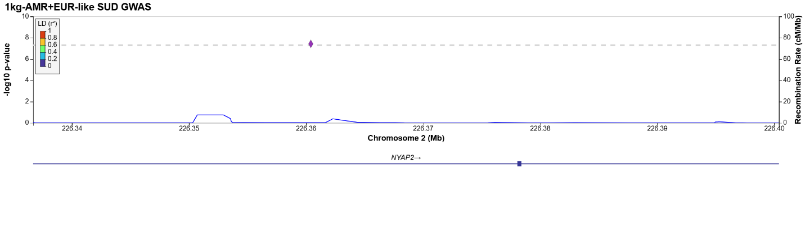
Locus 54:
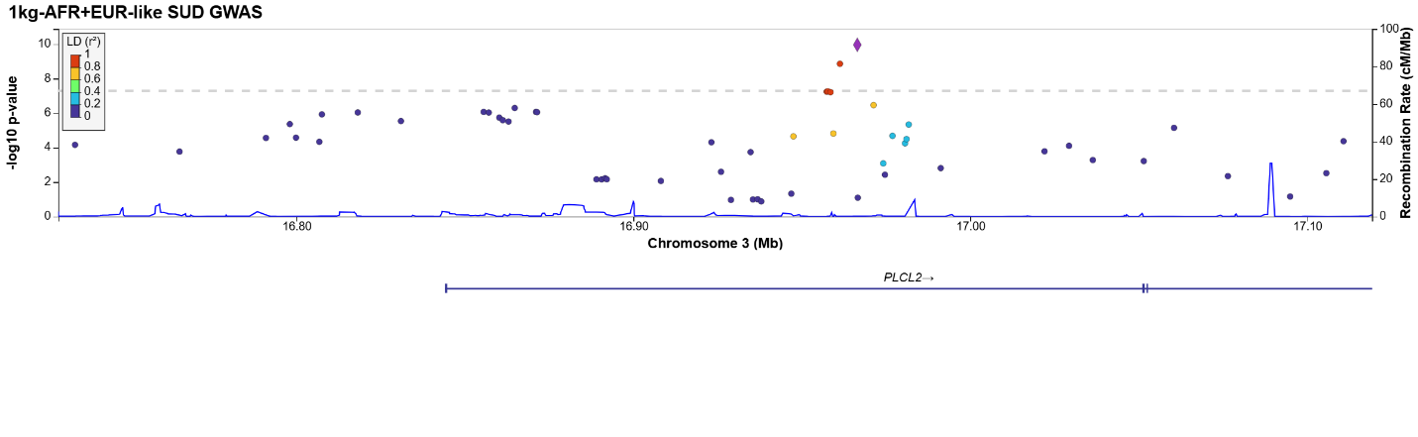
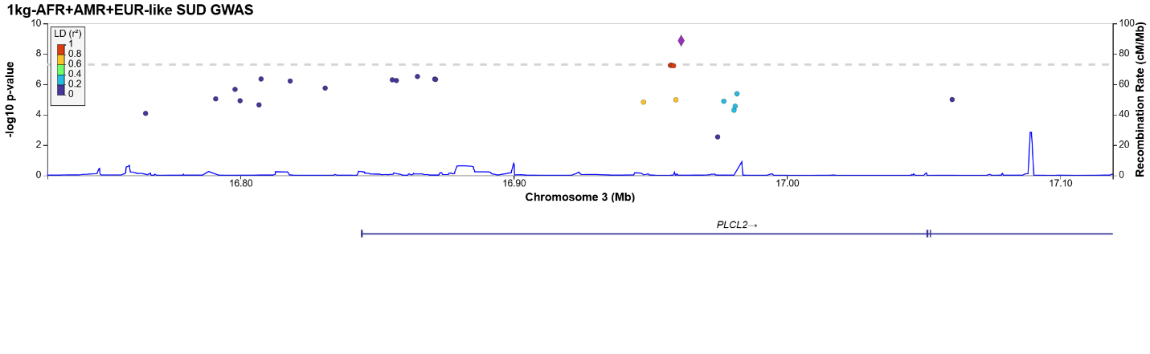
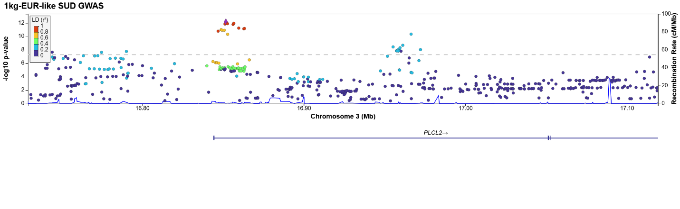
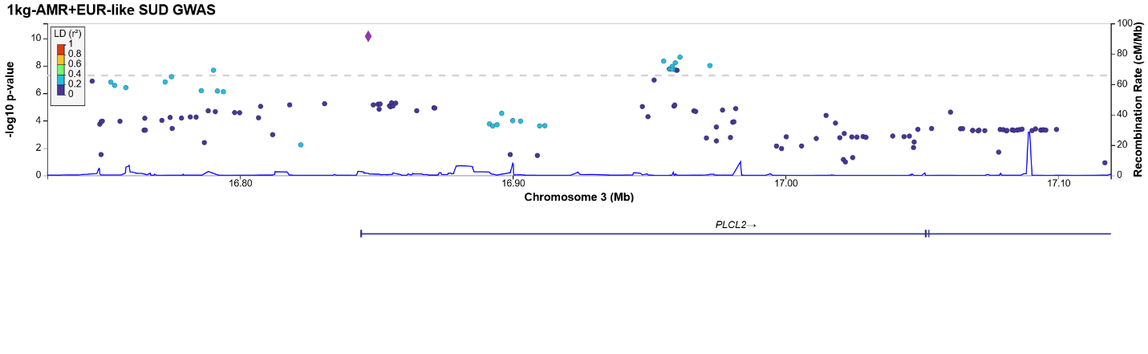
Locus 55:
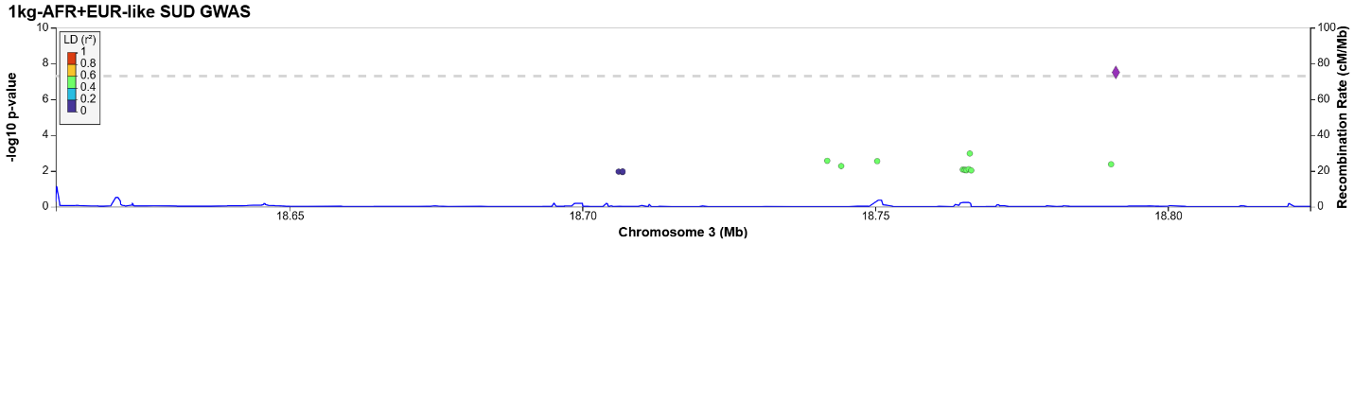
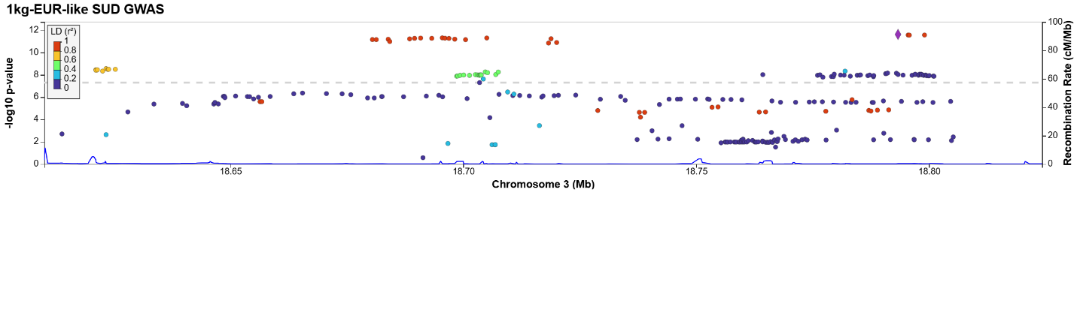
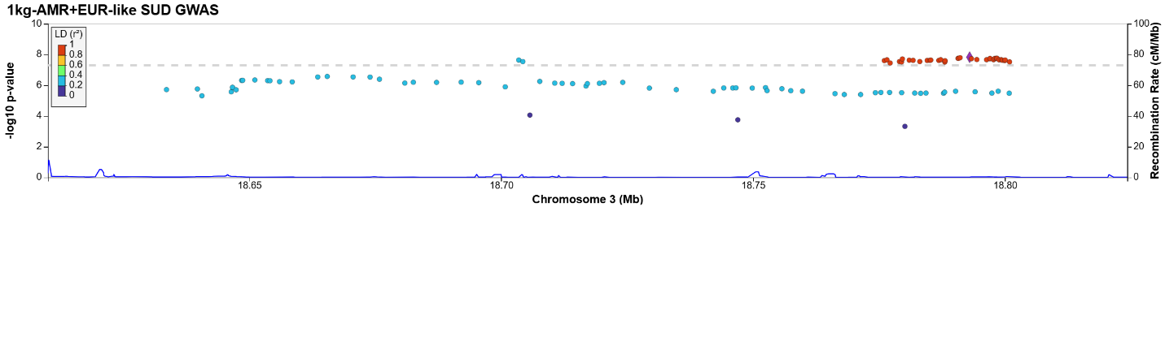
Locus 56:
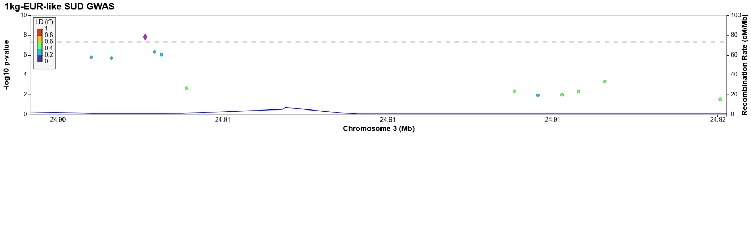
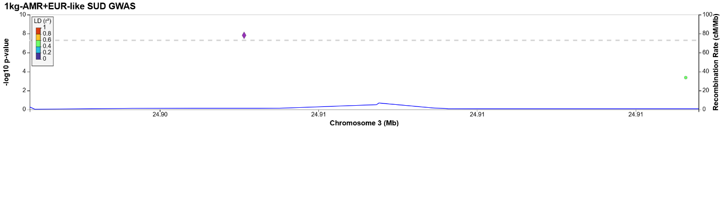
Locus 57:
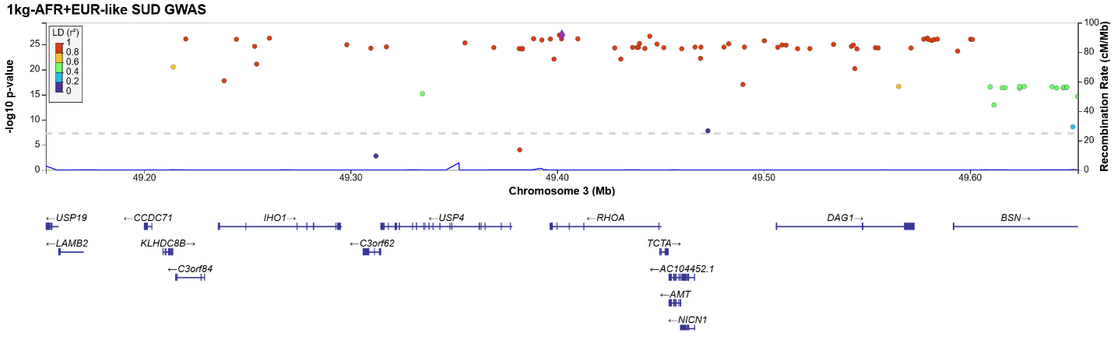
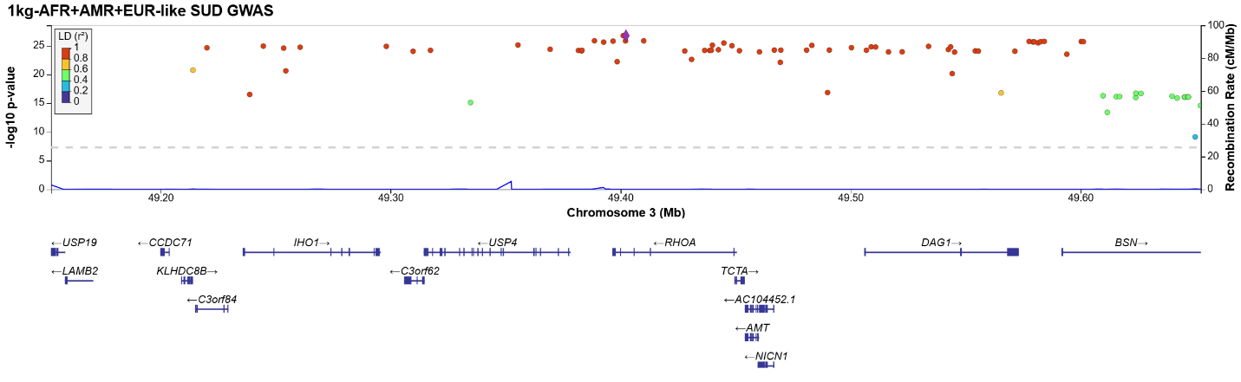
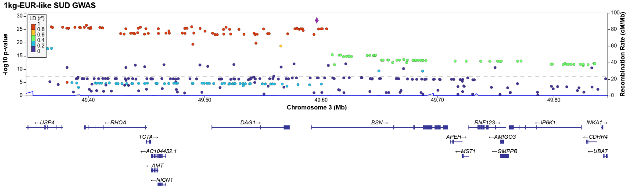
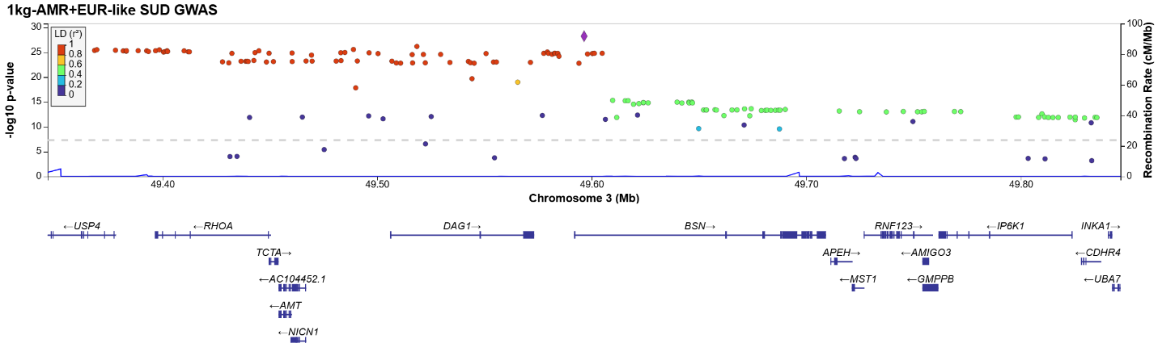
Locus 58:
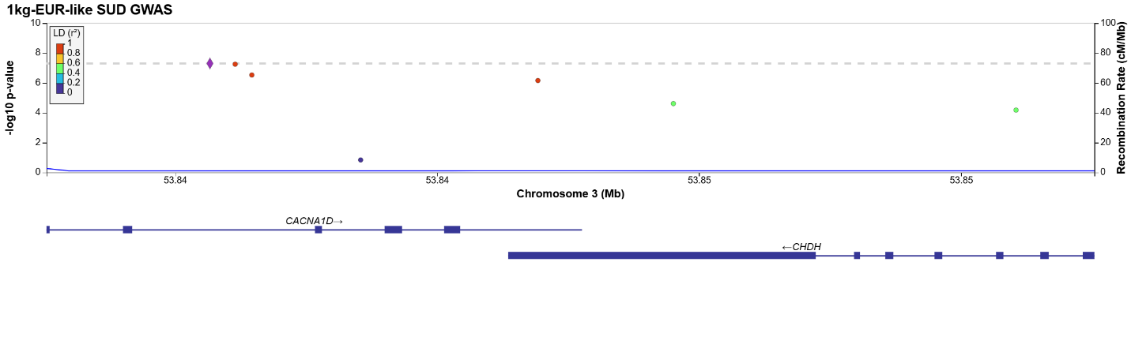
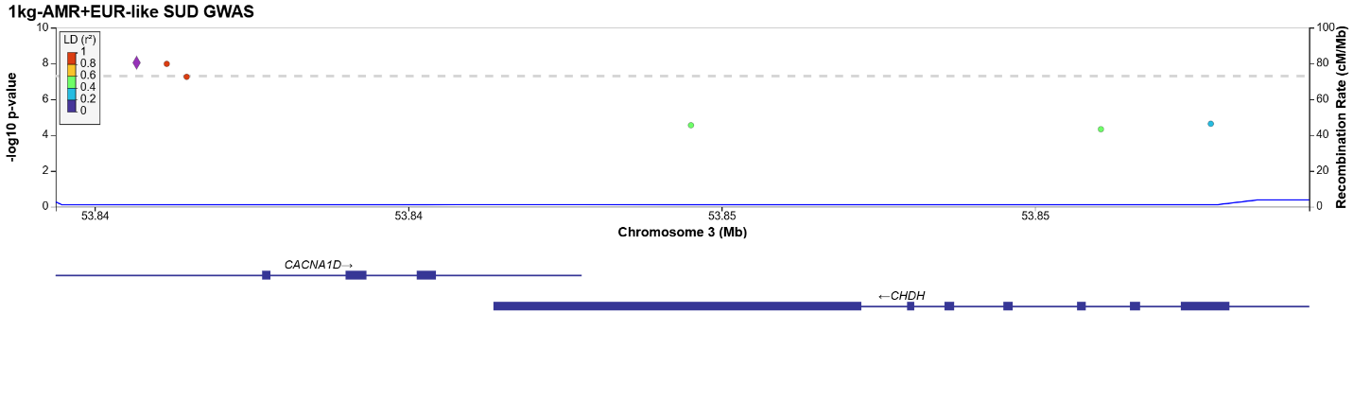
Locus 59:
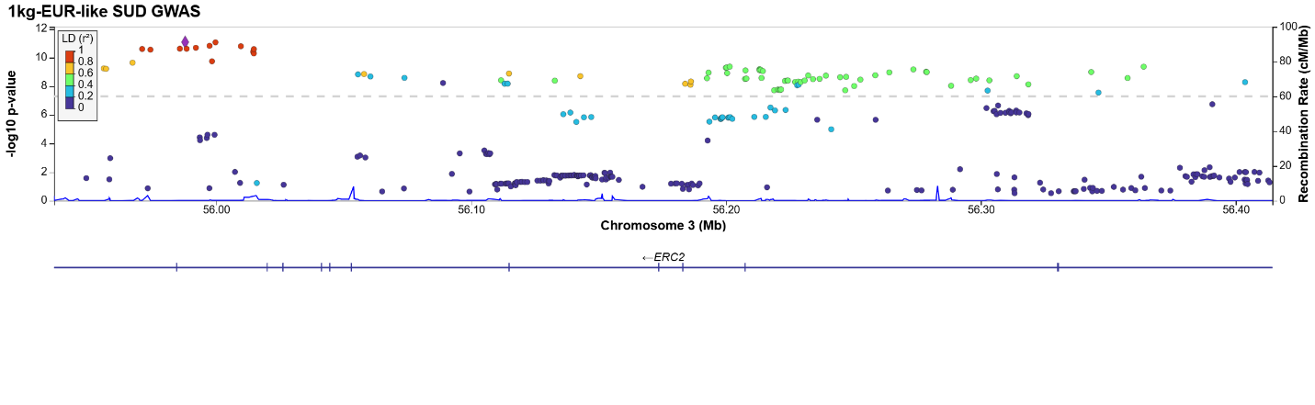
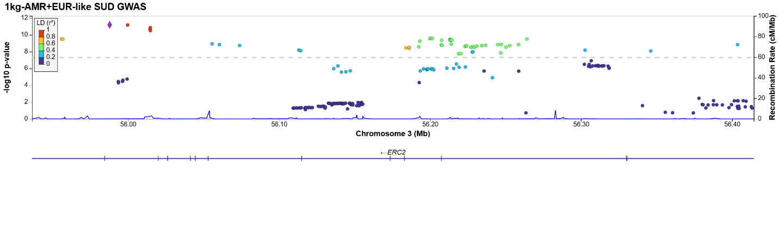
Locus 60:
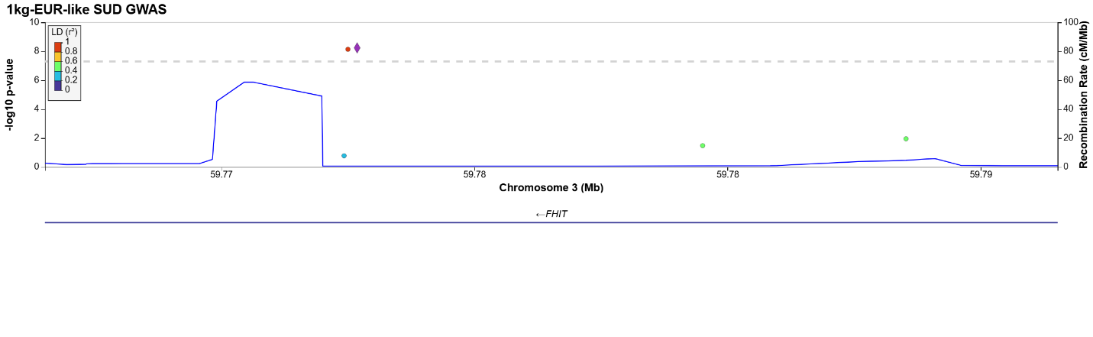
Locus 61:
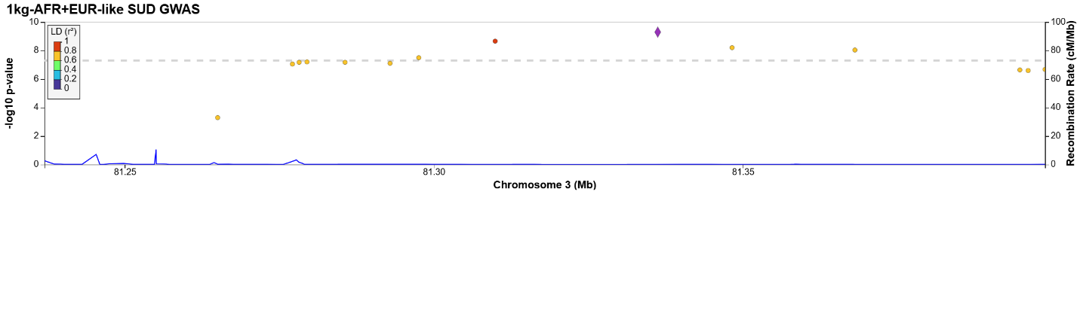
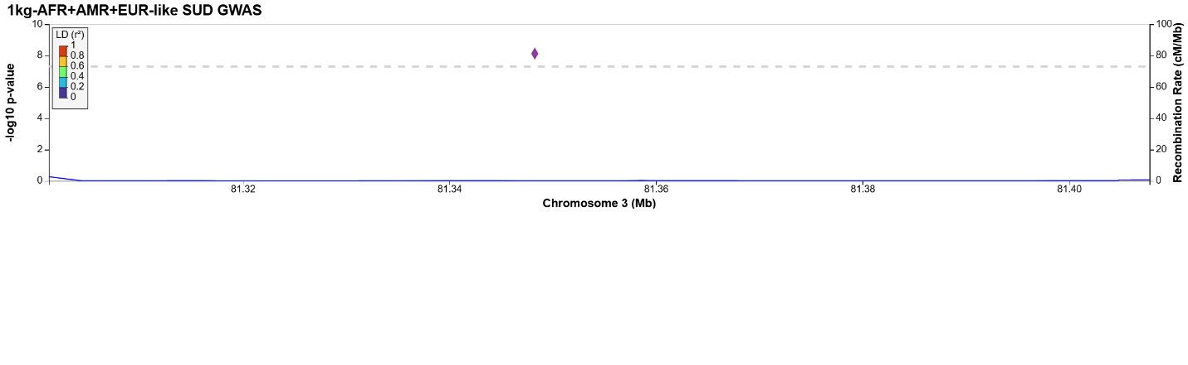
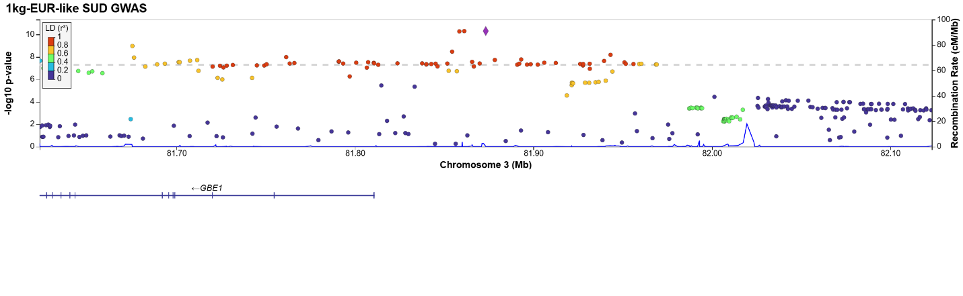
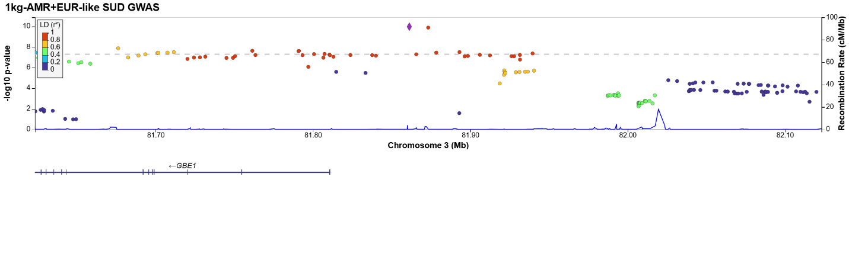
Locus 62:
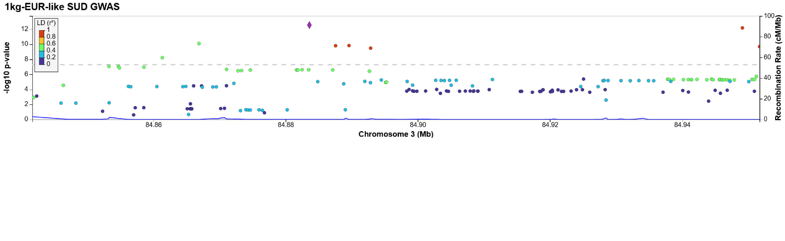
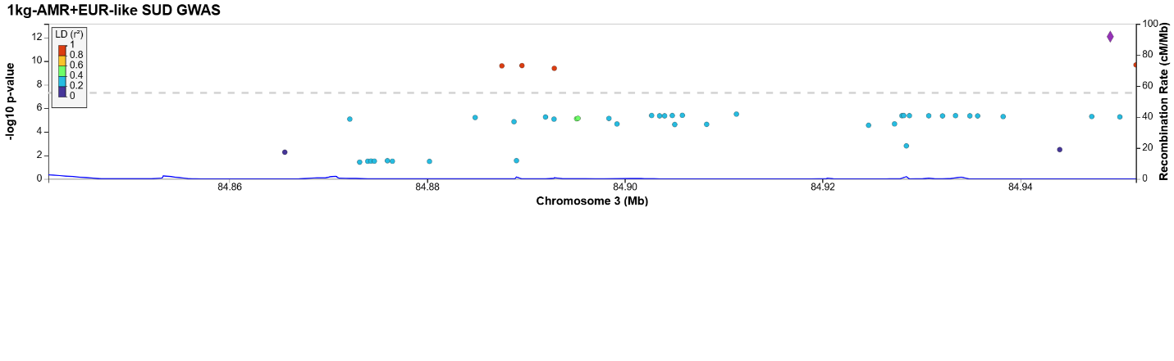
Locus 63:
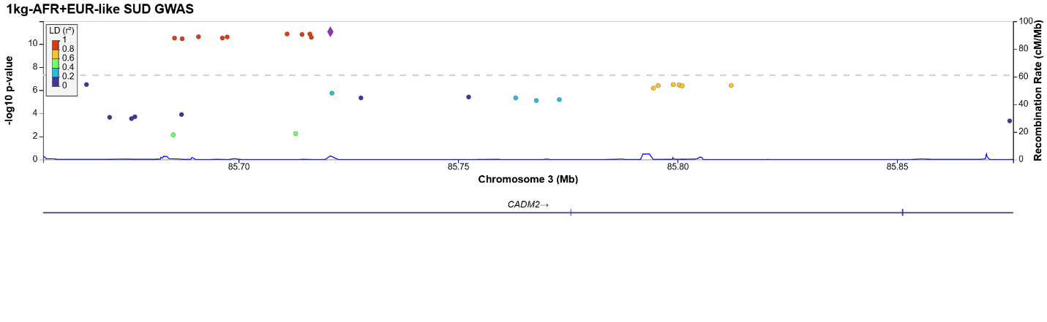
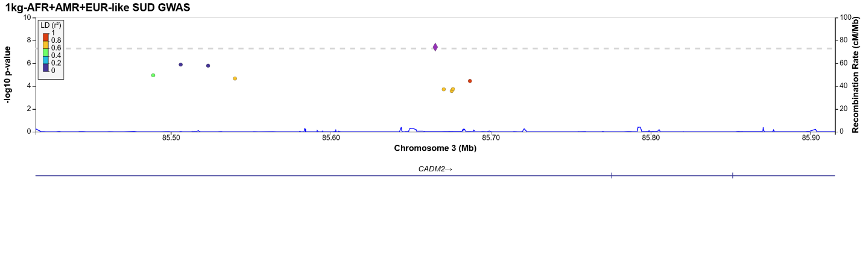
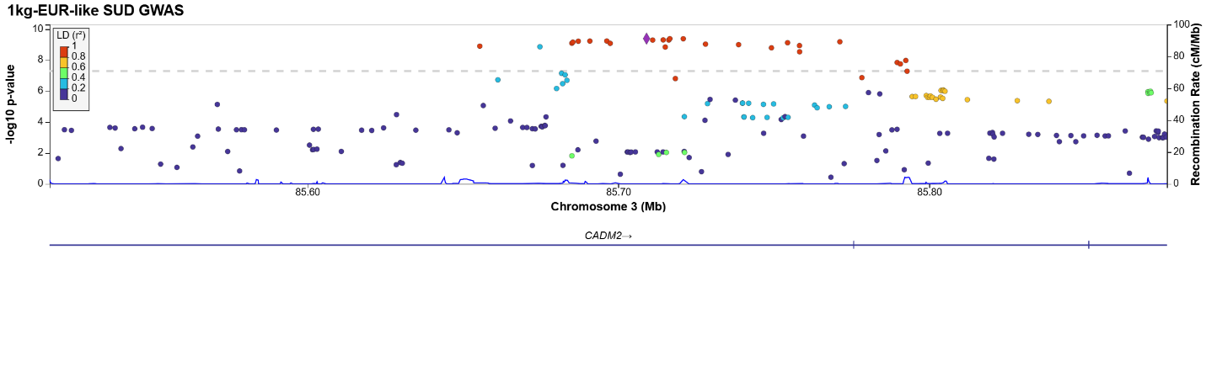
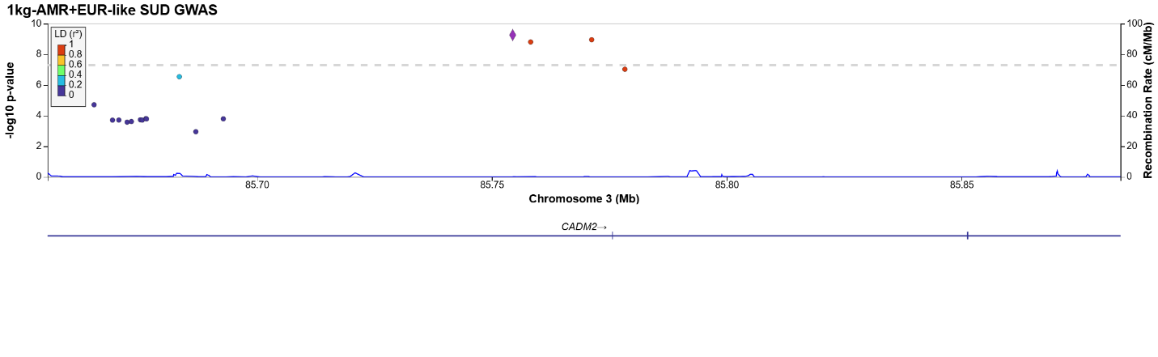
Locus 64:
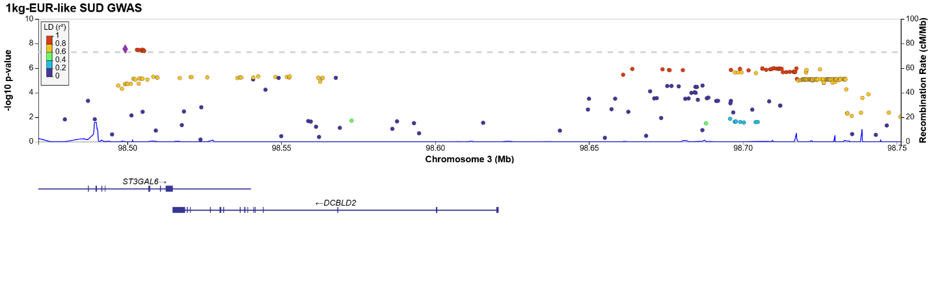
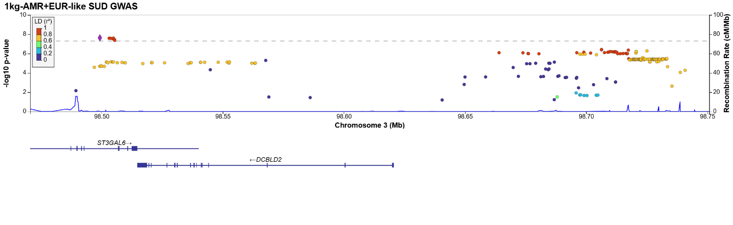
Locus 65:
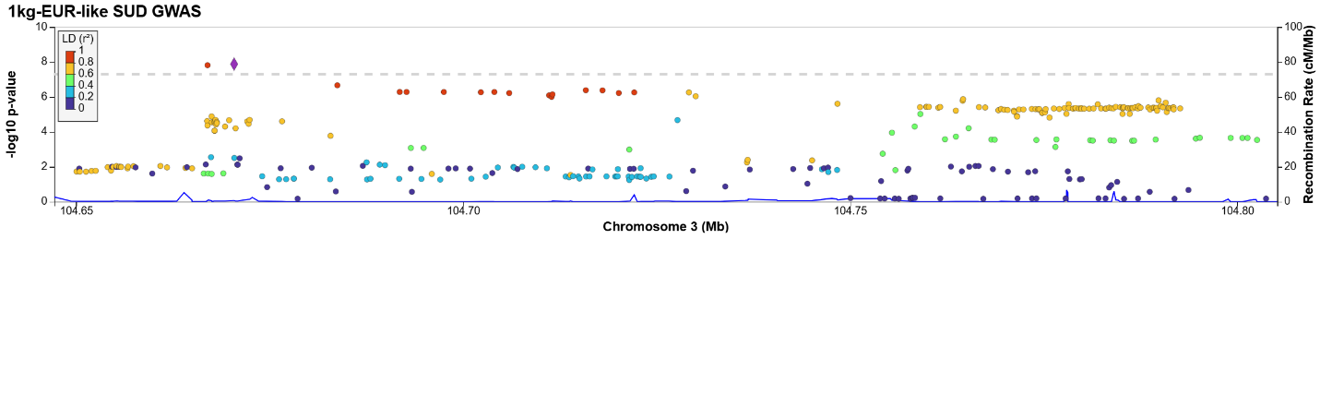
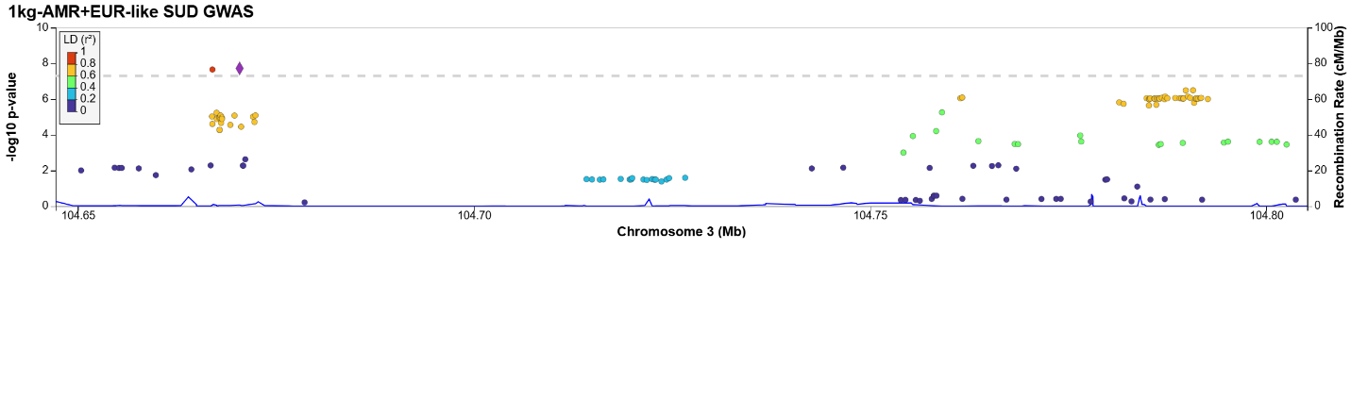
Locus 66:
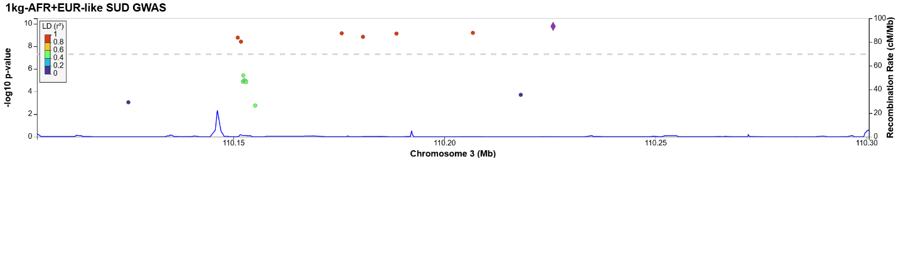
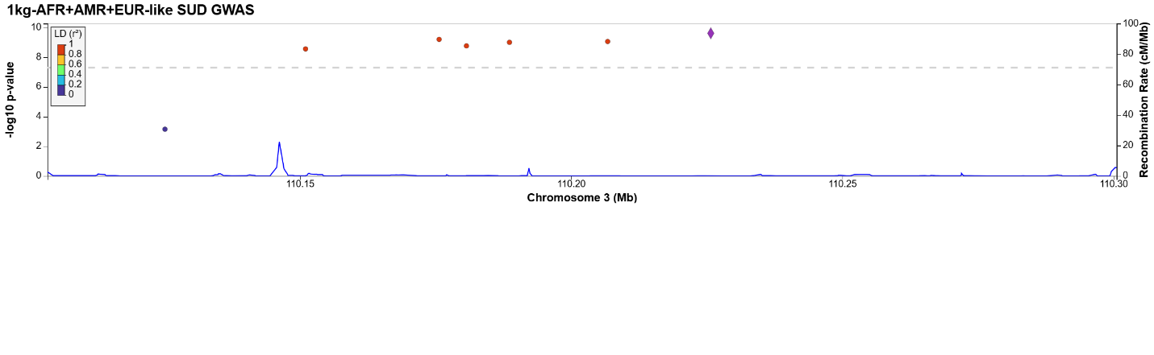
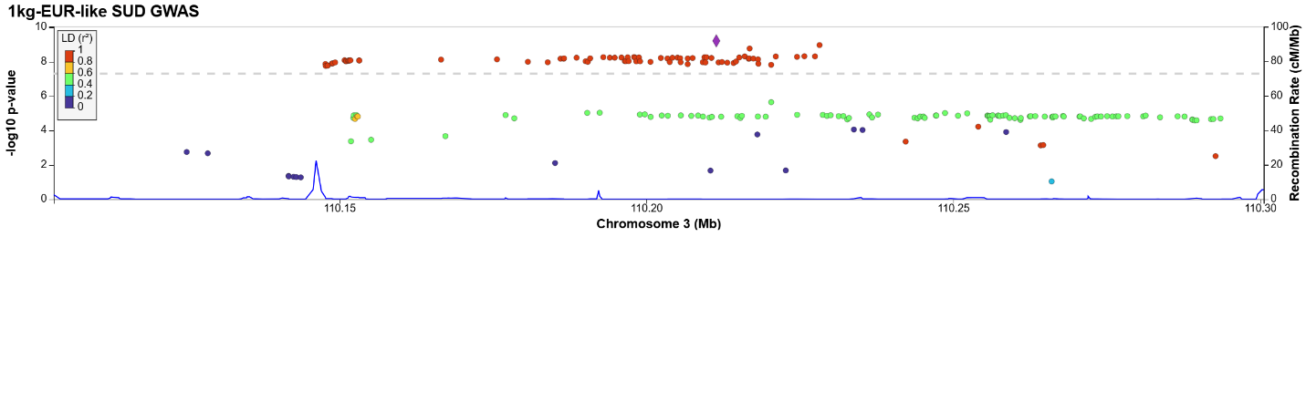
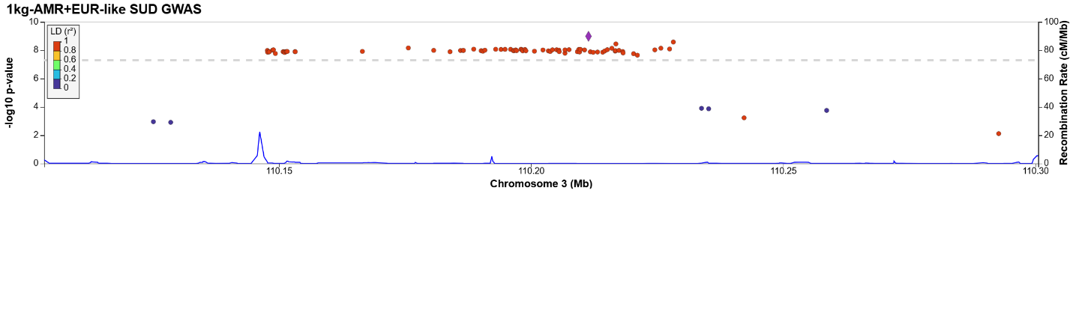
Locus 67:
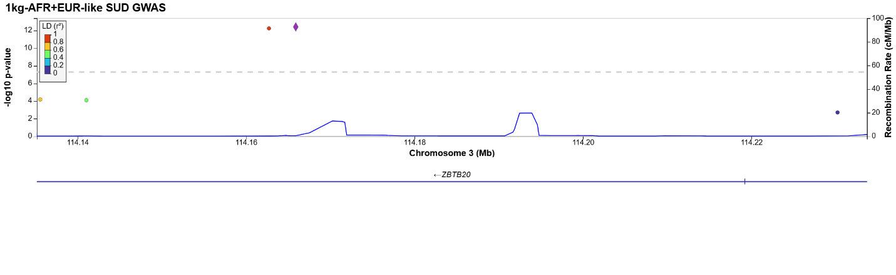
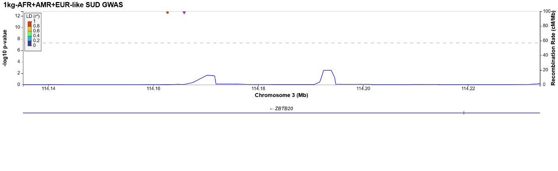
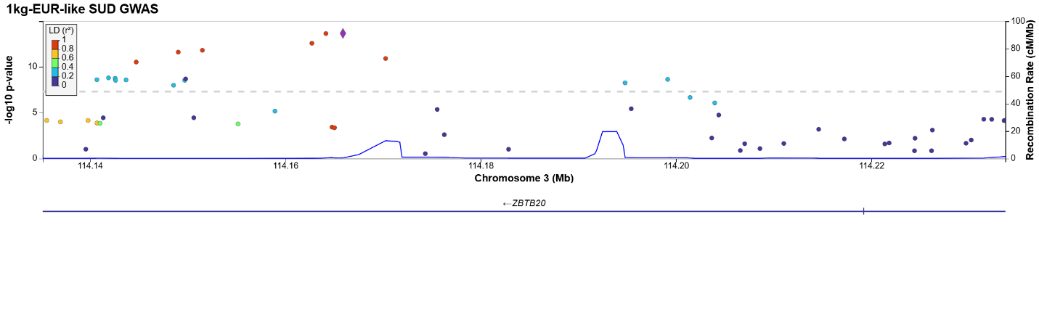
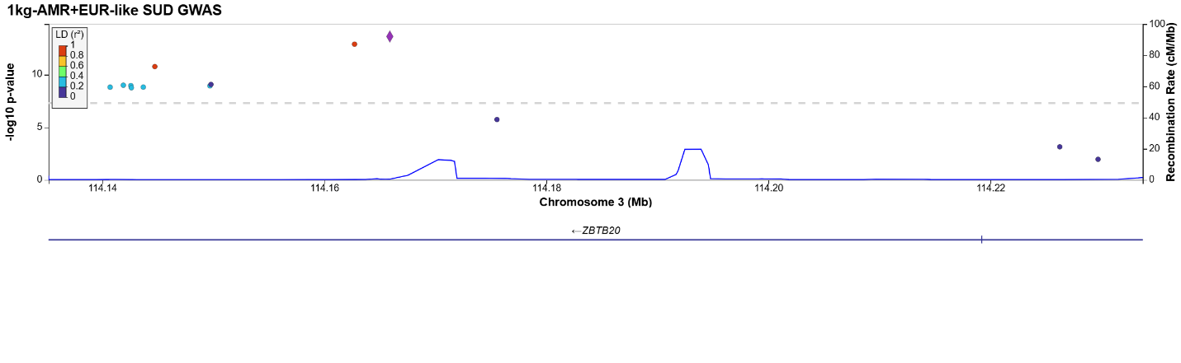
Locus 68:
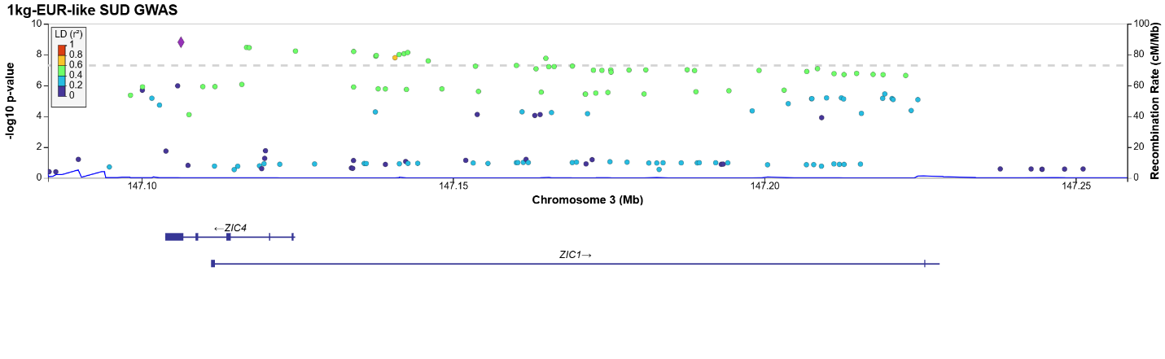
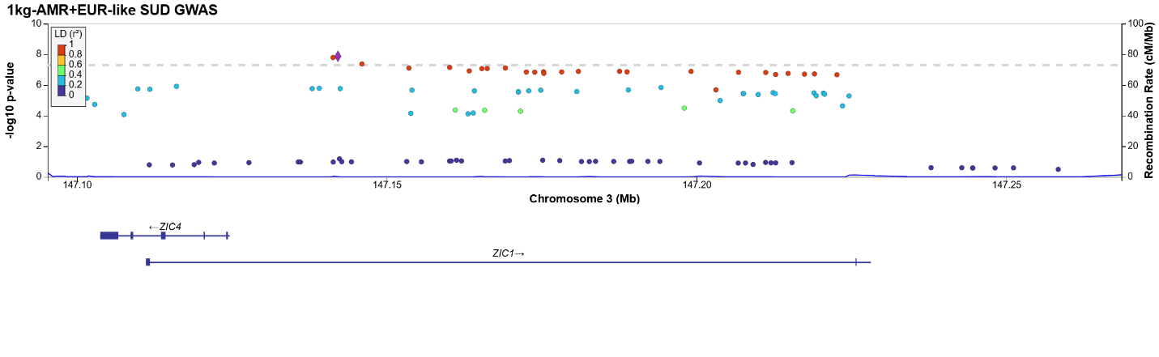
Locus 69:
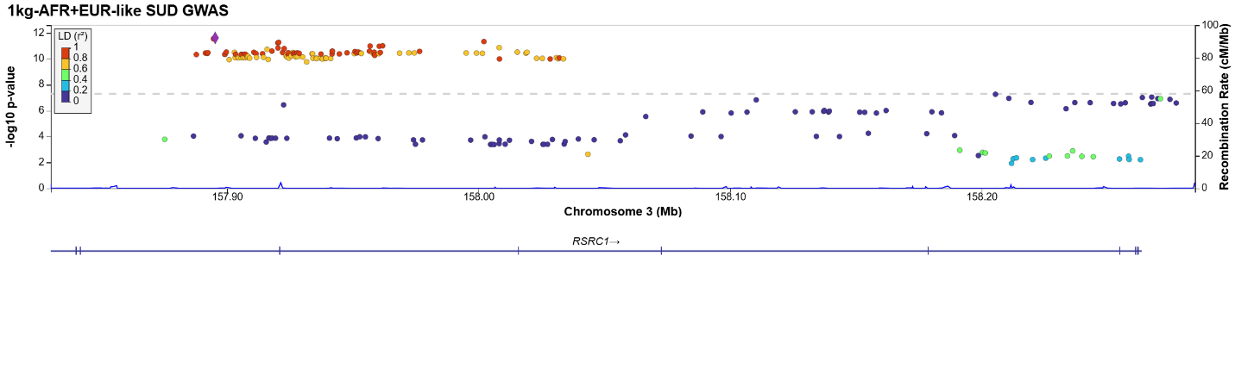
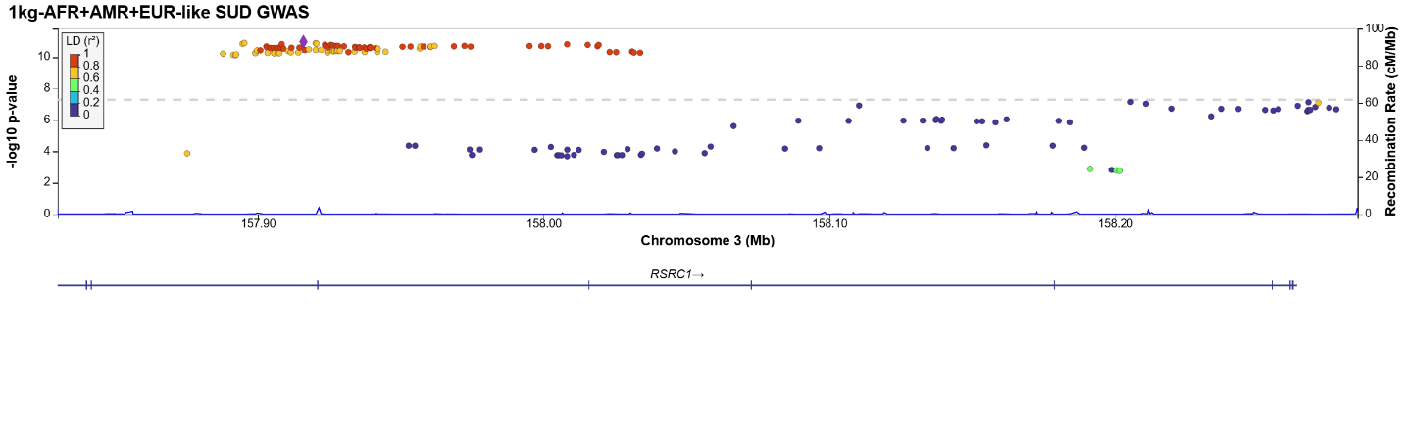
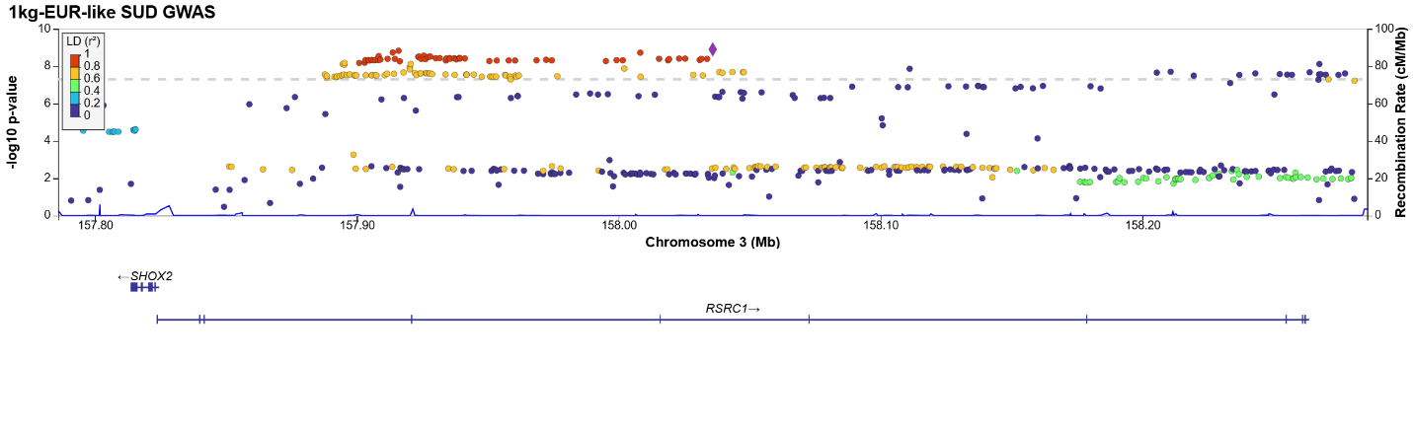
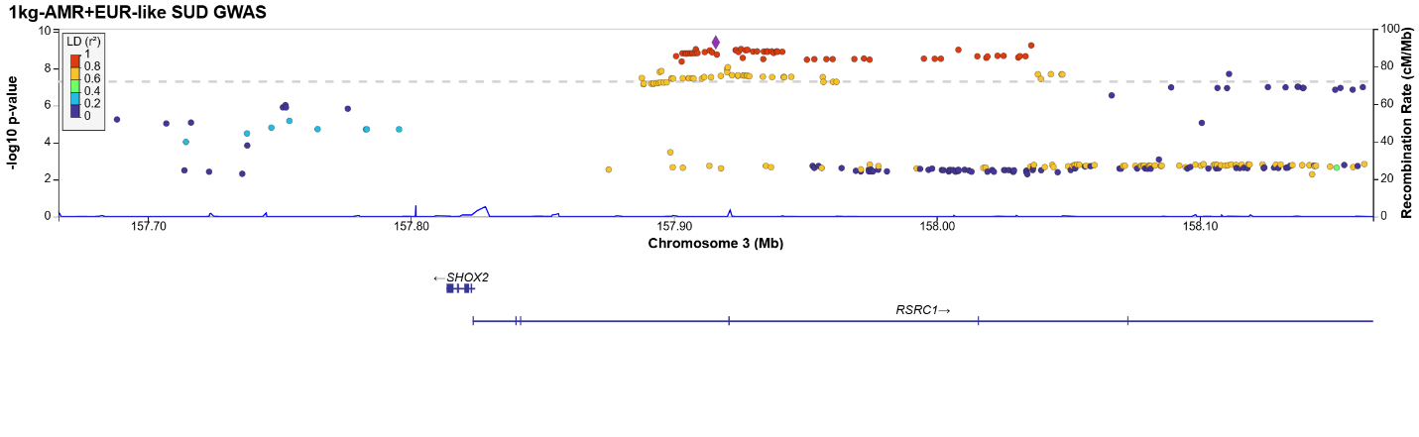
Locus 70:
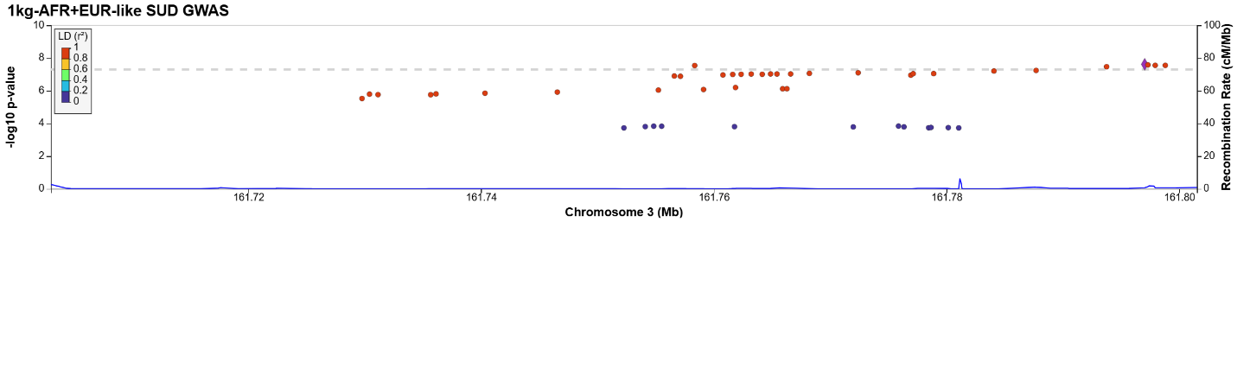
Locus 71:
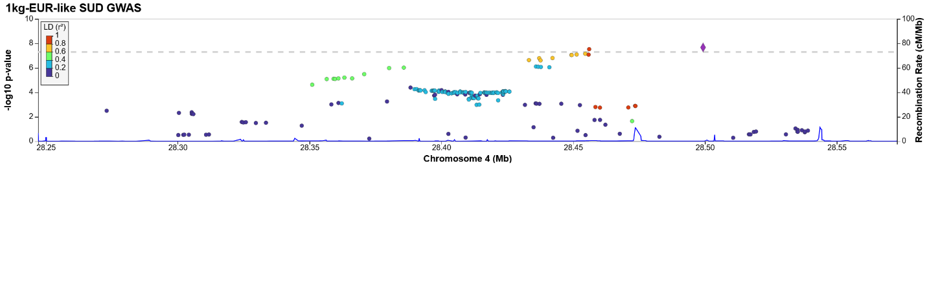
Locus 72:
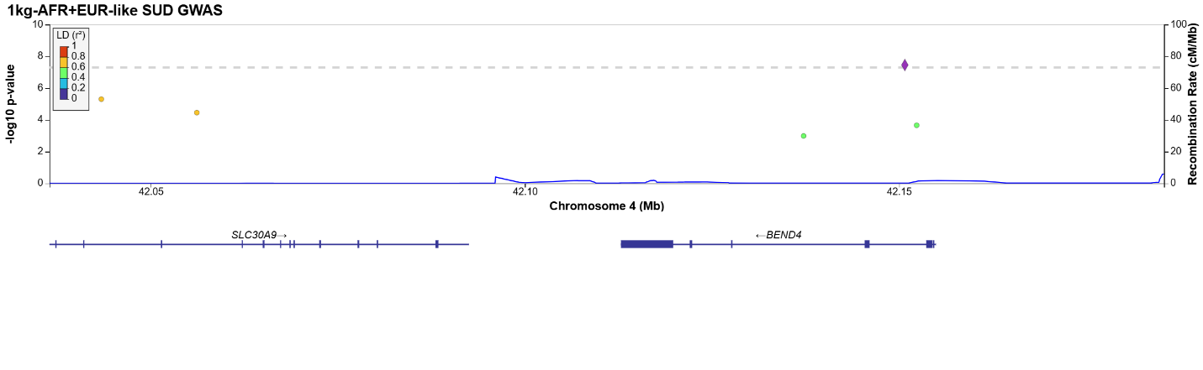
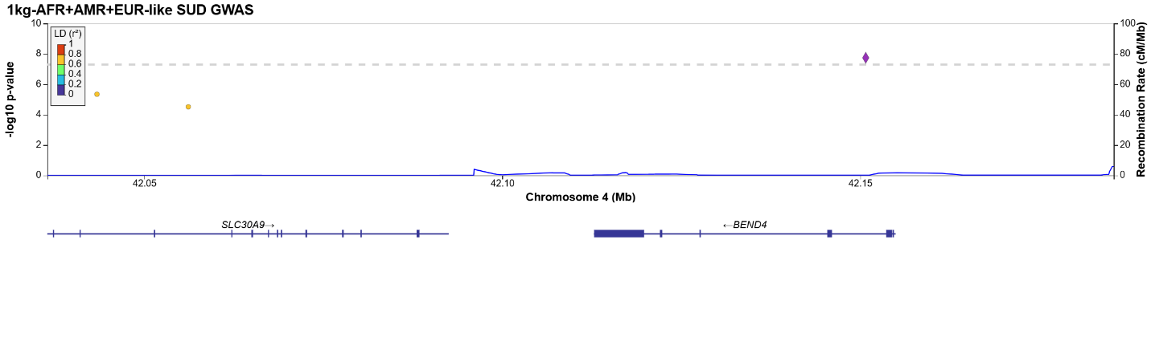
Locus 73:
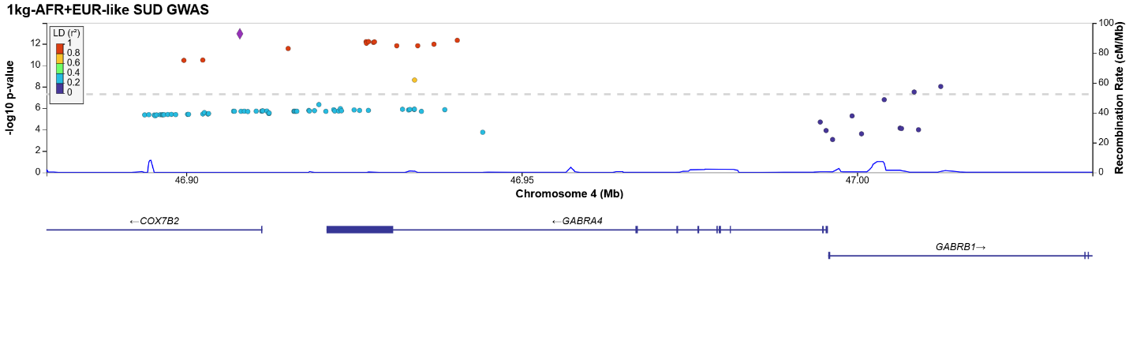
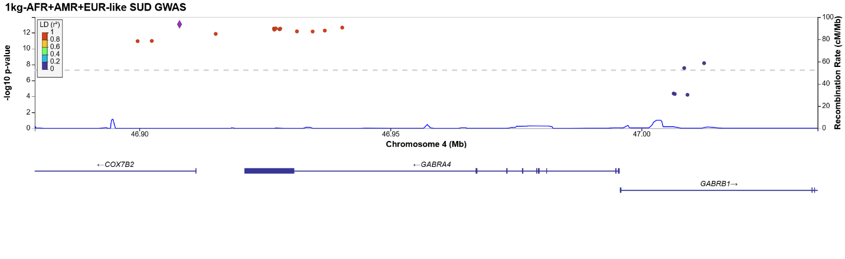
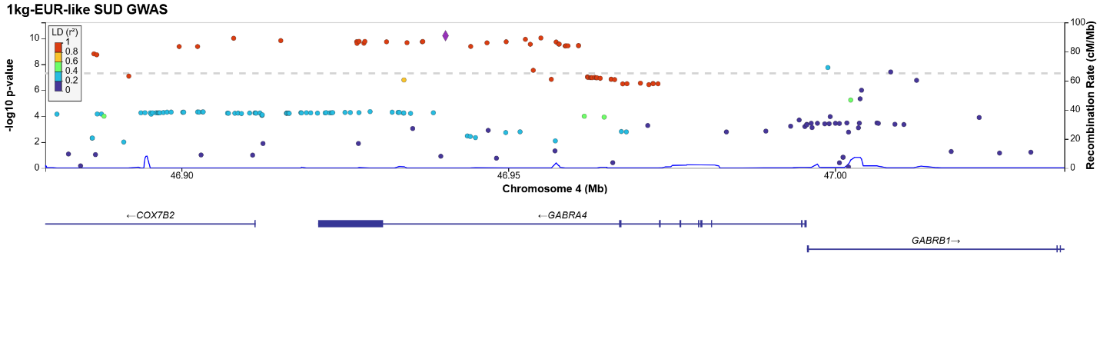
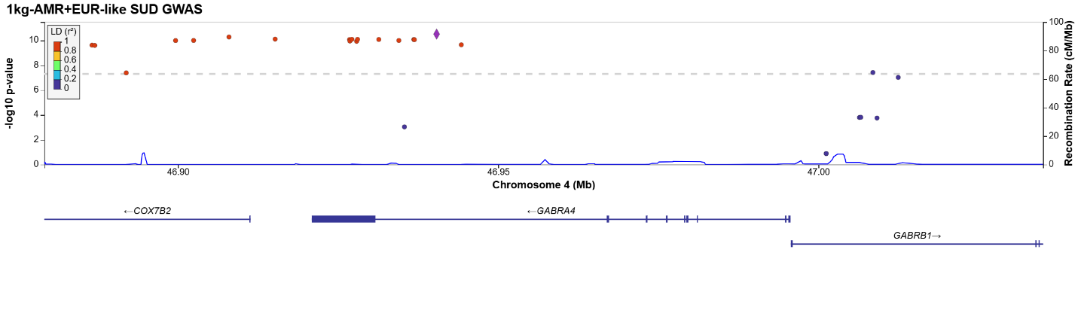
Locus 74:
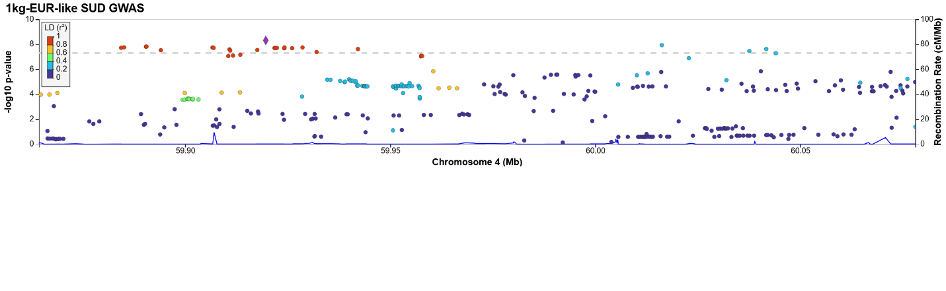
Locus 75:
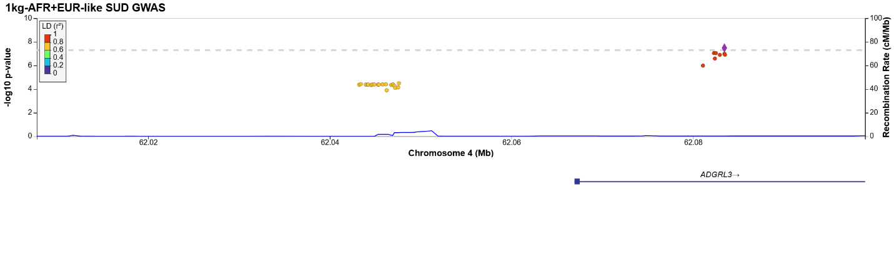
Locus 76:
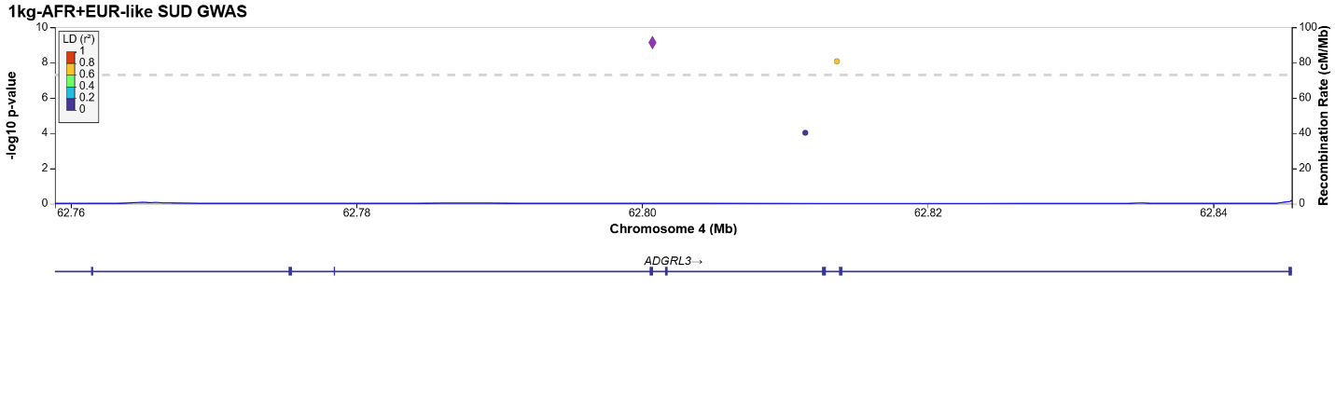
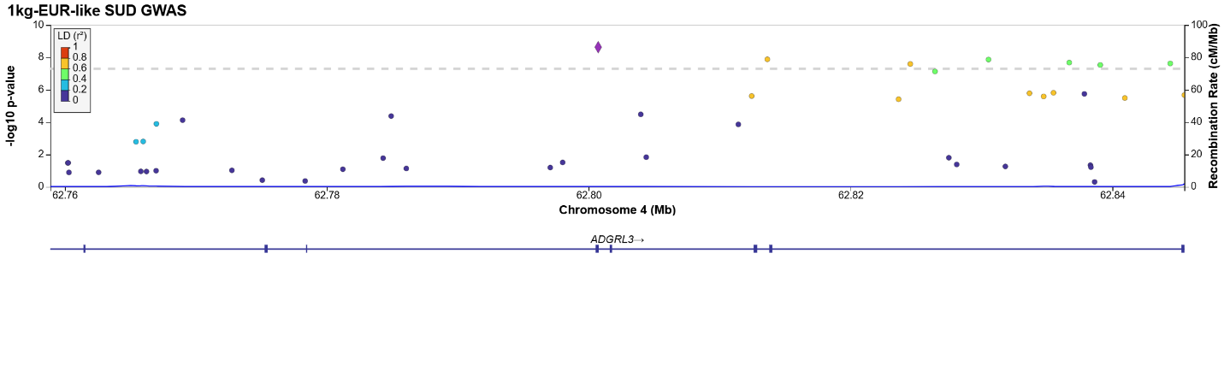
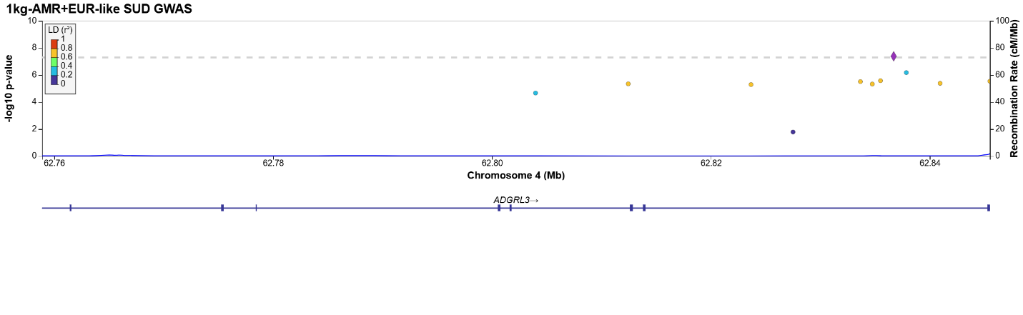
Locus 77:
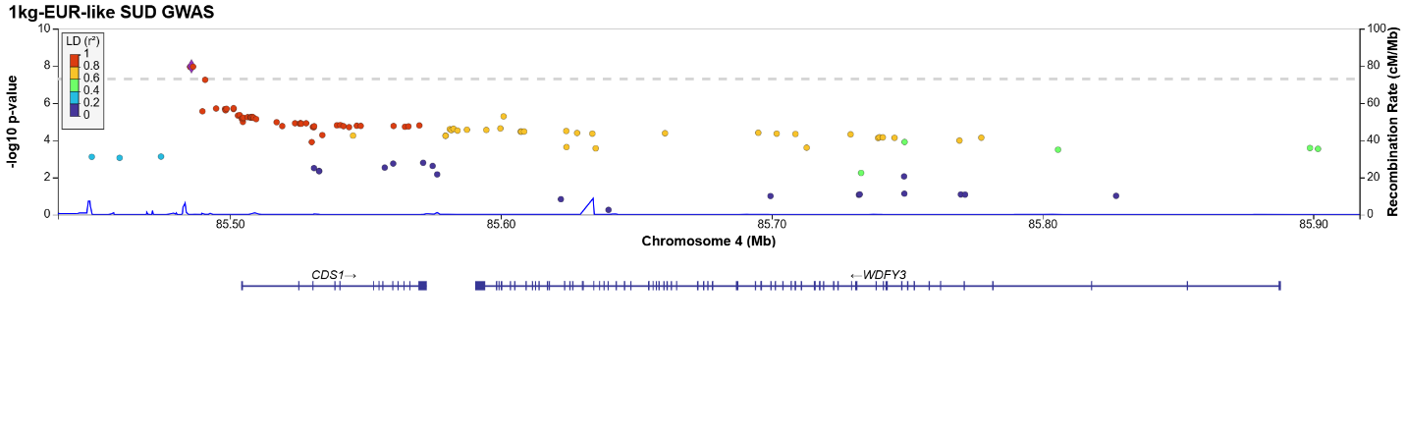
Locus 78:
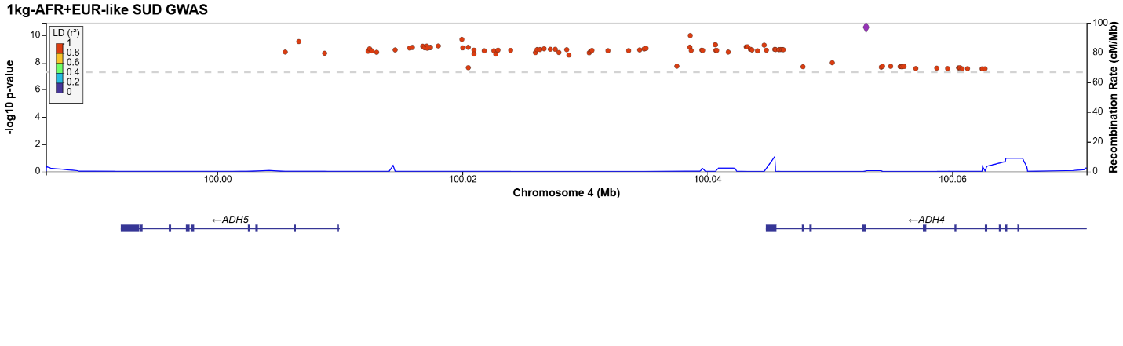
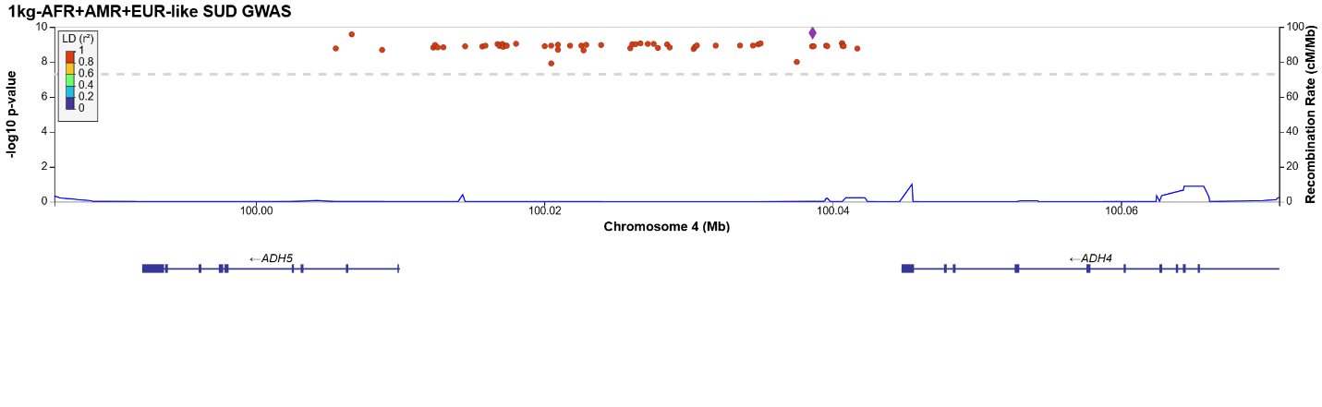
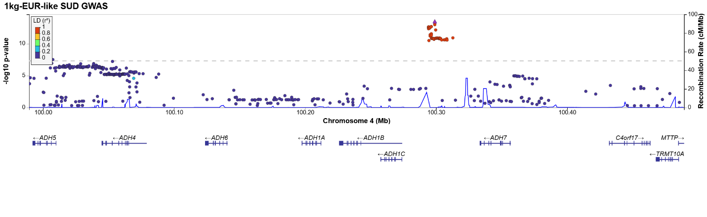
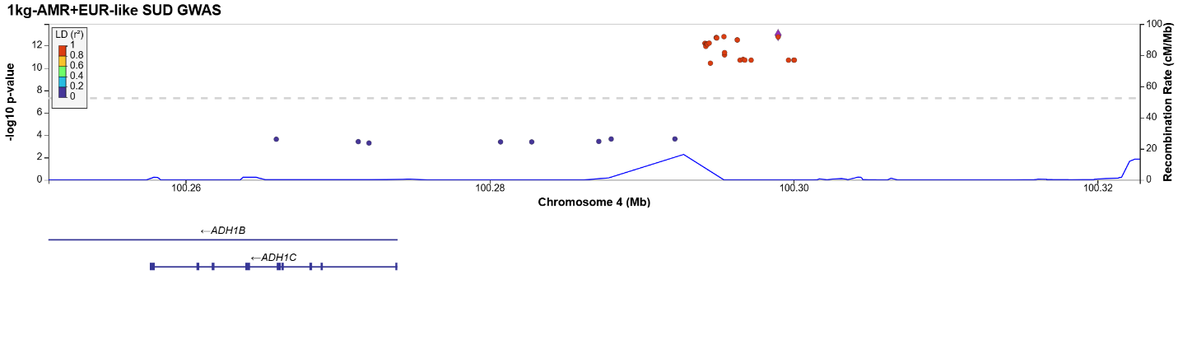
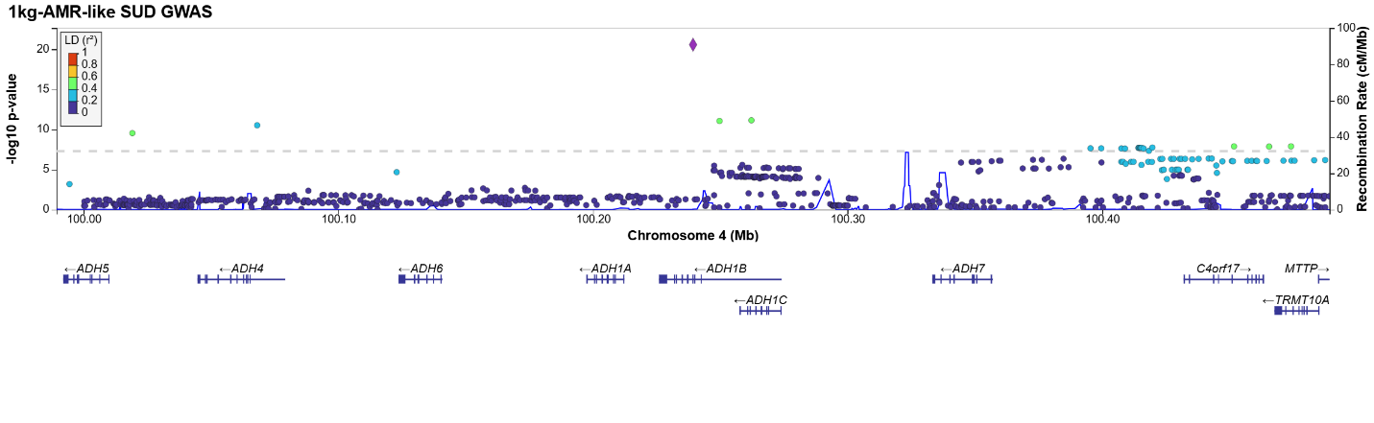
Locus 79:
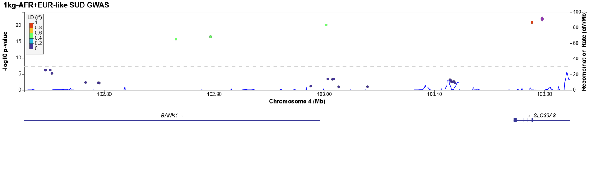
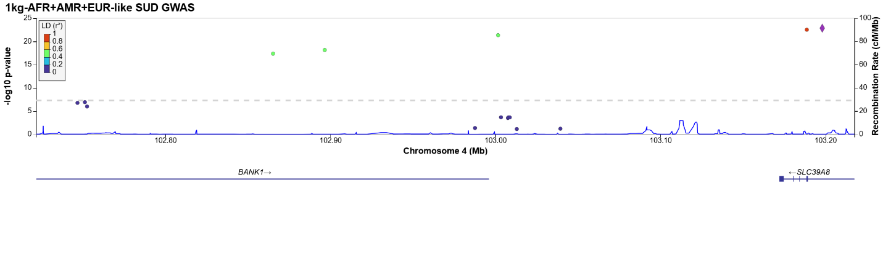
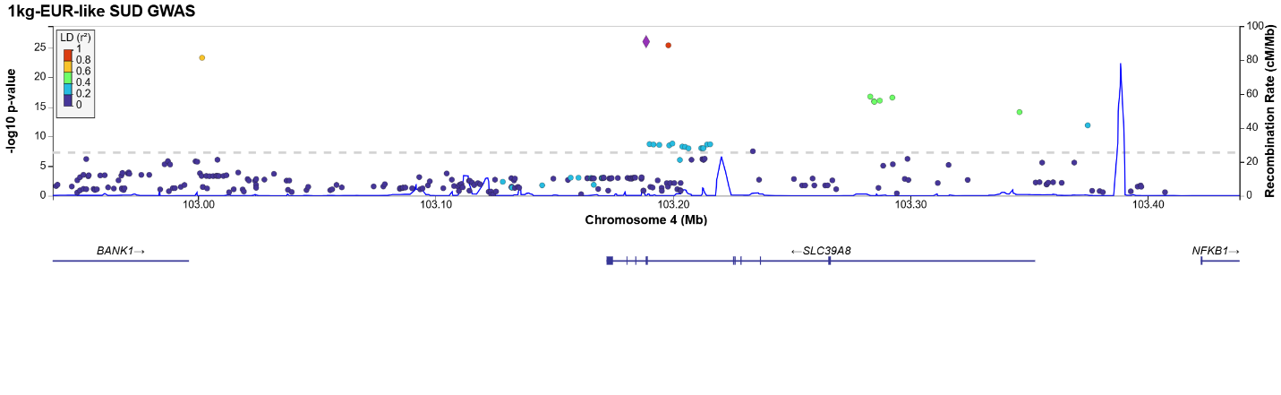
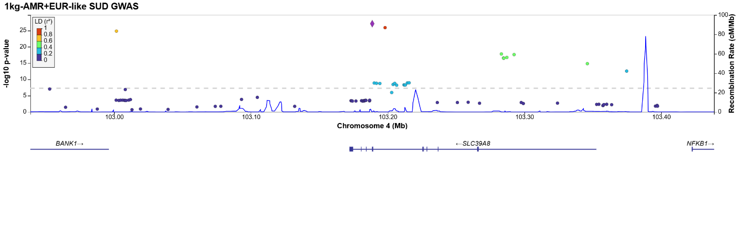
Locus 80:
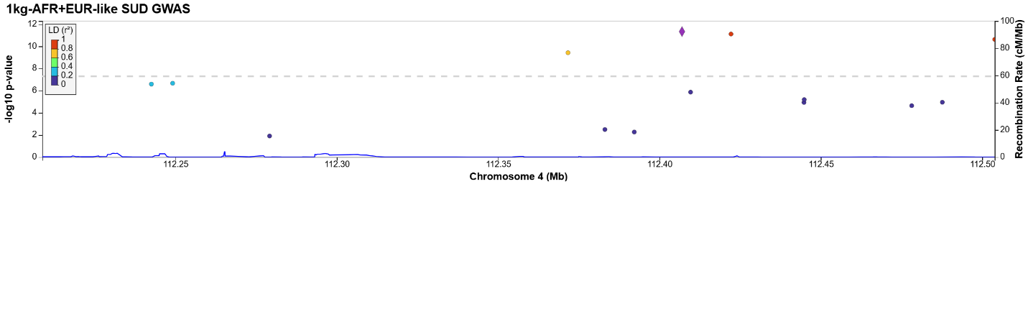
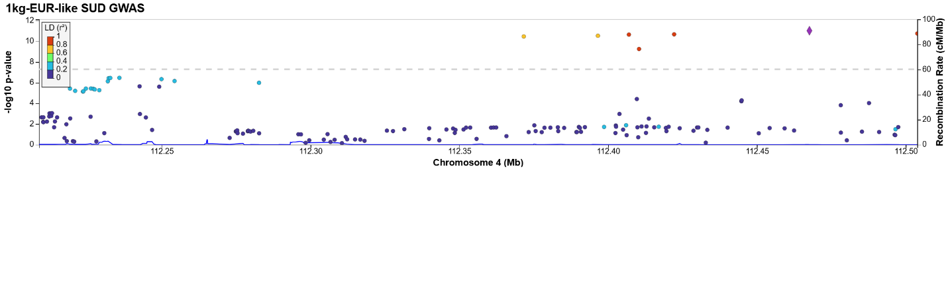
Locus 81:
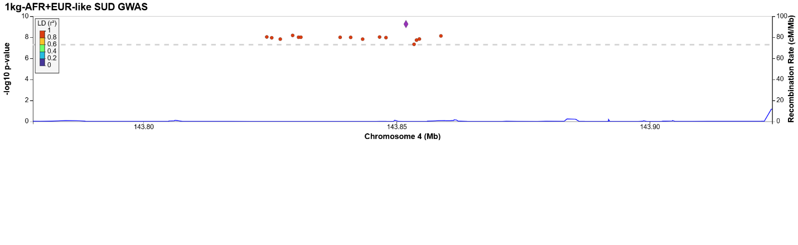
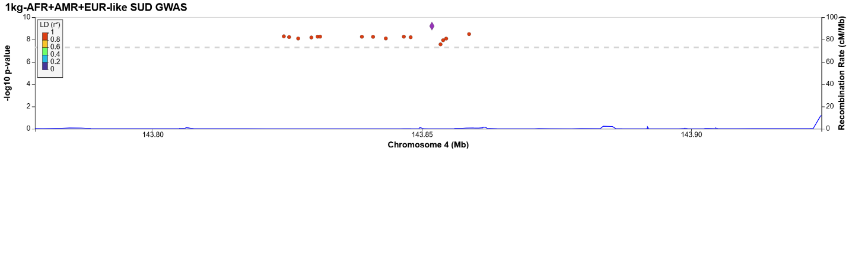
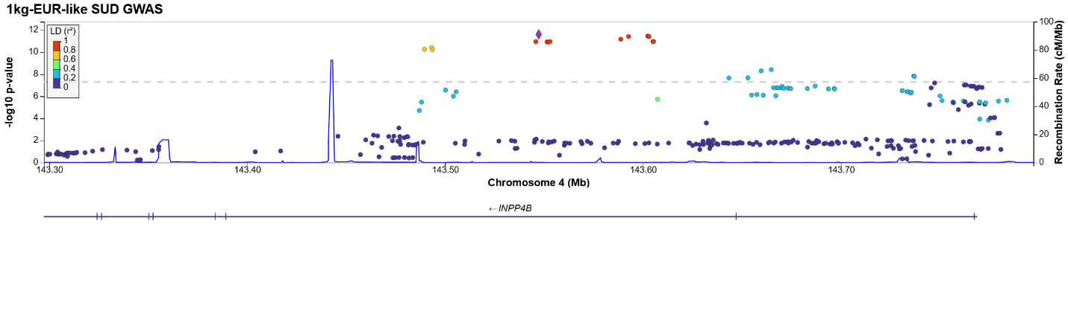
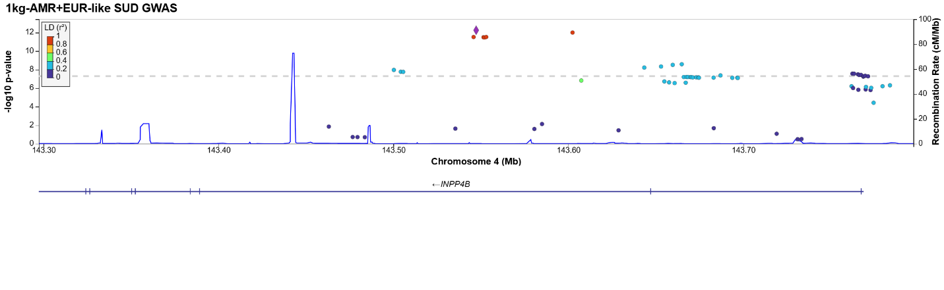
Locus 82:
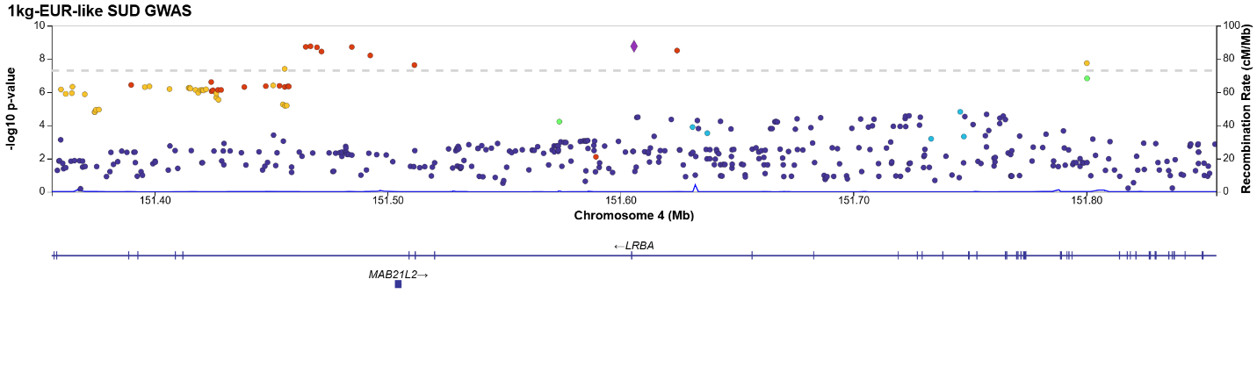
Locus 83:
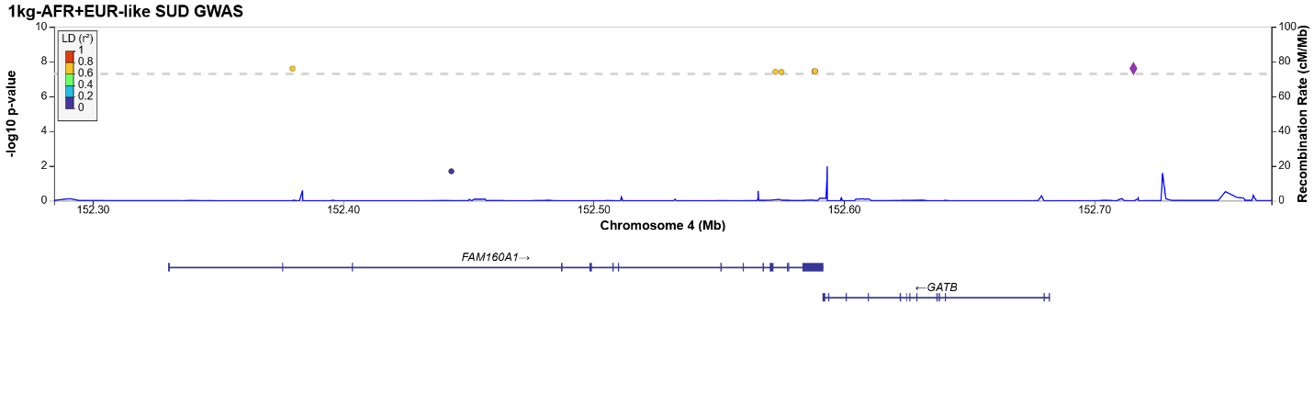
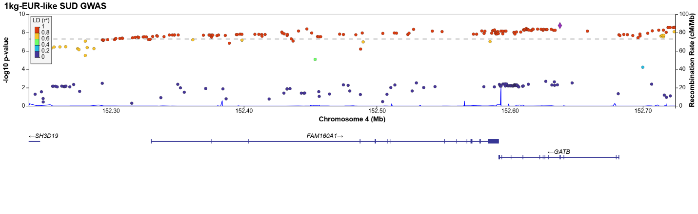
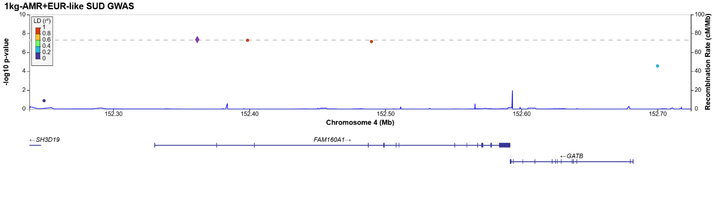
Locus 84:
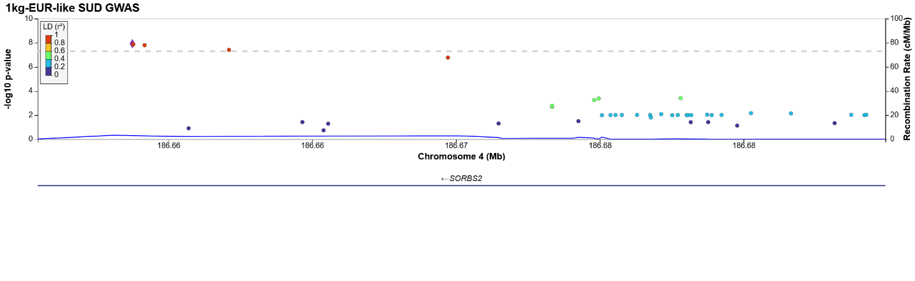
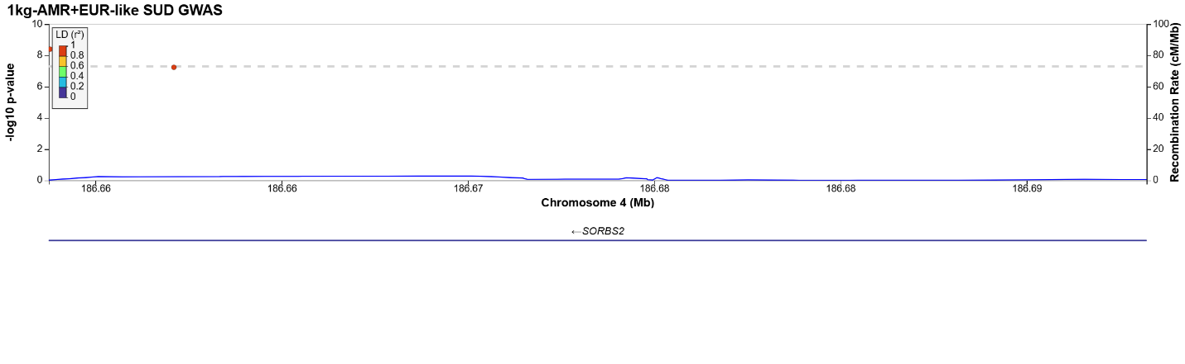
Locus 85:
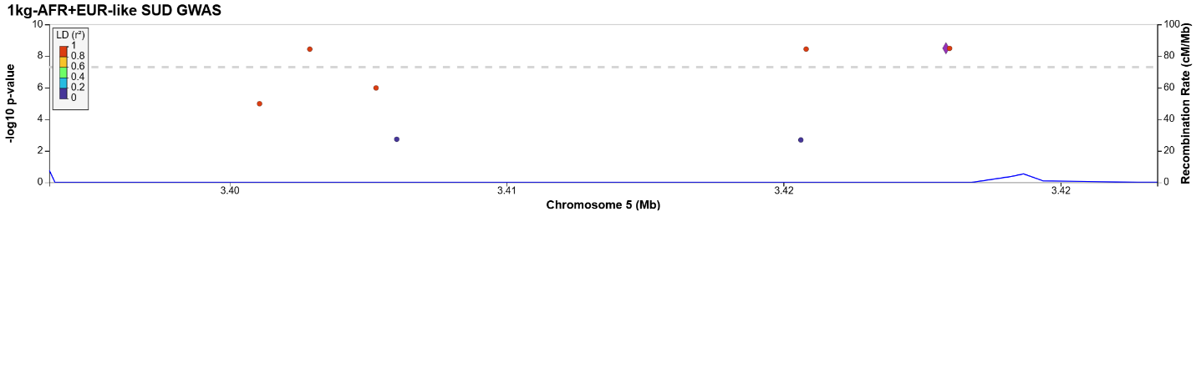
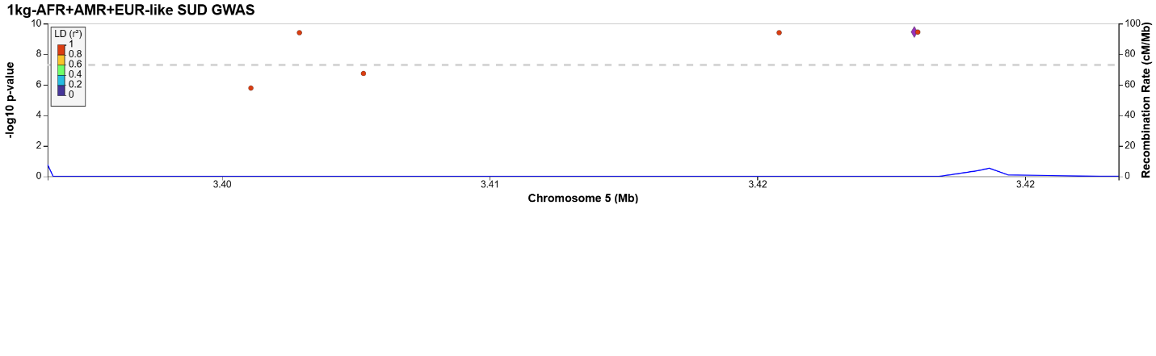
Locus 86:
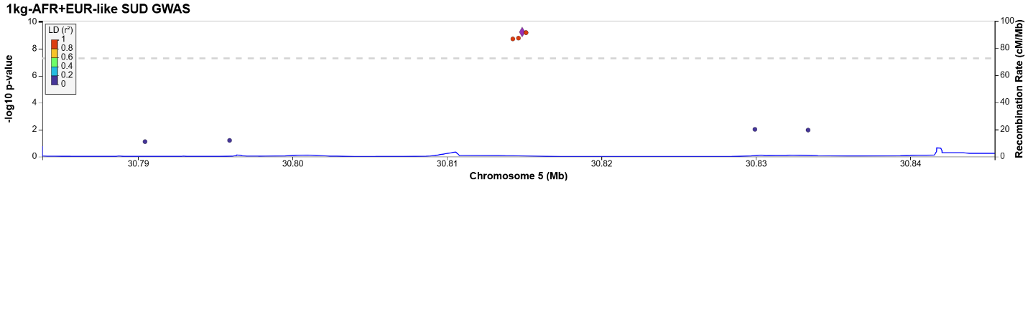
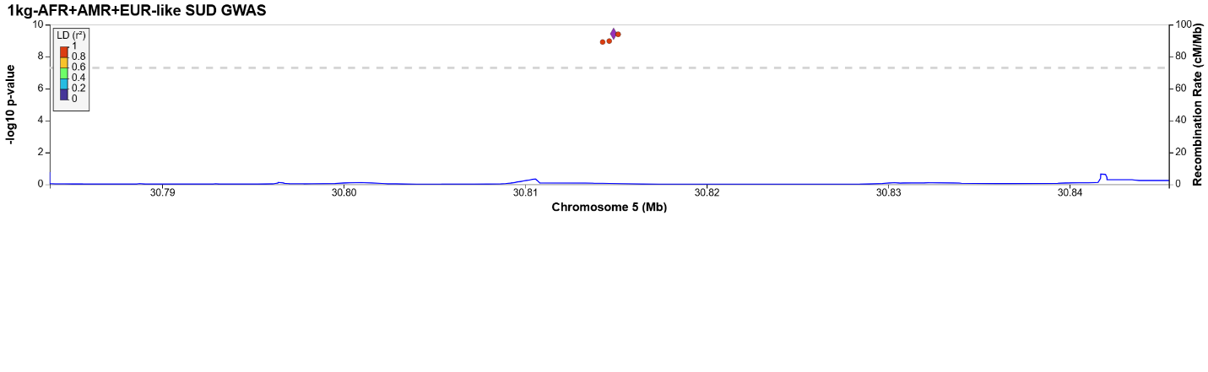
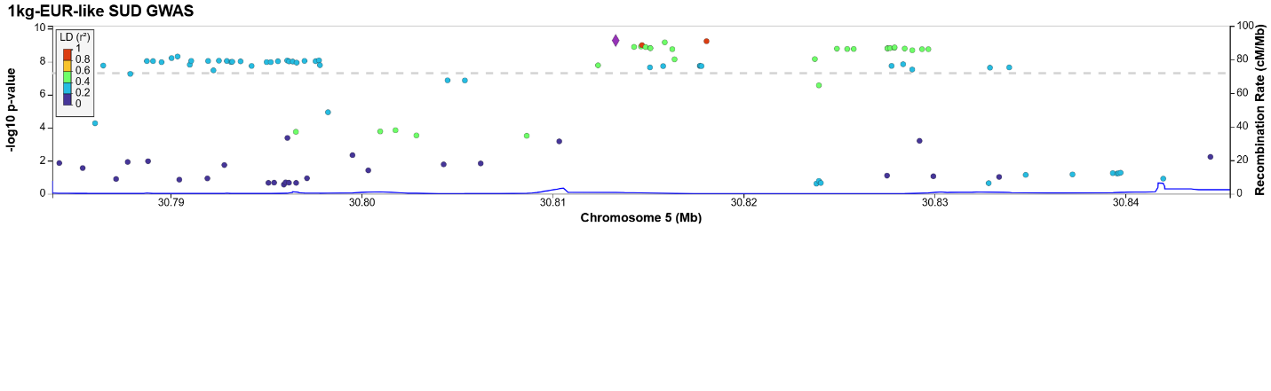
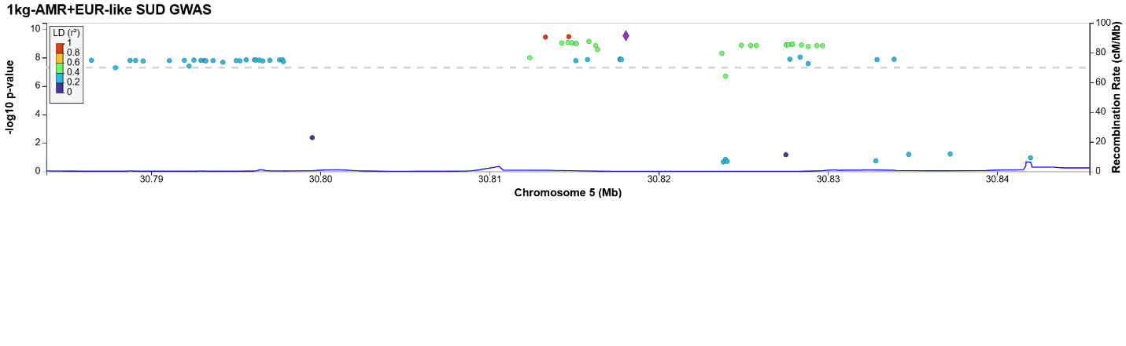
Locus 87:
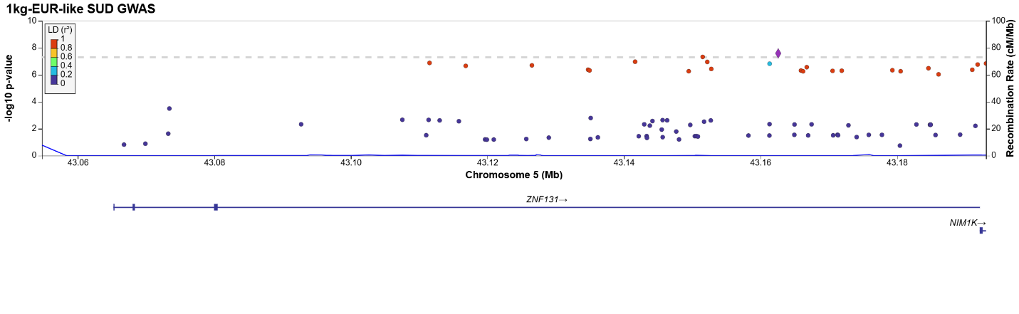
Locus 88:
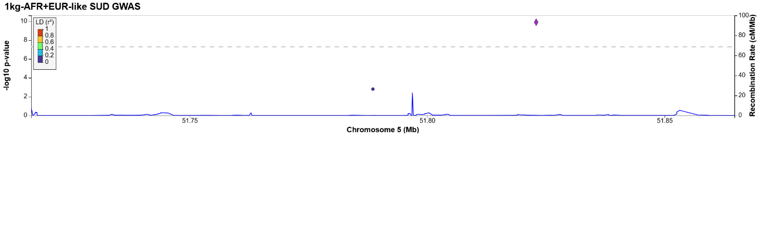
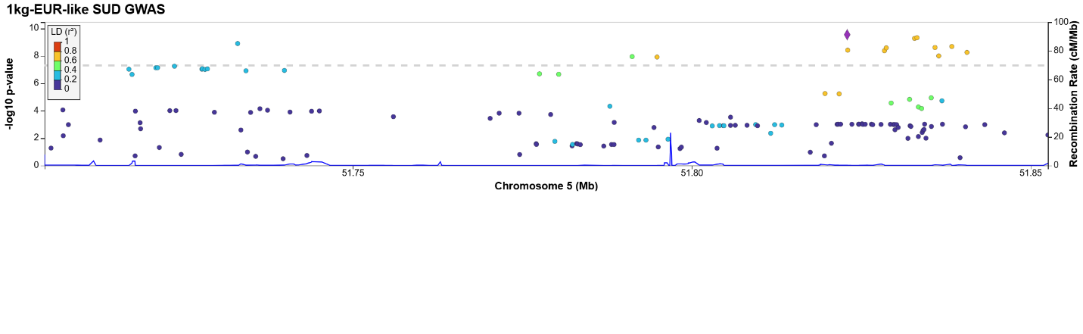
Locus 89:
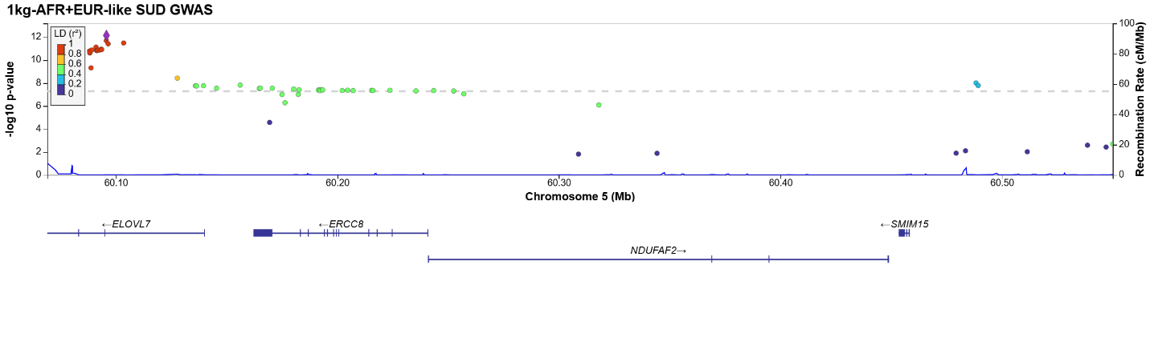
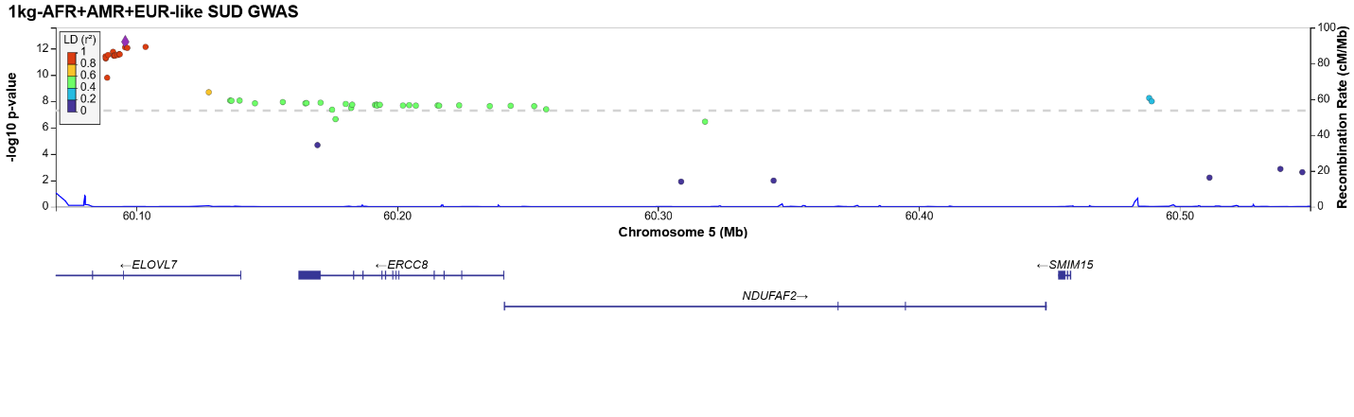
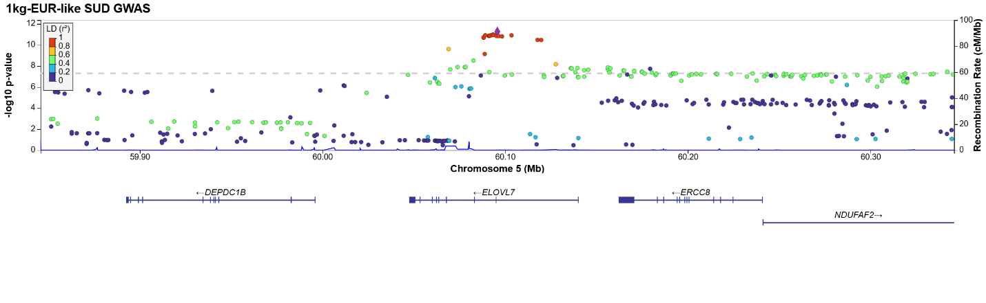
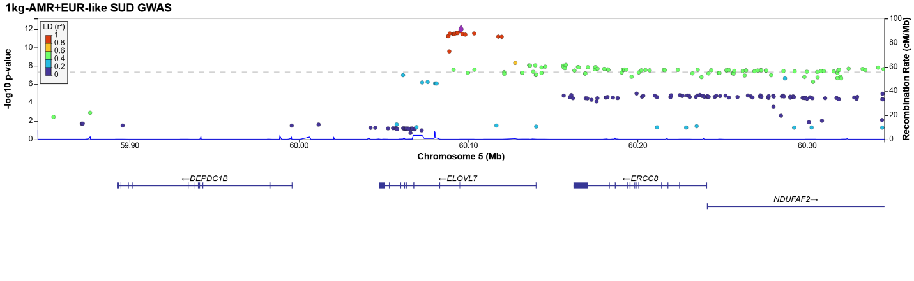
Locus 90:
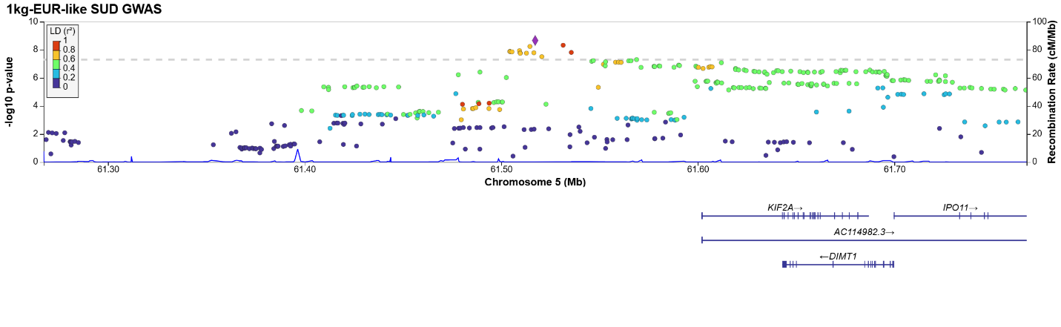
Locus 91:
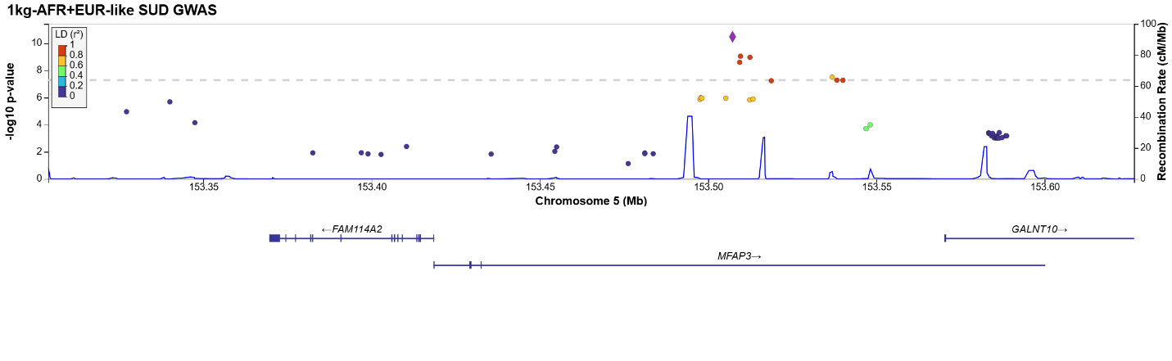
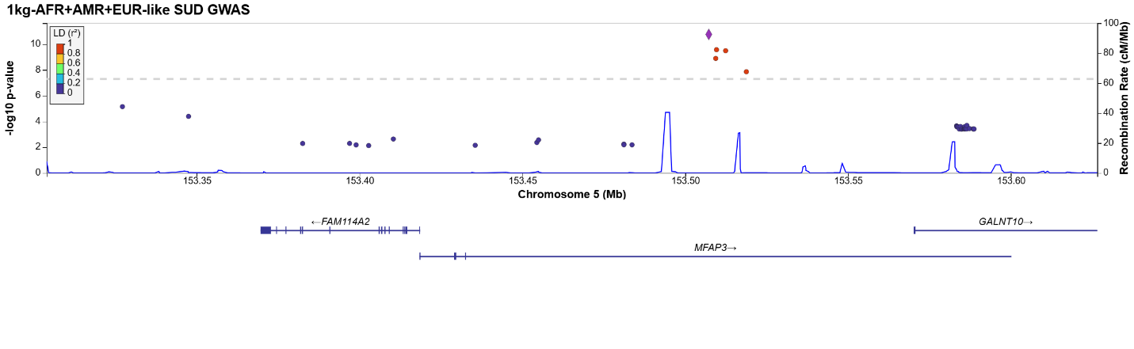
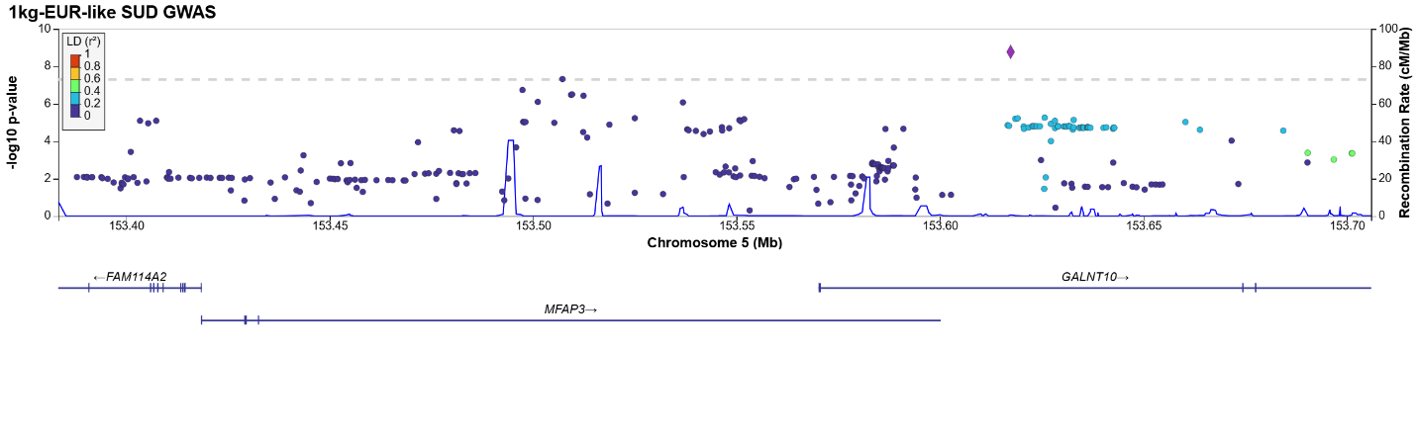
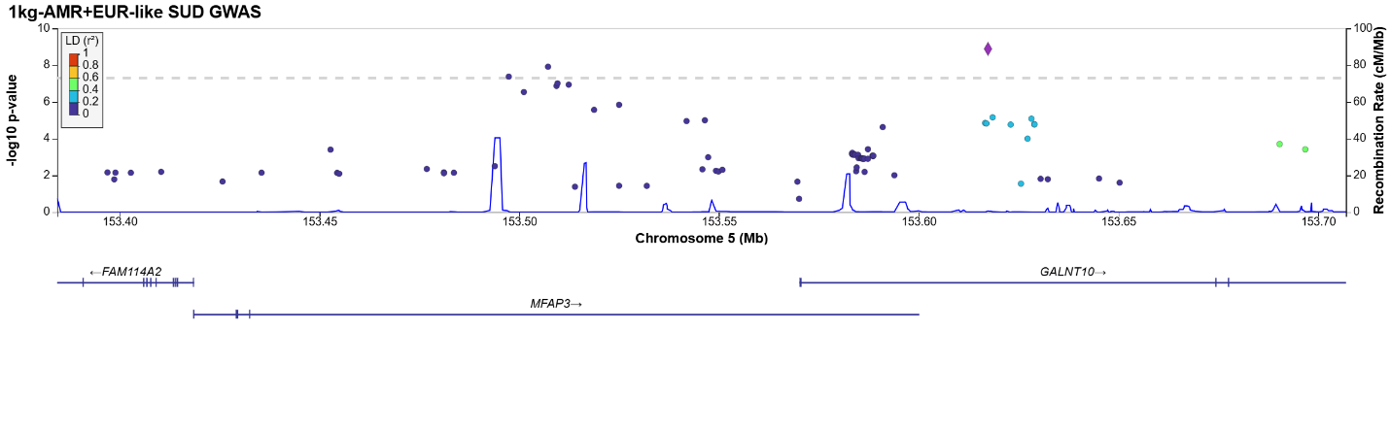
Locus 92:
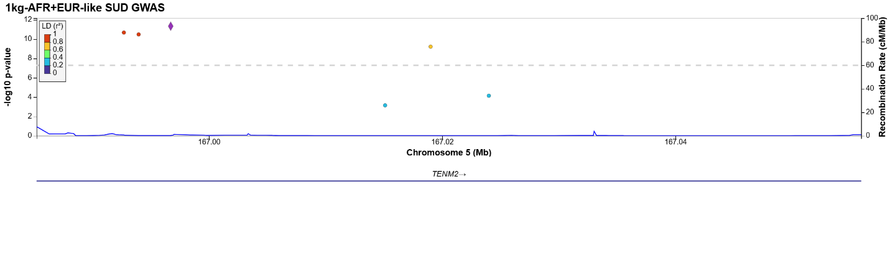
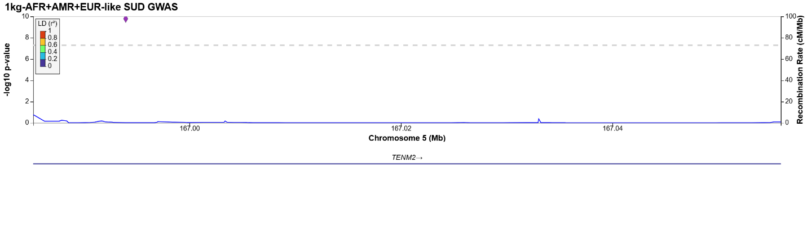
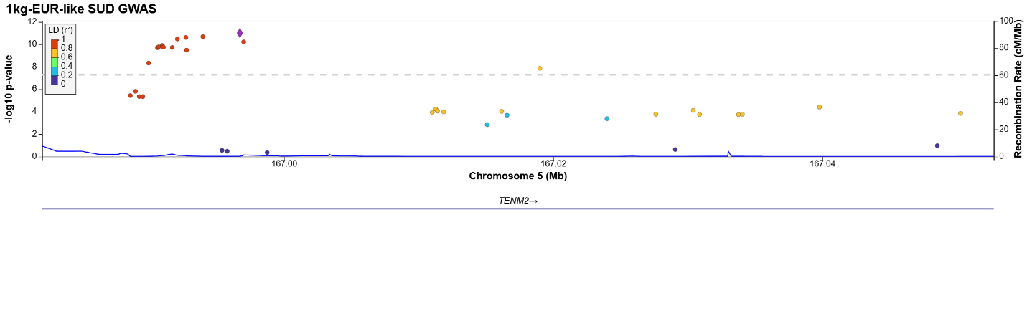
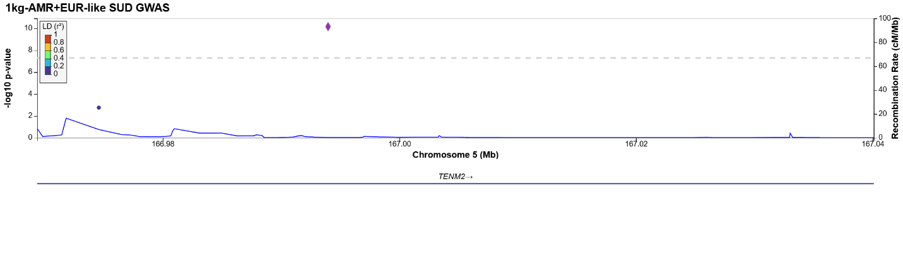
Locus 93:
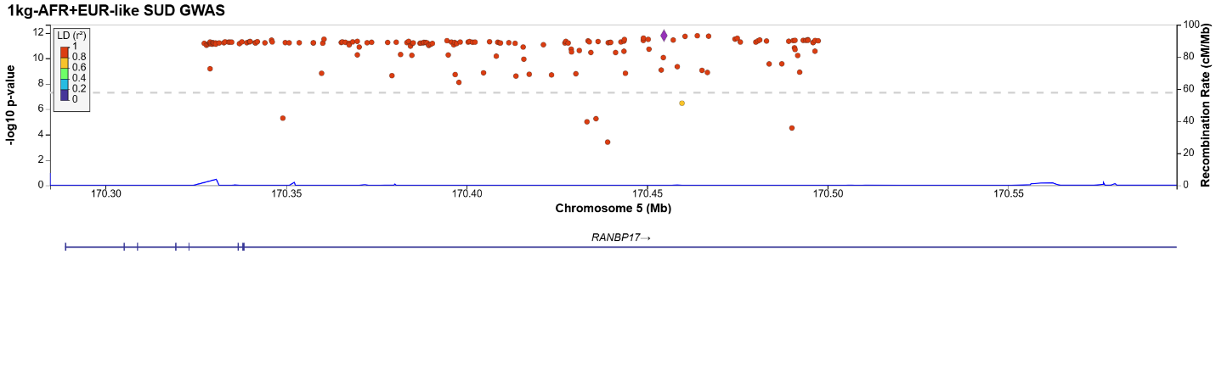
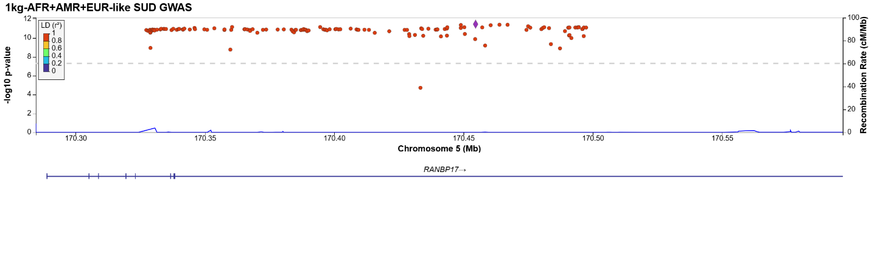
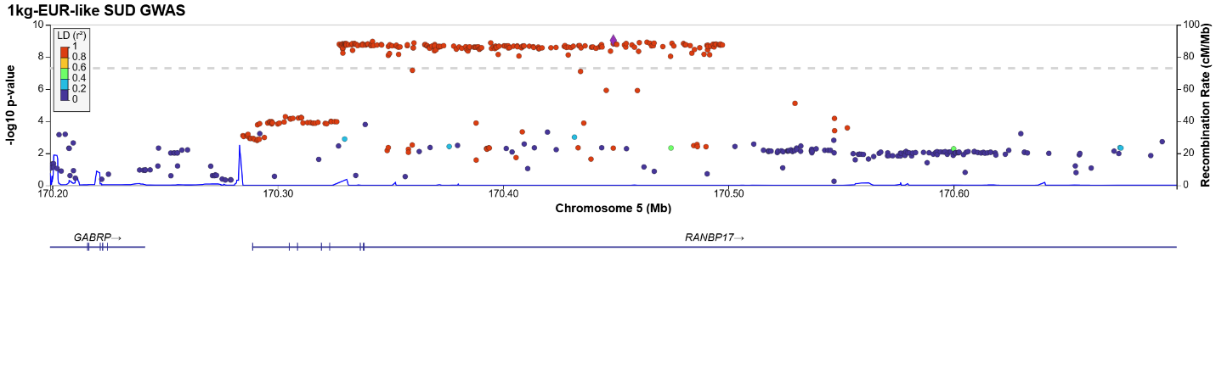
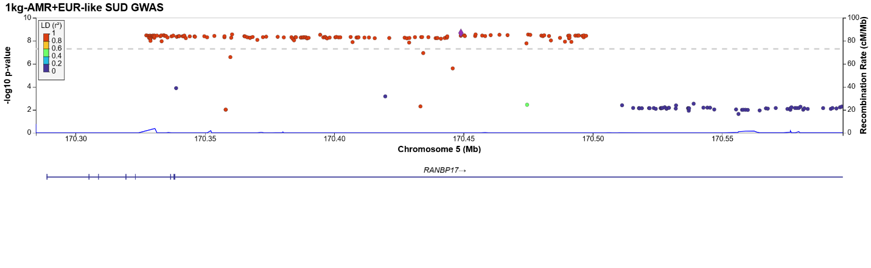
Locus 94:
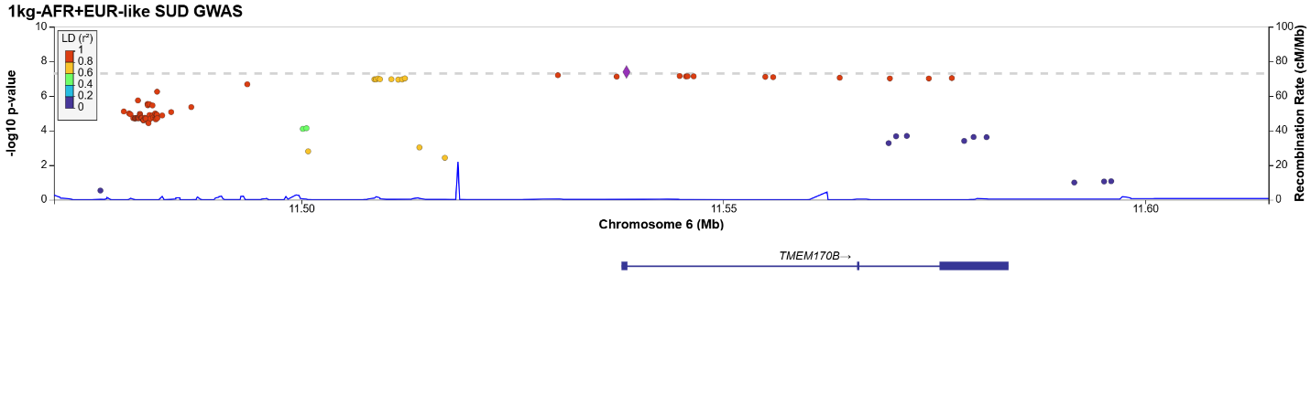
Locus 95:
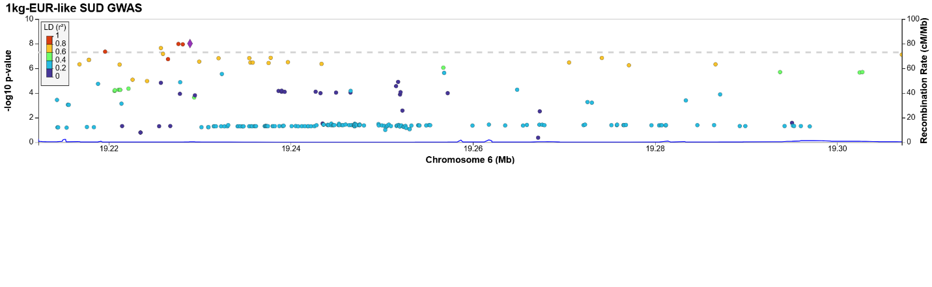
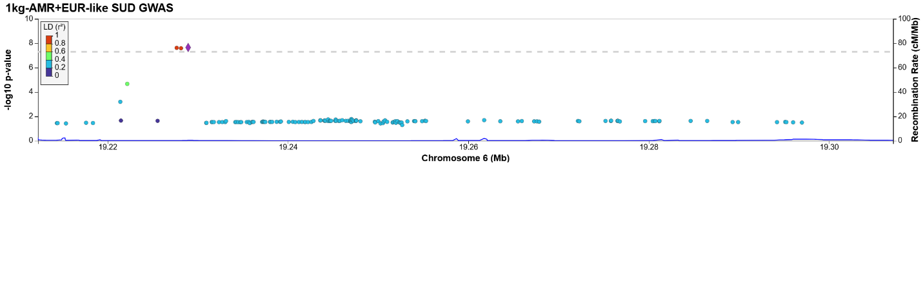
Locus 96:
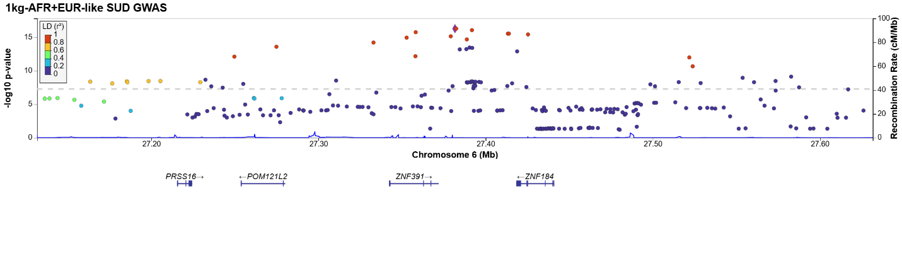
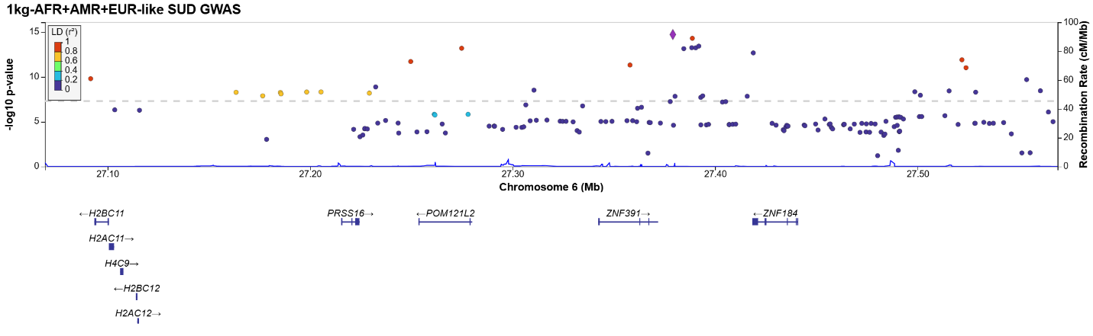
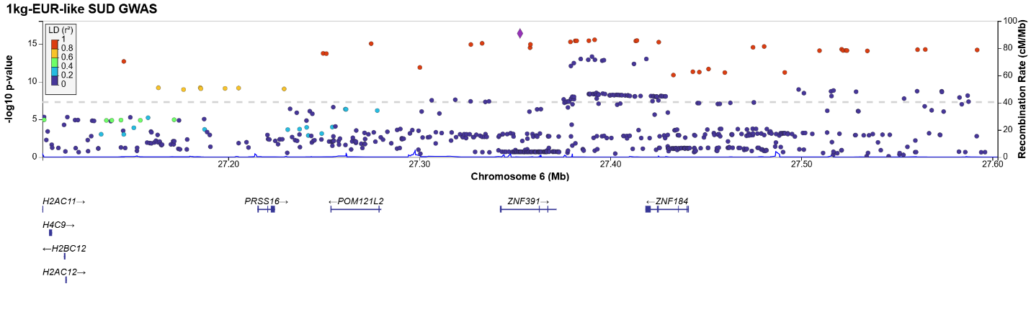
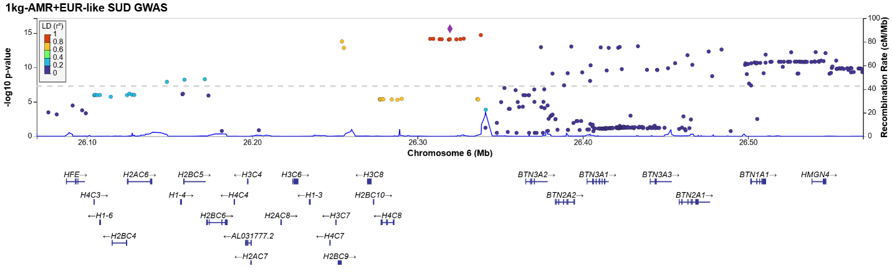
Locus 97:
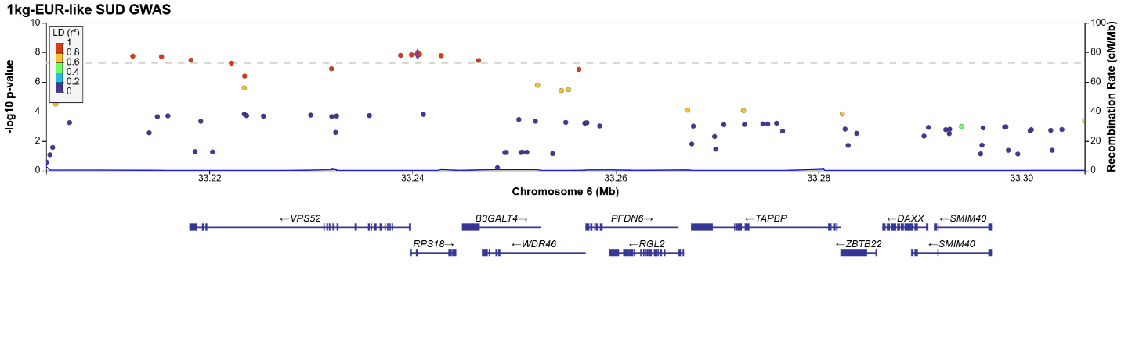
Locus 98:
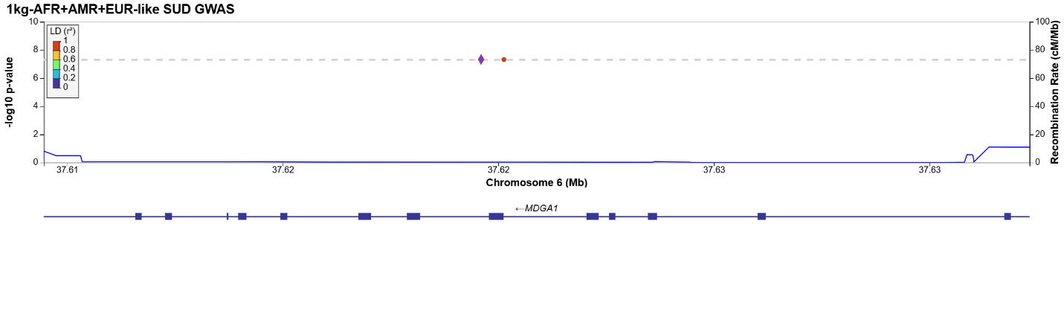
Locus 99:
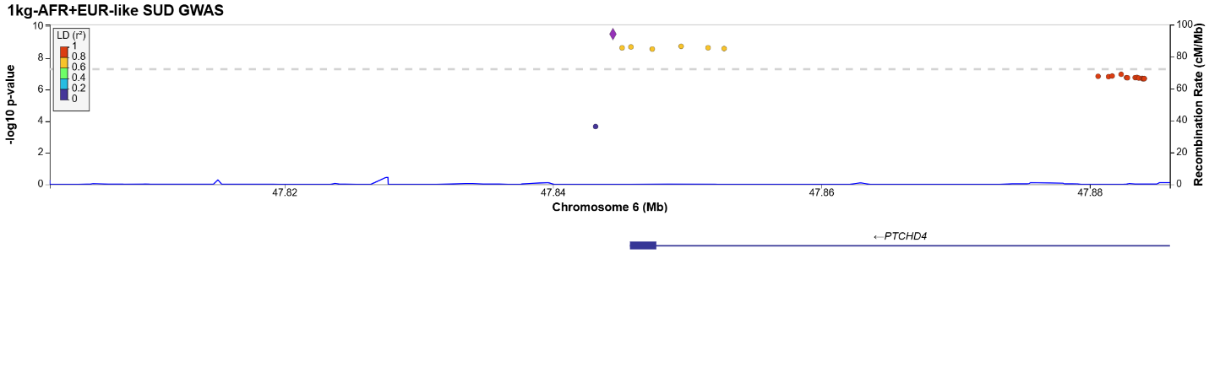
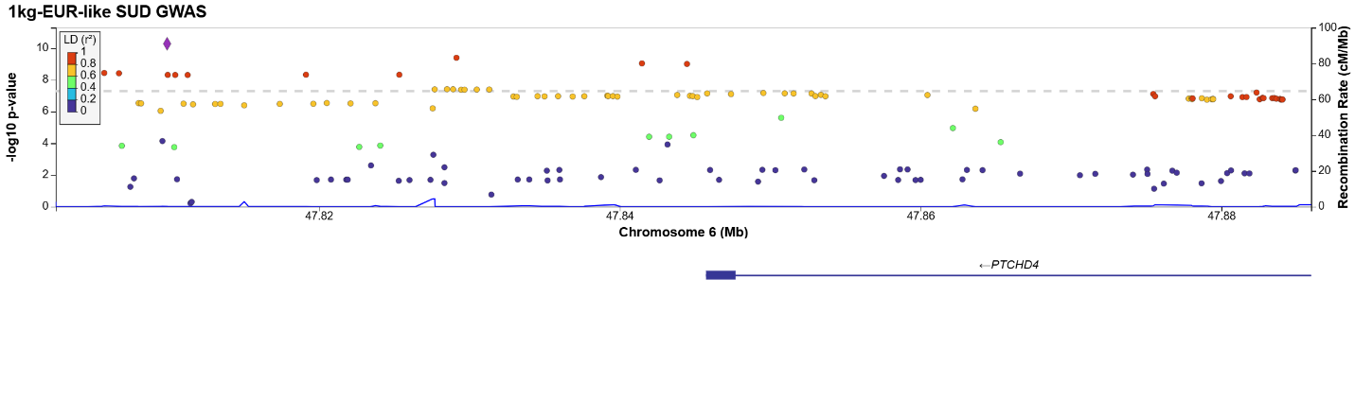
Locus 100:
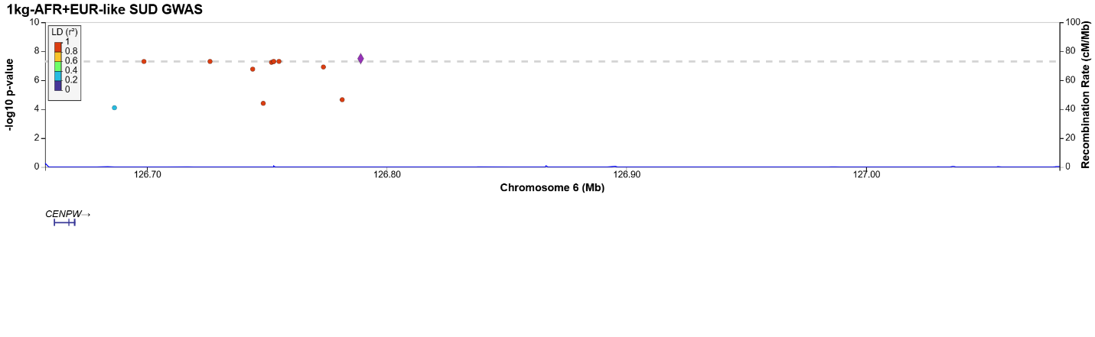
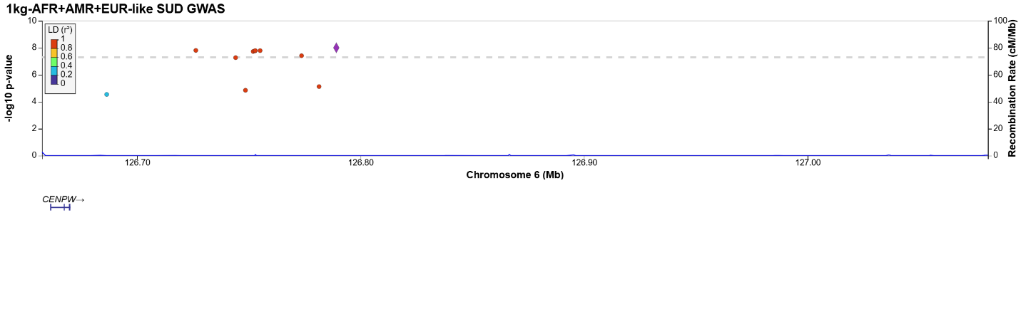
Locus 101:
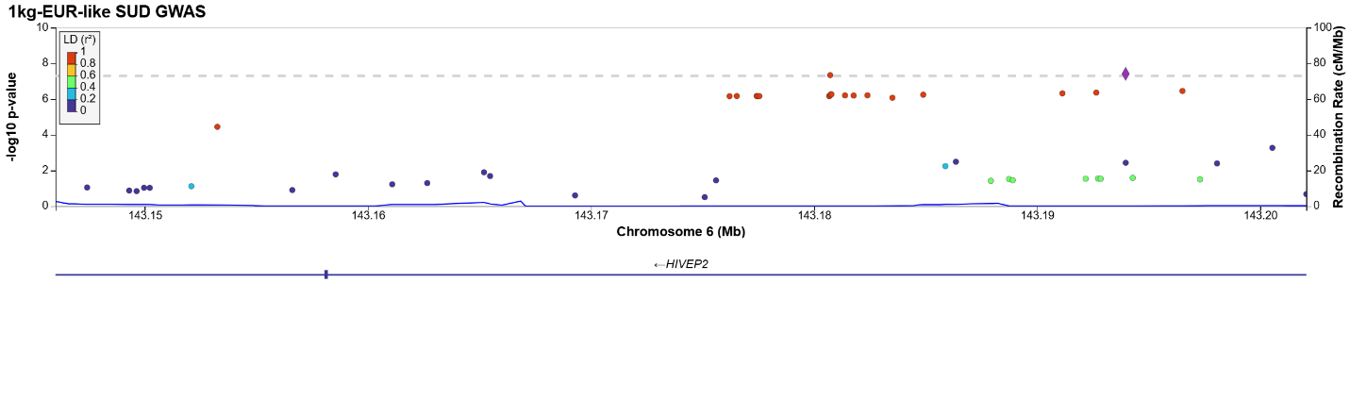
Locus 102:
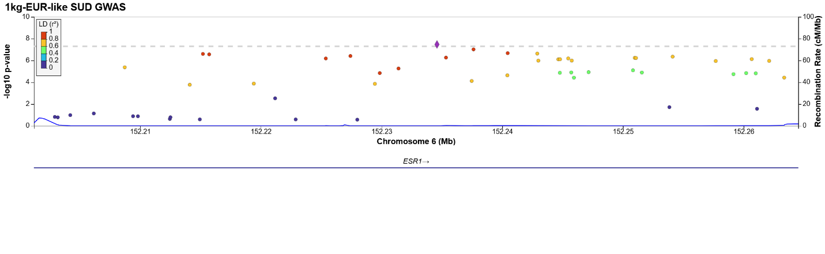
Locus 103:
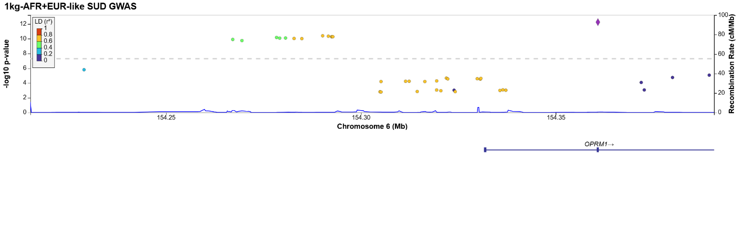
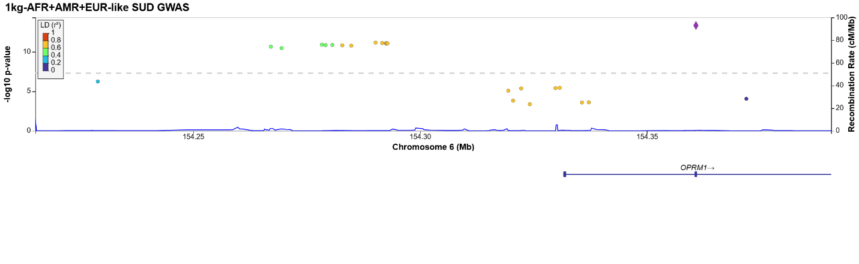
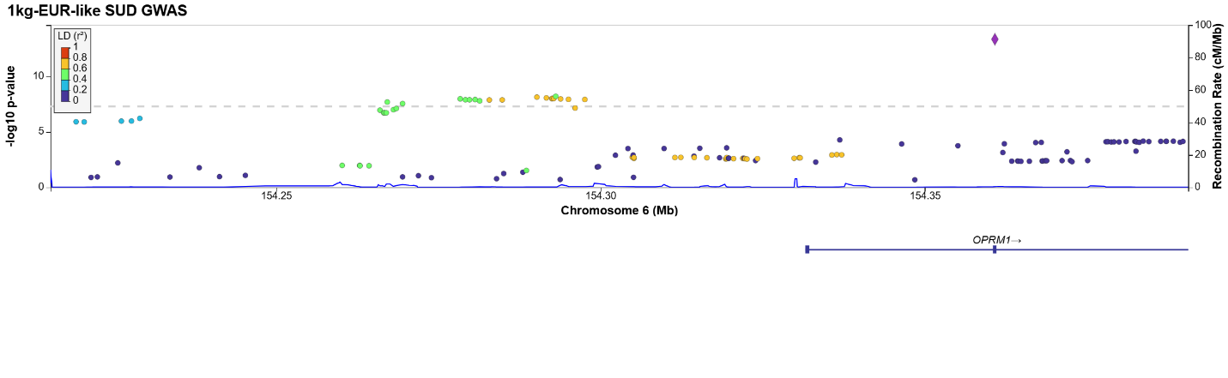
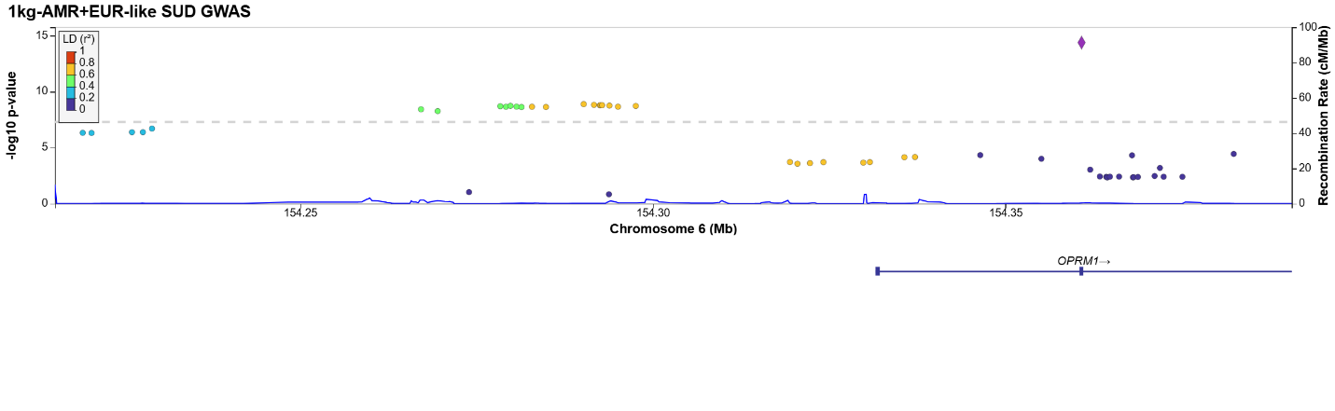
Locus 104:
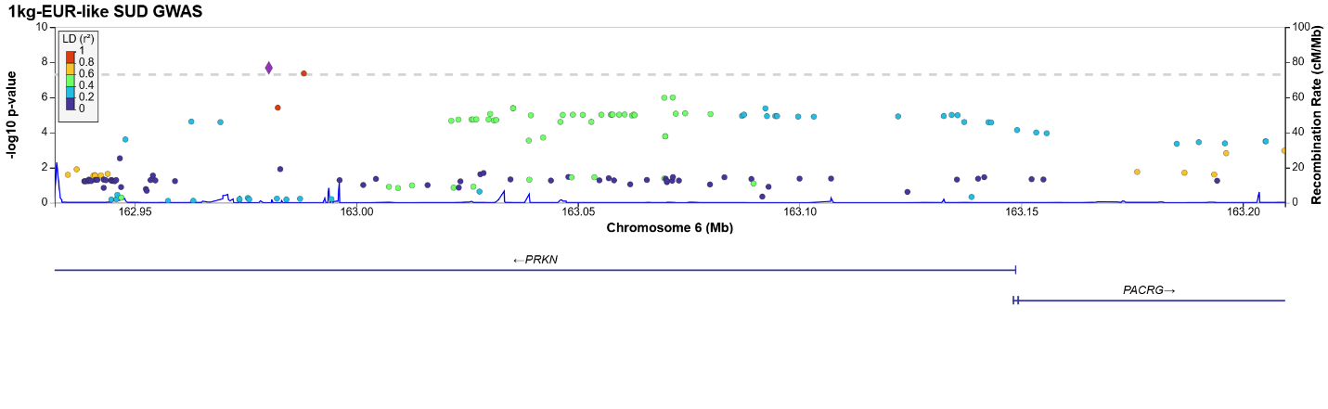
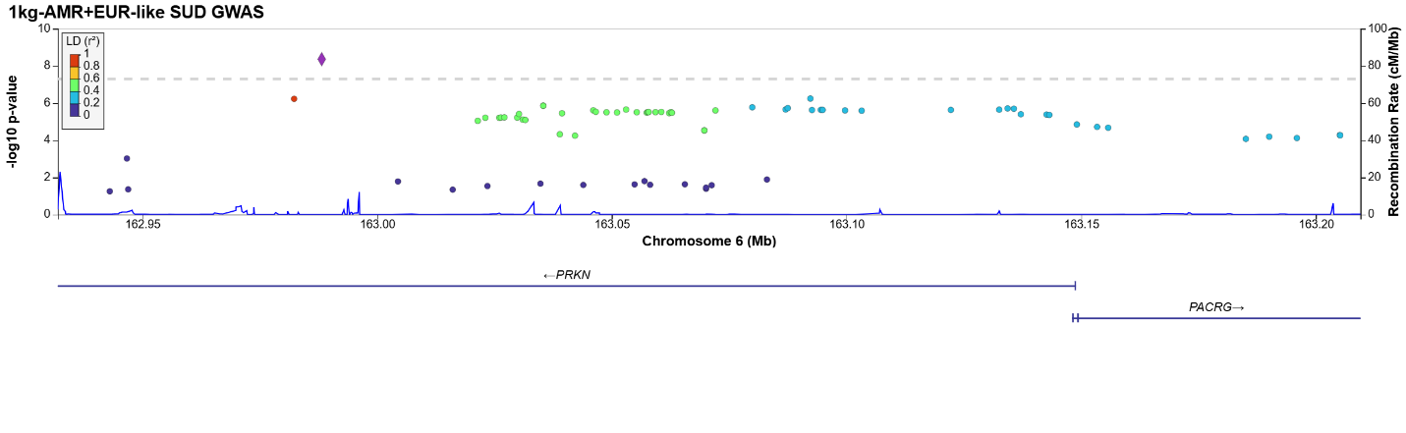
Locus 105:
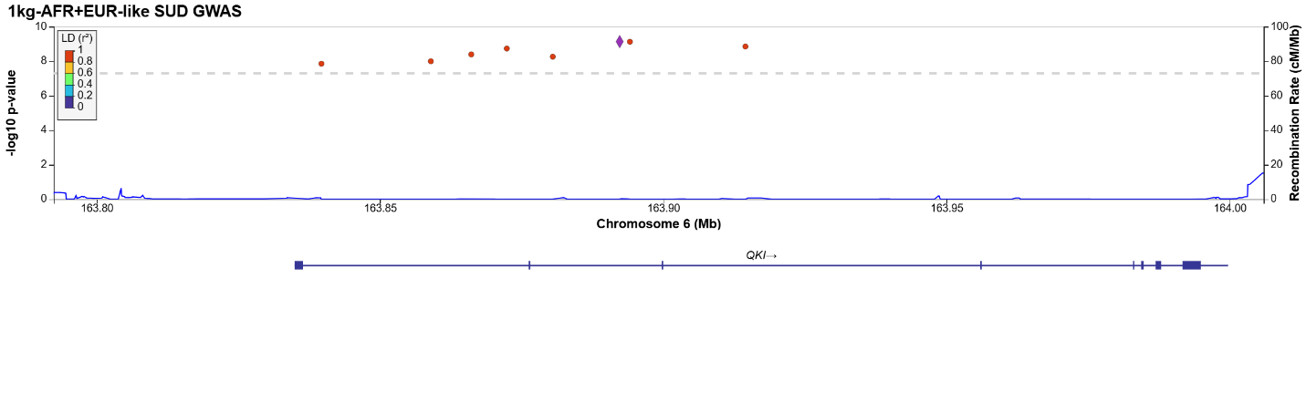
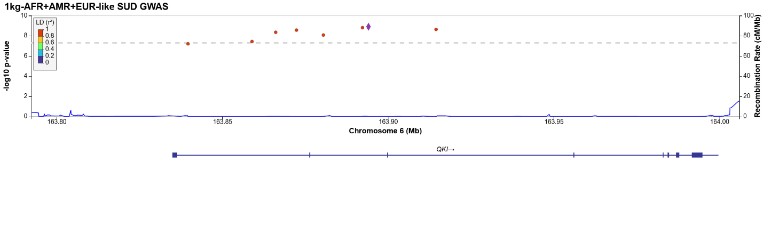
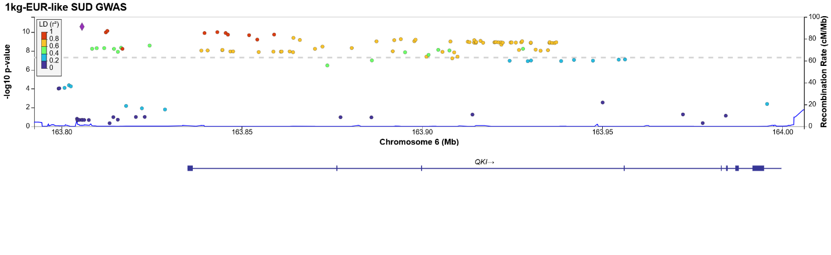
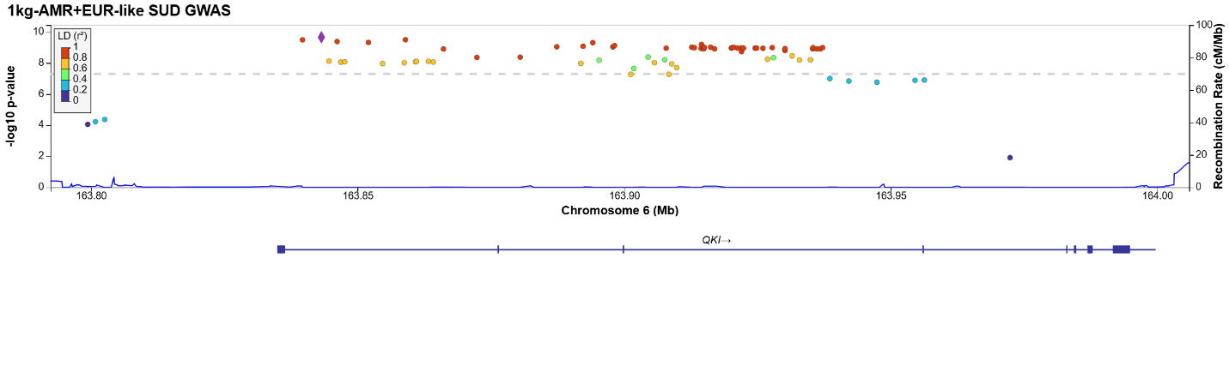
Locus 106:
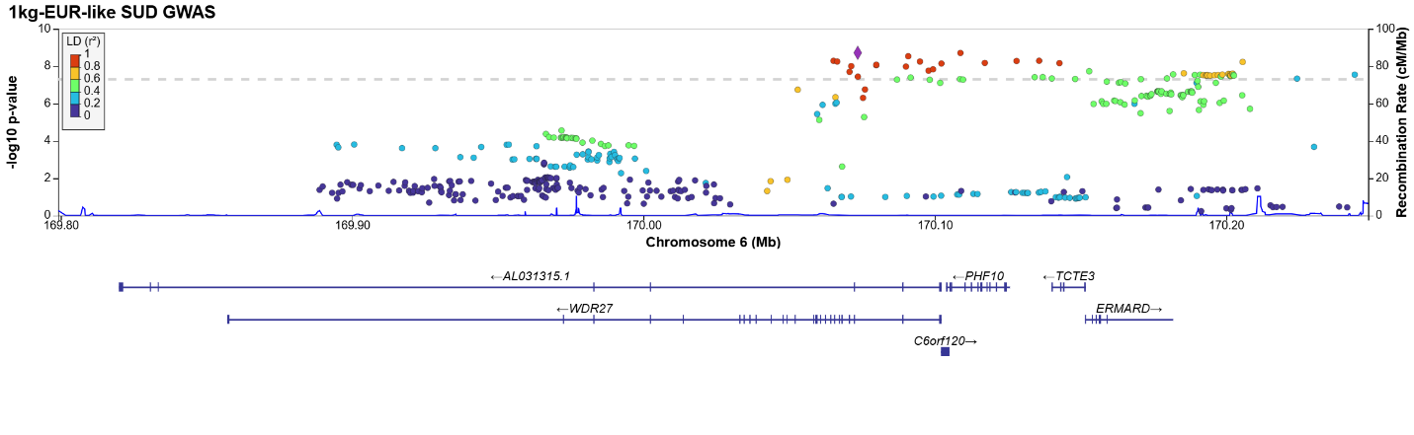
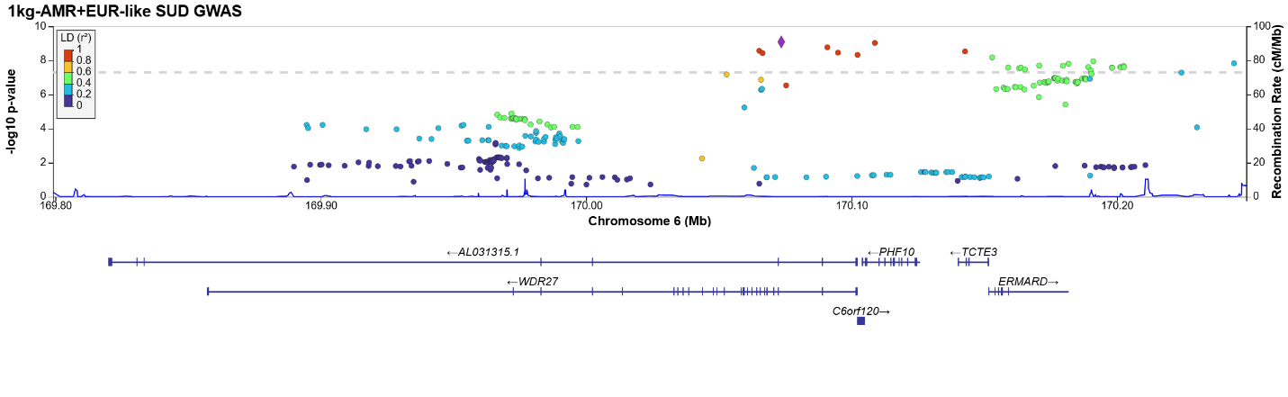
Locus 107:
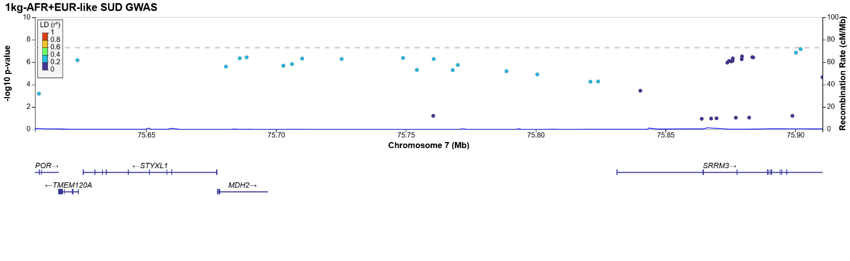
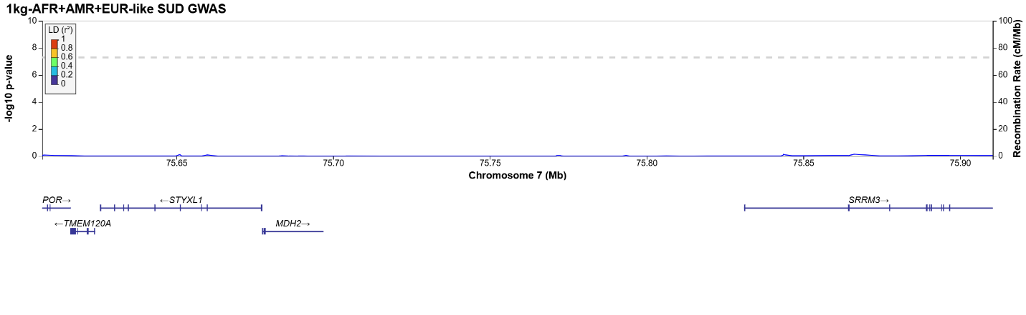
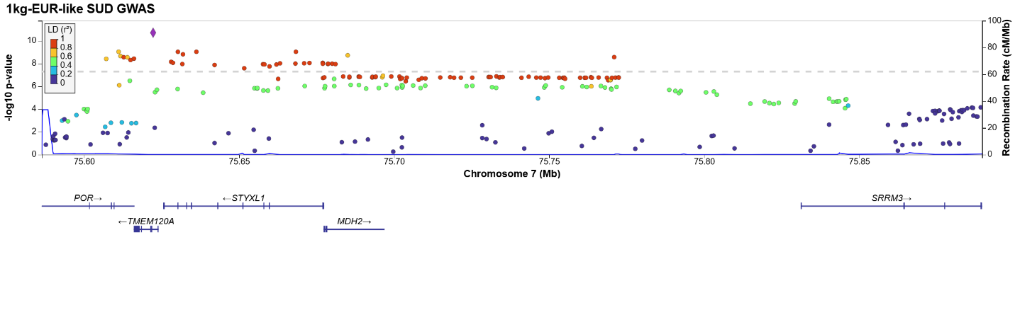
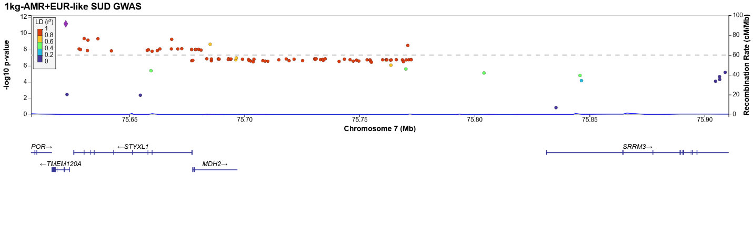
Locus 108:
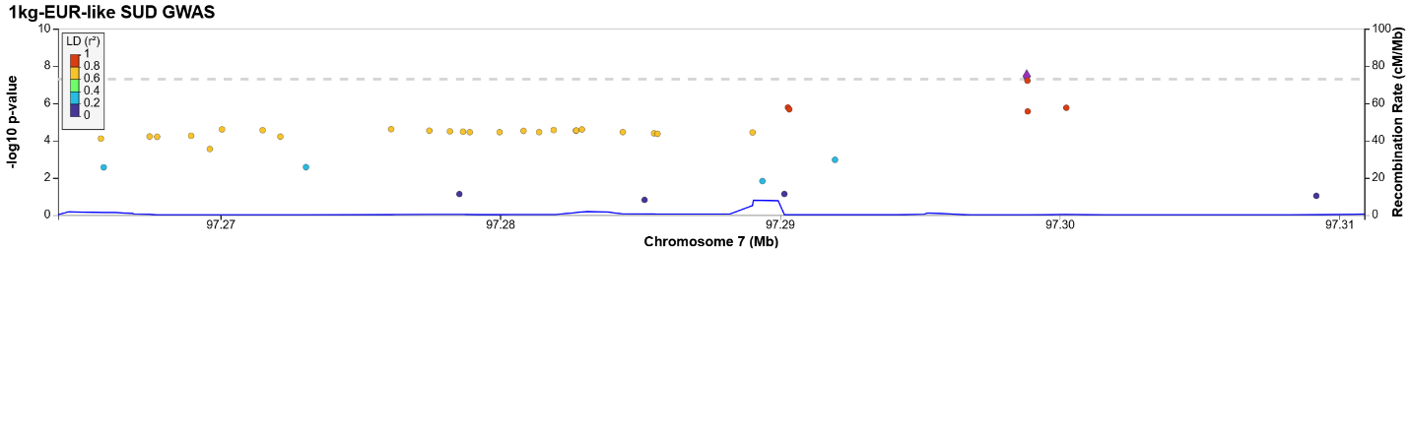
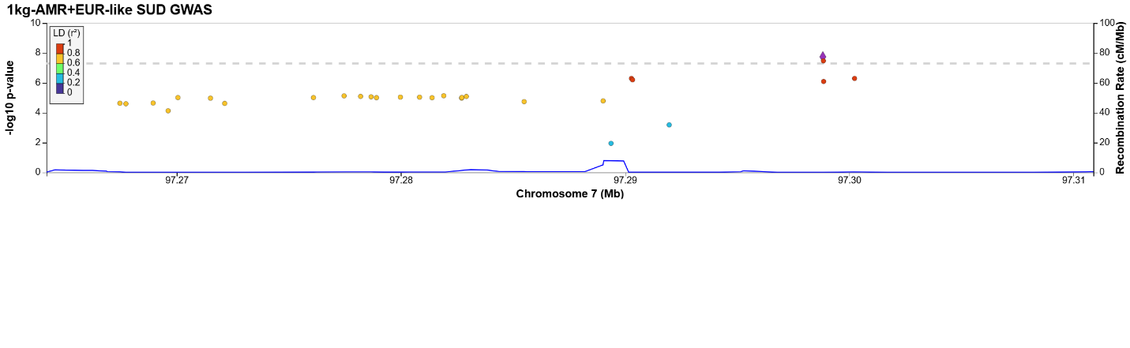
Locus 109:
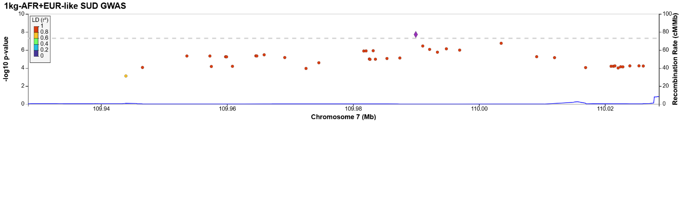
Locus 110:
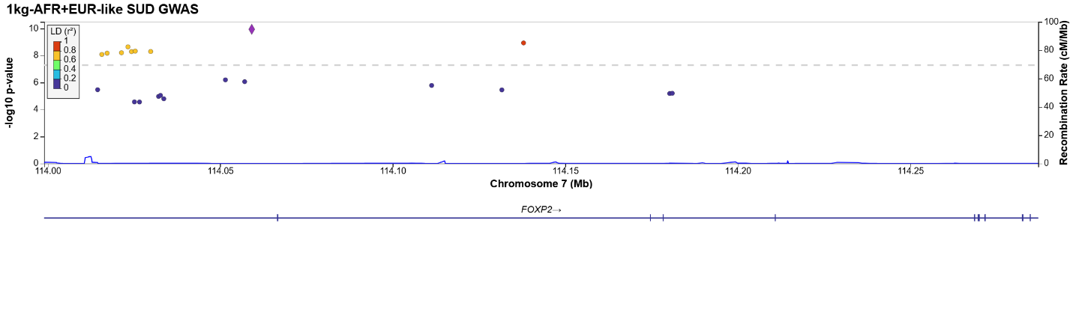
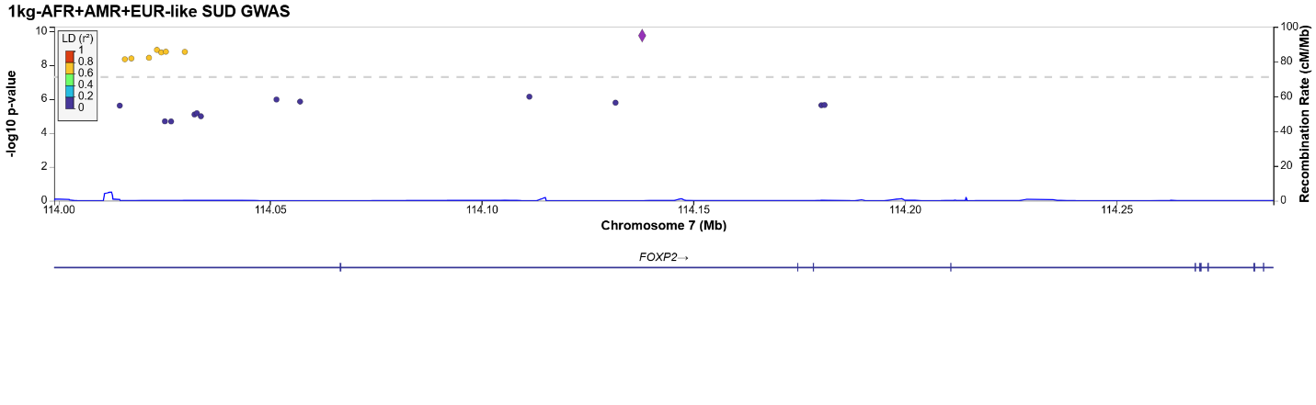
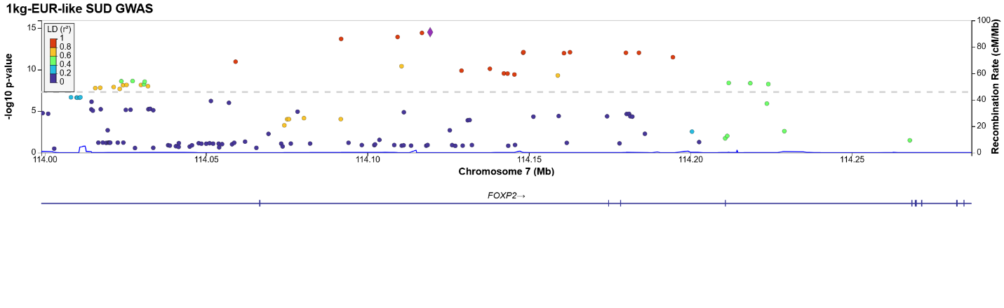
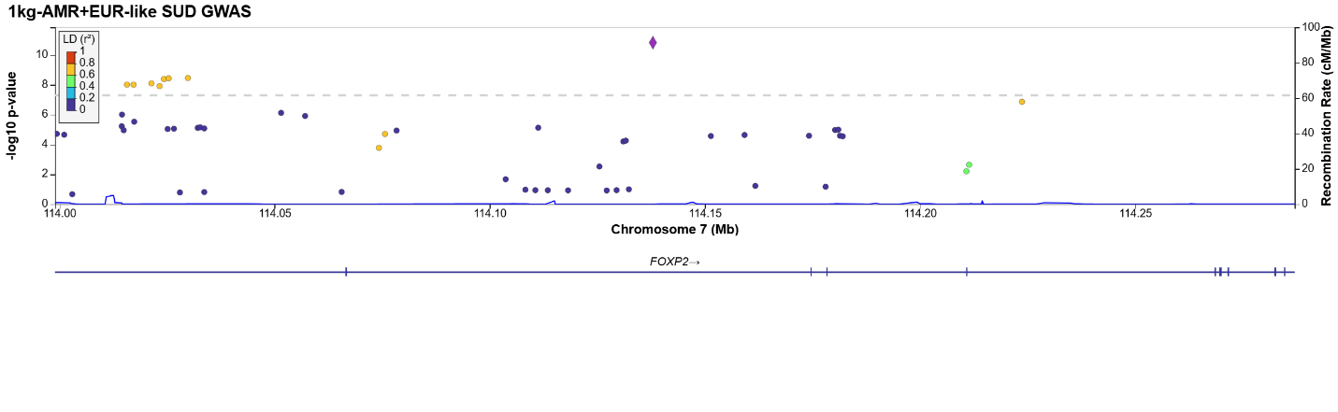
Locus 111:
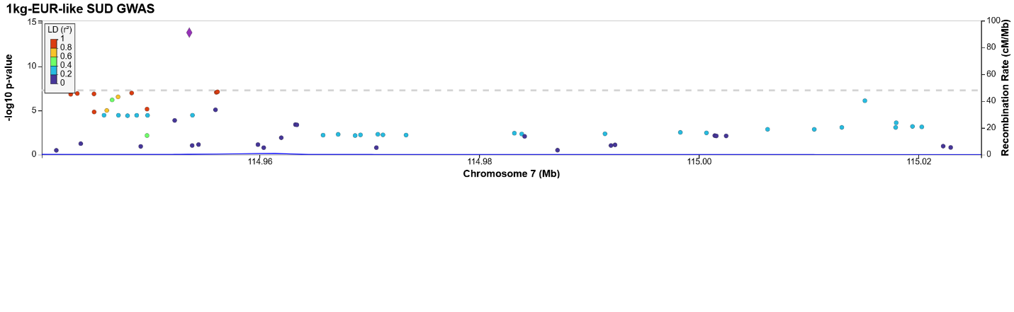
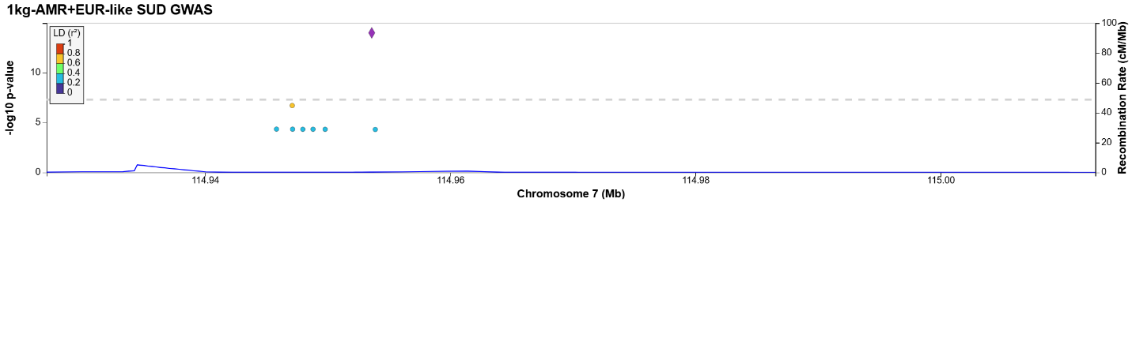
Locus 112:
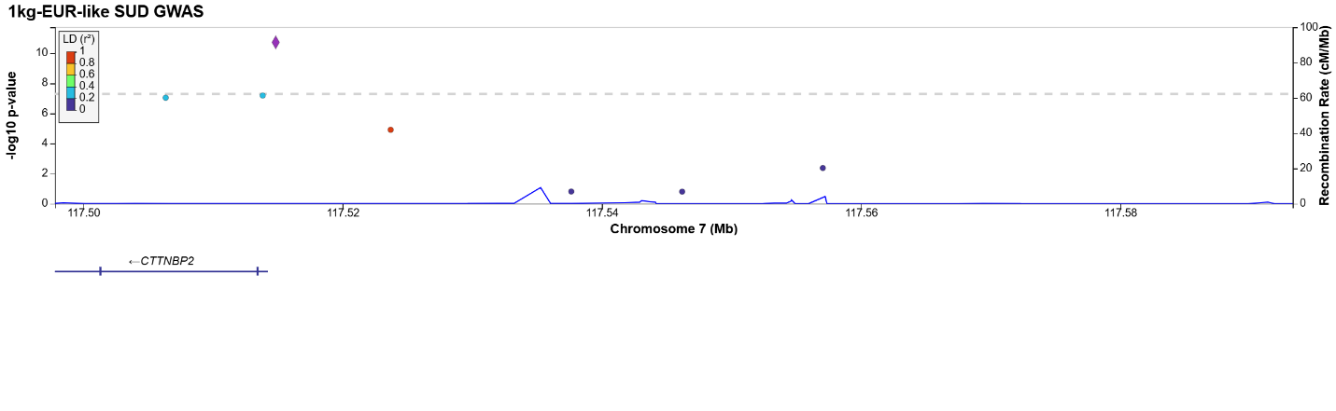
Locus 113:
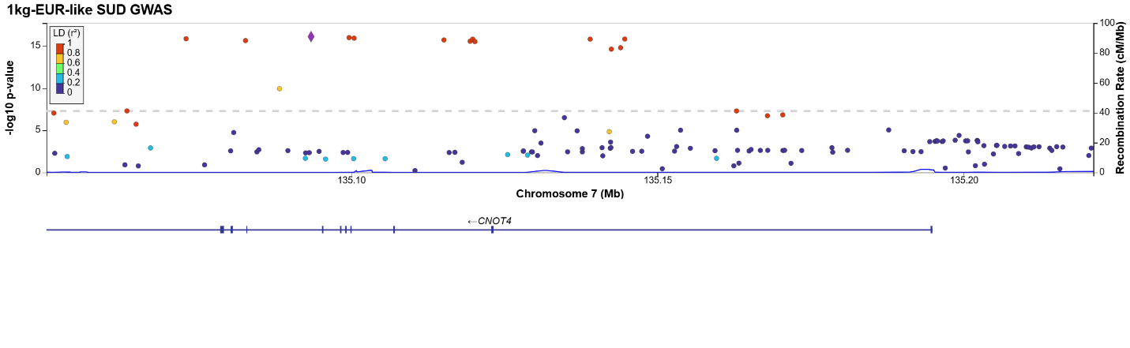
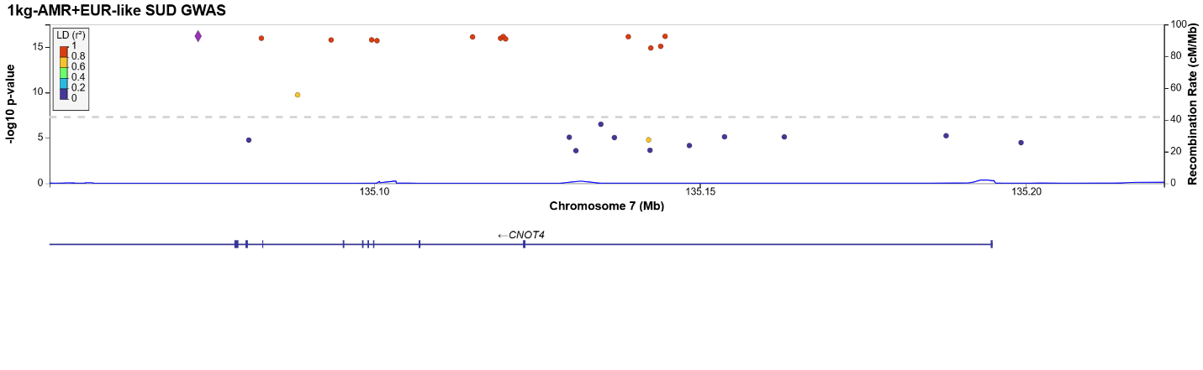
Locus 114:
Locus 115:
Locus 116:
Locus 117:
Locus 118:
Locus 119:
Locus 120:
Locus 121:
Locus 122:
Locus 123:
Locus 124:
Locus 125:
Locus 126:
Locus 127:
Locus 128:
Locus 129:
Locus 130:
Locus 131:
Locus 132:
Locus 133:
Locus 134:
Locus 135:
Locus 136:
Locus 137:
Locus 138:
Locus 139:
Locus 140:
Locus 141:
Locus 142:
Locus 143:
Locus 144:
Locus 145:
Locus 146:
Locus 147:
Locus 148:
Locus 149:
Locus 150:
Locus 151:
Locus 152:
Locus 153:
Locus 154:
Locus 155:
Locus 156:
Locus 157:
Locus 158:
Locus 159:
Locus 160:
Locus 161:
Locus 162:
Locus 163:
Locus 164:
Locus 165:
Locus 166:
Locus 167:
Locus 168:
Locus 169:
Locus 170:
Locus 171:
Locus 172:
Locus 173:
Locus 174:
Locus 175:
Locus 176:
Locus 177:
Locus 178:
Locus 179:
Locus 180:
Locus 181:
Locus 182:
Locus 183:
Locus 184:
Locus 185:
Locus 186:
Locus 187:
Locus 188:
Locus 189:

Locus 190:
Locus 191:
Locus 192:
Locus 193:
Locus 194:
Locus 195:
Locus 196:
Locus 197:
Locus 198:
Locus 199:
Locus 200:
Locus 201:
Locus 202:
Locus 203:
Locus 204:
Locus 205:
Locus 206:
Locus 207:
Locus 208:
Locus 209:
Locus 210:
Locus 211:
Locus 212:
Locus 213:
Locus 214:
Locus 215:
Locus 216:
Locus 217:
Locus 218:
Locus 219:
Locus 220:

Supplemental Figure 2: Manhattan plots of gene-based analyses. A: 1kg-EUR-like; B: 1kg-AFR-like; C: 1kg-AMR-like; D: meta-analysis of 1kg-AFR-like and 1kg-EUR-like; E: meta-analysis of 1kg-EUR-like and 1kg-AMR-like; F: meta-analysis of 1kg-AFR-like, 1kg-EUR-like, and 1kg-AMR-like.
A: 1kg-EUR-like
B: 1kg-AFR-like
C: 1kg-AMR-like
D: meta-analysis of 1kg-AFR-like and 1kg-EUR-like
E: meta-analysis 1kg-EUR-like and 1kg-AMR-like
F: meta-analysis of 1kg-AFR-like, 1kg-EUR-like, and 1kg-AMR-like

