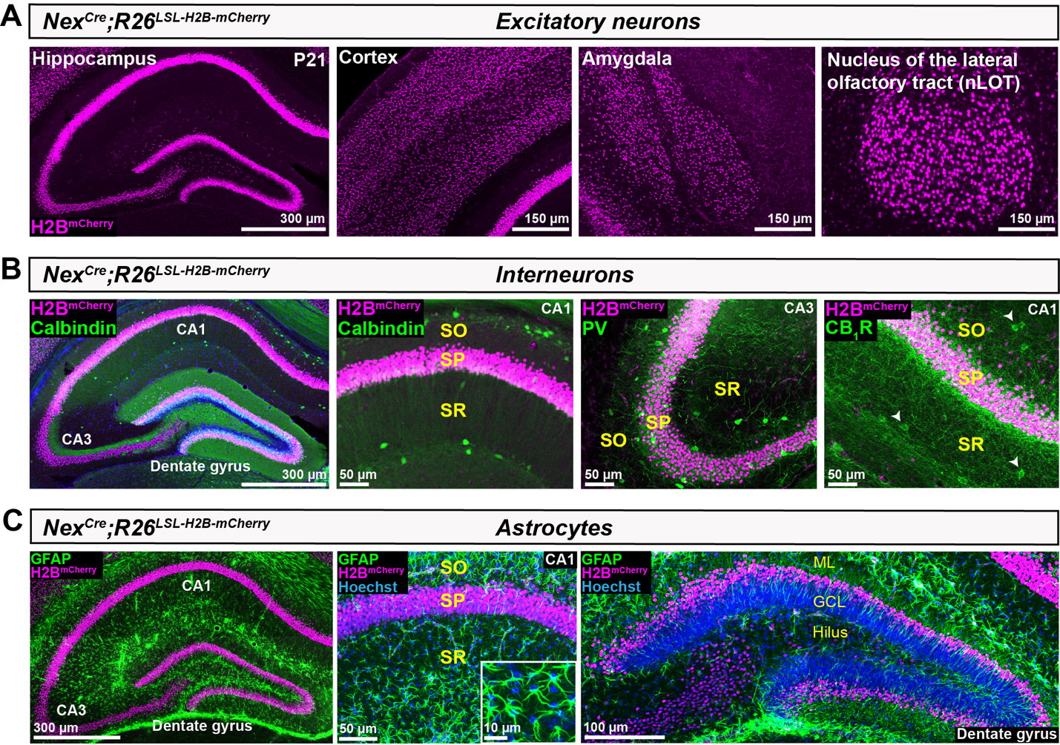
Figure S1. Nex^{Cre} drives recombination in forebrain pyramidal neurons but not interneurons or glia. (A) Coronal sections from Nex^{Cre};R26^{LSL-H2B-mCherry} reporter mice at P21 show mCherry+ nuclei (magenta) of pyramidal neurons in the hippocampus, cortex, amygdala, and nucleus of the lateral olfactory tract (nLOT). (B) Hippocampal sections from Nex^{Cre};R26^{LSL-H2B-mCherry} reporter mice immunostained for interneuron markers (green) Calbindin (left panels), Parvalbumin (middle panel), and CB₁R (right panel) show no overlap of interneuron cell bodies with mCherry+ nuclei. White arrowheads indicate CB₁R+ cell bodies. SO, stratum oriens; SP, stratum pyramidale; SR, stratum radiatum. (C) The astrocyte marker GFAP (green) shows no overlap with mCherry+ nuclei in the hippocampal CA regions or dentate gyrus (left and middle panels). Inset (middle panel) shows a magnified view of astrocyte nuclei (blue). mCherry+ nuclei occupy the outer third of the dentate gyrus granule cell layer (right panel). ML, molecular layer; GCL, granule cell layer.

