Supplementary Material
Enzymatic Degradation of Aromatic and Aliphatic Polyesters by P. pastoris expressed Cutinase 1 from Thermobifida cellulosilytica
Caroline Gamerith¹, Marco Vastano^{2,3}, Sahar Masoumeh Ghorbanpour², Sabine Zitzenbacher^{1,a}, Doris Ribitsch^{1,2}, Michael T. Zumstein⁴, Michael Sander⁴, Enrique Herrero Acero^{1,b}, Alessandro Pellis^{2,*}, Georg M. Guebitz^{1,2}
¹Austrian Centre of Industrial Biotechnology (ACIB), Tulln, Austria
² Institute of Environmental Biotechnology, University of Natural Resources and Life Sciences Vienna, Tulln, Austria
³ Universita degli Studi di Napoli Federico II, Dipartimento di Scienze Chimiche, Napoli, Italia
⁴ Institute of Biogeochemistry and Pollutant Dynamics, ETH Zurich, Zurich, Switzerland
ª present address: Richard Bittner AG, Feldkirchen, Austria
^{b} present address: Glanzstoff Industries GmbH, St.Poelten, Austria
* Correspondence:
Alessandro Pellis Ph.D.
alessandro.pellis@boku.ac.at

Supplementary Figures
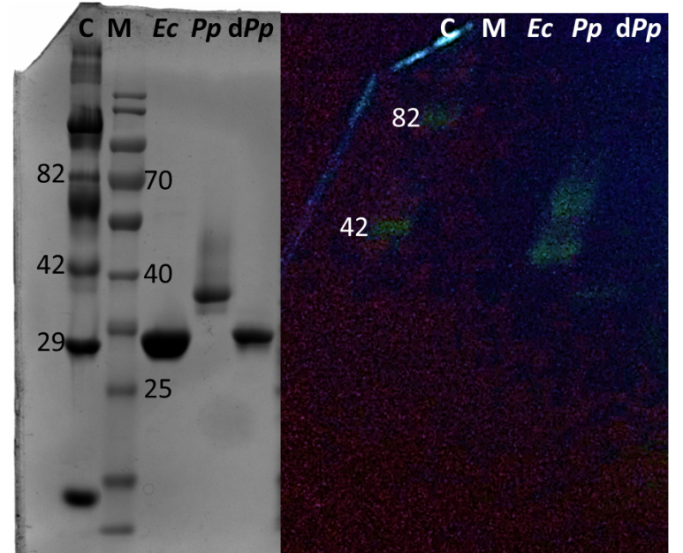
Figure S1. Glycostain gel analysis of E. coli and P. pastoris expressed Thc_Cut1. Left= SDS PAGE gel, Right= Glycostain gel; same samples were applied on both gels; C= Candy cane protein marker; M= peqGold protein marker IV; Ec= E. coli expressed Thc_Cut1; Pp= P. pastoris expressed Thc_Cut1; dPp= P. pastoris expressed Thc_Cut1 deglysolyated with Endo Hf.

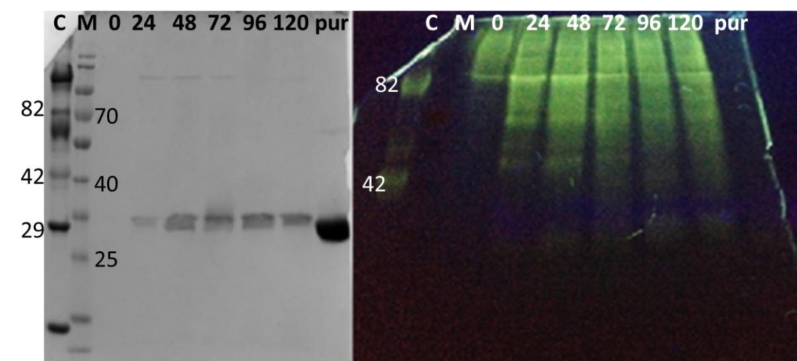
Figure S2. SDS-PAGE (12%) (left) and Glycostain gel (right) of P. pastoris fermentation supernatant samples withdrawn at different time points after induction during expression of Thc_Cut1_koST. C= Candy cane protein marker, M= peqGold protein marker IV, #= time after induction in h, pur= ÄKTA purified enzyme.
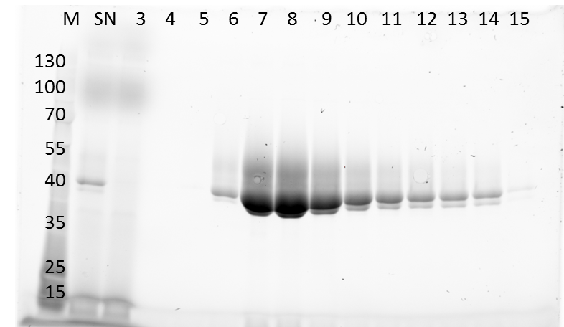
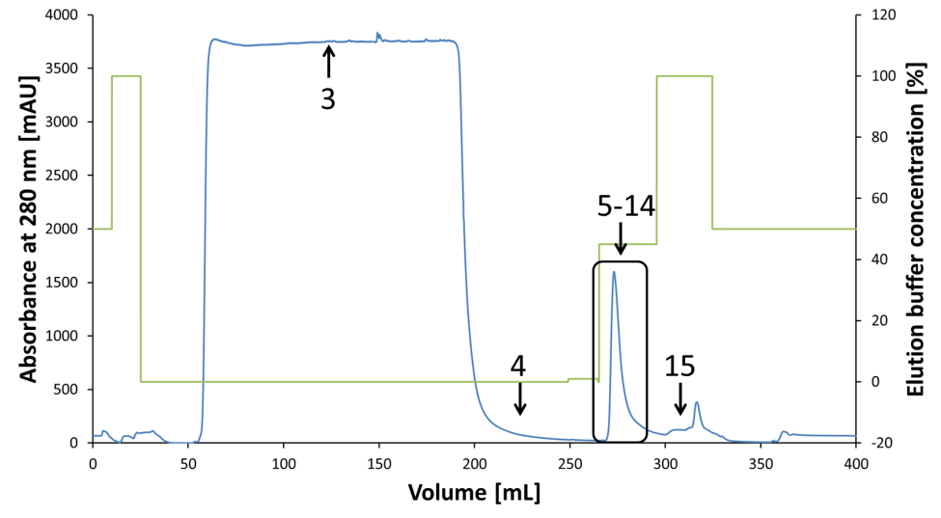
Figure S3. Purification of Thc_Cut1. Top: IMAC chromatogram, blue= absorbance at 280nm [mAU], green= elution buffer concentration [%]; Bottom: SDS-PAGE (12%) of fractions during purification; M= peqGold protein marker IV, SN= supernatant before purification, #= fractions according to chromatogram above.
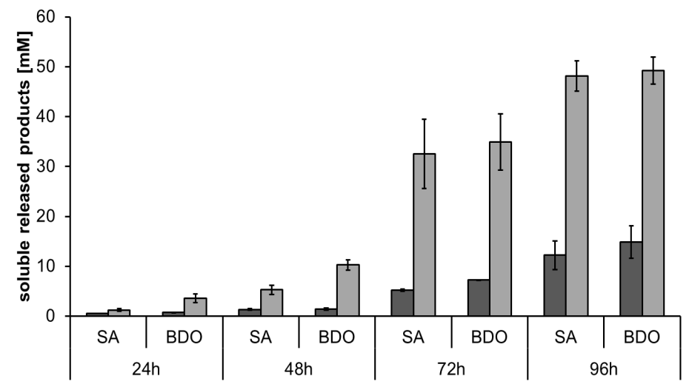
Figure S4. Concentrations of soluble released products succinic acid (SA) and 1,4-butanediol (BDO) upon enzymatic hydrolysis of PBS films by Thc_Cut1 (dark grey bars) and Thc_Cut1_ko_ST (middle grey bars). Time scan for 24, 48, 72 or 96 h was performed at 65 °C with 5 µM enzyme in 1 M KPi pH 8.0 with 0.5 x 1.0 cm PBS films at 100 rpm

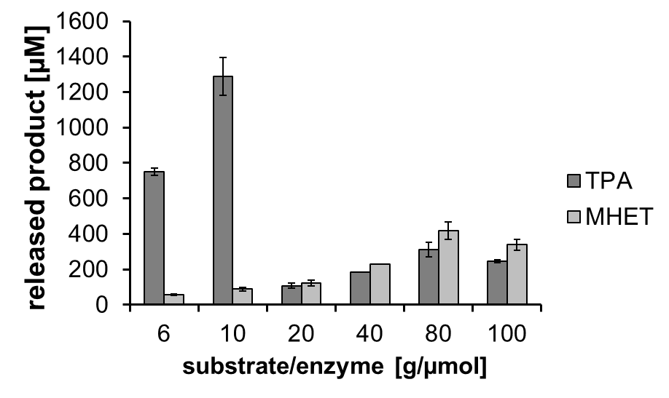
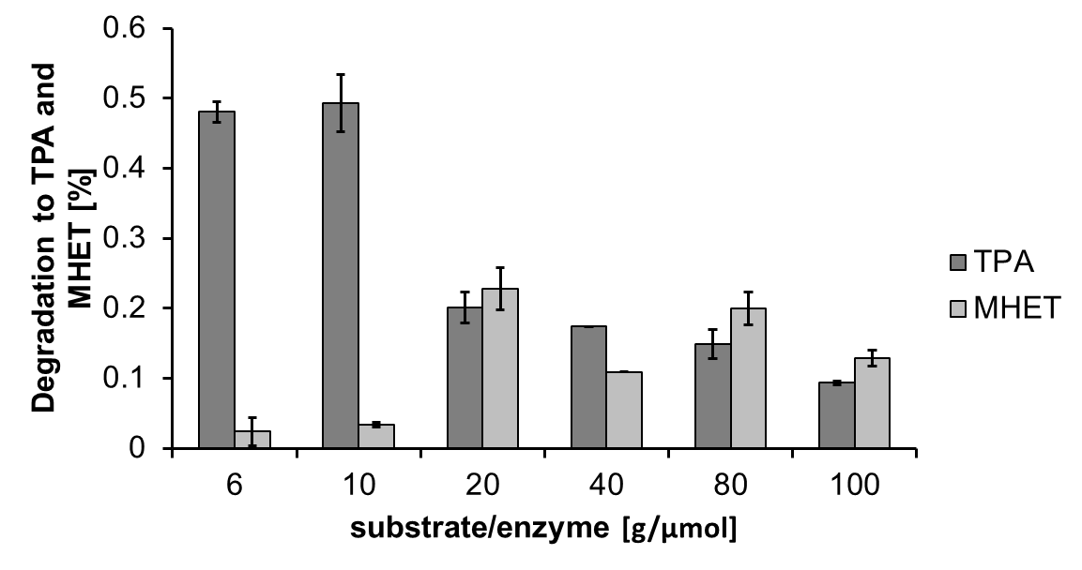
Figure S5. Concentrations (top) and percentage of degradation (bottom) to soluble released products terephthalic acid (TPA) (dark grey bars) and mono(2-hydroxyethyl) terephthalate (MHET) (light grey bars) upon enzymatic hydrolysis of PET powder by Thc_Cut1. Hydrolysis was performed for 24 h at 60 °C in 100 mM KPi pH 7.0 using different substrate-enzyme ratios at 300 rpm.

