Supplementary Material

Supplementary Tables

Spectrophotometric quantification of total triterpenes
Table S1. Analysis of variance (ANOVA) for the linear regression model used in the spectrophotometric quantification of total triterpenes.
Source | df | SS | MS | F
Regression | 1 | 6.5331 | 6.5331 | 3779.2561
Residual | 13 | 0.0224 | 0.0017
Total | 15 | 6.5555

Gastric Emptying Assay
Table S2. One-way ANOVA for the gastric emptying assay.
Source | SS | df | MS | F | P
Treatment | 2948 | 4 | 737.1 | 5.647 | 0.0024
Residuals | 3133 | 24 | 130.5

Table S3. Post hoc analysis (Dunnett's test) results for the gastric emptying experiment.
Comparison | Mean  difference | 95% CI  of difference | Standard Error | t | Adjusted P
V vs. CEECs 25 mg∙kg⁻¹ | 16.04 | -1.229 to 33.31 | 6.596 | 2.4314 | 0.0740
V vs. CEECs 50 mg∙kg⁻¹ | 25.00 | 7.731 to 42.27 | 6.596 | 3.7897 | 0.0033
V vs. CEECs 100 mg∙kg⁻¹ | 15.64 | -1.629 to 32.91 | 6.596 | 2.3707 | 0.0838
V vs. Loperamide 20 mg∙kg⁻¹ | 29.76 | 11.65 to 47.87 | 6.918 | 4.3020 | 0.0009

Castor oil-induced diarrhea model
Table S4 - Kruskal-Wallis test for the castor oil-induced diarrhea model.
Factor | Statistic (H) | df | P
Treatment | 22.98 | 4 | < 0.001

Table S5. Post hoc analysis (Dunn’s test) for the castor oil-induced diarrhea experiment.
Comparison | Mean rank difference | Adjusted P
V vs. CEECs 25 mg∙kg⁻¹ | 6.833 | 0.6721
V vs. CEECs 50 mg∙kg⁻¹ | 18.50 | 0.0008
V vs. CEECs 100 mg∙kg⁻¹ | 13.67 | 0.0233
V vs. Loperamide 20 mg∙kg⁻¹ | 20.17 | 0.0002

Magnesium sulfate-induced diarrhea model
Table S6. One-way ANOVA for the magnesium sulfate-induced diarrhea model.
Source | SS | df | MS | F | P
Treatment | 1.054 | 4 | 0.2635 | 8.419 | 0.0003
Residuals | 0.6886 | 22 | 0.03130

Table S7. Post hoc analysis (Dunnett's test) results for magnesium sulfate-induced diarrhea model.
Comparison | Mean  difference | 95% CI  of difference | Standard Error | t | Adjusted P
V vs. CEECs 25 mg∙kg⁻¹ | 0.0057 | -0.2879 to 0.2992 | 0.1119 | 0.0506 | > 0.9999
V vs. CEECs 50 mg∙kg⁻¹ | 0.1816 | -0.1120 to 0.4751 | 0.1119 | 1.6227 | 0.3201
V vs. CEECs100 mg∙kg⁻¹ | 0.1472 | -0.1339 to 0.4283 | 0.1071 | 1.3742 | 0.4590
V vs. Loperamide 20 mg∙kg⁻¹ | 0.5298 | 0.2488 to 0.8109 | 0.1071 | 4.9459 | 0.0002

Ethanol-induced gastric ulcer model
Table S8. Kruskal-Wallis test for the ethanol-induced gastric ulcer model.
Factor | Statistic (H) | df | P
Treatment | 13.75 | 4 | 0.0081

Table S9. Post hoc analysis (Dunn’s test) for the ethanol-induced gastric ulcer model.
Comparison | Mean rank difference | Adjusted P
V vs. CEECs 25 mg∙kg⁻¹ | 7.167 | 0.5250
V vs. CEECs 50 mg∙kg⁻¹ | 14.50 | 0.0484
V vs. CEECs 100 mg∙kg⁻¹ | 14.30 | 0.0164
V vs. Omeprazole 20 mg∙kg⁻¹ | 15.50 | 0.0045

Supplementary Figures
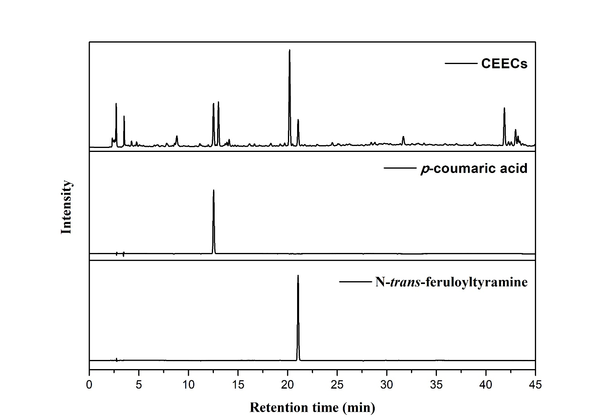
Supplementary Figure 1. Original HPLC chromatograms of the crude ethanolic extract of Cannabis sativa roots (CEECs) and of the individual reference standards analyzed under identical chromatographic conditions. The chromatograms correspond to the full, uncropped data used to generate the representative sections shown in Figure 2 of the main manuscript.

