Figure S1
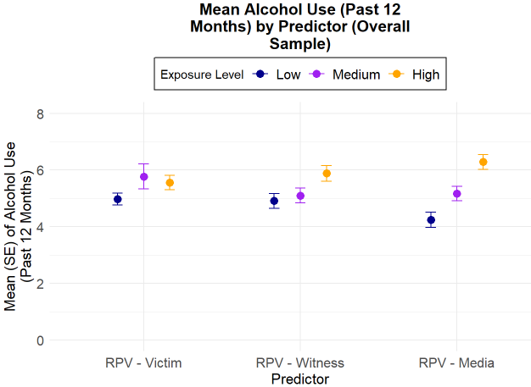
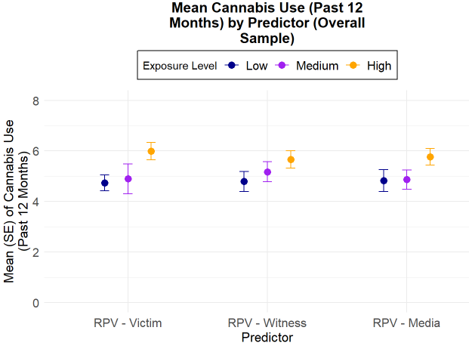
Substance Use Outcomes by Type of Lifetime Exposure to Racism-Based Police Violence
a
a
$η^{2}$= .0061
(small effect)
$η^{2}$= .0103
(medium effect)
$η^{2}$= .0396
(medium effect)
a
a
a
Note. RPV = racism-based police violence

$η^{2}$= .0188
(medium effect)
$η^{2}$= .0070
(small effect)
$η^{2}$= .0110
(medium effect)

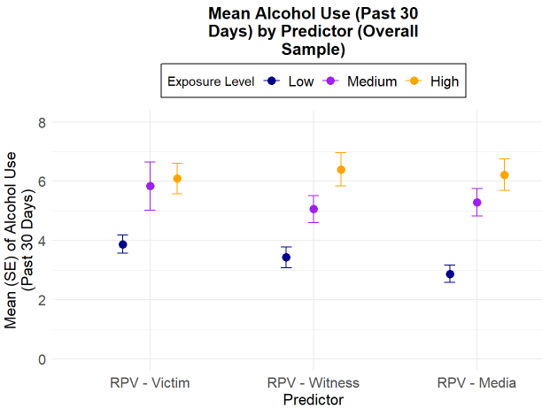
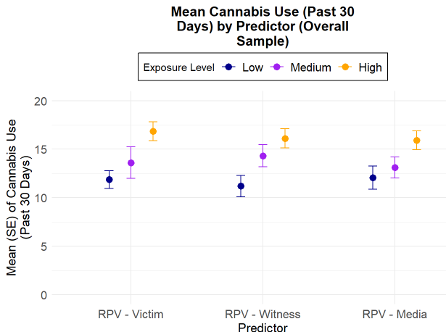
a
a
a
$η^{2}$= .0268
(medium effect)
$η^{2}$= .0343
(medium effect)
$η^{2}$= .0438
(medium effect)
a

$η^{2}$= .0179
(medium effect)
$η^{2}$= .0267
(medium effect)
$η^{2}$= .0340
(medium effect)

Note. RPV = Racism-based police violence

ª Significant ANOVA result (p < .05).

