Supplementary Information For
Addictive plasmids drive hospital transmission of mupirocin-resistant Staphylococcus aureus
Magdalena Podkowik,^{a,b,c} Ananyaa R Welling,^{b} Somrita Dey,^{a,c} Alice Tillman,^{b,c} Gregory Putzel,^{b,c} Courtney Takats,^{b,c}, Julian McWilliams,^{b,c} Stacey Bartlett,ª Nora Samhadaneh,^{b,c} Robert J. Ulrich,^{a,c} Kristine Rabii,^{d} Olufolakemi Olusanya,^{b,c} Caitlin Otto,^{e} Karl Drlica,^{f,g} Mila B. Ortigoza,^{a,b} Audrey Renson,^{d} Alejandro Pironti,^{b,c} Sarah Hochman,^{a,c} Bo Shopsin^{a,b,c}

ªDepartment of Medicine, Division of Infectious Diseases, NYU Grossman School of Medicine, New York, NY, USA;
^{b}Department of Microbiology, NYU Grossman School of Medicine, New York, NY, USA;
^{c}Antimicrobial-Resistant Pathogens Program, NYU Grossman School of Medicine, New York, NY, USA;
^{d}Department of Population Health, NYU Grossman School of Medicine, New York, NY, USA;
^{e}Clinical Microbiology and Diagnostic Immunology, NYU Grossman School of Medicine, New York, NY, USA;
^{f}Public Health Research Institute, New Jersey Medical School, Rutgers University, Newark, NJ, USA;
^{g}Department of Microbiology, Biochemistry & Molecular Genetics, New Jersey Medical School, Rutgers University, Newark, NJ, USA.

This file includes:

Supplementary Information text (Methods)
Supplementary Figures (S1 to S7)
Fig. S1. Structural comparison of major mupA-containing plasmid groups identified in the surveillance cohort
Fig. S2. Dated phylogeny of the E499 ileS1 truncation lineage.
Fig. S3. Effect of mupirocin on growth of mupA-containing strains with and without chromosomal ileS1 inactivation
Fig. S4. Daily colonization and transmission kinetics in the neonatal murine model.
Fig. S5. Effect of the ileS1 inactivation (‘addiction’) on colonization and transmission in a neonatal murine model
Fig. S6. Expression of selected stringent response–associated genes in mupA plasmid-containing and addicted strains
Fig. S7. Schematic representation of exogenous isoleucine synergizing with mupirocin to inhibit growth of mupA-containing strains under branched-chain amino acid (BCAA)-limited conditions.

Supplementary Tables (S1 to S6)
Table S1: Characteristics of patients harboring mupA-positive and mupA-negative S. aureus isolates
Table S2: Crude and adjusted transmission rate differences associated with mupA carriage
Table S3: Association between mupA carriage and transmission across MRSA clonal complexes and MSSA
Table S4. Bacterial strains used in the study
Table S5. Oligonucleotides used in the study
Table S6. S. aureus strains subjected to long-read sequencing and hybrid genome assembly for plasmid characterization.

References for SI citations
Supplementary Information Text (Methods)

Bacterial strains, plasmids, primers and growth conditions

S. aureus strains, plasmids, and primers used in the study are described in Supplementary Data (Tables 4 and 5). Bacterial cells were grown in tryptic soy broth (TSB), Luria-Bertani broth (LB; for E.coli) or RPMI at 37ºC or at 28 ºC with orbital shaking at 180 rpm. Colony formation was on tryptic soy agar (TSA) with or without defibrinated sheep blood, or Luria-Bertani Agar (LB) incubated at 37ºC, 30ºC or 28ºC. Where indicated, media were supplemented with chloramphenicol (15 μg/mL), mupirocin (30–250 μg/mL), cadmium chloride (0.3 mM), or isoleucine (15 μM to 10 mM).

For growth curve analysis, overnight cultures grown in TSB were diluted 1:1,000 in TSB, Roswell Park Memorial Institute medium (RPMI; Gibco, Thermo Fisher, Waltham, MA, # 11879020) or branched-chain-amino acid-deficient RPMI (US Biological, Salem, MA, #R8999). Growth was monitored at 37°C in 96-well plates (100 μL/well) with orbital shaking at 500 rpm, using BioTek LogPhase 600 microbiology reader (Agilent, Santa Clara, CA), measuring OD₆₀₀ at 40-minute intervals. Data represent the mean of three biological replicates; each performed with at least 3 three technical replicates.

Relacin growth assays

Relacin (1PlusChem LLC, San Diego, CA) was dissolved in DMSO to prepare a 500 mM stock solution. Overnight cultures were diluted 1:1000 into TSB with or without relacin (8 mM). Growth was monitored at 37°C in 96-well plates (100 μL per well) using a BioTek LogPhase 600 microbiology reader (Agilent, Santa Clara, CA, USA). Optical density (OD₆₀₀) was measured at 20-min intervals. Growth curves were performed using wild-type, plasmid-carrying (pMP1), and addicted (ileS1 Q299*) strains under identical conditions.

Isoleucine-mediated sensitization assays

To assess whether exogenous isoleucine altered susceptibility of mupA-containing strains to mupirocin, overnight cultures grown in TSB were diluted 1:1000 into branched-chain amino acid–deficient RPMI medium (US Biological, #R8999) supplemented with mupirocin (100 μg/mL) and/or isoleucine (15 or 30 μM). Branched-chain amino acid–deficient RPMI without supplementation was used for growth-control wells. Growth was monitored at 37°C in 96-well plates (100 μL per well) with orbital shaking (500 rpm) using a BioTek LogPhase 600 microbiology reader (Agilent). Optical density at 600 nm (OD₆₀₀) was measured at 40-min intervals.

Antimicrobials and chemicals

Antimicrobials, chemicals, and reagents were obtained from MilliporeSigma (Burlington, MA), Thermo Fisher Scientific (Waltham, MA), US Biological (Salem, MA), New England Biolabs (NEB; Ipswich, MA), 1PlusChem LLC (San Diego, CA) and Biomerieux (Durham, NC).

Bacterial disinfectant killing assays

To measure lethal action, overnight cultures were diluted (OD₆₀₀ ∼ 0.05) in fresh TSB medium and grown with shaking to early exponential (OD₆₀₀ ∼ 0.15) phase, and treated with 20% ethyl alcohol (EtOH), 13% 2-propanol, or 20 mM H₂O₂ for the times indicated. At the end of treatment, aliquots were removed, concentrated by centrifugation, serially diluted in phosphate-buffered saline, and plated for determination of viable counts at 24 h. The percent survival was calculated relative to a sample taken at the time of addition of the killing agent.

Construction of mutants
mupA plasmid transconjugants
mupA plasmid pMP1 was transferred from clinical isolate 1394 into laboratory strains LAC Cd^{R} (BS1158), RN4220 + SaPIbov1 (BS1142), and JH1 + pOS1-GFP (BS1951) by conjugation as described.¹ Recipient strains carried antibiotic resistance markers for counter-selection. Following conjugation, donor–recipient mixtures were plated on TSA containing mupirocin and tetracycline (30 μg/mL and 5 μg/mL, respectively) to select RN4220 transconjugants, or mupirocin and chloramphenicol (30 μg/mL and 15 μg/mL, respectively) to select JH1 transconjugants. Direct transfer from the donor strain 1394 to LAC Cd^{R} (BS1158) did not yield detectable transconjugants; therefore, RN4220 + pMP1 was used as an intermediate donor for LAC Cd^{R}, with selection on mupirocin (30 μg/mL) and CdCl₂ (0·3 mM).

The resulting strains, LAC CdR + pMP1 (BS1963) and JH1 + pMP1 (BS2045), were verified by antimicrobial susceptibility testing using Etest gradient strips (BioMérieux) as described.² Strain identities and plasmid content were subsequently confirmed by Oxford Nanopore and Illumina hybrid genome assembly (Plasmidsaurus, Eugene, OR). In BS2045, the multicopy GFP plasmid pOS1 was cured by a single passage on non-selective TSA, followed by screening for loss of GFP fluorescence and chloramphenicol resistance. The resulting cured derivative was re-sequenced by hybrid genome assembly to confirm plasmid loss and the absence of adventitious mutations.

ileS1 Q299 addiction mutant

The ileS1 Q299* mutant (BS2039; pMP1 ileS1 Q299*) was constructed in the LAC derivative BS1963 carrying the native mupA plasmid (pMP1) using allelic replacement with pIMAY-Z, as described by Monk and Stinear.³ pIMAY-Z contains a thermosensitive replicon, chloramphenicol resistance marker, and lacZ reporter for blue-white screening. A 1,103-bp ileS1 fragment carrying the Q299* (STOP) mutation was amplified from clinical isolate 52_054 and cloned into pIMAY-Z using BamHI and EcoRI restriction sites. The resulting construct was introduced into BS1963, and allelic exchange was performed according to the published protocol without modification.³

Measurement of mupA plasmid transfer frequency
Conjugation assays were performed as described.⁴ LAC + pMP1 and LAC + pMP1 ileS1 Q299* served as donors, and a chloramphenicol-resistant LAC derivative served as the recipient. Transconjugants were selected on TSA containing chloramphenicol and mupirocin. Conjugation frequency was calculated as the ratio of transconjugant to donor CFU. Each donor strain was tested in five biological replicates.

Measurement of biofilm formation

Biofilm formation was quantified using a crystal violet assay as previously described.⁵ Twelve-well tissue culture-treated polystyrene plates (Corning, Corning, NY, #CLS3513) were coated with fibrinogen (one mL per well, 100 µg/mL) and incubated overnight. Overnight broth cultures were diluted 1:100 into fresh TSB supplemented with 1% (w/v) glucose and 3% (w/v) NaCl (TSBG), added to 12-well plates (2 mL/well), and incubated statically at 37°C for 24 h. Following incubation, supernatants were discarded and adherent biofilms were washed three times with sterile phosphate-buffered saline (PBS), heat-fixed at 60°C for 1-h and stained with 1% (w/v) crystal violet (200 µL per well) for 10 min at room temperature. Excess stain was removed, and the biofilms were washed three times with PBS. Bound crystal violet was eluted with 2 mL of 33% (v/v) acetic acid incubated for ten min, diluted 1:2 in PBS, transferred to a 96-well flat-bottom, non–tissue culture–treated polystyrene plate (Corning, #CLS3370), and absorbance was measured at 595 nm using

a Synergy Neo2 plate reader (Agilent).

Measurement of gene expression by qRT-PCR
Overnight broth cultures of each bacterial strain were diluted (1:100) into fresh TSB medium supplemented with 1% w/v glucose (TSBG) 3% w/v NaCl, aliquoted into 12-well (2 mL per well) tissue-culture treated polystyrene plates (Corning, #CLS3799), and incubated statically at 37°C for 6 h or 12 h. Supernatants were discarded and biofilms were resuspended in one volume (333 μL) of sterile PBS and added to a 1·5 mL tube containing two volumes (667 μL) of RNAprotect Bacteria Reagent (Qiagen, Hilden, Germany, #76506). Samples were vortexed for 5 seconds, incubated for 5 min at room temperature, then centrifuged at 5,000 x g at 4ºC for 10 minutes.

Gene expression analysis was performed by qRT-PCR as described.⁶ Briefly, RNA was purified from biofilm-grown cells, and cDNA was synthesized using the Maxima First Strand cDNA Synthesis Kit (Thermo Fisher Scientific). Quantitative reverse-transcription PCR was performed using the QuantiNova™ SYBR Green PCR Kit (Qiagen). Primers were synthesized by IDT (Coralville, IA). Three independent biological replicates were analyzed in technical triplicate. Expression levels were normalized to rpoB, and relative gene expression was calculated using the 2^{–∆∆Ct} method.⁷

Measurement of S. aureus colonization and transmission in mice
Neonatal mouse colonization and transmission experiments were performed using a previously described model.⁸ Briefly, pups (four to seven days of age) were intranasally inoculated with 10⁶ CFU of S. aureus (LAC Cd^{R}, LAC Cd^{R} + pMP1, LAC Cd^{R} + pMP1 ileS1 Q299*, JH1, JH1 + pMP1; for strain numbers see Table S4) in three μL sterile phosphate-buffered saline (PBS) without anesthesia to restrict inoculation to the upper respiratory tract (URT). Inoculated (index) pups were immediately returned to their litter and remained cohoused with dam and littermates for the duration of the experiment. Bacterial shedding was assessed daily by gently tapping the nares of each pup 20 times onto CHROMagar plates, which were incubated at 37°C for 24–48 h to detect colonies. Transmission was assessed in contact littermates on days one to seven post-inoculation. At the experimental endpoint, pups and dam were euthanized and URT colonization was quantified by retrograde lavage. Briefly, 300 μL sterile PBS was instilled into the trachea and recovered through the nares. Lavage fluid was serially diluted in sterile PBS and plated on CHROMagar for colony-forming unit (CFU) enumeration. Index-to-contact pup ratios ranged from 1:3 to 1:4. All animal procedures were approved by the NYU Langone Health Institutional Animal Care and Use Committee (IACUC protocol # IA16-01941).

Whole-genome sequencing and analysis
Whole-genome sequencing, assembly, quality control, genotyping, phylogenetic analyses, and transmission inference were performed using methods previously described for the institutional genomic surveillance program.^{9,10} Briefly, genomic DNA was extracted using MagMAX DNA Multi-Sample Ultra 2.0 (Thermo Fisher Scientific), sequenced on an Illumina platform, and assembled following established quality-control procedures. Genomic analyses included assignment of sequence type and clonal complex, detection of mecA and SCCmec type, identification of Panton-Valentine leukocidin (PVL) and arginine catabolic mobile element (ACME) loci, phylogenetic reconstruction, and genomic surveillance-based transmission analyses. Additional details regarding read processing, assembly, contamination screening, genotyping, variant calling, phylogenetic reconstruction, and transmission analyses are provided in a prior publication.^{9,10}

For the present study, all clinical isolates except PSCP1394 and its derivative constructs underwent Illumina sequencing. To characterize mupA plasmids, a subset of 27 isolates (Supplementary Table 3) underwent additional Oxford Nanopore sequencing (Plasmidsaurus, Eugene, OR). Hybrid assemblies were generated by polishing Nanopore assemblies with Illumina reads using pypolca v0.3.1 (“--careful” mode). Strain PSCP1394, a clinical isolate carrying the mupA plasmid used in plasmid transfer and isogenic experiments, and its derivative constructs (LAC + pMP1 [BS1963] and LAC + pMP1 ileS1 Q299* [BS2039]) also underwent Oxford Nanopore and Illumina sequencing with hybrid assembly. Hybrid assemblies were used for plasmid characterization, assignment of plasmid structural groups, and comparative analyses of mupA-containing plasmids.

Assignment of mupA plasmid groups and distribution among S. aureus isolates
Complete mupA plasmid sequences were obtained from 27 isolates (Supplementary Table 6) subjected to Oxford Nanopore and Illumina hybrid assembly. Hybrid assemblies from these representative isolates, together with all short-read assemblies, were processed using MOB-recon v. 3.1.9¹¹ with default parameters to assign plasmid groups and annotate characteristic plasmid genes. Plasmid contigs from hybrid assemblies were compared using minimap v. 2.28¹² with parameters ‘-X -N 50 -p 0.1 -c’ and plotted with gggenomes (https://thackl.github.io/gggenomes/; Supplementary Fig. 1).

Because plasmid sequences from short-read assemblies are frequently fragmented across multiple contigs, mupA-encoding sequences were often located on small contigs and plasmids reconstructed by MOB-suite were not always complete. Consequently, mupA could not always be assigned to a reconstructed plasmid in the surveillance cohort. To maximize specificity, plasmid group assignments were restricted to assemblies in which mupA and adjacent plasmid group-defining sequences were present on the same contig and supported by MOB-suite predictions. This approach enabled inference of plasmid group membership for isolates lacking complete plasmid assemblies while minimizing misclassification arising from fragmented assemblies. Assigned plasmid groups were used to estimate the prevalence and distribution of mupA plasmids across the surveillance cohort and to annotate chromosomal phylogenies (Figs. 1A and 3A). For isolates in which mupA carriage could not be directly assigned to a plasmid or the chromosome, its location was inferred by assigning it to the reconstructed plasmid whose plasmid group matched that of the mupA-carrying plasmid in the genetically closest isolate, as determined by core-genome SNP distance.

Chromosomal integration of mupA
We analyzed 31 complete S. aureus genome assemblies from our historical collection (see Methods), which is enriched for mupA-positive CC8 isolates. The presence of mupA (NCBI accession NG_048008.1) was assessed using nucleotide BLAST¹³ with minimum thresholds of 95% nucleotide identity and 95% query coverage. Detection of mupA within a contig ≥2 Mb in length was interpreted as chromosomal integration. To identify mupA-addicted isolates, the 31 complete genomes were aligned to the CC8 reference genome of S. aureus strain FPR3757 (NCBI accession GCF_000013465.1) using Snippy,¹⁴ and variants were called in the chromosomal ileS1 (locus tag SAUSA300_RS05890). Isolates harboring stop-gain or frameshift mutations in ileS1 were classified as mupA-addicted.

Detection of patient-to-patient S. aureus hospital transmission
Hospital transmission events were identified using the genomic surveillance framework previously described,^{9,10} which was adapted from published genomic epidemiology approaches integrating genomic and epidemiologic data to infer transmission.^{15,16} Briefly, isolate pairs differing by ≤20 single-nucleotide variants (SNVs) were evaluated for epidemiologic linkage using electronic health record data. The 20-SNV threshold was selected on the basis of prior analyses demonstrating that within-host diversity and epidemiologically linked transmission pairs were almost uniformly separated by ≤20 SNVs. Transmission events were defined as genetically related isolates (≤20 SNVs) with epidemiologic linkage, including either direct linkage (shared unit, room, provider, or procedure during overlapping admissions) or indirect linkage (shared ward within six months without overlapping admissions). Genomically linked patients were grouped into genomic clusters defined as connected components of ≥2 patients linked by at least one ≤20-SNV comparison. Transmission clusters were defined as genomic clusters involving ≥3 patients that contained at least one epidemiologically supported transmission event. For all analyses, the outcome was patient-level involvement in at least one transmission event. Accordingly, transmission rates represent the proportion of patients involved in transmission rather than the number of pairwise transmission events. Because both members of a linked pair are counted as having participated in transmission, patient-level transmission rates generally exceed the number of unique pairwise transmissions. Additional details regarding genomic thresholds, linkage criteria, and cluster construction are described in the prior publications.^{9,10}

Statistical analysis
Prism software (GraphPad, Boston, MA) was used to perform statistical analyses. Statistical significance was determined using the Student’s t-test, Mann–Whitney U test, and ordinary one-way ANOVA, depending on the data type. Statistical significance was considered to be represented by p values of <0·05.

Propensity score weighting and estimation of adjusted transmission risk differences
To calculate adjusted risk ratios for transmission, we first developed a propensity score based on a logistic regression model regressing mupA presence/absence on factors previously identified as predictors of S. aureus transmission in our healthcare system,¹⁰ including lineage (MSSA vs. MRSA CC5 vs. MRSA CC8 vs. MRSA other), age, sex, race/ethnicity, Charlson score, hospital, number of hospital admissions in previous 6 months, total hospital LOS in previous 6 months, and number of antibiotic prescriptions in the previous 6 months. To identify the optimal model, we fit several models with the same covariates but with varying flexibility (including splines, interactions) and selected the model with the lowest Akaike’s Information Criterion. The final model included 3-degree of freedom natural cubic splines for all continuous variables and interactions between sex and lineage with all other variables. We used this propensity score model to create inverse probability of treatment weights as the inverse of the predicted probability of the mupA status of each isolate. Adjusted risk differences for transmission were calculated using an identity-link generalized linear model with robust standard errors, weighted by the inverse probability of treatment weights. Crude risk differences were calculated using the same model but without weights.

Supplementary Figures
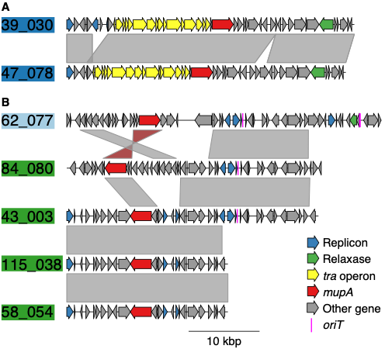

Supplementary Figure 1. Structural comparison of representative plasmids from the three major mupA-associated plasmid groups. Representative complete plasmids from the three major mupA-associated plasmid groups identified in the surveillance cohort were selected from 27 isolates subjected to Oxford Nanopore long-read sequencing and hybrid genome assembly for plasmid characterization (Supplementary Table 6). The distribution of all plasmid groups across the surveillance phylogeny is shown in Fig. 1A and, among mupA-positive isolates, in Fig. 3B. Plasmids are grouped according to structural similarity. Mobility predictions corresponded closely with the major structural groups, consistent with a recent regional survey of complete mupA-containing plasmids.¹⁷ (A) Representative Group 1 plasmids (39_030, 47_078; dark blue), predicted to be conjugative. (B) Representative Group 2 plasmids (green), including both mobilizable (84_080, 43_00) and non-mobilizable (115_038, 58_054) examples, and a representative Group 3 plasmid (67_077; light blue), predicted to be mobilizable. Plasmids were compared using minimap2.¹² Coding sequences (CDSs) are shown as arrows and colored according to predicted function. mupA (red), replicon (rep) genes (blue), conjugation-associated genes (yellow), and origin(s) of transfer (oriT; pink) are highlighted; other genes are shown in gray. Plasmids are ordered to emphasize structural homology within and between groups. Shaded regions between plasmids indicate homologous nucleotide sequences identified by pairwise alignment, with red shading indicating an inversion.

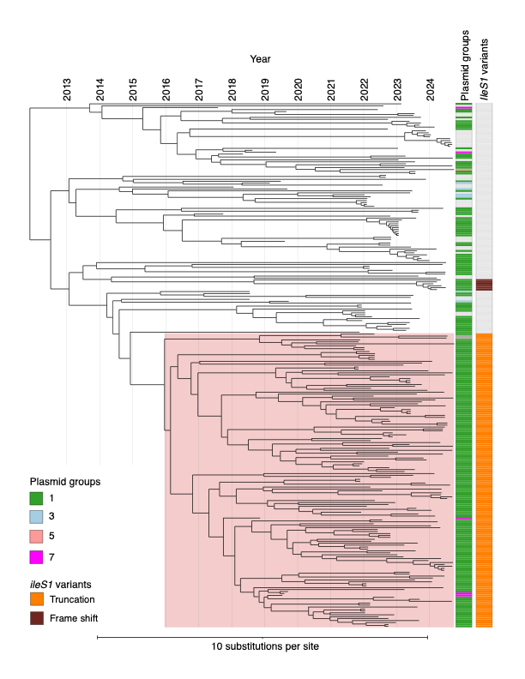
Supplementary Figure 2. Dated phylogeny of the E499 ileS1 truncation lineage. Time-scaled phylogeny of isolates belonging to the E499 ileS1 truncation lineage identified among mupA-positive MRSA isolates. The E499 lineage identified in the contemporary surveillance cohort (n = 271 isolates) is highlighted. To reconstruct the evolutionary history of the lineage, phylogenetically related isolates from historical collections (2017–2020) and the contemporary surveillance cohort (2022–2025) were included in the analysis. Annotation tracks indicate year of isolation, Mob-suite-imputed plasmid group, and ileS1 inactivation status. The dated phylogeny supports emergence of the E499 lineage before the start of genomic surveillance, with an inferred common ancestor dating to approximately 2015–2016. The lineage includes both mupA-positive and mupA-negative descendants derived from a common ancestor.

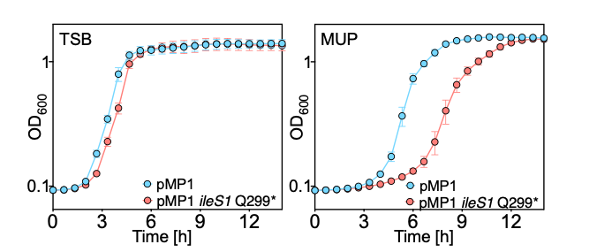
Supplemental Fig. 3. Effect of mupirocin on growth of mupA-containing strains with and without chromosomal ileS1 inactivation. (A) Overnight cultures of S. aureus LAC (BS1158) carrying the mupA-containing plasmid pMP1 (BS1963) or an isogenic ileS1 truncation mutant (ileS1 Q299* [BS2039]) were diluted 1000 x in fresh tryptic soy broth (TSB) without antibiotic. Growth was monitored by measuring the optical density at 600 nm (OD₆₀₀). (B) Growth of the same strains in TSB as in A supplemented with mupirocin (250 μg/mL). Mupirocin MICs were unchanged in the ileS1 Q299* mutant relative to the parental strain. Data represent the means ± SD from biological replicates (n = 3). Thus, addiction does not enhance resistance or fitness in the presence of mupirocin.

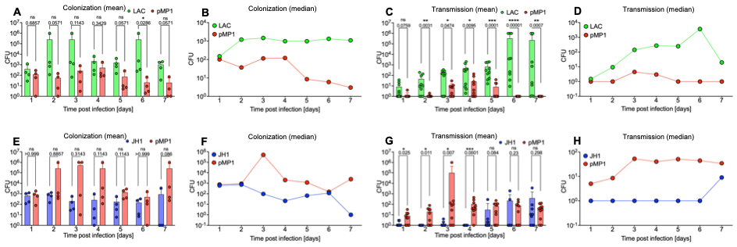

Supplementary Fig. 4. Daily colonization and transmission kinetics in the neonatal murine model. Neonatal mice were inoculated and monitored as described in Fig. 5. (A–D) Colonization and transmission kinetics of the CC8 strain LAC and its pMP1-containing derivative (BS1158 and BS1963, respectively). (E–H) Colonization and transmission kinetics of the CC5 strain JH1 and its pMP1-containing derivative (BS1231 and BS2045, respectively.) (A, B, E, F) Daily nasal colonization burden among inoculated index pups. (C, D, G, H) Daily nasal colonization burden among uninoculated contact pups following transmission. (A, C, E, G) Mean CFU at each time point. (B, D, F, H) Median CFU at each time point. All y-axes are shown as a logarithmic scale. To enable plotting on the log scale, a value of 1 was assigned to samples with no detectable S. aureus growth. Multiple Mann-Whitney tests were used to determine statistical differences between samples (*p<0.05, **p<0.01; ***p<0.001; ****p<0.0001) in panel A, C, E and G. Consistent with the cumulative analyses shown in Fig. 5, pMP1 reduced colonization and transmission in CC8 but increased both measures in CC5, indicating that the fitness consequences of plasmid carriage are strain dependent.

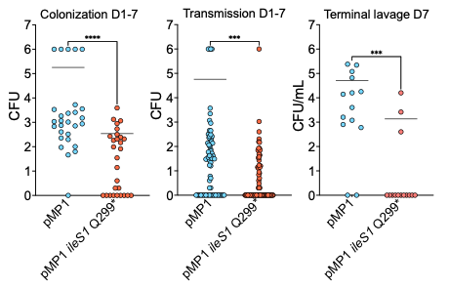
Supplementary Fig. 5. Effect of the ileS1 inactivation (‘addiction’) on colonization and transmission in a neonatal murine model. Colonization and transmission of the CC8 strain LAC + pMP1 (BS1963, labeled here as pMP1 for simplicity) and LAC + pMP1 ileS1 Q299* (BS2039, labeled as pMP1 ileS1 Q299*); Left, cumulative nasal colonization burden among inoculated index pups measured over days 1–7 post-inoculation. Middle, cumulative transmission burden among uninoculated contact pups measured over the same interval. Right, terminal upper respiratory tract colonization quantified by retrograde nasal lavage at the experimental endpoint. In each panel, blue indicates the mupA-plasmid–containing strain with chromosomal ileS1 inactivation. Each symbol represents an individual animal. All y-axes are shown on a logarithmic scale. A value of 1 was assigned to samples with no detectable S. aureus growth. To enable plotting on the log scale, a value of 1 was assigned to animals from which no S. aureus colony was recovered.
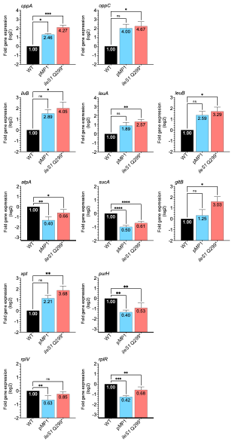

Supplementary Fig. 6. Expression of selected stringent response-associated genes in mupA plasmid-containing and addicted strains. Total cellular RNA was extracted from 12-h biofilm growth of S. aureus LAC wild-type (WT; BS1158), the isogenic mupA plasmid-containing derivative (pMP1; BS1963), and the addicted pMP1 ileS1 Q299* mutant (BS2039). Transcript abundance was quantified by reverse transcription quantitative PCR using rpoB as an internal control. Genes were selected to represent functional pathways associated with the stringent response, including oligopeptide transport, amino acid biosynthesis, central metabolism, and purine biosynthesis. Expression levels were normalized to those of the wild-type, which was assigned a value of 1. Bars indicate fold-change relative to wild type. Data represent the mean ± SEM of three independent experiments. Ordinary one-way Anova was used to determine statistical differences between samples (*p<0.05, **p<0.01; ***p<0.001; ****p<0.0001). The addicted strain generally showed larger effect sizes across several markers, with the clearest differences involving branched-chain amino acid biosynthesis genes (ilvB, leuA, and leuB), consistent with stronger stringent response-mediated relief of CodY repression.^{11,12} These transcriptional changes parallel the enhanced biofilm phenotype observed in addicted strains, a phenotype previously associated with CodY regulation.¹⁸

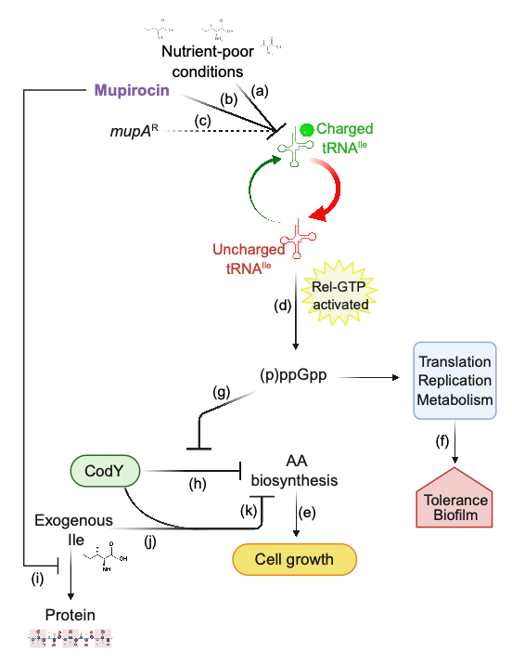

Supplementary Fig. 7. Schematic description of exogenous isoleucine synergizing with mupirocin to inhibit growth of mupA-containing strains under branched-chain amino acid (BCAA)-limited conditions. Under nutrient-poor conditions with limited BCAA availability (a), mupirocin partially inhibits isoleucyl-tRNA charging (b) despite the presence of the plasmid-encoded mupA resistance determinant (c). This shifts the balance from charged to uncharged tRNA-Ile, resulting in accumulation of uncharged tRNA-Ile at the ribosomal A site and low-level activation of the Rel-dependent stringent response. Activation of the stringent response increases production of the alarmone ppGpp (d), which suppresses translation, replication, and growth-associated metabolism (e) while promoting stress tolerance and biofilm formation (f). In parallel, ppGpp antagonizes CodY (g), relieving repression of amino acid (AA) biosynthetic pathways (h) and promoting adaptation to nutrient limitation and continued protein synthesis (i). Thus, cells can continue to grow despite ongoing mupirocin exposure. In this scenario, addition of exogenous isoleucine disrupts adaptation by maintaining CodY activity (j), thereby preventing induction of biosynthetic pathways required to replenish limiting amino acids (k). Furthermore, we hypothesize that the growth-inhibitory effect of exogenous isoleucine is amplified by mupirocin. By impairing incorporation of isoleucine into protein synthesis, mupirocin is expected to increase the effective intracellular availability of isoleucine or dysregulate intracellular isoleucine pools (l), allowing exogenous isoleucine to exert a disproportionate effect on intracellular isoleucine sensing and CodY activation. Under these conditions, even low concentrations of exogenous isoleucine, which are minimally growth inhibitory on their own, may be sufficient to maintain CodY activity despite persistent stringent-response signaling. This regulatory mismatch between amino acid sensing and the metabolic demands imposed by BCAA limitation prevents appropriate induction of amino acid biosynthetic pathways, creating a conditional vulnerability in mupA-containing strains whereby exogenous isoleucine and mupirocin synergize (h and k), culminating in growth collapse under BCAA-limited conditions.

Supplementary Tables
Supplementary Table 1. Characteristics of patients harboring mupA-positive and mupA-negative S. aureus isolates.
 | mupA (-)  (n = 9,108) | mupA (+)  (n = 1,213)
Age in years - mean (SD) | 62 (19) | 65 (18)
Age group - n (%)
18-24 | 200 (2.2%) | 19 (1.6%)
25-34 | 648 (7.1%) | 75 (6.2%)
35-44 | 1,012 (11%) | 91 (7.5%)
45-54 | 1,061 (12%) | 137 (11%)
55-64 | 1,554 (17%) | 192 (16%)
65-74 | 1,794 (20%) | 261 (22%)
75+ | 2,839 (31%) | 438 (36%)
Gender
Male | 5,369 (59%) | 771 (64%)
Female | 3,732 (41%) | 442 (36%)
Missing | 7 | 0
Race/ethnicity
Asian | 787 (9.2%) | 39 (3.4%)
Black | 1,309 (15%) | 124 (11%)
Hispanic | 1,996 (23%) | 186 (16%)
Other | 76 (0.9%) | 6 (0.5%)
White | 4,424 (51%) | 791 (69%)
Missing | 516 | 67
Charlson index score
0 | 4,585 (50%) | 603 (50%)
1-2 | 2,162 (24%) | 266 (22%)
3-4 | 1,556 (17%) | 206 (17%)
5+ | 805 (8.8%) | 138 (11%)
Hospital
Brooklyn | 2,306 (25%) | 262 (22%)
Tisch | 6,802 (75%) | 951 (78%)
# of Hospital Admissions | 1.73 (3.19) | 2.25 (3.28)
Cumulative Hospital Days | 8 (19) | 15 (26)
Cumulative # of Antibiotics | 10 (34) | 23 (51)
S. aureus type
MRSA | 3,088 (34%) | 1,041 (86%)
MSSA | 6,020 (66%) | 172 (14%)
Clonal complex
CC5 | 2,035 (22%) | 227 (19%)
CC8 | 2,329 (26%) | 859 (71%)
Other | 4,744 (52%) | 127 (10%)
Involved in Transmission Event | 467 (5.1%) | 190 (16%)

Note. Data are presented as mean (SD) or n (%). MRSA, methicillin-resistant Staphylococcus aureus; MSSA, methicillin-susceptible S. aureus; CC, clonal complex. Transmission events were defined as described in the Supplementary Methods.

Supplementary Table 2. Crude and adjusted transmission rate differences associated with mupA carriage.

 | Rate difference (95% CI)
Crude | 10.5 (8.4, 12.7)
Adjusted* | 11.3 (5.8, 16.9)

Note. *Adjusted using inverse probability of treatment weighting (IPTW) for MRSA versus MSSA status, clonal complex, hospitalization history (number of prior hospital admissions, cumulative hospital days), cumulative antibiotic exposure, age, sex, race/ethnicity, and Charlson comorbidity score.

Supplementary Table 3. Association between mupA carriage and transmission across MRSA clonal complexes and MSSA.
 | MRSA CC5 |  |  |  | MRSA CC8 |  |  |  | MRSA Other CC |  |  |  | MSSA
 | mupA (+) | mupA (-) | RD | mupA (+) |  | mupA (-) | RD | mupA (+) |  | mupA (-) | RD | mupA (+) |  | mupA (-) | RD
Transmission | 51 (26.3%) | 135 (12.9%) | 13.4 (6.1, 20.7) | 119 (14.6%) |  | 109 (7.4%) | 7.3 (4.5, 10.1) | 8 (23.5%) |  | 95 (17.0%) | 6.6 (-5.6, 18.7) | 12 (7.0%) |  | 128 (2.1%) | 4.9 (1.0, 8.7)
No transmission | 143 (73.7%) | 913 (87.1%) |  | 694 (85.4%) |  | 1371 (92.6%) |  | 26 (76.5%) |  | 465 (83.0%) |  | 160 (93.0%) |  | 5892 (97.9%)
Total | 194 | 1048 |  | 813 |  | 1480 |  | 34 |  | 560 |  | 172 |  | 6020

Note. Data are presented as n (%) of isolates within each lineage group stratified by mupA carriage and transmission status. Rate differences (RDs) compare the rate of transmission among mupA-positive versus mupA-negative isolates within each lineage group; 95% confidence intervals are shown in parentheses. Because CC5 and CC8 accounted for approximately 86% of MRSA isolates in the cohort, conclusions regarding lineage-specific effects in MRSA were based primarily on these clonal complexes. MRSA, methicillin-resistant Staphylococcus aureus; MSSA, methicillin-susceptible S. aureus; CC, clonal complex. Transmission events were defined as described in the Supplementary Methods.

Supplementary Table 4. Bacterial strainsª.

Strain | Background | Relevant Genotype | Reference or Source
BS1158 | LAC, USA300, CA-MRSA | agr group I wild-type (CC8), Erm^{S}, CadA in SaPI1 attS | 19
1394 | S. aureus clinical isolate | CC5 MRSA mupR, harboring a native pMP1 plasmid | This study
BS1963 | BS1158 | LAC Cd^{R} + pMP1 | This study
BS2039 | BS1158 | LAC Cd^{R} + pMP1 ileS1 Q299* | This study
BS1231 | JH1 | agr group II wild-type (CC5), | 20
BS2045 | JH1 | JH1 WT + pMP1 | 21
BS1462 | E. coli DH5α | DH5α with pIMAY-Z (Cm^{R} in E. coli; Cm^{R} in S. aureus) | 22
BS1000 | E. coli IM08B | SA08BΩP_{N25}-hsdS (CC8-1) (SAUSA300_0406) of NRS384 integrated between the essQ and cspB genes | 22
BS1142 | RN4220 | SaPIbov1::tetM | 23
BS1958 | BS1142 | RN4220 + pMP1 | This study
52_054 | S. aureus clinical isolate | CC8 MRSA mup^{R} ileS1 mutated at 895nt C>T, Q299STOP | This study
BS1951 | BS1231 | pOS1-GFP empty vector | This study
Note. CC, clonal complex; nt, nucleotide.
ªAll bacterial strains are S. aureus, unless otherwise indicated.

Supplementary Table 5. Oligonucleotides.
Name | Gene/  Target |  | Sequence 5’ 3’ | Reference  or Source
ileS1 cloning and introduction of the inactivating mutation
Fragment.FOR ileS1 mut | ileS1 |  | CCCCCCCTCGAGGTCGACGGTATCGATAAGCTTGATATCGGAATTTGCTTTAGAACAAATTGAATTACAGAAAAAAG | This study
Fragment.REV ileS1 mut |  |  | TTGGAGCTCCACCGCGGTGGCGGCCGCTCTAGAACTAGTGTTTGAACCGTGTTCTGCAAATAAATC | This study
ileS1 ver FOR |  |  | CTTGTCTGACGCTGTAGCAGAAGCACTG | This study
ileS1 ver REV |  |  | CTTTATCATCGATTGGACTAATTACTGGC | This study
qRT-PCR
rpoB F | rpoB |  | GAACATGCAACGTCAAGCAG | 24
rpoB R |  |  | AATAGCCGCACCAGAATCAC | 24
oppA RT1 | oppA |  | ACGATCCACAAAGTACTATTGC | 25
oppA RT2 |  |  | TAAATGCGTCATCAATGCTGTT | 25
oppC RT1 | oppC |  | ATGTCTTTTTAGGATTAGCAGC | 25
oppC RT2 |  |  | GTCAGTACCTAGTAGATGTTGA | 25
ilvB RT1 | ilvB |  | GCGTTCAGGATCAGAAGTGC | 26
ilvB RT2 |  |  | CACCTTGTTCGTGTCTTGCT | 26
xpt RT1 | xpt |  | GATTACTAAAATCTTAACCATTGAAGC | This study
xpt RT2 |  |  | ATGAATAGATGTTTCATAATAACCATCC | This study
purH RT1 | purH |  | ATCAAGAAGTATTGACGCGATTAAG | 27
purH RT2 |  |  | GATTGTTGTGGATTTTCTCCATATC | 27
atpA RT1 | atpA | TAGAAAGAGCAGCAAAATTAAA |  | 28
atpA RT2 | atpA | TTGTTGGTACATAAGCTGAAAT |  | 28
sucA RT1 | sucA | GCCGTGTTACATGATGAGCA |  | 29
sucA RT2 | sucA | CACCATATTGCGCTTCCCAA |  | 29
rplR RT1 | rplR | CTTGCTGCTTCAGCTAATGC |  | This study
rplR RT2 | rplR | CTTCAAAAGACAGCGACATTGCTAC |  | This study
rplV RT1 | rplV | CTTTAGCTTCTTCTTTACCGTCACTTAC |  | This study
rplV RT2 | rplV | GGACCAACATTAAAACGTTTCC |  | This study
leuA RT1 | leuA | GTGAACGGTATTGGTGAAAGAG |  | 30
leuA RT2 | leuA | GTGGTCCTTCCTTACATATAAAGC |  | 30
leuB RT1 | leuB | GGTGCAATCGGTGGACCTAA |  | 31
leuB RT2 | leuB | TAGCGCCTTTGACAACGGTA |  | 31
gltB RT1 | gltB | TTGCGAAGACAAGAGGGT |  | 32
gltB RT2 | gltB | CTAAACCAATCTCCCAAGGA |  | 32

Supplementary Table 6. S. aureus strains subjected to long-read sequencing and hybrid genome assembly for plasmid characterization.

# | Strain | Lineage
1 | 124_091 | CC121
2 | 124_098 | CC121
3 | 18_072 | CC121
4 | 128_053 | CC5
5 | 16_019 | CC5
6 | 39_030 | CC5
7 | 39_099 | CC5
8 | 42_100 | CC5
9 | 43_003 | CC5
10 | 46_001 | CC5
11 | 47_078 | CC5
12 | 58_054 | CC5
13 | 62_077 | CC5
14 | 7_079 | CC5
15 | 77_076 | CC5
16 | 1394 | CC5
17 | 101_092 | CC8
18 | 11_087 | CC8
19 | 112_052 | CC8
20 | 115_038 | CC8
21 | 25_073 | CC8
22 | 26_002 | CC8
23 | 28_003 | CC8
24 | 3_092 | CC8
25 | 49_077 | CC8
26 | 53_075 | CC8
27 | 84_080 | CC8
Note. Strains were selected for long-read sequencing to characterize the diversity of mupA plasmids identified within the surveillance cohort. Complete plasmid sequences were generated using Oxford Nanopore long-read sequencing and hybrid assembly.

SI References
1. Halsey CR, Fey PD. Conjugative Transfer in Staphylococcus aureus. Methods Mol Biol 2016; 1373: 83-7.
2. Kaderabkova N, Mahmood AJS, Mavridou DAI. Antibiotic susceptibility testing using minimum inhibitory concentration (MIC) assays. NPJ Antimicrob Resist 2024; 2(1): 37.
3. Monk IR, Stinear TP. From cloning to mutant in 5 days: rapid allelic exchange in Staphylococcus aureus. Access Microbiol 2021; 3(2): 000193.
4. Arbe-Carton K, Rey-Sogo A, Santos-Fernandez N, et al. Development of a high-throughput platform to measure plasmid transfer frequency. Frontiers in cellular and infection microbiology 2023; 13: 1269732.
5. Ulrich RJ, Podkowik M, Tierce R, et al. Prophage-encoded methyltransferase drives adaptation of community-acquired methicillin-resistant Staphylococcus aureus. J Clin Invest 2025; 135(18).
6. Podkowik M, Perault AI, Putzel G, et al. Quorum-sensing agr system of Staphylococcus aureus primes gene expression for protection from lethal oxidative stress. Elife 2024; 12.
7. Livak KJ, Schmittgen TD. Analysis of relative gene expression data using real-time quantitative PCR and the 2(-Delta Delta C(T)) Method. Methods 2001; 25(4): 402-8.
8. Ortigoza MB, Blaser SB, Zafar MA, Hammond AJ, Weiser JN. An infant mouse model of influenza virus transmission demonstrates the role of virus-specific shedding, humoral immunity, and sialidase expression by colonizing Streptococcus pneumoniae. mBio 2018; 9(6).
9. Podkowik M, Tillman A, Takats C, et al. CRISPR-Cas-associated SCCmec variants in methicillin-resistant Staphylococcus aureus evade rapid diagnostic detection. J Infect Dis 2026; 233(2): e534-e40.
10. Rabii KB, Takats C, Putzel G, et al. Sampling and host-strain interactions shape detection of Staphylococcus aureus transmission in hospitals. J Infect Dis 2026.
11. Robertson J, Bessonov K, Schonfeld J, Nash JHE. Universal whole-sequence-based plasmid typing and its utility to prediction of host range and epidemiological surveillance. Microb Genom 2020; 6(10).
12. Li H. Minimap2: pairwise alignment for nucleotide sequences. Bioinformatics 2018; 3 4(18): 3094-100.
13. Altschul SF, Gish W, Miller W, Myers EW, Lipman DJ. Basic local alignment search tool. J Mol Biol 1990; 215(3): 403-10.
14. Seemann T. Prokka: rapid prokaryotic genome annotation. Bioinformatics 2014; 30(14): 2068-9.
15. Coll F, Harrison EM, Toleman MS, et al. Longitudinal genomic surveillance of MRSA in the UK reveals transmission patterns in hospitals and the community. Sci Transl Med 2017; 9(413).
16. Coll F, Raven KE, Knight GM, et al. Definition of a genetic relatedness cutoff to exclude recent transmission of meticillin-resistant Staphylococcus aureus: a genomic epidemiology analysis. Lancet Microbe 2020; 1(8): e328-e35.
17. Terlecky AJ, Thom KV, Kan VW, et al. Genomic diversity and topical antimicrobial resistance in Staphylococcus aureus from clinical and carriage populations in the New York-New Jersey region. Antimicrob Agents Chemother 2026: e0065426.
18. Mlynek KD, Bulock LL, Stone CJ, et al. Genetic and Biochemical analysis of CodY-mediated cell aggregation in Staphylococcus aureus reveals an interaction between extracellular DNA and polysaccharide in the extracellular matrix. J Bacteriol 2020; 202(8).
19. Boles BR, Thoendel M, Roth AJ, Horswill AR. Identification of genes involved in polysaccharide-independent Staphylococcus aureus biofilm formation. PLoS One 2010; 5(4): e10146.
20. Duthie ES, Lorenz LL. Staphylococcal coagulase; mode of action and antigenicity. J Gen Microbiol 1952; 6(1-2): 95-107.
21. Geisinger E, Chen J, Novick RP. Allele-dependent differences in quorum-sensing dynamics result in variant expression of virulence genes in Staphylococcus aureus. J Bacteriol 2012; 194(11): 2854-64.
22. Chen J, Yoong P, Ram G, Torres VJ, Novick RP. Single-copy vectors for integration at the SaPI1 attachment site for Staphylococcus aureus. Plasmid 2014; 76: 1-7.
23. Ubeda C, Tormo-Mas MA, Penades JR, Novick RP. Structure-function analysis of the SaPIbov1 replication origin in Staphylococcus aureus. Plasmid 2012; 67(2): 183-90.
24. Dyzenhaus S, Sullivan MJ, Alburquerque B, et al. MRSA lineage USA300 isolated from bloodstream infections exhibit altered virulence regulation. Cell host & microbe 2023; 31(2): 228-42 e8.
25. Ding Y, Fu Y, Lee JC, Hooper DC. Staphylococcus aureus NorD, a putative efflux pump coregulated with the Opp1 oligopeptide permease, contributes selectively to fitness in vivo. J Bacteriol 2012; 194(23): 6586-93.
26. Yousuf B, Pasha R, Pineault N, Ramirez-Arcos S. Modulation of Staphylococcus aureus gene expression during proliferation in platelet concentrates with focus on virulence and platelet functionality. PLoS One 2024; 19(7): e0307920.
27. Roberts C, Anderson KL, Murphy E, et al. Characterizing the effect of the Staphylococcus aureus virulence factor regulator, SarA, on log-phase mRNA half-lives. J Bacteriol 2006; 188(7): 2593-603.
28. Pandey S, Sahukhal GS, Elasri MO. The msaABCR operon regulates persister formation by modulating energy metabolism in Staphylococcus aureus. Front Microbiol 2021; 12: 657753.
29. Acker KP, Wong Fok Lung T, West E, et al. Strains of Staphylococcus aureus that colonize and infect skin harbor mutations in metabolic genes. iScience 2019; 19: 281-90.
30. Wu Y, Wu Y, Zhu T, et al. Staphylococcus epidermidis SrrAB regulates bacterial growth and biofilm formation differently under oxic and microaerobic conditions. J Bacteriol 2015; 197(3): 459-76.
31. Suo B, Guan P, Dong Z, et al. Comparative Ttanscriptomic analysis of Staphylococcus aureus reveals the genes involved in survival at low temperature. Foods 2022; 11(7).
32. Wen X, Tang T, Bao T, et al. gltB encoding glutamate synthase is involved in persister and biofilm formation and virulence in Staphylococcus aureus. Microbiol Spectr 2025; 13(9): e0051125.

