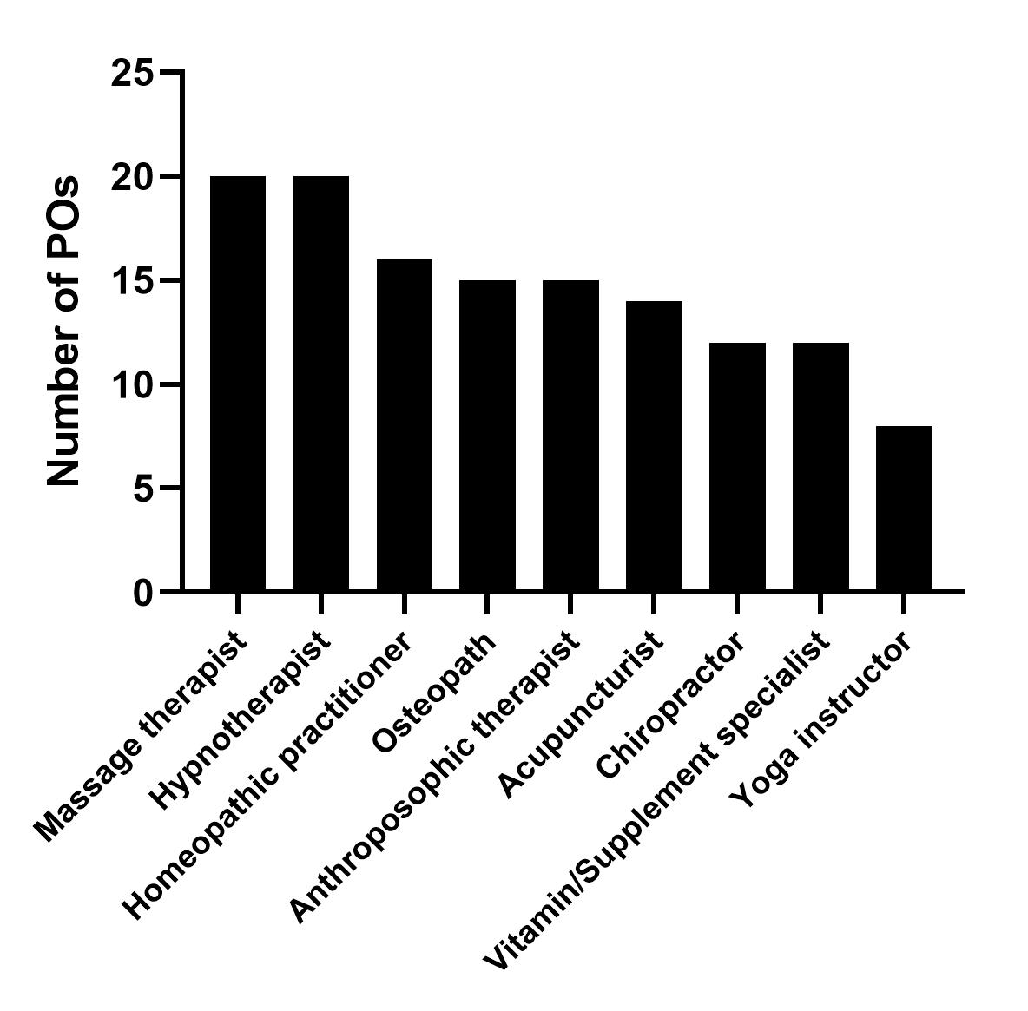
SUPPLEMENTARY FIGURE 1: Number of POs referring to specific CM providers.

