Supplement to
The Additional Diagnostic Potential of Tansbronchial Lung Cryobiopsy in Bronchoscopic Assessment of Sarcoidosis and Chronic Beryllium Disease – a Retrospective Analysis of 321 Patients
Terschluse, Feineis et al.,

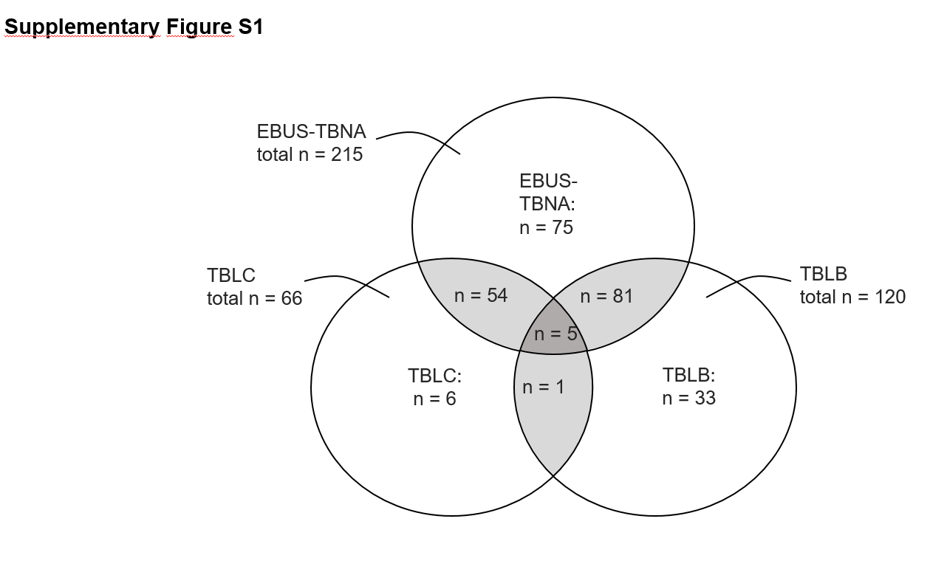

Supplementary Figure S1: Bronchoscopy interventions performed
Supplementary Figure shows the number (n) of different and overlapping bronchoscopic interventions performed to diagnose sarcoidosis. EBUS-TBNA: endobronchial ultrasound-guided transbronchial needle aspiration; TBLB = transbronchial lung (forceps) biopsy; TBLC = transbronchial lung cryobiopsy

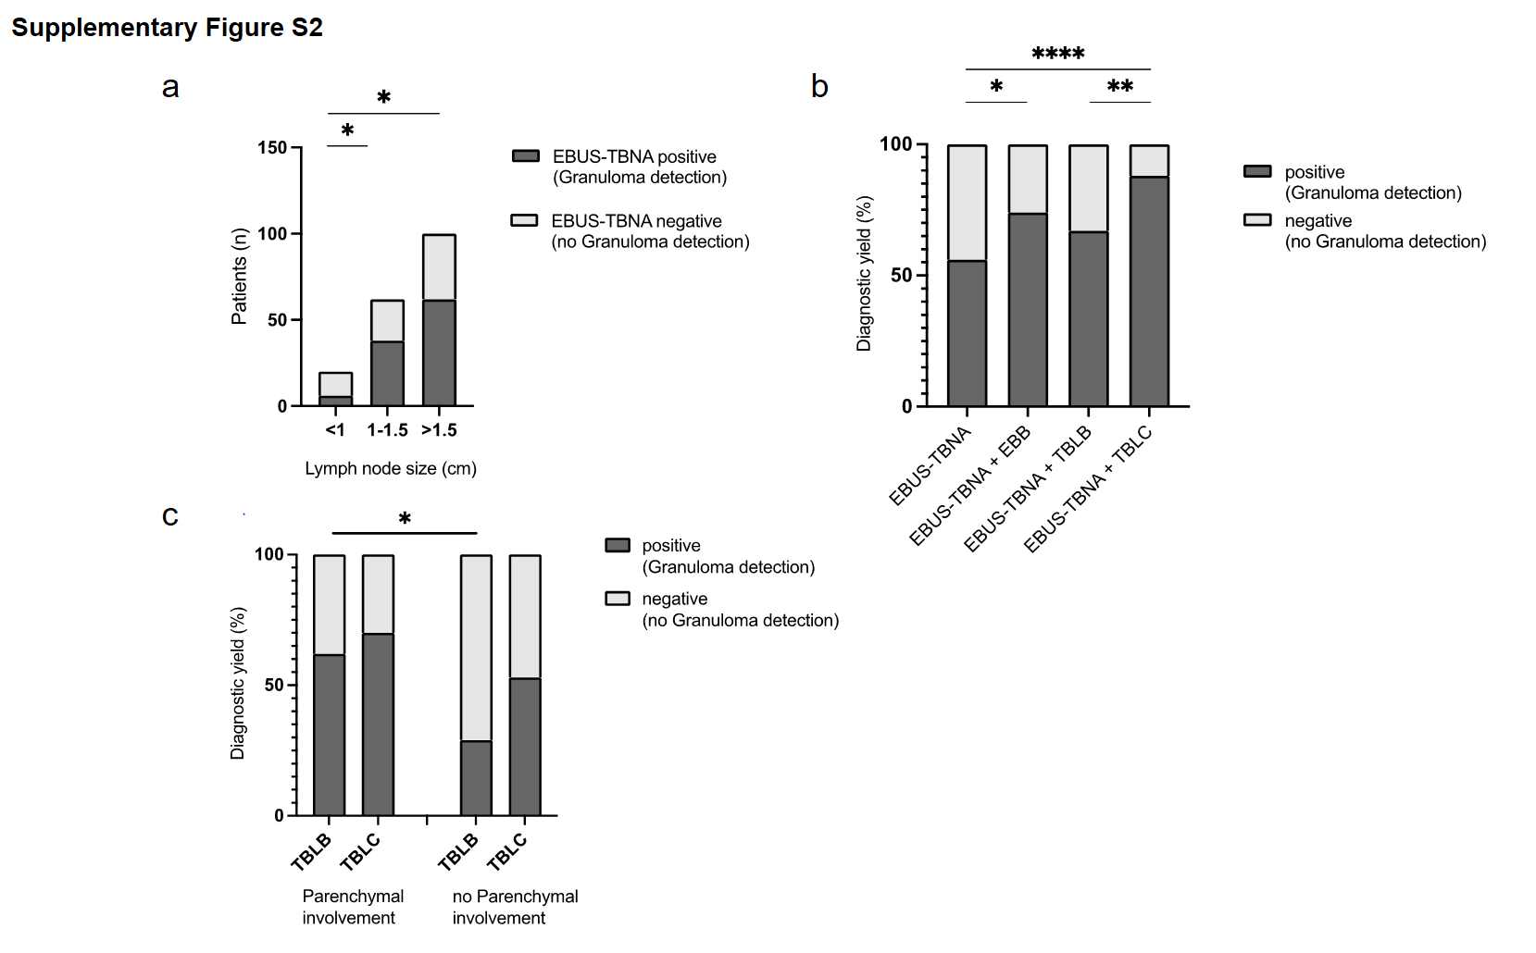

Supplementary Figure S2
a: Diagnostic yield of EBUS-TBNA according to lymph node size. The x-axis shows the maximum lymph node size in centimeters. The number of patients is displayed on the y-axis. Positive EBUS-TBNA results are represented by dark grey coloring of the bar, while negative results are indicated by light grey coloring. p-values: supplementary table S6.
b: Comparison of combined diagnostic yields.
p-values: Table 2
c: Diagnostic yields of TBLC and TBLB depending on parenchymal involvement detectable on CT scans.

Supplementary table S1: Comparison of baseline characteristics between patients with positive and negative EBUS-TBNA results.
 | Positive EBUS-TBNA (n=121) | Negative EBUS-TBNA (n=94) | p-value
Demography
Age (years) | 50.5 (14.5) | 48.9 (14.8) | 0.3740
Male, n (%) | 69 (57.0%) | 51 (54.3%) | 0.7820
(Former) Smokers, n (%) | 51/100 (51.0%) | 38/76 (50.0%) | >0.9999
BMI (kg/m²) | 28.4 (6.1) (n=118) | 27.4 (5.3) (n=85) | 0.4591
Lung function
FEV1 (%pred) | 88.0 (20.2) (n=116) | 85.9 (21.7) (n=84) | 0.7731
FVC (%pred) | 94.7 (19.7) (n=116) | 91.7 (21.5) (n=84) | 0.7014
FEV1/FVC | 76.4 (7.3) (n=116) | 75.8 (8.1) (n=84) | 0.6759
TLC (%pred) | 86.8 (14.3) (n=116) | 85.0 (15.5) (n=84) | 0.7468
DLCOcSB (%pred) | 80.7 (16.8) (n=104) | 76.4 (16.59) (n=73) | 0.1753
BAL
BAL %Alveolarmacrophages | 60.0 (39.5, 73.0) | 65.0 (53.8, 75.0) | 0.1589
BAL % Neutrophiles | 3.0 (1.0, 5.0) | 3.0 (1.0, 5.0) | 0.7224
BAL % Lymphocytes | 37.0 (21.0, 53.5) | 32.0 (21.0, 44.3) | 0.1839
BAL CD4/CD8 | 4.9 (2.4, 8.0) (n=101) | 3.9 (2.2, 7.0) (n=80) | 0.3485
BAL CD4/CD8 ≥3.5 n (%) | 66/101 (65.3%) | 49/80 (61,3%) | 0.6415
Serology
sIL2-R (U/ml) | 877.5 (486.5, 1568) (n=108) | 902.5 (518.0, 1431) (n=84) | 0.9995
Neopterin (nmol/l) | 14.4 (10.5, 23.6) (n=100) | 12.6 (9.0, 19.8) (n=79) | 0.0628
ACE (U/l) | 59.3 (41.1, 91.0) (n=59) | 55.7 (36.5, 79.6) (n=62) | 0.5548
Values are presented as proportion of patients in their study group or mean (standard deviation) except BAL and serological data are presented as median (range). Abbreviations: EBUS-TBNA = endobronchial ultrasound-guided transbronchial needle aspiration, FEV1 = forced expiratory volume in one second, FVC = forced vital capacity, TLC = total lung capacity, DLCO = diffusing capacity of the lung for carbon monoxide, BAL = bronchial alveolar lavage, sIL2-R = soluble interleukin-2 receptor, ACE = angiotensin-converting enzyme.

Supplementary Table S2: Comparing lymph node size and number of punctured lymph node stations by EBUS-TBNA

Lymph node size (cm) | Mean “number of lymph node stations“ | Median “ number of lymph node stations” | p-value (vs. „Lymph node size < 1cm“)
<1 | 1.8 (0.8) | 2 (3)
1-1.5 | 2.2 (1) | 2 (4) | 0.0668
>1.5 | 2.4 (1) | 3 (4) | 0.0227
1-1.5 vs >1.5: p=0.4477

Supplementary Table S3: Comparing the number of punctured lymph node stations of patients with positive and negative EBUS-TBNA results

p< 0.0001
 | EBUS positive (n=121) | EBUS negative (n=94)
Median (range) | 3 (5) | 1 (4)
Mean (SD) | 2.6 (1) | 1.6 (0.8)

Supplementary table S4: Diagnostic yield of EBUS-TBNA depending on lymphadenopathy (lymph node size >1cm).
 | EBUS-TBNA positive | EBUS-TBNA negative
Lymph node size >1cm | 100 | 62 | 162
Lymph node size <1cm | 6 | 14 | 20
 | 106 | 76 | 182
p = 0.0083, OR [95%CI] = 3.763 [1.452, 10.12]
Abbreviations: EBUS-TBNA = endobronchial ultrasound-guided transbronchial needle aspiration, PPV = positive predictive value, NPV = negative predictive value.

Supplementary table S5: Diagnostic yield of EBUS-TBNA according to lymph node size.

Lymph node size (cm) | Positive/Total (%) | p-value (vs. „Lymph node size < 1cm“)
<1 | 6/20 (30.0%)
1-1.5 | 38/62 (61.3%) | 0.0203
>1.5 | 62/100 (62.0%) | 0.0125
p-value = 1-1.5 vs >1.5: p>0.9999. Abbreviations: EBUS-TBNA = endobronchial ultrasound-guided transbronchial needle aspiration.

Supplementary table S6: Comparison of individual diagnostic yields

Biopsy technique | Positive/Total (% yield) | Difference (%) | p-value
Overall |  |  | 0.7643
EBUS-TBNA | 121/215 (56.3%)
TBLB | 71/120 (59.2%)
vs. EBUS-TBNA |  | +2.9% | 0.6458
TBLC | 42/66 (63.6%)
vs. EBUS-TBNA |  | +7.4% | 0.3202
vs. TBLB |  | +4.5% | 0.6383
EBB | 36/61 (59.0%)
vs. EBUS-TBNA |  | +2.7% | 0.7703
vs. TBLB |  | -0.2% | >0.9999
vs. TBLC |  | -4.6% | 0.7154
Abbreviations: EBUS-TBNA = endobronchial ultrasound-guided transbronchial needle aspiration, EBB = endobronchial biopsy, TBLB = transbronchial lung biopsy, TBLC = transbronchial lung cryobiopsy.

Supplementary table S7: Comparison of baseline characteristics between patients with positive and negative TBLB results.
 | Positive TBLB (n=71) | Negative TBLB (n=49) | p-value
Demography
Age (years) | 45.4 (13.1) | 51.7 (13.3) | 0.0138
Male, n (%) | 39 (54.9%) | 26 (53.1%) | 0.8543
(Former) Smokers, n (%) | 36/58 (62.1%) | 22/40 (55.0%) | 0.5342
BMI (kg/m²) | 26.9 (5.4) (n=64) | 27.1 (5.2) (n=45) | 0.6490
Lung function
FEV1 (%pred) | 87.0 (22.0) (n=63) | 84.3 (17.3) (n=45) | 0.4132
FVC (%pred) | 93.9 (21.3) (n=63) | 91.7 (18.5) (n=45) | 0.3719
FEV1/FVC | 75.8 (7.8) (n=63) | 75.4 (8.0) (n=45) | 0.9666
TLC (%pred) | 87.3 (16.6) (n=63) | 86.3 (14.4) (n=45) | 0.6832
DLCOcSB (%pred) | 75.0 (17.5) (n=53) | 77.9 (17.0) (n=37) | 0.3506
BAL
BAL %Alveolarmacrophages | 57.0 (38.0, 74.0) | 62.0 (50.0, 75.0) | 0.1795
BAL % Neutrophiles | 2.0 (1.0, 5.0) | 2.0 (1.0, 5.0) | 0.3075
BAL % Lymphocytes | 39.0 (24.0, 58.0) | 35.0 (23.5, 44.0) | 0.1472
BAL CD4/CD8 | 4.4 (3.1, 8.0) (n=61) | 3.7 (2.1, 6.1) (n=43) | 0.1438
BAL CD4/CD8 ≥3.5 n (%) | 42/61 (68.9%) | 23/43 (53.5%) | 0.1500
Serology
sIL2-R (U/ml) | 973.5 (643.8, 1698) (n=70) | 889.0 (616.0, 1138) (n=39) | 0.0733
Neopterin (nmol/l) | 12.8 (9.5, 20.6) (n=69) | 11.1 (8.0, 15.9) (n=49) | 0.1388
ACE (U/l) | 56.2 (31.4, 75.0) (n=57) | 56.3 (33.5, 68.3) (n=32) | 0.6291
Values are presented as proportion of patients in their study group or mean (standard deviation) except BAL and serological data are presented as median (range). Abbreviations: TBLB = transbronchial lung biopsy, FEV1 = forced expiratory volume in one second, FVC = forced vital capacity, TLC = total lung capacity, DLCO = diffusing capacity of the lung for carbon monoxide, BAL = bronchial alveolar lavage, sIL2-R = soluble interleukin-2 receptor, ACE = angiotensin-converting enzyme.

Supplementary table S8: Comparison of baseline characteristics between patients with positive and negative TBLC results.
 | Positive TBLC (n=42) | Negative TBLC (n=24) | p-value
Demography
Age (years) | 49.4 (14.4) | 50.9 (16.0) | 0.7633
Male, n (%) | 30 (71.4%) | 12 (50.0%) | 0.1119
(Former) Smokers, n (%) | 18/33 (54.5%) | 9/17 (52.9%) | >0.9999
BMI (kg/m²) | 29.0 (6.4) (n=41) | 28.0 (4.7) (n=23) | 0.8649
Lung function
FEV1 (%pred) | 79.4 (17.7) (n=40) | 90.5 (16.4) (n=23) | 0.0104
FVC (%pred) | 84.8 (20.0) (n=40) | 97.6 (12.7) (n=23) | 0.0113
FEV1/FVC | 74.2 (8.3) (n=40) | 77.8 (7.1) (n=23) | 0.0637
TLC (%pred) | 79.6 (13.9) (n=40) | 87.1 (12.2) (n=23) | 0.0470
DLCOcSB (%pred) | 75.5 (16.9) (n=34) | 80.7 (17.8) (n=21) | 0.3158
BAL
BAL %Alveolarmacrophages | 50.0 (35.8, 66.3) | 69.0 (55.3, 82.0) | 0.0004
BAL % Neutrophiles | 3.0 (1.0, 5.0) | 4.0 (1.3, 5.0) | 0.3137
BAL % Lymphocytes | 45.0 (29.8, 61.3) | 24.0 (12.3, 37.5) | 0.0001
BAL CD4/CD8 | 3.8 (1.8, 6.3) (n=39) | 2.7 (1.6, 6.8) (n=18) | 0.5571
BAL CD4/CD8 ≥3.5 n (%) | 21/39 (53.8%) | 8/18 (44.4%) | 0.5765
Serology
sIL2-R (U/ml) | 1167 (475.0, 2102) (n=39) | 521.0 (459.5, 757.5) (n=17) | 0.0092
Neopterin (nmol/l) | 16.2 (12.5, 25.4) (n=35) | 10.7 (9.3, 15.1) (n=17) | 0.0033
ACE (U/l) | 48.3 (40.4, 104.5) (n=26) | 46.7 (37.6, 68.1) (n=11) | 0.2394
Values are presented as proportion of patients in their study group or mean (standard deviation) except BAL and serological data are presented as median (range). Abbreviations: TBLC = transbronchial lung cryobiopsy, FEV1 = forced expiratory volume in one second, FVC = forced vital capacity, TLC = total lung capacity, DLCO = diffusing capacity of the lung for carbon monoxide, BAL = bronchial alveolar lavage, sIL2-R = soluble interleukin-2 receptor, ACE = angiotensin-converting enzyme.

Supplementary table S9: Evaluation of Cut-off values of TBLC determined by ROC-Analysis.
TBLC
 | Sensitivity | Specificity | PPV | NPV | Likelihood Ratio | p-value
FEV1 ≤ 83.55 %pred | 61.9% | 70.8% | 78.8% | 51.5% | 2.122 | 0.0203
FVC ≤ 89.45 %pred | 54.8% | 83.3% | 85.2% | 51.3% | 3.286 | 0.0038
TLC ≤ 85.05%pred | 59.5% | 70.8% | 78.1% | 50.0% | 2.041 | 0.0225
Lymphocytes ≥ 29.5 % | 76.2% | 66.7% | 80.0% | 61.5% | 2.286 | 0.0014
sIL2-R ≥ 934.0 U/ml | 64.3% | 62.5% | 75.0% | 50.0% | 1.714 | 0.0433
Neopterin ≥ 12.4 nmol/l | 83.3% | 45.8% | 72.9% | 61.1% | 1.538 | 0.0199
Abbreviations: TBLC = transbronchial lung cryobiopsy, sIL2-R = soluble interleukin-2 receptor, FEV1 = forced expiratory volume in one second, FVC = forced vital capacity, TLC = total lung capacity, PPV = positive predictive value, NPV = negative predictive value.

Supplementary table S10: Evaluation of Cut-off values of TBLB determined by ROC-Analysis.
TBLB
 | Sensitivity | Specificity | PPV | NPV | Likelihood Ratio | p-value
FEV1 ≤ 83.55 %pred | 46.0% | 51.1% | 56.9% | 40.4% | 0.9416 | 0.8458
FVC ≤ 89.45 %pred | 34.9% | 57.8% | 53.7% | 38.8% | 0.8271 | 0.5467
TLC ≤ 85.05%pred | 38.1% | 53.3% | 53.3% | 38.1% | 0.8163 | 0.4307
Lymphocytes ≥ 29.50 % | 67.6% | 40.8% | 62.3% | 46.5% | 1.142 | 0.4388
sIL2-R ≥ 934.0 U/ml | 52.9% | 53.9% | 67.3% | 38.9% | 1.145 | 0.5524
Neopterin ≥ 12.4 nmol/l | 55.1% | 55.0% | 67.9% | 41.5% | 1.224 | 0.3278
Abbreviations: TBLB = transbronchial lung biopsy, sIL2-R = soluble interleukin-2 receptor, FEV1 = forced expiratory volume in one second, FVC = forced vital capacity, TLC = total lung capacity, PPV = positive predictive value, NPV = negative predictive value.

Supplementary table S11: Demographic, lung function, BAL and serological parameters in relation with diagnostic success of TBLB and TBLC - ROC-Curve values.

 | AUC [95%CI] | Youden-Index | Cut-off value
Age (TBLB) | 0.6321 [0.5311, 0.7331] | 0.246 | <50.5 years
FEV1 (TBLC) | 0.6935 [0.5586, 0.8283] | 0.3457 | <83.6 % pred
FVC (TBLC) | 0.6913 [0.5610, 0.8216] | 0.4011 | <89.5 %pred
TLC (TBLC) | 0.6511 [0.5135, 0.7886] | 0.3207 | <85.1 %pred
BAL-Lymphocytes (TBLC) | 0.7748 [0.6598, 0.8898] | 0.4286 | >29.5%
sIL2-R (TBLC) | 0.7179 [0.5855, 0.8504] | 0.4978 | >934.0 U/ml
Neopterin (TBLC) | 0.7487 [0.6115, 0.886] | 0.4471 | >12.4 nmol/l
Abbreviations: TBLB = transbronchial lung biopsy, TBLC = transbronchial lung cryobiopsy, FEV1 = forced expiratory volume in one second, FVC = forced vital capacity, TLC = total lung capacity, BAL = bronchoalveolar lavage, sIL2-R = soluble interleukin 2 receptor.

Supplementary Table S12 Comparison of diagnostic yields of TBLB and TBLC.
 | TBLC positive | TBLC negative
TBLB positive | 0 | 0 | 0
TBLB negative | 4 | 2 | 6
 | 4 | 2 | 6
p > 0.9999, Abbreviations: TBLB = transbronchial lung biopsy, TBLC = transbronchial lung cryobiopsy.
Abbreviations: TBLB = transbronchial lung biopsy, TBLC = transbronchial lung cryobiopsy

Supplementary Table S13: Comparison of biopsy size of patients with positive and negative TBLC result

 | TBLC positive (n=38) | TBLC negative (n=24)
Median (range) mm | 0.7 (1.7) | 0.55 (1.8)
Mean (SD) mm | 0.8 (0.4) | 0.7 (0.4)
p=0.4245

Abbreviation: TBLC = transbronchial lung cryobiopsy.

Supplementary Table S14: Comparison of biopsy size of patients with positive and negative TBLB result

 | TBLB positive (n=65) | TBLB negative (n=46)
Median (range) mm | 0.4 (0.6) | 0.4 (0.9)
Mean (SD) mm | 0.4 (0.2) | 0.4 (0.2)
p=0.2932

Abbreviation: TBLB = transbronchial lung biopsy

Supplementary Table S15: Diagnostic yield of EBB depending on airway findings in CT-scans
 | EBB positive | EBB negative
Abnormal airway | 14 | 2 | 16
Normal airway | 15 | 20 | 35
 | 29 | 22 | 51
p = 0.0052, OR [95%CI] = 9.333 [2.061, 44.43]
Definition of abnormal airway: airwall thickening, airway compression, airway distorsion. Abbreviations: EBB = endobronchial biopsy

Supplementary Table S16: Diagnostic yields with no parenchymal involvement detected in CT-scans

Biopsy technique | Positive/Total (%) | p-value (vs. „EBUS-TBNA“)
EBUS-TBNA* | 37/59 (62.7%)
TBLB | 4/14 (28.6%) | 0.0341
TBLC | 10/19 (52.6%) | 0.5906
EBB | 3/10 (30%) | 0.0822
*Lymphadenopathy in n= 47/59 (80 %)

TBLB vs TBLC: p=0.2857

Abbreviations: EBUS-TBNA = endobronchial ultrasound-guided transbronchial needle aspiration, EBB = endobronchial biopsy, TBLB = transbronchial lung biopsy, TBLC = transbronchial lung cryobiopsy.

Supplementary Table S17: Comparison of complication rates of TBLB and TBLC
 | TBLC (n = 66) | TBLB (n = 120) | p-values | Odds ratios [95%CI]
Total complication rate | 16.7% (n = 11) | 9.2% (n = 11) | 0.1561 | 1.982 [0.8248, 4.744]
Pneumothorax | 10.6% (n = 7) | 6.7 % (n = 8) | 0.4023 | 1.661 [0.6231, 4.927]
Bleeding | 6.1% (n = 4) | 2.5% (n = 3) | 0.2475 | 2.516 [0.6549, 10.18]
Abbreviations: TBLB = transbronchial lung biopsy, TBLC = transbronchial lung cryobiopsy, CI = confidence interval

