Supplementary Material

Supplementary Table 1: RE-AIM evaluation framework to evaluate the HEAR-study screening program.
Definition of Domainª | In the context of HEAR | Data sources
Reach assesses number, proportion, and representativeness of individuals who are willing to participate, and reasons why or why not. | Assess the number and proportion of invited CCS who participated in the HEAR-study screening program and compare their clinical and sociodemographic characteristics to nonparticipants. | Childhood Cancer Registry (ChCR)  Participant baseline questionnaire
Effectiveness focuses on evaluating the program’s immediate and long-term impact (positive and negative), and whether the program achieves its objectives. | Assess the number and proportion of participants with (newly) detected hearing loss, the proportion of those who contacted a physician for further evaluation, and number of those acquiring a hearing aid after the screening program. | Audiogram results  Participant follow-up questionnaire 2
Adoption assesses stakeholders’ willingness to adopt and implement the program. | Explore experiences and satisfaction with the screening program from perspectives of participants and the hearing aid shops | Participant interviews  Participant follow-up questionnaire 1 & 2  Hearing aid shop employee questionnaire and interviews
Implementation evaluates the feasibility of implementing the program within real-world contexts, assessing the extent to which the program was delivered consistently and as intended.  Maintenance investigates the possibility of continuing the program beyond the research project for long-term sustainability. | Evaluate if the program was implemented as intended and assess necessary requirements for program implementation from the perspectives of stakeholders involved. | Hearing aid shop employee questionnaire and interviews  Clinician group discussions
ª Adapted according to definitions from Glasgow et al. 2019 [1].

Supplementary Figure 1: CCS self-reported reasons for participation in the HEAR-study from baseline questionnaire. (N=404)

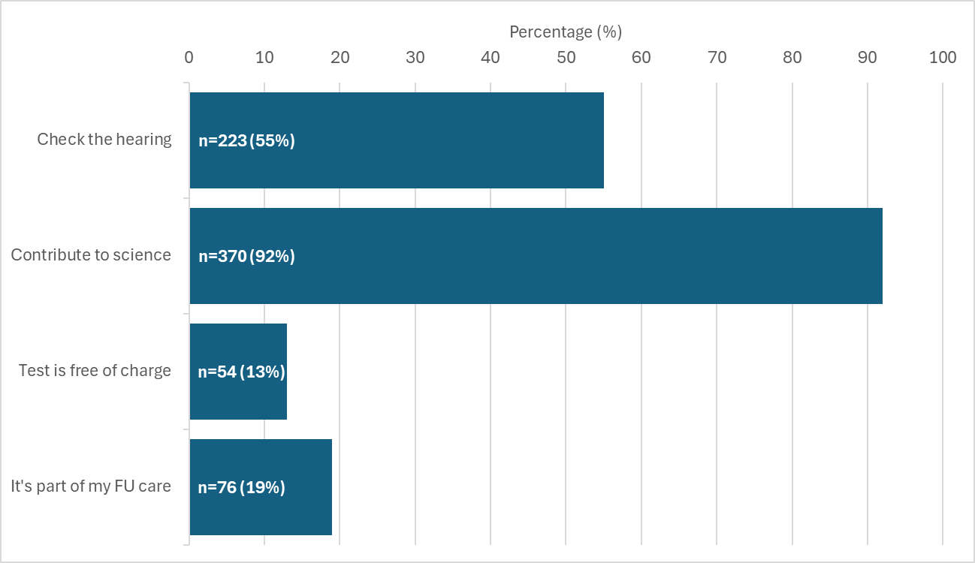
n=1 missing
Participants could select multiple answers, including “others”.
Abbreviations: n, number. FU, follow-up.

Supplementary Table 2: Prevalence and severity of hearing loss according to SIOP-Boston ototoxicity scale, CPT-AMA, and self-reported hearing loss after the hearing test stratified by risk group (high or standard risk group based on treatment exposure).

Hearing loss | High risk group | Standard risk group | Total
 | n (%) | n (%) | n (%)
SIOP-Boston ototoxicity scale | N=83 | N=236 | N=319
0-1 | 46 (55%) | 202 (86%) | 248 (78%)
2-4 | 37 (45%) | 34 (14%) | 71 (22%)
CPT-AMA | N=83 | N=236 | N=319
<20% | 71 (86%) | 230 (97%) | 301 (94%)
≥20% | 12 (14%) | 6 (3%) | 18 (6%)
Self-reported in follow-up questionnaire 2 | N=65 | N=193 | N=258
No impairment | 40 (62%) | 169 (88%) | 209 (81%)
Hearing impairment | 25 (38%) | 24 (12%) | 49 (19%)

Abbreviations: SIOP, International Society of Pediatric Oncology. CPT-AMA, Council on Physical Therapy, American Medical Association.
Risk groups: High, treated with platinum agents (cisplatin/carboplatin) or cranial radiation ≥ 30 Gray. Standard, treated with any other chemotherapy or radiation to head, neck or spine with any dose.
Hearing loss results from the high risk group have been published previously [2].
CPT-AMA: The CPT-AMA scale is widely used in the Swiss health system to determine eligibility for hearing aid coverage by the old-age, survivors and disability insurance (OASI/IV) [3]. CPT-AMA results in percentage of hearing loss, calculated through weighted percentage for hearing threshold at frequencies between 500-4000 Hz [4]. We calculated the mean percentage of hearing loss of both ears and categorized it into not clinically relevant (<20%), or clinically relevant hearing loss (≥20%), based on the guidelines for ENT specialists on the clarification mandate for the reimbursement of hearing aids by the OASI and IV [3].

Supplementary Table 3: General experiences of CCS participants with the hearing test.
 | SIOP 0-1  (N=232) | SIOP 2-4  (N=64) | Totalª  (N=296) | P-value
 | n (%) | n (%) | n (%)
Expectations for hearing test met^{b} |  |  |  | 0.04
Yes | 210 (91%) | 51 (80%) | 261 (88%)
No | 1 (0%) | 1 (2%) | 2 (1%)
Partly | 20 (9%) | 12 (19%) | 32 (11%)
Missing | 1 (0.4%) | 0 (0%) | 1 (0.3%)
Enough time for questions |  |  |  | 0.61
Yes | 223 (96%) | 63 (98%) | 286 (97%)
No | 9 (4%) | 1 (2%) | 10 (3%)
Communication of results |  |  |  | 0.18
Oral and written | 177 (76%) | 46 (72%) | 223 (75%)
Oral | 49 (21%) | 13 (20%) | 62 (21%)
Written | 5 (2%) | 4 (5%) | 9 (3%)
Other | 1 (0%) | 1 (3%) | 2 (1%)
Result was explained |  |  |  | 0.66
Yes, in detail | 206 (89%) | 55 (86%) | 261 (88%)
Yes, but I did not understand everything | 17 (7%) | 7 (11%) | 24 (8%)
No | 7 (3%) | 2 (3%) | 9 (3%)
Missing | 2 (0.9%) | 0 (0%) | 2 (0.7%)
Information received on how to proceed |  |  |  | 0.33
Yes | 154 (66%) | 48 (75%) | 202 (68%)
No | 66 (28%) | 13 (20%) | 79 (27%)
Do not know | 12 (5%) | 2 (3%) | 14 (5%)
Missing | 0 (0%) | 1 (1.6%) | 1 (0.3%)
Information was sufficient^{c} |  |  |  | 0.01
Yes | 154 (66%) | 46 (72%) | 200 (68%)
No | 0 (0%) | 2 (3%) | 2 (1%)
Did not receive information on how to proceed or do not remember | 78 (34%) | 15 (23%) | 93 (31%)
Missing | 0 (0%) | 1 (1.6%) | 1 (0.3%)
Would prefer discussing results directly with a doctor |  |  |  | <0.01
Yes | 40 (17%) | 26 (41%) | 66 (22%)
No | 192 (83%) | 38 (59%) | 230 (78%)
Plans to discuss results with physician |  |  |  | <0.01
Yes | 4 (2%) | 14 (22%) | 18 (6%)
No | 211 (91%) | 39 (61%) | 250 (84%)
Do not know | 17 (7%) | 11 (17%) | 28 (9%)
Travel duration to testing site |  |  |  | 0.58
<15min | 79 (34%) | 16 (25%) | 95 (32%)
15-30min | 101 (44%) | 32 (50%) | 133 (45%)
30-60min | 35 (15%) | 9 (14%) | 44 (15%)
>60min | 5 (2%) | 2 (3%) | 7 (2%)
Missing | 12 (5.2%) | 5 (7.8%) | 17 (5.7%)
Duration of hearing test |  |  |  | <0.05
<30min | 141 (61%) | 26 (41%) | 167 (56%)
30-60min | 91 (39%) | 37 (58%) | 128 (43%)
>60min | 0 (0%) | 1 (2%) | 1 (0%)

Table with column percentages.
ª Participants completing follow-up questionnaire 1 (N=296)
^{b}Further expectations:
- Wished more explanation about the diagram (audiogram)
- Wished for more information on hearing protection
- Wished for more information in general
^{c}Open questions:
- Can I improve my hearing? Can I do something about it? (n=6)
- Should I check my hearing again? When? How often? (n=3)
- Were there anomalies? (n=2)
- What should I expect in the future? Will my hearing become worse? (n=2)
- How do I manage my hyperacusis?
- What is the reason for my hearing loss?

Supplementary Figure 2: Answers from acousticians comparing study participants with usual customers. (Survey, N=13).
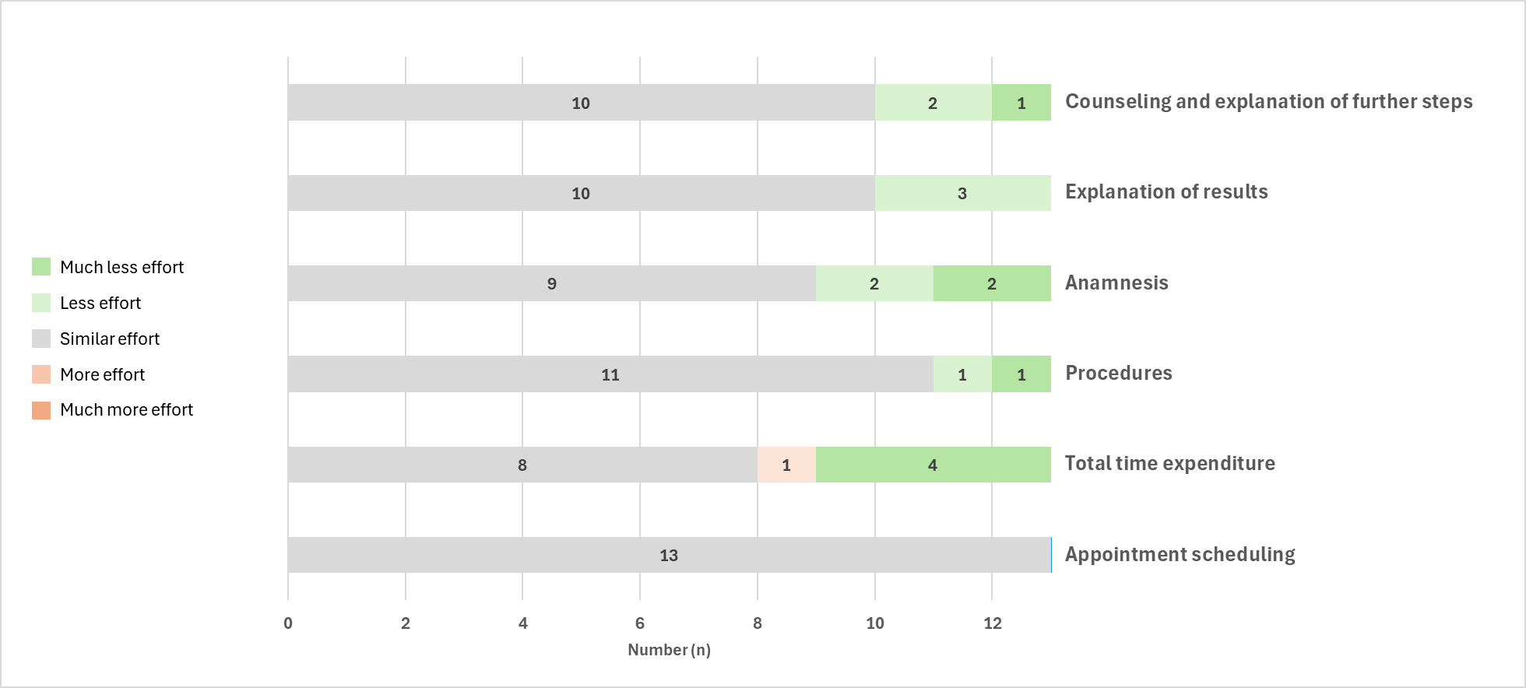
Abbreviations: n, number.

Supplementary Figure 3: Potential barriers as perceived by acousticians completing a survey (N=13).
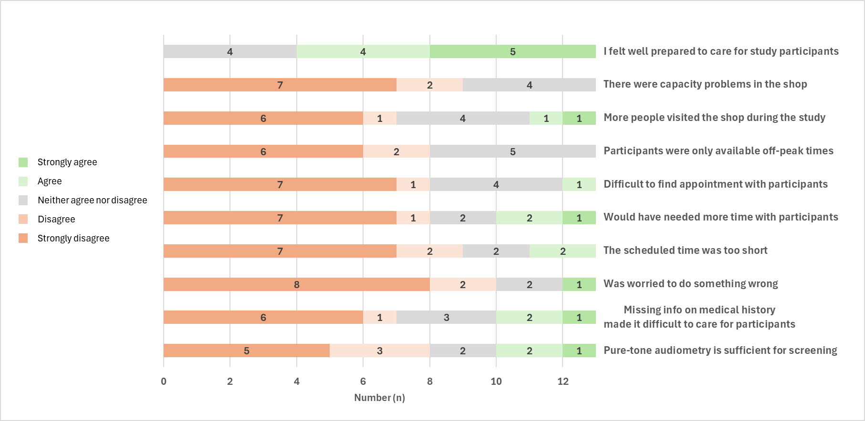
Abbreviations: n, number.

References
1 Glasgow RE, Harden SM, Gaglio B, et al. RE-AIM Planning and Evaluation Framework: Adapting to New Science and Practice With a 20-Year Review. Front Public Health. 2019;7:64. doi: 10.3389/fpubh.2019.00064
2 Jörger P, Nigg C, Žarković M, et al. Awareness about the risk of hearing loss after ototoxic treatments in Swiss childhood cancer survivors. Patient Educ Couns. 2025;136:108764. doi: 10.1016/j.pec.2025.108764
3 Bundesamt fuer Sozialversicherungen BSV. Richtlinien fuer ORL- Expertenaerzte zum Abklaerungsauftrag zur Verguetung von Hoergeraeten durch die Sozialversicherungen IV und AHV. 2018.
4 Council on Physical Therapy American Medical Association. TENTATIVE STANDARD PROCEDURE FOR EVALUATING PERCENTAGE OF USEFUL HEARING LOSS IN MEDICOLEGAL CASES. Archives of Otolaryngology - Head and Neck Surgery. 1942;36:590–2. doi: 10.1001/archotol.1942.03760040144015

