Supplementary Materials

The Cannabis Research Image Database (CRESIDA): an internationally standardized and validated image set for studying cannabis cue-reactivity

Janna Cousijn^{1*}, Emese Kroon^{1*}, Chao Suo^{2,3,4} Tom P Freeman⁵, Chandni Hindocha⁶, Marianna Quinones-Valera³, Valentina Lorenzetti³

¹Neuroscience of Addiction (NofA) lab, Center for Substance Use and Addiction Research (CESAR), Department of Psychology, Education & Child Studies, Erasmus University Rotterdam, The Netherlands
²QIMR Berghofer, Queensland, Australia
³Neuroscience of Addiction and Mental Health Programe, Healthy Brain and Mind Research Centre, School of Behavioural and Health Sciences, Faculty of Health Sciences, Australian Catholic University, Australia
⁴Turner Institute for Brain and Mental Health, School of Psychological Sciences & Monash
Biomedical Imaging Facility, Monash University, Victoria, Australia
⁵Addiction and Mental Health Group, Department of Psychology, University of Bath, UK
⁶Clinical Psychopharmacology Unit, Research Department of Clinical, Educational & Health Psychology, University College London

Correspondence: Janna Cousijn; cousijn@essb.eur.nl; Erasmus University Rotterdam, Department of Psychology, Education & Child Studies, Burgemeester Oudlaan 50, Rotterdam Zuid-Holland, Netherlands; Prof. Valentina Lorenzetti, PhD; valentina.lorenzetti@acu.edu.au; Neuroscience of Addiction and Mental Health Program, Healthy Brain and Mind Research Centre, School of Behavioural and Health Sciences, Faculty of Health Sciences, Australian Catholic University, Level 5 Daniel Mannix Building, 115 Victoria Parade, Fitzroy VIC 3065, Australia
* Authors contributed equally to this work.

Table S1. Sample characteristics per country
Categorical Outcomes | Description | Total |  | USA |  | NL |  | Australia
Categorical Outcomes | Description | N(%) |  | N(%) |  | N(%) |  | N(%)
Gender | Men | 385(43.3) |  | 310(60.4) |  | 51(37.0) |  | 24(63.2)
Gender | Women | 298(55.9) |  | 200(39.0) |  | 86(62.3) |  | 12(31.6)
Gender | Other | 6(0.8) |  | 3(0.6) |  | 1(0.7) |  | 2(5.3)
Employment | Not employed | 75(10.9) |  | 12(2.3) |  | 58(42.0) |  | 5(13.2)
Employment | Full-time | 500(72.6) |  | 474(92.4) |  | 8(5.8) |  | 18(47.4)
Employment | Part-time | 114(16.5) |  | 27(5.3) |  | 72(52.2) |  | 15(39.5)
Cannabis: product type | Strong flower or bud | 304(44.1) |  | 196(38.2) |  | 80(58.0) |  | 28(73.7)
Cannabis: product type | Weak flower | 157(22.8) |  | 136(26.5) |  | 17(12.3) |  | 4(10.5)
Cannabis: product type | Hash or resin/ | 99(14.4) |  | 62(12.1) |  | 37(26.8) |  | 0(0)
Cannabis: product type | Concentrates | 53(7.7) |  | 53(10.3) |  | 0(0) |  | 0(0)
Cannabis: product type | Edibles | 69(10.0) |  | 63(12.3) |  | 3(2.2) |  | 3(7.9)
Cannabis: product type | Other | 7(1.0) |  | 3(0.6) |  | 1(0.7) |  | 3(7.9)
Cannabis: method of use | Joint | 247(35.8) |  | 112(21.8) |  | 124(89.9) |  | 11(28.9)
Cannabis: method of use | Blunt | 51(7.7) |  | 44(8.6) |  | 3(2.2) |  | 4(10.5)
Cannabis: method of use | Pipe or other smoking device | 176(25.5) |  | 172(33.5) |  | 2(1.4) |  | 2(5.3)
Cannabis: method of use | Vaporizer | 65(9.4) |  | 54(10.5) |  | 2(1.4) |  | 9(23.7)
Cannabis: method of use | Bong or other water filtration device | 51(7.4) |  | 37(7.2) |  | 4(2.9) |  | 10(26.3)
Cannabis: method of use | Dabs | 16(2.3) |  | 16(3.1) |  | 0(0) |  | 0(0)
Cannabis: method of use | Hot knife | 12(1.7) |  | 12(2.3) |  | 0(0) |  | 0(0)
Cannabis: method of use | Eating it in food | 43(6.2) |  | 39(7.6) |  | 3(2.2) |  | 1(2.6)
Cannabis: method of use | Drinking it in tea or infusion | 25(3.6) |  | 25(4.9) |  | 0(0) |  | 0(0)
Cannabis: method of use | Other | 3(0.4) |  | 2(0.4) |  | 0(0) |  | 1(2.6)
Cannabis: medical use motives | Yes | 367(53.3) |  | 326(63.5) |  | 17(12.3) |  | 24(63.2))
Cannabis: medical use motives | No | 322(46.7) |  | 187(36.5) |  | 121(87.7) |  | 14(36.8)
Mix cannabis and tobacco | Yes | 416(60.4) |  | 283(55.2) |  | 117(84.8) |  | 16(42.1)
Mix cannabis and tobacco | No | 273(39.6) |  | 230(44.8) |  | 21(15.2) |  | 22(57.9)
Lifetime tobacco use | Yes | 583(84.6) |  | 423(82.5) |  | 127(92.0) |  | 33(86.8)
Lifetime tobacco use | No | 106(15.4) |  | 90(17.5) |  | 11(8.0) |  | 5(13.2)
Current tobacco use | Yes | 393(57.0) |  | 318(62.0) |  | 66(47.8) |  | 9(23.7)
Current tobacco use | No | 296(43.0) |  | 195(38.0) |  | 72(52.2) |  | 29(76.3)
Continuous Outcomes |  | M(SD) | Med(MAD) | M(SD) | Med(MAD) | M(SD) | Med(MAD) | M(SD) | Med(MAD)
Age |  | 34.29(11.61) | 32(7) | 37.73(10.80) | 34(6) | 21.96(3.26) | 21(2) | 32.50(10.84) | 29(7)
CUDIT-R short |  | 4.58(3.03) | 5(2) | 4.61(2.92) | 5(2) | 4.49(3.40) | 4(3) | 4.5(3.19) | 4(2)
Cannabis: days/week |  | 3.54(2.11) | 3(2) | 3.50(1.96) | 3(1) | 3.35(2.74) | 2(1) | 4.49(2.40) | 5.5(1.5)
Cannabis: use years |  | 11.44(9.82) | 7(4) | 13.17(10.19) | 10(5) | 4.70(3.60) | 4(1) | 12.61(9.79) | 9(6)
Cannabis: years monthly use |  | 10.80(9.62) | 7(4) | 12.77(9.86) | 10(6) | 3.83(3.55) | 3(1) | 9.50(9.51) | 5.5(3.5)
Cannabis: age first use |  | 22.23(7.54) | 20(4) | 22.80(7.99) | 21(4) | 16.35(2.21) | 16(1) | 17.57(4.46) | 16(1)
AUDIT short |  | 4.36(2.47) | 5(2) | 4.20(2.51) | 5(2) | 5.04(2.68) | 5(2) | 4.08(2.71) | 4(2)
Note. AUDIT: alcohol use disorder identification test; CUDIT-R: cannabis use disorder identification test-revised; Med: Median; MAD: median absolute deviation; M: mean; SD: standard deviation.

Table S2. Overview of image ratings per country for each image type
Image Type | Outcome | Country | N | Median | IQR | Mean | SD
Neutral | Craving | Australia | 38 | 1.101 | 3.037 | 2.112 | 2.712
Neutral | Craving | Netherlands | 138 | 1.095 | 2.964 | 1.701 | 1.699
Neutral | Craving | United States | 513 | 3.964 | 5.250 | 4.024 | 2.861
Neutral | Arousal | Australia | 38 | 1.339 | 2.822 | 2.121 | 2.496
Neutral | Arousal | Netherlands | 138 | 1.712 | 2.768 | 1.925 | 1.654
Neutral | Arousal | United States | 513 | 4.071 | 5.109 | 4.145 | 2.820
Neutral | Valence | Australia | 38 | 4.542 | 1.804 | 4.452 | 1.897
Neutral | Valence | Netherlands | 138 | 3.853 | 2.204 | 3.562 | 1.453
Neutral | Valence | United States | 513 | 5.321 | 2.602 | 5.371 | 1.948
Cannabis –  All Type | Craving | Australia | 38 | 5.797 | 3.512 | 5.436 | 2.916
Cannabis –  All Type | Craving | Netherlands | 138 | 4.875 | 4.940 | 4.363 | 2.954
Cannabis –  All Type | Craving | United States | 513 | 6.857 | 1.968 | 6.536 | 2.129
Cannabis –  All Type | Arousal | Australia | 38 | 5.404 | 5.243 | 4.969 | 3.070
Cannabis –  All Type | Arousal | Netherlands | 138 | 4.619 | 4.732 | 4.237 | 2.812
Cannabis –  All Type | Arousal | United States | 513 | 6.625 | 2.304 | 6.154 | 2.298
Cannabis –  All Type | Valence | Australia | 38 | 6.572 | 2.092 | 6.592 | 1.681
Cannabis –  All Type | Valence | Netherlands | 138 | 5.963 | 2.145 | 5.745 | 1.957
Cannabis –  All Type | Valence | United States | 513 | 6.833 | 1.791 | 6.856 | 1.492
Cannabis Image Type | Outcome | Country | N | Median | IQR | Mean | SD
Action | Craving | Australia | 38 | 5.850 | 3.507 | 5.422 | 2.901
Action | Craving | Netherlands | 138 | 4.841 | 5.074 | 4.492 | 2.967
Action | Craving | United States | 513 | 6.941 | 2.085 | 6.533 | 2.143
Action | Arousal | Australia | 38 | 5.824 | 5.037 | 4.915 | 3.092
Action | Arousal | Netherlands | 138 | 4.724 | 4.625 | 4.354 | 2.827
Action | Arousal | United States | 513 | 6.636 | 2.433 | 6.165 | 2.326
Action | Valence | Australia | 38 | 6.238 | 2.136 | 6.476 | 1.772
Action | Valence | Netherlands | 138 | 5.954 | 2.367 | 5.852 | 2.004
Action | Valence | United States | 513 | 6.800 | 1.882 | 6.829 | 1.533
Cannabis | Craving | Australia | 38 | 6.366 | 4.135 | 5.549 | 3.021
Cannabis | Craving | Netherlands | 138 | 5.000 | 5.601 | 4.295 | 3.050
Cannabis | Craving | United States | 513 | 7.000 | 2.000 | 6.623 | 2.173
Cannabis | Arousal | Australia | 38 | 5.405 | 5.240 | 5.172 | 3.147
Cannabis | Arousal | Netherlands | 138 | 4.167 | 5.036 | 4.108 | 2.919
Cannabis | Arousal | United States | 513 | 6.667 | 2.339 | 6.184 | 2.337
Cannabis | Valence | Australia | 38 | 7.358 | 2.541 | 7.037 | 1.760
Cannabis | Valence | Netherlands | 138 | 6.000 | 2.778 | 5.734 | 2.113
Cannabis | Valence | United States | 513 | 7.000 | 1.958 | 6.964 | 1.558
Paraphernalia | Craving | Australia | 38 | 5.700 | 4.375 | 5.219 | 2.932
Paraphernalia | Craving | Netherlands | 138 | 4.286 | 5.350 | 4.019 | 2.917
Paraphernalia | Craving | United States | 513 | 6.857 | 2.357 | 6.415 | 2.268
Paraphernalia | Arousal | Australia | 38 | 5.357 | 5.050 | 4.729 | 3.014
Paraphernalia | Arousal | Netherlands | 138 | 4.343 | 4.900 | 3.970 | 2.806
Paraphernalia | Arousal | United States | 513 | 6.571 | 2.714 | 6.073 | 2.413
Paraphernalia | Valence | Australia | 38 | 6.143 | 2.503 | 6.247 | 1.798
Paraphernalia | Valence | Netherlands | 138 | 5.500 | 2.447 | 5.439 | 2.140
Paraphernalia | Valence | United States | 513 | 6.857 | 2.000 | 6.799 | 1.620

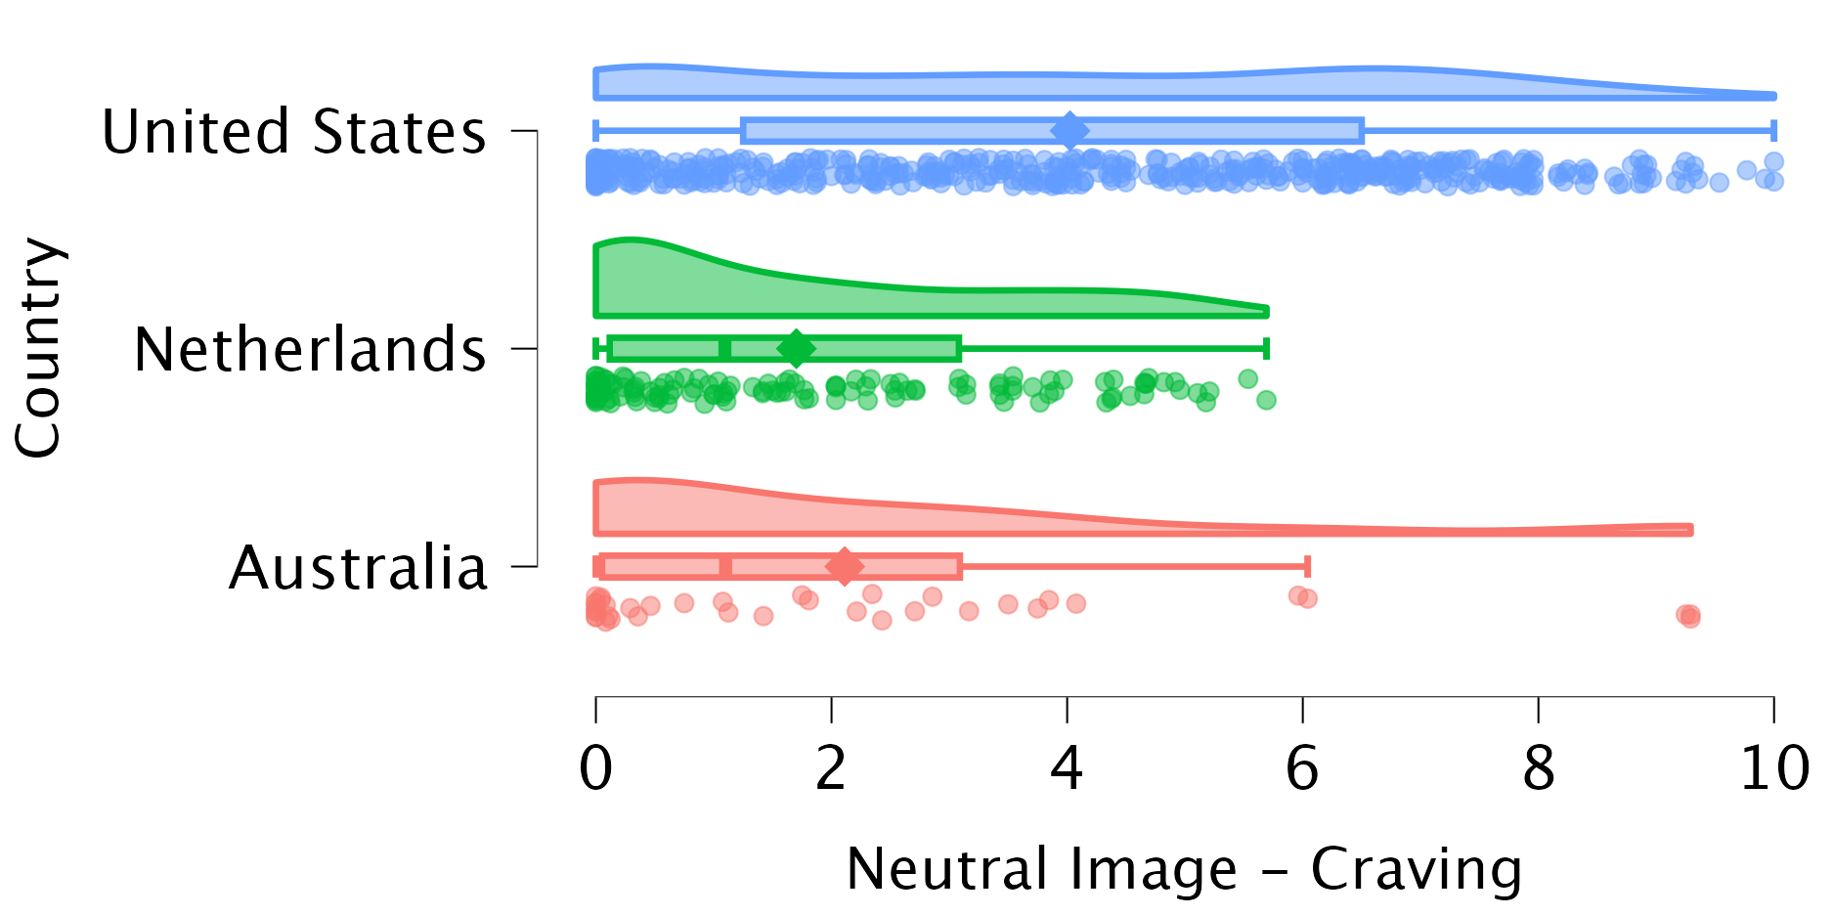
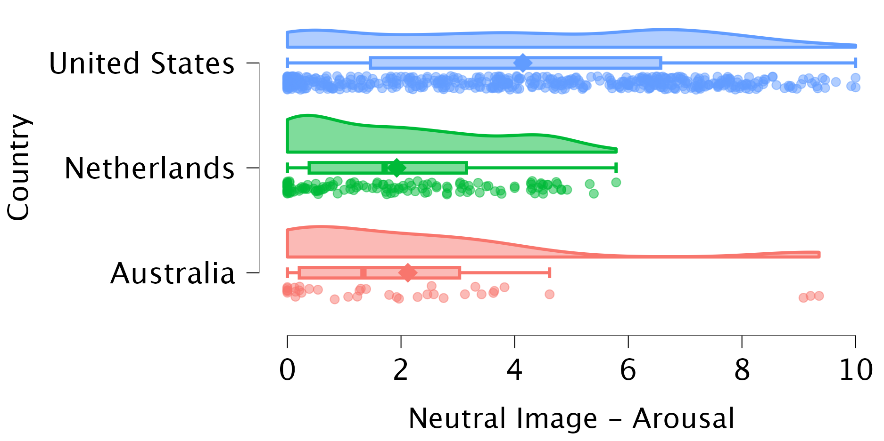
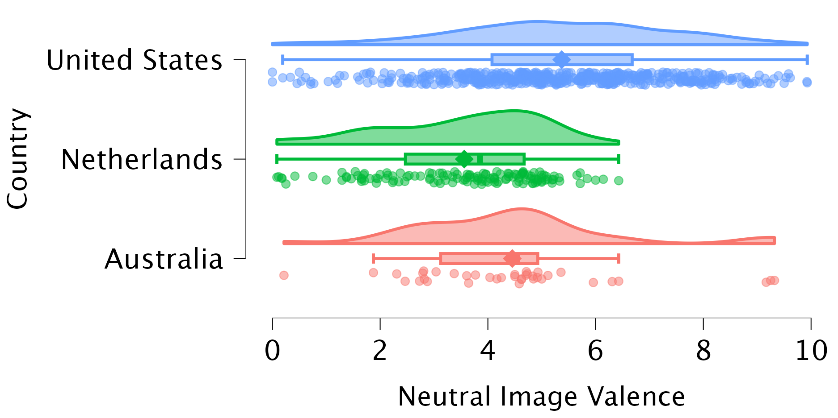

Figure S1. Overview of average craving, arousal and valence for neutral images presented per country. Diamond represents the mean.

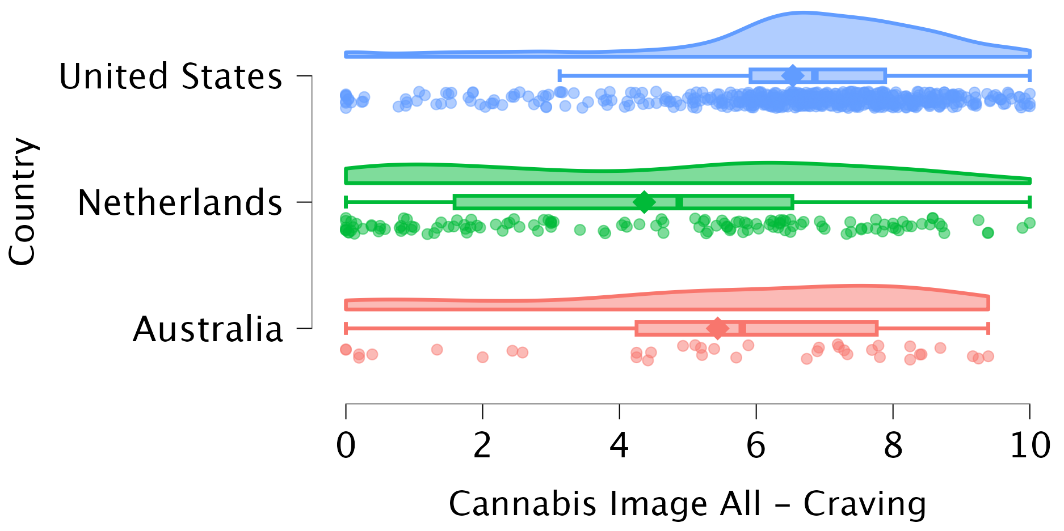
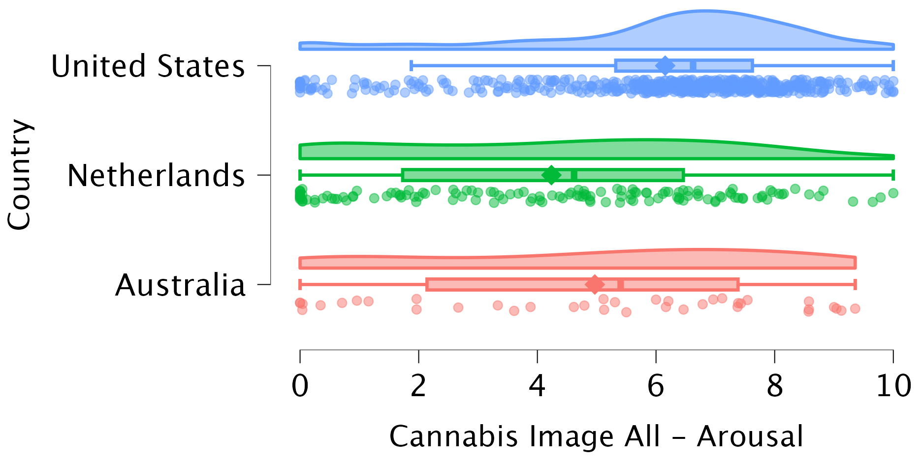
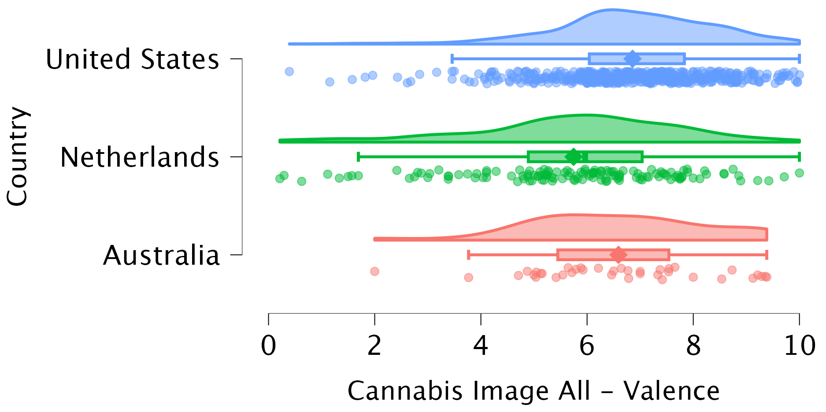

Figure S2. Overview of average craving, arousal and valence for cannabis images presented per country. Diamond represents the mean.

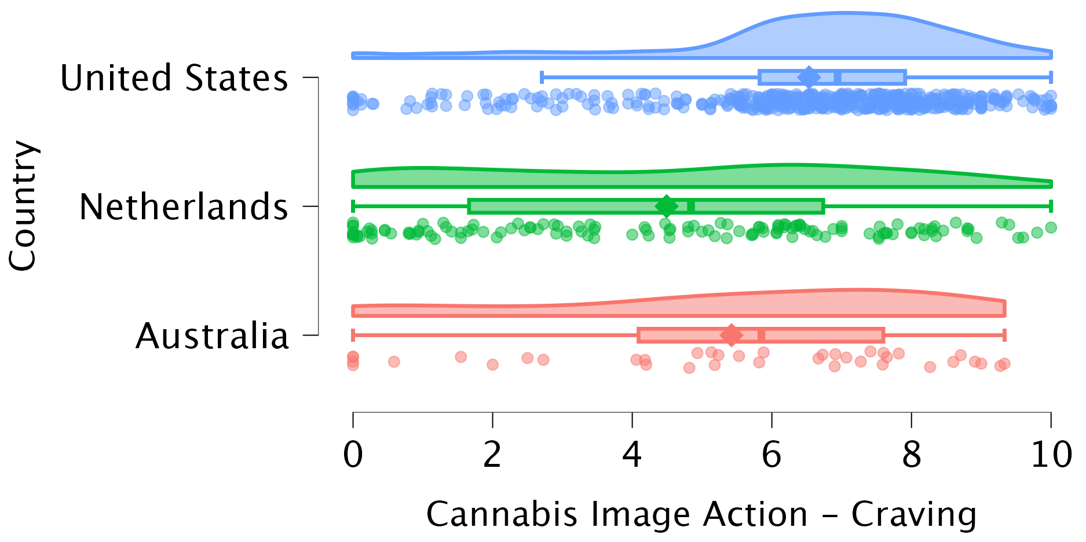
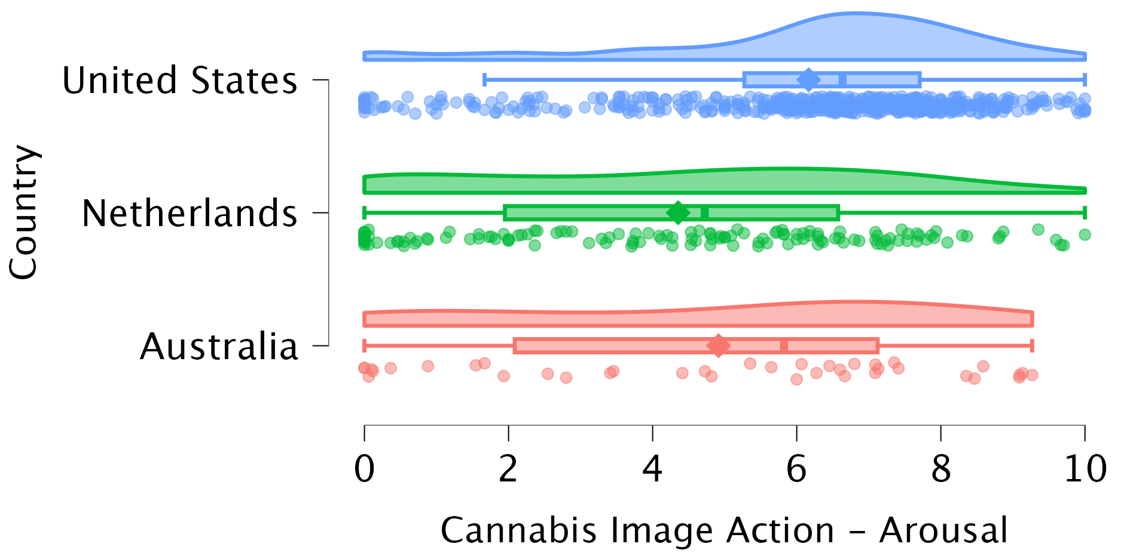
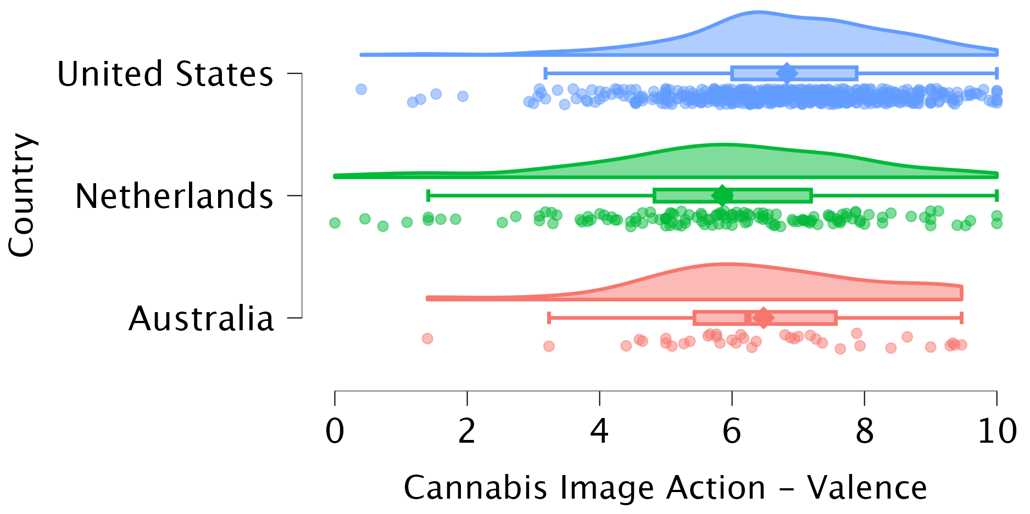

Figure S3. Overview of average craving, arousal and valence for cannabis images – action image subset - presented per country. Diamond represents the mean.

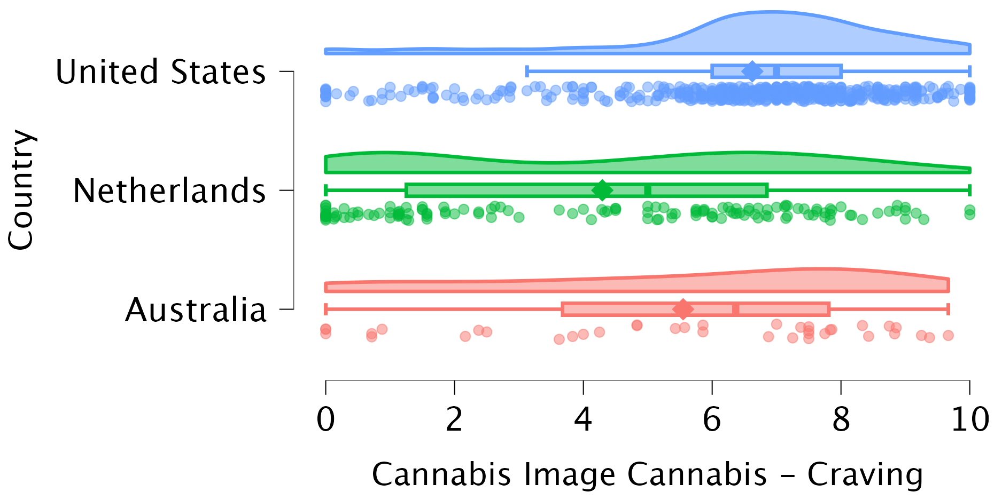
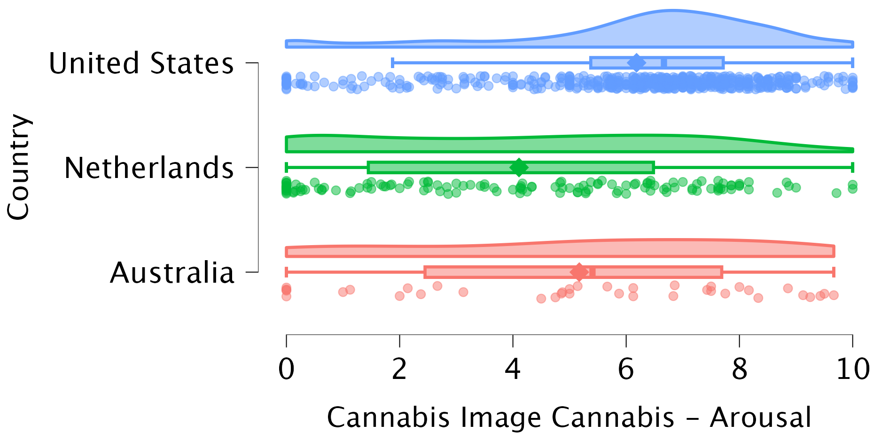
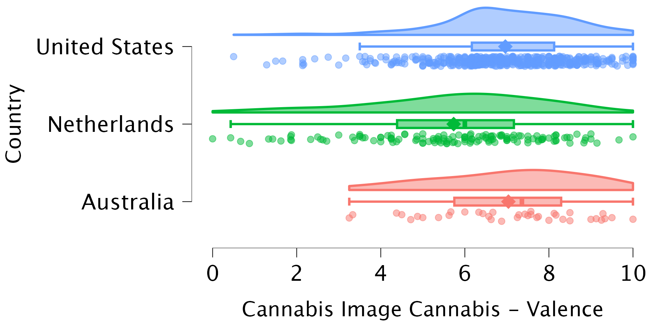

Figure S4. Overview of average craving, arousal and valence for cannabis images – cannabis image subset - presented per country. Diamond represents the mean.

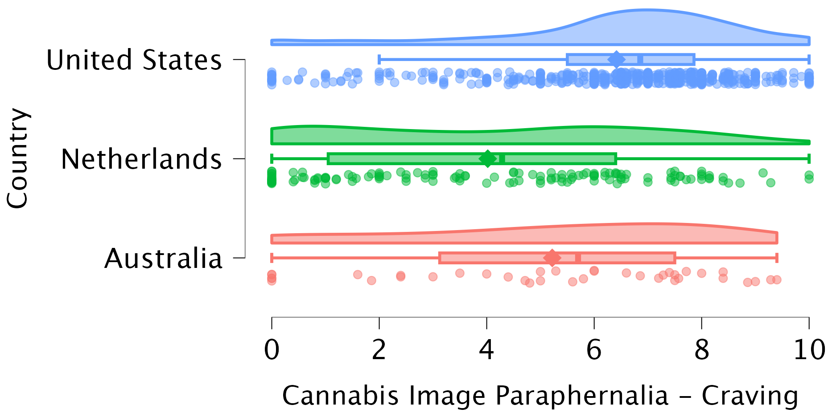
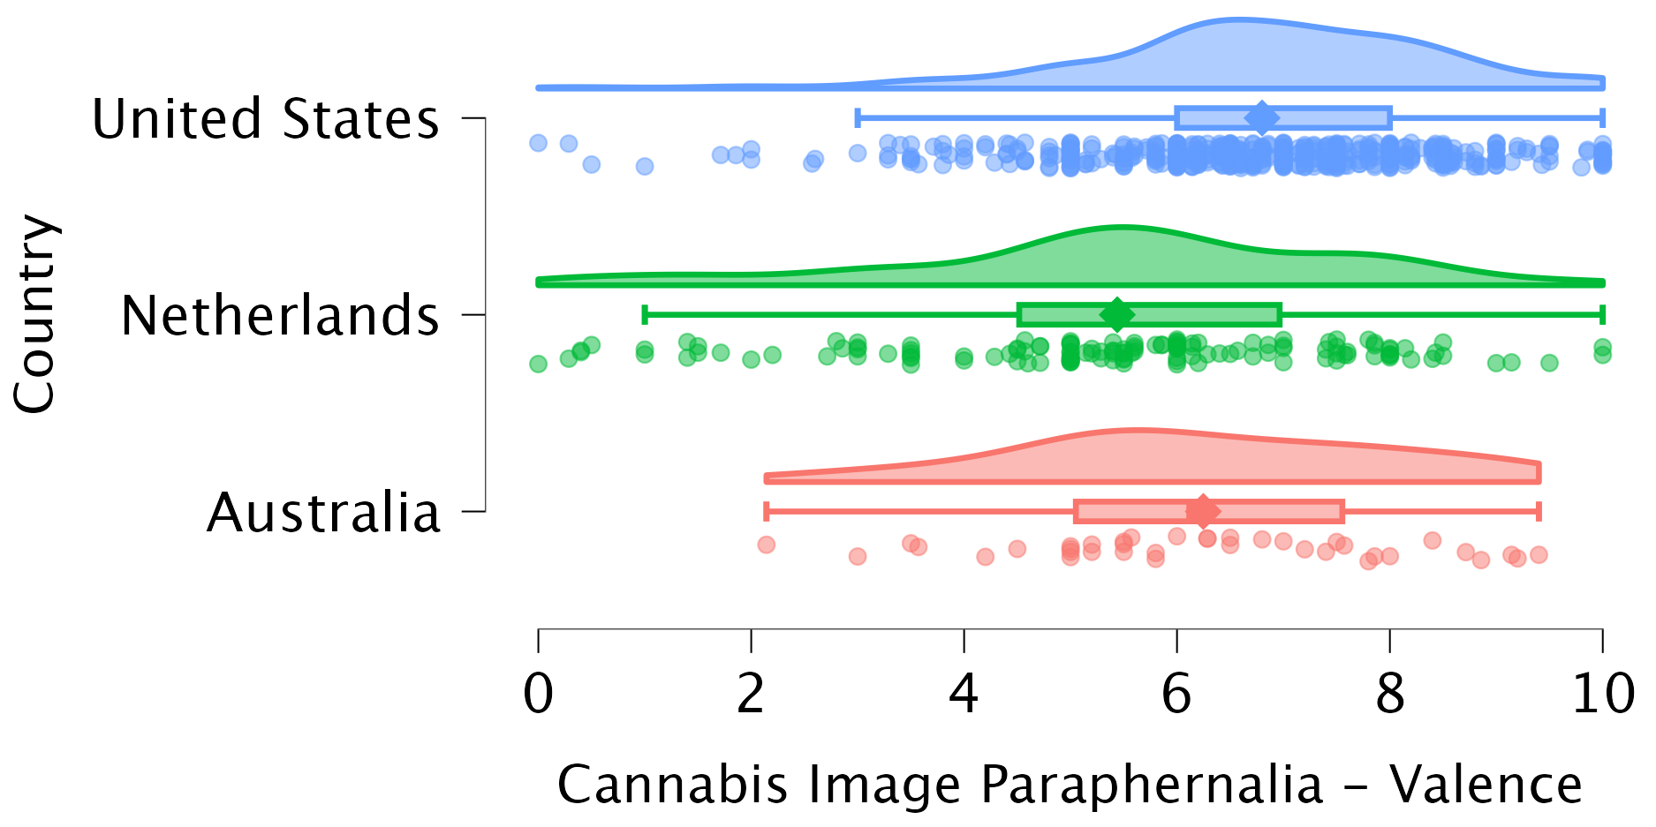

Figure S5. Overview of average craving, arousal and valence for cannabis images – paraphernalia image subset - presented per country. Diamond represents the mean.

