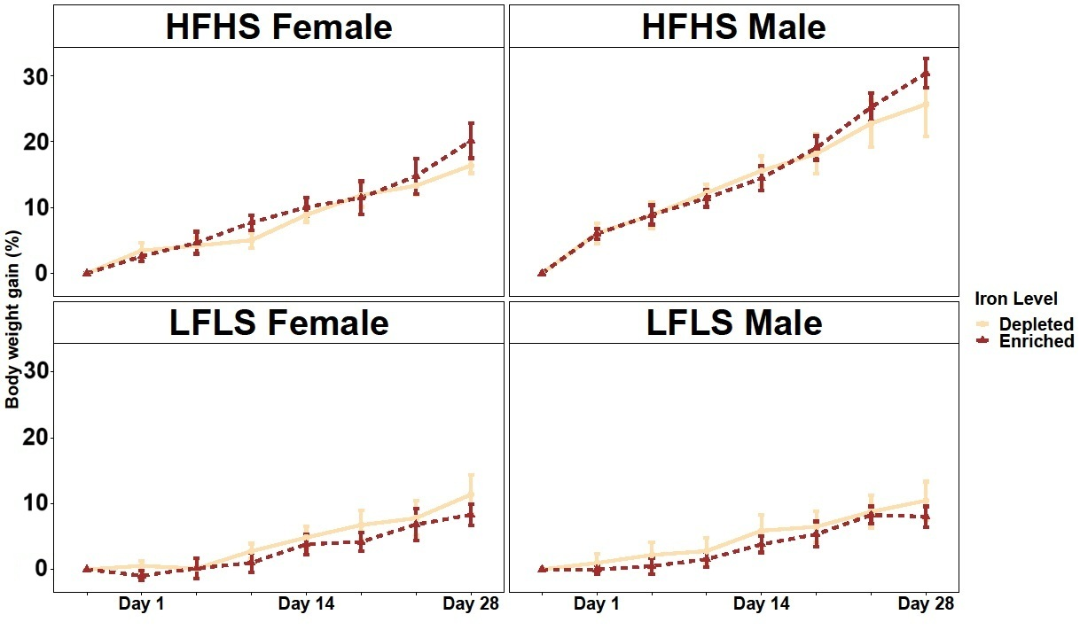
Figure S1: Weight gain in female and male mice fed with fed Fe-enriched and Fe-depleted LFLS or HFHS diets. Groups of 12 mice (6F/6M) were fed Fe-enriched and/or Fe-depleted diets for 28 days. Generalized linear regression models were used to identify the effects of time or Fe and interactions. Data are expressed as mean ± SEM (n = 6).

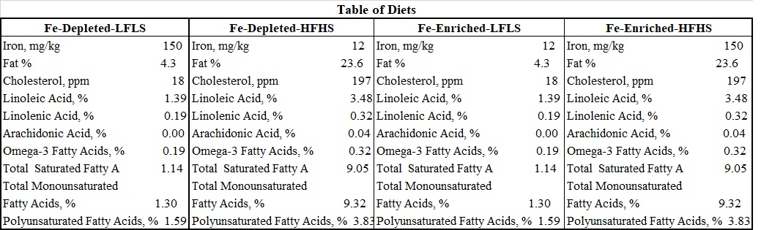
Table S1: Lipid and Fe content of diets.

