Supplementary figures
Fig S1 Emergency department asthma attendances by age group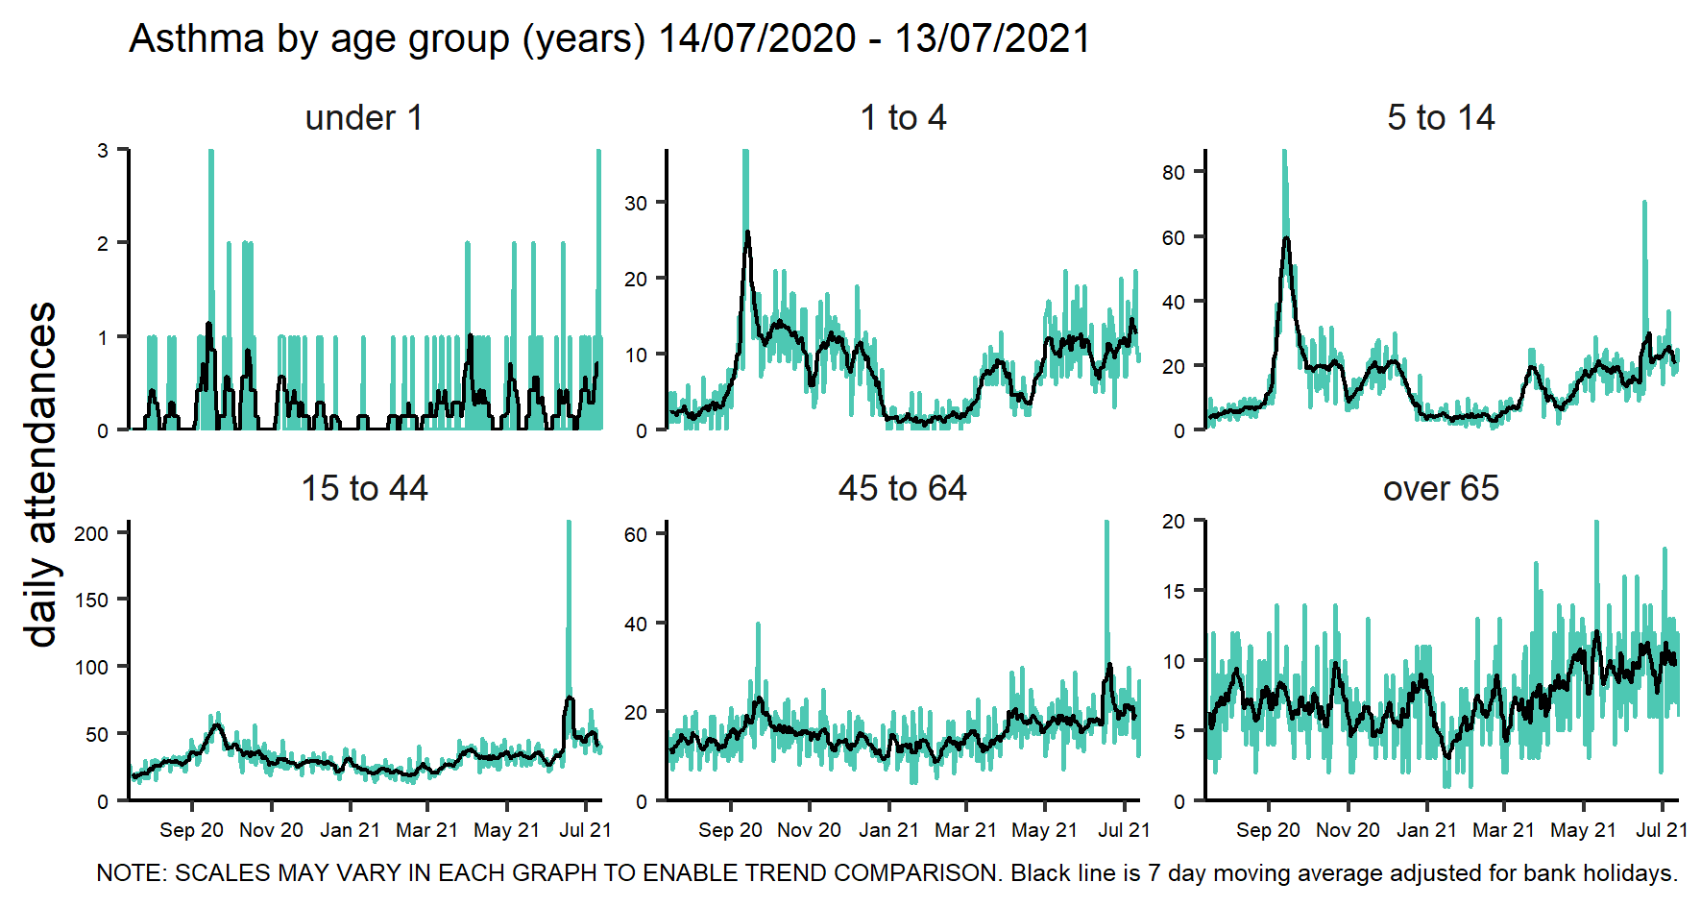
Fig S2 Emergency department asthma attendances by region of England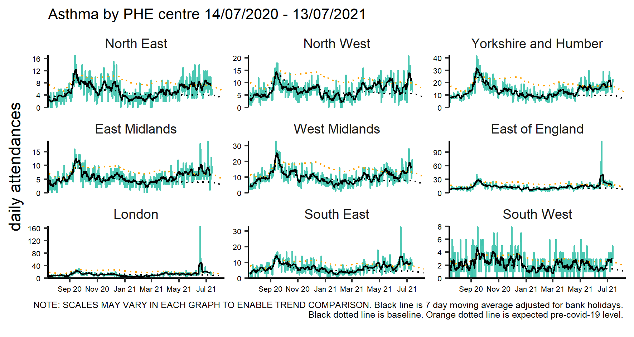
Fig S3 NHS 111 difficulty breathing calls by age group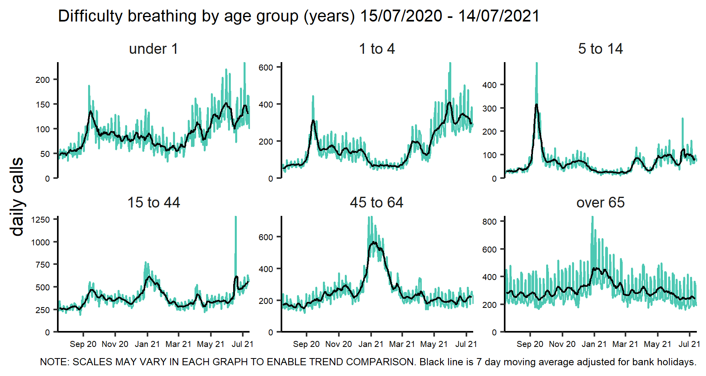
Fig S4 NHS 111 difficulty breathing calls by region of England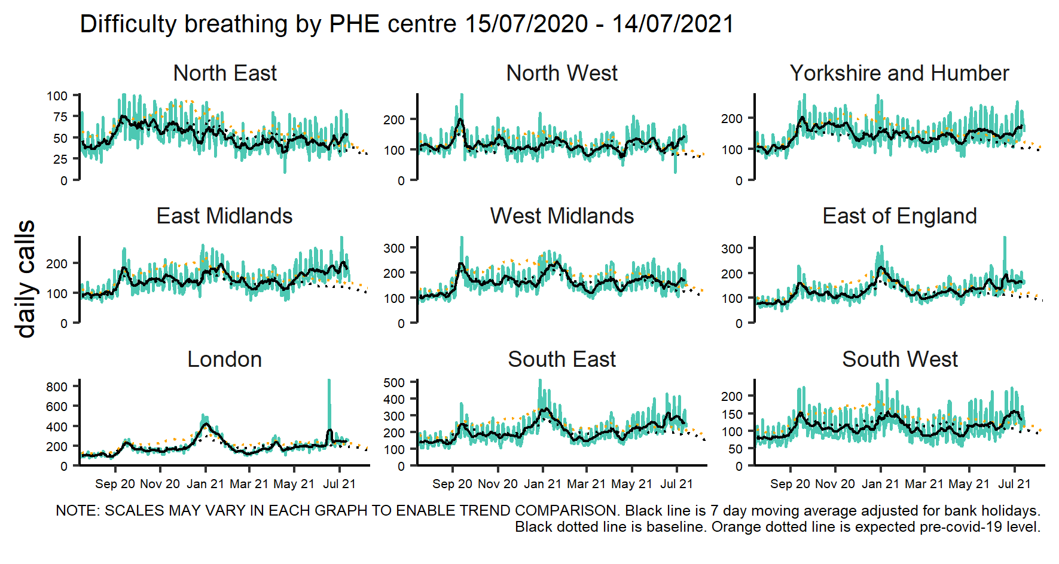
Fig S5 GP out of hours difficulty breathing/wheeze/asthma contacts by age group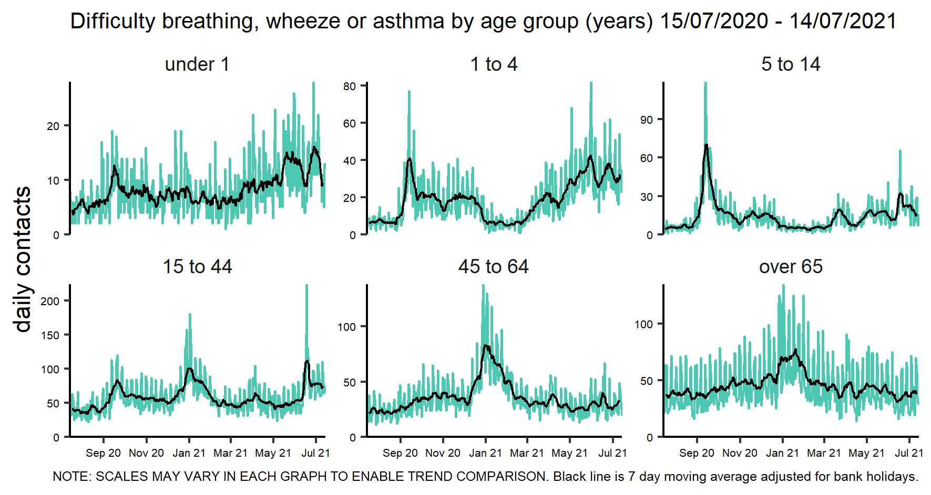
Fig S6 GP out of hours difficulty breathing/wheeze/asthma contacts by region of England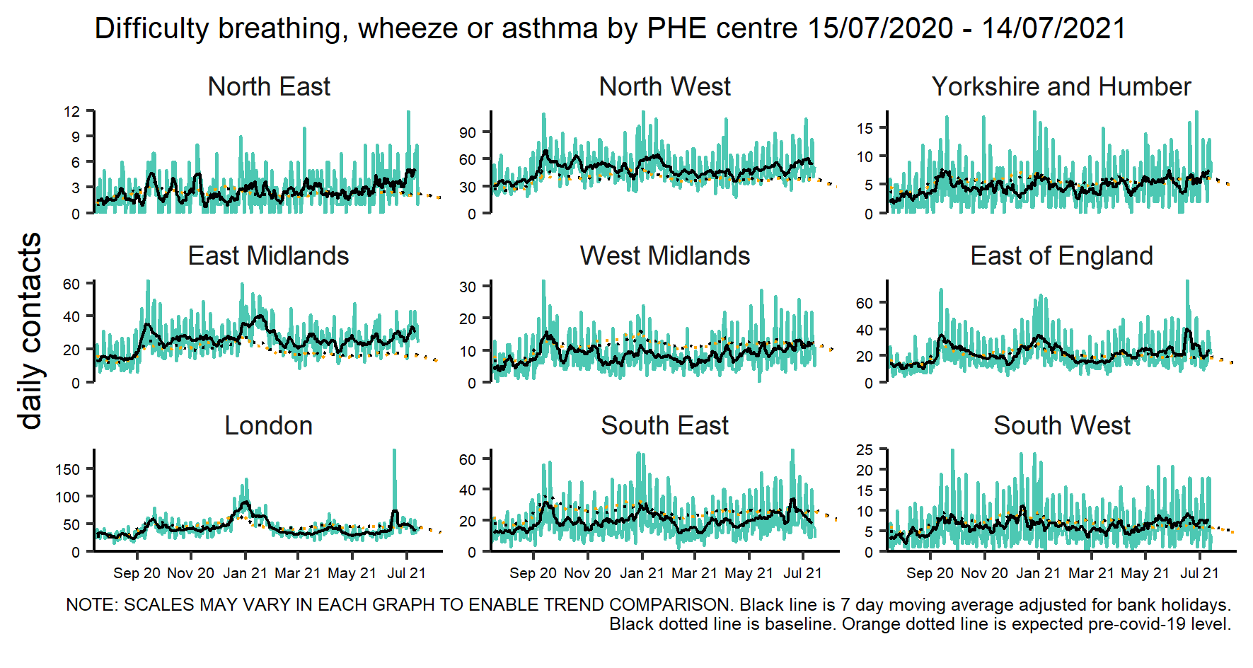
Fig S7 Ambulance breathing problems calls by region of England