Supplemental Materials for:

The Impact of Oral Cannabis Consumption During Pregnancy on Maternal Spiral Artery Remodelling, Fetal Growth and Offspring Behaviour in Mice

Tyrah M. Ritchie, Emily Feng, Fatemeh Vahedi, Sofya Ermolina, Christian J. Bellissimo, Erica DeJong, Ana L. Portillo, Sophie M. Poznanski, Lauren Chan, Sara M. Ettehadieh, Deborah M. Sloboda, Dawn M.E. Bowdish, and Ali A. Ashkar*

*Correspondence to: ashkara@mcmaster.ca

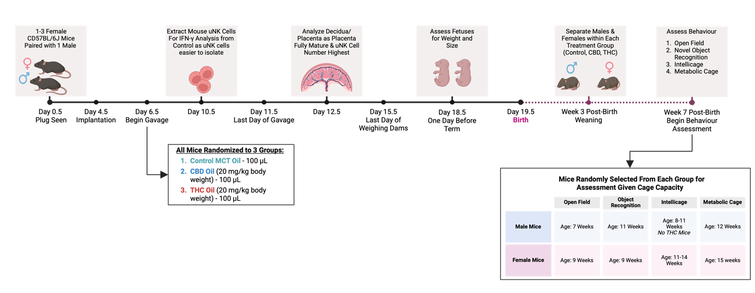
Supplemental Figure S1: Study Timeline. Graphic illustrating the experimental timeline and administration of cannabis oils to pregnant CD57BL/6J mice.

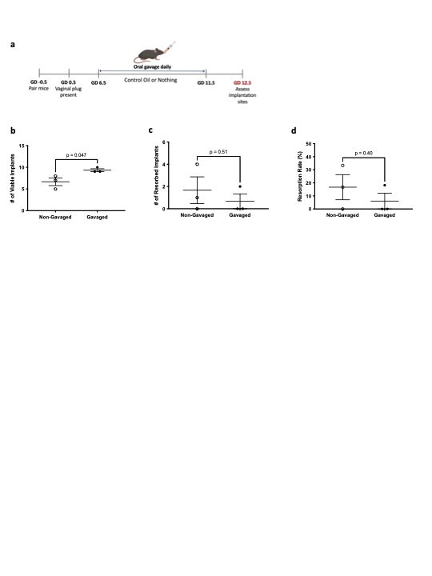

Supplemental Figure S2. Daily gavage of control oil does not affect fetal resorption by GD 12.5. Pregnant mice received either daily administration of 100 μL of control oil from GD 6.5-11.5 or were left untouched. a: Schematic illustrating experiment timeline. b-d: Following euthanization on GD 12.5 the uteri were excised, and implantation sites observed (n = 3 per group). b: Number of implants appearing viable. c: Number of resorbed implants. d: Resorption rate shown as percent of implants resorbed out of total implants. Data are means ± SEM. *P<0.05 (b-d two-tailed t test).

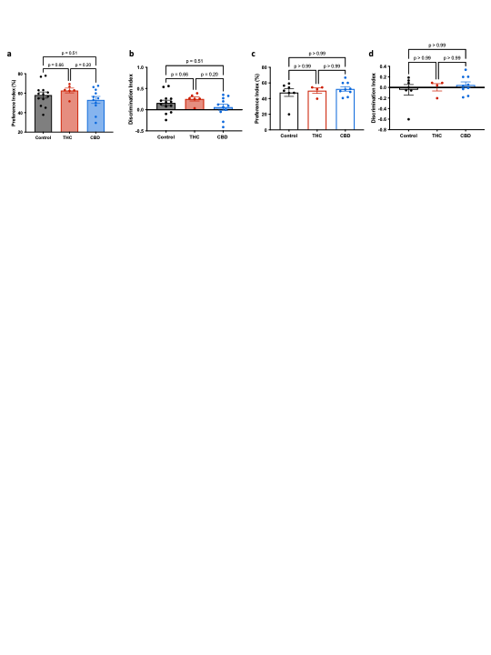
Supplemental Figure S3. Novel object recognition in mice exposed to cannabis in utero. Mice exposed to cannabis in utero were subject to novel object recognition testing for 10 minutes. a-b: Male mice. a: Preference index showing percentage of time spent exploring the new object (n = 6-13 per group). b: Discrimination index assessing ability to discriminate between novel and familiar objects (n = 6-13 per group). c-d: Female mice. c: Preference index (n = 4-9 per group). d: Discrimination index (n = 4-9 per group). Data are means ± SEM. (a-b: one-way ANOVA; c-d: Kuskal-Wallis test).

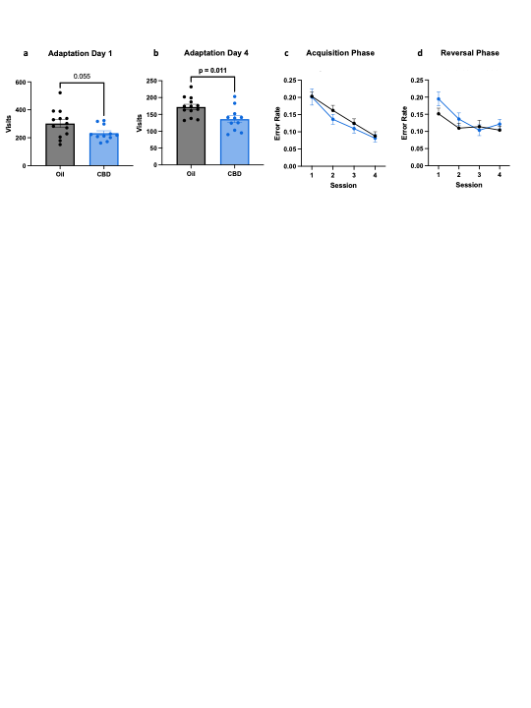
Supplemental Figure S4: Male mice exposed to CBD oil in utero exhibit lower levels of activity in the IntelliCage. Male mice exposed to CBD or control oil in utero were monitored in the IntelliCage system in separate cages. a: number of visits during adaptation phase day 1 (n = 11-13 per group). b: number of visits on adaptation phase day 4 (n = 11-13 per group). c: Error rate over the four-day acquisition phase (n = 11-13 per group). d: Error rate over the four-day reversal phase (n = 11-13 per group). Data are means ± SEM, *P<0.05 (a-b two-tailed t-test; c-d two-way ANOVA).

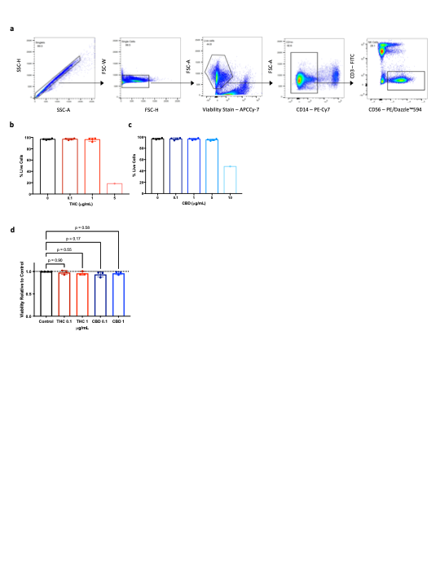
Supplemental Figure S5. Viability and gating strategy of human NK cells exposed to cannabinoids. a-c: Freshly isolated human PBMCs were stimulated with IL-15 in the presence or absence of various concentrations of THC and CBD. a: Gating strategy for flow cytometry to identify pbNK cells. b: Dose titration of THC shown as percent live cells (n = 1-4 per group). c: Dose titration of CBD shown as percent live cells (n = 1-4 per group). d: Viability of NKreg cells relative to control after six-day culture with THC or CBD (n = 3-4 per group). Data are means ± SEM.

