Appendix Tables 1–5

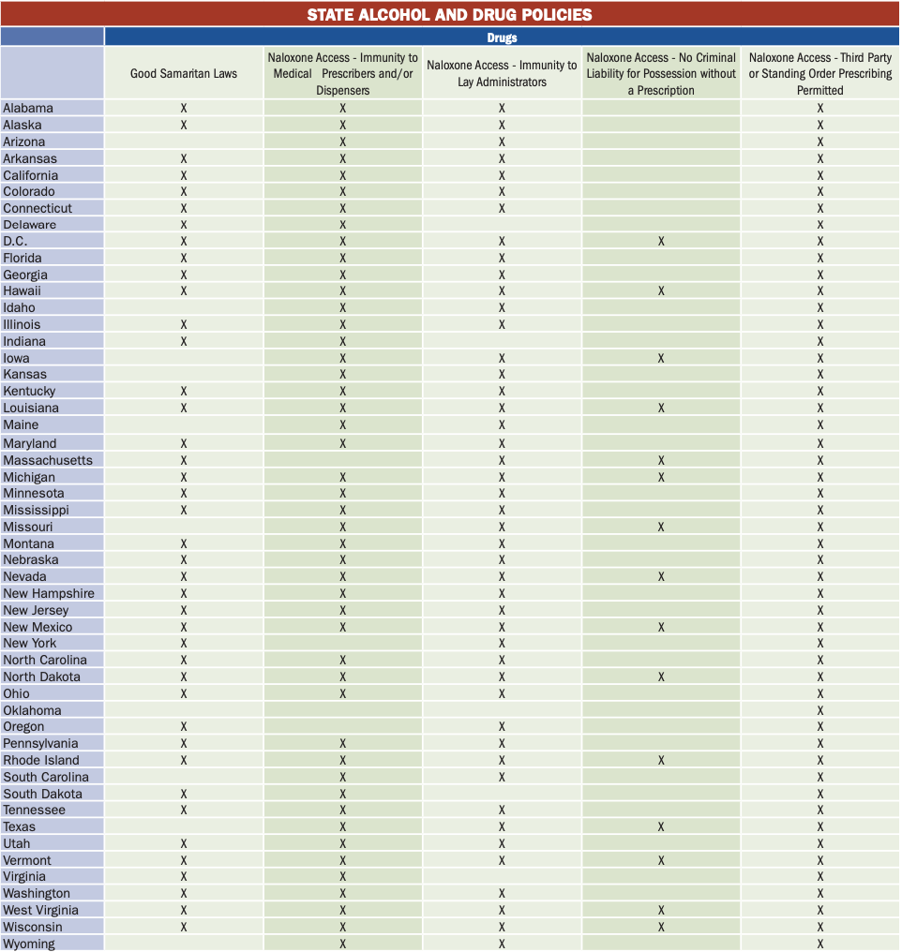
Table 1. State Drug Policies, including Good Samaritan Laws and Naloxone Access *

*Segal, L. M., De Biasi, A., Mueller, J. L., May, K., & Warren, M. (2017). Pain in the Nation: The Drug, Alcohol, and Suicide Crises and the Need for a National Resilience Strategy Retrieved from https://www.tfah.org/report-details/pain-in-the-nation/

Table 2. State Drug Policies, including Prescription Drug Monitoring Programs *
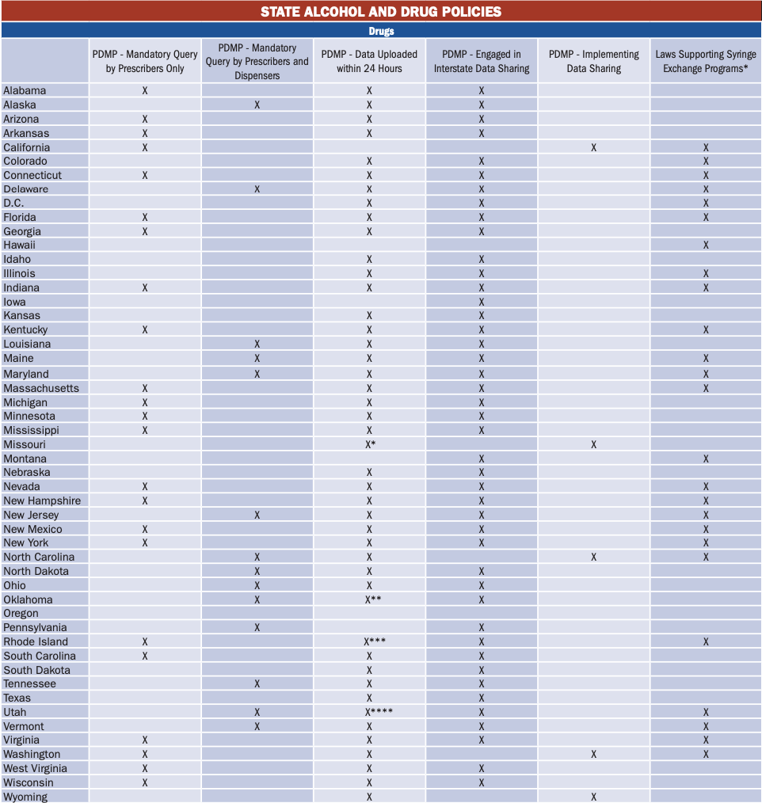
* Segal, L. M., De Biasi, A., Mueller, J. L., May, K., & Warren, M. (2017). Pain in the Nation: The Drug, Alcohol, and Suicide Crises and the Need for a National Resilience Strategy Retrieved from https://www.tfah.org/report-details/pain-in-the-nation/

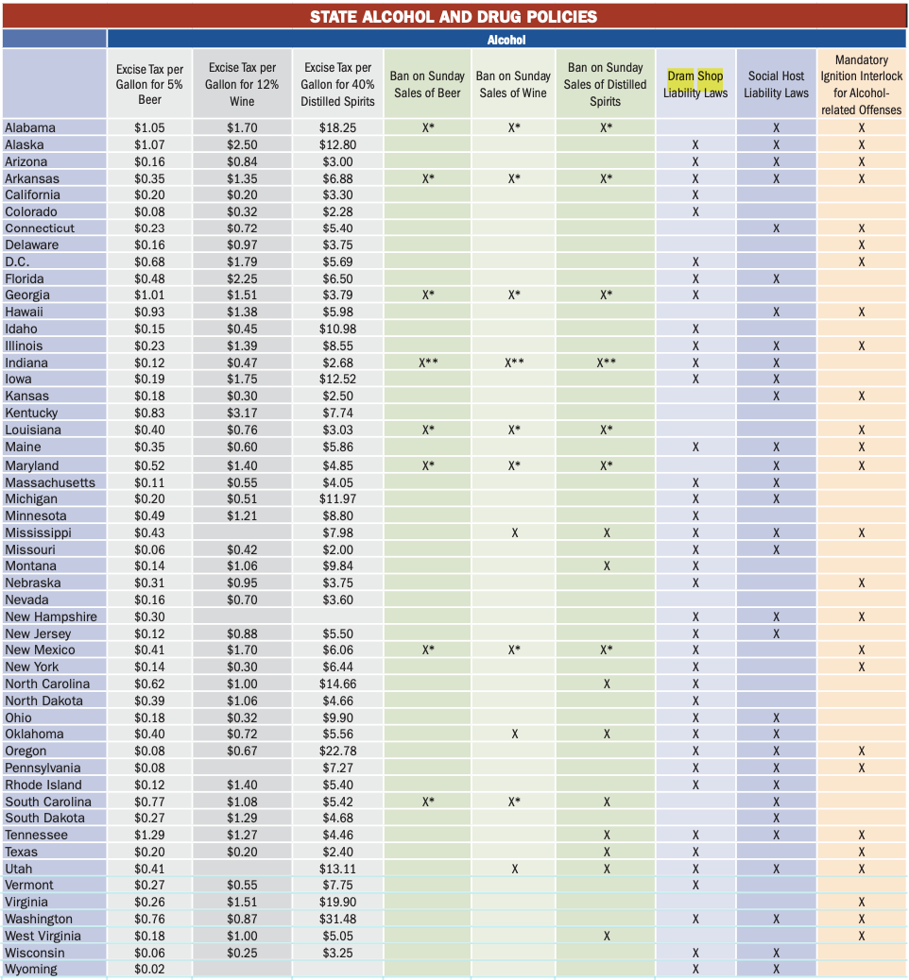
Table 3. State Alcohol Policies *
* Segal, L. M., De Biasi, A., Mueller, J. L., May, K., & Warren, M. (2017). Pain in the Nation: The Drug, Alcohol, and Suicide Crises and the Need for a National Resilience Strategy Retrieved from https://www.tfah.org/report-details/pain-in-the-nation/

Table 4. Prevention Policy Indicators, Including State Mental Health Budget Status *
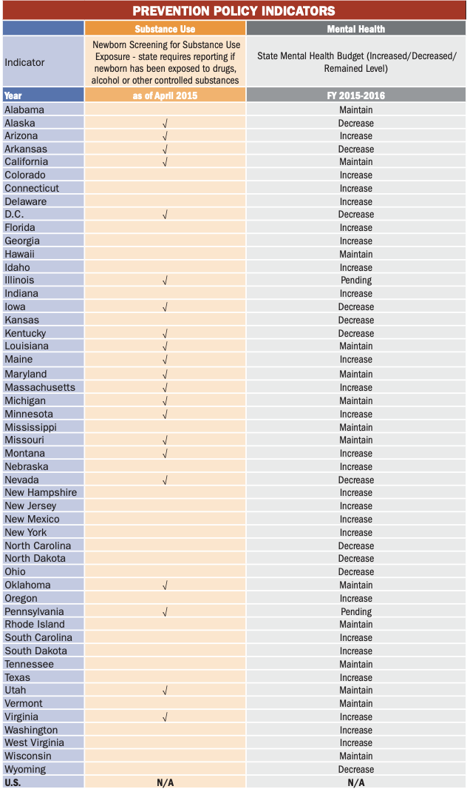

* Segal, L. M., De Biasi, A., Mueller, J. L., May, K., & Warren, M. (2017). Pain in the Nation: The Drug, Alcohol, and Suicide Crises and the Need for a National Resilience Strategy Retrieved from https://www.tfah.org/report-details/pain-in-the-nation/

Table 5. Overview and Objectives of Healthy People 2030