Supplementary Material

Navy Bean and Rice Bran Intake Alters the Plasma Metabolome of Children at Risk for Cardiovascular Disease
Katherine J. Li, Erica C. Borresen, NaNet Jenkins-Puccetti, Gary Luckasen, Elizabeth P. Ryan*
* Correspondence: Elizabeth P. Ryan: e.p.ryan@colostate.edu

Supplementary Figures and Tables

Supplementary Figures
Supplemental Figure 1. Cytoscape pathway visualizations of amino acid metabolites modulated by Navy Bean, Rice Bran, or Navy Bean + Rice Bran consumption. Amino acid metabolites modulated by Navy Bean, Rice Bran, or Navy Bean + Rice Bran consumption for 4 weeks compared to control (a,c,e) or compared to respective baseline (b,d,f), respectively. Nodes in red and blue represent significantly increased and decreased metabolites, respectively, compared to control at 4 weeks or compared to baseline. Node diameters are proportional to the magnitude of the fold-difference. Numbers within nodes represent pathway enrichment scores.
(a)
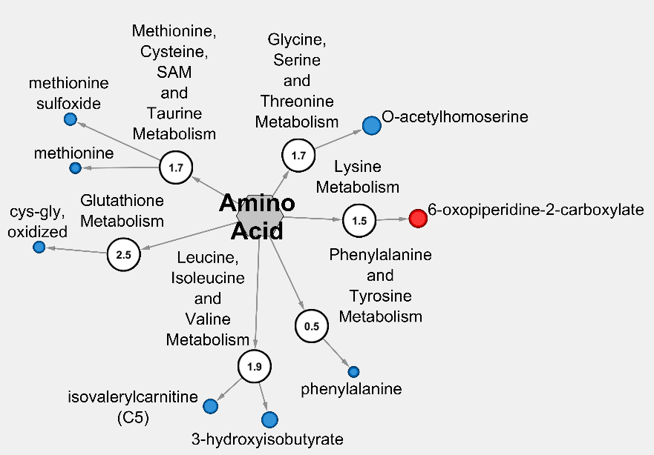
(b)
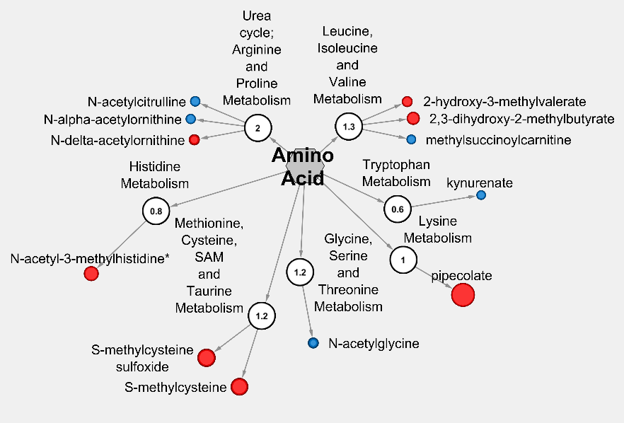
(c)
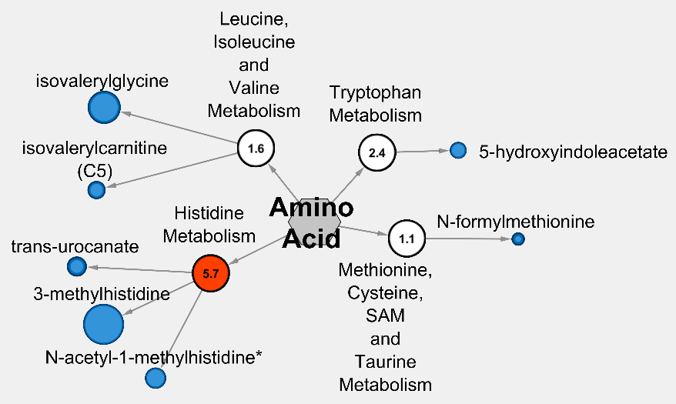
(d)
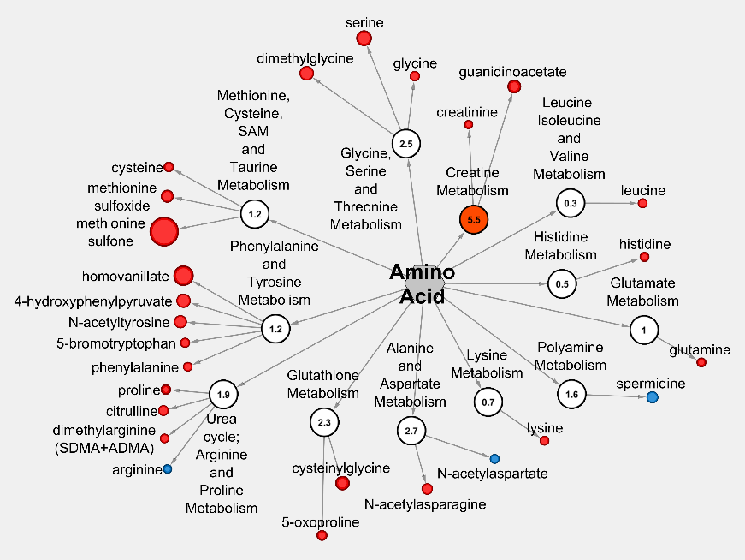
(e)
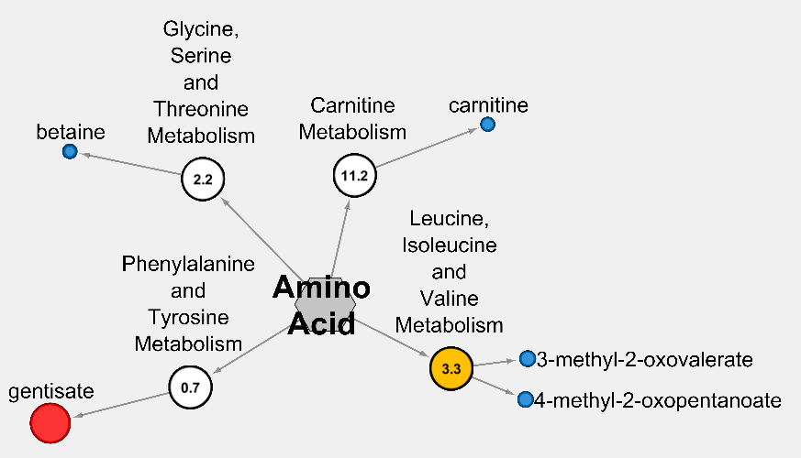
(f)
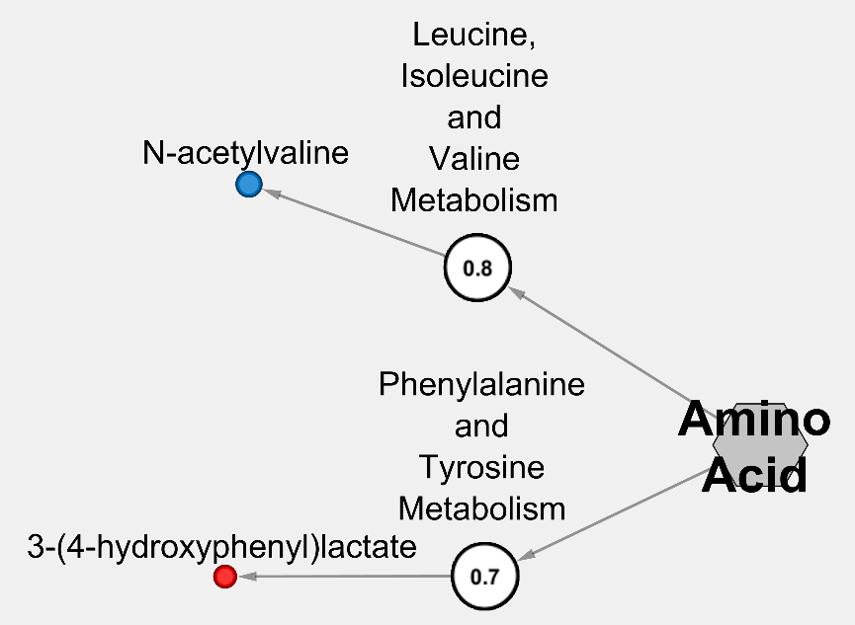
Supplemental Figure 2. Cytoscape pathway visualizations of phytochemicals and exogenous metabolites metabolites modulated by Navy Bean, Rice Bran, or Navy Bean + Rice Bran consumption. Phytochemicals and exogenous metabolites modulated by Navy Bean, Rice Bran, or Navy Bean + Rice Bran consumption for 4 weeks compared to control (a,c,e) or compared to respective baseline (b,d,f), respectively. Nodes in red and blue represent significantly increased and decreased metabolites, respectively, compared to control at 4 weeks or compared to baseline. Node diameters are proportional to the magnitude of the fold-difference. Numbers within nodes represent pathway enrichment scores.
(a)
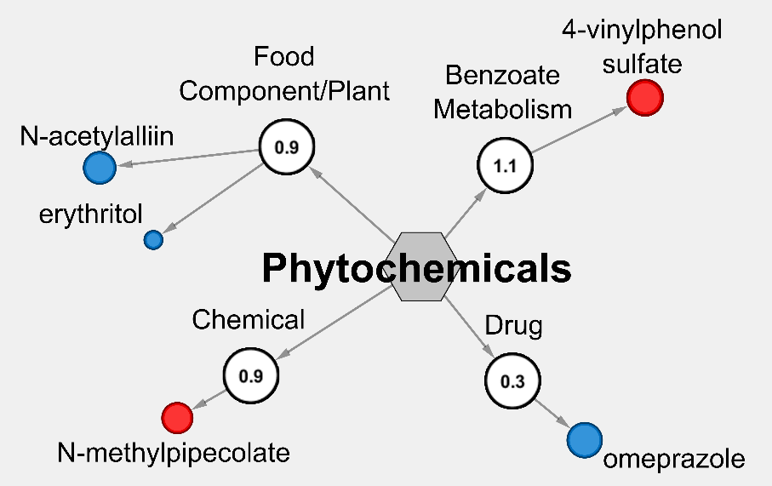
(b)
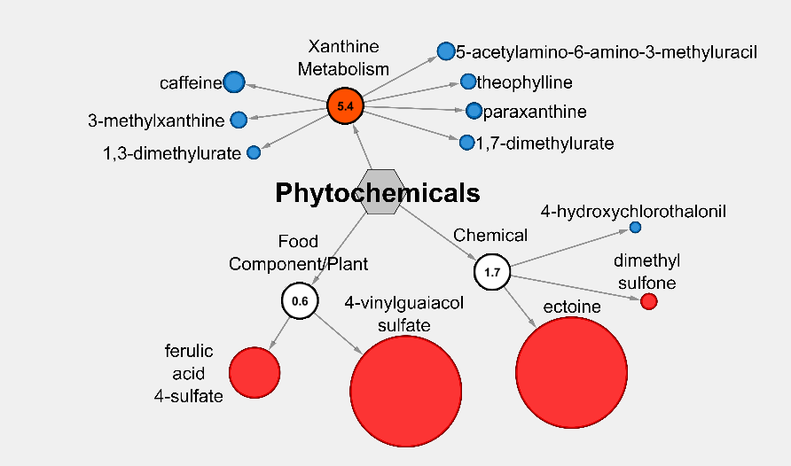

(c)
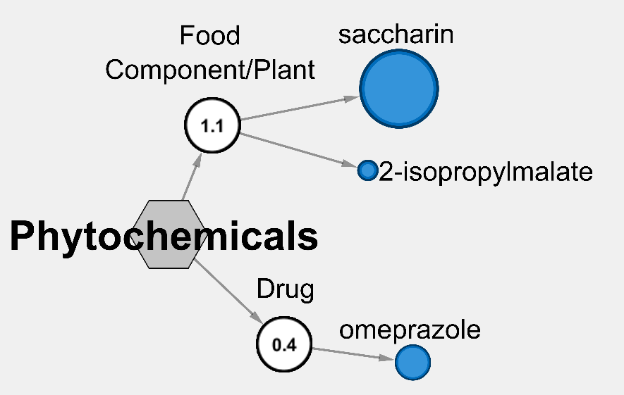
(d)
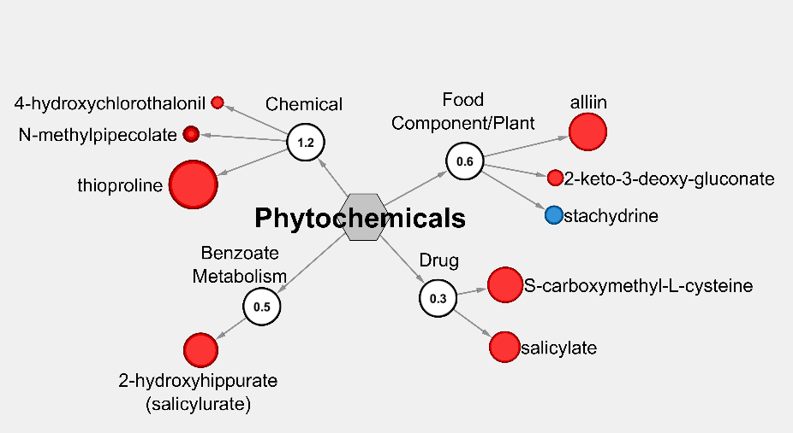
(e)
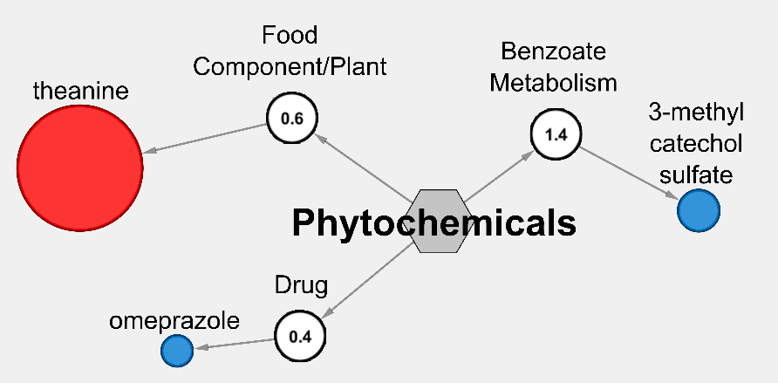
(f)
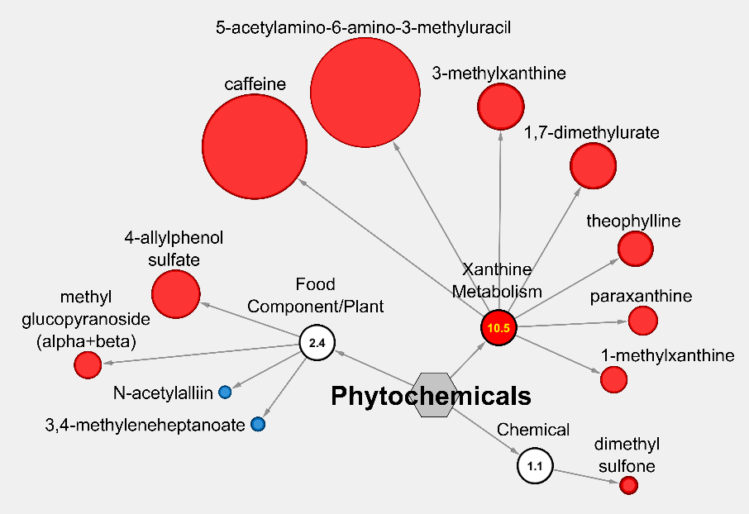

Supplementary Tables
Supplemental Table 1 Other Modulated Plasma Metabolites Following Navy Bean and/or
Rice Bran Consumption for 4 Weeks Compared to Baselineª
Metabolic Pathway |  | Metabolite | Fold-Change vs. Baseline^{b}
 |  | Metabolite | Control | Navy Bean | Rice Bran | Navy Bean + Rice Bran
Amino Acid
 | Gly, Ser & Thr Metabolism | glycine | 1.08 | 1.03 | 1.18↑* | 1.03
 | Gly, Ser & Thr Metabolism | N-acetylglycine | 0.77↓* | 0.76↓** | 1.18 | 0.93
 | Gly, Ser & Thr Metabolism | dimethylglycine | 1.29 | 0.93 | 1.65↑* | 0.93
 | Gly, Ser & Thr Metabolism | serine | 1.13 | 0.94 | 1.79↑** | 0.89
 | Ala & Asp Metabolism | N-acetylasparagine | 1.03 | 0.87 | 1.31↑* | 1.10
 | Ala & Asp Metabolism | N-acetylaspartate | 1.05 | 1.02 | 0.89↓* | 1.00
 | Glu Metabolism | glutamine | 1.02 | 1.03 | 1.12↑** | 0.99
 | His Metabolism | histidine | 1.04 | 0.99 | 1.14↑* | 1.03
 | His Metabolism | N-acetyl-3-methylhistidine | 1.11 | 1.79↑* | 0.86 | 1.00
 | Lys Metabolism | lysine | 1.11 | 1.00 | 1.12↑* | 1.04
 | Lys Metabolism | pipecolate | 1.85 | 2.86↑* | 1.52 | 1.53
 | Phe & Tyr Metabolism | phenylalanine | 1.07 | 0.97 | 1.11↑* | 1.04
 | Phe & Tyr Metabolism | tyrosine | 1.18↑* | 0.94 | 1.13 | 1.08
 | Phe & Tyr Metabolism | N-acetyltyrosine | 1.20 | 0.99 | 1.50↑* | 1.11
 | Phe & Tyr Metabolism | 4-hydroxyphenylpyruvate | 1.14 | 1.05 | 1.63↑* | 0.96
 | Phe & Tyr Metabolism | 3-(4-hydroxyphenyl) lactate | 1.00 | 0.98 | 1.05 | 1.17↑*
 | Phe & Tyr Metabolism | homovanillate | 1.49 | 1.19 | 2.32↑** | 1.02
 | Phe & Tyr Metabolism | N-formylphenylalanine | 1.15↑* | 1.96 | 1.16 | 1.14
 | Phe & Tyr Metabolism | 5-bromotryptophan | 1.08 | 1.06 | 1.15↑* | 1.01
 | Trp Metabolism | indolepropionate | 1.91↑* | 1.60 | 1.11 | 1.12
 | Trp Metabolism | kynurenate | 1.04 | 0.87↓* | 1.15 | 1.01
 | Trp Metabolism | 5-hydroxyindoleacetate | 1.47↑* | 0.97 | 0.91 | 1.08
 | Trp Metabolism | thioproline | 1.61 | 1.03 | 4.29↑** | 0.73
 | Leu, Ile & Val Metabolism | leucine | 1.07 | 0.94 | 1.14↑* | 1.01
 | Leu, Ile & Val Metabolism | isovalerylglycine | 3.83↑** | 1.57 | 1.25 | 0.86
 | Leu, Ile & Val Metabolism | 2,3-dihydroxy-2-methylbutyrate | 1.27 | 1.57↑* | 0.83 | 1.09
 | Leu, Ile & Val Metabolism | 2-hydroxy-3-methylvalerate | 0.98 | 1.32↑* | 0.95 | 1.00
 | Leu, Ile & Val Metabolism | N-acetylvaline | 1.41 | 0.97 | 1.32 | 0.76↓*
 | Leu, Ile & Val Metabolism | methylsuccinoylcarnitine (1) | 1.09 | 0.85↓* | 1.10 | 1.06
 | Met, Cys, SAM and Taurine Metabolism | methionine sulfone | 1.27 | 0.95 | 3.34↑** | 0.85
 | Met, Cys, SAM and Taurine Metabolism | methionine sulfoxide | 1.27 | 0.88 | 1.48↑* | 0.98
 | Met, Cys, SAM and Taurine Metabolism | cystathionine | 2.85↑** | 1.56 | 1.81 | 1.35
 | Met, Cys, SAM and Taurine Metabolism | cysteine | 1.02 | 0.97 | 1.20↑* | 1.03
 | Met, Cys, SAM and Taurine Metabolism | S-methylcysteine | 1.31 | 2.12↑** | 1.31 | 1.33
 | Met, Cys, SAM and Taurine Metabolism | S-methylcysteine sulfoxide | 1.34 | 2.19↑** | 1.62 | 1.79
 | Met, Cys, SAM and Taurine Metabolism | cysteine sulfinic acid | 0.76↓* | 0.87 | 1.00 | 1.21
 | Urea cycle; Arg & Pro Metabolism | arginine | 0.99 | 1.01 | 0.92↓* | 1.07
 | Urea cycle; Arg & Pro Metabolism | proline | 1.02 | 0.98 | 1.20↑** | 1.07
 | Urea cycle; Arg & Pro Metabolism | citrulline | 1.09 | 1.04 | 1.23↑* | 0.94
 | Urea cycle; Arg & Pro Metabolism | dimethylarginine (SDMA + ADMA) | 1.01 | 0.98 | 1.09↑* | 1.01
 | Urea cycle; Arg & Pro Metabolism | N-delta-acetylornithine | 1.01 | 1.33↑* | 0.94 | 1.10
 | Urea cycle; Arg & Pro Metabolism | N-alpha-acetylornithine | 1.21 | 0.81↓* | 1.04 | 1.21
 | Urea cycle; Arg & Pro Metabolism | N-acetylcitrulline | 1.34 | 0.80↓* | 1.02 | 1.65
 | Creatine Metabolism | creatinine | 0.97 | 0.98 | 1.06↑** | 1.00
 | Creatine Metabolism | guanidinoacetate | 1.19 | 1.09 | 1.58↑** | 1.04
 | Polyamine Metabolism | spermidine | 3.20 | 2.59 | 0.73↓* | 2.96
 | Glutathione Metabolism | cysteinylglycine | 1.03 | 1.13 | 1.64↑** | 1.19
 | Glutathione Metabolism | 5-oxoproline | 1.04 | 1.00 | 1.23↑** | 1.01
Peptide
 | Gamma-glutamyl Amino Acid | gamma-glutamylglutamate | 1.16 | 0.93 | 2.17↑*** | 0.86
 | Gamma-glutamyl Amino Acid | gamma-glutamylglutamine | 1.02 | 1.00 | 1.45↑*** | 0.98
 | Gamma-glutamyl Amino Acid | gamma-glutamylhistidine | 1.20 | 0.94 | 1.53↑* | 1.16
 | Gamma-glutamyl Amino Acid | gamma-glutamylleucine | 1.05 | 1.04 | 1.36↑** | 0.96
 | Gamma-glutamyl Amino Acid | gamma-glutamyl-alpha-lysine | 1.09 | 0.98 | 1.21↑* | 1.07
 | Gamma-glutamyl Amino Acid | gamma-glutamyl-epsilon-lysine | 0.84↓* | 1.00 | 1.09 | 1.34
 | Gamma-glutamyl Amino Acid | gamma-glutamylphenylalanine | 1.06 | 1.02 | 1.68↑** | 1.44
 | Gamma-glutamyl Amino Acid | gamma-glutamylthreonine | 1.46 | 1.05 | 2.27↑* | 0.91
 | Gamma-glutamyl Amino Acid | gamma-glutamyltryptophan | 1.02 | 0.95 | 1.32↑* | 0.90
 | Gamma-glutamyl Amino Acid | gamma-glutamyltyrosine | 1.12 | 0.93 | 1.16 | 1.23↑*
 | Gamma-glutamyl Amino Acid | gamma-glutamylvaline | 1.04 | 1.02 | 1.28↑* | 1.02
 | Fibrinogen Cleavage Peptide | DSGEGDFXAEGGGVR | 3.04 | 1.00 | 1.36 | 5.15↑*
 | Acetylated Peptides | phenylacetylglutamate | 1.00 | 1.33 | 0.91 | 1.87↑*
 | Acetylated Peptides | phenylacetylglutamine | 0.76↓* | 0.91 | 0.97 | 1.72
Carbohydrate
 | Glycolysis, Gluconeogenesis, and Pyruvate Metabolism | glucose | 0.96 | 1.05 | 0.91↓* | 1.08
 | Glycolysis, Gluconeogenesis, and Pyruvate Metabolism | glycerate | 0.89 | 0.94 | 0.80↓** | 1.05
 | Pentose Metabolism | arabitol/xylitol | 0.99 | 1.00 | 1.17↑** | 1.02
 | Pentose Metabolism | arabonate/xylonate | 0.86 | 1.08 | 0.84↓* | 1.13
 | Disaccharides and Oligosaccharides | sucrose | 0.77 | 1.89 | 0.80 | 2.60↑*
 | Aminosugar Metabolism | erythronate | 0.99 | 1.01 | 0.90↓* | 0.99
 | Aminosugar Metabolism | N-acetylglucosamine/N-acetylgalactosamine | 1.04 | 1.00 | 1.18↑** | 0.99
Energy
 | TCA Cycle | citrate | 1.01 | 0.97 | 1.09↑** | 0.97
 | TCA Cycle | fumarate | 2.65 | 2.37 | 0.41↓** | 1.41
Nucleotide
 | Purine Metabolism, (Hypo)Xanthine/Inosine containing | hypoxanthine | 2.15↑* | 1.04 | 3.15↑* | 0.90
 | Purine Metabolism, (Hypo)Xanthine/Inosine containing | N1-methylinosine | 1.05 | 0.90 | 1.36↑** | 0.97
 | Purine Metabolism, (Hypo)Xanthine/Inosine containing | allantoin | 0.82↓** | 0.76↓*** | 0.71↓*** | 1.07
 | Purine Metabolism, Adenine containing | adenosine 3',5'-cyclic monophosphate | 0.82↓* | 1.19 | 1.36 | 1.10
 | Purine Metabolism, Adenine containing | N6-carbamoylthreonyladenosine | 1.05 | 1.04 | 1.23↑* | 1.05
 | Purine Metabolism, Guanine containing | guanosine | 15.48↑* | 0.93 | 2.95 | 1.06
 | Pyrimidine Metabolism, Orotate containing | dihydroorotate | 1.40 | 2.25 | 2.58↑* | 0.93
 | Pyrimidine Metabolism, Uracil containing | uridine | 1.14 | 0.96 | 1.27↑* | 1.00
 | Pyrimidine Metabolism, Uracil containing | N-acetyl-beta-alanine | 1.06 | 0.93 | 1.18↑* | 1.01
 | Pyrimidine Metabolism, Cytidine containing | cytidine | 3.46 | 3.67 | 0.65↓* | 3.02
Cofactors/Vitamins
 | Nicotinate and Nicotinamide Metabolism | trigonelline (N'-methylnicotinate) | 2.42 | 7.65↑** | 2.25 | 1.15
 | Pantothenate and CoA Metabolism | pantothenate | 1.05 | 0.92 | 1.32↑** | 1.00
 | Ascorbate and Aldarate Metabolism | ascorbate (Vitamin C) | 1.25 | 1.43 | 3.55 | 1.99↑*
 | Tocopherol Metabolism | alpha-CEHC sulfate | 0.90 | 1.60 | 2.11 | 0.70↓*
 | Hemoglobin and Porphyrin Metabolism | bilirubin (Z,Z) | 1.46 | 1.34 | 2.20↑** | 0.93
 | Hemoglobin and Porphyrin Metabolism | bilirubin (E,E) | 0.69↓** | 0.64↓*** | 1.06 | 1.03
 | Hemoglobin and Porphyrin Metabolism | bilirubin (E,Z or Z,E) | 1.19 | 1.20 | 1.70↑** | 0.93
 | Vitamin B6 Metabolism | pyridoxal | 1.32 | 1.67 | 3.96↑* | 1.96
Phytochemicals/Other
 | Benzoate Metabolism | 2-hydroxyhippurate (salicylurate) | 1.88 | 1.34 | 3.05↑* | 3.82
 | Xanthine Metabolism | caffeine | 5.68 | 0.50↓* | 3.94 | 9.59↑*
 | Xanthine Metabolism | paraxanthine | 2.65↑* | 0.65↓* | 1.61 | 2.73↑*
 | Xanthine Metabolism | theophylline | 2.60 | 0.68↓* | 1.33 | 3.30↑*
 | Xanthine Metabolism | 1,3-dimethylurate | 1.25 | 0.79↓* | 1.22 | 1.29
 | Xanthine Metabolism | 1,7-dimethylurate | 2.96 | 0.71↓* | 1.70 | 4.29↑**
 | Xanthine Metabolism | 1-methylxanthine | 1.17 | 0.97 | 1.08 | 2.50↑*
 | Xanthine Metabolism | 3-methylxanthine | 2.24 | 0.64↓* | 2.03 | 4.32↑*
 | Xanthine Metabolism | 5-acetylamino-6-amino-3-methyluracil | 7.28↑* | 0.60↓* | 3.06 | 10.85↑*
 | Tobacco Metabolite | cotinine | 0.87↓* | 1.00 | 1.00 | 1.00
 | Food Component/Plant | retinal | 0.73↓* | 1.21 | 1.04 | 1.65
 | Food Component/Plant | alliin | 1.88 | 1.17 | 3.34↑* | 1.12
 | Food Component/Plant | N-acetylalliin | 1.98↑* | 1.09 | 1.20 | 0.82↓*
 | Food Component/Plant | ferulic acid 4-sulfate | 1.11 | 4.62↑* | 1.23 | 0.91
 | Food Component/Plant | stachydrine | 1.44 | 3.46 | 0.60↓* | 2.08
 | Food Component/Plant | 4-allylphenol sulfate | 9.19↑* | 2.54 | 4.66 | 4.47↑*
 | Food Component/Plant | methyl glucopyranoside (alpha + beta) | 1.55 | 1.67 | 1.00 | 2.55↑*
 | Food Component/Plant | 4-vinylguaiacol sulfate | 1.12 | 20.17↑* | 1.64 | 2.40
 | Food Component/Plant | umbelliferone sulfate | 6.74↑* | 0.95 | 1.00 | 0.86
 | Food Component/Plant | 2-keto-3-deoxy-gluconate | 1.02 | 1.02 | 1.46↑* | 1.32
 | Food Component/Plant | 3,4-methyleneheptanoate | 0.82 | 1.13 | 1.24 | 0.73↓**
 | Drug/Plant | omeprazole | 2.14↑* | 1.00 | 1.00 | 1.00
 | Drug/Plant | salicylate | 1.22 | 1.25 | 2.74↑* | 3.03
 | Drug/Plant | S-carboxymethyl-L-cysteine | 1.78 | 1.00 | 3.14↑* | 1.13
 | Chemical | dimethyl sulfone | 1.20 | 1.54↑* | 1.28 | 1.72↑**
 | Chemical | ectoine | 1.60 | 23.49↑* | 3.15 | 2.30
 | Chemical | N-methylpipecolate | 0.79↓** | 1.02 | 1.46↑*** | 0.96
 | Chemical | 4-hydroxychlorothalonil | 1.00 | 0.92↓* | 1.12↑* | 0.95
Alpha-CEHC, 2, 5, 7, 8-tetramethyl-2-(2'-carboxyethyl)-6-hydroxychroman; ADMA, asymmetric dimethylarginine; Ala, alanine; Arg, arginine; Asp, aspartate; Cys, cysteine; Glu, glutamate; Gly, glycine; His, histidine; Ile, isoleucine; Leu, leucine; Lys, lysine; Met, methionine; Phe, phenylalanine; Pro, proline; SAM, S-adenosyl methionine; SDMA, symmetric dimethylarginine; Ser, serine; TCA, tricarboxylic acid; Thr, threonine; Trp, tryptophan; Tyr, tyrosine; Val, valine.
ªMetabolites that were detected in plasma but non-significant (p>0.05) in dietary groups compared to respective baseline are not presented in this table. ^{b}Values presented are mean metabolite ratios/fold-changes. Statistically-significantly increased (↑) fold-changes are bolded and highlighted in red, and statistically-significantly decreased (↓) fold-changes are bolded and highlighted in blue (*p≤0.05; **p≤0.01; ***p≤0.001).

Supplemental Table 2 Relative Abundance of Food Metabolites With Dual Plasma Detection from Children Consuming
Navy Bean and/or Rice Bran for 4 Weeks
Metabolic Pathway | Metabolite | HMDB | Diet Intervention
Metabolic Pathway | Metabolite | HMDB | Navy Bean | Rice Bran
Amino Acid
Ala & Asp Metabolism | alanine | HMDB00161 | 22,623,284 | 154,873,584
Ala & Asp Metabolism | asparagine | HMDB00168 | 312,901,248 | 854,978,432
Ala & Asp Metabolism | aspartate | HMDB00191 | 178,237,616 | 313,753,824
Ala & Asp Metabolism | N-acetylalanine | HMDB00766 | 256,331 | -
Ala & Asp Metabolism | N-acetylasparagine | HMDB06028 | 710,549 | 2,219,634
Ala & Asp Metabolism | N-acetylaspartate | HMDB00812 | 411,785 | -
Creatine Metabolism | creatine | HMDB00064 | - | 691,673
Creatine Metabolism | guanidinoacetate | HMDB00128 | - | 1,080,912
Glu Metabolism | glutamate | HMDB00148 | 332,101,376 | 949,940,800
Glu Metabolism | glutamine | HMDB00641 | 8,096,717 | 176,320,032
Glu Metabolism | N-acetylglutamate | HMDB01138 | 444,456 | 2,615,805
Glu Metabolism | N-acetylglutamine | HMDB06029 | - | 746,564
Glu Metabolism | pyroglutamine |  | 3,915,682 | 21,470,568
Glutathione Metabolism | 5-oxoproline | HMDB00267 | 247,470,496 | 13,207,618
Glutathione Metabolism | cysteine-glutathione disulfide | HMDB00656 | - | 1,270,450
Glutathione Metabolism | glutathione, oxidized | HMDB03337 | - | 73,523,688
Glutathione Metabolism | ophthalmate | HMDB05765 | - | 2,325,022
Gly, Ser & Thr Metabolism | betaine | HMDB00043 | 10,722,703 | 304,460,288
Gly, Ser & Thr Metabolism | glycine | HMDB00123 | 2,313,037 | 2,299,147
Gly, Ser & Thr Metabolism | N-acetylglycine | HMDB00532 | - | 439,641
Gly, Ser & Thr Metabolism | N-acetylserine | HMDB02931 | 338,999 | 156,770
Gly, Ser & Thr Metabolism | O-acetylhomoserine |  | 91,969 | 127,549
Gly, Ser & Thr Metabolism | serine | HMDB00187 | 5,971,022 | 85,386,120
Gly, Ser & Thr Metabolism | threonine | HMDB00167 | 39,759,256 | 43,382,872
Guanidino & Acetamido Metabolism | 4-guanidinobutanoate | HMDB03464 | 11,928,345 | 122,057,408
His Metabolism | 3-methylhistidine | HMDB00479 | - | 67,425
His Metabolism | 4-imidazoleacetate | HMDB02024 | - | 3,308,998
His Metabolism | histidine | HMDB00177 | 16,185,785 | 8,606,607
His Metabolism | imidazole lactate | HMDB02320 | - | 432,494
His Metabolism | imidazole propionate | HMDB02271 | 202,127 | -
His Metabolism | N-acetylhistidine | HMDB32055 | - | 10,576,467
His Metabolism | trans-urocanate | HMDB00301 | - | 709,868
Leu, Ile & Val Metabolism | 2-hydroxy-3-methylvalerate | HMDB00317 | 319,706 | 337,822
Leu, Ile & Val Metabolism | 3-hydroxy-2-ethylpropionate | HMDB00396 | - | 144,142
Leu, Ile & Val Metabolism | 3-methyl-2-oxobutyrate | HMDB00019 | 305,952 | -
Leu, Ile & Val Metabolism | 3-methyl-2-oxovalerate | HMDB03736 | 395,053 | 278,537
Leu, Ile & Val Metabolism | 4-methyl-2-oxopentanoate | HMDB00695 | 457,715 | 156,834
Leu, Ile & Val Metabolism | alpha-hydroxyisocaproate | HMDB00746 | 469,919 | 195,324
Leu, Ile & Val Metabolism | alpha-hydroxyisovalerate | HMDB00407 | - | 74,789
Leu, Ile & Val Metabolism | beta-hydroxyisovalerate | HMDB00754 | 34,909 | 520,932
Leu, Ile & Val Metabolism | ethylmalonate | HMDB00622 | - | 3,100,378
Leu, Ile & Val Metabolism | isobutyrylcarnitine | HMDB00736 | - | 324,838
Leu, Ile & Val Metabolism | isobutyrylglycine | HMDB00730 | 143,829 | 220,797
Leu, Ile & Val Metabolism | isoleucine | HMDB00172 | 73,242,192 | 122,538,464
Leu, Ile & Val Metabolism | isovalerate | HMDB00718 | 910,678 | 1,178,115
Leu, Ile & Val Metabolism | isovalerylcarnitine | HMDB00688 | - | 295,877
Leu, Ile & Val Metabolism | isovalerylglycine | HMDB00678 | 88,008 | 258,226
Leu, Ile & Val Metabolism | leucine | HMDB00687 | 154,497,152 | 133,660,944
Leu, Ile & Val Metabolism | methylsuccinate | HMDB01844 | 1,049,436 | 5,893,828
Leu, Ile & Val Metabolism | N-acetylisoleucine |  | - | 132,477
Leu, Ile & Val Metabolism | N-acetylleucine | HMDB11756 | - | 151,219
Leu, Ile & Val Metabolism | N-acetylvaline | HMDB11757 | 137,856 | 221,255
Leu, Ile & Val Metabolism | valine | HMDB00883 | 100,709,928 | 135,666,352
Lys Metabolism | 2-aminoadipate | HMDB00510 | 631,719 | 11,574,106
Lys Metabolism | glutarate (pentanedioate) | HMDB00661 | 138,430 | 551,722
Lys Metabolism | lysine | HMDB00182 | 13,117,043 | 23,819,276
Lys Metabolism | N2-acetyllysine | HMDB00446 | 105,633 | 579,540
Lys Metabolism | N6-acetyllysine | HMDB00206 | 1,653,600 | 1,393,616
Lys Metabolism | N-6-trimethyllysine | HMDB01325 | 17,655,794 | 42,744,088
Lys Metabolism | pipecolate | HMDB00070 | 8,570,766,336 | 20,772,442
Met, Cys, SAM & Taurine Metabolism | 2-hydroxybutyrate | HMDB00008 | 114,593 | 155,680
Met, Cys, SAM & Taurine Metabolism | cysteine | HMDB00574 | 45,081 | 65,957
Met, Cys, SAM & Taurine Metabolism | methionine | HMDB00696 | 17,036,198 | 43,163,732
Met, Cys, SAM & Taurine Metabolism | methionine sulfone |  | 445,226 | 103,816
Met, Cys, SAM & Taurine Metabolism | methionine sulfoxide | HMDB02005 | 213,844 | 15,724,799
Met, Cys, SAM & Taurine Metabolism | N-acetylmethionine | HMDB11745 | 553,640 | 444,416
Met, Cys, SAM & Taurine Metabolism | N-acetyltaurine |  | - | 437,749
Met, Cys, SAM & Taurine Metabolism | S-adenosylhomocysteine | HMDB00939 | 2,650,590 | 2,438,966
Met, Cys, SAM & Taurine Metabolism | S-methylcysteine | HMDB02108 | 226,654,064 | -
Met, Cys, SAM & Taurine Metabolism | taurine | HMDB00251 | - | 1,720,630
Phe & Tyr Metabolism | 3-(4-hydroxyphenyl)lactate | HMDB00755 | 174,583 | 422,103
Phe & Tyr Metabolism | 3-(4-hydroxyphenyl)propionate | HMDB02199 | - | 91,241
Phe & Tyr Metabolism | 3-methoxytyrosine | HMDB01434 | 1,171,878 | 95,780
Phe & Tyr Metabolism | 3-phenylpropionate (hydrocinnamate) | HMDB00764 | - | 79,594
Phe & Tyr Metabolism | 4-hydroxyphenylpyruvate | HMDB00707 | 266,042 | 76,873
Phe & Tyr Metabolism | N-acetylphenylalanine | HMDB00512 | 327,515 | 248,397
Phe & Tyr Metabolism | N-acetyltyrosine | HMDB00866 | - | 124,359
Phe & Tyr Metabolism | N-formylphenylalanine |  | 276,093 | 295,357
Phe & Tyr Metabolism | phenylalanine | HMDB00159 | 249,640,912 | 146,600,208
Phe & Tyr Metabolism | phenyllactate | HMDB00779 | 169,872 | 340,857
Phe & Tyr Metabolism | phenylpyruvate | HMDB00205 | 195,117 | -
Phe & Tyr Metabolism | tyrosine | HMDB00158 | 27,884,908 | 106,920,152
Polyamine Metabolism | 4-acetamidobutanoate | HMDB03681 | 1,846,783 | 2,554,135
Polyamine Metabolism | 5-methylthioadenosine | HMDB01173 | 3,644,063 | -
Polyamine Metabolism | N-acetylputrescine | HMDB02064 | 207,892 | 1,170,238
Polyamine Metabolism | spermidine | HMDB01257 | 21,052,426 | 4,807,387
Trp Metabolism | indole-3-carboxylic acid | HMDB03320 | 118,743 | 622,346
Trp Metabolism | indoleacetate | HMDB00197 | - | 2,258,563
Trp Metabolism | kynurenate | HMDB00715 | - | 322,359
Trp Metabolism | kynurenine | HMDB00684 | 333,660 | 341,555
Trp Metabolism | N-acetyltryptophan | HMDB13713 | 228,472 | -
Trp Metabolism | picolinate | HMDB02243 | - | 265,771
Trp Metabolism | serotonin | HMDB00259 | - | 5,753,170
Trp Metabolism | tryptophan | HMDB00929 | 207,239,376 | 233,788,992
Trp Metabolism | xanthurenate | HMDB00881 | - | 328,114
Urea cycle; Arg & Pro Metabolism | arginine | HMDB00517 | 483,593,984 | 157,627,392
Urea cycle; Arg & Pro Metabolism | citrulline | HMDB00904 | 8,234,870 | 3,331,102
Urea cycle; Arg & Pro Metabolism | dimethylarginine (SDMA + ADMA) | HMDB01539 | 618,972 | 17,090,950
Urea cycle; Arg & Pro Metabolism | homocitrulline | HMDB00679 | 3,120,438 | 1,874,632
Urea cycle; Arg & Pro Metabolism | N-acetylarginine | HMDB04620 | 956,820 | 1,132,691
Urea cycle; Arg & Pro Metabolism | N-delta-acetylornithine |  | 131,186,960 | 3,704,738
Urea cycle; Arg & Pro Metabolism | N-methylproline |  | 3,593,033 | 6,995,909
Urea cycle; Arg & Pro Metabolism | ornithine | HMDB03374 | 1,117,834 | 1,732,765
Urea cycle; Arg & Pro Metabolism | proline | HMDB00162 | 79,332,312 | 176,096,400
Urea cycle; Arg & Pro Metabolism | trans-4-hydroxyproline | HMDB00725 | 3,733,790 | 5,215,292
Carbohydrate
Advanced Glycation End-product | N6-carboxymethyllysine |  | - | 942,803
Aminosugar Metabolism | erythronate | HMDB00613 | 7,839,455 | 21,380,400
Aminosugar Metabolism | glucuronate | HMDB00127 | - | 858,124
Aminosugar Metabolism | N-acetylgalactosamine | HMDB00212 | 302,439 | 61,414
Aminosugar Metabolism | N-acetylglucosamine | HMDB00215 | 72,471 | 89,155
Disaccharides & Oligosaccharides | sucrose | HMDB00258 | 21,856,802 | 80,941,968
Fructose, Mannose & Galactose Metabolism | fructose | HMDB00660 | 10,205,347 | 19,963,404
Fructose, Mannose & Galactose Metabolism | mannitol | HMDB00765 | 98,908 | 440,706
Fructose, Mannose & Galactose Metabolism | mannose | HMDB00169 | 533,469 | -
Fructose, Mannose & Galactose Metabolism | sorbitol | HMDB00247 | 199,290 | 1,976,820
Glycolysis, Gluconeogenesis, & Pyruvate Metabolism | glucose | HMDB00122 | 6,482,590 | 39,644,908
Glycolysis, Gluconeogenesis, & Pyruvate Metabolism | glycerate | HMDB00139 | 6,059,944 | 15,721,188
Glycolysis, Gluconeogenesis, & Pyruvate Metabolism | lactate | HMDB00190 | 5,391,952 | 1,094,495
Glycolysis, Gluconeogenesis, & Pyruvate Metabolism | pyruvate | HMDB00243 | 2,237,065 | 2,489,029
Pentose Metabolism | arabinose | HMDB00646 | 241,577 | 274,619
Pentose Metabolism | arabitol | HMDB00568 | - | 602,780
Pentose Metabolism | ribitol | HMDB00508 | 375,254 | 1,082,531
Pentose Metabolism | ribonate | HMDB00867 | 3,172,713 | 15,624,751
Pentose Metabolism | xylitol | HMDB02917 | 35,227 | 84,737
Pentose Metabolism | xylonate | HMDB60256 | 95,690 | 236,192
Pentose Metabolism | xylose | HMDB00098 | 1,208,074 | 188,364
Cofactors and Vitamins
Ascorbate & Aldarate Metabolism | arabonate | HMDB00539 | 137,147 | 336,740
Ascorbate & Aldarate Metabolism | ascorbate (Vitamin C) | HMDB00044 | - | 45,480
Ascorbate & Aldarate Metabolism | gulonic acid |  | 46,846,640 | 11,174,010
Ascorbate & Aldarate Metabolism | oxalate (ethanedioate) | HMDB02329 | 9,103,215 | 94,841,352
Ascorbate & Aldarate Metabolism | threonate | HMDB00943 | 18,759,394 | 44,200,380
Nicotinate & Nicotinamide Metabolism | nicotinamide | HMDB01406 | 33,466,068 | 2,451,008
Nicotinate & Nicotinamide Metabolism | trigonelline (N'-methylnicotinate) | HMDB00875 | 2,776,756,224 | 743,469,632
Pantothenate & CoA Metabolism | pantothenate | HMDB00210 | 3,332,029 | 56,316,984
Riboflavin Metabolism | flavin adenine dinucleotide | HMDB01248 | - | 83,614
Tocopherol Metabolism | alpha-CEHC | HMDB01518 | 33,191 | -
Tocopherol Metabolism | alpha-tocopherol | HMDB01893 | 10,846 | 29,343
Tocopherol Metabolism | beta-tocopherol | HMDB06335 | - | 5,935
Tocopherol Metabolism | gamma-tocopherol | HMDB01492 | 87,629 | -
Vitamin B6 Metabolism | pyridoxal | HMDB01545 | 535,409 | 3,098,192
Vitamin B6 Metabolism | pyridoxate | HMDB00017 | 974,169 | 25,918,946
Energy
Oxidative Phosphorylation | phosphate | HMDB01429 | 39,321,208 | 43,862,232
TCA Cycle | 2-methylcitrate | HMDB00379 | 53,875 | 37,479
TCA Cycle | alpha-ketoglutarate | HMDB00208 | 4,611,359 | 44,272,720
TCA Cycle | citrate | HMDB00094 | 2,266,094,848 | 1,145,700,864
TCA Cycle | fumarate | HMDB00134 | 3,286,081 | 18,322,948
TCA Cycle | malate | HMDB00156 | 152,110,960 | 301,898,720
TCA Cycle | succinate | HMDB00254 | 22,823,878 | 149,132,480
Lipid
Carnitine Metabolism | carnitine | HMDB00062 | 5,489,914 | 8,522,175
Carnitine Metabolism | deoxycarnitine | HMDB01161 | 5,917,737 | 240,476
Endocannabinoid | oleic ethanolamide | HMDB02088 | 3,581,612 | 288,953
Endocannabinoid | palmitoyl ethanolamide | HMDB02100 | 6,014,241 | 1,690,296
Endocannabinoid | stearoyl ethanolamide | HMDB13078 | 865,381 | -
Fatty Acid Metabolism (also BCAA Metabolism) | butyrylcarnitine | HMDB02013 | - | 350,453
Fatty Acid Metabolism (Acyl Carnitine) | acetylcarnitine | HMDB00201 | 472,839 | 1,821,132
Fatty Acid, Amino | 2-aminoheptanoate |  | - | 192,392
Fatty Acid, Branched | 13-methylmyristic acid |  | 4,494,557 | 2,902,330
Fatty Acid, Branched | 15-methylpalmitate (isobar with 2-methylpalmitate) |  | 4,652,166 | 4,674,955
Fatty Acid, Branched | 17-methylstearate |  | 166,714 | 177,665
Fatty Acid, Dicarboxylate | 2-hydroxyadipate | HMDB00321 | 871,593 | 968,765
Fatty Acid, Dicarboxylate | 2-hydroxyglutarate | HMDB00606 | 3,356,396 | 21,331,188
Fatty Acid, Dicarboxylate | 2-methylglutarate | HMDB00752 | 311,425 | 785,973
Fatty Acid, Dicarboxylate | 3-methyladipate | HMDB00555 | 449,103 | 853,830
Fatty Acid, Dicarboxylate | adipate | HMDB00448 | 560,170 | 1,114,174
Fatty Acid, Dicarboxylate | azelate (nonanedioate) | HMDB00784 | 862,324 | 12,045,892
Fatty Acid, Dicarboxylate | dodecanedioate | HMDB00623 | 247,310 | 719,101
Fatty Acid, Dicarboxylate | hexadecanedioate | HMDB00672 | 247,596 | 460,787
Fatty Acid, Dicarboxylate | maleate (cis-Butenedioate) | HMDB00176 | 2,421,072 | 2,412,261
Fatty Acid, Dicarboxylate | pimelate (heptanedioate) | HMDB00857 | - | 362,240
Fatty Acid, Dicarboxylate | sebacate (decanedioate) | HMDB00792 | 717,683 | 981,630
Fatty Acid, Dicarboxylate | suberate (octanedioate) | HMDB00893 | - | 1,558,489
Fatty Acid, Dicarboxylate | tetradecanedioate | HMDB00872 | 363,911 | 406,749
Fatty Acid, Dicarboxylate | undecanedioate | HMDB00888 | 159,669 | 1,826,683
Fatty Acid, Dihydroxy | 12,13-DiHOME | HMDB04705 | 100,619 | 123,204,584
Fatty Acid, Dihydroxy | 9,10-DiHOME | HMDB04704 | - | 59,692,256
Fatty Acid, Monohydroxy | 13-HODE + 9-HODE |  | 6,419,312 | 7,082,311,680
Fatty Acid, Monohydroxy | 2-hydroxydecanoate |  | 372,178 | 1,503,139
Fatty Acid, Monohydroxy | 2-hydroxyoctanoate | HMDB02264 | 116,929 | 216,494
Fatty Acid, Monohydroxy | 2-hydroxypalmitate | HMDB31057 | 1,917,395 | 2,900,843
Fatty Acid, Monohydroxy | 2-hydroxystearate |  | 1,199,831 | 1,403,719
Fatty Acid, Monohydroxy | 3-hydroxydecanoate | HMDB02203 | 247,479 | 446,182
Fatty Acid, Monohydroxy | 3-hydroxylaurate | HMDB00387 | 479,893 | 764,962
Fatty Acid, Monohydroxy | 3-hydroxymyristate |  | 1,755,883 | 2,469,780
Fatty Acid, Monohydroxy | 3-hydroxyoctanoate | HMDB01954 | 91,000 | 421,384
Fatty Acid, Monohydroxy | 8-hydroxyoctanoate | HMDB00711 | 141,502 | 1,151,467
Fatty Acid, Monohydroxy | alpha-hydroxycaproate | HMDB01624 | - | 206,678
Glycerolipid Metabolism | glycerol | HMDB00131 | - | 314,740,832
Glycerolipid Metabolism | glycerol 3-phosphate | HMDB00126 | - | 1,958,323
Glycerolipid Metabolism | glycerophosphoglycerol |  | 1,858,490 | 1,807,928
Inositol Metabolism | chiro-inositol | HMDB34220 | - | 594,942
Long Chain Fatty Acid | 10-heptadecenoate (17:1n7) | HMDB60038 | 2,408,783 | 15,274,945
Long Chain Fatty Acid | 10-nonadecenoate (19:1n9) | HMDB13622 | 329,098 | 3,135,657
Long Chain Fatty Acid | arachidate (20:0) | HMDB02212 | 9,515,176 | 146,200,672
Long Chain Fatty Acid | behenate (22:0) | HMDB00944 | 44,904 | 562,987
Long Chain Fatty Acid | eicosenoate (20:1n9 or 11) | HMDB02231 | 3,450,340 | 153,264,032
Long Chain Fatty Acid | erucate (22:1n9) | HMDB02068 | 676,536 | 6,825,225
Long Chain Fatty Acid | margarate (17:0) | HMDB02259 | 15,128,211 | 24,053,634
Long Chain Fatty Acid | myristate (14:0) | HMDB00806 | 37,736,836 | 605,839,808
Long Chain Fatty Acid | myristoleate (14:1n5) | HMDB02000 | 1,293,227 | 71,952,344
Long Chain Fatty Acid | nonadecanoate (19:0) | HMDB00772 | 3,270,887 | 7,285,277
Long Chain Fatty Acid | oleate (18:1n9) | HMDB00207 | 1,810,953 | 116,389,256
Long Chain Fatty Acid | palmitate (16:0) | HMDB00220 | 341,317,568 | 4,410,091,008
Long Chain Fatty Acid | palmitoleate (16:1n7) | HMDB03229 | 8,392,570 | 254,569,488
Long Chain Fatty Acid | pentadecanoate (15:0) | HMDB00826 | 12,145,118 | 26,355,804
Long Chain Fatty Acid | stearate (18:0) | HMDB00827 | 373,335,008 | 777,727,808
Lysolipid | 1-linolenoylglycerophosphocholine (18:3n3) |  | 2,115,701 | -
Lysolipid | 1-linoleoylglycerophosphocholine (18:2n6) | HMDB10386 | 3,258,714 | 2,582,632
Lysolipid | 1-linoleoylglycerophosphoethanolamine | HMDB11507 | 4,183,353 | 1,510,417
Lysolipid | 1-linoleoylglycerophosphoinositol |  | 1,213,923 | 1,203,001
Lysolipid | 1-oleoylglycerophosphocholine (18:1) | HMDB02815 | 2,806,843 | 10,265,586
Lysolipid | 1-oleoylglycerophosphoethanolamine | HMDB11506 | 1,760,717 | 717,505
Lysolipid | 1-oleoylglycerophosphoinositol |  | 427,362 | 736,794
Lysolipid | 1-palmitoylglycerophosphocholine (16:0) | HMDB10382 | 6,579,422 | 6,239,088
Lysolipid | 1-palmitoylglycerophosphoethanolamine | HMDB11503 | 6,287,152 | 481,117
Lysolipid | 1-palmitoylglycerophosphoglycerol |  | 6,437,455 | 1,559,198
Lysolipid | 1-palmitoylglycerophosphoinositol | HMDB61695 | 6,104,352 | 1,154,040
Lysolipid | 1-stearoylglycerophosphocholine (18:0) | HMDB10384 | 487,947 | 734,759
Lysolipid | 1-stearoylglycerophosphoinositol | HMDB61696 | 166,519 | -
Lysolipid | 2-palmitoylglycerophosphocholine | HMDB61702 | 367,344 | 334,454
Lysolipid | palmitoyl-oleoyl-glycerophosphoglycerol (2) |  | 519,265 | 266,693
Medium Chain Fatty Acid | 5-dodecenoate (12:1n7) | HMDB00529 | 610,748 | 2,283,128
Medium Chain Fatty Acid | caprate (10:0) | HMDB00511 | 4,638,353 | 9,519,592
Medium Chain Fatty Acid | caproate (6:0) | HMDB00535 | 1,101,043 | 1,972,581
Medium Chain Fatty Acid | caprylate (8:0) | HMDB00482 | 1,811,655 | 3,612,798
Medium Chain Fatty Acid | heptanoate (7:0) | HMDB00666 | 1,620,164 | 587,364
Medium Chain Fatty Acid | laurate (12:0) | HMDB00638 | 21,266,886 | 64,618,424
Mevalonate Metabolism | 3-hydroxy-3-methylglutarate | HMDB00355 | 31,241,704 | 16,946,286
Monoacylglycerol | 1-linolenoylglycerol | HMDB11569 | 3,450,437 | 9,402,899
Monoacylglycerol | 1-linoleoylglycerol (1-monolinolein) |  | 21,300,358 | 230,424,096
Monoacylglycerol | 1-myristoylglycerol (1-monomyristin) | HMDB11561 | 460,374 | 2,894,156
Monoacylglycerol | 1-oleoylglycerol (1-monoolein) | HMDB11567 | 3,200,321 | 156,829,376
Monoacylglycerol | 1-palmitoylglycerol (1-monopalmitin) | HMDB31074 | 4,925,272 | 59,331,344
Monoacylglycerol | 1-pentadecanoylglycerol (1-monopentadecanoin) |  | 266,202 | 587,997
Monoacylglycerol | 2-linoleoylglycerol (2-monolinolein) | HMDB11538 | 627,637 | 14,604,158
Monoacylglycerol | 2-oleoylglycerol (2-monoolein) |  | 1,599,837 | 12,237,595
Monoacylglycerol | 2-palmitoylglycerol (2-monopalmitin) | HMDB11533 | 1,064,524 | 6,357,550
Phosphatidylcholine | oleoyl-linoleoyl-glycerophosphocholine (1) |  | 4,122,321 | 3,183,703
Phosphatidylcholine | oleoyl-linoleoyl-glycerophosphocholine (2) |  | 1,462,078 | 704,027
Phosphatidylcholine | palmitoyl-linoleoyl-glycerophosphocholine (1) |  | 2,743,083 | 379,486
Phosphatidylcholine | palmitoyl-linoleoyl-glycerophosphocholine (2) |  | 6,176,508 | 1,744,728
Phosphatidylcholine | palmitoyl-oleoyl-glycerophosphocholine (1) |  | 1,427,999 | 672,909
Phosphatidylinositol | oleoyl-linoleoyl-glycerophosphoinositol (1) |  | 901,792 | 1,397,967
Phosphatidylinositol | palmitoyl-linoleoyl-glycerophosphoinositol (1) |  | 5,876,814 | 2,985,819
Phospholipid Metabolism | choline | HMDB00097 | 599,931,008 | 722,152,256
Phospholipid Metabolism | choline phosphate | HMDB01565 | 14,146,123 | 31,528,856
Phospholipid Metabolism | glycerophosphoethanolamine | HMDB00114 | 375,492 | 1,438,771
Phospholipid Metabolism | glycerophosphoinositol |  | 4,778,728 | 5,136,834
Phospholipid Metabolism | glycerophosphorylcholine | HMDB00086 | 30,075,690 | 235,681,840
Polyunsaturated Fatty Acid (n3 and n6) | adrenate (22:4n6) | HMDB02226 | 4,237,159 | 13,052,575
Polyunsaturated Fatty Acid (n3 and n6) | dihomo-linoleate (20:2n6) | HMDB05060 | 168,998 | 6,043,261
Polyunsaturated Fatty Acid (n3 and n6) | dihomo-linolenate (20:3n3 or n6) | HMDB02925 | 148,339 | -
Polyunsaturated Fatty Acid (n3 and n6) | docosadienoate (22:2n6) | HMDB61714 | - | 470,588
Polyunsaturated Fatty Acid (n3 and n6) | eicosapentaenoate (20:5n3) | HMDB01999 | 340,610 | -
Polyunsaturated Fatty Acid (n3 and n6) | linoleate (18:2n6) | HMDB00673 | 137,026,912 | 9,465,325,568
Polyunsaturated Fatty Acid (n3 and n6) | linolenate [alpha or gamma; (18:3n3 or 6)] | HMDB03073 | 92,844,024 | 1,212,979,072
Secondary Bile Acid Metabolism | deoxycholate | HMDB00626 | 245,714 | -
Short Chain Fatty Acid | valerate | HMDB00892 | 512,490 | 731,165
Sphingolipid Metabolism | sphinganine | HMDB00269 | 86,719 | 1,265,766
Steroid | 5alpha-pregnan-3beta,20beta-diol monosulfate (1) |  | 579,307 | 383,456
Sterol | 4-cholesten-3-one | HMDB00921 | - | 76,873
Sterol | campesterol | HMDB02869 | 83,182 | 557,692
Nucleotide
Purine and Pyrimidine Metabolism | methylphosphate | HMDB61711 | - | 4,804,545
Purine and Pyrimidine Metabolism | allantoin | HMDB00462 | 5,677,627 | 45,643,132
Purine and Pyrimidine Metabolism | hypoxanthine | HMDB00157 | - | 296,190
Purine and Pyrimidine Metabolism | inosine | HMDB00195 | 725,618 | 4,457,137
Purine and Pyrimidine Metabolism | xanthine | HMDB00292 | 3,433,657 | 2,351,023
Purine and Pyrimidine Metabolism | xanthosine | HMDB00299 | 2,829,760 | 684,372
Purine Metabolism, Adenine containing | 1-methyladenine | HMDB11599 | 3,572,021 | 4,436,731
Purine Metabolism, Adenine containing | adenine | HMDB00034 | 52,913,220 | 33,490,908
Purine Metabolism, Adenine containing | adenosine | HMDB00050 | 248,412,320 | 252,077,504
Purine Metabolism, Adenine containing | adenosine 3',5'-cyclic monophosphate | HMDB00058 | 116,257 | -
Purine Metabolism, Adenine containing | adenosine 5'-monophosphate | HMDB00045 | 78,325,392 | 5,988,936
Purine Metabolism, Adenine containing | N6-succinyladenosine | HMDB00912 | 133,123 | 2,101,457
Purine Metabolism, Guanine containing | 7-methylguanine | HMDB00897 | 799,079 | -
Purine Metabolism, Guanine containing | guanosine | HMDB00133 | 26,257,364 | 13,375,566
Purine Metabolism, Guanine containing | N1-methylguanosine | HMDB01563 | 145,521 | 226,924
Purine Metabolism, Guanine containing | N2,N2-dimethylguanosine | HMDB04824 | - | 86,624
Pyrimidine Metabolism, Cytidine containing | cytidine | HMDB00089 | 8,651,506 | 8,561,558
Pyrimidine Metabolism, Cytidine containing | cytosine | HMDB00630 | 311,982 | 1,079,091
Pyrimidine Metabolism, Orotate containing | dihydroorotate | HMDB03349 | 54,087 | 83,752
Pyrimidine Metabolism, Orotate containing | orotate | HMDB00226 | 220,015 | 579,924
Pyrimidine Metabolism, Uracil containing | 2'-deoxyuridine | HMDB00012 | 89,195 | -
Pyrimidine Metabolism, Uracil containing | 4-ureidobutyrate |  | 23,173,338 | 1,333,347
Pyrimidine Metabolism, Uracil containing | 5-methyluridine (ribothymidine) | HMDB00884 | - | 75,035
Pyrimidine Metabolism, Uracil containing | beta-alanine | HMDB00056 | 374,733 | 246,109
Pyrimidine Metabolism, Uracil containing | N-acetyl-beta-alanine |  | 721,809 | 894,407
Pyrimidine Metabolism, Uracil containing | pseudouridine | HMDB00767 | 137,876 | 3,217,247
Pyrimidine Metabolism, Uracil containing | uracil | HMDB00300 | 120,433 | 351,026
Pyrimidine Metabolism, Uracil containing | uridine | HMDB00296 | 15,209,662 | 20,129,712
Pyrimidine Metabolism, Uracil containing | isoleucylglycine |  | - | 453,871
Pyrimidine Metabolism, Uracil containing | valylglutamine |  | - | 554,544
Pyrimidine Metabolism, Uracil containing | valylleucine |  | 81,889 | 4,001,783
Gamma-glutamyl Amino Acid | gamma-glutamyl-2-aminobutyrate |  | 4,909,089 | 1,425,246
Gamma-glutamyl Amino Acid | gamma-glutamylalanine | HMDB29142 | 1,173,894 | 9,018,161
Gamma-glutamyl Amino Acid | gamma-glutamylglutamate | HMDB11737 | 1,865,509 | 1,271,113
Gamma-glutamyl Amino Acid | gamma-glutamylglutamine | HMDB11738 | 312,071 | 3,280,159
Gamma-glutamyl Amino Acid | gamma-glutamylisoleucine | HMDB11170 | 5,561,916 | 805,042
Gamma-glutamyl Amino Acid | gamma-glutamylleucine | HMDB11171 | 419,273,760 | 512,326
Gamma-glutamyl Amino Acid | gamma-glutamylmethionine | HMDB29155 | 10,306,020 | 603,857
Gamma-glutamyl Amino Acid | gamma-glutamylphenylalanine | HMDB00594 | 4,832,061 | 879,103
Gamma-glutamyl Amino Acid | gamma-glutamylthreonine | HMDB29159 | 197,085 | 176,494
Gamma-glutamyl Amino Acid | gamma-glutamyltryptophan | HMDB29160 | 2,153,754 | 1,366,673
Gamma-glutamyl Amino Acid | gamma-glutamyltyrosine | HMDB11741 | 458,681 | 566,542
Gamma-glutamyl Amino Acid | gamma-glutamylvaline | HMDB11172 | 5,477,714 | 5,105,156
Phytochemicals/Other
Benzoate Metabolism | 2-hydroxyhippurate (salicylurate) | HMDB00840 | - | 86,256
Benzoate Metabolism | benzoate | HMDB01870 | 4,307,687 | 5,354,217
Chemical | N-methylpipecolate |  | 64,955,940 | 7,209,496
Chemical | O-sulfo-L-tyrosine |  | 78,572 | 484,287
Chemical | sulfate | HMDB01448 | 27,710,566 | 10,203,519
Drug/Plant | 6-oxopiperidine-2-carboxylic acid |  | 3,627,378 | 2,112,532
Drug/Plant | salicylate | HMDB01895 | 308,467 | 8,155,134
Food Component/Plant | 2,3-dihydroxyisovalerate | HMDB12141 | 217,133 | 491,428
Food Component/Plant | 2-isopropylmalate | HMDB00402 | 1,599,339 | 125,371
Food Component/Plant | 2-piperidinone |  | 51,866,064 | 43,266,232
Food Component/Plant | ergothioneine | HMDB03045 | 2,149,285 | -
Food Component/Plant | erythritol | HMDB02994 | - | 285,837
Food Component/Plant | gluconate | HMDB00625 | 6,867,422 | 32,796,584
Food Component/Plant | homostachydrine | HMDB33433 | 192,234 | 784,996
Food Component/Plant | indolin-2-one |  | 427,580 | 1,449,349
Food Component/Plant | quinate | HMDB03072 | 246,228 | 10,826,823
Food Component/Plant | stachydrine | HMDB04827 | 3,451,568 | 35,157,772
Alpha-CEHC, 2, 5, 7, 8-tetramethyl-2-(2'-carboxyethyl)-6-hydroxychroman; ADMA, asymmetric dimethylarginine; Ala, alanine; Arg, arginine; Asp, aspartate; BCAA = branched-chain amino acid; Cys, cysteine; 9,10-diHOME, (12Z)-9,10-dihydroxyoctadec-12-enoic acid; 12,13-diHOME; 12,13-dihydroxy-9Z-octadecenoic acid; Glu, glutamate; Gly, glycine; His, histidine; 9-HODE, 13-hydroxyoctadecadienoic acid; 13-HODE, 13-hydroxyoctadecadienoic acid; HMDB, Human Metabolome Database; Ile, isoleucine; Leu, leucine; Lys, lysine; Met, methionine; Phe, phenylalanine; Pro, proline; SAM, S-adenosyl methionine; SDMA, symmetric dimethylarginine; Ser, serine; TCA, tricarboxylic acid; Thr, threonine; Trp, tryptophan; Tyr, tyrosine; Val, valine.

