APPENDIX A - Questions used to test stakeholders' knowledge of emerging substances in Study 1 (translated from French)

CBD
Question 1: What do you know about CBD?
Question 2: What is the legal status of CBD?
Question 3: What are the different ways it is consumed?
Question 4: What effects do consumers look for?
Question 5: What risk and harm reduction advice could you give?
Question 6: On a scale of 1 to 10, how comfortable do you feel approaching this substance in the field?

Nitrous oxide
Question 1: What is nitrous oxide?
Question 2: What effects are consumers looking for?
Question 3: What are the immediate risks of inhaling nitrous oxide?
Question 4: What are the risks of regular use and/or high doses?
Question 5: Is nitrous oxide addictive?
Question 6: What risk and harm reduction advice could you give?
Question 7: On a scale of 1 to 10, how comfortable do you feel about dealing with this substance in the field?

MDMA
Question 1: What's the difference between ecstasy and MDMA?
Question 2: What are the different ways it is consumed?
Question 3: What effects do users seek?
Question 4: How can MDMA be detected?
Question 5: To which substance family does MDMA belong?
Question 6: What risk and harm reduction advice could you give?
Question 7: On a scale of 1 to 10, how comfortable do you feel approaching this substance in the field?
APPENDIX B - Questions used to assess attitudes and intentions to drink and consume emerging substances in Study 2 (translated from French)

Nitrous oxide
- On a scale of 1 to 10, to what extent do you think the consequences of nitrous oxide consumption could have a negative effect on your health? 1 for no effect, 10 for a significant effect.
- On a scale of 1 to 10, how much do you intend to reduce your consumption of nitrous oxide in the future? 1 for no intention to reduce, 10 for a strong intention to reduce.
- On a scale of 1 to 10, how much do you think you intend to continue using nitrous oxide in the future? 1 for no intention to maintain the same consumption, 10 for a strong intention to maintain the same consumption.
- On a scale of 1 to 10, to what extent do you believe that the consequences of nitrous oxide consumption have no negative effect on your health? 1 for no negative effect, 10 for a significant negative effect.
- Can you name some places where you can get information, or talk about the substance or your consumption?
- On a scale of 1 to 10, to what extent do you think the consequences of MDMA use could have a negative effect on your health? 1 for no negative effect, 10 for a significant negative effect.

MDMA
- Have you ever used MDMA in your life?
- On a scale of 1 to 10, how much do you think you intend to reduce your MDMA consumption in the future? 1 for no intention to decrease, 10 for a strong intention to decrease.
- On a scale of 1 to 10, how much do you think you intend to continue using MDMA in the future? 1 for no intention to maintain the same level of consumption, 10 for a strong intention to maintain the same level of consumption.
- On a scale of 1 to 10, to what extent do you feel that the consequences of MDMA use have no negative effect on your health? 1 for no negative effect, 10 for a strong negative effect

CBD
- Have you ever used CBD in your life?
- On a scale of 1 to 10, to what extent do you think the consequences of CBD consumption could have a negative effect on your health? 1 for no effect, 10 for a significant effect.
- On a scale of 1 to 10, how much do you think you intend to reduce your CBD consumption in the future? 1 for no intention to decrease, 10 for a strong intention to decrease.
- On a scale of 1 to 10, how do you rate your desire to continue your CBD consumption in the future? 1 for no intention to maintain the same consumption, 10 for a strong intention to maintain the same consumption.
- On a scale of 1 to 10, to what extent do you think the consequences of CBD consumption have no negative effect on your health? 1 for no negative effect, 10 for a strong negative effect.
- Can you name some places where you can get information, or talk about the substance or your consumption?

Alcohol
- Have you ever consumed alcohol in your life?
- On a scale of 1 to 10, to what extent do you think the consequences of alcohol consumption could have a negative effect on your health? 1 for no effect, 10 for a significant effect.
- On a scale of 1 to 10, how much do you think you intend to reduce your alcohol consumption in the future? 1 for no intention to reduce, 10 for a strong intention to reduce.
- On a scale of 1 to 10, how would you rate your intention to continue drinking in the future? 1 for no intention to continue drinking, 10 for a strong intention to continue drinking.
- On a scale of 1 to 10, to what extent do you believe that the consequences of alcohol consumption have no negative effect on your health? 1 for no negative effect, 10 for a strong negative effect.
Can you name any places where you can get information or talk about the substance or your consumption?

Tobacco
- Have you ever used tobacco in your life?
- On a scale of 1 to 10, to what extent do you think the consequences of tobacco consumption could have a negative effect on your health? 1 for no effect, 10 for a significant effect.
- On a scale of 1 to 10, how much do you think you intend to cut down on smoking in the future? 1 for no intention to cut down, 10 for a strong intention to cut down.
- On a scale of 1 to 10, how much do you think you intend to continue smoking in the future? 1 for no intention to maintain the same level of consumption, 10 for a strong intention to maintain the same level of consumption.
- On a scale of 1 to 10, to what extent do you feel that the consequences of tobacco consumption have no negative effect on your health? 1 for no negative effect, 10 for a significant negative effect

APPENDIX C – Instagram Posts and items used in Study 3

Posts for nitrous oxide
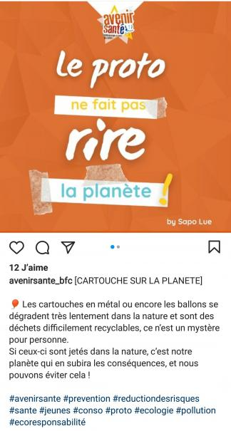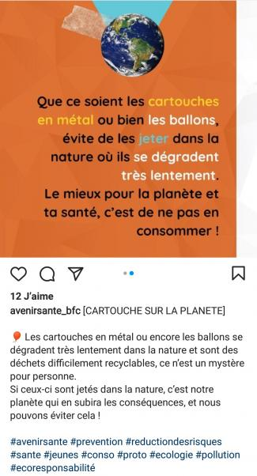​​​​​​​
Post 1
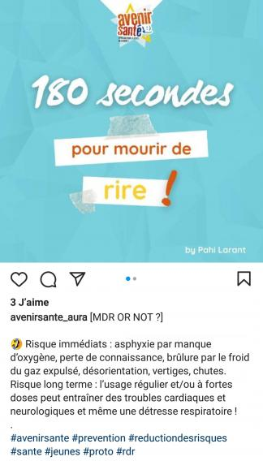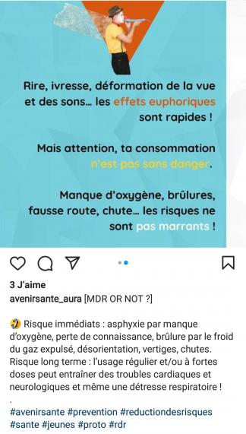

Post 2
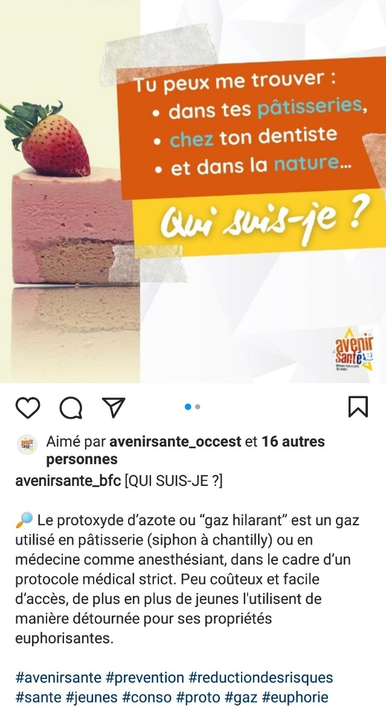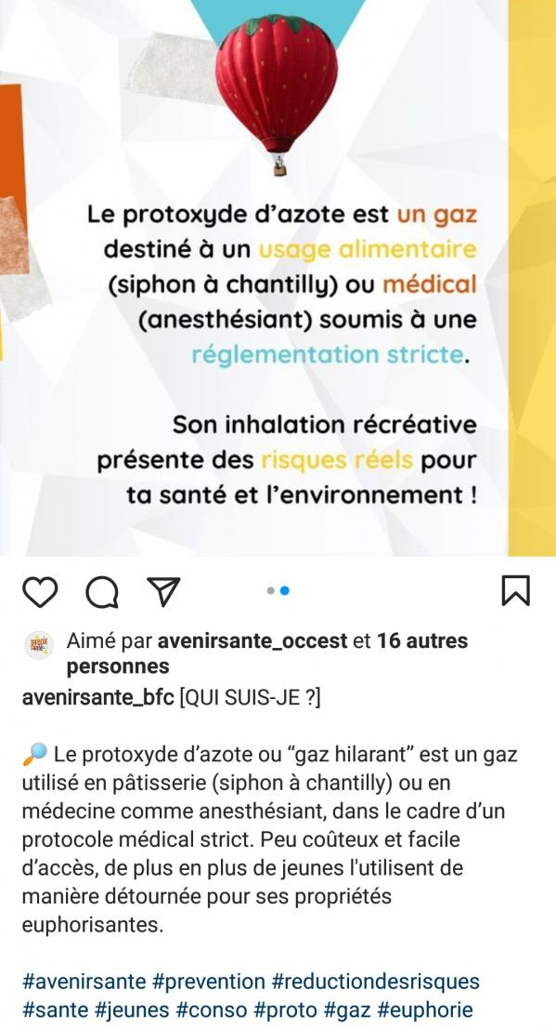

Post 3

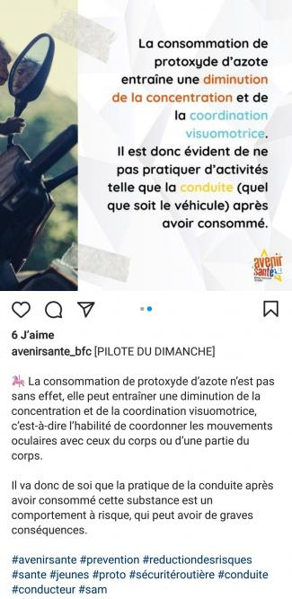
Post 4

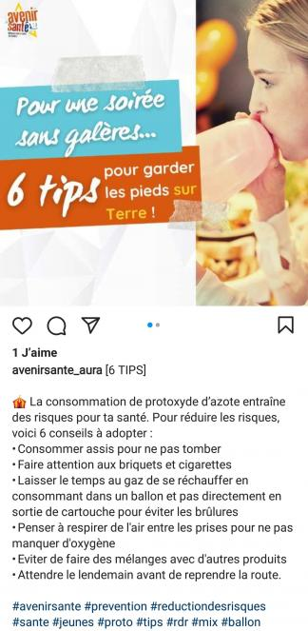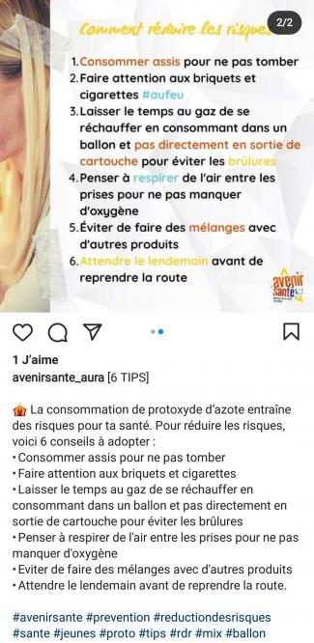
Post 5

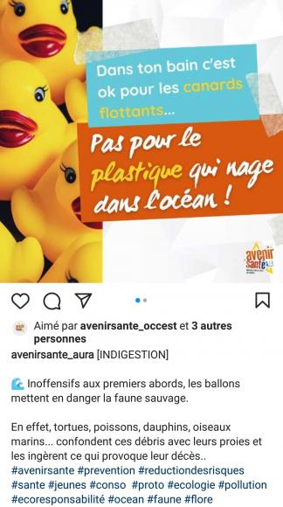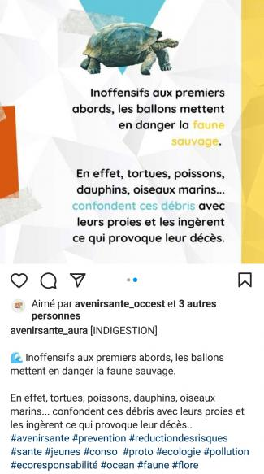
Post 6

Alcohol
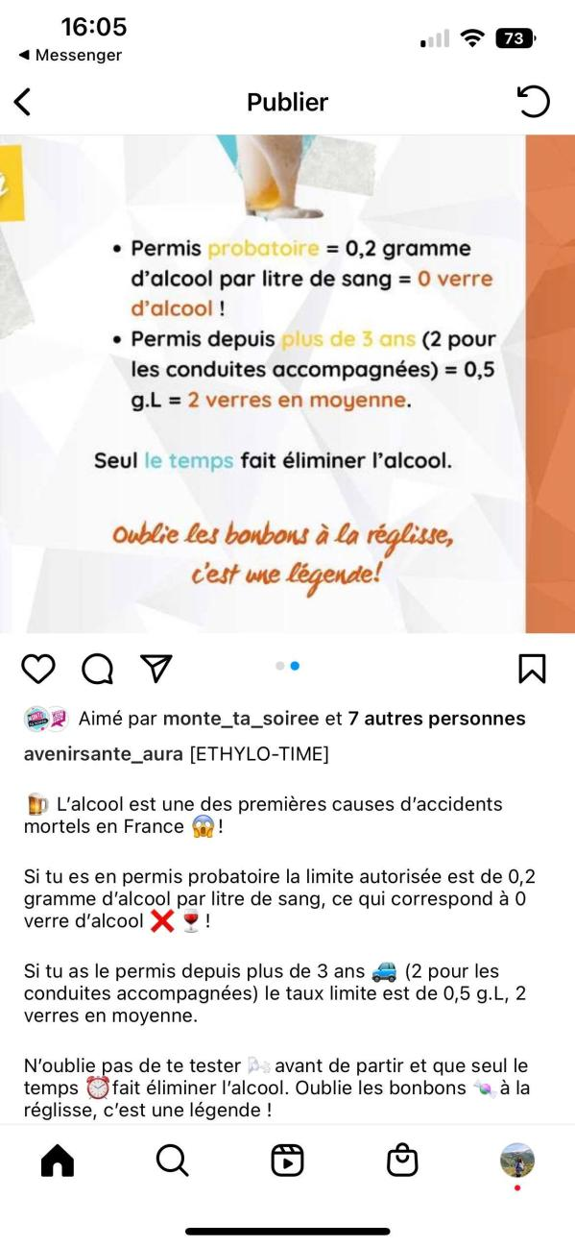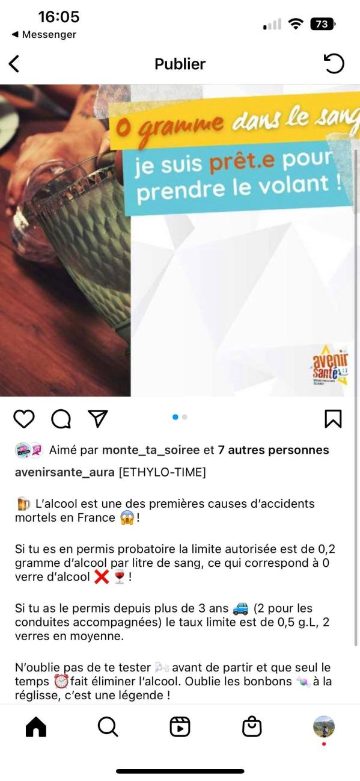
Post 1

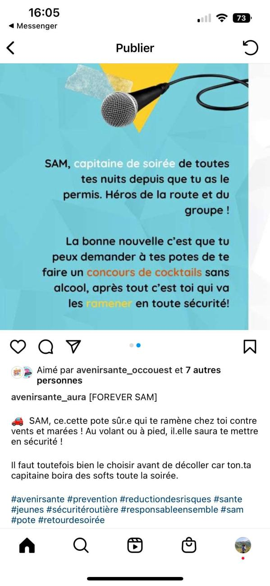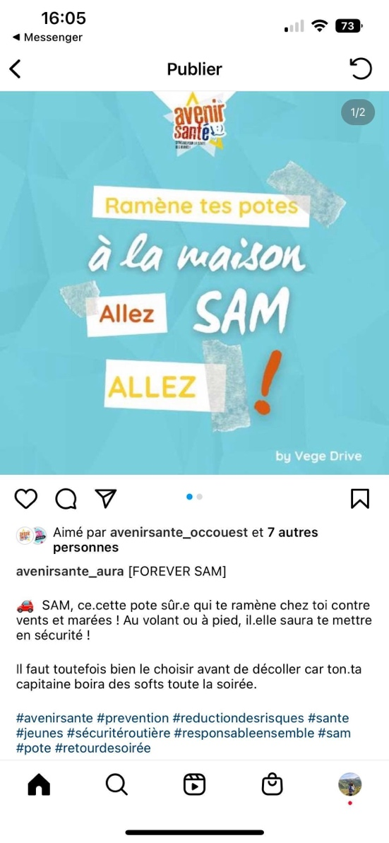
Post 2

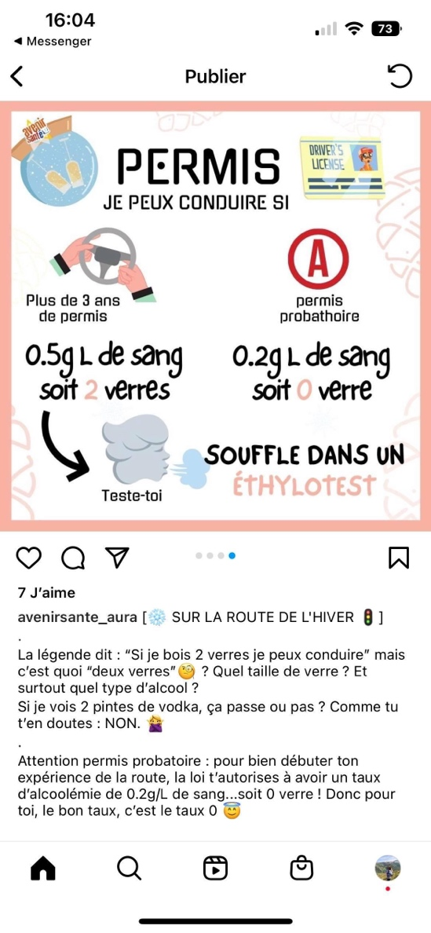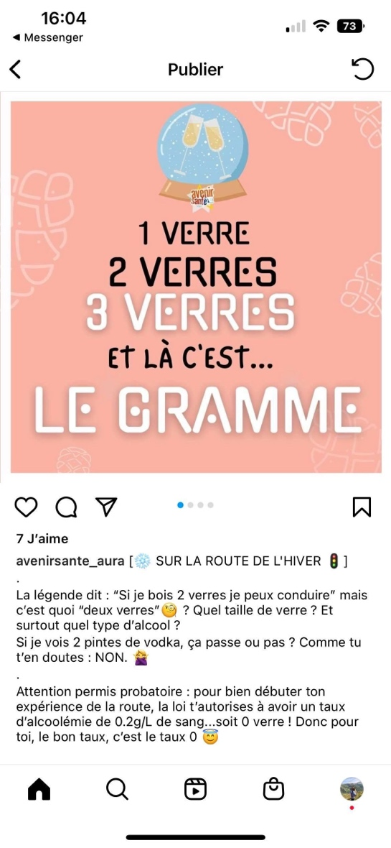
Post 3

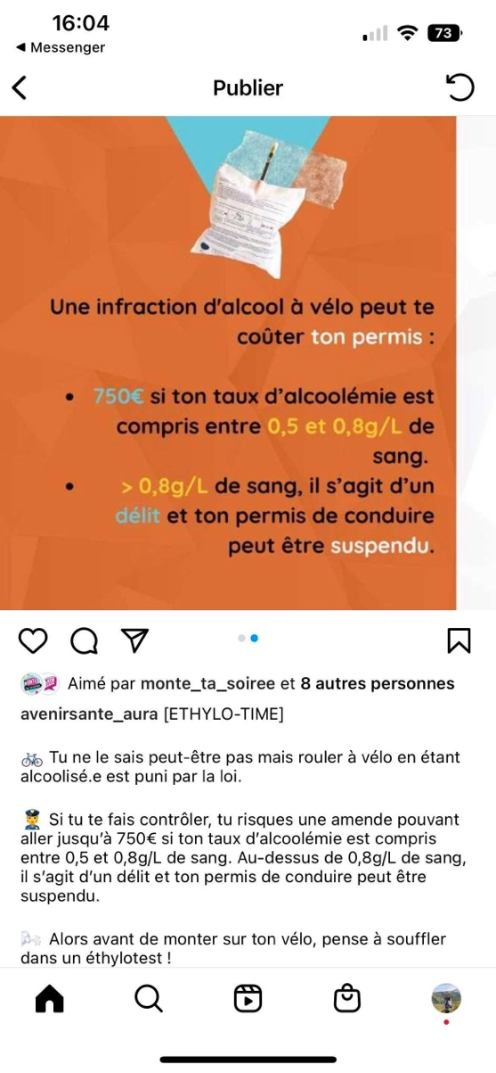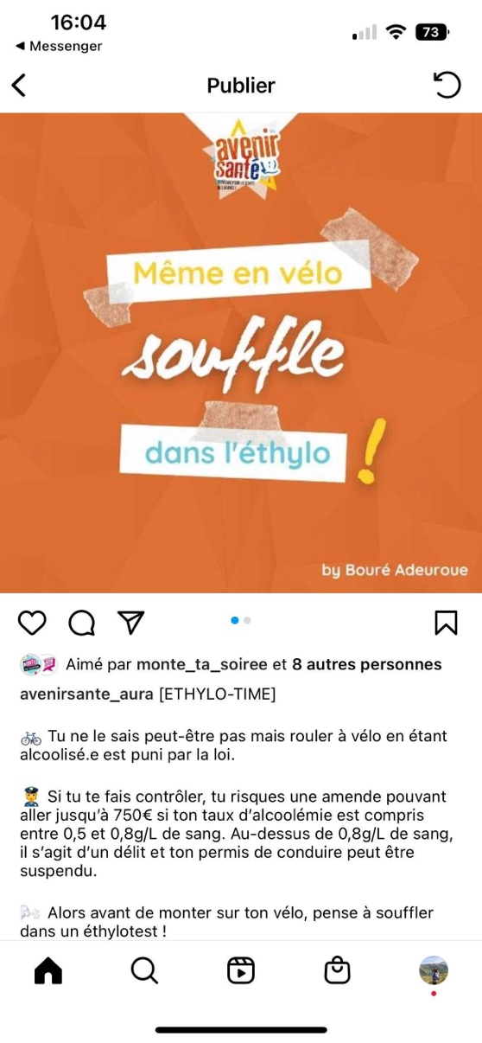
Post 4

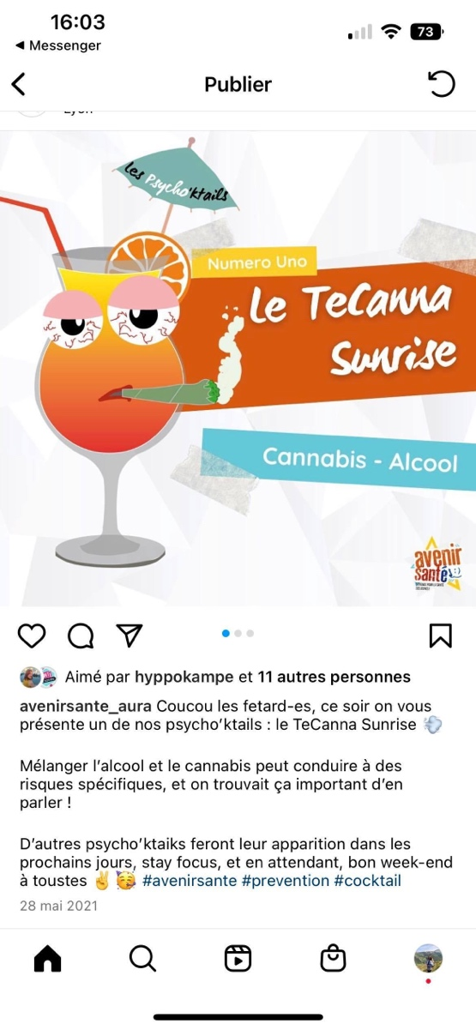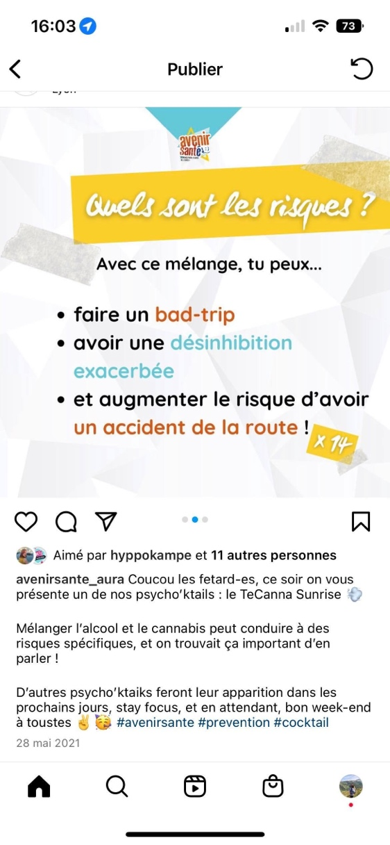
Post 5

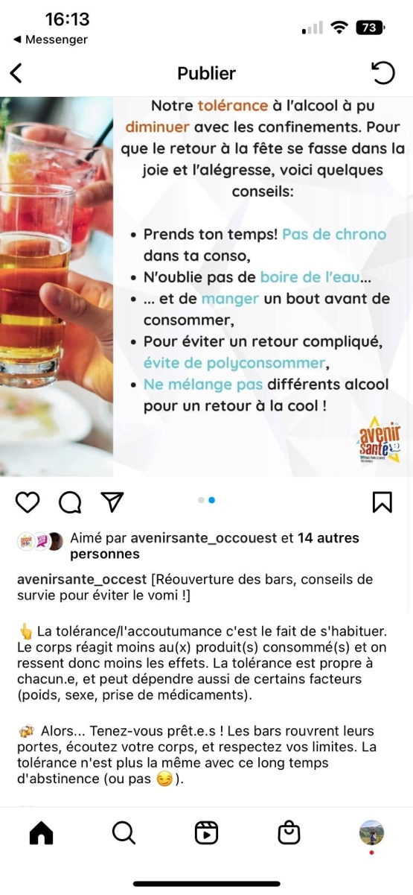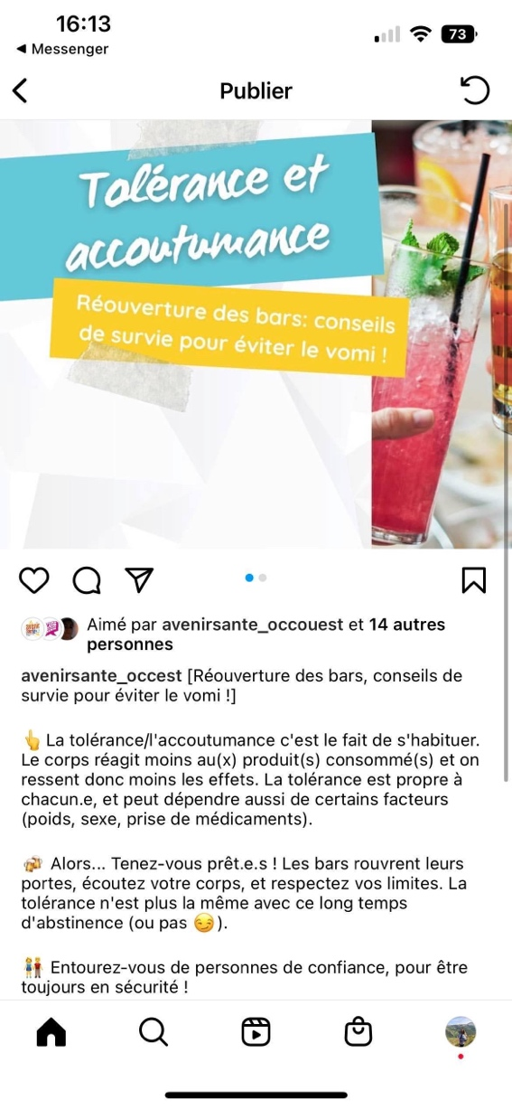
Post 6
Questions about intentions to drink alcohol/consume nitrous oxide
- How much nitrous oxide do you plan to use in the future?
- How much alcohol do you plan to consume in the future?

Questions about attitudes toward alcohol and nitrous oxide
- Do you think that using nitrous oxide is (i) 1- Healthy to 7- Unhealthy, (ii) 1- Wise to 7- Unwise, (iii) 1- Good to 7- Bad and (iv) 1- Safe to 7- Dangerous?
- Do you think drinking alcohol is (i) 1- Healthy to 7- Unhealthy, (ii) 1- Wise to 7- Unwise, (iii) 1- Good to 7- Bad and (iv) 1- Safe to 7- Dangerous.

Questions about memorization
We're now going to ask you a few questions about the content of the posts you've viewed. Each question may have several correct answers.
What dose of alcohol is equivalent to a glass of wine?
▢ 1 glass of beer (33)
▢ 1 glass of whisky (33)
▢ 1 glass of champagne (33)
To lower blood alcohol levels, you need to:
▢ Decrease quantities when resuming (25)
▢ Space out alcohol consumption (25)
▢ Drink water (25)
▢ Eat (25)
Riding a bike while under the influence of alcohol is punishable by law with:
▢ A fine (100)
▢ Withdrawal of license points (0)
▢ 3 months' imprisonment (0)
On a probationary license, what is the authorized alcohol limit?
▢ 0.2 g of alcohol per liter of blood (50)
▢ 0 glass of alcohol (50)
▢ 1 glass of alcohol (0)
If I plan to drive:
▢ I should think about appointing a party captain (50)
▢ I shouldn’t drink (50)
▢ It's okay to drink under 0.5 g of alcohol (3)
If I mix alcohol and cannabis, I risk:
▢ Having a road accident (33)
▢ Being too uninhibited (33)
▢ Having a bad trip (3)
What is nitrous oxide?
▢ Medical laughing gas (50)
▢ Laughing gas for food use (50)
▢ A toxic gas (0)
Consuming nitrous oxide:
▢ Increases the probability of having a road accident (100)
▢ Makes you more alert while driving (0)
▢ Interacts with alcohol to make you drowsy (0)
What are the short-term risks of nitrous oxide consumption?
▢ Asphyxia (25)
▢ Loss of consciousness (25)
▢ Burns (25)
▢ Disorientation (25)
What are the long-term risks of nitrous oxide consumption?
▢ Heart disorders (33)
▢ Neurological disorders (33)
▢ Respiratory distress (33)
Discarded waste nitrous oxide cartridges:
▢ Are a cause of pollution in general for the planet (50)
▢ Can kill animals that ingest them (50)
▢ Are not likely to kill animals (0)
If I’m going to consume nitrous oxide, it's best to do it:
▢ Sitting (20)
▢ Standing (0)
▢ Using a balloon (20)
▢ Breathing in air between balloons (20)
▢ Without mixing (20)
▢ Without driving afterwards (20)
▢ Without breathing in air between balloons (0)

