Improving postsurgical fall detection for older Americans using LLM-driven analysis of clinical narrative

Appendix 1. Regular expression protocol
Category | Example
Original inclusion regex | Sure fall:  '(before|after|prior to|while) (the )?fall(ing)?'  Simple fall:  'f(a|e)ll(s|ing|en)?'
Original exclusion regex | ['fallopian', '(tube|line|catheter) f(a|e)ll(s|en|ing|ings)? out', '(level|rate) f(a|e)ll(s|en|ing|ings)?', 'f(a|e)ll(s|en|ing|ings)? (\S+ )?(rate|level)', '(level|history of|by a|possible|may have) (\S+ )?f(a|e)ll(s|en|ing|ings)?', 'f(a|e)ll(s|en|ing|ings)? (sustained |last )?(\S+)?(month|year|jan(uary)? |feb(uary)?|mar(ch)?|apr(il)?|jun(e)?|jul(y)?|aug(ust)?|sep(tember)?|oct(ober)?|nov(ember)?|dec(ember)?)(s)?( ago)?', 'f(a|e)ll(s|en|ing|ings)? (from|off|off of) (\S+ )?(motor|bi)cycle', 'f(a|e)ll(s|en|ing|ings)? asleep', 'f(a|e)ll(s|en|ing|ings)? clinic', 'frequent f(a|e)ll(s|en|ing|ings)?', 'f(a|e)ll(s|ing|en|ings)? level', 'not sure (that|whether|if) (\S+ )?f(a|e)ll(s|ing|en|ings)?', 'fall (and )?(return )?precaution(s)?', '(almost|nearly|would have) f(a|e)ll(s|ing|en)?', 'faint (and|&) fall', 'last fall', 'fall of', '(pressure|map |systolic) f(a|e)ll(s|ing|en)?', 'f(a|e)ll(s|ing|en)? (pressure|map(s)? |systolic)', '(AC|anticoagulation|lovenox|NOAC|warfarin|coumadin|rivaroxaban|heparin|eliquis|dabigatran|plavix|aggrenox|aspirin) (due to|because of)( increased| frequent | risk of | chances of | chance of )? f(a|e)ll(s|en|ing|ings)?( risk)?', '(will|would|risk of|chance of|chances of) f(a|e)ll(s|en|ing|ings)?', 'f(a|e)ll(s|en|ing|ings)? off the wagon']
New exclusion regex | ['f(a|e)ll(s|en|ing)? away', 'f(a|e)ll(s|en|ing)? out ', 'slips, trips, and falls', '200,000 of those falls', 'arter', 'history of', 'chance(s)?', 'pressure', 'farewell', 'fear of fall', 'fearful of fall', 'could have fallen', 'could fall', 'f(a|e)ll(s|en|ing)? below', 'fall prec', 'predisposition', 'absence of', 'fall score', 'fall sign', 'assessment', 'next fall', 'afraid of fall', 'fall safety', 'previous fall(s)?', 'earlier this', 'precaution', 'agreement', 'video', 'teaching', 'prevent', 'risk', 'this fall', 'f(a|e)ll(s|en|ing|ings)? off', 'f(a|e)ll(s|en|ing|ings)? into', 'infallibilities', 'crestfallenness', 'fallaciousness', 'infallibility', 'crestfallenly', 'fallibilities', 'fallownesses', 'fallaciously', 'crestfallen', 'fallibility', 'fallaleries', 'infallible', 'fallacious', 'chapfallen', 'chopfallen', 'downfallen', 'chainfalls', 'fallboards', 'fallfishes', 'infallibly', 'nightfalls', 'fallowness', 'waterfalls', 'shortfalls', 'shortfall', 'waterfall', 'nightfall', 'fallboard', 'chainfall', 'befalling', 'evenfalls', 'downfalls', 'deadfalls', 'fallbacks', 'fallaways', 'fallalery', 'fallacies', 'infalling', 'footfalls', 'fallowing', 'windfalls', 'snowfalls', 'rockfalls', 'landfalls', 'rainfalls', 'pratfalls', 'rainfall', 'downfall', 'windfall', 'landfall', 'snowfall', 'fallible', 'fallback', 'pratfall', 'footfall', 'rockfall', 'fallaway', 'farfalle', 'deadfall', 'evenfall', 'fallfish', 'dewfalls', 'catfalls', 'befallen', 'icefalls', 'fallibly', 'falloffs', 'fallouts', 'fallowed', 'pitfalls', 'outfalls', 'unfallen', 'fallout', 'fallacy', 'pitfall', 'falloff', 'outfall', 'icefall', 'dewfall', 'befalls', 'catfall', 'fallals', 'fallers', 'infalls', 'fallows', 'fallow', 'befall', 'faller', 'infall', 'fallal', 'fellmongerings', 'fellowshipping', 'fellmongeries', 'fellmongering', 'schoolfellows', 'fellowshiping', 'fellowshipped', 'schoolfellow', 'fellowshiped', 'fellmongered', 'fellatrices', 'fellatrixes', 'fellmongers', 'fellmongery', 'fellowships', 'yokefellows', 'playfellows', 'fellowship', 'playfellow', 'yokefellow', 'fellnesses', 'bedfellows', 'fellmonger', 'fellations', 'bedfellow', 'fellating', 'fellaheen', 'fellatios', 'fellators', 'fellation', 'fellatrix', 'fellowing', 'fellowman', 'fellowmen', 'refelling', 'woolfells', 'fellatio', 'fellator', 'fellable', 'fellahin', 'fellated', 'fellates', 'fellowly', 'fellness', 'fellowed', 'woolfell', 'refelled', 'fellate', 'fellahs', 'felling', 'fellies', 'fellers', 'fellest', 'felloes', 'fellows', 'fellow', 'feller', 'fellah', 'felloe', 'felled', 'refell', 'fellas', 'befell', 'fella', 'felly', 'fells']
Negations | ['no ', 'not ', "n't", 'negative', 'never', 'denies', 'deny']

Appendix 2. Prompt examples
Figure 1. Zero-shot prompting example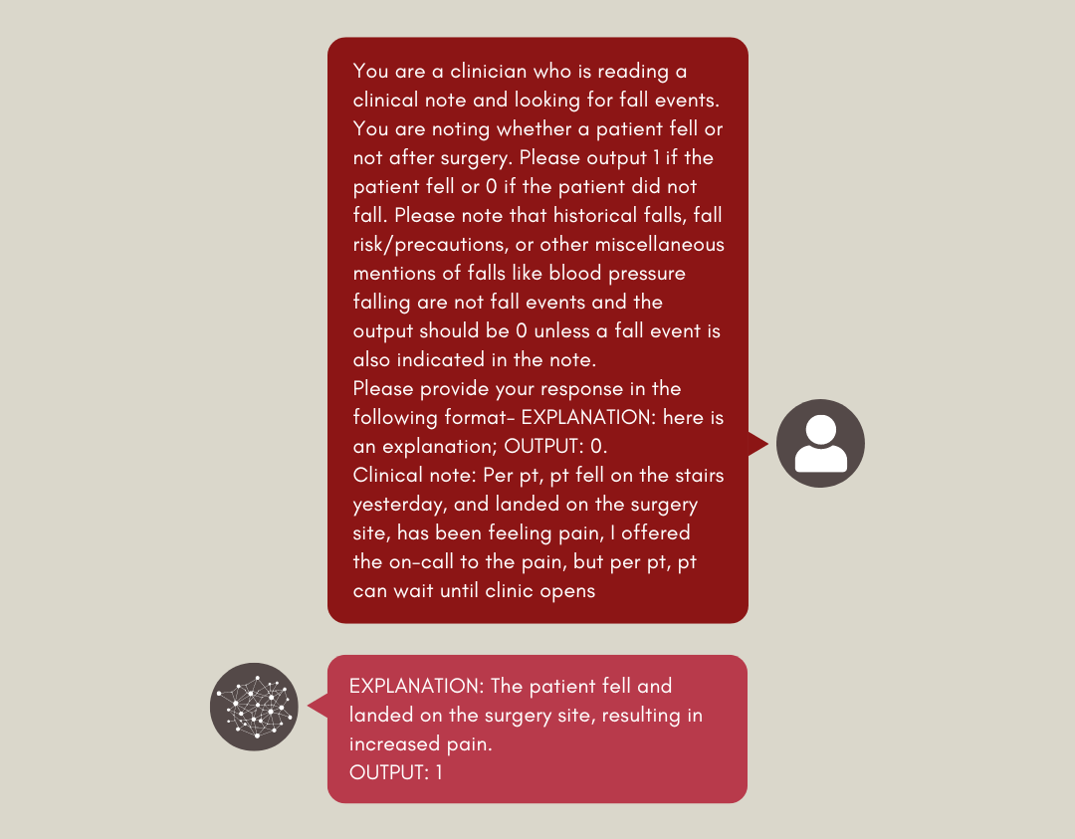

Figure 2. Few-shot prompting example
