Impact of the mouse estrus cycle on cannabinoid receptor agonist-induced molecular and behavioural outcomes.
Hye Ji J Kim¹, Ayat Zagzoog¹, Tallan Black¹, Sarah L Baccetto¹, Udoka C Ezeaka¹, Robert B Laprairie^{1,2}
¹Health Sciences Bldg. Rm 3B36, 107 Wiggins Rd., College of Pharmacy and Nutrition, University of Saskatchewan, Saskatoon SK, Canada S7N 5E5
²Sir Charles Tupper Medical Bldg. Rm 6E, 5850 College Dr., Department of Pharmacology, College of Medicine, Dalhousie University, Halifax NS, Canada B3H 4R2
*Correspondence:
Robert B Laprairie
robert.laprairie@usask.ca
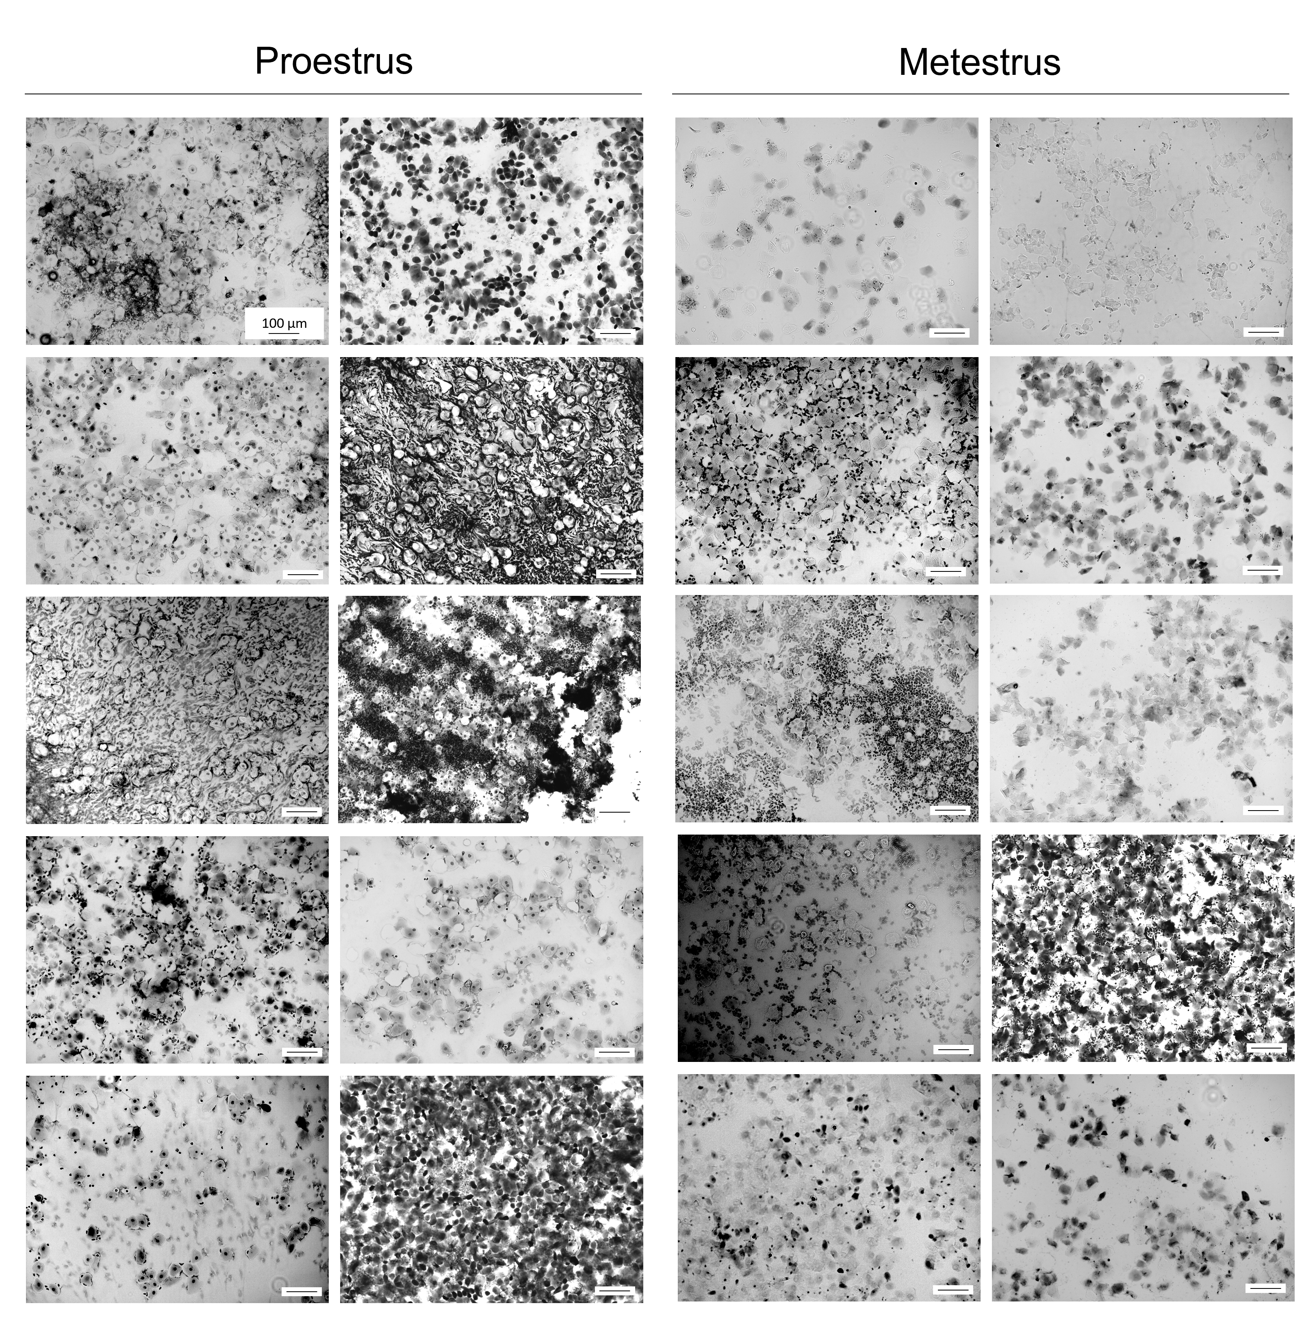
Fig. 1. Light microscopy images of vaginal epithelial cells from female mice in the study indicating either proestrus or estrus.

