Supplementary Information

Supplementary Figure 1 – Fishbourne diagram depicting issues encountered with the low number of PI recorded.

Low record of pharmacy interventions
Staff
Lack of understanding on the advantages of recording interventions
Time limitation
No protected time to complete this task
System/materials
AWID does not accept retrospective data
AWID is not easy to use
AWID is “clunky” and slow
AWID is not adapted to Powys hospitals
Management
Did not inform other team members about recording interventions
Did not motivate hospital teams to record interventions
Targets for PI have not been defined

AWID – All Wales Intervention Database; PI – Pharmacy interventions.

Supplementary Figure 2- Pareto chart highlighting frequency of key contributors for inadequate or low record number of pharmacy interventions.

MM – medicines management.

Supplementary Figure 3 – Pharmacy Intervention Record Tool — xPIRT main page.

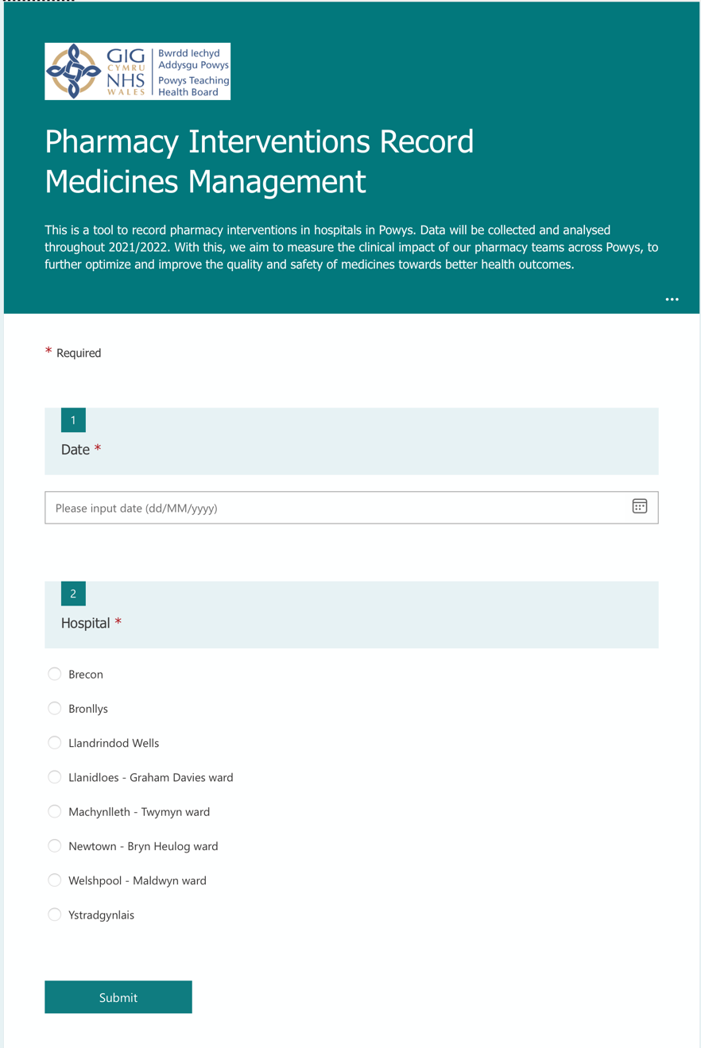
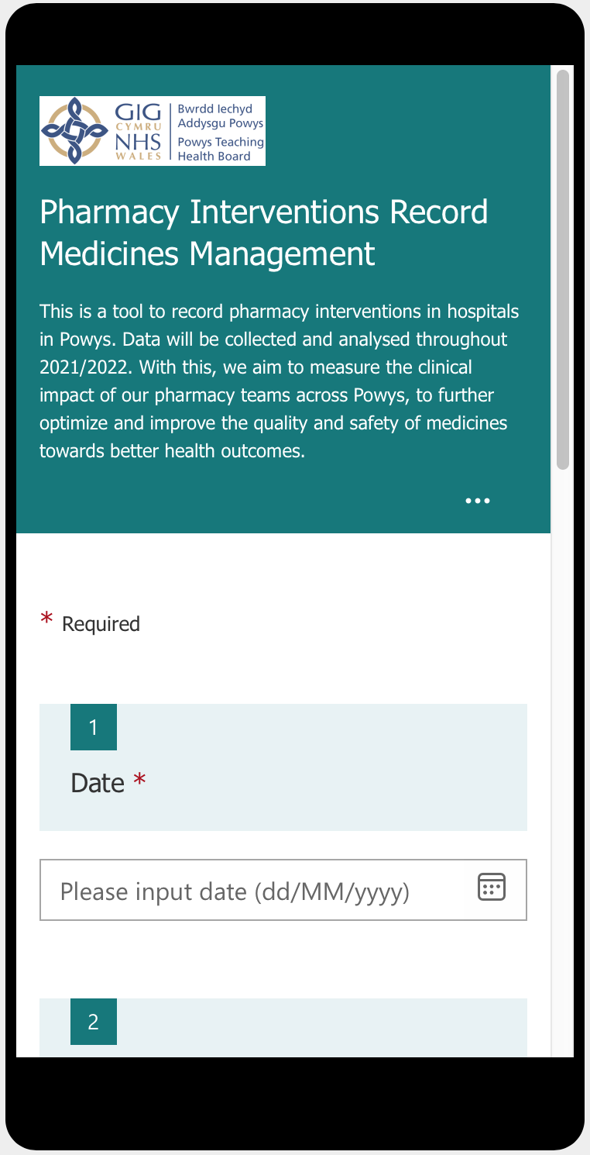

Supplementary Figure 4 - Driver diagram depicting changes to be implemented in PDSA cycle 2.

To record 180 interventions until 08/04/2022.

AND

To have all pharmacy team staff recording at least one intervention until 08/04/2022.
Recording PI
Easy to use recording tool
Leadership support
Interventions results to be easily accessed
Interventions results to be easily editable
Tackle time limitations
xPIRT can be used on a computer or phone
xPIRT Interactive Board in place
To share an editable file with interventions’ results
To address in the meeting: only required 3 min per week per staff, to meet goal
Weekly reminder email to be sent
To address in the meeting: data to be used in clinical governance meetings, to inform the need for specific local guidelines and for CPD.
To address in the meeting: PI made by project’s ‘champion’ are not considered for the project
Team to be reminded of recording interventions
Set clear goals regarding data usage
Clarify project ‘champion’’s bias in measuring improvement

PI – Pharmacy interventions; CPD – continuing professional development.

Supplementary Figure 5 – xPIRT Dashboard.

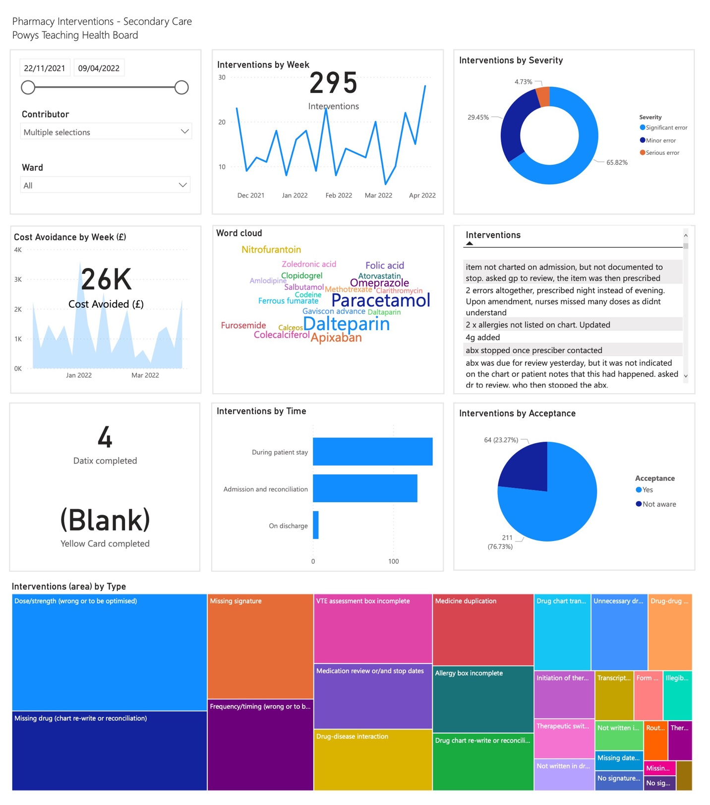

Supplementary Figure 6 – Flow chart with process pathway following a PI.

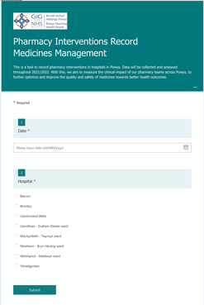
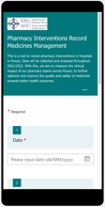
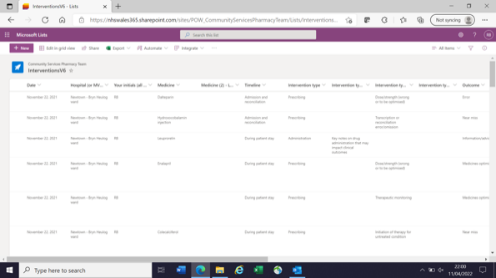
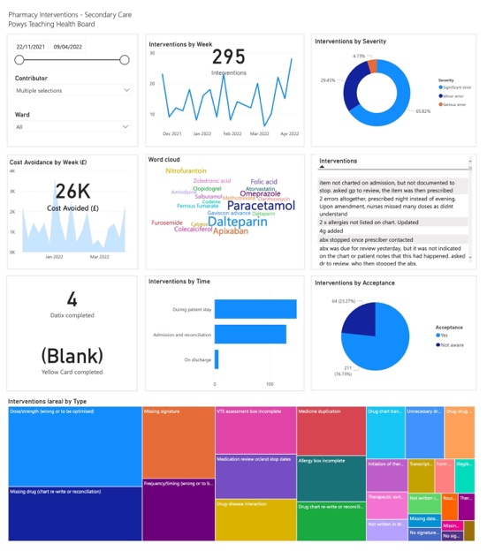
Recording tool
Average recording time is 2 minutes.

Data is organised in an automatic table that can be editable anytime.

Interactive Dashboard in available to our team and is updated every hour, based on xPIRT List.
This can be shared with ward and prescribers.

xPIRT

xPIRT List

xPIRT.Dashboard

xPIRT Toolkit

