Supplementary material
Table S1. The characteristics of the clean and styrene contaminated soil.
Parameter | Clean soil | Styrene contaminated soil
pH | 7.71 | 7.68
EC (dS/m) | 3.86 | 3.75
Organic matter (%) | 2.73 | 2.72
Phosphorus (g/kg) | 0.234 | 0.234
Potassium (g/kg) | 0.216 | 0.216
Calcium (g/kg) | 4.452 | 4.452
Magnesium (g/kg) | 0.422 | 0.422

Tabel S2. Life cycle assessment of 1 cubic meter of styrene-contaminated soil by a combination of carbon-based nanoscale zero-valent iron and phytoremediation by marigolds (Tagetes erecta L.)
Condition | Inventory | Impact kg tCO₂ | Impact kg tCO₂/m³
nZVI-AC | 12.55 KWh of electrical energy  (Production of AC 10 kg and green-synthesized nZVI 1kg)  No carbon Seqestration | 5.8x10⁻²
nZVI-AC |  |  | 0.0020
nZVI-AC+ marigold  (Tagetes erecta L.) | 12.55 KWh of electrical energy  (Production of AC 10 kg and green-synthesized nZVI 1kg) | 5.8x10⁻²
nZVI-AC+ marigold  (Tagetes erecta L.) | 1000 little of water for plant growth  Carbon Sequestration | 1.8x10⁻² | 0.0027
+ transportation inventory depends distances between dealer and contaminated sites. It was assumed that the distance was the same area.
+ operation and maintenance cost for phytoremediation: US$ 37.7/m³ (Wan et al., 2016).
Wan X, Lei M, Chen T. Cost-benefit calculation of phytoremediation technology for heavy-metal-contaminated soil. Sci Total Environ. 2016 Sep 1;563-564:796-802. doi: 10.1016/j.scitotenv.2015.12.080. Epub 2016 Jan 4. PMID: 26765508.

Tabel S3. Adsorption isotherm of styrene in activated and soil.
Treatment | Soil (g) | Initial concentration (mg/L) | After concentration at 4 h (mg/L) | Mass of adsorbate (mg/L) | Adsorption isotherm (mg/kg)
AC | 10 | 9.41 | 3.52 | 0.59 | 29.45
Soil | 10 | 9.41 | 4.10 | 0.53 | 26.55

. 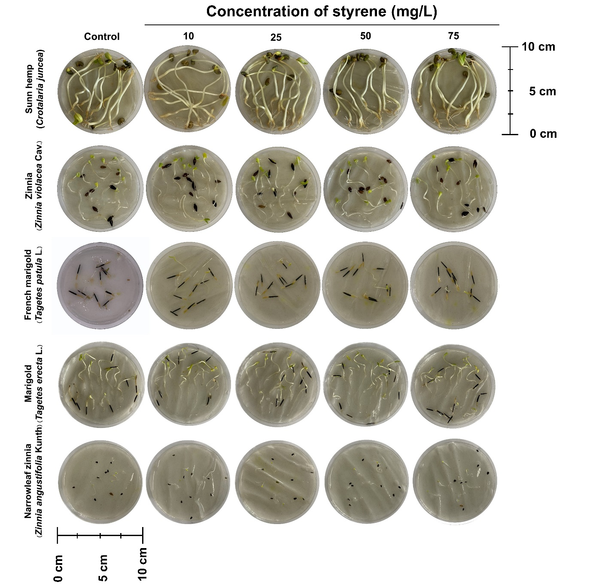
Fig. S1. Root physiology of five plants for phytoremediation.

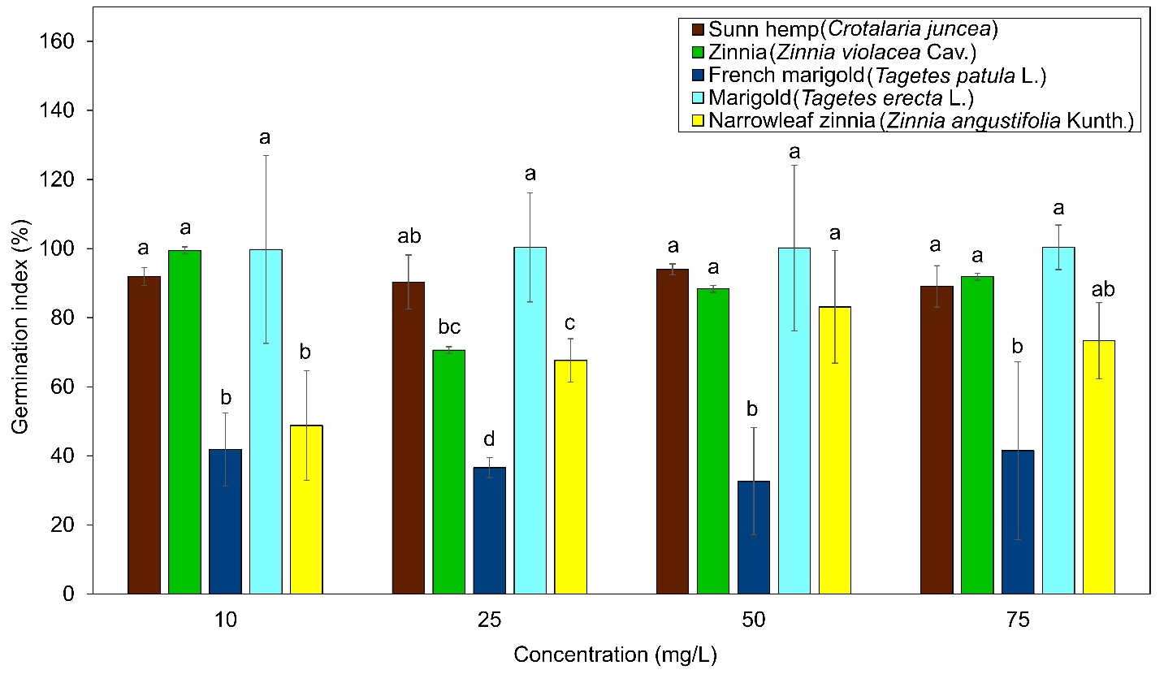
Fig. S2. Germination index of plants in different concentrations

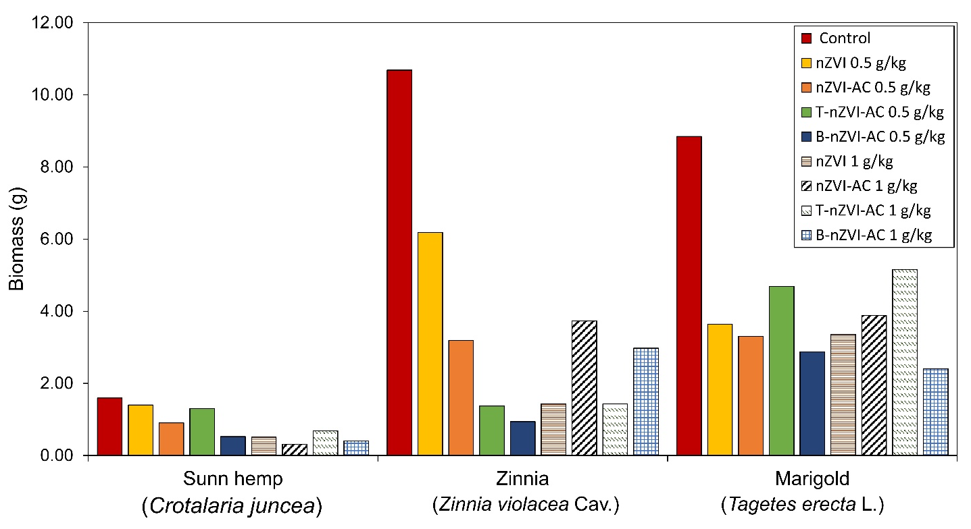
Fig. S3. Biomass of plants in styrene 5 mg/L and different nZVI

Fig. S4. Root, stem, leaf, and stomata anatomy of marigold. Epidermis (ep), cortex (co), phloem (ph), xylem (sx), and pith (pi); ×1000.

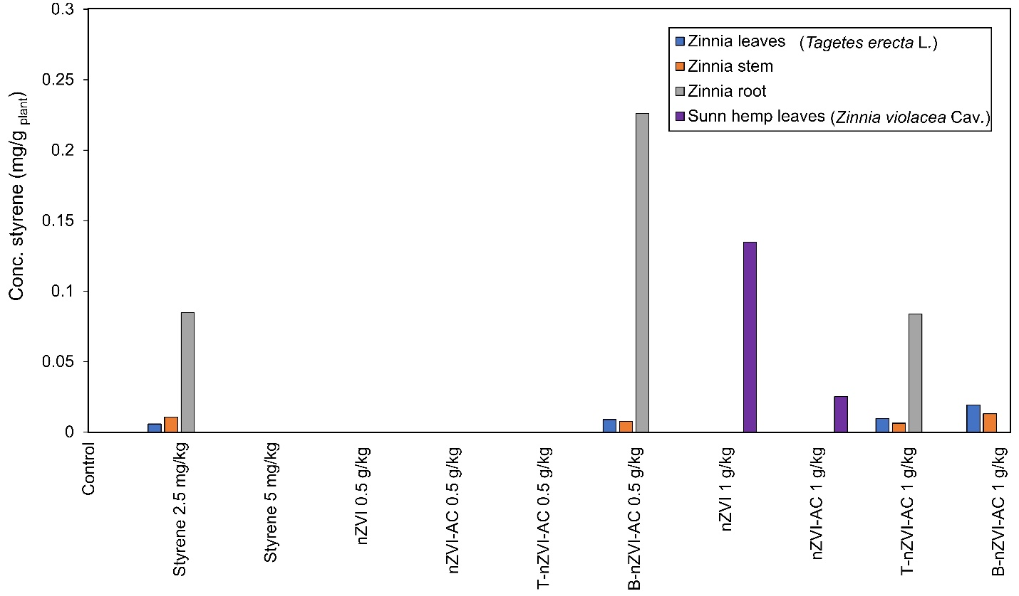
Fig. S5. Concentration of styrene in sunn hemp (leaves) and zinnia (leaves, stem and root).

