Deep Learning–Driven Insights into Substance Use During the COVID-19 Pandemic from Social Media Data

1 Data and Methods

1.1 Substance types and their associated keywords
The following table presents the associated keywords and slang words for each substance type used in the study.
Table S1. Substance types and their associated keywords
Substance Type | Keywords
tobacco | nicotine, tobacco, cigarette, cigars, bidis, snuff
alcohol | liquor, beer, wine
cannabinoids | marijuana, blunt, dope, ganja, grass, herb, joint, bud, mary jane, pot, reefer, green, trees, smoke, sinsemilla, skunk, weed, hashish, boom, gangster, hash, hash oil, hemp
opioids | heroin, smack, horse, brown sugar, dope, H, junk, skag, skunk, white horse, China white, opium, laudanum, paregoric, big O, black stuff, block, gum, hop
stimulants | cocaine, hydrochloride, blow, bump, C, candy, Charlie, coke, crack, flake, rock, snow, toot, amphetamine, Biphetamine, Dexedrine, bennies, black beauties, crosses, hearts, LA turnaround, speed, truck drivers, uppers, methamphetamine, Desoxyn,meth, ice, crank, chalk, crystal, fire, glass, go fast, speed
club_drugs | mdma, ecstasy, adam, clarity, eve, lovers speed, peace, uppers, flunitrazepam, rohypnol, forget-me pill, mexican valium, r2, roach, roche, roffles, roofinol, rope, rophies, ghb, Gamma-hydroxybutyrate, G, Georgia home boy, grievous bodily harm, liquid ecstasy, soap, scoop, goop, liquid X
dissociative_drugs | ketamine, Ketalar SV, cat Valium, K, Special K, vitamin K, pcp and analogs, phencyclidine, angel dust, boat, hog, love boat, peace pill, salvia divinorum, salvia, shepherdess’s herb, maria pastora, magic mint, sally-d, dextromethorphan, dxm, robotripping, robo, triple
hallucinogens | Lsd, Lysergic acid diethylamide, acid, blotter, cubes, microdot, yellow sunshine, blue heaven, mescaline, Buttons, cactus, mesc, peyote, psilocybin, Magic mushrooms, purple passion, shrooms, little smoke
other_compounds | anabolic_steroids, anadrol, oxandrin, durabolin, depo-testosterone, equipoise, roids, juice, gym candy, pumpers, inhalants, Solvents, paint thinners, gasoline, glues, gasses, butane, propane, aerosol propellants, nitrous oxide, nitrites, isoamyl, isobutyl, cyclohexyl, laughing gas, poppers, snappers, whippets
prescription_medications | cns_depressants, stimulants, opioid pain relievers, oxyContin, oxycodone, vicodin, norco and lortab, hydrocodone, acetaminophen, Percocet, oxycodone, acetaminophen, Tramadol, Codeine, morphine, methadone, Demerol, meperidine, acetaminophen, tylenol, excedrin, vanquish, aspirin, Bayer, bufferin, ecotrin, excedrin, vanquish, diclofenac, voltaren Gel, ibuprofen, advil, motrin IB, naproxen, aleve

1.2 Annotated sample tweets
The following table shows sample tweets that are annotated by the experts as Substance Use or Non-Substance Use.
Table S2. Annotated tweet sample
Tweet | Substance Use
@USER bring me a blunt pls | Yes
Been rolling this same blunt since opening my eyes at 6:50 | Yes
OH in the press room: "I was really confused about that -- where he was getting his heroin from." | Yes
Happy Birthday @USER !!!! We getting lit tonight! | Yes
How much coke she did no wonder age OD'd. Damn. | Yes
I do have Brown as my WR/RB flex, so, yayy?? #... | No
april was annoying but tolerable BUT THEN SHE GOT DEREK SHOT OHMYGOD FUCK APRIL TOO | No
im addicted to my manz😋😍idc, idc. | No

1.3 RoBERTa Configurations
The settings and hyperparameters used in the design and training RoBERTa model are provided below in Table S3 and S4.
Table S3. Model settings
Variable | Value
tokenizer | ByteLevelBPETokenizer
vocab_size | 8192
min_frequency | 2
special_tokens | ["<s>", "<pad>", "</s>", "<unk>", "<mask>"]
max_position_embeddings | 514
num_attention_heads | 12
num_hidden_layers | 6
hidden_size | 768

Table S4. Training hyperparameters
Variable | Value
batch_size | 16
epoch | 32
learning_rate | 1e-4
weight_decay | 0.01
seed | 42
max_len | 128

1.4 Theme and their associated keywords
Table S5. Six major themes and corresponding keywords
Theme | Keywords
covid | covid, corona, coronavirus, outbreak, spread, viral, virus, flu, infect, pcr test, national emergency, wuhan, CDC, ncov, cov2, SARS, mask, sanitizer, toll, new disease, news, positive, test, cases, dangerous year, fake year, fda, flatten, quarantine, lockdown, pandemic, epidemic, ventilator, symptomatic, incubation, transmission, immune, vaccine, hard to breath, shortness of breath, start nose, variant
economic | job, job loss, jobless, no job, lost job, income, salary, paycheck, money, bills, bill raise, check, saving, wage, fulltime, unemployed, economy, layoff, recession, stimulus, evict, laid, bankrupt, owe, afford, eviction, credit, debt, loan, financial crisis, inflation, poor, poverty, normalize risk, cost, homeless, rent, mortgage, no food, no shelter, wallet, hungry street, fda
social | lockdown, bully, loneliness, emptiness, lonely, distancing, insecurities, no one care, trap, feel ignore, ignored, bored, quarantine, alone, stay home, stayhome, stay safe, stayathome, single, solo, lockup, disconnect, silence, off limit, frayed, indoor
mental health | sad, angry, mad, tension, depress, tire, exhausted, fear, scared, stress, worry, disappear, selfharm, crisis, dizzi, no hunger, no sleep, no hope, hopeless, loneliness, no will, quit life, no motivation, no motif, no focus, no dedication, cannot focus, panic, panic attack, rapid heartbeat, heartbeat fast, suicidal thought, ending my life, no reason to live, feeling worthless, seeking a way out, feel like a burden, struggling to cope, lack of purpose, wanting the pain to stop, mental pain, mental anguish, feel pressure, feel trapped, desperation, broken inside, losing the will to live, dark thought, depression, anxiety, ptsd, bipolar, intrusive, trauma, burnout, grief, dyingfeel, sorrow
supply disruption | steal, deliver, refuse, small rate, sellout, sell bath, sell illegal, sell weed, cheap deal, box sale, sale, order, order pack, cut safe, strong, weak, legal high, dangerous, toxic, industry, contaminated, local, import, international, darknet, market, stock alert, batch, customs, seizure, permit, lack, shortage, crisis, sale, buy drug, supply
medical disruption | health crisis, emergency admission, admission drop, crisis, pharmacy, shut down, cut off, on hold, locked out, dead end, dry, mia, rehab, virtual, telehealth, teletherapy, telemedicine, appointment, close clinic, limited hours, waitlist, treatment full, medical line, freeze, overload, emergency, drought, no help line, customer service

1.5 Sample Tweets with identified substance type
The table presents the sample tweets identified as Substance Use posts by the RoBERTa model.
Table S6. Sample tweets with identified substance type
Tweet | Substance Type
florida suspend alcohol consumption bar state announces record singleday increase nearly 9000 new coronaviru… | alcohol
taurus szn bitch let eat amp toast unheard wine pretty label bed | alcohol
walk away local brewer day insist wear mask order beer… | alcohol
buy father day card dad bald beer drink serial farter navigate minefield | alcohol
drinking alcohol cause terrible disease cancer make human sad new new disease ca… | alcohol
wine drunk merry thanksgiving | alcohol
jimin know run alcohol big mood | alcohol
pass alcohol drug test include clean record brake fail go hill completely company… | alcohol
agree great beer | alcohol
ny take action stop spread response rise covid number establishment state liquor license… | alcohol
patient lung cancer catch sneak behind ward smoke igbo be nigerian patient frustrate wearyface | cannabinoids
nah yeah never catch talk shit people life esp smoke cus… | cannabinoids
addict weed lol nice smoke wake up get shower also | cannabinoids
smoke signal fire | cannabinoids
doctor ask drink smoke say yes know go help you… | cannabinoids
smoke cousin mexico and | cannabinoids
eat jean jacket cover peanut butter smoke cig | cannabinoids
raise right mean drink party smoke raise right treat people man… | cannabinoids
“ aye come outside bouta smoke ” me | cannabinoids
still hard believe pop smoke dead | cannabinoids
never funny msnbc regular offend bloomberg describe oligarch man li… | club_drugs
mom amp sister leave middle night amp never come back father addict drug amp die | club_drugs
really need rooftop bar whisky bourbon cigar need destress properly | club_drugs
can not believe bitch run mayor ’ s main goal rile invigorate protester the… | club_drugs
let bitch kno fine every chance get nigga gas station get fucked | club_drugs
drinking get fuck up even drink | club_drugs
outside work smoking guy approach find job company reach full capacity terms… | club_drugs
bcos get hand out afl football public amp happy take it nearly ever… | club_drugs
even get coffee you | club_drugs
girl wana talk bout period pain ever roll ankle this | club_drugs
lorraine cox stalk murder devon last year illegal iraqi immigrant come boat france and… | dissociative_drugs
ketamine date rape drug | dissociative_drugs
would rather tube amp drink boat somewhere degree weather | dissociative_drugs
drop slight hint recreational ketamine use it | dissociative_drugs
get drunk boat today | dissociative_drugs
spce actually double triple quadruple unlike others high short lowe… | dissociative_drugs
party boat captain shirtless drunk | dissociative_drugs
bts ’ triple crown sb inkigayo crown dna crown fake love crown idol crown boy love crown crown dynamite crown life go crown butter new… | dissociative_drugs
rick ross easily besides boat cocaina lie sell claim bitch wrap legs around hi… | dissociative_drugs
happen smoky meet beatles syndicate boat row | dissociative_drugs
lemonlemonlemon eyeshadow buttercupcake acidberry midori liquid lipstick roc | hallucinogens
please call pick acid bucket google how keep blood liqui… | hallucinogens
spider get high build different kind web weed caffeine mescaline lsd | hallucinogens
use easily able drink bottle echo fall apple cactus jack night wake fresh | hallucinogens
nobody like drain terrible odor come it degrade grease fatty acid clog drain wi… | hallucinogens
paint town redtongue little prickly pear cactus fruit sell street marrakech good | hallucinogens
know harvest timescissors become brownish turn grey weed ener… | hallucinogens
roomate try figure acid weed give giggle | hallucinogens
instead give billion trump wall fix flint water crisis 55 mil feed homeless vet mealsday for… | hallucinogens
since daughter graduate homeschool two son still give great lit option thank you | hallucinogens
spiritual successor okami hope come plateforms apple arcade | opioids
fox try xmen origins hopefully good | opioids
camera smack sana ’ s face… cameraman look drunk would last day twice | opioids
bit top shout horse maybe horse rude her | opioids
oregon vote legalize possession heroin antifa seem notice vandalize starbucks https… | opioids
way get thru mercury retrograde wo one argument friendship end something revealed car pr… | opioids
take advantage people know drunk gross amp hope hell | opioids
get high horse know sort quickly | opioids
hope tell sh1te replace bar thiago problem be… | opioids
fool horse bar scene | opioids
cow milk gross drink gasoline | other_compounds
joe rogan gateway drug plastic bag full gasoline | other_compounds
another dirkjake doodle— why car cat movie teeth drink gasoline food source that… | other_compounds
trump say word “ ethanol ” too mean drink gasoline tank moron grow cut… | other_compounds
moment dusty living room gamer save family zombie droids drunken sorcerer… | other_compounds
jaebeom jinyoung handshake leave ahgases get drink 갓세븐 USER… | other_compounds
great job hillbilly mad pay drink gasoline | other_compounds
know right much cheap buy liter gasoline | other_compounds
goto yogurt drink indeed nourishment body act gasoline engine kindly ha… | other_compounds
man drinking gasoline | other_compounds
mexico really legalize cocaine | stimulants
idc cold outside still gonn drink ice coffee | stimulants
crack | stimulants
think time crack | stimulants
can not even blow nose without think | stimulants
even coke bore camp | stimulants
pablo escobars son reveals dad work sell cocaine medium silent | stimulants
jungkook get drunk jungkook think people nice respect other | stimulants
mama adunni put smile people face house make fit get chicken drink house rice dey | stimulants
back 2011 blonde patch hit street harder crack 80 ’ s | stimulants
yes cele look two share cigarette hidden lunch box wonder get the… | tobacco
hello alanna bledman solemnly swear give smoking day night see cigarette | tobacco
new ashtray cigarette | tobacco
never want trade place cigarette fuck bad | tobacco
new questionif really care adverse impact cigarettes health wh… | tobacco
pov listen cigarette sex think crush overwhelmingly sad | tobacco
like alex smith radiohead mac demarco modern baseball weezer neutral milk hotel cigarettes se… | tobacco
eric garner kill sell cigarette | tobacco
year year one item get tax heavily without fail cigarette so highly doubt the… | tobacco
new men admit role scheme money cigarette offer homeless people skid row in… | tobacco

1.6 Sample Tweets with identified theme
Table S7. Sample tweets with identified themes
Tweet | Theme
corona virus flu virus miley cyrus idgaf bet close liquor store | covid
say year ago smoke kill guess believe thing covid | covid
wendy lanski survive covid take drug tout trump part treatment get ongoing rapi… | covid
corona virus get people horny depressed creative true alcoholicsi | covid
day quarantine wine become new favorite drink | covid
waste money time pandemic thousand unemployed tell eat drink inside resta… | economic
donald right money cdc claim new covid case people wear mask … | economic
snide alcoholsoaked subversive flew crosscountry ensure american people get financial relief from… | economic
sugar daddy use get drunk emotional tell like money uhh doiiiiiiiiii | economic
never forget job growth donald trump slow obamabiden—even covid | economic
tire asl smoke amp sleep get wearyface | mental health
home get drunk damn sad | mental health
bro rehab currently fight heroin addiction fight mental health and… | mental health
literally feel pain forget bout life drunk life | mental health
pree tire get put shroom | mental health
stay home long get imaginary kid catch one smoking | social
cancel quarantine drunk skeleton halloween shirthappy quaro halloween | social
quarantine routine pour drank headshot drink sit drank … | social
social distancing front wine shop | social
sweet leave alone though cuz smoke weed order much restaurant | social
pls sell weed distribute alcohol protest venue maintain peace amp keep aggressionviolence is… | supply disruption
order complete drug alcohol diversion program felony sentence day jail for… | supply disruption
sell weed literally major felony essential business open pandemic much america amp yet many are… | supply disruption
local deli sell mexican coke turn moldy expiration date stay safe | supply disruption
say weed come strong probably order least wing good | supply disruption
hitchens cancel today would likely often drunk inappropriate young… | medical disruption
rehab piss drinker | medical disruption
deadly public health crisis year terrify talk potus politica… | medical disruption
problem drug alcohol addiction find best rehab facility meet need factor | medical disruption
mitch mcconnell cocaine good amp lace fine blow need rehab idiot | medical disruption

2 Result

2.1 Trend Analysis
Figure S1. Proportion of substance use tweets count from 2019 through 2021
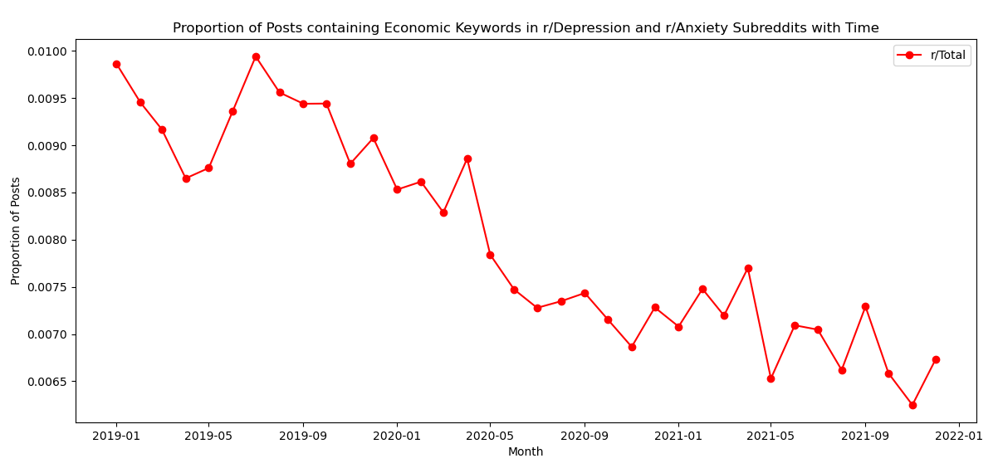

Figure S2. Substance use trend in pre, during and post COVID-19 pandemic 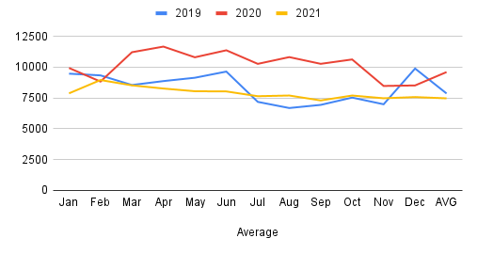

2.2 Substance Use Trend in 7 days Before and After the COVID-19 Pandemic declaration day
Figure S3. Substance use trend in 7 days before and after the COVID-19 pandemic declaration day

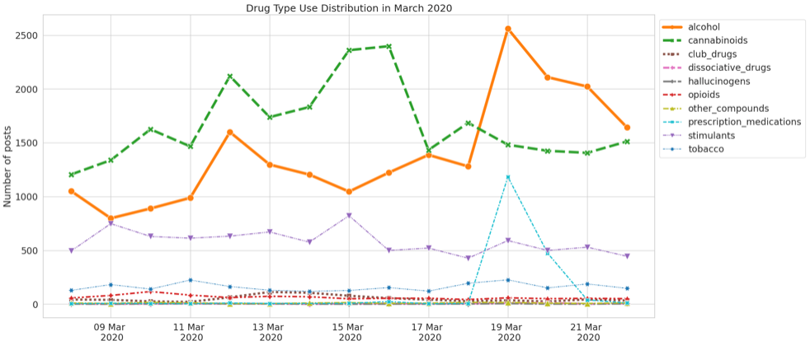

3 k-means Clustering Analysis

3.1 k-means Clustering Analysis
Figure S4. Elbow diagram to predict ‘k’ value in k-mean clustering method.
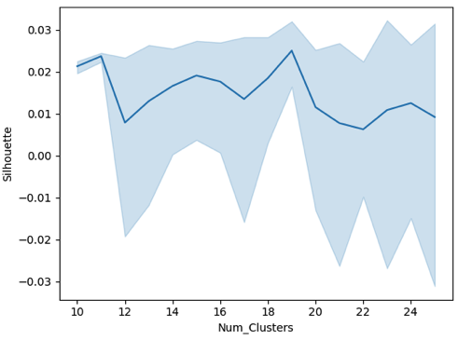
Table S8. k-mean clustering keywords performed for 2020 substance use posts
Cluster 0: fuck nobody get drink smoke drunk shit weed without cunt say know high need give people nigga take really amp let stop right one make beer day man think even
Cluster 1: weed smoke weed smoke one need day amp people get high make know time think good shit say really man lol smell would buy give love nigga thing see come call
Cluster 2: glass fire lit glass wine wine get lit get liquid wine glass drink one memphis need take look amp smoke water day know see make pour tonight would shit good right night without
Cluster 3: show head hit weed zoom food drink fly folk follow food force foot forever forget four free frequency floor flavor fresh fix feeling felt fight figure fill finally find fine fine wine
Cluster 4: high get high get low high high fly time know take think right one amp people even make say need horse give shit day lol still let look much really school five
Cluster 5: drink get smoke drunk one day know people need say make time amp would think take coffee good let really lol shit eat even never right come still water night
Cluster 6: smoke pop pop smoke get cigarette know say amp get smoke would one nigga weed think need come day smoke cigarette blunt shit lol people smoke weed see let even smoke crack really time crack
Cluster 7: beer hold beer hold drink beer drink get madison madison beer one good day amp make buy would cold say time root craft need love new think today come know bottle great well
Cluster 8: alcoholic asf eligible heroin mercury tree downgrade hide innocence get turn know amp one year make voter people say would vote think fine drink need look even day good time
Cluster 9: everybody drink get smoke know drunk lol weed nobody tonight shit else sleep say need high amp talk right house love time one except good lmao piss stop take make
Cluster 10: smoking stop smoking stop quit cigarette get weed gun smoke say crack blunt shit amp start know think hot good make day one love need time people lol would really fuck
Cluster 11: know tequila upgrade street say drunk slow make amp thing need one people good day think time year covid give look would right shit well really lmfao call trump come
Cluster 12: wine bottle bottle wine drink wine red red wine drink amp get fine fine wine good wine drunk make wineglass age get wine white need night time love taste day one drunk buy know tonight would
Cluster 13: bitch fuck get smoke drunk drink nigga stop need say shit high lmfao know take weed amp call really bad lmao love crack street one let yes tire money coke
Cluster 14: alcohol pain take coke crack drinking drug cigarette liquor cocaine stop nose know say make people need amp blunt one store think use liquor store feel day time good much would
Cluster 15: get tire tired worry hate tire get honestly stop shit one use slowly cheat must already person day figure fire leave bitch honest really half lol everyday even amp bro well
Cluster 16: bar sleep way get drink night drunk need one day take well amp good know eat tonight say really make still think hour smoke people would back time tire right
Cluster 17: drunk get drunk get love night tonight friend know think home say time amp lol right one make shit really miss day people last see tweet take call let look come
Cluster 18: blunt roll hit need smoke smoke blunt get amp right day light pa let fat put one say would nigga lol time think shit first know bitch really drop another good

4 Factor Analysis

4.1 Factor Analysis
Figure S5. Scree plot for identifying the number of factors
