SUPPLEMENTARY MATERIALS

Evaluating respiratory syncytial virus immunization strategies for infants in Canada: a cost-utility analysis

Gebremedhin B. Gebretekle, PhD, MSc ¹, Marie Lan, MSc ^{1,2}, Min Xi, MSc ^{1,3}, Raphael Ximenes, PhD ¹, Sarah A. Buchan, PhD, MSc ^{2,3,4,5}, Elissa M Abrams MD, MPH ^{1,6,7}, Melissa K Andrew, MD, PhD, MSc(PH) ⁸, Nicholas Brousseau, MD, MSc ⁹, April Killikelly, PhD, MSc ¹, Deborah Money, MD¹⁰, Jesse Papenburg, MD, MSc^{11,12,13}, Ellen Rafferty, PhD, MPH ^{14,15}, Joan L Robinson, MD ¹⁶, Winnie Siu, MD, MSc ^{1,17}, Matthew Tunis, PhD ¹, and Ashleigh R. Tuite, PhD MPH ^{1,3*}

¹Centre for Immunization Surveillance and Programs, Public Health Agency of Canada, Ottawa, Ontario, Canada
²Institute of Health Policy, Management and Evaluation, University of Toronto, Toronto, Ontario, Canada
³Dalla Lana School of Public Health, University of Toronto, Toronto, Ontario, Canada
⁴Communicable Disease Control, Public Health Ontario, Toronto, Ontario, Canada
⁵Populations and Public Health, ICES, Toronto, Ontario, Canada
⁶Section of Allergy and Clinical Immunology, Department of Pediatrics, University of Manitoba, Winnipeg, Manitoba, Canada
⁷Division of Allergy and Immunology, Department of Pediatrics, University of British Columbia, Vancouver, British Columbia, Canada
⁸Department of Medicine (Geriatrics), Dalhousie University, Halifax, Nova Scotia, Canada
⁹Department of Social and Preventive Medicine, Université Laval, Québec, Canada
¹⁰Department of Obstetrics & Gynaecology, University of British Columbia, Vancouver, British Columbia, Canada
¹¹Department of Epidemiology, Biostatistics and Occupational Health, School of Population and Global Health, McGill University, Montreal, Quebec, Canada
¹²Division of Pediatric Infectious Diseases, Department of Pediatrics, Montreal Children’s Hospital, McGill University Health Centre, Montreal, Quebec, Canada
¹³Division of Microbiology, Department of Clinical Laboratory Medicine, McGill University Health Centre, Montreal, Quebec, Canada
¹⁴Institute of Health Economics, Edmonton, Alberta, Canada
¹⁵Department of Medicine, Faculty of Medicine and Dentistry, University of Alberta, Edmonton, Alberta, Canada
¹⁶Department of Pediatrics, University of Alberta, Edmonton, Alberta, Canada.
¹⁷School of Epidemiology and Public Health, University of Ottawa, Ottawa, Ontario, Canada

This Supplementary material provides additional information regarding parameterisation of the model, and includes figures and tables supporting results reported in the main text, as well as the results of secondary analyses.

Content
- Model parameter inputs and assumptions
  - RSV incidence rate by age and calendar month (S1 Figure)
  - Cost parameters (S1 Table)
  - RSV-associated health utility decrements (S2 Table)
  - Inputs for higher burden and higher medical costs scenario (S3 Table)
  - Effectiveness and waning assumptions (S2-S4 Figures)

- Results
  - Primary analysis results (S4 Table)
  - Secondary analysis results (mAb only programs) (S5 Figure)
  - Longer protection duration scenario results (S6 Figure)
  - Higher RSV burden and higher medical costs scenario results (S7-S8 Figures)
  - Results for the societal perspective (S9-S11 Figures)

- References
- Model parameter inputs and assumptions

  - RSV incidence rate by age and calendar month

S1 Figure. RSV incidence rate per 1000 population, by age and calendar month for infants under 1 year born in Ontario, Canada (2009 to 2015).

  - Cost parameters
S1 Table. Cost parameters
Parameter | Base | Range | Reference
Cost of administration per dose ($) | 17.20 | 0 – 30 | Papenburg et. al.,2020; Abu-Raya et. al.,2020 (1, 2)
Cost per product dose ($)
RSVpreF | 230 | 50 – 400 | Public listed price, Pfizer
Nirsevimab | 750 | 50 – 750 | Public listed price, Sanofi
Cost per patient with RSV managed in inpatient setting per day ($)
Per diem in pediatric general ward | 1538 | 1154 – 1923* | Lanctôt et. al., 2008 (3)
Per diem in ICU | 3753 | 2815 – 4691* | Lanctôt et. al., 2008; CIHI, 2016 (3, 4)
Attributable 30-day cost per patient with RSV requiring outpatient healthcare provider visit ($)
<3 months | 253 | 190 – 316* | Rafferty et. al., 2022 (5)
3 - <6 months | 140 | 105 – 175* | Rafferty et. al., 2022 (5)
6m - <1 year | 137 | 103 – 171* | Rafferty et. al., 2022 (5)
1- <2 years | 124 | 93 – 155* | Rafferty et. al., 2022 (5)
Attributable 30-day cost per patient with RSV requiring ED visit ($)
<3 months | 232 | 174 – 290* | Rafferty et. al., 2022 (5)
3 - <6 months | 143 | 107 – 178* | Rafferty et. al., 2022 (5)
6m - <1 year | 136 | 102 – 170* | Rafferty et. al., 2022 (5)
1- <2 years | 130 | 98 – 163* | Rafferty et. al., 2022 (5)
Out-of-pocket costs ($)
Cost of transportation to vaccination | 3.78 | 2.83 – 4.72* | Mitchell et. al., 2017 (6)
Cost of transportation to outpatient care | 3.78 | 2.83 – 4.72* | Mitchell et. al., 2017 (6)
Cost of transportation to inpatient care | 188 | 14 – 1,986 | Mitchell et. al., 2017 (6)
Cost of childcare and home health after inpatient discharge | 339 | 124 – 993 | Mitchell et. al., 2017 (6)
Other out-of-pocket costs for patients with RSV managed in inpatient setting (such as over-the-counter medications and other non-transportation or home expenses) | 387 | 37 – 5,404 | Mitchell et. al., 2017 (6)
Caregiver workdays lost
Hospitalization | 7.3 | 1.1 – 68.1 | Mitchell et. al., 2017 (6)
Outpatient healthcare provider visit | 2.5 | 0.5 – 5 | Fragaszy et. al., 2018 (7)
ED visit | 2.5 | 0.5 – 5 | Fragaszy et. al., 2018 (7)
Visit healthcare provider for vaccination | 0.5 |  | Assumption
Labour force participation (%)
Age 16+ | Age-specific values |  | Statistics Canada, 2022 (8)
Caregiver | 88.6% |  | Statistics Canada, 2022 (8)
Average employment income ($)
Age 16+ | Age-specific values |  | Statistics Canada, 2022 (9)
Caregiver | 62,400 |  | Statistics Canada, 2022 (9)

*Range defined as ±25% of the base value
ED: emergency department; ICU: intensive care unit; RSV: respiratory syncytial virus
  - RSV-associated health utility decrements
S2 Table. RSV-associated QALY losses
Parameter | Base | Range | Reference
Outpatient primary care visit
Infants | 0.00845 | 0.005 – 0.0454 | Glaser et. al., 2022; Régnier et. al., 2013 (10, 11)
Caregivers | 0.00423 | 0.0 – 0.025 | Glaser et. al., 2022; Régnier et. al., 2013 (10, 11)
ED visit |  |  | Glaser et. al., 2022; Régnier et. al., 2013 (10, 11)
Infants | 0.0135 | 0.008 – 0.0454 | Glaser et. al., 2022; Régnier et. al., 2013 (10, 11)
Caregivers | 0.00675 | 0.0 – 0.025 | Glaser et. al., 2022; Régnier et. al., 2013 (10, 11)
Pediatric general ward hospitalization
Infants | 0.0169 | 0.01 – 0.0726 | Glaser et. al., 2022 (10)
Caregivers | 0.0067 | 0.0 – 0.0373 | Glaser et. al., 2022 (10)
ICU admission
Infants | 0.0245 | 0.0145 – 0.1053 | Roy, 2013 (12); Assumption
Caregivers | 0.0097 | 0.0 – 0.0541 | Roy, 2013 (12); Assumption

ED: emergency department; ICU: intensive care unit
  - Inputs for higher burden and higher medical costs scenario
S3 Table. Parameters for higher burden and higher medical costs scenario analysis
Parameter | Base | Reference
RSV-associated hospitalization rate
Relative hospitalization increase in Northern Canada compared to the rest of Canada | 5 | Karron et al., 1999, Singleton et. al., 2022 (13, 14)
Average cost per RSV case ($)
Outpatient visit | 1,747 | Nourbakhsh et. al., 2021(15)
Pediatric ward | 18,869 | Nourbakhsh et. al., 2021(15)
ICU | 73,532 | Nourbakhsh et. al., 2021(15)
Immunization characteristics
Cost of administration per dose | 50 | Banerji et. al., 2016; Nourbakhsh et. al., 2021 (15, 16)
Cost of transportation ($)
All transportation cost (including medical evacuation cost of $16,576) | 18,010 | Banerji et. Al. 2013 (16)

  - Effectiveness and waning assumptions

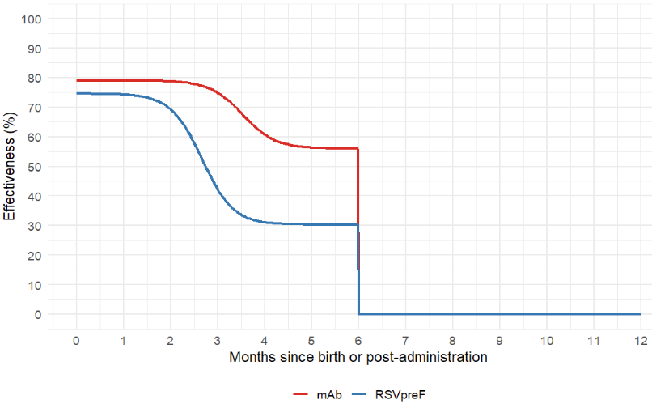
S2 Figure. Effectiveness of RSVpreF and monoclonal antibodies (mAb) against Medically Attended Lower Respiratory Tract Infection (MA-LRTI), by month.

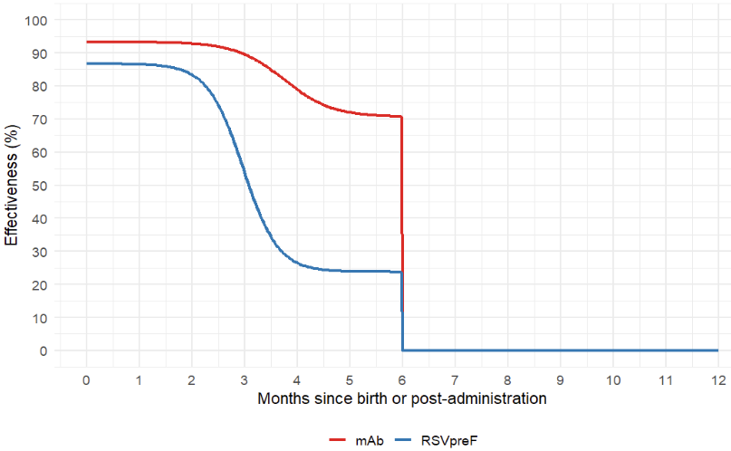
S3 Figure. Effectiveness of RSVpreF and monoclonal antibodies (mAb) against hospitalization, by month.
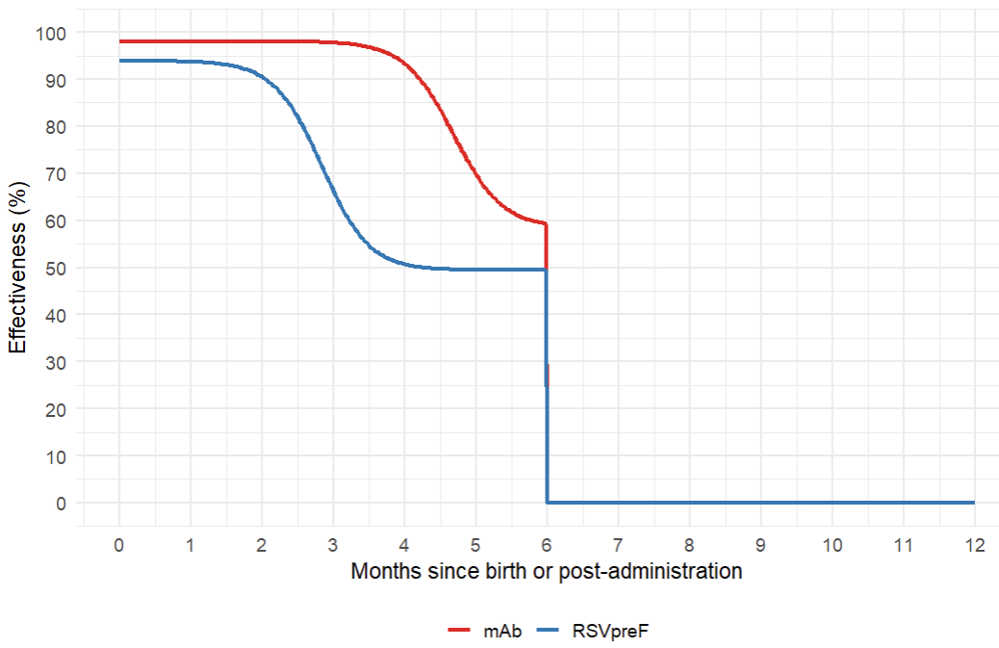

S4 Figure. Effectiveness of RSVpreF and mAb effectiveness against intensive care unit admission, by month.

- Results

  - Primary analysis results

S4 Table. Results of the primary analysis showing costs, QALY losses, and sequential incremental cost-effectiveness ratios (ICERs), in which monoclonal antibody and/or RSVpreF programs are compared stepwise to identify the most efficient options from a health system perspective *
Strategies | Costs  (2024 CAD) | QALY loss | Sequential ICER
Seasonal mAb (moderate or high-risk) + catch-up (moderate or high-risk) | 304,140 | -12.4818
Seasonal RSVpreF + seasonal mAb (high-risk) + catch-up (high-risk) | 340,054 | -11.4676 | 35,408
Seasonal RSVpreF at 32-36 weeks of pregnancy for those with in-season deliveries | 378,003 | -14.0409 | dominated
Seasonal RSVpreF + seasonal mAb (all unimmunized) + catch-up (high-risk) | 435,265 | -10.7470 | 132,131
Seasonal mAb (all infants) + catch-up (high-risk) | 545,696 | -10.6472 | dominated
Seasonal RSVpreF + seasonal mAb (all unimmunized) with catch-up (all infants) | 675,550 | -10.6311 | 1,107,414
Seasonal mAb (all infants) + catch-up (all infants) | 774,523 | -10.5314 | 1,975,226

* Monoclonal antibody and/or RSVpreF programs are compared stepwise to identify the most efficient options from a health system perspective All RSVpreF programs are seasonally administered between 32^{0/7} and 36^{6/7} weeks of pregnancy to those with in-season due dates (November to April) i.e., all infants born outside of the RSV season and high-risk infants (born before 32 weeks of gestational age) born during the RSV season were not protected by the RSVpreF pregnancy vaccine. Seasonal monoclonal antibody for “all unimmunized infants” refer to administration of monoclonal antibody (nirsevimab or clesrovimab) both to infants at high-risk and to those not at high-risk who were born to unvaccinated pregnant women and pregnant people during the RSV season. For combination programs, infants received protection from either product (RSVpreF or monoclonal antibody), not both.
  - Secondary analysis results (mAb only programs)

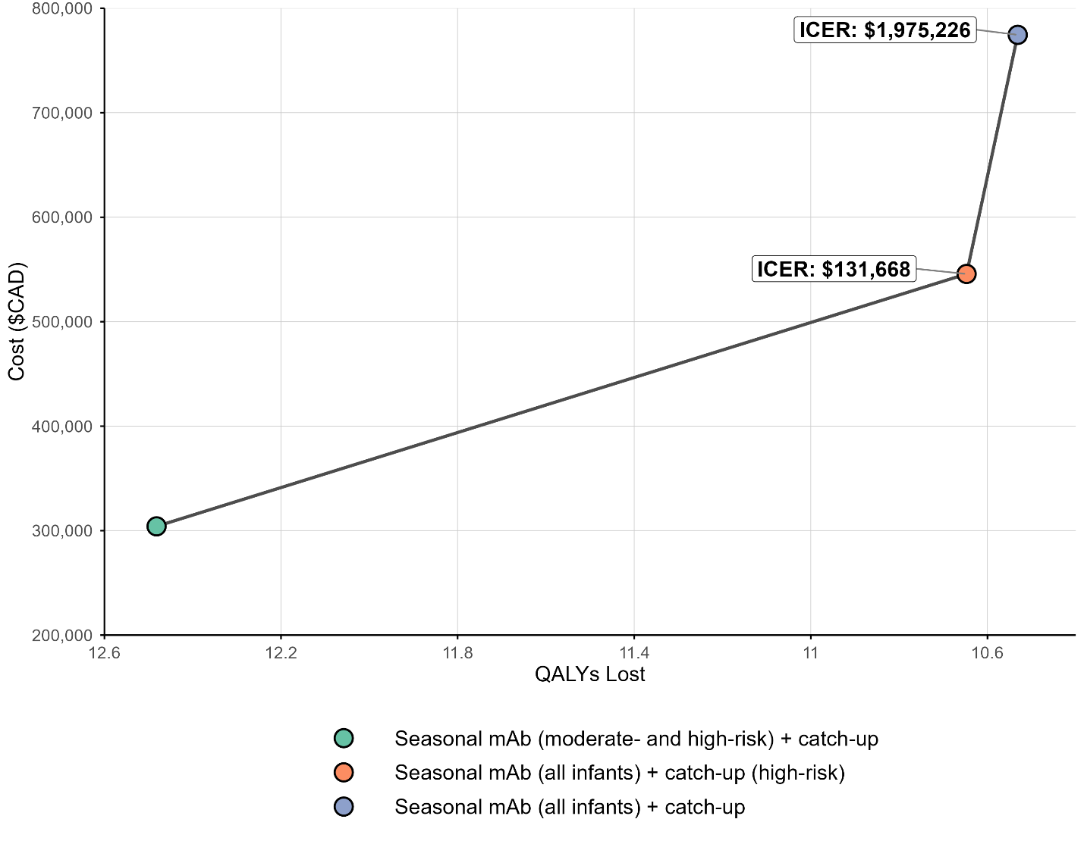
S5 Figure. Results of the secondary analysis showing costs, QALY losses, and sequential incremental cost-effectiveness ratios (ICERs), in which monoclonal antibody only programs are compared stepwise to identify the most efficient options from a health system perspective

  - Longer protection duration scenario results

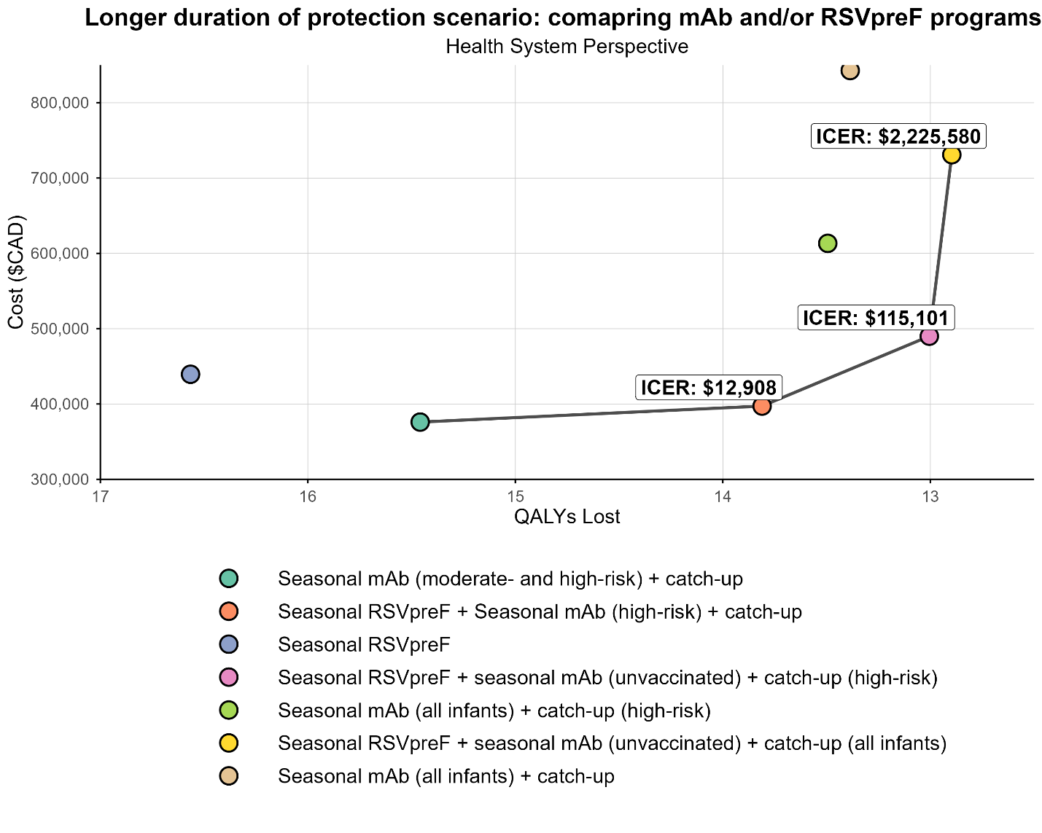
S6 Figure. Results of longer duration of protection scenario showing costs, QALY losses, and sequential incremental cost-effectiveness ratios (ICERs) from a health system perspective.

  - Higher RSV burden and higher medical costs scenario results

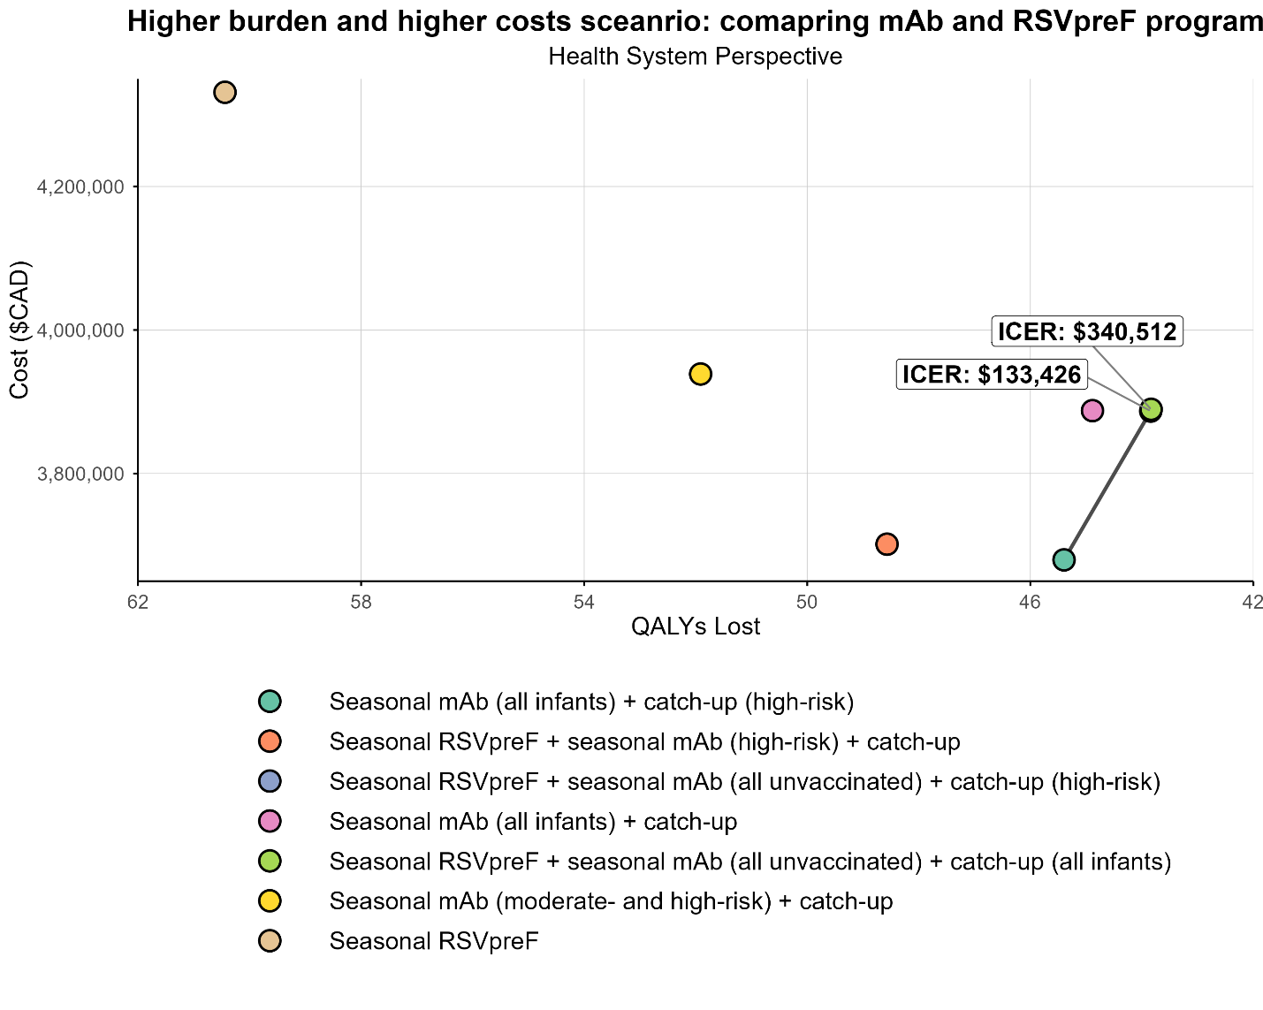
S7 Figure. Results of high burden and medical costs scenario showing costs, QALY losses, and sequential incremental cost-effectiveness ratios (ICERs) from a health system perspective. Note: The ICER for the broad combination program (seasonal RSVpreF plus mAb for infants born to unvaccinated pregnant women and pregnant people, with catch-up for high-risk) was $133,426/QALY when compared to broad monoclonal antibodies program (seasonal monoclonal antibodies for all infants with catch-up for infants at high-risk). The ICER for the universal combination program (seasonal RSVpreF plus mAb for all infants born to unvaccinated pregnant women and pregnant people, with catch-up for all infants) was $340,512/QALY, compared to the broad combination program.

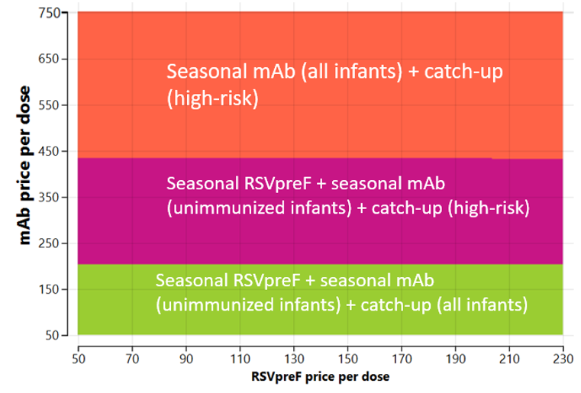
S8 Figure. Two-way sensitivity analysis for high burden and higher medical costs setting using a $50,000 per QALY cost-effectiveness threshold from a health system perspective.

  - Results for the societal perspective

In addition to the health system perspective, a societal perspective was applied to capture the broader economic impact of RSV disease and associated prevention strategies. Under this perspective, additional costs included:
- Productivity losses due to RSV-related deaths, calculated using a human capital approach. This method quantified the present value of future earnings lost due to premature mortality among infants, discounted over the expected working lifetime. Age-specific labour force participation rates and average wage data were sourced from Statistics Canada (8, 9).
- Caregiver productivity losses associated with time taken off work to care for infants who required medical attention for RSV. Time lost was assumed to vary by healthcare setting (e.g., hospitalization, emergency department, or outpatient primary care visits) and was estimated using average earnings and labour force participation rates for adults aged 25–54 years (8, 9).
- Out-of-pocket expenses, including direct non-medical costs borne by families (e.g., over-the-counter medications, home health care expenses, and other miscellaneous household costs related to care) (S1 Table).
These additional costs were incorporated to calculate total societal costs, and a separate incremental cost-effectiveness ratio (ICER) was computed for each strategy. complete results from the societal perspective are provided here.

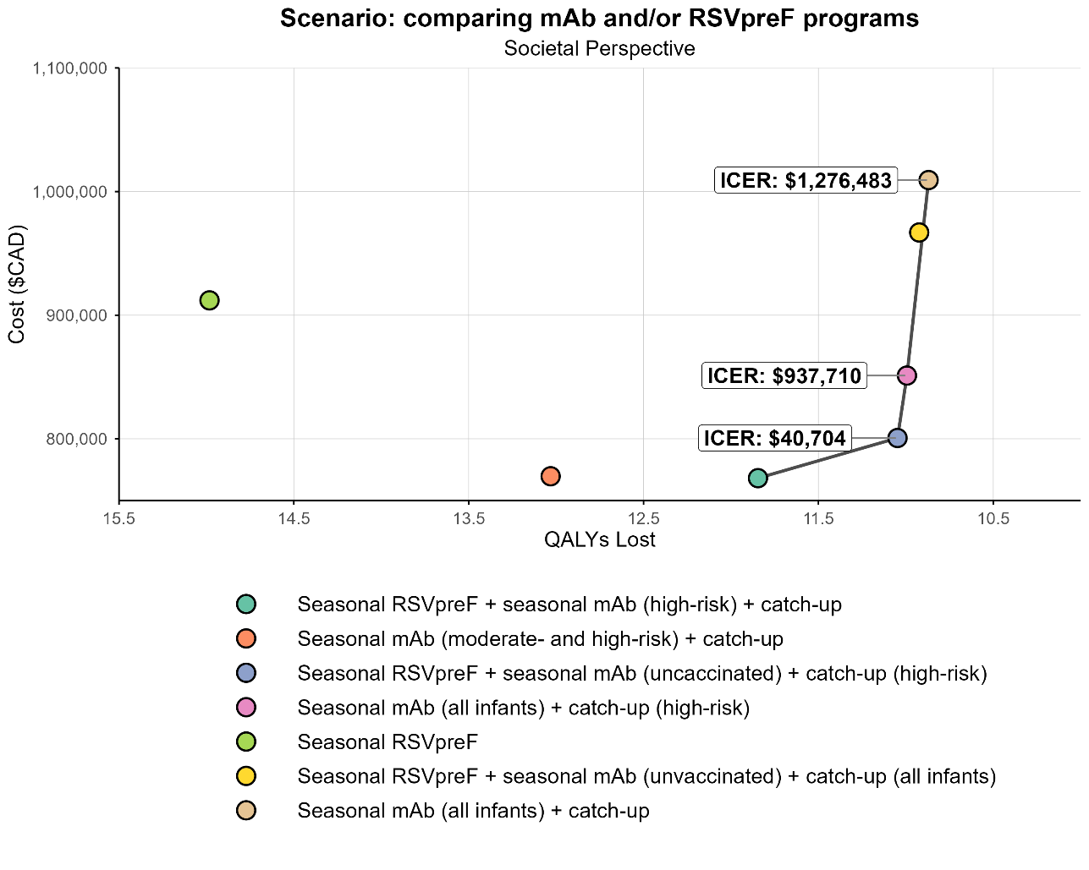
S9 Figure. Results of the primary cost-utility analysis showing costs, QALY losses, and sequential incremental cost-effectiveness ratios, in which monoclonal antibody and/or RSVpreF programs are compared stepwise to identify the most efficient options from a societal perspective.

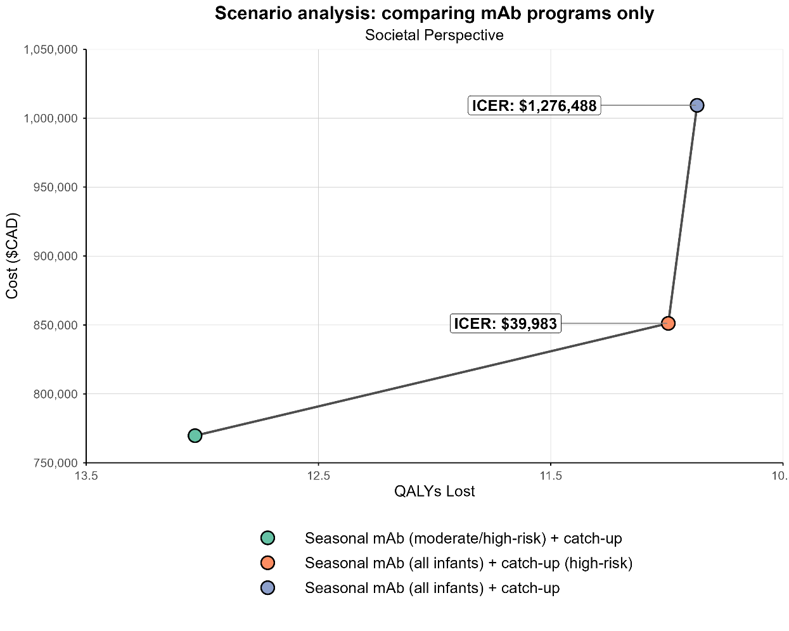
S10 Figure. Results of the secondary analysis showing costs, QALY losses, and sequential incremental cost-effectiveness ratios (ICERs), in which monoclonal antibody only programs are compared stepwise to identify the most efficient options from a societal perspective

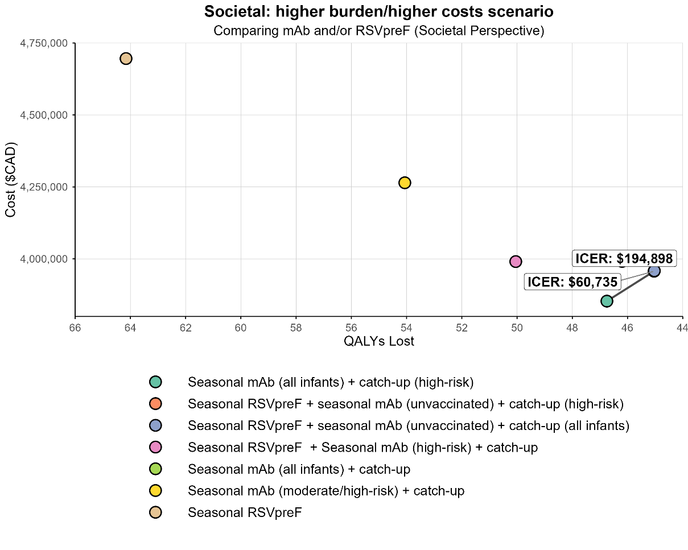
S11 Figure. Results of high burden and higher medical costs scenario showing costs, QALY losses, and sequential incremental cost-effectiveness ratios (ICERs) from a societal perspective. Note: The ICER for the broad combination program (seasonal RSVpreF plus mAb for infants born to unvaccinated pregnant women and pregnant people, with catch-up for high-risk) was $60,735/QALY when compared to broad monoclonal antibodies program (seasonal monoclonal antibodies for all infants with catch-up for infants at high-risk). The ICER for the universal combination program (seasonal RSVpreF plus mAb for all infants born to unvaccinated pregnant women and pregnant people, with catch-up for all infants) was $194,898/QALY, compared to the broad combination program.

- References
1. Abu-Raya B, Coyle D, Bettinger JA, Vaudry W, Halperin SA, Sadarangani M; for members of the Canadian Immunization Monitoring Program, ACTive (IMPACT). Pertussis vaccination in pregnancy in Canada: a cost-utility analysis. CMAJ Open. 2020;8(4):E651-E658. doi: 10.9778/cmajo.20200060.
2. Papenburg J, Saleem M, Teselink J, Li A, Caouette G, Massé É, Lanctôt KL. Cost-analysis of Withdrawing Immunoprophylaxis for Respiratory Syncytial Virus in Infants Born at 33-35 Weeks Gestational Age in Quebec: A Multicenter Retrospective Study. Pediatr Infect Dis J. 2020;39(8):694-699. doi: 10.1097/INF.0000000000002719.
3. Lanctôt KL, Masoud ST, Paes BA, Tarride JE, et al. The cost-effectiveness of palivizumab for respiratory syncytial virus prophylaxis in premature infants with a gestational age of 32–35 weeks: a Canadian-based analysis. Curr Med Res Opin. 2008;24(11):3223-37. doi: 10.1185/03007990802484234.
4. Canadian Institute for Health Information (CIHI). Care in Canadian ICUs. 1–36 (2016).
5. Rafferty E, Paulden M, Buchan SA, Robinson JL, Bettinger JA, Kumar M, et al. Evaluating the Individual Healthcare Costs and Burden of Disease Associated with RSV Across Age Groups. Pharmacoeconomics. 2022;40(6):633-45.
6. Mitchell I, Defoy I, Grubb E. Burden of Respiratory Syncytial Virus Hospitalizations in Canada. Can Respir J. 2017;2017:4521302. doi: 10.1155/2017/4521302.
7. Fragaszy EB, Warren-Gash C, White PJ, Zambon M, Edmunds WJ, Nguyen-Van-Tam JS, Hayward AC; Flu Watch Group. Effects of seasonal and pandemic influenza on health-related quality of life, work and school absence in England: Results from the Flu Watch cohort study. Influenza Other Respir Viruses. 2018;12(1):171-182.
8. Statistics Canada. Table 14-10-0327-02. Unemployment rate, participate rate and employment rate by sex, annual. DOI: 2022. Available at: https://doi.org/10.25318/1410032701-eng.
9. Statistics Canada. Table 11-10-0239-01 Income of individuals by age group, sex and income source, Canada, provinces and selected census metropolitan areas. DOI: 2022. Available at: https://doi.org/10.25318/1110023901-eng.
10. Glaser EL, Hariharan D, Bowser DM, et al. Impact of Respiratory Syncytial Virus on Child, Caregiver, and Family Quality of Life in the United States: Systematic Literature Review and Analysis The Journal of Infectious Diseases. 2022;226(Suppl 2):S236-S245.
11. Regnier SA. Respiratory syncytial virus immunization program for the United States: impact of performance determinants of a theoretical vaccine. Vaccine. 2013;31(40):4347-54.
12. Roy, LM. Deriving health utility weights for infants with Respiratory Syncytial Virus (RSV). University of British Columbia. Thesis/Dissertation, 2013. Accessed 20 June 2023. Available at: https://open.library.ubc.ca/collections/ubctheses/24/items/1.0074259.
13. Singleton R, Semling C, Parker J. Palivizumab Prophylaxis in Alaska for the 2022–23 RSV Season. States of Alaska Epidemiology Bulletin No. 11; 2022. Accessed 25 July 2023. Available at: https://epi.alaska.gov/bulletins/docs/b2022_11.pdf.
14. Karron R SR, Bulkow L et al. Severe respiratory syncytial virus disease in Alaska Native children. J Infect Dis. 1999;180:41–9.
15. Nourbakhsh S, Shoukat A, Zhang K, Poliquin G, Halperin D, Sheffield H, et al. Effectiveness and cost-effectiveness of RSV infant and maternal immunization programs: A case study of Nunavik, Canada. EClinicalMedicine. 2021;41:101141.
16. Banerji A, Ng K, Moraes TJ, Panzov V, Robinson J, Lee BE. Cost-effectiveness of palivizumab compared to no prophylaxis in term infants residing in the Canadian Arctic. CMAJ Open. 2016;4(4):E623-E633.

